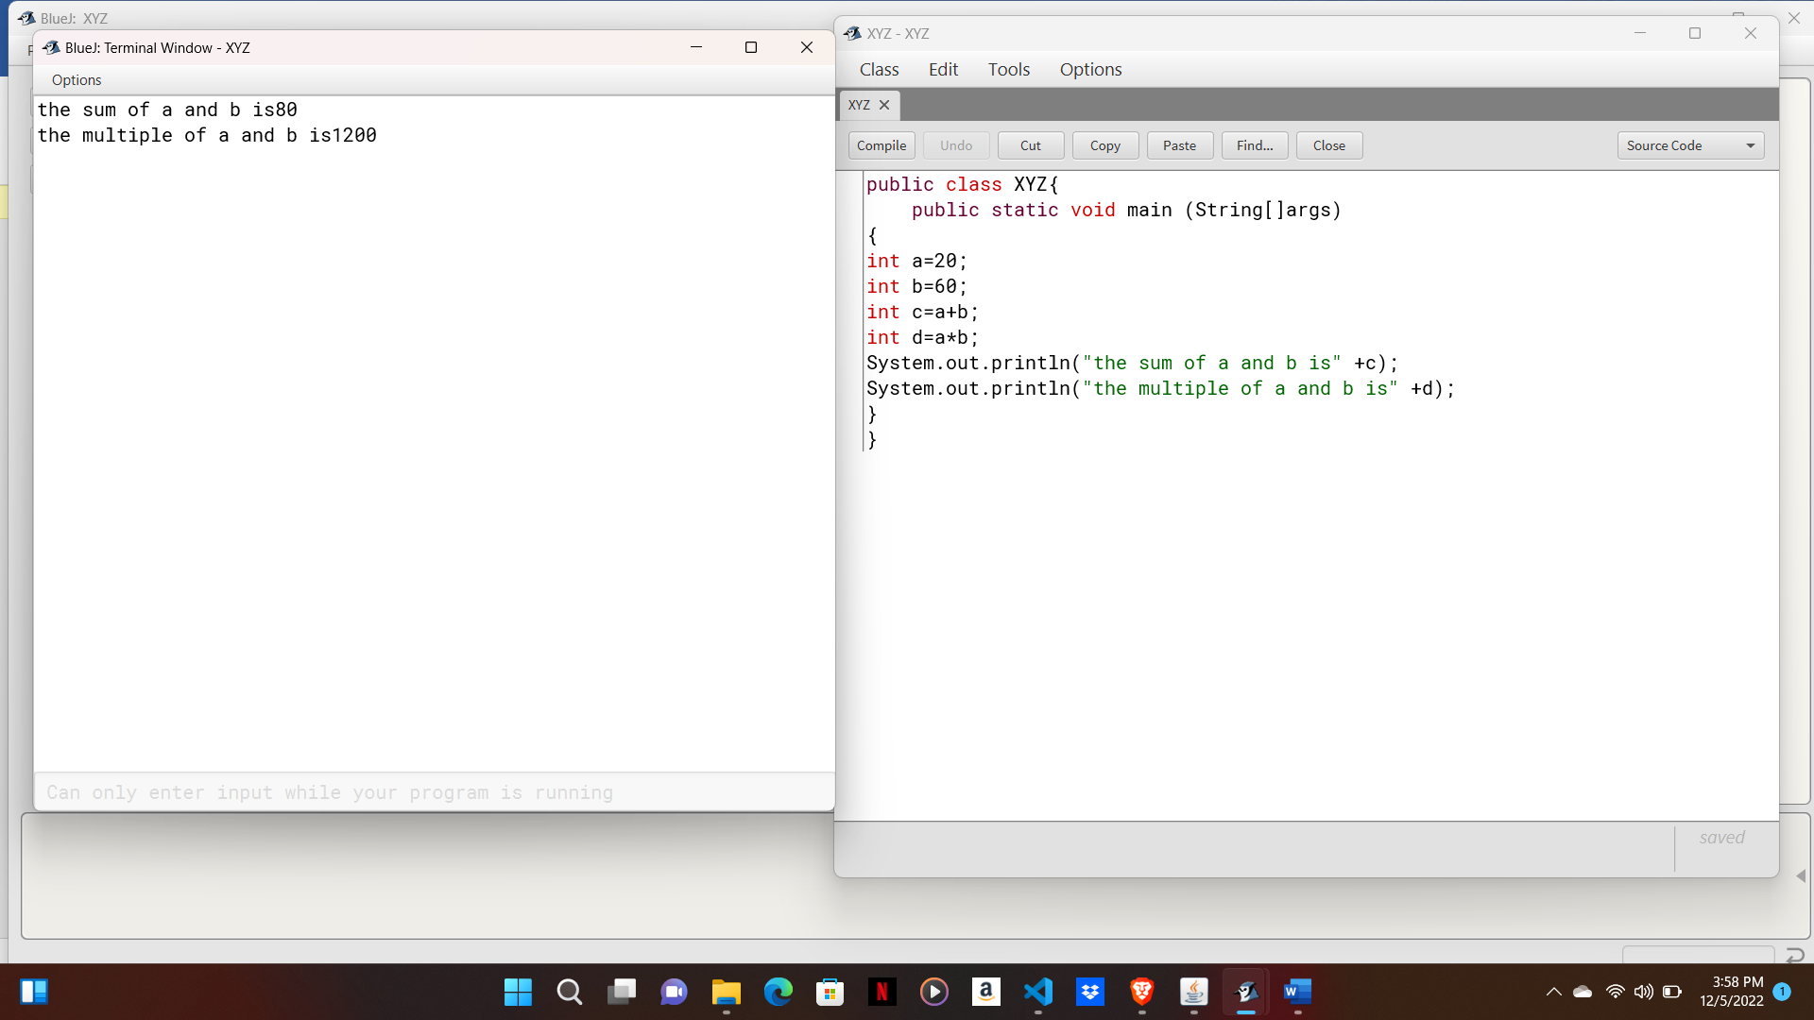

Algorithm:

Step 1- Start.

Step 2- Input 2 numbers and store it in 2 different variables.

Step 3- Perform the calculation of sum and product.

Step 4- Print sum and product.

Step 5- Stop.

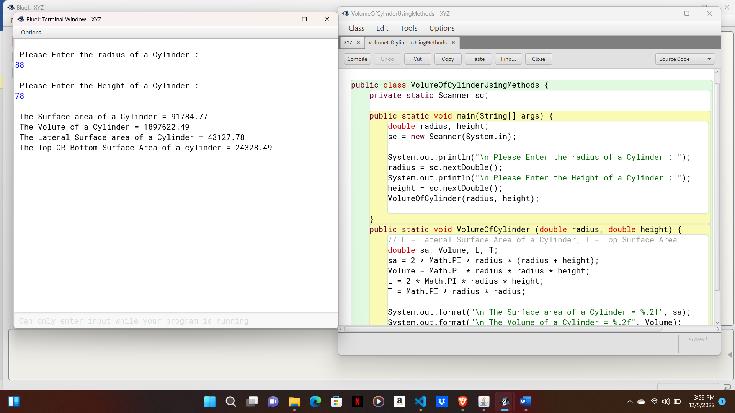

Algorithm:

Step 1- Start.

Step 2- Input radius and height of cylinder.

Step 3- Perform the calculation of volume.

Step 4- Print volume of cylinder.

Step 5- Stop.

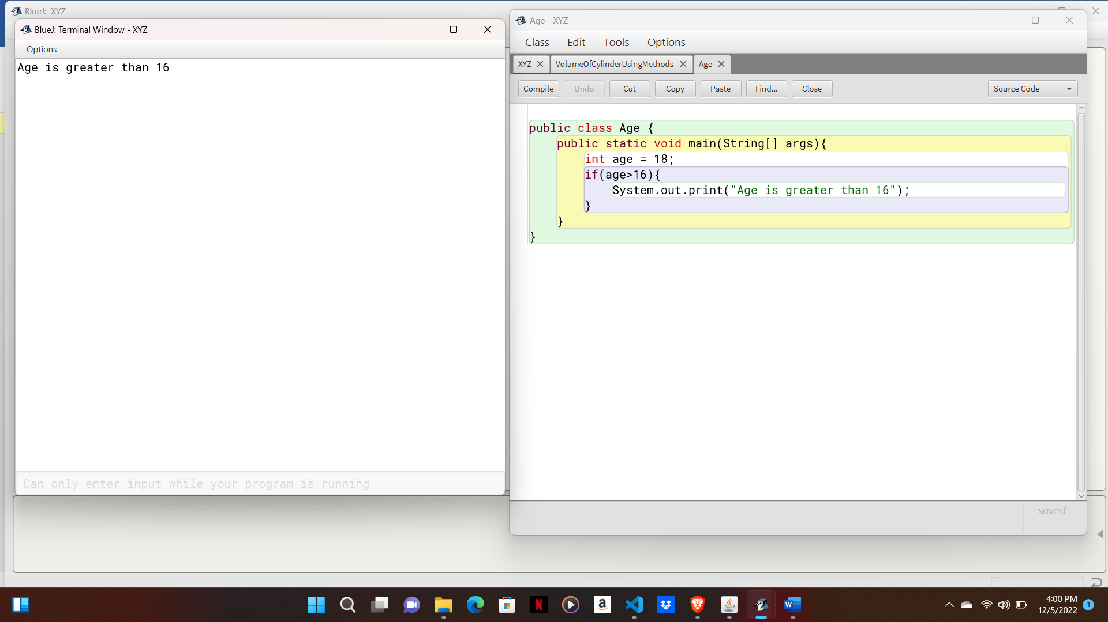

Algorithm:

Step 1- Start.

Step 2- Input age.

Step 3- If age is Greater than 16 yes, go to step 4, no go to step 5.

Step 4- Age is greater than 16.

Step 5- Stop.

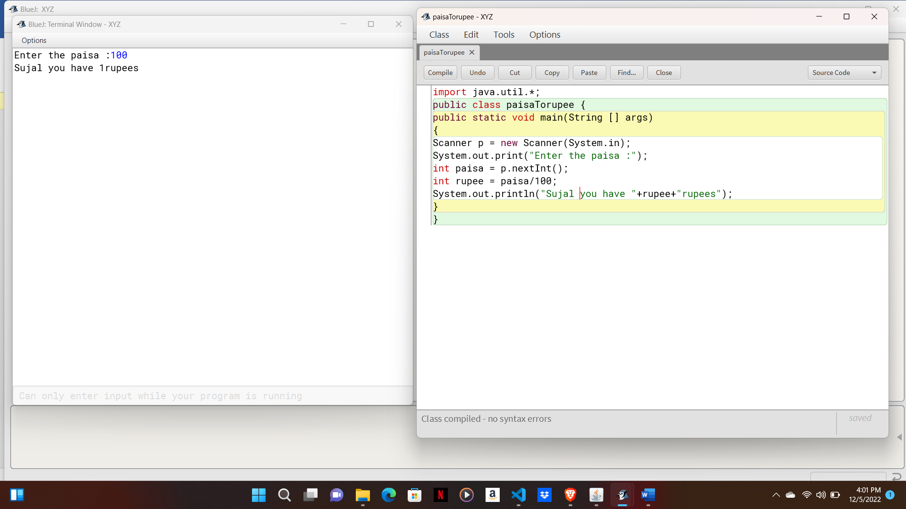

Algorithm:

Step 1- Start.

Step 2- Input Paisa.

Step 3- Convert into rupee.

Step 4- Print paisa to rupees.

Step 5- Stop.

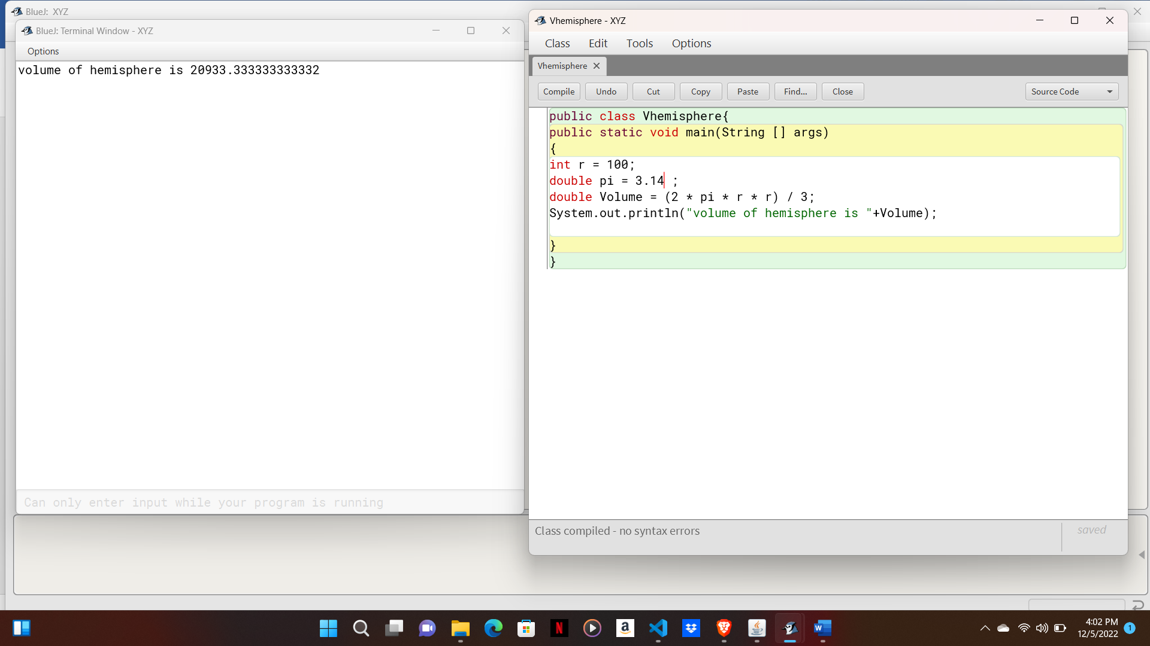

Algorithm:

Step 1- Start.

Step 2- Input radius ,pi and volume.

Step 3- Perform the calculation of volume of hemisphere.

Step 4- Print volume of hemisphere.

Step 5- Stop.

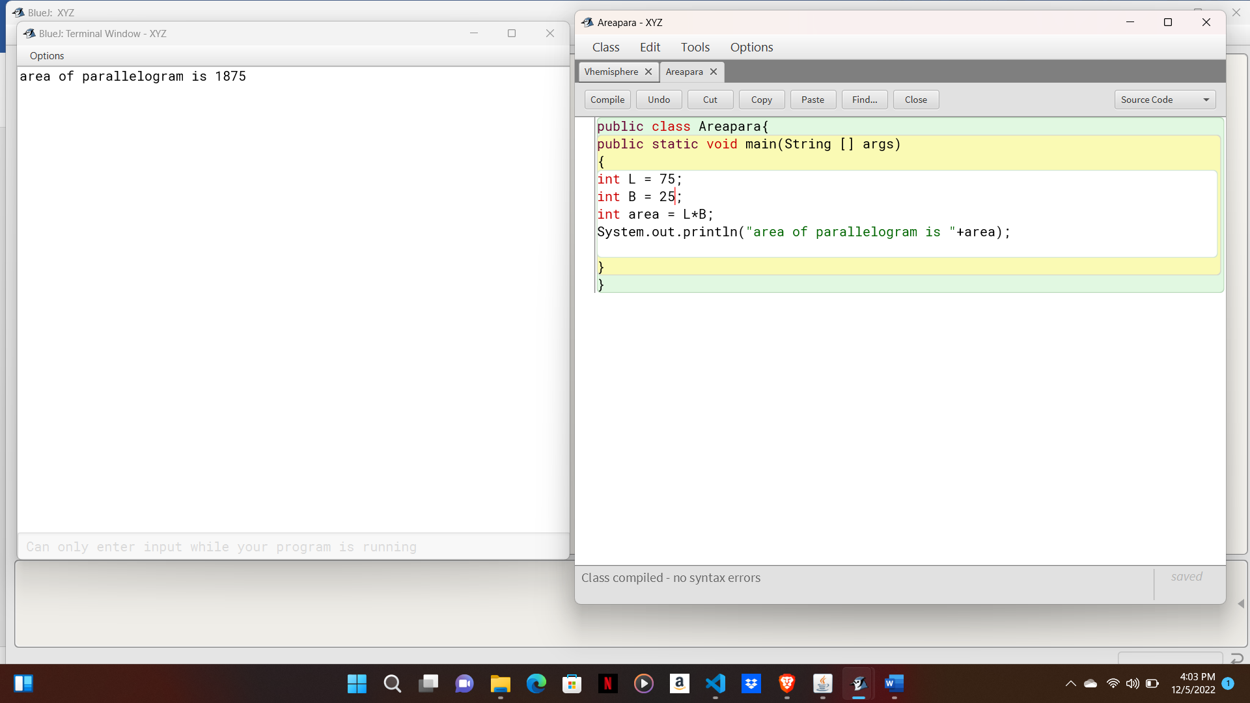

Algorithm:

Step 1- Start.

Step 2- Input length, breadth and area.

Step 3- Perform the calculation to find area of parallelogram.

Step 4- Print area of parallelogram.

Step 5- Stop.

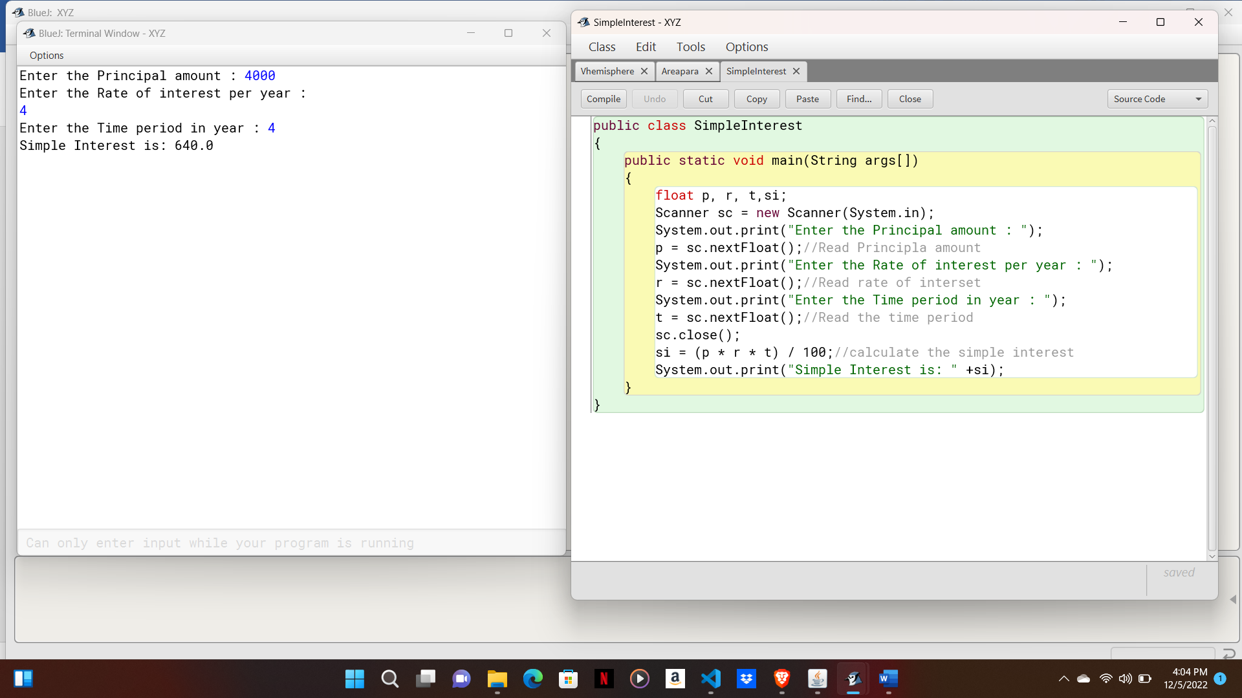

Algorithm:

Step 1- Start.

Step 2- Input principle,rate,time.

Step 3- Perform the calculation to find simple interest.

Step 4- Print simple interest.

Step 5- Stop.

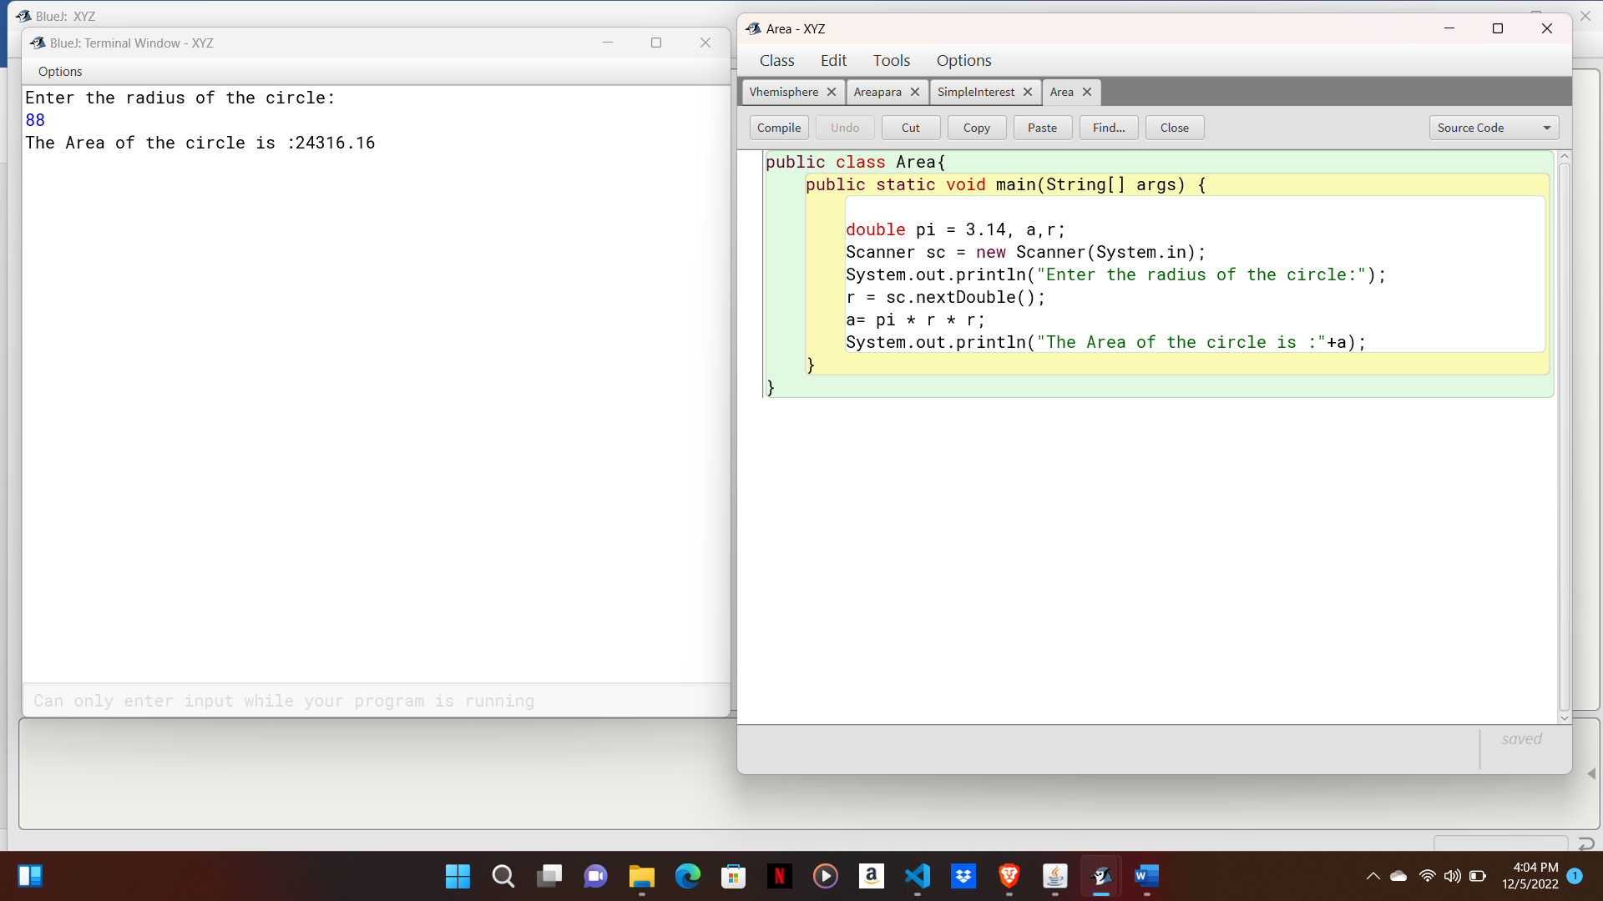

Algorithm:

Step 1- Start.

Step 2- Input pi, radius and area.

Step 3- Perform the calculation to find area of circle.

Step 4- Print area of circle.

Step 5- Stop.

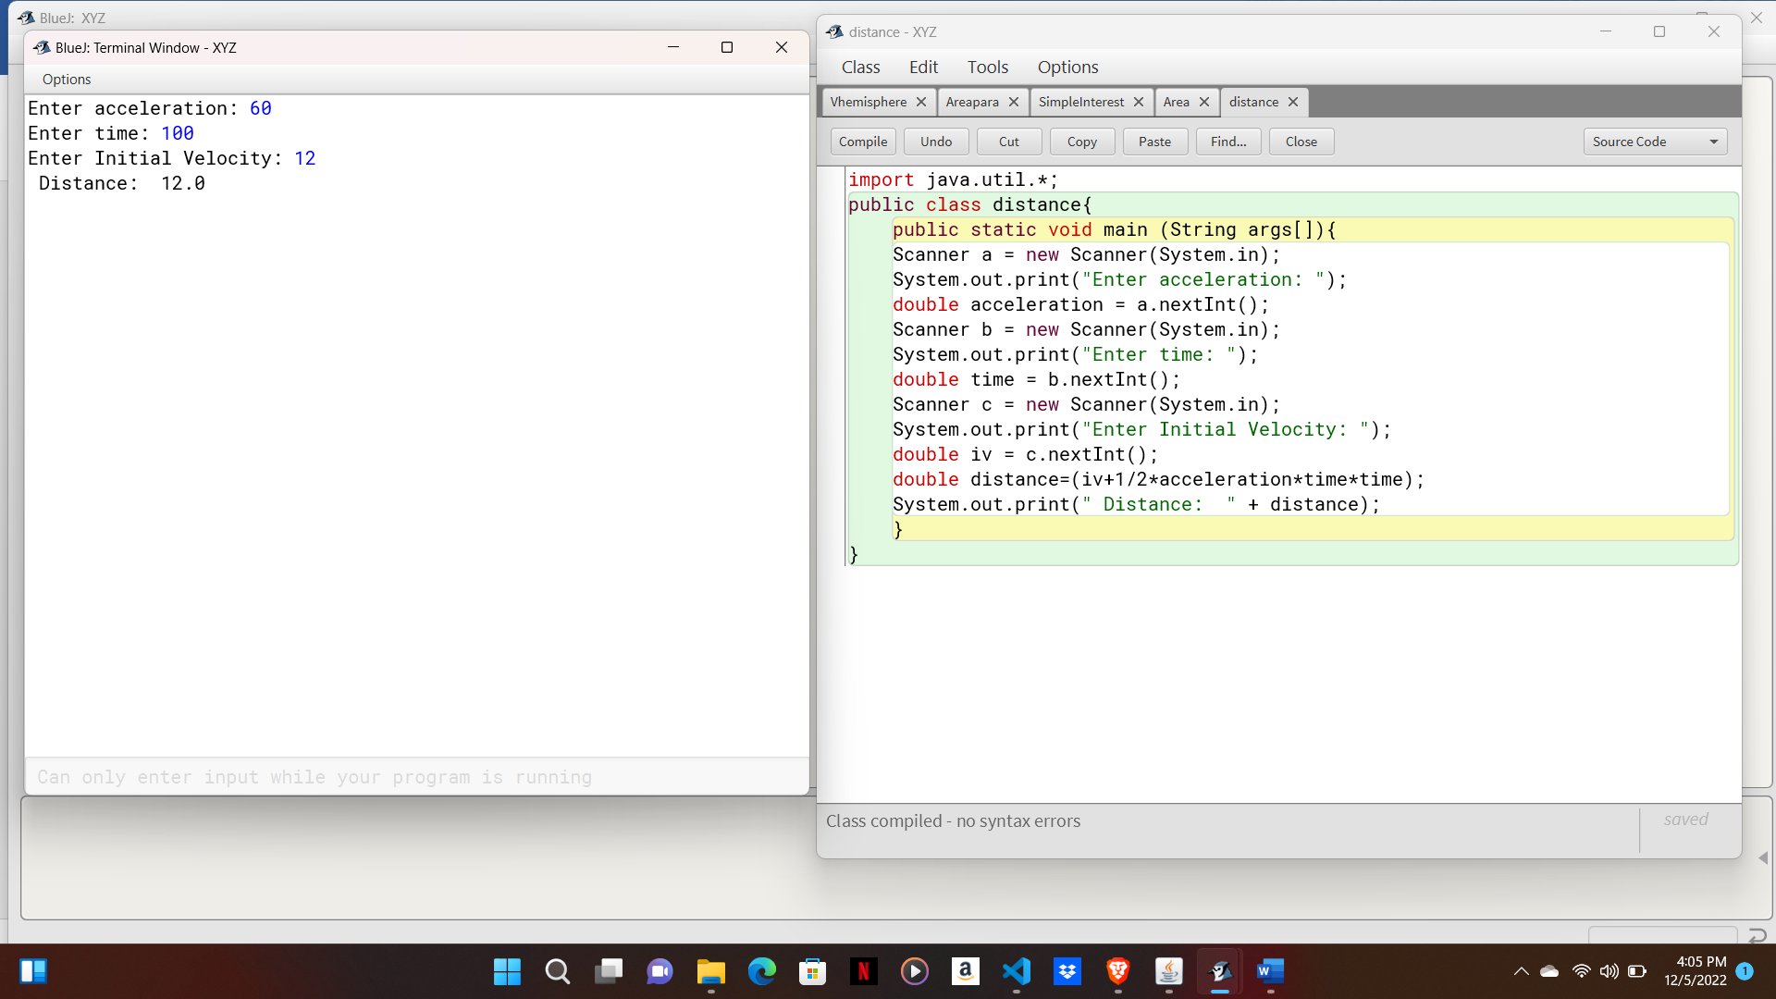

Algorithm:

Step 1- Start.

Step 2- Input acceleration, time and initial velocity.

Step 3- Perform the calculation of distance.

Step 4- Print distance.

Step 5- Stop.

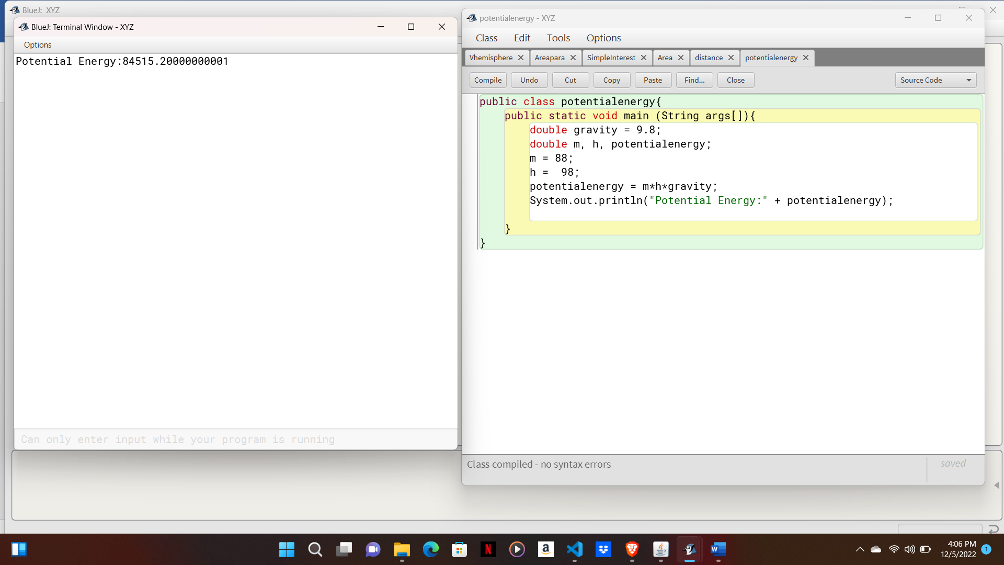

Algorithm:

Step 1- Start.

Step 2- Input 2 numbers and store it in 2 different variables.

Step 3- Perform the calculation of sum and product.

Step 4- Print potential energy.

Step 5- Stop.

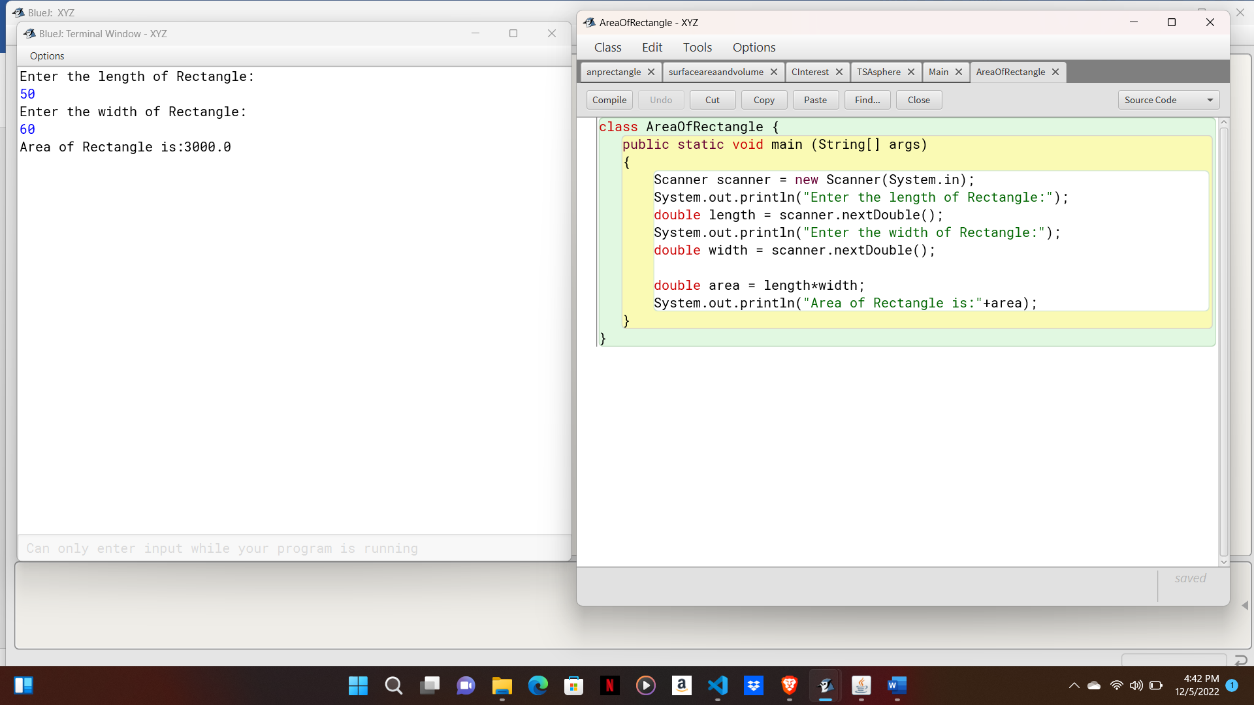

Algorithm:

Step 1- Start.

Step 2- Input length, width and area.

Step 3- Perform the calculation of area of rectangle.

Step 4- Print area of rectangle.

Step 5- Stop.

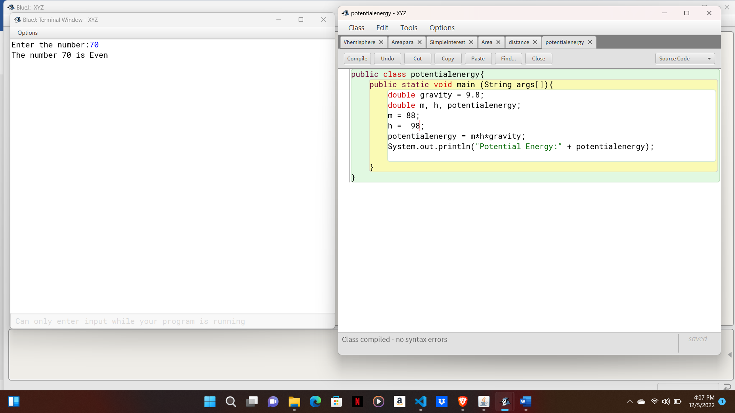

Algorithm:

Step 1- Start.

Step 2- Input potential energy and gravity.

Step 3- Perform the calculation of potential energy.

Step 4- Print potential energy.

Step 5- Stop.

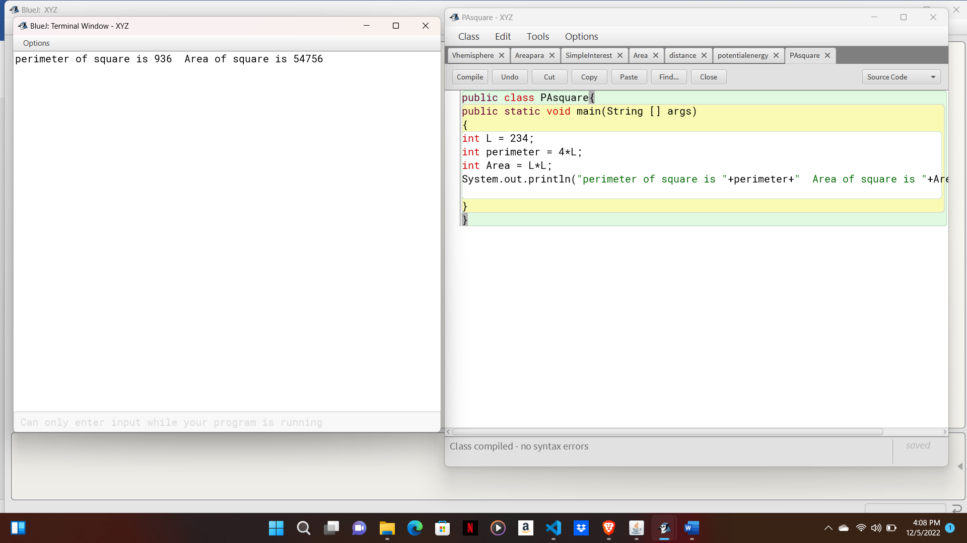

Algorithm:

Step 1- Start.

Step 2- Input length, perimeter and area.

Step 3- Perform the calculation of perimeter of square.

Step 4- Print perimeter of square.

Step 5- Stop.

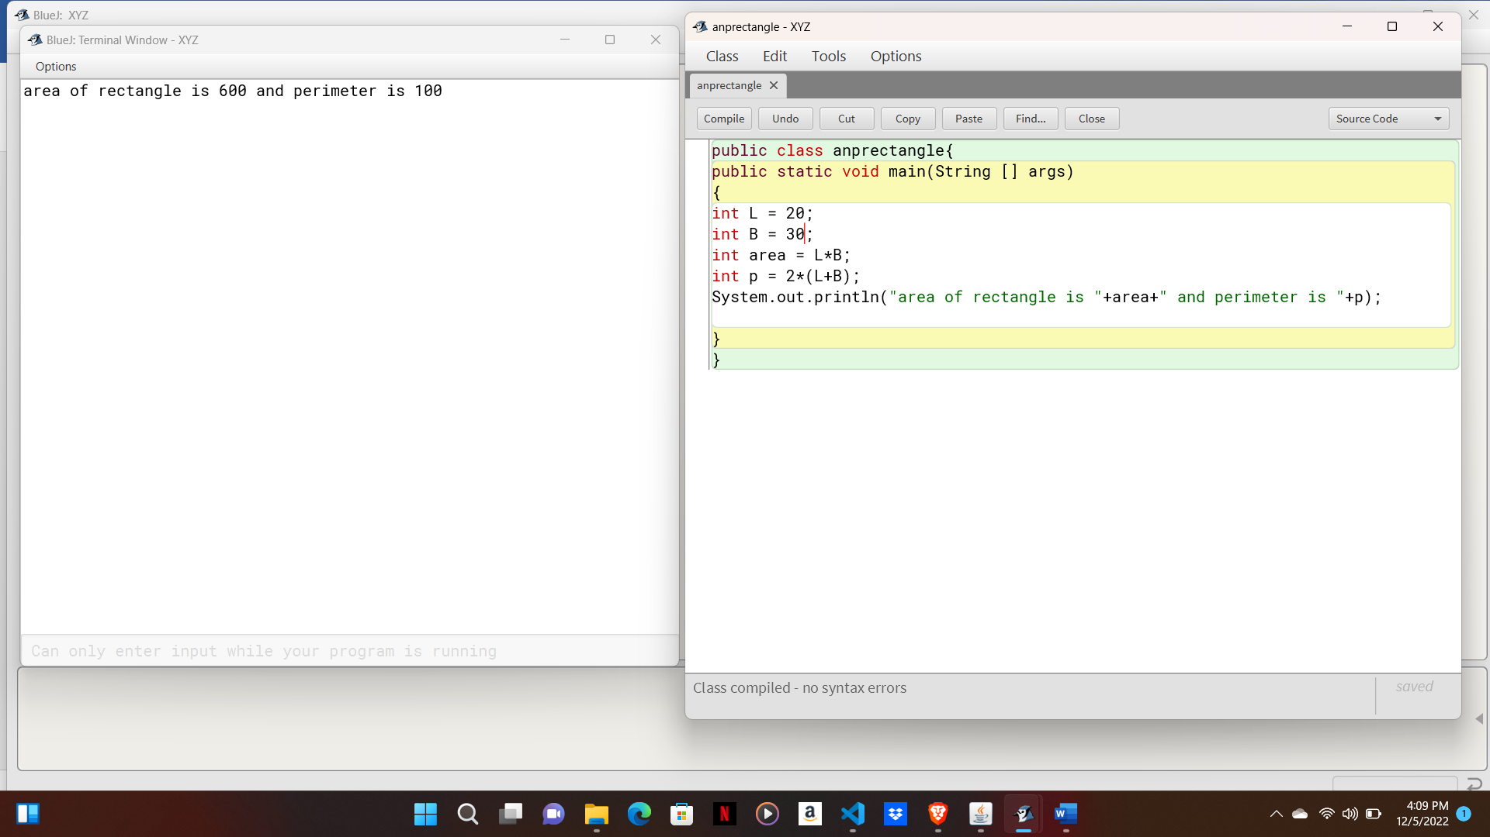

Algorithm:

Step 1- Start.

Step 2- Input length breadth and area.

Step 3- Perform the calculation of area of rectangle.

Step 4- Print area of rectangle.

Step 5- Stop.

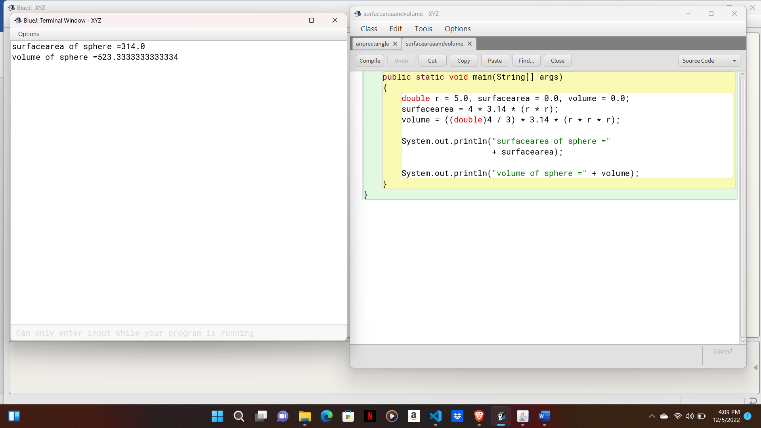

Algorithm:

Step 1- Start.

Step 2- Input pi, radius and volume.

Step 3- Perform the calculation of volume of sphere.

Step 4- Print volume of sphere.

Step 5- Stop.

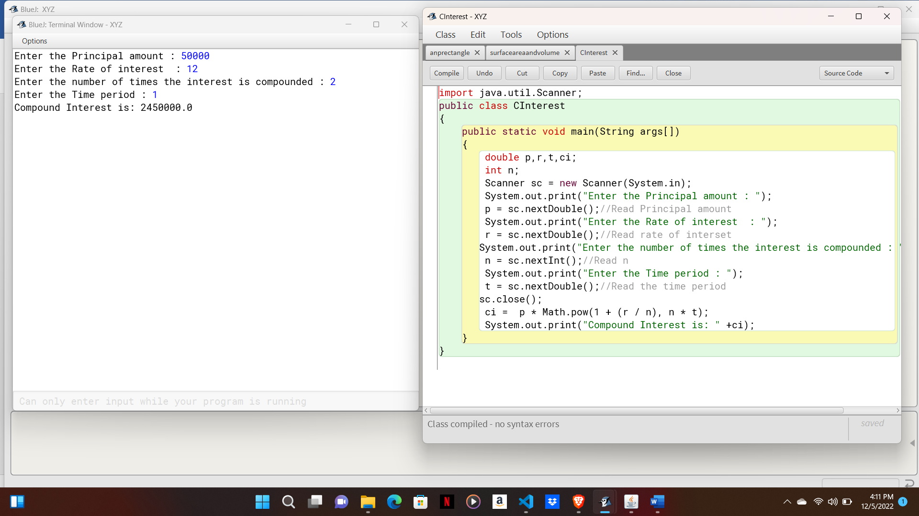

Algorithm:

Step 1- Start.

Step 2- Input principle, time, rate.

Step 3- Perform the calculation of compound interest.

Step 4- Print compound interest.

Step 5- Stop.

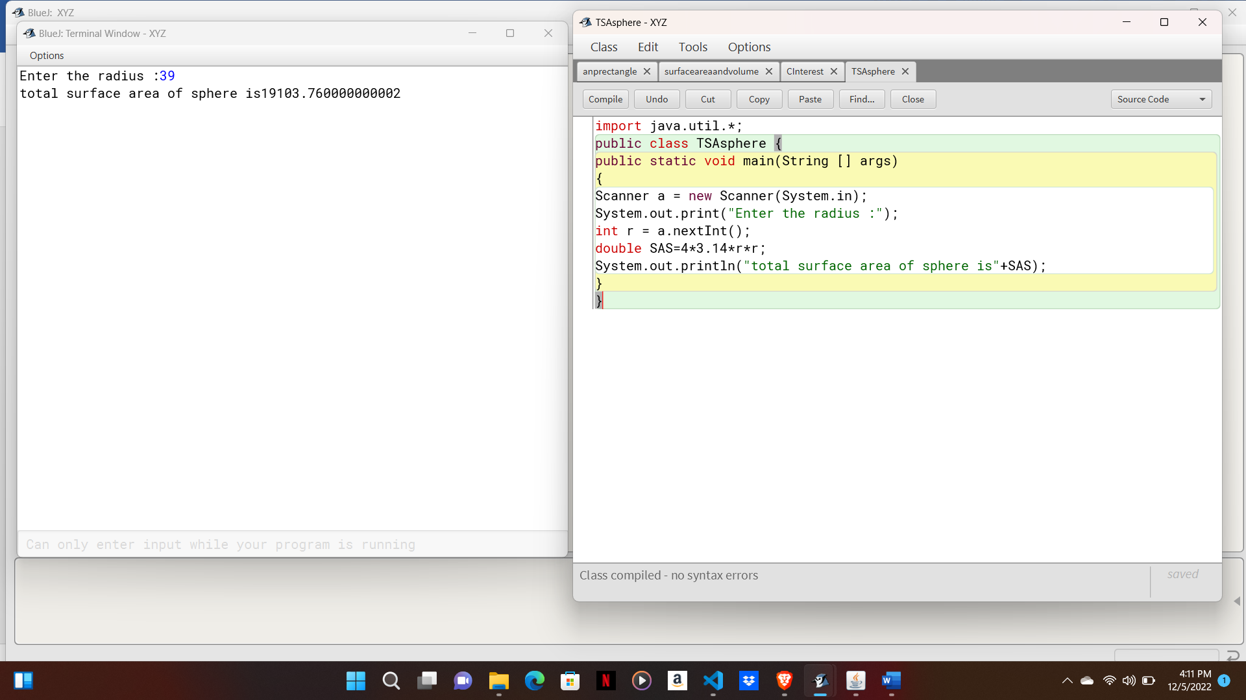

Algorithm:

Step 1- Start.

Step 2- Input radius.

Step 3- Perform the TSA of sphere.

Step 4- Print.

Step 5- Stop.

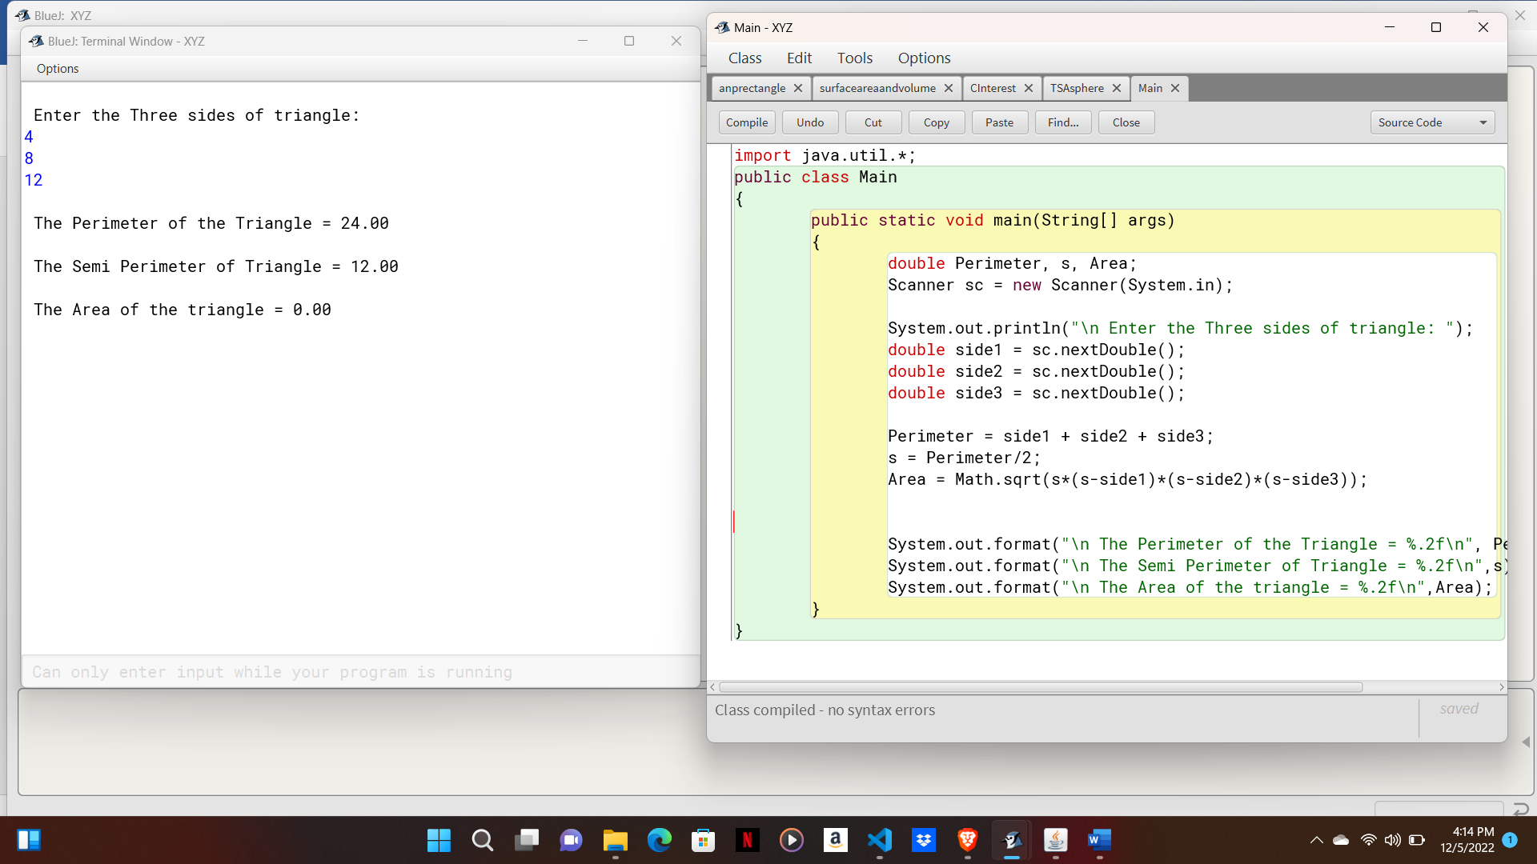

Algorithm:

Step 1- Start.

Step 2- Input three sides of triangle.

Step 3- Perform the calculation of triangle.

Step 4- Print.

Step 5- Stop.