THE BETTING PROCESS
Standard Operating Guide for Placing, Tracking, and Settling Sports Bets
Operational workflow • Practical controls • Platform reference

Document title | The Betting Process — Standard Operating Guide
Prepared by | Sujal
Date | 23 October 2026
Version | 1.0 (Issued)
Applies to | Stake · BC.Game · Roobet · Rollbit · Shuffle · Gamdom
Document type | Professional process reference

Purpose. This document defines the complete, step-by-step betting process — from account setup and bankroll management through bet placement, live tracking, settlement, and withdrawal. It is intended as a reference for adults placing sports bets with online bookmakers where legally permitted.

Responsible gambling. Betting is entertainment, not a source of income. Only bet what you can afford to lose, set deposit and loss limits before you start, and never chase losses. If betting stops being fun, stop — and use the self-exclusion tools or support resources listed in Section 2.

Document Control
Version | Date | Author | Change summary | Status
1.0 | 23 Oct 2026 | Sujal | Initial release — end-to-end betting process with platform-specific notes | Issued

Contents
1. Purpose and Scope
2. Responsible Gambling — Read First
3. Glossary of Betting Terms
4. Phase 1 — Account and Bankroll Setup
5. Phase 2 — Placing a Bet
6. Phase 3 — During the Event
7. Phase 4 — Settlement and Withdrawal
8. Bet Types Quick Reference
9. Platform Playbook (Screenshot Notes)
10. Appendix — Screenshot Index

1. Purpose and Scope
This guide standardises how a sports bet is placed, from account setup until any winnings are withdrawn. It draws on real mobile and desktop product screens from Stake, BC.Game, Roobet, Rollbit, Shuffle and Gamdom. The screenshots illustrate navigation and review points; they are not endorsements, and interfaces, features and availability may change.
Scope:
- Account registration, identity verification (KYC) and deposit.
- Choosing sports, markets and reading odds.
- Building the bet slip, setting stake, and confirming the bet.
- Tracking live bets, cash out, and in-play markets.
- Settlement check and withdrawal of winnings.
Out of scope:
- Casino games, slots, crash games and raffles (except where noted).
- Financial or investment advice — betting outcomes are never guaranteed.
- Legal advice — confirm that online betting is permitted in your jurisdiction before you start.

2. Responsible Gambling — Read First
Golden rules. 1. Participate only if you meet the legal age and betting is permitted where you live. 2. Treat every stake as money you may lose. 3. Set a bankroll and never exceed it. 4. Set deposit, loss and time limits before your first bet. 5. Never chase losses or borrow to bet. 6. If betting affects your mood, sleep or finances, stop and seek support.

Platform tools to use:
- Deposit limits (daily / weekly / monthly).
- Loss limits and session time limits.
- Reality checks (session duration reminders).
- Self-exclusion / cool-off periods.
- Two-factor authentication (2FA) to secure the account.
Support: Gamblers Anonymous (gamblersanonymous.org) or a qualified local gambling-support service. For legal questions, check the rules that apply in your state or country before placing a real-money bet.

3. Glossary of Betting Terms
Term | Meaning
Stake | The amount of money risked on a bet.
Odds (decimal) | The multiplier applied to the stake to calculate the total return (stake × odds). Example: ₹1,000 @ 2.50 returns ₹2,500.
Market | The specific outcome being bet on (e.g. match winner, over/under goals, both teams to score).
Selection | One outcome added to the bet slip.
Bet slip | The panel where selections, stake, and potential return are shown before confirming.
Parlay / Accumulator | Multiple selections combined into one bet; all must win for the bet to pay. Higher return, higher risk.
Cash out | Settling a live bet early for an offered amount before the event ends.
In-play / Live | Betting on an event after it has started, with odds that move in real time.
KYC | Know Your Customer — identity checks that a platform may require before deposits or withdrawals.
Bankroll | The total amount of money set aside exclusively for betting.
Settlement | The bookmaker grading a bet as won, lost, or void after the event finishes.
RTP | Return to Player — the theoretical percentage returned to players over time (casino products).

4. Phase 1 — Account and Bankroll Setup

Step 1 — Choose a platform
Pick a bookmaker that is reputable, holds a recognisable licence, covers the sports you want, and offers a clean mobile experience. The table below summarises the six platforms reviewed for this guide, based on live product screenshots.
Platform | Device focus | Standout feature (from screenshots) | Best used for
Stake | Mobile | Live counters on sport chips; full 1×2 market priced inline in the list | Live soccer and fast market navigation
BC.Game | Mobile | Quick-bet button inside the odds row; big-win social proof above the fold | Quick bet placement on mobile
Roobet | Mobile / Desktop | My Bets as a top-level sports tab; per-sport in-play state line | Tracking settled and active bets
Rollbit | Desktop | Combo quick-bet builder; promotional bets feed on the home page | Parlays and combo bets
Shuffle | Mobile / Desktop | Clean tennis bet slip on mobile; dense desktop sportsbook | Tennis and general sportsbook browsing
Gamdom | Desktop | Sports hub layout; rewards tiers visible in the account | Bonus tracking and rewards status

Step 2 — Register and verify the account
1. Open the registration form and enter accurate email, phone and date-of-birth details. Use a strong, unique password.
2. Enable two-factor authentication where available to protect the account and balance.
3. Confirm your email or phone using the one-time code. The BC.Game example masks the destination and provides Paste and resend controls; email confirmation is separate from identity verification.
4. Complete KYC when requested using the platform's secure upload flow. Requirements vary; check withdrawal requirements before depositing significant funds.
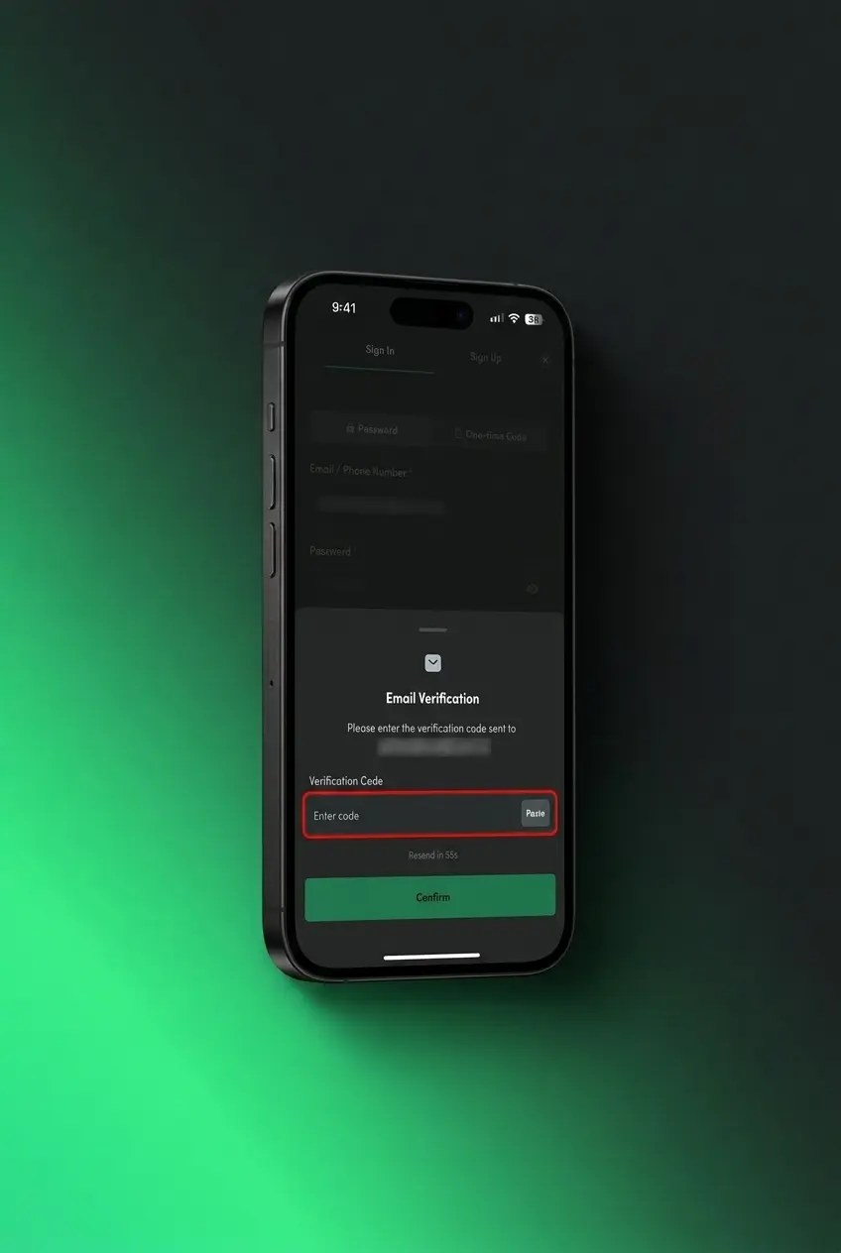
Figure 1 — BC.Game mobile: email verification with a masked destination, Paste control and resend countdown.

Step 3 — Deposit and set your bankroll
1. Decide your bankroll — money you can afford to lose, kept separate from essential and daily finances.
2. Deposit through the cashier using an available method; check fees, payment network, processing time and any bonus conditions first.
3. Set a fixed unit size before betting. An illustrative guardrail is 1–2% of bankroll per bet; this limits exposure but does not improve the odds.
4. Apply deposit, loss and time limits in the account settings before the first bet (see Section 2).
Example guardrail | 1–2% of bankroll per bet; never increase a stake to chase losses.
Before depositing | Check verification, withdrawal, fee and payment-method requirements.
Security | Enable 2FA where available; never share passwords or one-time codes.

5. Phase 2 — Placing a Bet

Step 4 — Pick the sport and market
Open the sportsbook, choose a sport, then a competition and event. Look for live indicators — Stake, for example, shows live counters on the sport chips (Tennis 48, Soccer 4, Baseball 8) with the current score sitting inside the same card as the price, so you can enter a live market in one tap.
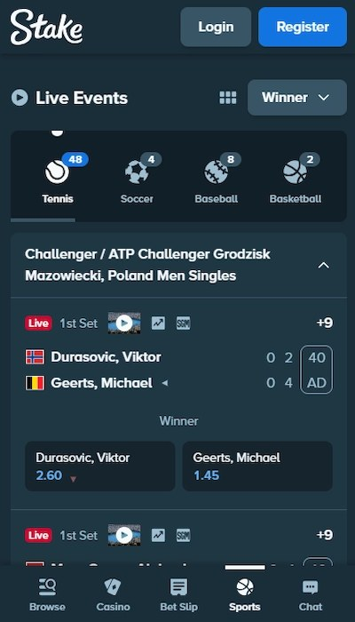
Figure 2 — Stake mobile: live counters on sport chips and the score inside the event card.

Step 5 — Read the odds and implied probability
These examples use decimal odds. Implied probability is 1 ÷ odds — for example, decimal odds of 2.00 convert to 50%. This is a mathematical conversion, not a prediction or guarantee. Stake's mobile list prices the full 1×2 row inline for each match, with a chip for additional markets, so you can review the event, market and price before opening the slip.
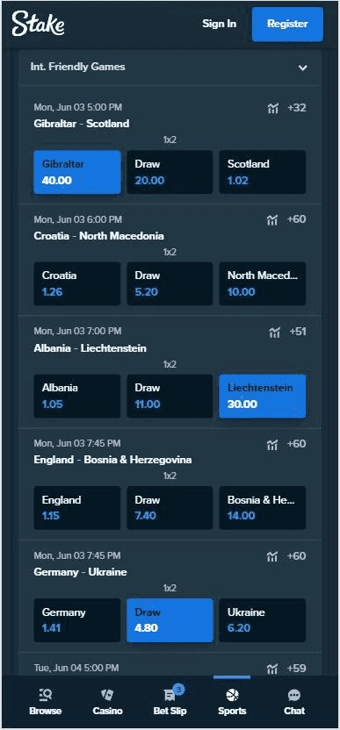
Figure 3 — Stake mobile: the 1×2 market priced inline, with a chip showing additional markets.

Step 6 — Add selections to the bet slip
Tap the odds of your chosen outcome to add it to the slip. On BC.Game mobile, the green bet-slip button sits in the market area; on Shuffle mobile, Bet Slip remains available in the bottom bar. Open the slip and review every selection before staking — a bet normally cannot be edited after confirmation.
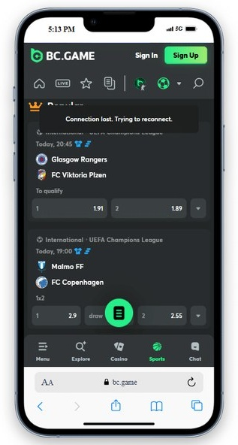
Figure 4 — BC.Game mobile: a prominent bet-slip control within the sports market view.
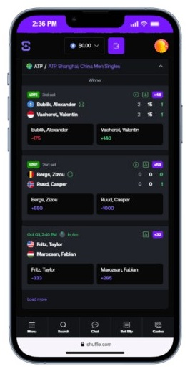
Figure 5 — Shuffle mobile: live tennis prices with Bet Slip retained as a bottom-bar destination.

Step 7 — Set the stake and verify the potential return
1. Enter your stake within the fixed unit limit you set in Step 3.
2. Check the potential total return — stake × decimal odds for a single, or stake × combined decimal odds for a parlay. Potential profit is total return minus stake.
3. Confirm the bet type — single, parlay/accumulator or system (see Section 8).
4. Review the final slip — event, market, selection, odds, stake, return and any promotion conditions.

Step 8 — Place the bet and confirm
Tap “Place Bet” (or “Confirm”) and wait for an acceptance message or bet ID. If Quick Bet is enabled, check whether it reduces confirmation steps before using it. The Rollbit example below shows why the bet-type tab, leg count and each selection must be reviewed before submission.
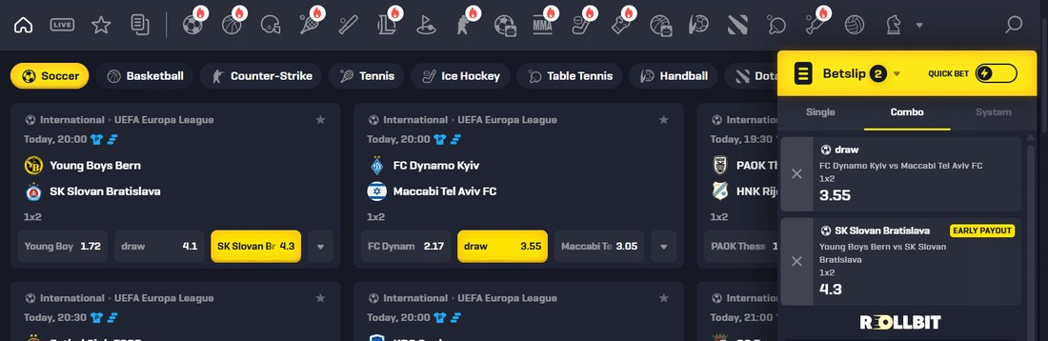
Figure 6 — Rollbit desktop: Single / Combo / System tabs, two listed legs and a visible Quick Bet toggle.
Pro tip. Save the accepted bet details (bet ID, selections, stake, odds and timestamp) for any later query. If the connection drops during submission, check My Bets before retrying so you do not place a duplicate.

6. Phase 3 — During the Event

Step 9 — Track the bet in “My Bets”
Open “My Bets” from the sports navigation to review active and settled wagers, their status and potential returns. Roobet places My Bets beside All Sports in the top-level navigation. Use the bet ID and acceptance status—not a selection badge alone—as evidence that the wager was recorded.
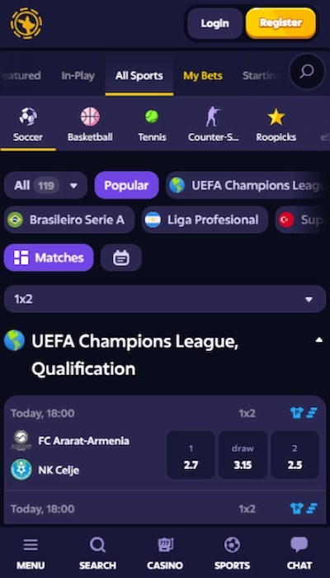
Figure 7 — Roobet mobile: My Bets available as a first-class tab in the sports navigation.

Step 10 — Live betting and cash out (optional)
If the event is underway, use the in-play list, which shows each league's state line (halftime, minute, quarter) beside the market and price. Roobet's mobile in-play view names the market above every price, so you know exactly what you are backing at each live moment.
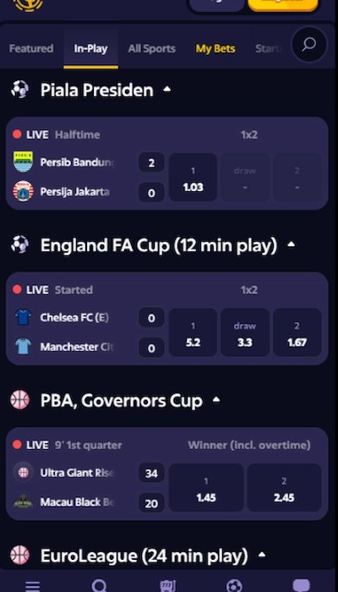
Figure 8 — Roobet mobile: in-play state lines, scores and market labels shown alongside live prices.
Cash out — where offered. Cash out can settle an eligible live bet early for the amount shown. The offer moves with live odds and may be suspended or unavailable. Accepting it ends the bet at that value; you give up the original full payout if the selection later wins.

7. Phase 4 — Settlement and Withdrawal

Step 11 — Check settlement
1. Wait for the event to finish — the bookmaker grades the bet as won, lost, or void.
2. Check “My Bets” / settled bets for the result and the payout credited to your balance.
3. Query discrepancies quickly using the bet ID and your screenshot from Step 8.

Step 12 — Withdraw winnings
1. Confirm KYC is complete — most platforms block withdrawals from unverified accounts.
2. Open the cashier/withdrawal section and choose your payout method and network.
3. Enter the amount within min/max limits; note fees and expected processing time.
4. Withdraw to an account in your own name — third-party payouts are usually rejected.
Withdrawal checklist. KYC complete ✅ • 2FA enabled ✅ • Amount within limits ✅ • Correct network/address ✅ • Screenshot of withdrawal request ✅

8. Bet Types Quick Reference
Bet type | How it works | Review priority | Relative risk
Single | One selection on one market. | Confirm the event, market, selection and price. | Lower than a parlay; stake still at risk
Parlay / Accumulator | Two or more selections; all must win. | Check every leg and the combined odds. | Higher; one losing leg loses the bet
System | A combination of smaller parlays, depending on the format. | Check total cost, combination count and payout rules. | Varies by format; not a guarantee
In-play / Live | Placed after the event starts; odds and availability move quickly. | Check the score, game state, market label and acceptance. | Fast-moving; suspension and price changes possible

Promotions may include trigger conditions, minimum stakes and maximum payouts. Read the terms before opting in. A promotion does not remove the risk of losing, and every added parlay leg adds another way for the bet to lose.

9. Platform Playbook (Screenshot Notes)
Use these observations as navigation shortcuts, not as rules or endorsements. Interfaces, market availability and feature names can change; always verify the live slip in front of you.
Platform | Workflow shortcut | Illustrated in
Stake | Use live counters to enter active events; compare inline 1×2 prices before opening a selection. | Figures 2–3 · Steps 4–5
BC.Game | Complete account-code verification; use the sports-screen bet-slip control to review selections. | Figures 1 and 4 · Steps 2 and 6
Roobet | Use My Bets for active and settled wagers; check game state and market labels on in-play events. | Figures 7–8 · Steps 9–10
Rollbit | Choose Single, Combo or System explicitly; review every leg and the Quick Bet setting before submitting. | Figure 6 · Step 8
Shuffle | Use the persistent Bet Slip destination in the bottom bar to return to your selections. | Figure 5 · Step 6
Gamdom | Scan the sports hub for available markets; review rewards and promotional terms separately from bet rules. | Reference screenshot pack

Interface check. A familiar icon or green/yellow highlight is not confirmation that a bet was accepted. Always verify the final status in the bet slip or My Bets and retain the bet ID where available.

10. Appendix — Screenshot Index
The eight figures in this guide come from the real product screenshot pack in the project workspace. Two phone captures are trimmed only to remove blank white margins; their interface content is unchanged.
Figure | Platform / device | Source file | Process reference
1 | BC.Game / mobile | 05_bcgame_mobile_email_verification.jpg | Step 2 · Verify account
2 | Stake / mobile | 01_stake_mobile_live_soccer.jpg | Step 4 · Select event
3 | Stake / mobile | 02_stake_mobile_market_density.jpg | Step 5 · Review odds
4 | BC.Game / mobile | 03_bcgame_mobile_quickbet_fab.jpg | Step 6 · Open bet slip
5 | Shuffle / mobile | 12_shuffle_mobile_tennis_betslip.jpg | Step 6 · Review selections
6 | Rollbit / desktop | 10_rollbit_desktop_quickbet_combo.jpg | Step 8 · Confirm bet
7 | Roobet / mobile | 06_roobet_mobile_nav_mybets.jpg | Step 9 · Track bet
8 | Roobet / mobile | 07_roobet_mobile_inplay.jpg | Step 10 · In-play review

End of document. Questions or process improvements should be sent to the document owner. This guide does not guarantee betting outcomes and is not financial or legal advice. Bet responsibly.

