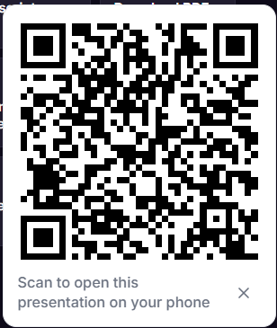
JO Biji ppt jovti hoy to nicheno QR scan karo or Link click karo

OR
LINK:-
https://prezi.com/craft?load=rmkwd4u30hrc

