SQL Documentation for Urban Retail Co. Inventory Management System

**Table of Contents**

1. SQL Infrastructure Design
2. Database Schema Overview
3. Table Descriptions
4. View Descriptions
5. Query Documentation
6. Data Import Procedures
7. Performance Considerations
8. Maintenance Guidelines

# 1. SQL Infrastructure Design

A modular, SQL-centric pipeline ensures clear separation of concerns:

* **Staging**: Temporary tables mirror raw data, isolating ingestion issues.
* **Core Schema**: Master (stores, products) and fact (inventory_data) tables store cleaned data.
* **Analytics Layer**: SQL VIEWs encapsulate business logic (reorder points, turnover).
* **Reporting Layer**: Aggregated VIEWs present KPIs for visualization tools or email reports.

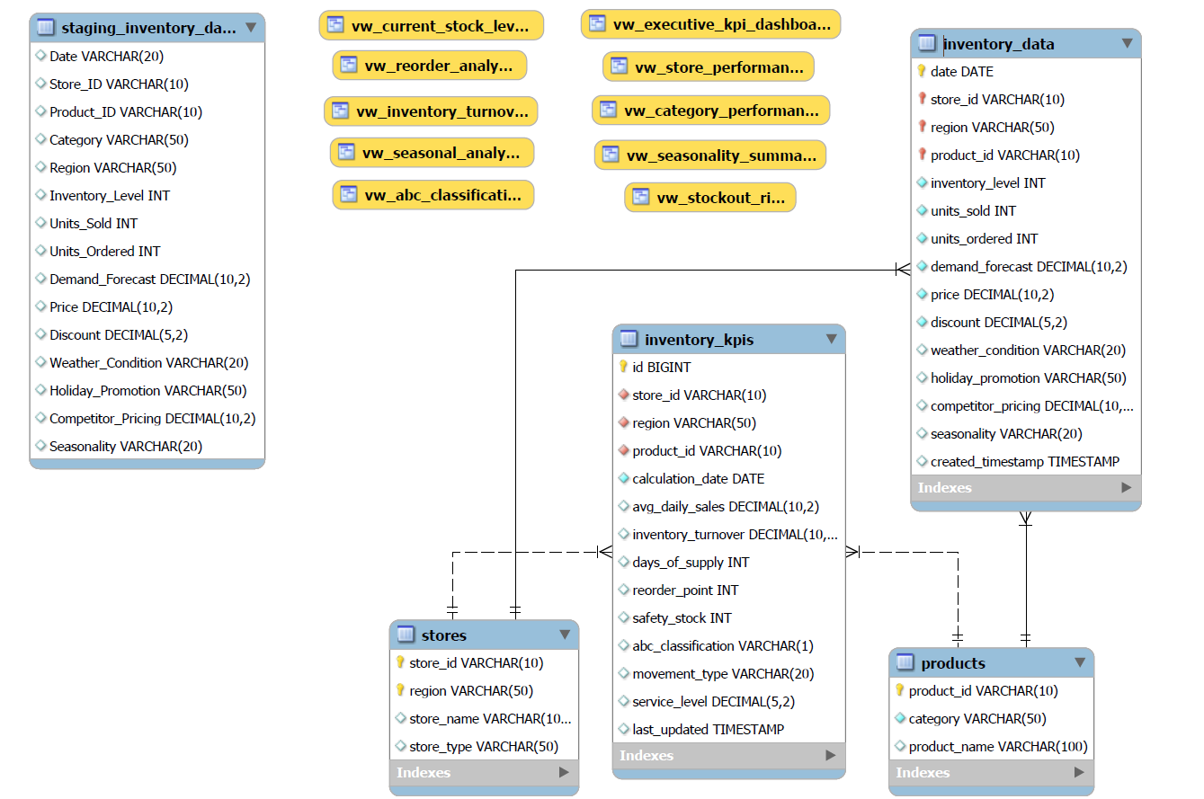

# 2. Database Schema Overview

The Urban Retail Co. inventory management database follows a normalized design with composite primary keys to accurately model the retail inventory environment. The schema consists of four main tables:

* **stores**: Master table for store information with (store_id, region) composite primary key
* **products**: Master table for product catalog data
* **inventory_data**: Main fact table containing daily inventory transactions
* **inventory_kpis**: Calculated metrics table for performance analysis

The schema supports relational integrity through foreign key constraints while maintaining optimal query performance through strategic indexing.

# 2. Table Descriptions

**stores**

CREATE TABLE stores (  
 store_id VARCHAR(10) NOT NULL COMMENT 'Store identifier',  
 region VARCHAR(50) NOT NULL COMMENT 'Store region (West, East, South, etc.)',  
 store_name VARCHAR(100) COMMENT 'Generated store name',  
 store_type VARCHAR(50) DEFAULT 'Retail' COMMENT 'Type of store',  
   
 PRIMARY KEY (store_id, region),  
 INDEX idx_region (region),  
 INDEX idx_store_id (store_id)  
) ENGINE=InnoDB COMMENT='Master table for store information with composite PK';

* **Purpose**: Maintains store master data with composite primary key to support multiple regions per store ID
* **Key Fields**: store_id, region (composite PK)
* **Indexes**: Optimized for region-based and store-based lookups

**products**

CREATE TABLE products (  
 product_id VARCHAR(10) NOT NULL PRIMARY KEY COMMENT 'Unique product identifier',  
 category VARCHAR(50) NOT NULL COMMENT 'Product category (Electronics, Toys, etc.)',  
 product_name VARCHAR(100) COMMENT 'Product name (auto-generated)',  
   
 INDEX idx_category (category)  
) ENGINE=InnoDB COMMENT='Master table for product information';

* **Purpose**: Stores product catalog information
* **Key Fields**: product_id (PK), category
* **Indexes**: Category-based lookups for category analysis

**inventory_data**

CREATE TABLE inventory_data (  
 date DATE NOT NULL COMMENT 'Transaction date',  
 store_id VARCHAR(10) NOT NULL COMMENT 'Store identifier',  
 region VARCHAR(50) NOT NULL COMMENT 'Store region',  
 product_id VARCHAR(10) NOT NULL COMMENT 'Product identifier',  
 inventory_level INT NOT NULL DEFAULT 0 COMMENT 'Inventory level on this date',  
 units_sold INT NOT NULL DEFAULT 0 COMMENT 'Units sold on this date',  
 units_ordered INT NOT NULL DEFAULT 0 COMMENT 'Units ordered on this date',  
 demand_forecast DECIMAL(10,2) NOT NULL DEFAULT 0 COMMENT 'Demand forecast',  
 price DECIMAL(10,2) NOT NULL DEFAULT 0 COMMENT 'Product price',  
 discount DECIMAL(5,2) NOT NULL DEFAULT 0 COMMENT 'Discount percentage',  
 weather_condition VARCHAR(20) COMMENT 'Weather condition on this date',  
 holiday_promotion VARCHAR(50) COMMENT 'Holiday/promotion information',  
 competitor_pricing DECIMAL(10,2) DEFAULT 0 COMMENT 'Competitor pricing',  
 seasonality VARCHAR(20) COMMENT 'Season on this date',  
 created_timestamp TIMESTAMP DEFAULT CURRENT_TIMESTAMP COMMENT 'Record creation timestamp',  
   
 PRIMARY KEY (date, store_id, region, product_id),  
 FOREIGN KEY (store_id, region) REFERENCES stores(store_id, region),  
 FOREIGN KEY (product_id) REFERENCES products(product_id),  
   
 INDEX idx_date_store_region (date, store_id, region),  
 INDEX idx_store_region_product (store_id, region, product_id),  
 INDEX idx_date_range (date)  
) ENGINE=InnoDB COMMENT='Main fact table for daily inventory data';

* **Purpose**: Main fact table containing daily inventory transactions
* **Key Fields**: date, store_id, region, product_id (composite PK)
* **Foreign Keys**: References stores and products tables
* **Indexes**: Optimized for date-range queries and store/product analysis

**inventory_kpis**

CREATE TABLE inventory_kpis (  
 id BIGINT AUTO_INCREMENT PRIMARY KEY COMMENT 'Auto-generated ID',  
 store_id VARCHAR(10) NOT NULL COMMENT 'Store identifier',  
 region VARCHAR(50) NOT NULL COMMENT 'Store region',  
 product_id VARCHAR(10) NOT NULL COMMENT 'Product identifier',  
 calculation_date DATE NOT NULL COMMENT 'KPI calculation date',  
 avg_daily_sales DECIMAL(10,2) DEFAULT 0 COMMENT 'Average daily sales (90-day)',  
 inventory_turnover DECIMAL(10,2) DEFAULT 0 COMMENT 'Annualized inventory turnover',  
 days_of_supply INT DEFAULT 0 COMMENT 'Days of supply at current sales rate',  
 reorder_point INT DEFAULT 0 COMMENT 'Calculated reorder point',  
 safety_stock INT DEFAULT 0 COMMENT 'Calculated safety stock',  
 abc_classification VARCHAR(1) DEFAULT 'C' COMMENT 'ABC classification (A/B/C)',  
 movement_type VARCHAR(20) DEFAULT 'SLOW_MOVER' COMMENT 'Movement classification',  
 service_level DECIMAL(5,2) DEFAULT 95.00 COMMENT 'Target service level percentage',  
 last_updated TIMESTAMP DEFAULT CURRENT_TIMESTAMP ON UPDATE CURRENT_TIMESTAMP,  
   
 FOREIGN KEY (store_id, region) REFERENCES stores(store_id, region),  
 FOREIGN KEY (product_id) REFERENCES products(product_id),  
   
 UNIQUE KEY uk_store_region_product_date (store_id, region, product_id, calculation_date)  
) ENGINE=InnoDB COMMENT='Calculated KPIs and metrics for inventory management';

* **Purpose**: Stores calculated inventory metrics for performance tracking
* **Key Fields**: id (PK), store_id, region, product_id, calculation_date
* **Foreign Keys**: References stores and products tables
* **Unique Constraint**: Prevents duplicate KPI records

# 3. View Descriptions

The system implements several analytical views to support business intelligence and decision-making:

**vw_current_stock_levels**

* **Purpose**: Provides current inventory levels and status for all products
* **Key Features**: Uses window functions to get latest inventory position
* **Business Use**: Stock level monitoring and inventory status reporting

**vw_reorder_analysis**

* **Purpose**: Identifies products requiring reorder with calculated reorder points
* **Key Features**: Implements statistical safety stock calculations
* **Business Use**: Procurement planning and stockout prevention

**vw_inventory_turnover**

* **Purpose**: Calculates inventory efficiency metrics
* **Key Features**: Annualized turnover calculations and movement classification
* **Business Use**: Inventory efficiency monitoring and optimization

**vw_abc_classification**

* **Purpose**: Implements Pareto (ABC) analysis for product classification
* **Key Features**: Cumulative percentage calculations using window functions
* **Business Use**: Focused inventory management based on value contribution

**vw_seasonal_analysis**

* **Purpose**: Analyzes seasonal impact on sales patterns
* **Key Features**: Seasonal index calculations versus baseline
* **Business Use**: Seasonal planning and demand forecasting

# 4. Query Documentation

**Stock Level Monitoring**

* Identifies low or critical stock conditions
* Output: product ID, stock level, store ID, region

**Reorder Point Analysis**

* Compares inventory to reorder points to detect replenishment needs

**Inventory Turnover Analysis**

* Outputs turnover ratio and classification
* View supports filtering by category or product

**ABC Classification Analysis**

* Aggregates product count and revenue contribution by ABC class

SELECT store_id, region, abc_classification, COUNT(*), SUM(...) FROM vw_abc_classification GROUP BY ...;

**Seasonal Impact Analysis**

* Analyzes seasonality trends for planning
* Example category and season values provided for demonstration

# 5. Data Import Procedures

**Staging Import**

* CSV load into staging_inventory_data via LOAD DATA INFILE
* Fields parsed and cleansed for date formats and nulls

**Data Population**

-- Insert stores

INSERT IGNORE INTO stores (...) SELECT DISTINCT ... FROM staging_inventory_data;

-- Insert products

INSERT IGNORE INTO products (...) SELECT DISTINCT ... FROM staging_inventory_data;

-- Insert inventory

INSERT IGNORE INTO inventory_data (...) SELECT ... FROM staging_inventory_data;

* Ensures deduplication and correct referential links

# 6. Performance Considerations

**Index Strategy**

The database uses a strategic indexing approach:

* **Composite Primary Keys**: For enforcing uniqueness and referential integrity
* **Secondary Indexes**: For common query patterns on date ranges, categories, etc.
* **Covering Indexes**: Where possible to avoid table lookups

**Query Optimization**

* **Window Functions**: Used for efficient ranking and row selection
* **Common Table Expressions (CTEs)**: For readability and query organization
* **Join Order**: Optimized to start with the most restrictive conditions
* **Selective Indexing**: Balances performance with storage requirements

**Large Dataset Handling**

* **Partitioning**: Consider partitioning inventory_data by date for large datasets
* **Summary Tables**: Pre-calculate metrics for faster dashboard performance
* **Data Retention**: Implement archiving strategy for historical data

# 7. Maintenance Guidelines

**Regular Maintenance Tasks**

1. **Update Table Statistics**: Run ANALYZE TABLE periodically
2. **Index Optimization**: Review and optimize indexes based on query patterns
3. **KPI Recalculation**: Refresh inventory_kpis table daily **\***

**Monitoring Recommendations *[1]**

1. **Query Performance**: Monitor slow queries log
2. **Storage Growth**: Track database size and growth rate
3. **Data Quality**: Implement checks for data completeness and accuracy

# Conclusion

This SQL documentation provides a comprehensive reference for the Urban Retail Co. Inventory Management System. The schema design with composite primary keys, strategic indexing, and analytical views enables efficient inventory analysis and decision support. Regular maintenance and optimization will ensure continued performance as the system scales with business growth.

1. **\*** To be implemented in actual working environment