TATHYA 2025
Cognition – Data Science and Analytics Club, GIM

Business Case: Zenkart Analysis
Objectives
- Data Cleaning
Develop strategies to manage to handle missing values in Income, DeliveryTime, Rating
- Income and DeliveryTime had <5% missing values. I used overall median imputation because both features are skewed and contain outliers, and the median is a simple and robust choice that does not distort the distribution.
- Rating was not imputed because its missingness reflects real customer behaviour (many customers simply do not rate). Instead, I kept it as missing and created a binary feature HasRated to capture whether a customer provided feedback. Identify and fix outliers in Price, CLV, and DeliveryTime data types
Identify and fix outliers in Price, CLV, and DeliveryTime data types
- Price:
Outliers were detected using the IQR rule. Three unusually high values exceeded the upper threshold (Q3 + 1.5×IQR) and were capped at ₹7421.75. This reduces the influence of extreme prices while keeping all observations in the dataset.
- DeliveryTime:
The IQR method flagged a few values beyond the statistical upper bound (9.2 days). Although delivery times of 9–10 days are realistic, these rare long delays could distort clustering and classification. Therefore, all values above 9.2 days were capped at this limit.
- CLV:
CLV had a single high outlier identified using the IQR method. Since CLV represents long-term customer value and extremely large values can distort segmentation and churn models, the outlier was capped at the IQR upper limit. This keeps the distribution realistic while preventing one unusually high customer value from influencing the analysis.

Before
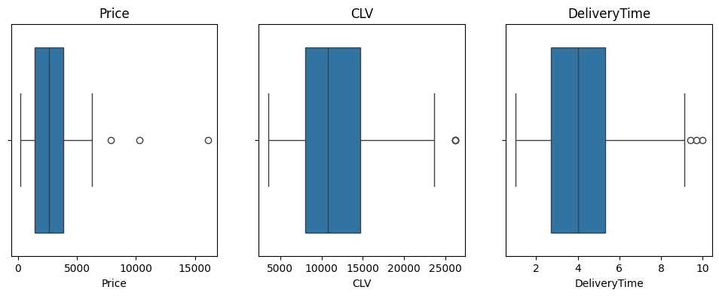
After
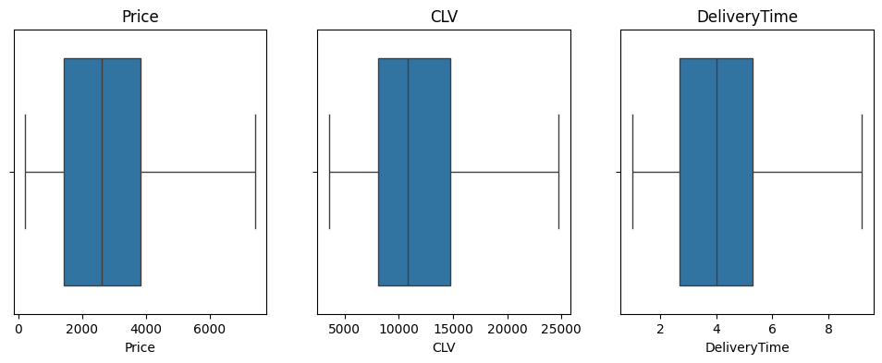

- Clustering:
Group customers into meaningful segments based on demographics and purchasing behaviour to help Zenkart understand customer behaviour.
Creating a Customer-Level Dataset
To create true customer groups, I aggregated the data by CustomerID, resulting in one row per customer. This allowed me to calculate important behavioural features such as Recency, Frequency, Monetary spend, AvgDeliveryTime, CLV, and demographic attributes like Age, Income, and CityTier.
Feature Selection
- Behavioural features: Recency, Frequency, Monetary value, CLV, AvgDeliveryTime
- Demographic features: Age, Income, CityTier
RFM features describe how active and valuable a customer is, while demographics help identify who these customers are. AvgDeliveryTime was included because delivery issues may influence customer experience and retention.
Scaling
The selected features operate on very different scales (e.g., Income in thousands vs. CityTier between 1–3). Since K-Means relies on distance calculations, unscaled data would give disproportionate importance to larger-scale variables.
I applied StandardScaler, which standardizes each feature to mean 0 and standard deviation. This is the most used scaling method for K-Means and ensures all features contribute equally.
Handling Missing Values
A few customers were missing Age in the aggregated dataset. These were imputed using the median.
Selecting the Number of Clusters
I used the Elbow Method to choose the optimal number of clusters. The WCSS curve dropped sharply between k = 3 and k = 5. Based on this trend, I selected k = 4 as the optimal number of customer segments.

Cluster Profiles
The four clusters formed by K-Means highlight distinct customer groups:
Cluster | Segment Name | Key Traits
0 | Mid-Tier Loyal Customers | Moderate income, buy regularly, stable spenders
1 | Dormant / At-Risk Customers | Very high recency, low frequency, low spend, churn-prone
2 | Premium High-Value Customers | High income, high CLV, strong revenue contributors
3 | Price-Sensitive Slow-Delivery Customers | Lower income, low orders, longer delivery times

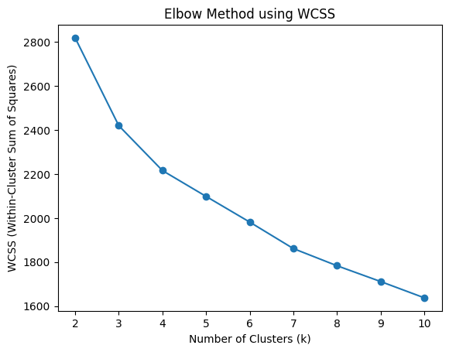
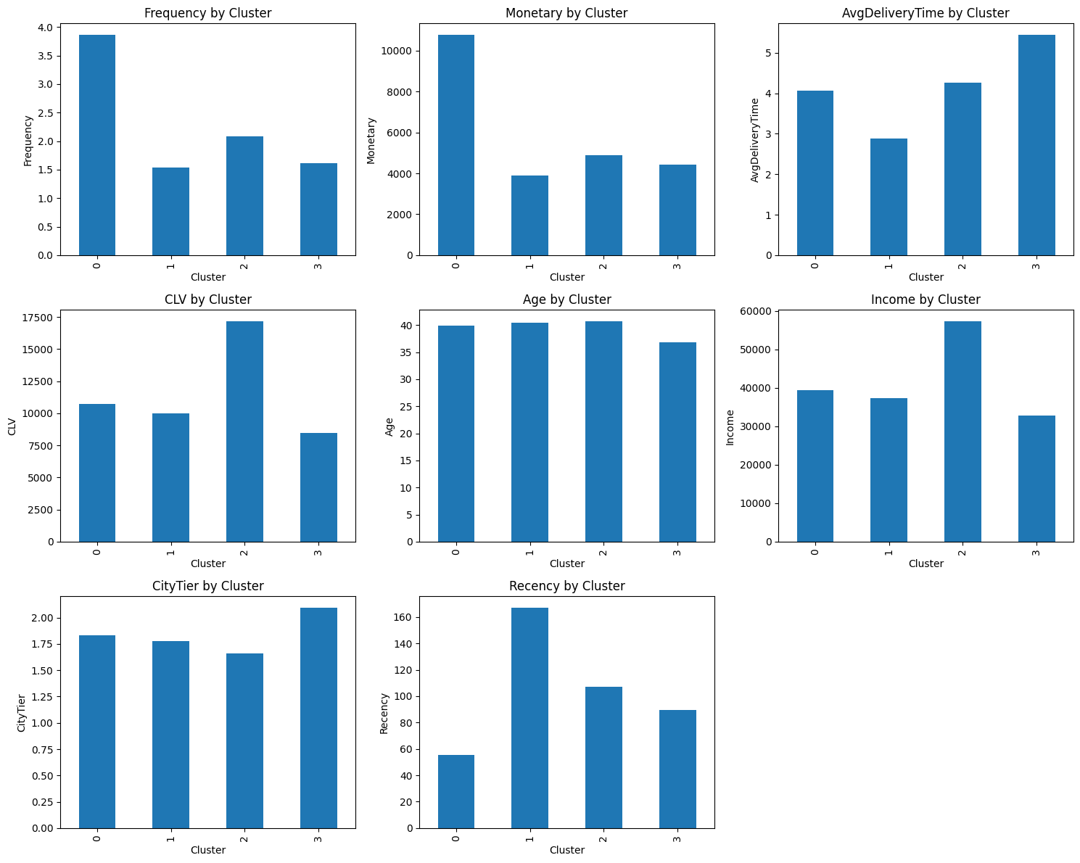

- Classification:
Predict whether a customer is likely to churn (1) or stay active (0)
To predict whether a customer is likely to churn, I first created a customer-level dataset by aggregating all transactions using CustomerID. For each customer, I calculated key behavioural and demographic features:
- Recency (days since last purchase)
- Frequency (number of orders)
- Monetary value (total spend)
- AvgDeliveryTime
- CLV
- Age, Income, and CityTier
These features capture both purchasing behaviour and customer characteristics, which are essential for churn analysis.
I then split the data into an 80/20 train–test split and applied StandardScaler so that variables with large numeric ranges (e.g., Income, Monetary) do not dominate the model. I used Logistic Regression because it is simple, interpretable, and well-suited for binary classification problems like churn.
Handling Class Imbalance
The churn data was highly imbalanced, with far more non-churn customers than churners. The initial model achieved 81% accuracy, but recall for churn was only 12%, meaning the model failed to identify most customers who were actually at risk. This behaviour is typical when the majority class dominates the model’s learning.
To address this, I applied class_weight='balanced', which increases the importance of the minority class during training. After applying class balancing:
- Churn recall improved from 12% to 76%
- Accuracy decreased to 60%, which is expected
Although accuracy dropped, the balanced model became much more effective at identifying churners, which is far more important for retention strategies. This final model therefore provides better practical value for Zenkart by helping identify customers who may leave soon.
Alternative Model
As an alternative, I also considered using a Decision Tree classifier, which naturally handles non-linear relationships and can perform better on imbalanced data. Decision Trees are also easy to interpret and provide simple rule-based explanations.

- Time Series Analysis: Forecast sales for the next 10–12 weeks.
Assess how missing data and outliers impact the forecasting model's accuracy.
To understand future demand, I converted the transaction data into a weekly time series by summing total sales for each week. This produced a clean weekly sales trend that could be used for forecasting.
I used a simple Exponential Smoothing model to forecast sales for the next 12 weeks, as it is easy to interpret and works well for short-term retail forecasting. Before modelling, I checked for missing weeks and outliers. Missing values were filled using forward fill, and extreme weekly spikes were capped using the IQR method.
I evaluated the model using the last 12 weeks of actual sales.
- The forecast built on the raw data gave a MAPE of 34.7%.
- After cleaning missing values and capping outliers, the MAPE improved to 16.5%.
This shows that cleaning the time series helped the model capture the underlying trend more accurately. The final 12-week forecast provides a stable estimate of upcoming sales and can support inventory planning and marketing decisions.
