LOCALMEETUP
OAUTH 2.0
AUTHENTICATION FLOW
Frontend and Spring Boot implementation guide
DOCUMENT SCOPE
As-built documentation based on the React + TypeScript frontend and Spring Boot NewUserService source in this workspace. It describes current code, identifies absent or unverified pieces, and makes no application-code changes.

Prepared 8 November 2026
For developer onboarding and maintenance

Table of Contents
Open in Microsoft Word and choose Update Table to populate page numbers.
CONTENTS FIELD
The contents field is generated from Heading 1 and Heading 2. Refresh it in Word with References > Update Table (or select the field and press F9).

1. Introduction and Authentication Architecture
This guide follows OAuth sign-in from the login screen to the protected dashboard and through a later refresh. It documents the implementation rather than assuming a conventional SPA redirect callback. The current design opens a backend authorization URL in a popup, returns a short-lived one-time code to the opener with postMessage, exchanges that code for an API response containing a JWT, and navigates within React Router.
The browser has two cooperating windows: the main React application and a popup that temporarily visits Spring Boot, the OAuth provider and the backend callback endpoint. The JWT is not placed in a URL or sent in the popup message. The popup message carries only the one-time exchange code and provider identifier.

As-built system boundaries
- Frontend: React 19, TypeScript, React Router, Redux Toolkit, Axios and Vite. Redux is provided by ReduxProvider; there is no AuthContext or AuthProvider in the inspected source.
- Backend: Spring Boot / Spring Security OAuth2 Client, Spring MVC, Spring Data JPA and MySQL. IntelliJ and Eclipse NewUserService trees contain corresponding implementations.
- Identity providers: Google and GitHub for the requested flow. The UI also renders Facebook and Discord; backend configuration currently has Google, GitHub and Discord registrations, not Facebook.
- JWT: generated and signed by the backend, stored in browser localStorage under key token, and validated again by the backend for API requests.
CALLBACK ROUTE CLARIFICATION
The frontend has /oauth/callback, but OAuthButton does not navigate there. OAuth2AuthenticationSuccessHandler returns popup HTML that postMessages to the opener. OAuthCallback currently redirects direct visits to /login; it is not the active completion path.

2. Technology Stack
Layer | Technology / implementation | Role in this flow
Browser UI | React + TypeScript; Vite; React Router | Login UI, popup lifecycle, message verification, dashboard navigation and route guard.
Client state | Redux Toolkit + React Redux | authSlice receives loginSuccess after exchange; state is in-memory and not persisted.
HTTP | Axios userServiceApiClient | OAuth code exchange; shared interceptors read token and process HTTP 401 responses.
Security | Spring Security OAuth2 Client | Authorization request, provider callback, provider code handling and user attributes.
Backend | Spring Boot MVC; SecurityFilterChain | OAuth handler, authentication API, service and JWT-backed API authorization.
Persistence | Spring Data JPA; MySQL; UserRepository | Lookup by credentials email and persist a newly registered User/Credentials pair.
Token | JJWT-backed JwtToken | Sign token with subject, role claim, issued time and expiry; validate signature on backend.

3. Complete OAuth Login Flow
Diagram 1 shows the successful Google/GitHub path. Provider approval is followed by a callback to Spring Security on the backend, not a redirect to the React callback page. The backend transfers an opaque, temporary code to the opener; the opener makes a same-service POST to retrieve the JWT response.

Diagram 1. Complete OAuth Authentication Flow
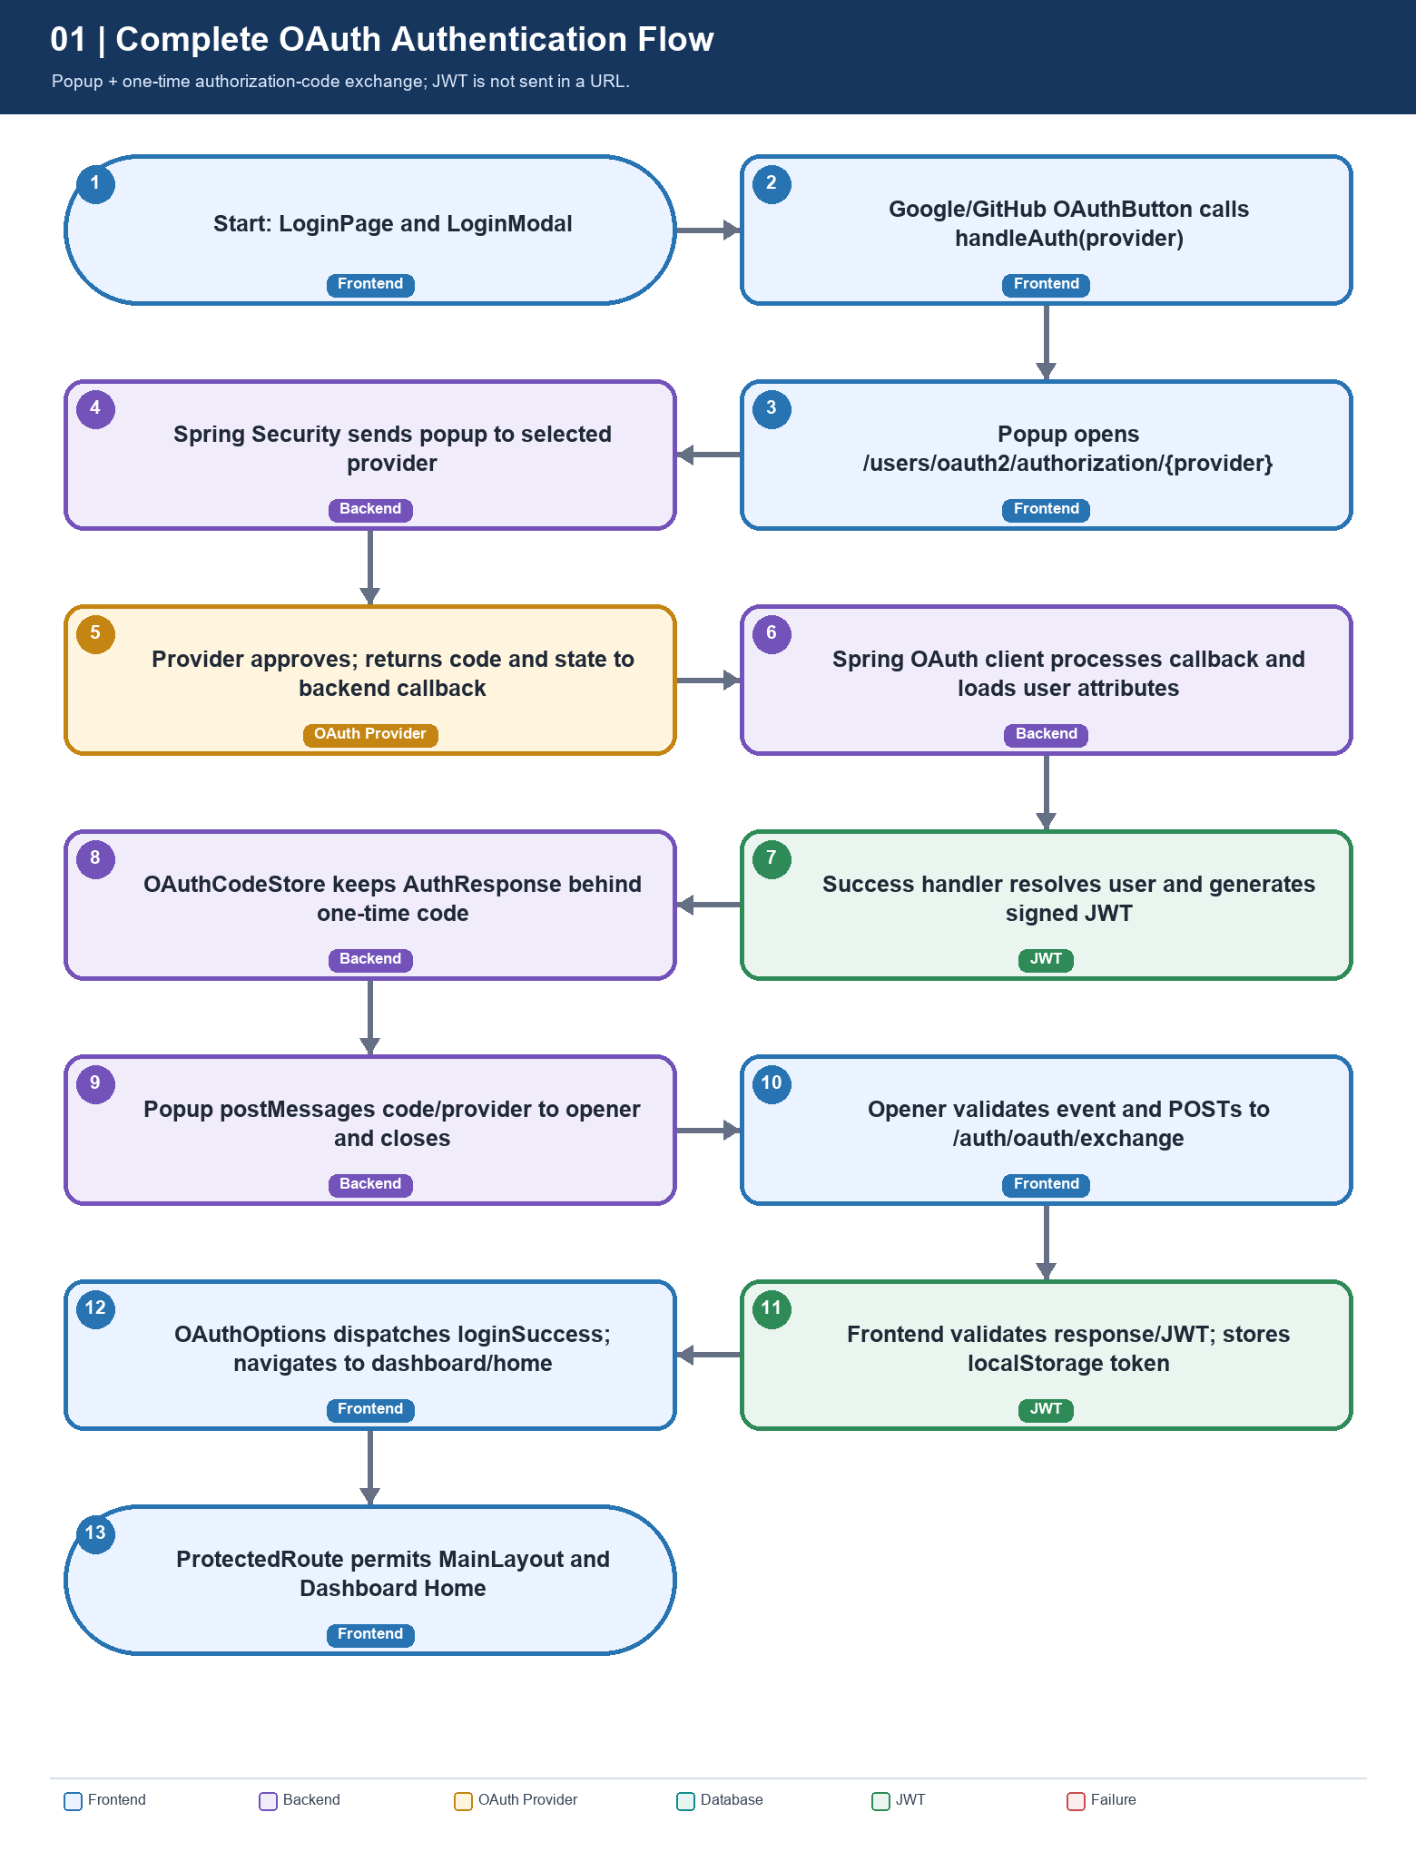
The JWT response reaches the main window only after the one-time code exchange. The popup message itself contains no JWT.

How to read the flow
- LoginPage renders LoginModal and OAuthOptions. OAuthOptions configures Google and GitHub buttons alongside Discord and Facebook.
- OAuthButton.handleClick calls handleAuth(provider). The API utility builds the backend authorization URL from userServiceApiClient.defaults.baseURL and opens a popup.
- Spring Security starts provider authorization. The provider redirects its authorization response to the registered backend callback URL.
- Spring processes the callback and constructs an OAuth2AuthenticationToken. The custom success handler maps attributes and calls AuthService.registerOuth.
- The success handler creates AuthResponse, stores it behind a cryptographically random single-use code for 120 seconds, and returns HTML to the popup.
- Popup HTML postMessages type oauth:result, status, provider and code, then closes. The opener checks backend origin, popup source, message schema and provider.
- The opener POSTs code/provider to /auth/oauth/exchange. AuthController consumes the code and returns ApiResponse<AuthResponse>.
- Frontend validates the response and token, writes localStorage token, dispatches loginSuccess and replaces navigation with /dashboard/home.
- ProtectedRoute validates the stored JWT before rendering Outlet. MainLayout then renders dashboard HomePage.

4. Frontend Execution Details

Login, initiation and popup lifecycle
src/pages/LoginPage.tsx renders LoginModal, which includes OAuthOptions. OAuthOptions maps providers to OAuthButton. OAuthButton sets loading state, prevents a duplicate click while busy, calls handleAuth and forwards a parsed response or error message.
src/api/oauth/oauthlogin.ts defines OAuthProvider, validates the postMessage payload shape, derives the backend base URL, constructs /oauth2/authorization/{provider}, opens a 500 x 650 popup and listens for a message. The listener requires event.origin to equal the backend origin and event.source to equal the opened popup. It rejects provider mismatches, ignores malformed/untrusted messages and prevents duplicate processing. A timer detects popup closure; a second timer expires after five minutes.

Code exchange, token storage and Redux
exchangeCode POSTs {code, provider} to /auth/oauth/exchange using userServiceApiClient. parseOAuthResponse requires success=true and data.token, validates optional field types, and returns id, token, tokenType, name, username, email and roles. validateJwt rejects malformed tokens or tokens without a future expiration. The utility then writes the token to localStorage; once handleAuth resolves, OAuthButton calls OAuthOptions.handleAuthenticated.
OAuthOptions.handleAuthenticated dispatches authSlice.loginSuccess with user fields and token, clears the UI error and navigates with replace to routePaths.dashboardHome (/dashboard/home). The Redux auth slice sets isAuthenticated, user and token in memory.

React route configuration and callback page
App wraps AppRoutes in BrowserRouter. AppRoutes combines unprotected and protected route objects. The dashboard tree nests ProtectedRoute -> MainLayout -> HomePage and other dashboard pages. Unknown paths go to /login. The unprotected route table contains /oauth/callback, but OAuthCallback simply renders Navigate to /login. The popup-based implementation does not use this route to receive its code.

Diagram 3. Frontend OAuth Execution Flow
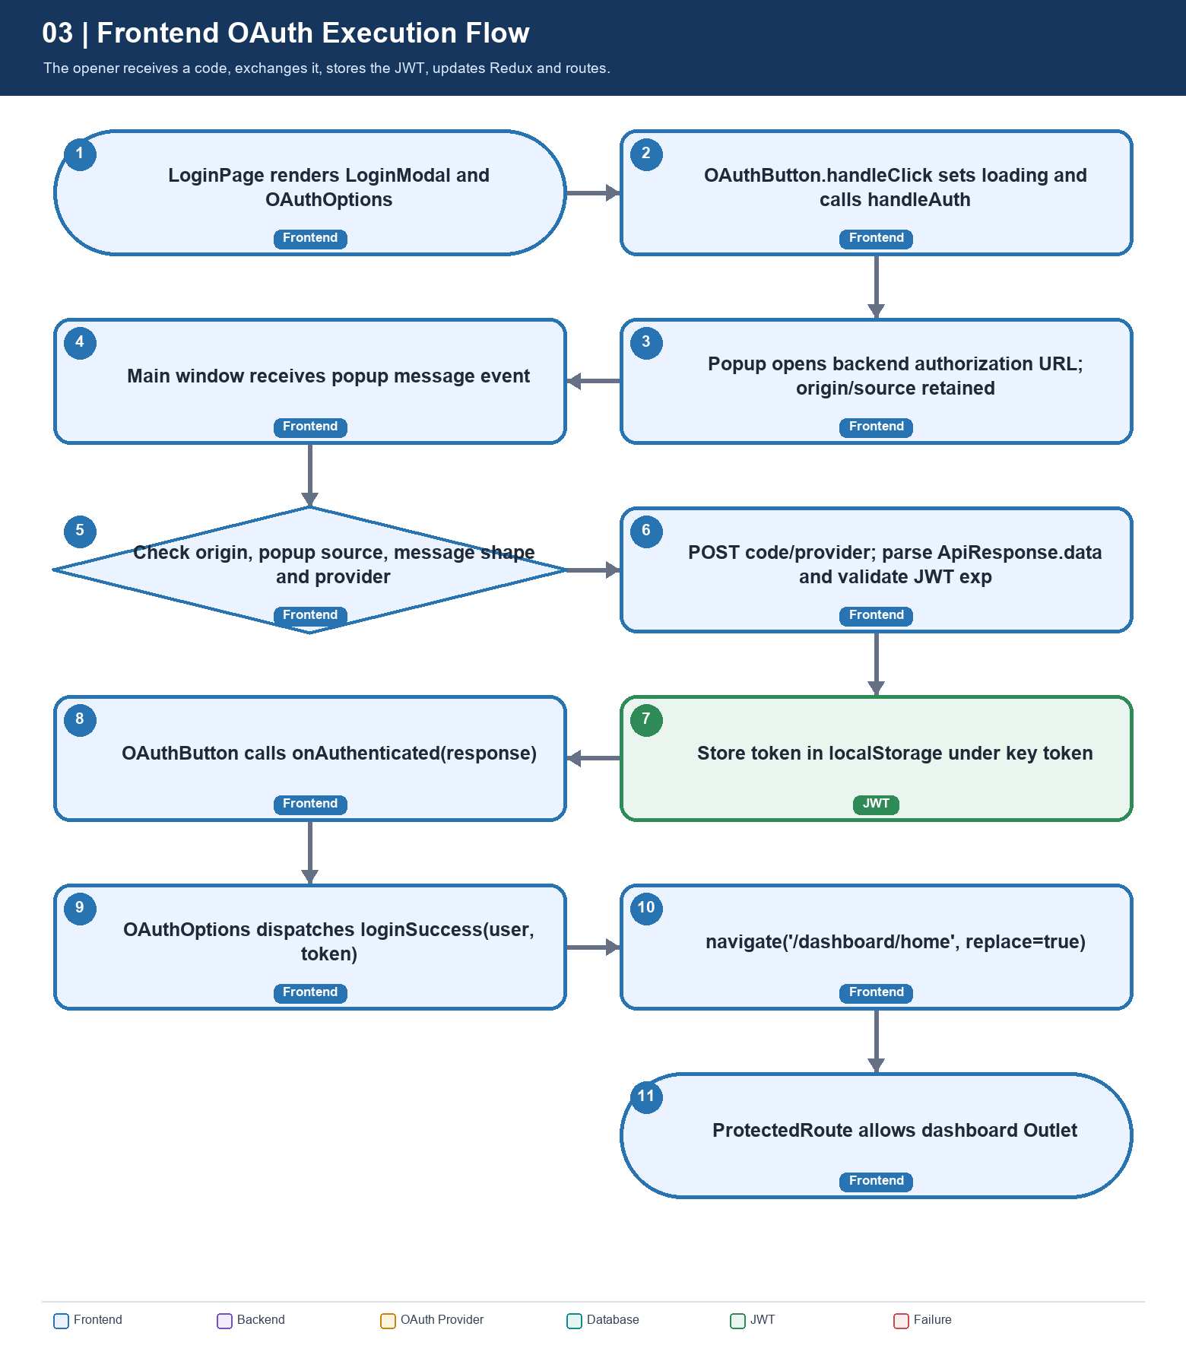
Frontend completion starts with the popup message listener and ends after the guard permits the requested dashboard route.

5. Backend Execution Details

Security filter chain and provider callback
SecurityConfig.securityFilterChain configures CSRF disabled, CORS using app.frontend-url, a stateless session policy, public /auth/**, /oauth2/** and /login/** routes, role-protected /admin/**, /manager/** and /user/** routes, and JWTfilter before UsernamePasswordAuthenticationFilter. oauth2Login uses OAuth2AuthenticationSuccessHandler as both success and failure handler.
Spring Security OAuth2 Client owns provider authorization and callback processing. No custom OAuth2UserService was found. OAuth2AuthenticationSuccessHandler reads OAuth2AuthenticationToken, the authorized client registration ID and principal attributes after Spring authenticates the callback.

Success handler, user service and token handoff
onAuthenticationSuccess calls saveOAuthUser(provider, attributes), converts the DTO to User/Credentials, invokes AuthService.registerOuth, calls JwtToken.generateToken and builds AuthResponse. It then asks OAuthCodeStore.issue to save that response behind a random code and writes HTML containing no-store headers, a nonce-based script policy and frame-ancestors none. The script posts the result to the configured frontend origin and closes the popup.
The same class implements AuthenticationFailureHandler. onAuthenticationFailure returns an oauth:result error, determining the provider from the callback path where possible. Runtime failures while mapping or registering an account are logged and returned as a generic OAuth error. There is no separate OAuth2AuthenticationFailureHandler class.

One-time exchange endpoint
AuthController.exchangeOAuthCode accepts OAuthCodeExchangeRequest with nonblank code and provider. It calls OAuthCodeStore.consume; an absent, expired, wrong-provider or consumed code becomes HTTP 401. On success it returns ApiResponse<AuthResponse>. OAuthCodeStore is an in-memory ConcurrentHashMap, generates a 32-byte random URL-safe code, removes expired entries, checks provider equality, and atomically removes a consumed entry.

Diagram 2. Backend OAuth Execution Flow
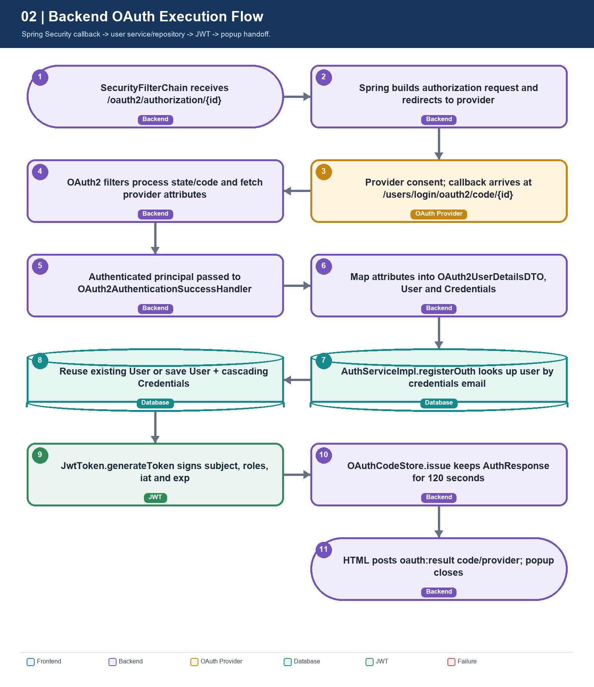
OAuthCodeStore is process-local memory; user records are persisted using the JPA repository and configured relational database.

6. OAuth Provider Communication
The browser is sent to the backend entry point, not directly to an OAuth provider. Spring Security uses the matching registration to build the provider request and receives the callback at the backend. It processes the provider response and exposes attributes to OAuth2AuthenticationSuccessHandler.
Provider | Frontend button | Backend registration | As-built status
Google | Yes | registration.google | Configured; GOOGLE_CLIENT_ID / GOOGLE_CLIENT_SECRET are external environment values.
GitHub | Yes | registration.github | Configured in both backend copies; GITHUB_CLIENT_ID / GITHUB_CLIENT_SECRET are external.
Discord | Yes | registration.discord + provider.discord | Configured with identify/email scopes and a custom user-info endpoint.
Facebook | Yes | No registration found | UI and handler know the name, but backend initiation needs a Spring registration and credentials.

Provider attributes used by the handler
Provider | Attributes read | Notable behavior
Google | sub, email, name, given_name, family_name, picture, email_verified, locale | Email is used as username and email; other profile values remain in the temporary DTO.
GitHub | id, login, email, name, avatar_url, html_url | Email may be absent/private; handler uses it for both credentials username and email.
Discord | id, username, email, global_name, avatar, verified, locale | Profile fields are not persisted by the shown User entity.
Facebook | id, name, email | Mapping branch exists, but no client registration was found.

REGISTERED REDIRECT URI
Template: {baseUrl}/login/oauth2/code/{registrationId}. With local port 7070 and context path /users, a local callback is typically http://localhost:7070/users/login/oauth2/code/google or .../github. Reverse proxies and production hosts change the public URL; check it against the deployed URL and provider console.

7. User Registration and Existing User Verification
saveOAuthUser builds OAuth2UserDetailsDTO from provider attributes. The DTO includes providerUserId and profile fields, but the inspected handler does not persist them in a separate identity/link table. OAuth2UserDetailsDTOToUser creates Credentials with email as username and email, a random UUID string as the password value, and an email-verified flag defaulting to true if no provider value is available. It creates a User and sets RegistrationSource from the provider name.
AuthServiceImpl.registerOuth queries by credentials email using UserRepository.findByCredentialsEmail. If found, it returns that UserDetailsImpl. Otherwise it sets role USER and status ACTIVE and saves the User; User.credentials is a cascading one-to-one relationship, so Credentials is saved with the aggregate. DataIntegrityViolationException is converted to IllegalArgumentException.
IDENTITY LINKING LIMIT
Existing-account checks are email-based. Although the temporary provider DTO contains providerUserId, no durable provider-subject mapping was found in the inspected User/Credentials entities or repository. Provider email availability and verification therefore affect account matching and first-time registration.

User has a required one-to-one Credentials relationship and a required firstName column. Credentials has unique username and email, plus role/status. UserRepository.findActiveUserByIdentifier is later used by UserDetailsServiceImpl to load a non-deleted active account by email or username.

8. JWT Generation and Storage

Backend token contents and signing
JwtToken.generateToken sets subject to UserDetails.getUsername(), includes a roles claim, issued-at time and expiration, and signs with the configured HMAC secret. Startup validation requires a nonempty secret of at least 32 UTF-8 bytes and a positive lifetime. application.yaml defaults JWT_EXPIRATION to 86,400,000 milliseconds (24 hours), unless overridden.

Frontend storage and client-side checks
After the exchange response parses, validateJwt checks the three-part JWT form, base64url-decodes its payload, requires exp and checks that it is in the future. This is a structure/expiry check only: browser code does not verify the JWT signature. The validated token is stored under localStorage key token. userServiceApiClient's request interceptor attaches the stored token to API calls as a Bearer credential.
On refresh, Redux state starts from authSlice's initial state, but ProtectedRoute independently reads and validates localStorage. A valid token therefore permits the route even though Redux user/isAuthenticated are not rehydrated by the shown provider. Token persistence exists; complete user/profile restoration does not.
TOKEN HANDLING
The popup message contains a short-lived one-time code, not a JWT. The JWT arrives in the exchange response body and is then written to localStorage. Local storage is readable by same-origin JavaScript, so XSS prevention is essential; Secure, HttpOnly cookies are a possible future alternative if the architecture is adapted.

9. Protected Routes and Authentication Validation
ProtectedRoute calls validateStoredJwt during render. If valid, it renders Outlet. If missing, malformed, expired or otherwise invalid, an effect clears an existing invalid stored token and the route renders Navigate to /login with the original location in state.from. LoginModal can use that location for a later email/password redirect. OAuth navigates directly to /dashboard/home after its success callback.
On backend API calls, JWTfilter reads Authorization: Bearer ..., asks JwtToken to parse and verify claims, loads the current active account via UserDetailsServiceImpl, validates that the token subject matches the current username and installs an authenticated principal in SecurityContextHolder. The browser check improves navigation; backend validation is the trust boundary for protected API data.

Diagram 4. JWT and Protected Route Flow
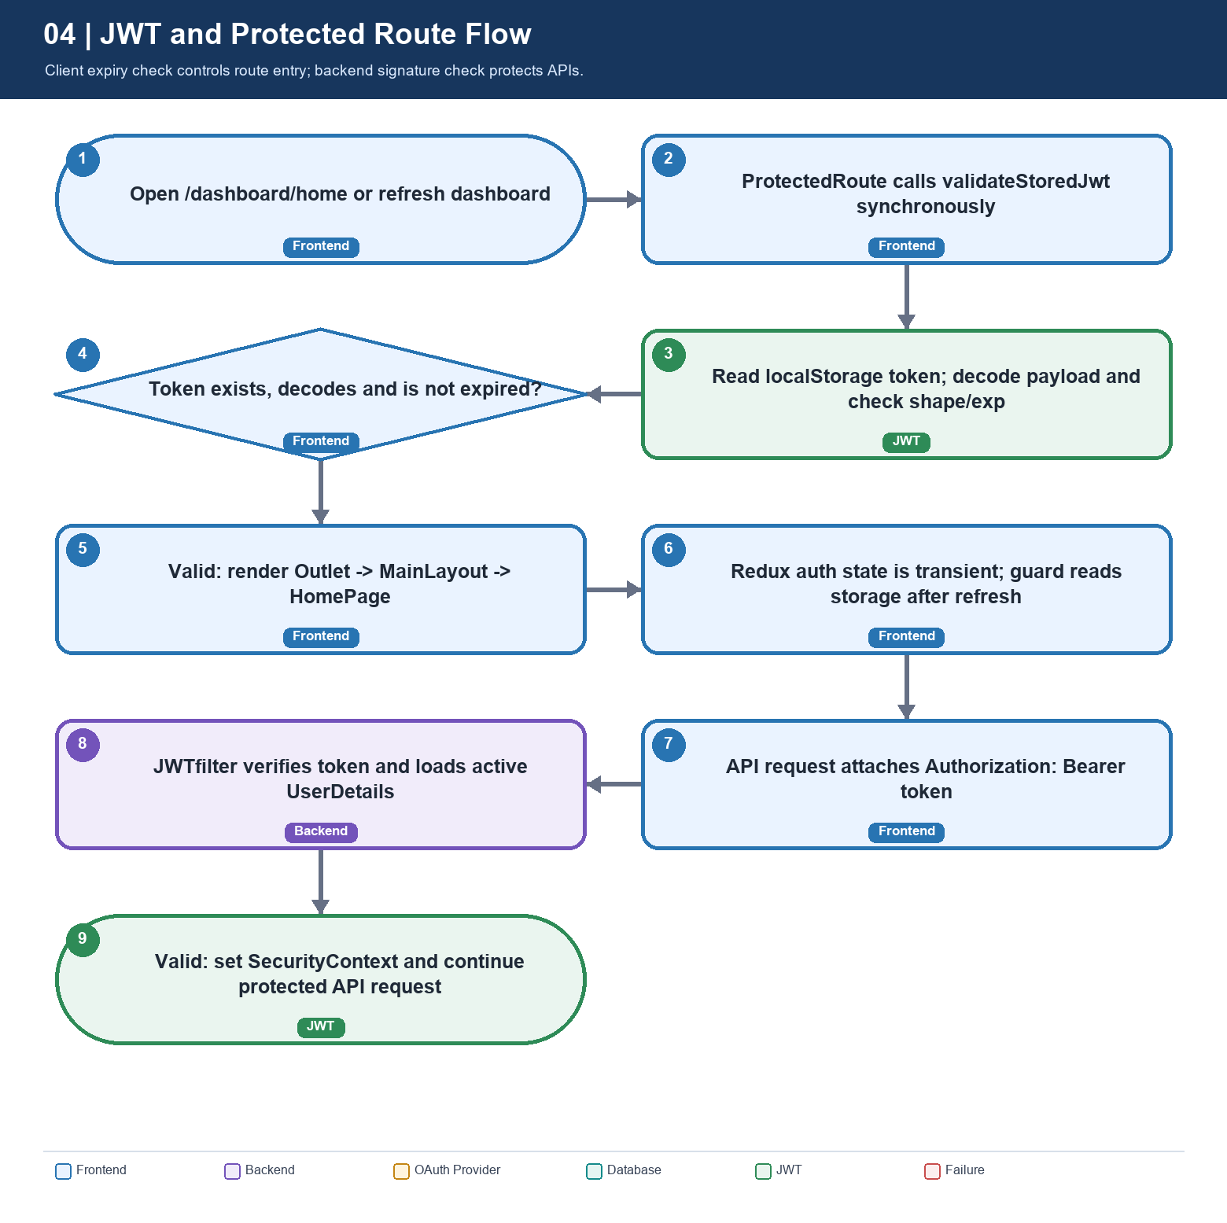
React checks token shape and expiry. Backend API authorization verifies the signed credential and reloads the account.

10. OAuth Failure and Exception Handling
A blocked popup, closed popup, five-minute timeout, provider cancellation, backend account-processing failure, invalid exchange code, malformed API response or invalid/expired JWT rejects the OAuth promise. OAuthButton catches the error and passes a human-readable message to OAuthOptions, which renders it with role=alert. Provider failures or caught account-processing errors do not yield a JWT to the frontend.

Diagram 5. OAuth Failure Handling Flow
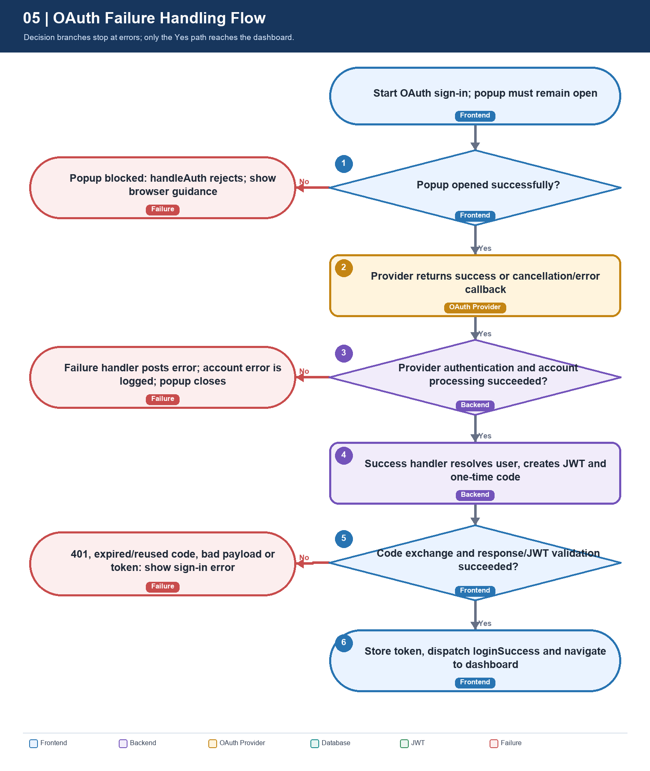
Provider success alone is not sufficient: code exchange and client-side token validation must finish before the UI authenticates or navigates.

Failure cases and current response
Failure point | Current behavior | Diagnostic
Popup blocked | handleAuth rejects with browser guidance; OAuthOptions displays it. | Check popup policy and user-gesture context.
Popup closed / timeout | Polling rejects on closure; five-minute timer closes and rejects. | Check provider callback and service availability.
Provider denies / callback fails | Configured failure handler writes oauth:result error and closes popup. | Inspect backend OAuth configuration and provider logs.
Account processing fails | Success handler logs provider/exception and posts generic error. | Check provider attributes, required user fields and DB.
Invalid message origin/source | Frontend ignores event; no credentials are accepted. | Compare exact frontend origin, API origin and popup ID.
Code exchange rejected | Backend returns 401; Axios interceptor clears token and sets main window to /login. | Check TTL, provider string, instance affinity and code consumption.
Bad response / JWT | Parser or validateJwt throws; OAuthButton displays the error. | Check envelope, token exp and endpoint behavior.
localStorage unavailable | Storage error rejects exchange; OAuth button reports failure. | Check browser storage restrictions.

UNVERIFIED RUNTIME PATHS
This is a static source review. Provider credentials, provider-console callback allowlists, live database behavior, deployed TLS/proxy headers and interactive Google/GitHub sign-in were not exercised.

11. API Endpoints and Callback URLs
Purpose | Method and path | Request / response
Start OAuth | GET {userServiceBase}/oauth2/authorization/{provider} | Popup request; provider is a Spring registration ID such as google or github.
Provider callback | GET {baseUrl}/login/oauth2/code/{registrationId} | Spring callback; local service context adds /users before /login/oauth2/code.
OAuth exchange | POST {userServiceBase}/auth/oauth/exchange | JSON {code, provider}; response ApiResponse<AuthResponse>.
Credential login | POST http://localhost:7070/users/auth/login | Related normal login endpoint; loginUser currently uses fetch and a fixed base URL.
Frontend SPA callback | GET {frontendOrigin}/oauth/callback | Route exists but redirects to /login; not used by popup completion.
Dashboard | /dashboard/home | Protected React route; entered after stored JWT passes guard.

Local development configuration observed
Setting | Source value/default | Use
Vite port | .env PORT=3000; vite.config.ts uses env.PORT | Expected browser origin http://localhost:3000.
Backend base URL | VITE_USER_SERVICE_URL=http://localhost:7070/users | Build popup URL and exchange endpoint.
Backend context | server.port=7070; context-path=/users | Places authentication routes beneath /users.
Frontend origin | FRONTEND_URL override; backend default http://localhost:3000 | CORS allow-origin and popup postMessage target.

12. Important Classes, Methods and File Paths
The backend exists under both Backend/IntelliJ/NewUserService and Backend/Eclipse/NewUserService. Paths below use IntelliJ as the primary reference; corresponding OAuth handler, security, service, entity, repository and configuration files also exist in the Eclipse tree.
File / class | Relevant responsibility
FrontendTS/src/pages/LoginPage.tsx; LoginModal.tsx | Login screen and normal credential form.
FrontendTS/src/components/mycomponents/auth/outh/OAuthOptions.tsx | Provider list; loginSuccess dispatch; /dashboard/home navigation.
FrontendTS/src/components/mycomponents/auth/outh/OAuthButton.tsx | Loading state; handleAuth call; error presentation.
FrontendTS/src/api/oauth/oauthlogin.ts | Popup URL, postMessage checks, code exchange, parse, JWT validation and token storage.
FrontendTS/src/routes/AppRoutes.tsx; unprotected/authRoutes.tsx | Route table; includes the inactive-for-popup /oauth/callback route.
FrontendTS/src/routes/unprotected/OAuthCallback.tsx | Direct visits navigate to /login; not a result receiver.
FrontendTS/src/routes/routepaths/dashboardRoutes.tsx; protected/ProtectedRoute.tsx | Protected dashboard tree and token guard.
FrontendTS/src/store/slices/authSlice.ts; providers/redux-provider.tsx | Transient Redux authentication state; no persisted auth provider.
FrontendTS/src/validations/jwt/jwtValidator.ts | Token storage access, payload decoding and expiry validation.
FrontendTS/src/api/axios/userServiceApiClient.ts; axiosConfig.ts | Service URL and request/401 interceptors.
Backend/IntelliJ/NewUserService/src/main/java/com/users/config/SecurityConfig.java | Filter chain, CORS, stateless policy, OAuth handlers and API rules.
Backend/IntelliJ/NewUserService/src/main/java/com/users/config/security/oauth/OAuth2AuthenticationSuccessHandler.java | Success/failure handlers; attribute mapping; JWT/code creation; popup HTML.
Backend/IntelliJ/NewUserService/src/main/java/com/users/config/security/oauth/OAuthCodeStore.java | In-memory, provider-bound, single-use code with 120-second expiry.
Backend/IntelliJ/NewUserService/src/main/java/com/users/controller/AuthController.java | POST /auth/oauth/exchange and related login/register APIs.
Backend/IntelliJ/NewUserService/src/main/java/com/users/service/implementation/AuthServiceImpl.java | registerOuth email lookup/reuse or new user persistence.
Backend/IntelliJ/NewUserService/src/main/java/com/users/repository/UserRepository.java | findByCredentialsEmail and active user identifier lookup.
Backend/IntelliJ/NewUserService/src/main/java/com/users/entities/User.java; Credentials.java | JPA relationship, required/unique identity columns, role and status.
Backend/IntelliJ/NewUserService/src/main/java/com/users/config/security/jwt/JwtToken.java; JWTfilter.java | Backend JWT generation, signature/subject validation and SecurityContext.
Backend/IntelliJ/NewUserService/src/main/java/com/users/config/security/jwt/UserDetailsImpl.java; Backend/IntelliJ/NewUserService/src/main/java/com/users/service/implementation/UserDetailsServiceImpl.java | Authorities/account state and active account lookup.
Backend/IntelliJ/NewUserService/src/main/resources/application.yaml | Provider registrations, callback template, context, frontend origin and token lifetime.

ABSENT COMPONENTS VERIFIED
No custom OAuth2UserService, standalone OAuth2AuthenticationFailureHandler, PublicRoute, AuthContext or AuthProvider was found. OAuth2AuthenticationSuccessHandler implements both Spring handler interfaces; ReduxProvider provides the frontend store.

13. Sequence of Execution (Step-by-Step)
- User clicks Google or GitHub in LoginModal -> OAuthOptions -> OAuthButton.
- OAuthButton.handleClick starts loading and calls handleAuth(provider).
- handleAuth creates the backend authorization URL and calls window.open. A blocked popup produces a user-visible error.
- Spring Security creates an OAuth authorization request and redirects the popup to the selected provider.
- Provider authenticates the user and redirects its authorization response to the backend callback. Spring processes it and exposes provider attributes.
- OAuth2AuthenticationSuccessHandler.onAuthenticationSuccess maps provider claims into OAuth2UserDetailsDTO and then a User/Credentials model.
- AuthServiceImpl.registerOuth queries UserRepository.findByCredentialsEmail; it reuses a matching account or persists a new User and cascading Credentials.
- JwtToken.generateToken creates a signed JWT. AuthResponse packages token, type, id, name, username, email and roles.
- OAuthCodeStore.issue stores AuthResponse under a random, one-use code with 120-second expiry. Popup HTML postMessages code/provider/status to the configured frontend origin and closes.
- The opener verifies origin, source, schema and provider. It POSTs code/provider to AuthController.exchangeOAuthCode.
- OAuthCodeStore.consume removes a matching unexpired code. Backend returns ApiResponse<AuthResponse>; invalid/replayed/expired codes return 401.
- Frontend parses the envelope and validates token structure/expiration, writes localStorage token and resolves the popup promise.
- OAuthButton calls OAuthOptions.handleAuthenticated; Redux loginSuccess updates in-memory state and React Router replaces URL with /dashboard/home.
- ProtectedRoute checks stored JWT. A refresh repeats the check from localStorage independently of Redux initialization.
- Subsequent protected API requests carry Bearer authorization; JWTfilter verifies the credential and creates the backend security context.

14. Potential Issues and Improvement Recommendations
These are maintenance recommendations based on the inspected implementation, not changes made for this deliverable. The local frontend origin currently matches: backend FRONTEND_URL defaults to http://localhost:3000 and Vite PORT is 3000. Production overrides must match exactly.
Priority | Observation | Recommended follow-up
High | OAuthCodeStore is process-local; codes are lost on restart and unavailable on another backend instance. | Use a shared short-TTL store for multiple instances; retain atomic consume, provider binding and replay prevention.
High | Account linking uses email; providerUserId is transient. GitHub may not return an email. | Persist provider + immutable subject ID; define verified-email linking and handle absent email without violating required columns.
High | JWT is in localStorage and readable by same-origin JavaScript. | Maintain strict XSS defenses; consider a Secure, HttpOnly, SameSite cookie approach if the architecture supports it.
Medium | Facebook appears in frontend but has no backend registration. | Disable/remove it or configure and test a matching Spring registration.
Medium | Frontend checks token shape/exp, not signature; Redux auth state is not rehydrated after refresh. | Keep backend signature validation authoritative; optionally hydrate profile/state via a protected endpoint and show a loading state.
Medium | Shared Axios 401 interceptor deletes token and redirects to /login, including failed OAuth code exchange. | Review whether exchange errors should remain in the login UI instead of global navigation.
Medium | OAuth login is configured with SessionCreationPolicy.STATELESS. | Test authorization-request state persistence and callback validation with deployed Spring Security/proxy settings.
Medium | Provider secrets and callback allowlists are environment-managed, not verified by source inspection. | Keep secrets out of source; verify exact redirect URIs, HTTPS origin, scopes and forwarded headers per environment.
Low | /oauth/callback redirects to /login and is not used by popup completion. | Clarify its unused status or repurpose only when adopting a redirect-based flow.
Low | Credential login stores a token but LoginModal does not dispatch authSlice.loginSuccess. | Synchronize Redux state too if other UI surfaces depend on it.

Operational checklist
- Set FRONTEND_URL to the exact browser origin, without a path; it is used for CORS and postMessage.
- Set VITE_USER_SERVICE_URL to the reachable backend base, including /users.
- Set Google/GitHub client credentials in environment variables and register the exact backend callback URL at each provider.
- Use HTTPS in deployed environments and ensure proxy host/scheme forwarding yields the public callback URL.
- Confirm the frontend and popup use the expected backend origin, provider identifiers match, and exchange completes within 120 seconds.
- Test success, cancellation, provider denial, missing email, existing-account match, popup blocking, refresh, expiration and invalid/replayed code.

15. Final Architecture Summary
LocalMeetUP currently uses a backend-mediated OAuth2 Authorization Code flow inside a popup. Spring Security talks to the provider and delivers authenticated attributes to OAuth2AuthenticationSuccessHandler. The handler resolves or creates a user, issues a signed JWT, stores the response behind a short-lived one-time code and sends only that code to the opener. The frontend validates the message, exchanges the code, checks token structure/expiry, stores the JWT, updates Redux and navigates to /dashboard/home. ProtectedRoute restores access after refresh by re-reading localStorage; backend JWTfilter separately verifies the signed token on API calls.
For Google and GitHub the source contains both frontend buttons and backend client registrations. The codebase does not use a React callback component to finish the popup flow, does not contain a custom OAuth2UserService, and does not have a dedicated failure-handler class. Operational boundaries include exact origin/callback configuration, provider credential availability, email-based account matching, process-local code storage and browser localStorage security.
IMPLEMENTATION SNAPSHOT
This document records the source state inspected on 8 November 2026. It is an architecture and onboarding reference, not a substitute for provider-console configuration, deployment review or end-to-end testing.

