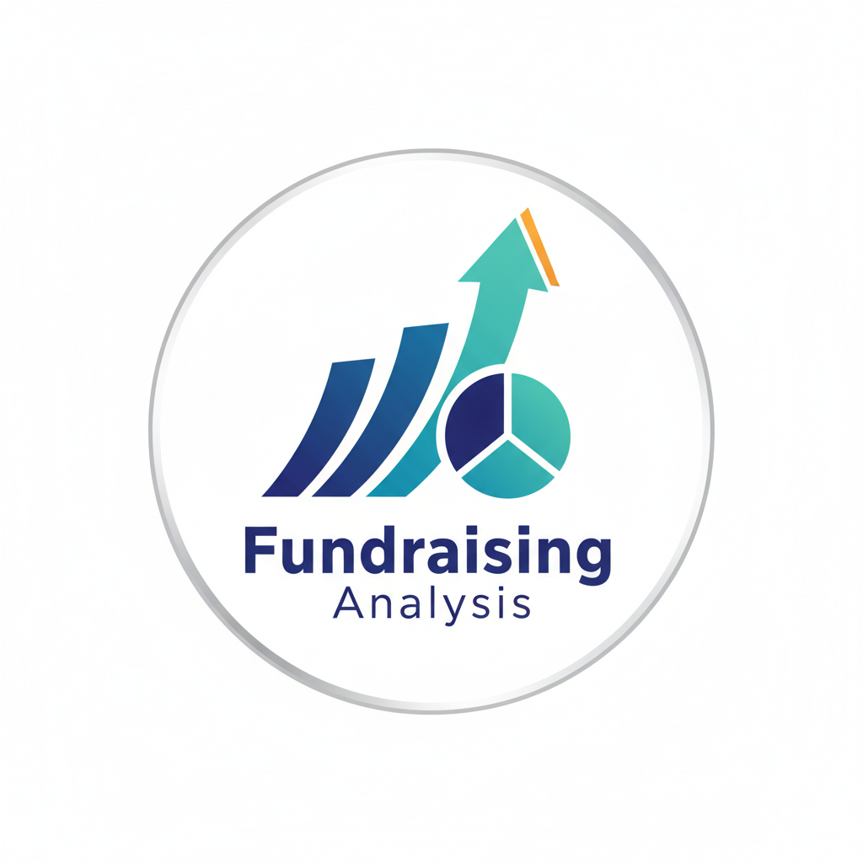
Sujalkarbhari1
https://github.com/sujalkarbhari1
Abstract
This report presents an analytical overview of a Fundraising Business Intelligence (BI) model developed to evaluate global fundraising patterns, marketing expenditures, donor engagement, and campaign performance across various countries, platforms, and currencies. Using visual analytics and aggregated metrics, this model provides insights aimed at optimizing fundraising strategies, improving donor acquisition, and identifying high-performing markets and platforms. The findings support strategic decision-making for fundraising organizations aiming to increase global reach and operational efficiency.

Project Overview

Modern fundraising initiatives rely heavily on data-driven decision-making to understand donor behavior, marketing effectiveness, and campaign outcomes. The Fundraising Business Intelligence Model consolidates campaign-related data from multiple regions, currencies, and platforms to generate insights that can guide resource allocation and performance improvement.
This model captures key performance indicators, including:
- Total Funds Raised
- Marketing Spend
- Donor Count
- Campaign Types (Online, Offline, Hybrid)
- Fundraising Platforms (e.g., GoFundMe, Indiegogo, JustGiving, Kickstarter)
- Country & Regional Fundraising Distribution
Through dashboards, maps, and advanced visual analytics, the system highlights patterns, relationships, and trends that influence campaign success.

Business Problem

Fundraising organizations face key operational and strategic challenges, such as:
- Identifying the most profitable markets
- Optimizing marketing spend vs. funds raised
- Determining which platforms yield the highest donor conversions
- Evaluating the role of campaign duration and media coverage
- Detecting inefficiencies in currency revenue performance
- Understanding regional fundraising disparities
Without consolidated intelligence, fundraising campaigns may experience:
- High marketing spend with minimal returns
- Poor donor engagement
- Inefficient campaign strategies
- Missed global opportunities
This BI model solves these issues by transforming raw fundraising data into actionable insights.

Data Analysis and Insights
Based on dashboard visuals:
4.1 Key Metrics Summary
Metric | Value
Average Campaign Duration | 105.24 days
Average Media Coverage | 49.95 mentions
Average Social Media Reach | 499.27K
Total Donor Count | 1,984
These values indicate that campaigns are long-running and moderately covered by media, with high social media engagement relative to donor count—suggesting opportunity for improving conversion.

4.2 Country Performance
Top countries by total funds raised include:
- Korea
- Congo
- British Virgin Islands
- Bolivia
- Namibia
While these countries show strong revenue performance, marketing spend varies disproportionately, indicating varying marketing ROI across regions.

4.3 Platform Performance
Fundraising platforms ranked by funds raised:
- GoFundMe (0.32bn)
- Indiegogo (0.32bn)
- JustGiving (0.31bn)
- Kickstarter (0.30bn)
Observation: Although values are close, GoFundMe and Indiegogo lead slightly, suggesting higher donor trust and platform effectiveness.

4.4 Currency Performance Based on Campaign Type
There are notable performance variations across currencies such as USD, INR, EUR, GBP, and AUD with respect to campaign type. For example:
- USD and INR campaigns reflect higher hybrid performance
- EUR and AUD show decreasing trends tied to offline campaigns
This highlights regional currency sensitivity and donor behavior in hybrid vs. online environments.

4.5 Regional and Campaign Type Drill-Down
- Asia leads globally with the highest total fundraising value.
- Inside Asia, the British Virgin Islands, Korea, and Honduras stand out.
- Campaign type performance shows:
  - Offline campaigns generate the highest donations
  - Online campaigns attract the widest donor reach
  - Hybrid models provide balanced engagement

Conclusion
The Fundraising Business Intelligence Model effectively reveals patterns and performance variations across geography, platform type, currency, and campaign structure. The analysis indicates that while global engagement is strong, especially on major platforms and in certain regions, donor conversion efficiency varies significantly. Media coverage and campaign duration influence performance, though not always proportionally.

Recommendations
Based on insights:
- Improve Conversion Funnel
Since high social media reach does not match donor count, implement targeted retargeting, storytelling campaigns, and simplified donor journeys.
- Prioritize High-Performing Platforms
Focus new fundraising launches on GoFundMe and Indiegogo, while optimizing presence on others based on region.
- Optimize Marketing Spend Allocation
Use predictive analytics to allocate budget toward regions and currencies demonstrating higher ROI—particularly hybrid and online-dominant regions.
- Expand High-Value Geographic Markets
Strengthen campaigns in high-performing regions such as Asia and Latin America, while identifying low-performing countries for tailored marketing or withdrawal decisions.
- Standardize Multi-Currency Strategy
Introduce currency-specific engagement strategies to address fluctuations observed in EUR, GBP, and AUD campaigns.

