Project 1 - URL Shortener using Go

Problem of the Project
1. Input: long url
2. Output: shortened url route

Tech Stack: HTML, CSS, Go, MongoDB Atlas

Flowchart
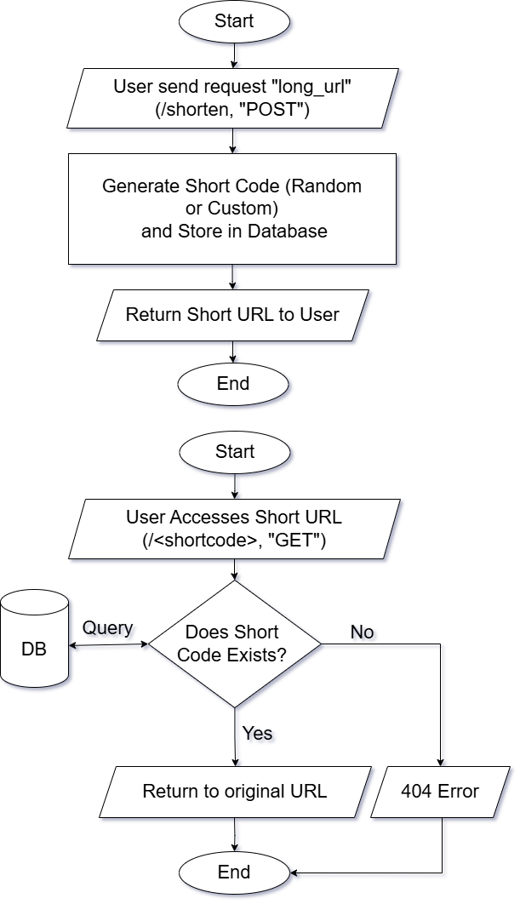

OUTPUT
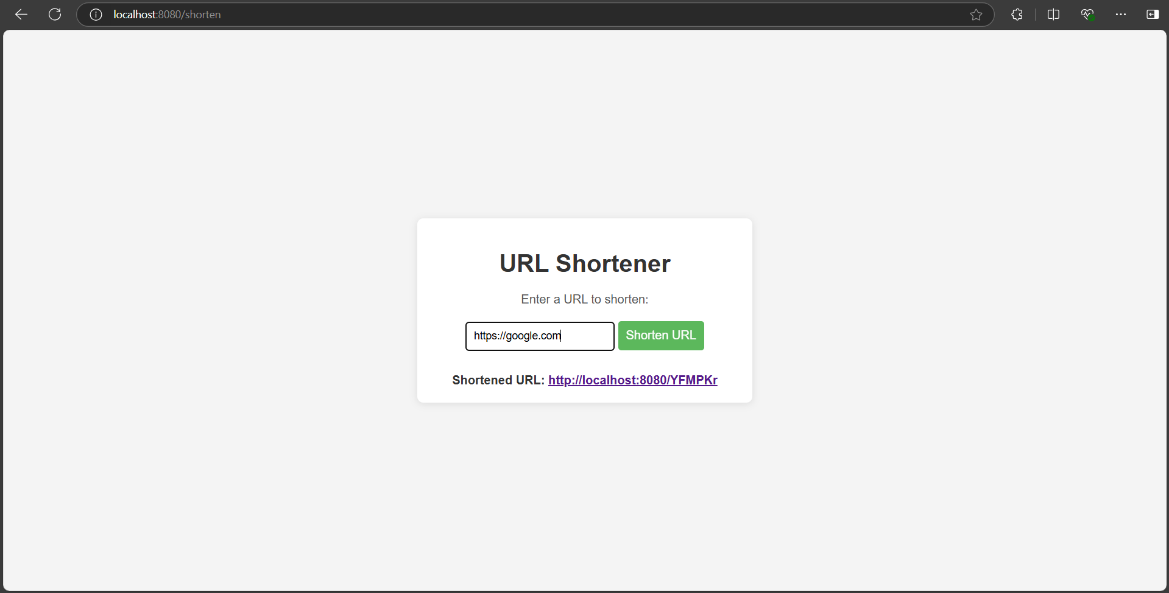
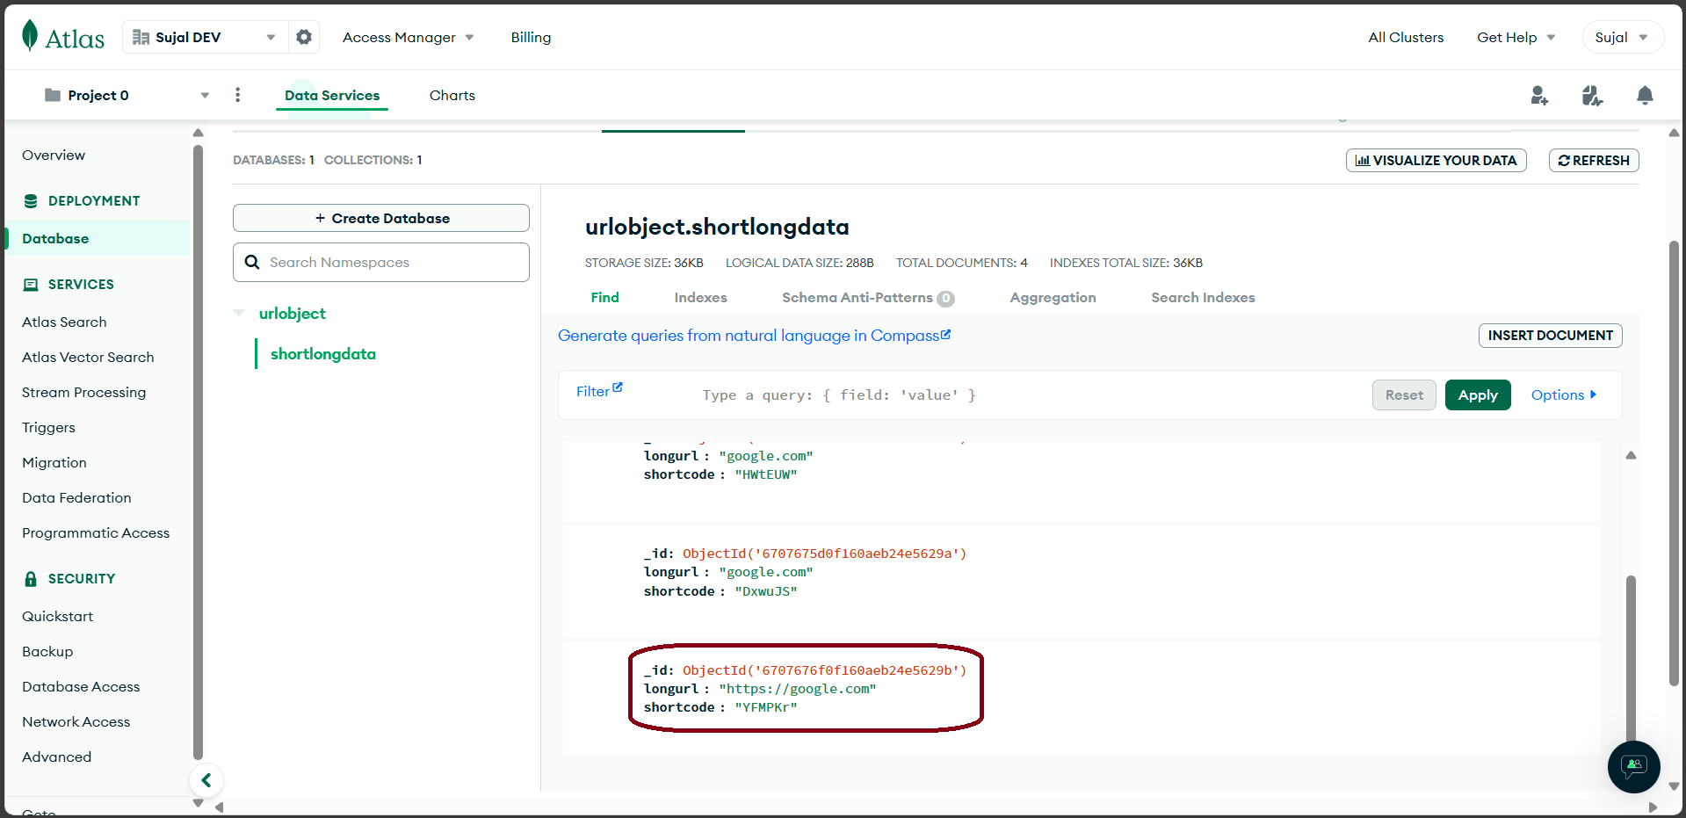
Go Implementation

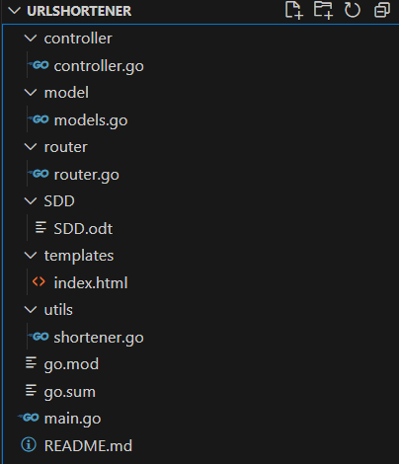
Directory structure (MVC- Model View Controller Approach)

Controller: It is the most important folder which handles all the important functions of this project. Such as connecting to the MongoDB Atlas Servers, shortening URLs, redirecting back shortened URLs to original URLs,etc.

Model: It is where the json/bson structure of the URL object is defined which consists of two components - longurl and shortcode

Router: Corresponding controller function calls according to the routes are written inside this file

SDD: (or) Software Design Document is the document which consists of the detail documentaion and functions of this project “URL Shortener using Go”

Templates: it is the directory where html files are saved in order to serve when the HOME page is needed

Utils: (or) Utilities is the directory where shortener.go is saved which is responsible for the function of randomly generating the short code URL by using a random seed function from math pkg

Main.go: It is the main file where the program starts and using http.ListenAndServe() listens to a specific port(i.e. here 8080) and gives signal to the router to start

Controller.go Working Structure

1. init() Function
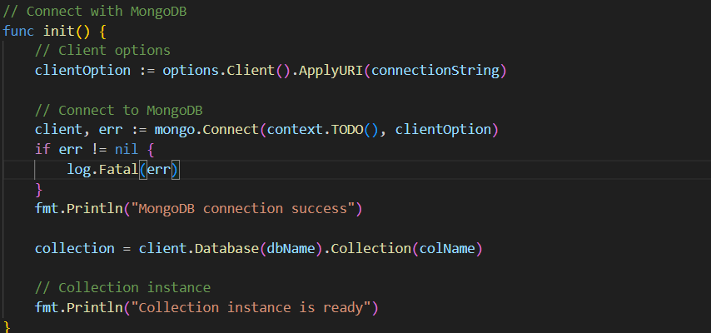
Purpose: responsible for connecting to the database and using database name(dbName) and collection name(colName) and giving out collection variable so that operations can be performed on colName collection

2. inserShortenUrlRecord() Function
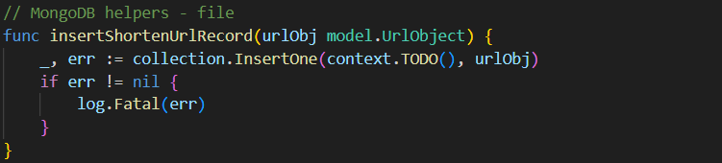
Purpose: pushes an URL object (which contains shortcode and corresponding longurl) to the MongoDB database collection

3. checkShortenUrl() Function
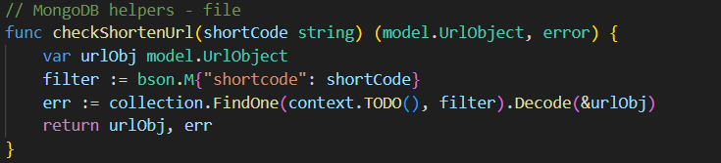
Purpose: checks whether the newly created shortcode already exists in Database for eliminating coinciding situations. bson is being passed with the shortcode and this filter is then searched in the collection

4. GetHomePage() Function
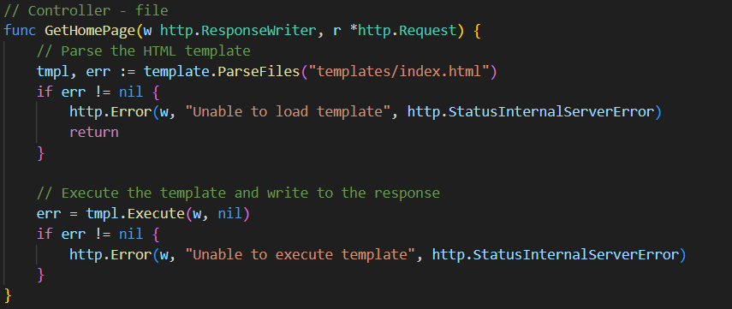
Purpose: It parses the “index.html” file from “templates/index.html” directory and loads it into tmpl and then tmpl.Execute() loads the file in the localhost “/” route

5. ReturnOriginalUrl() Function
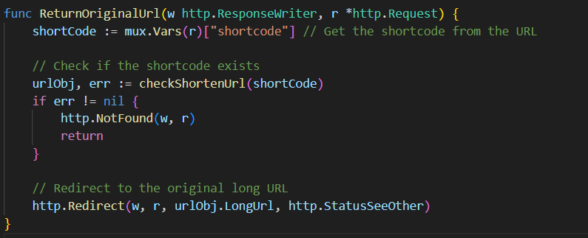
Purpose: Retrieves the original URL associated with the provided shortcode and redirects to it

6. CreateShortenUrl() Function
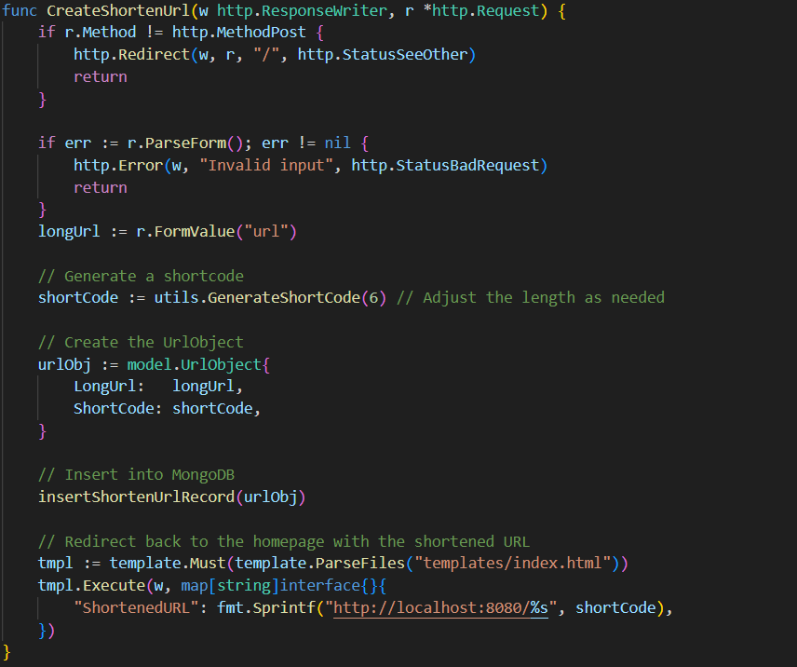
Purpose: Retrieves the original URL associated with the provided shortcode and redirects to it

