Practical XI

Objects and Classes

Submitted by 12220076

# OVERVIEW & PURPOSE

* Understand and Implement classes and object’s concepts

# Content

OVERVIEW & PURPOSE 1

Content 2

TODO: Coding Challenge #1 3



# TODO: Coding Challenge #1

1. a) Create a ***Circle*** class to simulate a Circle. Within the class, you should have:
   1. One property, ***radius***.
   2. A method ***getArea()*** which returns the circle's area. You should use the constant ***PI*** from the ***Math*** library.
   3. A method ***enlargeCircle()*** such that the circle’s radius will be tripled.
   4. A method  ***shrinkCircle()*** such that the circle’s radius will be halved.

b) In the main program,

1. Create an instance of Circle named ***circle1*** with ***radius*** of 2.
2. Display the area of ***circle1*** as shown in the program output.
3. Enlarge the radius of ***circle1*** by 3 times and display the area of ***circle1*** as shown in the program output.
4. Halve the radius of ***circle1*** and display the area of ***circle1*** as shown in the program output.

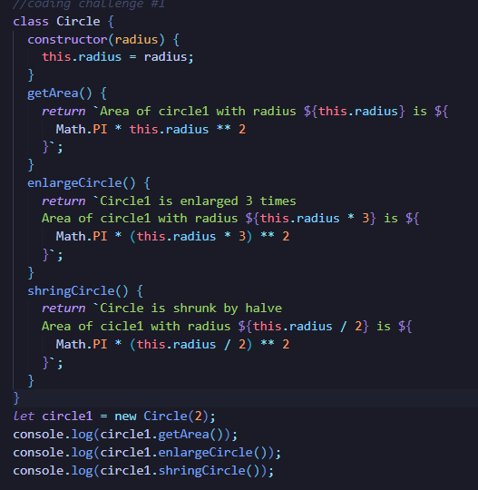

Program output:

|  |
| --- |
| Area of circle1 with radius 2.0 is 12.566370614359172  Circle is enlarged 3 times  Area of circle1 with radius 6.0 is 113.09733552923255  Circle is shrunk by halve  Area of circle1 with radius 3.0 is 28.274333882308138 |

2. a) Write ***BankAccount*** class that will be used to create bank accounts for all users of the bank. The class consists of the following:

1. Two properties, ***name*** (String type) and ***savings*** (float type).
2. Write the method ***getBalance()*** that returns a String value in the following format:

*<name> + “has $”+ <savings>*

For example,

Tom has $1234.0

b) In the main program, write codes to generate the following output:

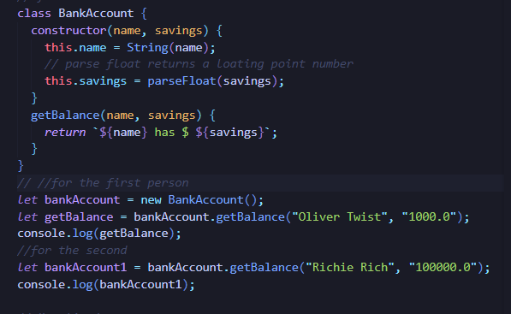

Program output:

|  |
| --- |
| Oliver Twist has $1000.0  Richie Rich has $100000.0 |

3. Write a class named ***Fan*** to model fans. The properties of the ***Fan*** class are ***speed*** and ***on*** of ***integer*** type and ***boolean*** type respectively.

The values of ***speed***: ***1***, ***2*** and ***3*** denote the speed of the fan as slow, medium and fast respectively.

The value of ***on***: ***true*** denotes the fan is on and ***false*** denotes the fan is off.

Code a method ***getState()*** that returns the state of the fan object as shown.

|  |
| --- |
| For example if ***speed*** is ***2*** and ***on*** is ***true***, invoking ***showState()*** will return:  ***on*** at ***medium*** speed  For example if ***on*** is ***false***, invoking ***showState()*** will display:  ***off*** |

In the main program,

* + 1. Instantiate 2 Fan objects. The first fan has ***on*** status with ***low*** speed, and the second fan also has ***on*** status with ***fast*** speed.
    2. Invoke ***getState()*** method to display the state of both fans.
    3. Switch off the first fan and set the speed of the second fan to medium.
    4. Invoke ***getState()*** again to display the state of both fans.

Program output:

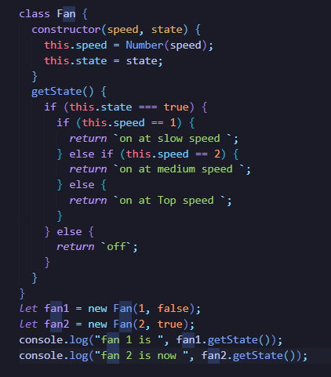

|  |
| --- |
| Fan 1 is on at low speed  Fan 2 is on at fast speed  Fan 1 is now off  Fan 2 is now on at medium speed |

GOOD LUCK 😊

**~ End of Practical ~**