Task 1: What is an ER Diagram? Draw an Entity Relationship Diagram with Data Types
An Entity Relationship (ER) Diagram is a graphical representation of the entities (objects), their attributes, and the relationships between them in a database. It is used during database design to organize data efficiently.
Example:
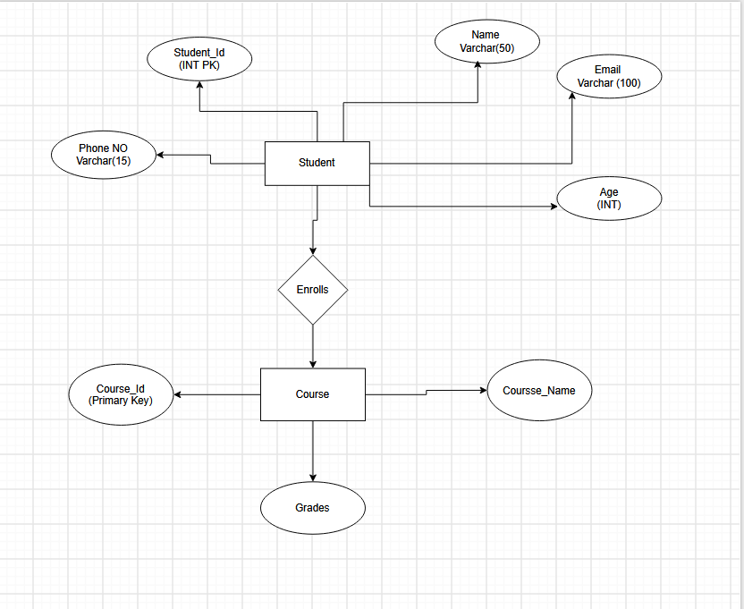

Task 2: What do you understand by Indexing in DBMS? How does it work?
Indexing is a technique used in a Database Management System (DBMS) to improve the speed of data retrieval. An index is a separate data structure that stores the values of one or more columns along with pointers to the corresponding rows in the table.
How Indexing Works
- An index is created on one or more columns.
- The DBMS stores the indexed values in sorted order.
- When a query searches for a value, the DBMS first checks the index.
- The index points directly to the required row instead of scanning the entire table.

Task 3: Do you think Indexing strategy improves query performance? Explain.
Yes, indexing significantly improves query performance.
An indexing strategy helps the DBMS locate records quickly without scanning every row in a table. It is especially useful for large databases containing thousands or millions of records.
Benefits
- Faster Search: Finds records quickly using indexed columns.
- Reduced Query Time: Queries execute much faster than full table scans.
- Efficient Sorting: Speeds up ORDER BY and GROUP BY operations.
- Better Join Performance: Improves joins between multiple tables.
- Improved Overall Database Performance: Frequently accessed data can be retrieved efficiently.

Task 4: What are the ACID Properties in RDBMS? Explain.
ACID is a set of four properties that ensure database transactions are processed accurately, reliably, and consistently in a Relational Database Management System).
1. Atomicity (All or Nothing)
- A transaction is treated as a single unit.
- Either all operations are completed successfully, or none of them are performed.
- If any step fails, the entire transaction is rolled back.
2. Consistency
- Ensures the database remains in a valid state before and after a transaction.
- All database rules, constraints, and relationships are maintained.
3. Isolation
- Multiple transactions can occur at the same time without interfering with each other.
- Each transaction behaves as if it is running alone.
4. Durability
- Once a transaction is successfully committed, the changes are permanently stored.
- The data remains safe even if the system crashes or there is a power failure.
Task 5:
Alter a table to add a column with unique key
ALTER TABLE Customer
ADD COLUMN email VARCHAR(50) UNIQUE;
Task 6:Add a check constraint to your column (eg: balance > 0)
create table Accounts(
id serial,
custName varchar (10),
balance int check (balance>0)
);
Task 7: use where clause and check if it works
select name from customer where id=101;
Task 8:use order by
select * from accounts order by balance desc;
Task 9: use LIMIT
select * from accounts order by balance desc LIMIT 2;

Task 10:Create queries for left outer join ,Right outer join ,Inner join ,Cross join
create table frontend_developers (
id int primary key,
name varchar(20),
project_id varchar(20)
);
insert into frontend_developers values (101, 'Ashok', 'P01');
insert into frontend_developers values (102, 'Kishore', 'P02');
insert into frontend_developers values (103, 'Sagar', 'P03');
insert into frontend_developers values (104, 'Hitesh', 'P04');
insert into frontend_developers values (105, 'Hari', 'P44');

select * from frontend_developers;
create table backend_developers (
id int primary key,
name varchar(20),
project_id varchar(20)
);
insert into backend_developers values (111, 'Sam', 'P11');
insert into backend_developers values (122, 'Ritu', 'P22');
insert into backend_developers values (103, 'Sagar', 'P33');
insert into backend_developers values (144, 'Nikky', 'P44');

select * from frontend_developers;
select * from backend_developers;

-- inner join
SELECT
frontend_developers.id,
frontend_developers.name AS frontend_name,
backend_developers.name AS backend_name,
frontend_developers.project_id AS frontend_project,
backend_developers.project_id AS backend_project
FROM frontend_developers
INNER JOIN backend_developers
ON frontend_developers.id = backend_developers.id;

--left outer join
SELECT
frontend_developers.id,
frontend_developers.name AS frontend_name,
backend_developers.name AS backend_name
FROM frontend_developers
LEFT OUTER JOIN backend_developers
ON frontend_developers.id = backend_developers.id;

--right outer join
Select
frontend_developers.id , frontend_developers.name ,
backend_developers.id , backend_developers.name
from frontend_developers
right outer join backend_developers
on frontend_developers.id= backend_developers.id;

--cross join
SELECT
frontend_developers.name AS frontend_name,
backend_developers.name AS backend_name
FROM frontend_developers
CROSS JOIN backend_developers;

--full outer join
SELECT
f.id,
f.name AS frontend_name,
b.name AS backend_name
FROM frontend_developers f
FULL OUTER JOIN backend_developers b
ON f.id = b.id;

--Full Outer join Using Union
SELECT
f.id,
f.name AS frontend_name,
b.name AS backend_name
FROM frontend_developers f
LEFT JOIN backend_developers b
ON f.id = b.id

UNION

SELECT
f.id,
f.name AS frontend_name,
b.name AS backend_name
FROM frontend_developers f
RIGHT JOIN backend_developers b
ON f.id = b.id;

Task 11: Indexing
CREATE INDEX idx_frontend_name
ON frontend_developers(name);

--create unique index
CREATE UNIQUE INDEX idx_frontend_project
ON frontend_developers(project_id);

--create partial index
CREATE INDEX idx_project_p44
ON frontend_developers(project_id)
WHERE project_id = 'P44';

--view all index
SELECT indexname, indexdef
FROM pg_indexes
WHERE tablename = 'frontend_developers';

Task 12: Schemas in PostgreSQL
1. Create a Schema
A schema is a logical container used to organize database objects such as tables, views, and functions.
Query:
CREATE SCHEMA company;

2. Create a Schema with Owner
This command creates a schema and assigns ownership to a specific PostgreSQL user.
Query:
CREATE SCHEMA AUTHORIZATION postgres;
Note: Replace postgres with your PostgreSQL username if it is different.

3. Create a Table Inside the Schema
A table can be created inside a schema by specifying the schema name before the table name.
Query:
CREATE TABLE company.employees (
id SERIAL PRIMARY KEY,
name VARCHAR(50),
department VARCHAR(30)
);

4. Insert Records into the Table
Insert sample data into the table.
Query:
INSERT INTO company.employees (name, department)
VALUES
('Ashok', 'Frontend'),
('Sagar', 'Backend');

5. Display the Table Data
Retrieve all records from the table.
Query:
SELECT * FROM company.employees;

Task 13:
Can you create a java code and connect with the postgresql’

6. Drop a Schema
Deletes an empty schema.
Query:
DROP SCHEMA company;
Note: This command works only if the schema contains no objects.

7. Drop a Schema with All Objects
Deletes the schema along with all tables and other objects inside it.
Query:
DROP SCHEMA company CASCADE;

Task 14:
package com.example.jdbc;
import java.sql.*;
public class Main {
public static void main(String[] args) {
String url = "jdbc:postgresql://localhost:5432/BankDB";
String username = "postgres";
String password = "sujal";
try {
Connection connection =
DriverManager.getConnection(url, username, password);
System.out.println("Connected Successfully");
Statement statement =
connection.createStatement();
ResultSet result =
statement.executeQuery("SELECT * FROM Accounts");
while(result.next()){
System.out.println(
result.getInt("id") + " " +
result.getString("name") + " " +
result.getString("email") + " " +
result.getDouble("balance")
);
}
connection.close();
}catch(Exception e){
e.printStackTrace();
}
}
}

