Task 1: Why is there a need for DBMS?
A Database Management System (DBMS) is needed because it provides an efficient, secure, and organized way to store and manage data.
Need for DBMS
- Reduces data redundancy – Minimizes duplicate copies of data.
- Maintains data consistency – Ensures the same data is accurate throughout the database.
- Data sharing – Allows multiple users to access data simultaneously.
- Data security – Protects data from unauthorized access using authentication and permissions.
- Data integrity – Ensures data is accurate and valid using constraints.

Task 2: Why not the traditional file system?
Traditional file systems have several limitations that led to the development of DBMS.
Limitations of the Traditional File System
- Data redundancy – The same data is stored in multiple files.
- Data inconsistency – Different files may contain conflicting information.
- Difficulty in accessing data – Retrieving data requires writing separate programs.
- Poor data sharing – Sharing data among multiple users is difficult.
- Weak security – Limited control over who can access or modify data.

Task 3: Explain the Concept of Data Independence in DBMS
Data Independence is the ability of a DBMS to change the database structure at one level without affecting the next higher level or the application programs. It allows modifications to the database without requiring changes to user applications.

Task 4: Different Types of Database Models (with Examples)
A database model defines how data is organized, stored, and related in a database.
1. RDBMS
- It organizes data into tables (relations) composed of rows and columns.
- Uses primary keys to uniquely identify rows and foreign keys to establish relationships between tables.
- Queries are written in SQL (Structured Query Language), which allows for efficient data manipulation and retrieval.
Examples: MySQL, Oracle, Microsoft SQL Server and PostgreSQL.
2.NoSql DBMS
- They are designed to handle large-scale data and provide high performance for scenarios where relational models might be restrictive.
- They store data in various non-relational formats, such as key-value pairs, documents, graphs or columns.
- These flexible data models enable rapid scaling and are well-suited for unstructured or semi-structured data.
Examples: MongoDB, Cassandra, DynamoDB and Redis.
3.OODBMS
- It integrates object-oriented programming concepts into the database environment, allowing data to be stored as objects.
- Supports complex data types and relationships, making it ideal for applications requiring advanced data modeling and real-world simulations.
Examples: ObjectDB, db4o.
4. Hierarchical Database
- Organizes data in a tree-like structure, where each record (node) has a single parent and have multiple children.
- This model is similar to a file system with folders and subfolders.
- It is efficient for storing data with a clear hierarchy, such as organizational charts or file directories.
- Navigation is fast and predictable due to the fixed structure.
- It lacks flexibility and is difficult to restructure or handle complex many-to-many relationships.
Example: IBM Information Management System (IMS).
5.Network Database
- It uses a graph-like model to allow more complex relationships between entities.
- Unlike the hierarchical model, it permits each child to have multiple parents, enabling many-to-many relationships.
- Data is represented using records and sets, where sets define the relationships.
- It is more flexible than the hierarchical model and better suited for applications with complex data linkages.
Example: Integrated Data Store (IDS), TurboIMAGE.
6.Cloud-Based Database
- Hosted on cloud computing platforms like AWS, Azure or Google Cloud.
- They offer on-demand scalability, high availability, automatic backups and remote accessibility.
- These databases can be relational (SQL) or non-relational (NoSQL) and are maintained by cloud service providers, reducing administrative overhead.
- They support modern application requirements, including distributed access and real-time analytics.
Example: Amazon RDS (for SQL), MongoDB Atlas (for NoSQL), Google BigQuery.
Task 5: Concurrency Control in DBMS
Concurrency Control is the process of managing simultaneous access to the database by multiple users while maintaining data consistency and integrity.
Why is it Important?
- Prevents data inconsistency
- Avoids lost updates
- Maintains data integrity
- Ensures correct transaction execution
Task 6: Indexes in DBMS
An index is a data structure that speeds up data retrieval from a database table by providing quick access to rows.
How Indexes Improve Query Performance
- Reduce the time needed to search records
- Avoid full table scans
- Improve the performance of SELECT, WHERE, ORDER BY, and JOIN queries
Example
Without an index, finding Student ID 1050 requires checking many records. With an index, the database directly locates the required record.

Task 7: Deadlock in DBMS
A deadlock occurs when two or more transactions wait indefinitely for each other to release resources, so none of them can proceed.
Example
- Transaction T1 locks Table A and waits for Table B.
- Transaction T2 locks Table B and waits for Table A.
- Both transactions wait forever, creating a deadlock.
Deadlock Prevention Strategies
- Resource Ordering – Request resources in a fixed order.
- Preemption – Force one transaction to release its resources.
- Wait-Die Scheme – Older transactions wait; younger ones are rolled back.
- Wound-Wait Scheme – Older transactions force younger ones to roll back.

Task 08:
What do you understand by Relational model?
Relational Model is a database model that stores data in the form of tables (relations) consisting of rows and columns. Each table represents an entity, rows represent records, and columns represent attributes. Relationships between tables are created using keys such as primary keys and foreign keys.
Example: A Student table with columns like Student_ID, Name, and Course_ID represents student data in a relational database.

Task 09:
Specify key terms that you encounter in RDBMS. Give brief explanation
- Relation: A table in a database that stores data in rows and columns.
- Tuple: A single row or record in a table.
- Attribute: A column in a table that represents a property of an entity.
- Primary Key: An attribute that uniquely identifies each record in a table.
- Foreign Key: An attribute that creates a link between two tables by referring to the primary key of another table.
- Candidate Key: An attribute or set of attributes that can uniquely identify a record.
- Super Key: A set of attributes that uniquely identifies a record, possibly with extra attributes.
- Degree: The number of attributes (columns) in a relation.
- Cardinality: The number of tuples (rows) in a relation.
- Constraint: Rules applied to maintain data accuracy and integrity.
- Normalization: The process of organizing data to reduce redundancy and improve consistency.

Task 10:
What are different types of keys in RDBMS?
Explain using diagrams ..
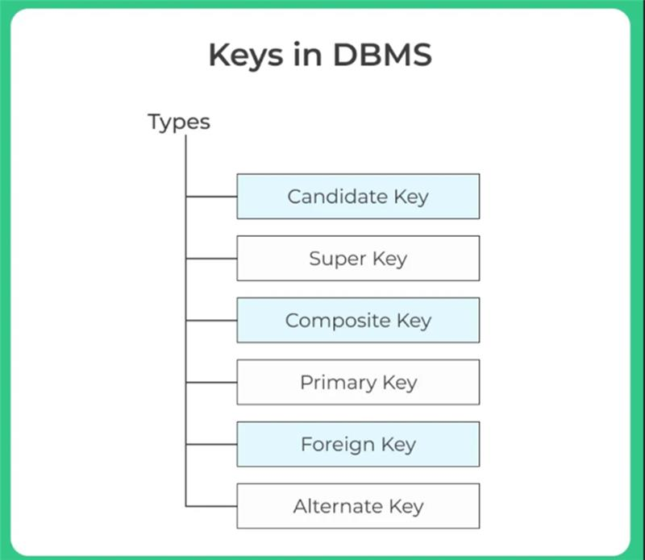

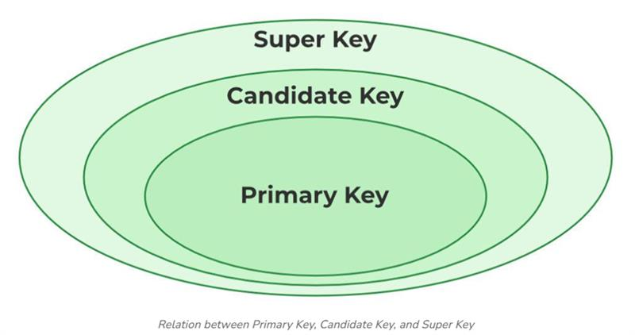

Types of keys
• Candidate Key: A key that can uniquely identify each record in a table.
• Super Key: A set of attributes that uniquely identifies a record, with or without extra attributes.
• Composite Key: A key formed using two or more attributes to uniquely identify a record.
• Primary Key: A selected candidate key used to uniquely identify records in a table.
• Foreign Key: A key that creates a relationship between two tables by referencing a primary key.
• Alternate Key: A candidate key that is not chosen as the primary key.

Task 11:
As you know diff keys in RDBMS what is the difference between primary key, foreign key, and unique key?
- A Primary Key is a key that uniquely identifies each record in a table and cannot contain duplicate or NULL values.
- A Foreign Key is a key that is used to create a relationship between two tables by referring to the primary key of another table and can contain duplicate values. A
- Unique Key ensures that all values in a column are unique and prevents duplicate entries, but it may allow NULL values.

Task 12
How does transaction management work in DBMS? Give an example of commit and rollback
- Transaction Management in DBMS is the process of managing database transactions to ensure data consistency, accuracy, and reliability. It controls the execution of multiple operations by using transaction commands like COMMIT and ROLLBACK.
Example:
COMMIT:
When a user transfers ₹1000 from Account A to Account B, after successfully completing the transaction, COMMIT permanently saves the changes in the database.
ROLLBACK:
If an error occurs during the transfer process, ROLLBACK cancels all changes and restores the database to its previous state.

Task 13
What is normalization? Why is it necessary in database design?
Normalization is the process of organizing data in a database to reduce data redundancy and improve data consistency by dividing large tables into smaller related tables.
It is necessary because it:
- Reduces duplicate data.
- Improves data consistency.
- Maintains data integrity.
- Avoids insertion, update, and deletion anomalies.
- Makes database design more efficient and easier to maintain.

Task 14: 1NF (First Normal Form)
1NF means:
- Each cell should contain only one value.
- No multiple values in one column.
- No repeating groups.
Example (Not in 1NF)
Student_ID | Name | Subjects
101 | Alice | DBMS, Java
Problem: The Subjects column contains more than one value.
After 1NF
Student_ID | Name | Subject
101 | Alice | DBMS
101 | Alice | Java

Task 15: 2NF (Second Normal Form)
2NF means:
- The table must already be in 1NF.
- Every non-key column should depend on the entire primary key, not just part of it.
Example (Not in 2NF)
Student_ID | Course_ID | Student_Name | Course_Name
101 | C01 | Alice | DBMS
101 | C02 | Alice | Java
102 | C01 | Bob | DBMS
Problem:
- Student_Name depends only on Student_ID.
- Course_Name depends only on Course_ID.
After 2NF
Student Table
Student_ID | Student_Name
101 | Alice
102 | Bob
Course Table
Course_ID | Course_Name
C01 | DBMS
C02 | Java
Enrollment Table
Student_ID | Course_ID
101 | C01
101 | C02
102 | C01
Result: Every non-key column depends on the whole primary key.

Task 16: 3NF (Third Normal Form)
3NF means:
- The table must already be in 2NF.
- A non-key column should depend only on the primary key, not on another non-key column.
Example (Not in 3NF)
Student_ID | Student_Name | Dept_ID | Dept_Name
101 | Alice | D01 | CSE
102 | Bob | D02 | ECE
Problem:
- Dept_Name depends on Dept_ID, not directly on Student_ID.
After 3NF
Student Table
Student_ID | Student_Name | Dept_ID
101 | Alice | D01
102 | Bob | D02
Department Table
Dept_ID | Dept_Name
D01 | CSE
D02 | ECE
Result: Every non-key column depends only on the primary key.

Task 17
What do you understand by joins? Explain all joins with examples
- A Join is an SQL operation used to combine data from two or more tables based on a common column.
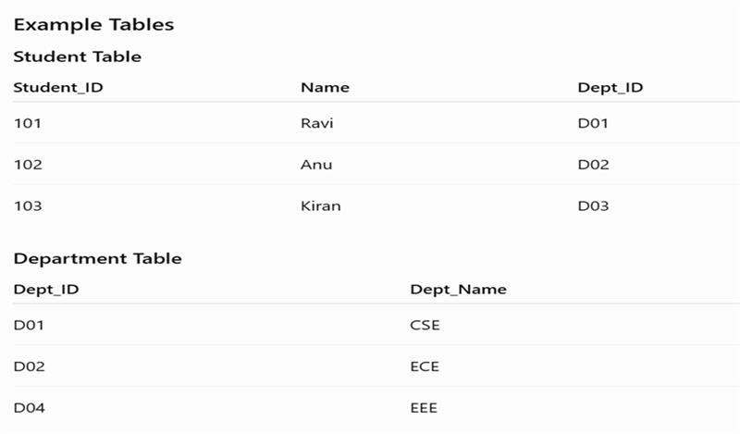
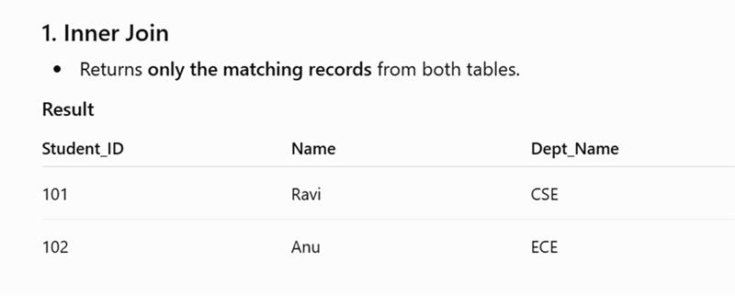
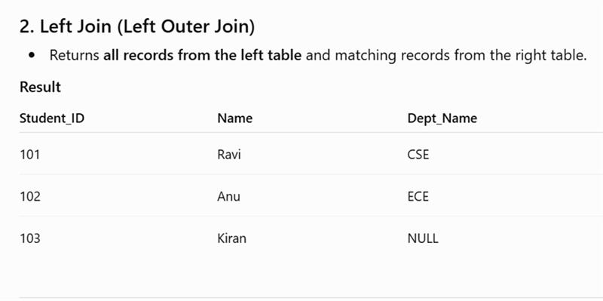
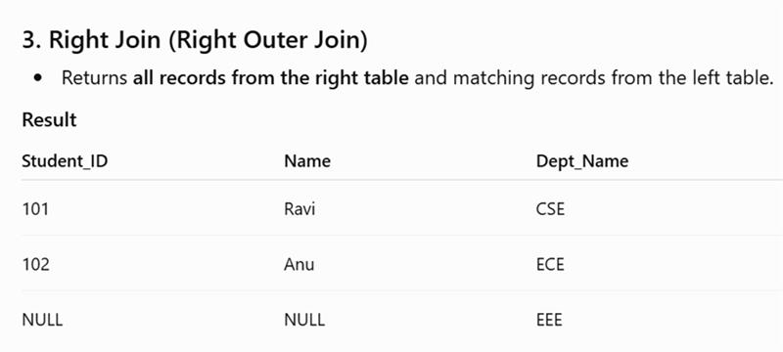

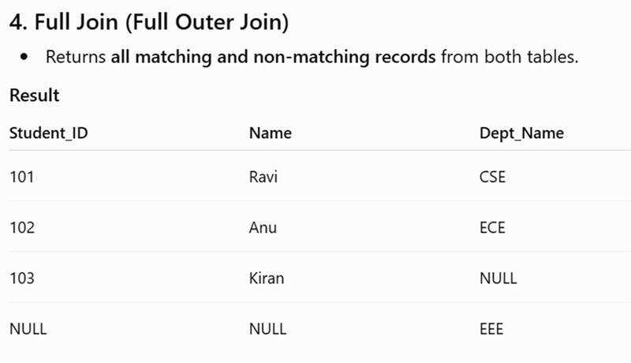
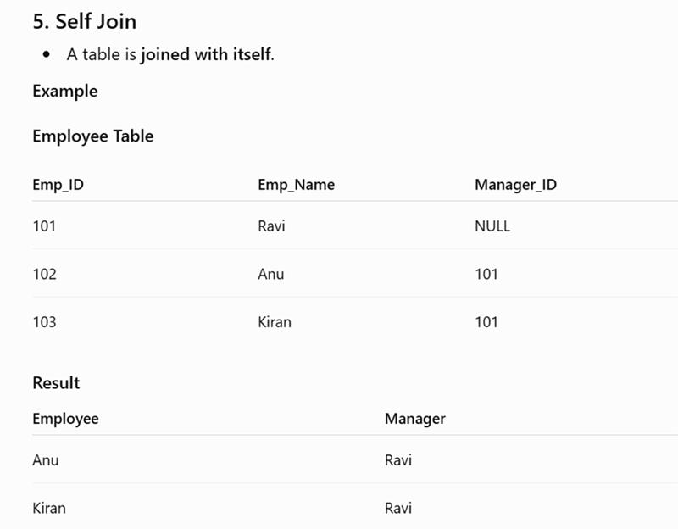

6. Cross Join
- Returns the Cartesian product of two tables (every row from one table is combined with every row from the other table).

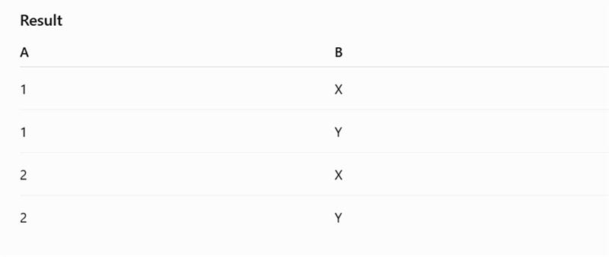
Home Task
What is BCNF explain with example
- BCNF an advanced form of 3NF. A table is in BCNF if every determinant is a candidate key. In other words, every attribute that determines another attribute must itself be a candidate key.
- Example

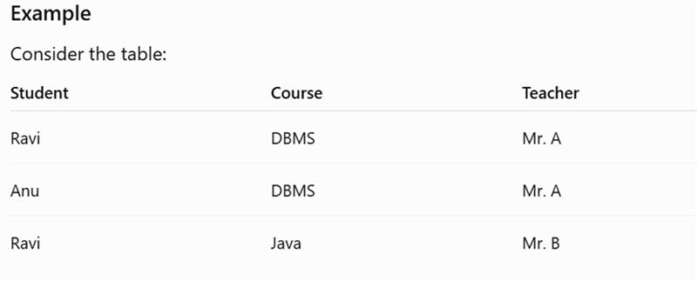
Convert to BCNF
Teacher Table
Teacher | Course
Mr. A | DBMS
Mr. B | Java
Student_Teacher Table
Student | Teacher
Ravi | Mr. A
Anu | Mr. A
Ravi | Mr. B
Now, every determinant (Teacher) is a candidate key in its table, so the tables are in BCNF.

