Department of Computer Technology

Vision of the Department
To be a well-known centre for pursuing computer education through innovative pedagogy, value-based education and industry collaboration.

Mission of the Department
To establish learning ambience for ushering in computer engineering professionals in core and multidisciplinary area by developing Problem- solving skills through emerging technologies.

Session 2025-2026
Mission: To be a good data scientist
Vision: To help businesses uncover crucial insights

Program Educational Objectives of the program (PEO): (broad statements that describe the professional and career accomplishments)
PEO1 | Preparation | P: Preparation | Pep-CL abbreviation pronounce as Pep-si-lL easy to recall
PEO2 | Core Competence | E: Environment (Learning Environment)
PEO3 | Breadth | P: Professionalism
PEO4 | Professionalism | C: Core Competence
PEO5 | Learning Environment | L: Breadth (Learning in diverse areas)

Program Outcomes (PO): 1. Understand and Apply Parallel Programming Concepts
- Analyse and Improve Program Performance.
- Demonstrate Practical Skills in HPC Tools and Environments.
Keywords of POs:
Engineering knowledge, Problem analysis, Design/development of solutions, Conduct Investigations of Complex Problems, Engineering Tool Usage, The Engineer and The World, Ethics, Individual and Collaborative Team work, Communication, Project Management and Finance, Life-Long Learning

PSO Keywords: Cutting edge technologies, Research

“I am an engineer, and I know how to apply engineering knowledge to investigate, analyse and design solutions to complex problems using tools for entire world following all ethics in a collaborative way with proper management skills throughout my life.” to contribute to the development of cutting-edge technologies and Research.

Integrity: I will adhere to the Laboratory Code of Conduct and ethics in its entirety.

Name and Signature of Student and Date
Sujal Kumeriya – 05/11/2025

Department of Computer Technology

Vision of the Department
To be a well-known centre for pursuing computer education through innovative pedagogy, value-based education and industry collaboration.

Mission of the Department
To establish learning ambience for ushering in computer engineering professionals in core and multidisciplinary area by developing Problem- solving skills through emerging technologies.

Session | 2025-26 (ODD) | Course Name | HPC Lab
Semest er | 7 | Course Code | 22ADS706
Roll No | 64 | Name of Student | Sujal Kumeriya

Practical Number | 9
Course Outcome | - Understand and Apply Parallel Programming Concepts  - Analyse and Improve Program Performance
Aim | Context Switching Overhead
Problem Definition | Context Switching Overhead
Theory (100  words) | - Introduction  Context switching refers to the process where the CPU switches from one task (thread or process) to another. This involves saving the state of the current task and loading the state of the next one. Although necessary for multitasking, it introduces an overhead — known as 'context switching overhead' — because the CPU spends time switching instead of executing useful instructions.  - Code Explanation  The provided Python code benchmarks the performance overhead of context switching between threads and processes compared to a baseline scenario with no switching.  Here’s what each section of the code does:  - do_work() – Simulates computational work to mimic real CPU activity.  - benchmark_baseline() – Measures the time taken to complete operations without any context switching.  - benchmark_thread_context_switches() – Uses multiple threads and queues to measure how long it takes for threads to pass control between each other.  - benchmark_process_context_switches() – Uses multiple processes and pipes to measure the performance of context switching between processes.  - Summary Section – Compares the baseline, thread, and process results, calculating overhead and relative performance.

Department of Computer Technology

Vision of the Department
To be a well-known centre for pursuing computer education through innovative pedagogy, value-based education and industry collaboration.

Mission of the Department
To establish learning ambience for ushering in computer engineering professionals in core and multidisciplinary area by developing Problem- solving skills through emerging technologies.

Code: | import threading import multiprocessing import time  import os  from queue import Queue  # Configuration NUM_SWITCHES = 10000  WORK_ITERATIONS = 1000 # Simulated work between switches  def do_work():  """Simulate some CPU work""" total = 0  for i in range(WORK_ITERATIONS): total += i * i  return total  # ============= THREAD CONTEXT SWITCHING =============  def thread_worker(queue_in, queue_out, thread_id, num_switches):  for i in range(num_switches): queue_in.get()  do_work() queue_out.put(thread_id)  def benchmark_thread_context_switches(num_threads=4): print(f"\n{'='*60}")  print(f"THREAD CONTEXT SWITCHING ({num_threads} threads)")  print(f"{'='*60}")  queues = [Queue() for _ in range(num_threads)] threads = []  for i in range(num_threads):  next_queue = queues[(i + 1) % num_threads] t = threading.Thread(  target=thread_worker,

Department of Computer Technology

Vision of the Department
To be a well-known centre for pursuing computer education through innovative pedagogy, value-based education and industry collaboration.

Mission of the Department
To establish learning ambience for ushering in computer engineering professionals in core and multidisciplinary area by developing Problem- solving skills through emerging technologies.

args=(queues[i], next_queue, i, NUM_SWITCHES
// num_threads)
)
threads.append(t)
start_time = time.perf_counter() for t in threads:
t.start() queues[0].put(0)
for t in threads: t.join()
total_time = time.perf_counter() - start_time switches_per_second = NUM_SWITCHES / total_time avg_switch_time_us = (total_time / NUM_SWITCHES) *
1_000_000
print(f"Total switches: {NUM_SWITCHES:,}") print(f"Total time: {total_time:.4f} seconds") print(f"Switches per second:
{switches_per_second:,.0f}") print(f"Average time per switch:
{avg_switch_time_us:.2f} microseconds") return total_time
# ============= PROCESS CONTEXT SWITCHING =============
def process_worker(pipe_in, pipe_out, proc_id, num_switches):
for i in range(num_switches): pipe_in.recv()
do_work() pipe_out.send(proc_id)

def benchmark_process_context_switches(num_processes=4): print(f"\n{'='*60}")
print(f"PROCESS CONTEXT SWITCHING ({num_processes}
processes)")

Department of Computer Technology

Vision of the Department
To be a well-known centre for pursuing computer education through innovative pedagogy, value-based education and industry collaboration.

Mission of the Department
To establish learning ambience for ushering in computer engineering professionals in core and multidisciplinary area by developing Problem- solving skills through emerging technologies.

print(f"{'='*60}")
pipes = [multiprocessing.Pipe() for _ in range(num_processes)]
processes = []
for i in range(num_processes):
next_pipe = pipes[(i + 1) % num_processes] p = multiprocessing.Process(
target=process_worker, args=(pipes[i][0], next_pipe[1], i,
NUM_SWITCHES // num_processes)
)
processes.append(p)
start_time = time.perf_counter() for p in processes:
p.start() pipes[0][1].send(0)
for p in processes: p.join()
total_time = time.perf_counter() - start_time switches_per_second = NUM_SWITCHES / total_time avg_switch_time_us = (total_time / NUM_SWITCHES) *
1_000_000
print(f"Total switches: {NUM_SWITCHES:,}") print(f"Total time: {total_time:.4f} seconds") print(f"Switches per second:
{switches_per_second:,.0f}") print(f"Average time per switch:
{avg_switch_time_us:.2f} microseconds") return total_time
# ============= BASELINE (NO CONTEXT SWITCHING)
=============
def benchmark_baseline():

Department of Computer Technology

Vision of the Department
To be a well-known centre for pursuing computer education through innovative pedagogy, value-based education and industry collaboration.

Mission of the Department
To establish learning ambience for ushering in computer engineering professionals in core and multidisciplinary area by developing Problem- solving skills through emerging technologies.

print(f"\n{'='*60}")
print(f"BASELINE (No context switching)") print(f"{'='*60}")
start_time = time.perf_counter() for i in range(NUM_SWITCHES):
do_work()
total_time = time.perf_counter() - start_time operations_per_second = NUM_SWITCHES / total_time avg_time_us = (total_time / NUM_SWITCHES) *
1_000_000
print(f"Total operations: {NUM_SWITCHES:,}") print(f"Total time: {total_time:.4f} seconds") print(f"Operations per second:
{operations_per_second:,.0f}") print(f"Average time per operation:
{avg_time_us:.2f} microseconds") return total_time
# ============= MAIN EXECUTION =============
if name == " main ":
print("\nCONTEXT SWITCHING PERFORMANCE BENCHMARK")
print(f"Python version: {os.sys.version}") print(f"CPU count: {multiprocessing.cpu_count()}") print(f"Work iterations per switch:
{WORK_ITERATIONS:,}")
baseline_time = benchmark_baseline() thread_time =
benchmark_thread_context_switches(num_threads=4) process_time =
benchmark_process_context_switches(num_processes=4)
print(f"\n{'='*60}")
print("SUMMARY & OVERHEAD ANALYSIS")
print(f"{'='*60}")

Department of Computer Technology

Vision of the Department
To be a well-known centre for pursuing computer education through innovative pedagogy, value-based education and industry collaboration.

Mission of the Department
To establish learning ambience for ushering in computer engineering professionals in core and multidisciplinary area by developing Problem- solving skills through emerging technologies.

thread_overhead = ((thread_time - baseline_time) / baseline_time) * 100
process_overhead = ((process_time - baseline_time) / baseline_time) * 100
process_vs_thread = (process_time / thread_time)
print(f"Baseline time:
{baseline_time:.4f}s")
print(f"Thread switching time: {thread_time:.4f}s ({thread_overhead:+.1f}% overhead)")
print(f"Process switching time: {process_time:.4f}s ({process_overhead:+.1f}% overhead)")
print(f"\nProcess switches are
{process_vs_thread:.2f}x slower than thread switches")
Output :-

Department of Computer Technology

Vision of the Department
To be a well-known centre for pursuing computer education through innovative pedagogy, value-based education and industry collaboration.

Mission of the Department
To establish learning ambience for ushering in computer engineering professionals in core and multidisciplinary area by developing Problem- solving skills through emerging technologies.

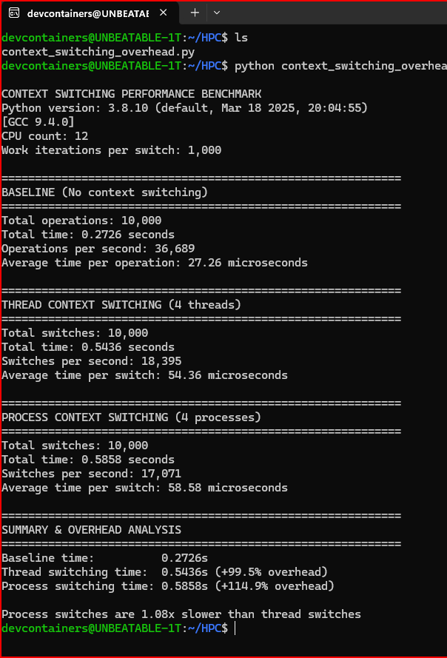

Department of Computer Technology

Vision of the Department
To be a well-known centre for pursuing computer education through innovative pedagogy, value-based education and industry collaboration.

Mission of the Department
To establish learning ambience for ushering in computer engineering professionals in core and multidisciplinary area by developing Problem- solving skills through emerging technologies.

Output Analysis | The output shows three major parts:  - Baseline (No context switching) – Represents the ideal performance with no task switching.  - Thread Context Switching – Shows the performance when multiple threads are switching using shared memory.  - Process Context Switching – Shows the performance when separate processes switch using inter-process communication.  From the benchmark:  - Baseline time: 0.2726s  - Thread switching time: 0.5436s (+99.5% overhead)  - Process switching time: 0.5858s (+114.9% overhead)  Thus, **process switches are 1.08× slower than thread switches** because processes have separate memory spaces and require more operating system resources during switching.  4. Comparison Between Thread and Process Context Switching
 |  | Aspect | Comparison
 |  | Execution Context | Threads share the same memory space; processes have isolated memory.
 |  | Switching Mechanism | Thread switches are lighter since they share resources; process switches require full context change.
 |  | Overhead | Threads have lower overhead compared to processes.
 |  | Performance | Process switching is slower (1.08× slower in this benchmark).
Link of student Github profile where lab assignment has been  uploaded | https://github.com/sujalkumeriya59/HPC_LAB

Department of Computer Technology

Vision of the Department
To be a well-known centre for pursuing computer education through innovative pedagogy, value-based education and industry collaboration.

Mission of the Department
To establish learning ambience for ushering in computer engineering professionals in core and multidisciplinary area by developing Problem- solving skills through emerging technologies.

Conclusion | Context switching is essential for multitasking but introduces performance overhead. Threads, sharing the same memory space, are faster to switch between, whereas processes require additional effort by the OS to handle separate memory spaces, resulting in higher overhead.
Plag Report (Similarity index < 12%) | 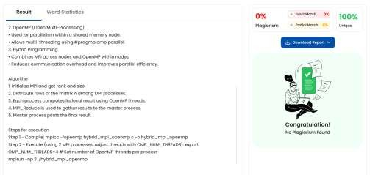
Date | 05/11/2025

