A MAJOR PROJECT PROPOSAL ON
“INTEGRATION OF OPEN-SOURCE SECURITY TOOLS FOR A UNIFIED SOC FRAMEWORK”



Submitted by:
Rupesh Mahato | [230023]
Sujal Lamichhane | [230024]
Ujjwal Kandel | [230026]

Submitted to:
Department of BCS (NT & CS)
Forbes College
Bharatpur-2, Kshetrapur
November 30th, 2025

EXECUTIVE SUMMARY
In today’s rapidly evolving cybersecurity environment, organizations require an integrated and automated approach to detect, correlate, and respond to threats in real time. This project focuses on building a unified Security Operations Center (SOC) framework using pfSense, Wazuh SIEM, Shuffle SOAR, MISP, VirusTotal, AlienVault OTX, TheHive, and Cortex as an interconnected monitoring and incident response ecosystem. The architecture combines perimeter security, log correlation, automated workflows, and threat intelligence enrichment within a controlled lab setting. Simulated attack scenarios including reconnaissance, exploitation, brute-force attempts, reverse shells, and malware activity were executed to test the system’s detection and automation capabilities. Wazuh successfully correlated alerts from both network and endpoint sources, Shuffle automated enrichment and response actions, and TheHive with Cortex provided detailed case management and analysis. This project demonstrates the effectiveness of integrating open-source and enterprise security tools to create a cost-efficient, scalable SOC environment suitable for academic research and real-world implementation. Ultimately, it highlights the importance of centralized visibility, layered defense, and automation in strengthening modern cybersecurity operations.
Key Words: SOC, Wazuh, pfSense, Shuffle SOAR, TheHive, Cortex, MISP, VirusTotal, AlienVault OTX, Threat Intelligence, SIEM, Incident Response, Reverse Shells, Cyberattacks.

TABLE OF CONTENTS
EXECUTIVE SUMMARY i
LIST OF FIGURES iii
LIST OF TABLES iv
CHAPTER 1: INTRODUCTION 1
1.1 Background 1
1.2 Problem Statement 1
1.3 Objectives 2
1.4 Products and Service Requirements 2
CHAPTER 2: LITERATURE REVIEW 6
CHAPTER 3: METHODOLOGY 7
3.1 Network Architecture 7
3.2 Working Flow 8
3.3 Flowchart 9
CHAPTER 4: EPILOUGE 10
4.1 Expected Outcomes 10
4.2 Time Schedule 10
4.3 Budget Analysis 11
CONCLUSION 12
REFERENCE 13

LIST OF FIGURES
Figure 1. 1: pfSense 2
Figure 1. 2: Suricata 2
Figure 1. 3: Wazuh 3
Figure 1. 4: Kali Linux 3
Figure 1. 5: Ubuntu 3
Figure 1. 6: Cortex 4
Figure 1. 7: TheHive 4
Figure 1. 8: MISP 4
Figure 1. 9: Shuffle 5
Figure 1. 10: AlienVault 5
Figure 1. 11: VirusTotal 5

Figure 3. 1: Network Architecture 7
Figure 3. 2: Working Flow 8
Figure 3. 3: Flowchart 9

LIST OF TABLES
Table 4. 1: Time Schedule 10
Table 4. 2: Budget Analysis 11

ABBREVATIONS | DEFINITIONS
DMZ | Demilitarized Zone
HIDS | Host-based Intrusion Detection System
IDS | Intrusion Detection System
IPS | Intrusion Prevention System
NSM | Network Security Monitoring
SIEM | Security Information and Event Management
SMEs | Small and Medium-sized Enterprises
SOAR | Security, Orchestration, Automation and Response
SOC | Security Operations Center
VM | Virtual Machine
XDR | Extended Detection and Response
LIST OF ACRONYMS

CHAPTER 1: INTRODUCTION

1.1 Background
As digital infrastructures expand, organizations face increasing cyber threats such as malware infections, intrusion attempts, phishing campaigns, and data breaches, with these attacks growing more sophisticated and difficult to detect through traditional security mechanisms. To ensure continuous protection, the Security Operations Center (SOC) has become essential for real-time monitoring, detection, analysis, and response. However, building a SOC typically requires costly enterprise-grade tools that many small and medium-sized organizations cannot afford. To address this challenge, this project proposes a Unified SOC Framework that integrates pfSense as the perimeter firewall, Wazuh as the SIEM and endpoint monitoring platform, Shuffle for automated response, and threat intelligence sources such as MISP, VirusTotal, and AlienVault OTX, along with TheHive and Cortex for incident management and enrichment. These tools operate within a structured architecture encompassing an Isolation Zone, Corporate Perimeter, DMZ, and Internal LAN, enabling real-time threat detection, automated workflows, enriched intelligence, and efficient incident response that closely resembles the capabilities of a professional SOC environment.

1.2 Problem Statement
Even with the availability of multiple cybersecurity tools, organizations encounter major operational challenges:
- Fragmented Visibility: Security tools often operate independently, resulting in disconnected logs, incomplete monitoring, and poor situational awareness.
- Delayed Incident Response: Manual investigation, lack of automation, and scattered alerts slow down detection and response to threats.
- High Cost of SOC Implementation: Enterprise-grade SOC tools and infrastructure are expensive, making advanced security monitoring difficult for small and medium-sized organizations.

Objectives
The primary objectives of this project are as follows:
- Enhance Threat Detection and Visibility: Integrate SIEM, threat intelligence and network monitoring to gain real-time visibility into security events.
- Automate Incident Response: Use SOAR workflows (Shuffle) and TheHive-Cortex to reduce manual work, speed up response and impove accuracy.

Products and Service Requirements

- pfSense Firewall Appliance: A free, open-source firewall and router distribution based on FreeBSD. pfSense provides enterprise-grade features such as NAT, VLANs, DHCP, DNS, and VPN support. In this project, pfSense is deployed as a virtual or physical appliance and serves as the perimeter security device, integrating with Suricata for network-level intrusion detection and traffic inspection [1].
Figure 1. 1: pfSense

- Suricata IDS/IPS Software: An open-source, high-performance network threat detection engine capable of real-time intrusion detection (IDS), intrusion prevention (IPS), and network security monitoring (NSM). Installed as a package in pfSense, Suricata operates in IDS mode to analyze packets, generate alerts on suspicious traffic patterns, and forward logs for correlation in Wazuh [2].
Figure 1. 2: Suricata


- Wazuh Manager and Dashboard: A comprehensive open-source Security Information and Event Management (SIEM) platform. It provides threat detection, integrity monitoring, log analysis, and incident response capabilities. Wazuh collects and correlates logs from both the network (Suricata) and host-level agents, displaying security events in its built-in web dashboard. It includes rule sets, decoders, and active responses to automate threat mitigation.
Figure 1. 3: Wazuh
- Wazuh Agent Software: Lightweight agents installed endpoint machines (Windows/Linux) to monitor system activity, perform file integrity checks, collect audit logs, and report to the Wazuh Manager. These agents help provide host-based intrusion detection (HIDS) and full endpoint visibility for real-time alerting and correlation [3].

- Kali Linux Virtual Machine: An open-source, Debian-based Linux distribution specifically designed for penetration testing and ethical hacking. Kali Linux is used in the lab environment to simulate various attack vectors (e.g., brute-force, reverse shell, scanning, exploitation) to validate the detection and logging capabilities of the integrated system [4].
Figure 1. 4: Kali Linux

- Ubuntu/Windows Endpoints: Generic operating system platforms used as victim machines for attack simulation. They are equipped with Wazuh agents and are targeted by Kali Linux to generate real-world security events. These machines help demonstrate the effectiveness of Wazuh’s detection capabilities [5].
Figure 1. 5: Ubuntu


- Cortex: Cortex is an open-source, scalable analysis engine used to automate observable and artifact analysis. In the lab environment, Cortex connects with TheHive to process indicators such as IP addresses, hashes, URLs, and domains. It performs enrichment and malware analysis tasks using multiple analyzers (e.g., HybridAnalysis, VirusTotal, WHOIS). This enables the SOC to validate automated incident triaging, enrichment workflows, and threat-intelligence correlation capabilities [6].
Figure 1. 6: Cortex
- TheHive: TheHive is an open-source Security Incident Response Platform (SIRP) used for case management, alert handling, event correlation, and collaborative investigation. In the lab setup, TheHive integrates with Wazuh, Cortex, and MISP to collect alerts, create investigation cases automatically, assign tasks, and track response actions. It helps validate coordinated incident handling, analyst workflow automation, and traceability of security events [7].

Figure 1. 7: TheHive

- MISP: MISP (Malware Information Sharing Platform) is an open-source threat-intelligence sharing system designed to collect, store, and distribute Indicators of Compromise (IOCs). In the SOC lab, MISP is used to feed threat intelligence to TheHive and Cortex, allowing automated enrichment and correlation of suspicious activities detected by Wazuh. Its use enables testing of IOC ingestion, sharing workflows, and threat intelligence automation [8].
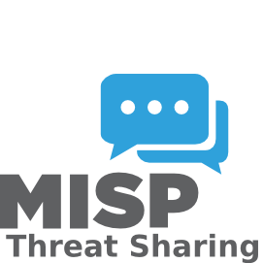
Figure 1. 8: MISP


- Shuffle SOAR: Shuffle is an open-source Security Orchestration, Automation, and Response (SOAR) platform used to automate incident workflows through drag-and-drop playbooks. In the lab environment, Shuffle integrates with Wazuh, TheHive, Cortex, and MISP to automate tasks such as alert forwarding, IOC enrichment, case creation, and email notifications. It is used to evaluate the SOC’s automation capabilities and reduce manual response time [9].

Figure 1. 9: Shuffle


- AlienVault: AlienVault is an open-source security information and event management platform combining asset discovery, vulnerability assessment, intrusion detection, and log correlation. In the lab setup, AlienVault is used to correlate logs from endpoints, firewalls, and detection tools to validate threat detection accuracy across multiple data sources. It plays a key role in testing SIEM event processing, correlation rules, and unified threat visibility [10].

Figure 1. 10: AlienVault


- VirusTotal: VirusTotal is a widely used cloud-based malware analysis and reputation service that aggregates results from multiple antivirus engines, sandboxes, and URL scanners. In the SOC lab, VirusTotal is used through Cortex analyzers to validate malicious file/hash detection, enrich investigation cases, and compare local detection results with global threat intelligence. This helps test reputation-based detection, IOC verification, and external threat-feed integration [11].
Figure 1. 11: VirusTotal

CHAPTER 2: LITERATURE REVIEW
Open-source Security Information and Event Management (SIEM) tools like Wazuh and OSSIM provide effective log monitoring, event correlation, and agent-based visibility, offering cost-efficient solutions for SOCs [12]. Studies such as SAIBERSOC show that these platforms can be tested for detection accuracy and response performance using simulated attacks [13].
Security Orchestration, Automation, and Response (SOAR) platforms reduce manual tasks and speed up incident investigation. Open-source solutions like Shuffle SOAR provide scalable automation, while threat intelligence platforms such as MISP and AlienVault OTX help analysts correlate alerts with global threat data [14].
Incident response tools like TheHive and Cortex enable collaborative investigations with case management and automated workflows. Modular SOC architectures demonstrate flexibility and adaptability, and integrating SIEM, SOAR, threat intelligence, and response tools improves detection accuracy and response time [15]. This project implements a unified open-source SOC framework leveraging these tools.

CHAPTER 3: METHODOLOGY

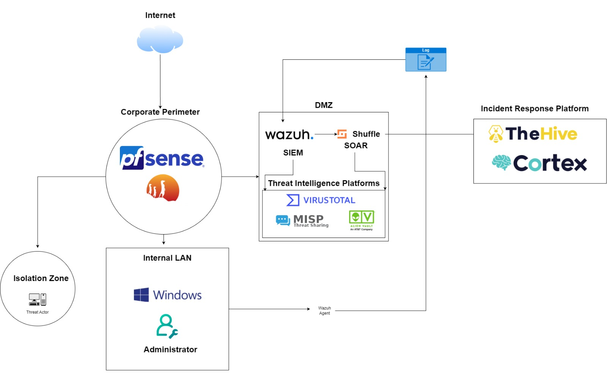
3.1 Network Architecture
Figure 3. 1: Network Architecture
This SOC architecture uses pfSense as the main perimeter firewall to filter all Internet traffic, forwarding essential logs to the DMZ where Wazuh SIEM centrally collects and analyzes security data from pfSense, Windows endpoints, and threat-intelligence sources like VirusTotal, MISP, and AlienVault OTX. When Wazuh detects suspicious activity, it triggers Shuffle SOAR, which automates responses such as threat enrichment, blocking malicious IPs, and generating incidents in TheHive—the primary incident-response platform. Cortex supports TheHive by performing deeper analysis of malware samples, file hashes, URLs, and IPs to accelerate investigations. Within the internal LAN, Windows systems send logs through Wazuh agents, and compromised machines can be moved to the isolation zone to prevent lateral movement. Together, this architecture delivers a unified, automated, intelligence-driven SOC for effective monitoring, detection, and incident response.

3.2 Working Flow
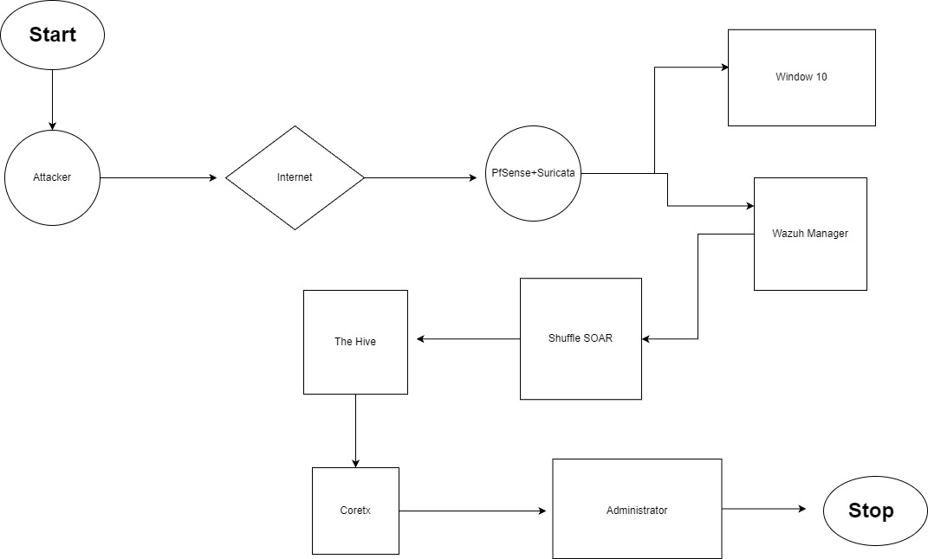
Figure 3. 2: Working Flow
This diagram illustrates the workflow of a unified SOC environment, beginning when an attacker sends malicious traffic through the internet toward the organization’s network, where pfSense and Suricata act as the first security layer by inspecting and detecting suspicious activity. The logs and alerts generated by these systems are forwarded to the Wazuh Manager, which correlates network and endpoint events from Windows 10 to identify potential threats. When a threat is detected, Wazuh sends the alert to Shuffle SOAR, which enriches and processes the information before automatically creating an incident case in TheHive for deeper investigation. From TheHive, analysts can run Cortex analyzers to gather additional threat intelligence, such as IP reputation or file hash analysis. Based on these insights, the administrator reviews the findings, applies necessary security actions such as blocking the attacker or updating firewall rules and concludes the incident, completing the workflow.

3.3 Flowchart
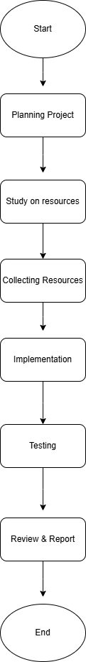
Figure 3. 3: Flowchart

CHAPTER 4: EPILOUGE

4.1 Expected Outcomes
The expected outcome of this project is the successful deployment of a fully functional SOC environment that integrates SIEM, SOAR, Threat Intelligence, and Incident Response tools into a unified security framework. This setup will enable real-time detection of common cyber-attacks such as brute-force attempts, malware execution, and port scanning, while automated workflows will enrich alerts, generate cases, and notify analysts for faster and more accurate responses. With centralized logging and interactive dashboards, the SOC will significantly improve visibility into network activities and overall security posture. Additionally, the project will demonstrate a cost-effective SOC model suitable for educational, research, and small-business use, supported by documentation and detailed analysis of attack scenarios that highlight how the SOC identifies, investigates, and mitigates threats.

4.2 Time Schedule
Date | Days | Key Tasks
30 Nov – 5 Dec | 6 | Preliminary Research
6 Dec – 13 Dec | 8 | Infrastructure Preparation
14 Dec – 21 Dec | 8 | Tool Installation & Configuration
22 Dec – 29 Dec | 8 | System Integration
30 Dec – 3 Jan | 5 | Issue Resolution
4 Jan – 9 Jan | 6 | Testing & Verification
10 Jan – 15 Jan | 6 | Final Reporting & Documentation
16 Jan – 20 Jan | 5 | Buffer & Submission
Table 4. 1: Time Schedule

4.3 Budget Analysis
Item | Estimated Cost (USD)
Hardware (Servers / VM Hosts) | $1200 – $2500
pfSense & Network Setup | $0 – $300
SIEM & IDS Tools (Wazuh, Suricata) | $0
SOAR Platform (Shuffle) | $0 – $200
Threat Intelligence Tools (TheHive, Cortex, MISP) | $0
VirusTotal API (Optional) | $0 – $600
Storage for Logs & Backups | $200 – $600
Miscellaneous | $100 – $300
Total Estimated Budget | $1500 – $4500

Table 4. 2: Budget Analysis
1 United States Dollar = 142.70 NPR

CONCLUSION
This project presents a comprehensive, unified Security Operations Center (SOC) framework designed to integrate multiple open-source and enterprise cybersecurity tools into a single, cohesive system, enabling organizations to monitor, detect, analyze, and respond to threats more effectively. By leveraging Wazuh for host-based intrusion detection and log analysis, Shuffle for automating repetitive security workflows, MISP, OTX, and VirusTotal for enriched threat intelligence, and TheHive with Cortex for structured incident management and automated response, the framework ensures that security events are intelligently correlated, prioritized, and acted upon in real time. This approach not only provides a cost-effective and scalable solution for small and medium-sized organizations that cannot afford expensive SOC infrastructure but also serves as a practical model for research, training, and educational purposes, allowing students and professionals to experiment with real-world security operations. By demonstrating the importance of tool integration, workflow automation, and layered defense, the project highlights how a unified SOC enhances organizational resilience, improves detection accuracy, accelerates incident response, and creates a strong, adaptable cybersecurity posture.

REFERENCE
[1] J. Buechler et al., pfSense: The Definitive Guide. Reed Media Services, 2011.
[2] Open Information Security Foundation (OISF), “Suricata: Open Source IDS/IPS/NSM Engine.” [Online]. Available: https://suricata.io
[3] Wazuh Inc., “Wazuh Documentation,” 2024. [Online]. Available: https://documentation.wazuh.com
[4] Offensive Security, “Kali Linux: Penetration Testing and Ethical Hacking Linux Distribution.” [Online]. Available: https://www.kali.org
[5] Canonical Ltd. (Ubuntu) and Microsoft (Windows), official documentation. [Online]. Available: https://ubuntu.com | https://microsoft.com/windows
[6] Cortex. Cortex: Observable Analysis and Automation Engine. TheHive Project. Available at: https://github.com/TheHive-Project/Cortex
[7] TheHive. TheHive: Security Incident Response Platform (SIRP). TheHive Project. Available at: https://github.com/TheHive-Project/TheHive
[8] MISP Project. MISP – Malware Information Sharing Platform & Threat Sharing. Available at: https://www.misp-project.org
[9] Shuffle SOAR. Shuffle – Open Source Security Orchestration & Automation Platform. Available at: https://shuffler.io
[10] AlienVault OSSIM. OSSIM – Open Source Security Information and Event Management. AT&T Cybersecurity. Available at: https://cybersecurity.att.com/products/ossim
[11] VirusTotal. VirusTotal – Free Online Virus, Malware, and URL Scanner. Google. Available at: https://www.virustotal.com
[12] M. Rosso, M. Campobasso, G. Gankhuyag, and L. Allodi, "SAIBERSOC: Synthetic Attack Injection to Benchmark and Evaluate the Performance of Security Operation Centers," arXiv preprint, 2020. [Online]. Available: https://arxiv.org/abs/2010.08453
[13] N. Rastogi, S. Dutta, M. J. Zaki, A. Gittens, and C. Aggarwal, "MALOnt: An Ontology for Malware Threat Intelligence," arXiv preprint, 2020. [Online]. Available: https://arxiv.org/abs/2006.11446
[14] A. S. Shatnawi, B. Al-Duwairi, M. M. Almazari, M. S. Alshakhatreh, and A. N. Khader, "Adaptable Plug and Play Security Operations Center Leveraging a Novel Programmable Plugin-based Intrusion Detection and Prevention System," arXiv preprint, 2022. [Online]. Available: https://arxiv.org/abs/2204.04576
[15] K. Walavalkar, K. Walavalkar, Y. Jagdale, S. Gharge, and A. Nerurkar, "Security Operations Center using open-source tools," JETIR, vol. 11, no. 6, 2024. [Online]. Available: https://jetir.org/papers/JETIR2406A44.pdf

