UCHALA DUMBELL GYM (UD GYM)
MANAGEMENT SYSTEM
Comprehensive Architecture Design & Project Documentation
―――――――――――――――――――――――――――――――――――――――――――――――――――――――
DOCUMENT STRUCTURE OVERVIEW:
1. FRONT-END DESIGN – PROTOTYPE
2. BUSINESS LOGIC DESIGN
3. DATABASE DESIGN
➡️ SCREENSHOTS OF ACTUAL FRONT-END / APPLICATION
➡️ RELEVANT SOURCE CODE
➡️ SCREENSHOTS OF ACTUAL DATABASE TABLES
➡️ TEST CASES IN TABULAR FORMAT

1. FRONT-END DESIGN – PROTOTYPE
Objective: Design and structure all visual interfaces, interactive screens, form elements, and user navigation workflows for the Uchala Dumbell Gym (UD Gym) web application across three primary user roles: Gym Owner/Admin, Personal Trainers, and Gym Members.

A. User Interfaces / Screens List
# | Screen Title | File Name | Role | Description
1 | Home / Landing Page | index.html | Public / All | Overview of gym facilities, equipment vault, pricing cards, and portal login access.
2 | Membership Plans Showcase | plans.html | Public / Members | Display of Starter, Pro, and Elite subscription tiers and monthly/annual perks.
3 | Member Login Page | member-login.html | Gym Members | Authentication screen for athletes using Member ID/Phone and secret password.
4 | Member Dashboard | member-dashboard.html | Gym Members | Personal profile, subscription expiry badge, monthly attendance logs, workout split.
5 | Trainer Login Page | trainer-login.html | Trainers | Secure login interface for personal trainers and gym coaches.
6 | Trainer Dashboard | trainer-dashboard.html | Trainers | Overview of assigned athletes, daily coaching schedule, and shift timing.
7 | Assigned Trainees Directory | trainer-members.html | Trainers | List of assigned gym athletes with their workout goals and progress logs.
8 | Trainer Workout Logger | trainer-workouts.html | Trainers | Form to record exercises, muscle categories, sets, reps, weight, and duration.
9 | Trainer Attendance Portal | trainer-attendance.html | Trainers | Quick check-in interface for floor trainers during workout sessions.
10 | Owner Login Page | owner-login.html | Owner / Admin | Administrative gateway for gym owners with credential validation.
11 | Owner Master Dashboard | owner-dashboard.html | Owner / Admin | KPI cards (Total Members, Active Trainers, Revenue, Today Check-ins) & analytics.
12 | Member Management | members.html | Owner / Admin | Enroll new members (Auto UDG-xxx ID), search athletes, edit/delete memberships.
13 | Trainer Management | trainers.html | Owner / Admin | Add/onboard trainers (TRN-xxx ID), manage payroll, shifts, and specializations.
14 | Plans Management | plans.html | Owner / Admin | Add or update membership plan pricing, duration (1, 3, 6, 12 months), and perks.
15 | Daily Attendance Register | attendance.html | Owner / Admin | Real-time date-filtered attendance table with check-in time and status toggle.

B. Screen Design (Prototypes & Wireframes)
1. Landing & Portal Selection Screen Prototype (index.html):
+-------------------------------------------------------------------------+
| [LOGO] UCHALA DUMBELL GYM [Home] [Plans] [About] [Login] |
+-------------------------------------------------------------------------+
| |
| BUILD YOUR ULTIMATE PHYSIQUE AT UCHALA DUMBELL GYM |
| State-of-the-Art Equipment | Elite Trainers | Custom Diets |
| |
| +-------------------+ +-------------------+ +--------------------+ |
| | MEMBER PORTAL | | TRAINER PORTAL | | OWNER PORTAL | |
| | Track workouts & | | Manage athletes | | Gym analytics, | |
| | attendance logs | | & log routines | | billing & staff | |
| | [ Member Login ] | | [ Trainer Login ] | | [ Owner Login ] | |
| +-------------------+ +-------------------+ +--------------------+ |
+-------------------------------------------------------------------------+
2. Universal Login Screen Prototype (member/trainer/owner-login.html):
+-------------------------------------------------------------------------+
| UCHALA DUMBELL GYM |
| ================== |
| [ User Login ] |
| |
| User ID / Phone / Username: [ UDG-101 ] |
| Password: [ ********** ] |
| |
| [ LOGIN ] |
| |
| ( ! ) Error / Success Notification Banner |
| Forgot Password? Contact Gym Front Desk |
+-------------------------------------------------------------------------+
3. Owner Master Dashboard Prototype (owner-dashboard.html):
+----------------+--------------------------------------------------------+
| UD GYM OWNER | DASHBOARD OVERVIEW [Admin: Sujal Sir] |
+----------------+--------------------------------------------------------+
| [■] Dashboard | +---------------+ +---------------+ +---------------+ |
| [👥] Members | | TOTAL MEMBERS | | ACTIVE TRAIN | | TODAY CHECK-IN| |
| [🏋️] Trainers | | 148 | | 8 | | 42 | |
| [💳] Plans | +---------------+ +---------------+ +---------------+ |
| [📅] Attendance| |
| [🚪] Logout | RECENT ENROLLMENTS & LOGS |
| | +---------+-----------------+------------+----------+ |
| | | ID | Name | Plan | Status | |
| | +---------+-----------------+------------+----------+ |
| | | UDG-101 | Rahul Sharma | Pro (3 Mo) | Active | |
| | | UDG-102 | Amit Verma | Elite (1Y) | Active | |
| | | UDG-103 | Priya Patil | Starter | Active | |
| | +---------+-----------------+------------+----------+ |
+----------------+--------------------------------------------------------+
4. Member Management & Enrollment Prototype (members.html):
+----------------+--------------------------------------------------------+
| UD GYM OWNER | MANAGE MEMBERS |
+----------------+--------------------------------------------------------+
| | ADD NEW MEMBER ENROLLMENT |
| | Full Name: [ Ramesh Kumar ] Phone: [ 9876543210] |
| | Select Plan: [ Pro Plan (3M) ▼] Joined: [ 2026-09-12] |
| | Password: [ 123456 ] |
| | [ + Enroll Member ] |
| | |
| | REGISTERED ATHLETES DIRECTORY [ Search... 🔍 ] |
| | +---------+--------------+------------+--------+----+ |
| | | Mem ID | Name | Plan | Status | Act| |
| | +---------+--------------+------------+--------+----+ |
| | | UDG-101 | Rahul Sharma | Pro Plan | Active | 🗑️ | |
| | | UDG-102 | Amit Verma | Elite Plan | Active | 🗑️ | |
| | +---------+--------------+------------+--------+----+ |
+----------------+--------------------------------------------------------+
5. Trainer Workout Logging Prototype (trainer-workouts.html):
+----------------+--------------------------------------------------------+
| UD GYM TRAINER | ATHLETE WORKOUT LOGGER [Trainer: TRN-101]|
+----------------+--------------------------------------------------------+
| [■] Dashboard | LOG NEW WORKOUT SET |
| [👥] Trainees | Athlete Name: [ Rahul Sharma ▼] |
| [💪] Workouts | Exercise: [ Incline Dumbbell Bench Press ] |
| [📅] Check-In | Category: [ Hypertrophy / Chest ] |
| [🚪] Logout | Sets x Reps: [ 4 Sets x 12 Reps ] Weight: [ 28 kg ] |
| | Duration: [ 45 Mins ] Date: [ Today ] |
| | [ Save Workout Record ] |
| | |
| | TODAY'S LOGGED EXERCISE SESSIONS |
| | • Rahul Sharma — Incline DB Press (4x12 @ 28kg) |
| | • Amit Verma — Barbell Squat (5x5 @ 100kg) |
+----------------+--------------------------------------------------------+

C. Navigation Flow Diagram
[ WEBSITE LANDING ] (index.html)
|
+-------------------------+-------------------------+
| | |
v v v
[ Member Portal ] [ Trainer Portal ] [ Owner Portal ]
| | |
(member-login.html) (trainer-login.html) (owner-login.html)
| | |
v v v
[ Member Dashboard ] [ Trainer Dashboard ] [ Owner Dashboard ]
• Profile Details • Assigned Trainees • Member Management
• Active Plan Expiry • Log Workouts • Trainer Management
• Attendance History • Mark Check-In • Pricing Plans
• Workout Routines • Shift Times • Attendance Logs

2. BUSINESS LOGIC DESIGN
Objective: Detail the backend workflows, data processing pipelines, financial algorithms, validation rules, and authorization layers executing in the Express.js application layer.

A. System Business Modules
# | Module Name | Business Processing Description
1 | Authentication & Security | Verifies credentials for Owner, Trainer, and Member. Protects administrative and personal data routes.
2 | Member Enrollment & Auto-ID | Computes sequential identity keys (UDG-101 + count), checks unique constraints, and assigns default plans.
3 | Trainer Onboarding & Payroll | Calculates trainer IDs (TRN-101 + count), stores shift assignments, specializations, and salary metrics.
4 | Membership Expiry Engine | Processes subscription validity (30, 90, 180, 365 days) and calculates remaining active days.
5 | Daily Attendance Tracker | Enforces single check-in rule per day per member, logs arrival timestamps, and calculates daily footfall.
6 | Workout & Routine Split Engine | Validates exercise categories (Strength, Hypertrophy, Cardio), weights, repetitions, and trainer-assigned routines.
7 | Financial & KPI Analytics | Aggregates total gross revenue, trainer payroll liabilities, active subscriptions, and floor check-ins.

B. Business Rules & Execution Logic
1. Member Registration Logic (Input -> Processing -> DB -> Output):
Input: { name: 'Rahul Sharma', phone: '9876543210', plan: 'Pro Plan', password: 'secret' }
Validation: Check if Name and Phone are non-empty. Validate 10-digit phone format.
Processing: count = Member.countDocuments()
memberId = 'UDG-' + (101 + count)
joinDate = new Date().toISOString().split('T')[0]
status = 'Active'
Database: Member.create({ memberId, name, phone, plan, password, joinDate, status })
Output: HTTP 201 Created -> { success: true, data: savedMemberRecord }
2. Daily Attendance Check-In Logic:
Input: { memberId: 'UDG-101', status: 'Present', time: '07:30 AM' }
Validation: Verify memberId exists in members collection.
Processing: today = CurrentDate (YYYY-MM-DD)
existingRecord = Attendance.findOne({ memberId, date: today })
Logic: IF existingRecord exists THEN
Update existingRecord.status = status, time = time
existingRecord.save()
ELSE
newRecord = new Attendance({ memberId, memberName, date: today, time, status })
newRecord.save()
Output: HTTP 200/201 -> { success: true, message: 'Attendance recorded successfully' }

C. Mathematical Formulas & Calculations
📌 Formulas & Calculation Engine
1. Membership Expiry Calculation:
Expiry Date = Join Date + (Plan Duration in Months × 30 Days)
• Starter Plan (1 Month): Join Date + 30 Days
• Pro Plan (3 Months): Join Date + 90 Days
• Elite Plan (1 Year): Join Date + 365 Days
2. Total Gym Revenue Aggregation:
Total Revenue (₹) = Sum of (Plan Price for each enrolled member)
• Starter Plan: ₹1,200 | Pro Plan: ₹3,000 | Elite Plan: ₹9,999
3. Trainer Payroll Liability:
Monthly Payroll Expense = Sum of (Trainer.salary for all active trainers)

D. Validation Rules Table
Input Field | Target Model | Validation Rule | Error Handling & Behavior
Phone Number | Member / Trainer | Must be non-empty string of exactly 10 digits. | Reject with 400 Bad Request if invalid format.
Member ID | Member | Auto-generated pattern 'UDG-xxx'; strictly unique. | Prevent manual tampering, auto-incremented by DB count.
Trainer ID | Trainer | Auto-generated pattern 'TRN-xxx'; strictly unique. | Sequential auto-assignment guarantees collision avoidance.
Password | All Users | Minimum 6 characters required. | Defaults to '123456' for members or 'trainer123' for trainers.
Attendance Date | Attendance | ISO Date string 'YYYY-MM-DD'. | Auto-defaults to server current UTC date split.
Attendance Status | Attendance | Must be enum: ['Present', 'Absent']. | Defaults to 'Present' if omitted.
Salary | Trainer | Positive numeric value > 0. | Defaults to ₹20,000 baseline if unassigned.

E. User Roles and Permissions Matrix
System Feature / Action | Owner / Admin | Personal Trainer | Gym Member
View Revenue & Owner KPI Metrics | ✅ Full Access | ❌ Restricted | ❌ Restricted
Add / Delete Members | ✅ Full Access | ❌ Restricted | ❌ Restricted
Add / Manage Trainers & Payroll | ✅ Full Access | ❌ Restricted | ❌ Restricted
Configure Plans & Pricing | ✅ Full Access | ❌ Restricted | ❌ Restricted
Log Athlete Workouts & Reps | ✅ Full Access | ✅ Full Access | ❌ Read Only
Mark Floor Attendance | ✅ Full Access | ✅ Full Access | ❌ Read Only
View Personal Workout Routine | ✅ Full Access | ✅ Assigned Trainees | ✅ Own Record Only
View Personal Attendance Log | ✅ Full Access | ✅ Assigned Trainees | ✅ Own Record Only

3. DATABASE DESIGN
Objective: Define the data models, document structures, primary and reference keys, and relationships stored inside the MongoDB Atlas cloud database.

A. Identify Entities / Collections
The system persists structured data in MongoDB Atlas utilizing 5 primary collections: (1) 'members', (2) 'trainers', (3) 'attendances', (4) 'workouts', and (5) 'owners'.

B. Table / Collection Schemas
1. members Collection Schema:
Field Name | Data Type | Key / Constraint | Field Description
_id | ObjectId | PK (Auto) | MongoDB unique internal document identifier.
memberId | String | UK, Required | Unique public member code (e.g. 'UDG-101').
name | String | Required | Full name of the registered gym athlete.
phone | String | Required | 10-digit primary contact phone number.
plan | String | Required | Enrolled subscription package (Starter, Pro, Elite).
password | String | Required | Authentication password hash/string.
joinDate | String | Default Today | Registration date formatted as YYYY-MM-DD.
status | String | Default 'Active' | Current status flag ('Active' or 'Expired').
createdAt | Date | Timestamp | Auto-generated record creation timestamp.
updatedAt | Date | Timestamp | Auto-generated record last update timestamp.
2. trainers Collection Schema:
Field Name | Data Type | Key / Constraint | Field Description
_id | ObjectId | PK (Auto) | MongoDB unique internal document identifier.
trainerId | String | UK, Required | Unique public trainer code (e.g. 'TRN-101').
name | String | Required | Full name of the fitness trainer/coach.
phone | String | Required | Primary contact telephone number.
specialization | String | Required | Domain expertise (CrossFit, Bodybuilding, Cardio).
salary | Number | Required | Monthly fixed compensation in INR (₹).
shift | String | Required | Work shift allocation (Morning / Evening).
password | String | Default 'trainer123' | Authentication password for trainer portal.
traineesCount | Number | Default 0 | Total active assigned athlete count.
3. attendances Collection Schema:
Field Name | Data Type | Key / Constraint | Field Description
_id | ObjectId | PK (Auto) | MongoDB unique internal record identifier.
memberId | String | FK (Ref: Member) | Foreign key referencing members.memberId.
memberName | String | Required | Cached athlete name for rapid table rendering.
date | String | Required | Check-in date formatted as YYYY-MM-DD.
time | String | Default '--:--' | Time of arrival on gym floor (e.g. '07:15 AM').
status | String | Enum ['Present','Absent'] | Attendance flag for the specific session.
4. workouts Collection Schema:
Field Name | Data Type | Key / Constraint | Field Description
_id | ObjectId | PK (Auto) | MongoDB unique internal record identifier.
athleteName | String | FK (Ref: Member) | Foreign reference to the target athlete.
exercise | String | Required | Name of movement (e.g. 'Incline DB Bench Press').
category | String | Required | Muscle group or style ('Hypertrophy / Chest').
setsReps | String | Required | Volume specification (e.g. '4 Sets x 12 Reps').
weight | String | Default '—' | Load weight lifted (e.g. '28 kg').
duration | String | Default '30 min' | Workout session duration.
date | String | Default Today | Execution date formatted as YYYY-MM-DD.
5. owners Collection Schema:
Field Name | Data Type | Key / Constraint | Field Description
_id | ObjectId | PK (Auto) | MongoDB unique internal identifier.
username | String | UK, Required | Administrative login username ('sujalsir' / 'admin').
password | String | Required | Secret access password.
name | String | Default 'Gym Owner' | Display title for the admin account.

C. Primary Key & Foreign Key Mappings
📌 Relational Constraints & Cardinality
• Primary Key (PK): 'memberId' in 'members' and 'trainerId' in 'trainers' uniquely identify records.
• Foreign Key (FK): 'memberId' in 'attendances' links every check-in event to a specific Member.
• Reference Link: 'athleteName' in 'workouts' establishes a relationship with the Member entity.
• Cardinality:
- Member to Attendance: 1 : N (One member has many attendance records)
- Member to Workout: 1 : N (One member has many workout logs)
- Trainer to Member: 1 : N (One trainer coaches many trainees)
- Owner to Entities: 1 : N (Owner manages all members, trainers, and plans)

D. Entity Relationship (ER) Diagram
+-------------------+ +--------------------+
| OWNER | 1 * | TRAINER |
|-------------------|--------------|--------------------|
| PK _id | employs | PK _id |
| UK username | | UK trainerId |
| name | | name, salary |
+-------------------+ +--------------------+
| 1 | 1
| |
| manages | coaches
v * v *
+-------------------+ +--------------------+
| MEMBER | 1 * | WORKOUT |
|-------------------|--------------|--------------------|
| PK _id | performs | PK _id |
| UK memberId | | FK athleteName |
| name, phone | | exercise, reps |
| plan, status | | weight, date |
+-------------------+ +--------------------+
| 1
|
| marks
v *
+-------------------+
| ATTENDANCE |
|-------------------|
| PK _id |
| FK memberId |
| date, time |
| status |
+-------------------+

➡️ SCREENSHOTS OF ACTUAL FRONT-END / APPLICATION
Below are the structured placeholders and UI walkthrough captions for the live running application interfaces. Actual visual captures can be pasted directly into the respective sections:
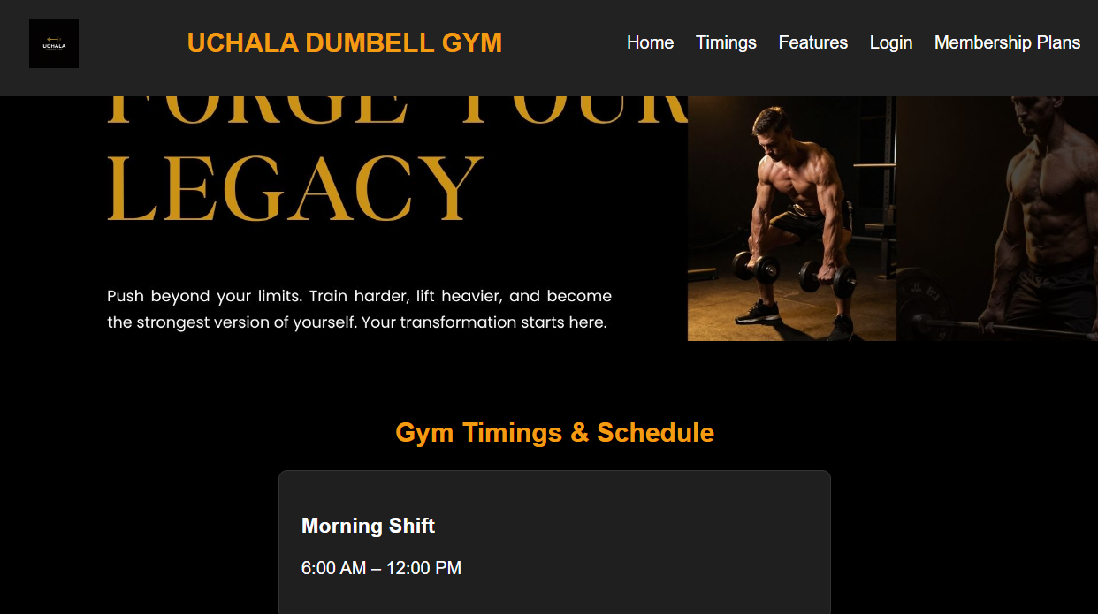

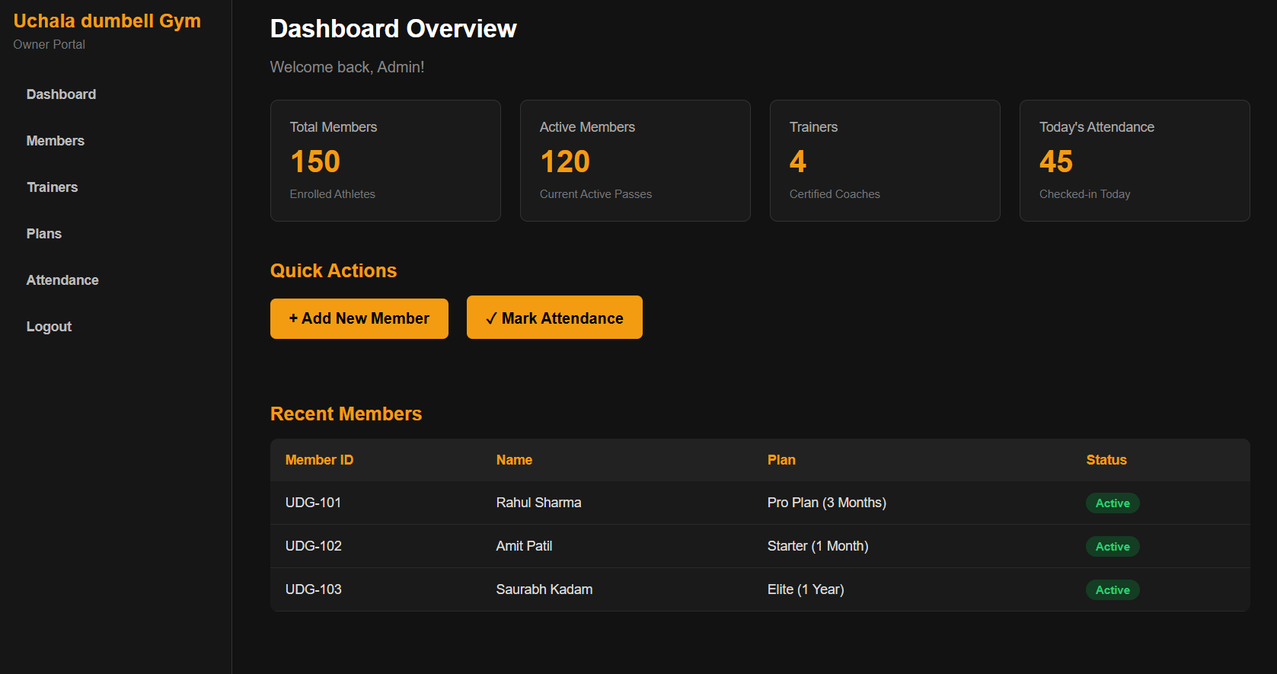

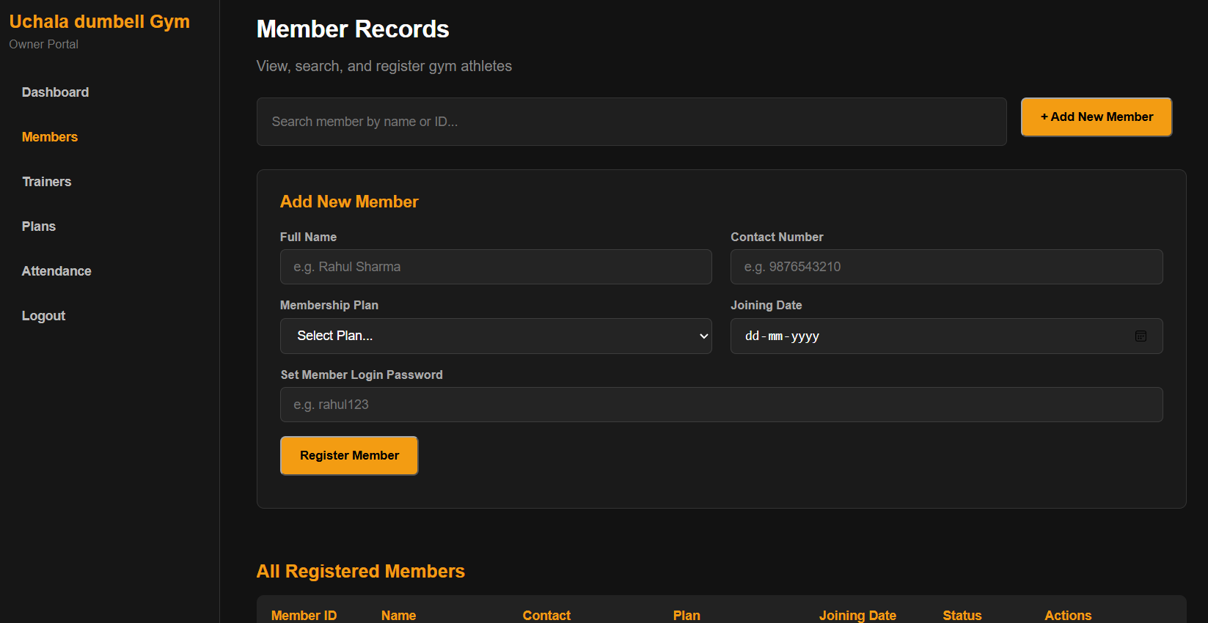
Member Management & Registration (members.html)
Description: Displays new athlete registration form, auto UDG-ID generator, dynamic search bar, and active member directory table.
(Paste actual application screenshot here)

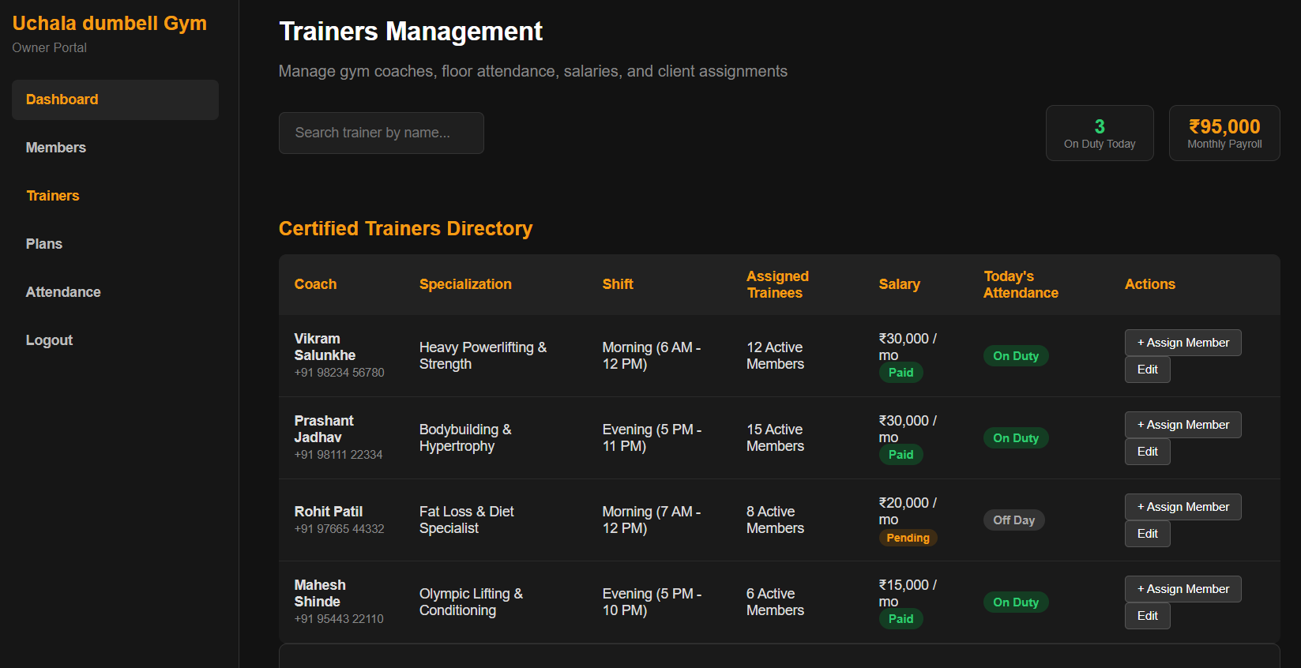
Trainer Management & Payroll Roster (trainers.html)
Description: Displays trainer onboarding modal, salary specification fields, shift allocations, and active coach table.
(Paste actual application screenshot here)

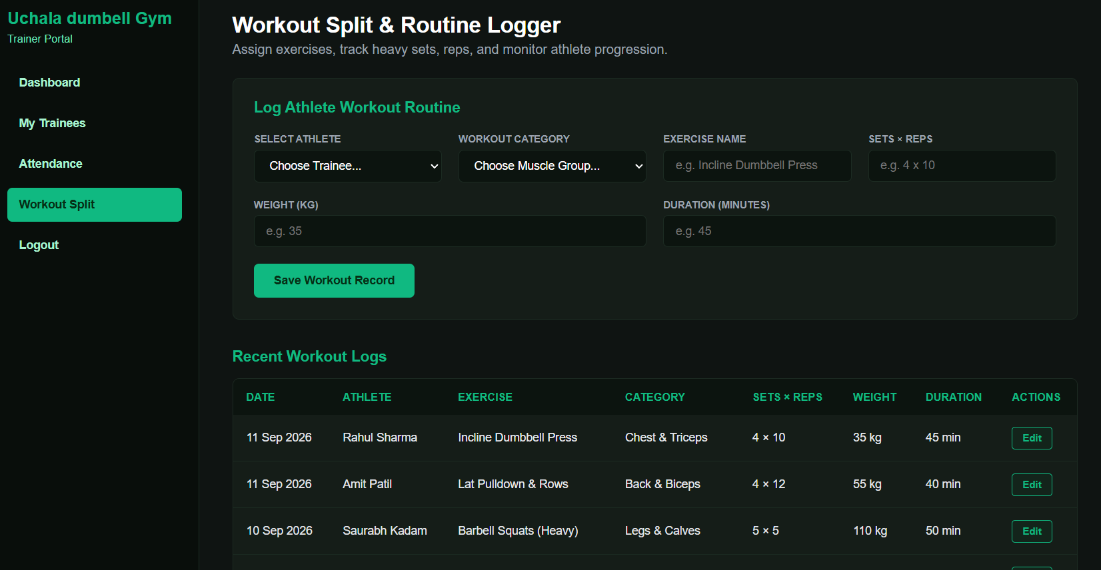Trainer Workout Logging Portal (trainer-workouts.html)
Description: Displays athlete routine builder, sets/reps logger, dumbbell load tracking, and daily workout stream.
(Paste actual application screenshot here)

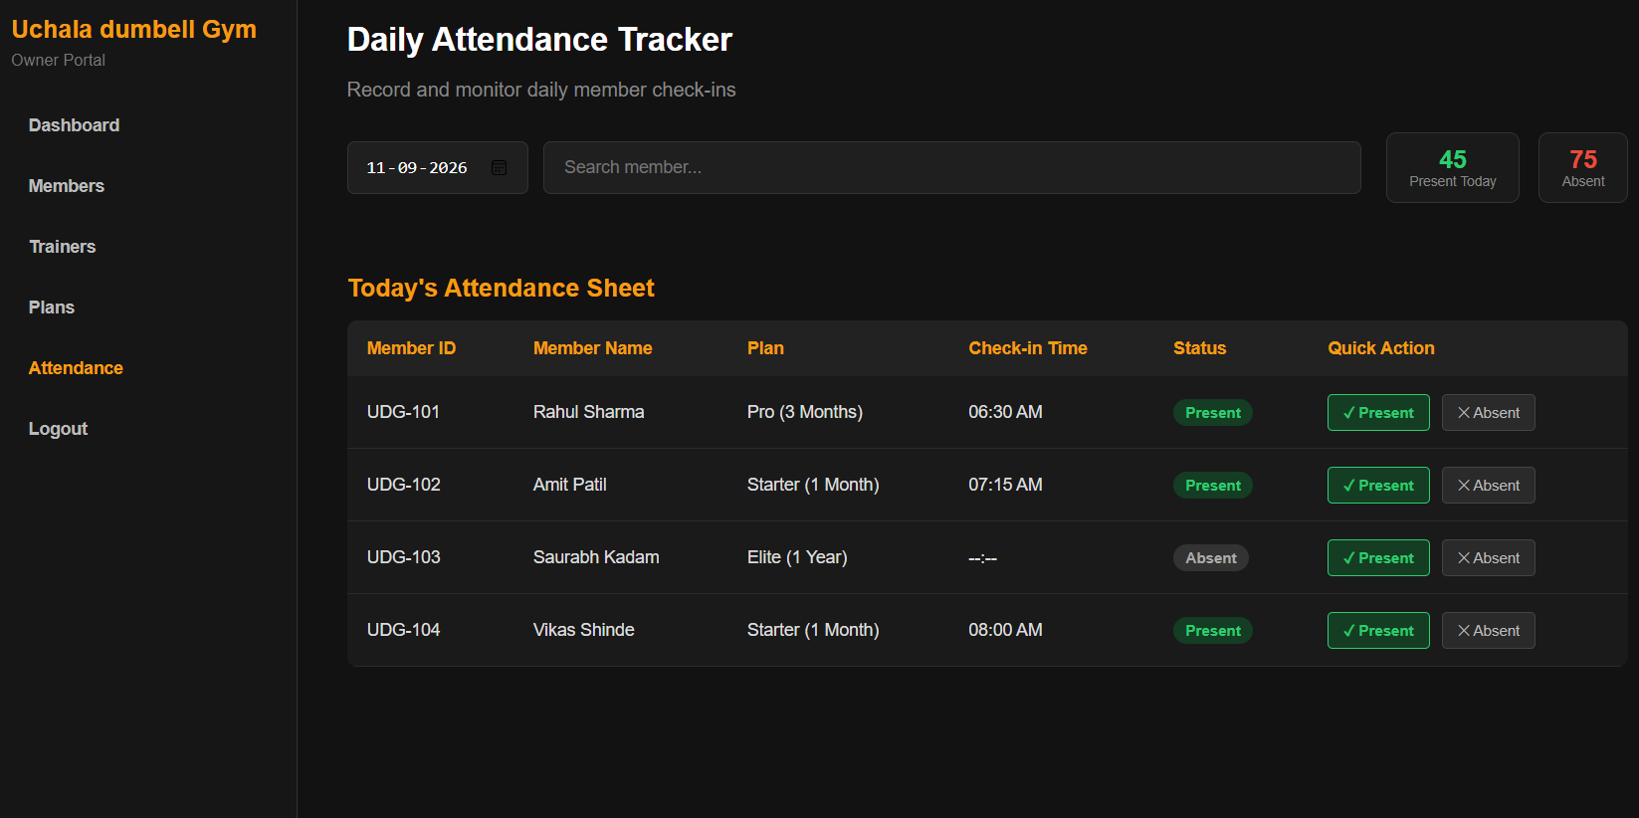
Daily Floor Attendance Register (attendance.html)
Description: Displays live date picker, check-in timestamp recorder, Present/Absent indicators, and daily attendance summary.
(Paste actual application screenshot here)

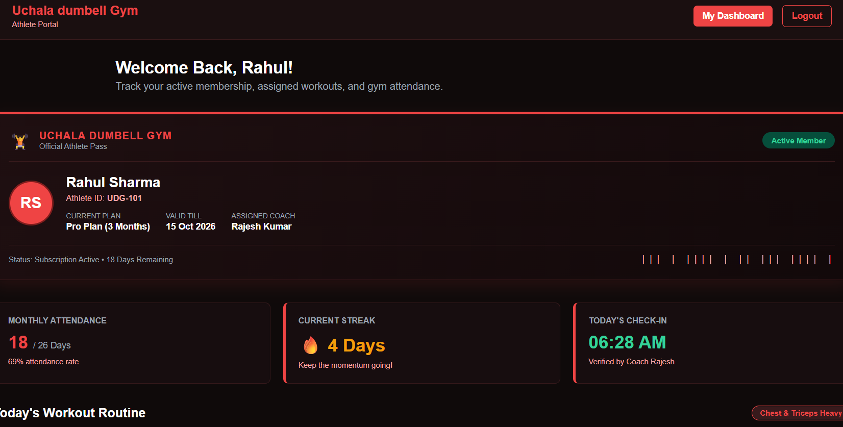
Member Personal Dashboard (member-dashboard.html)
Description: Displays athlete profile, subscription expiry badge, workout split card, and personal attendance history.
(Paste actual application screenshot here)

➡️ RELEVANT SOURCE CODE
Key implementation source code files establishing backend REST APIs, Mongoose data schemas, and client-side controller logic:

1. Backend Server Setup (server.js)
// server.js - Node.js / Express Server Configuration
const express = require("express");
const mongoose = require("mongoose");
const cors = require("cors");
const dotenv = require("dotenv");
const path = require("path");
dotenv.config();
const app = express();
app.use(cors());
app.use(express.json());
app.use(express.urlencoded({ extended: true }));
app.use(express.static(path.join(__dirname)));
// Connect to MongoDB Atlas
mongoose.connect(process.env.MONGO_URI, {
useNewUrlParser: true,
useUnifiedTopology: true
}).then(() => console.log("MongoDB Atlas Connected Successfully"))
.catch(err => console.error("MongoDB Connection Error:", err));
// API Routes
app.use("/api/auth", require("./routes/authRoutes"));
app.use("/api/members", require("./routes/memberRoutes"));
app.use("/api/trainers", require("./routes/trainerRoutes"));
app.use("/api/attendance", require("./routes/attendanceRoutes"));
app.use("/api/workouts", require("./routes/workoutRoutes"));
const PORT = process.env.PORT || 5000;
app.listen(PORT, () => console.log(`Server running on port ${PORT}`));

2. Member Schema Model (models/member.js)
// models/member.js - Mongoose Member Schema
const mongoose = require("mongoose");
const memberSchema = new mongoose.Schema({
memberId: { type: String, required: true, unique: true },
name: { type: String, required: true },
phone: { type: String, required: true },
plan: { type: String, required: true },
password: { type: String, required: true },
joinDate: { type: String, default: () => new Date().toISOString().split("T")[0] },
status: { type: String, default: "Active" }
}, { timestamps: true });
module.exports = mongoose.model("Member", memberSchema);

3. Member REST API Routes (routes/memberRoutes.js)
// routes/memberRoutes.js - Member Enrollment and Auto-ID Generator
const express = require("express");
const router = express.Router();
const Member = require("../models/member");
// GET all members
router.get("/", async (req, res) => {
try {
const members = await Member.find().sort({ createdAt: -1 });
res.json({ success: true, data: members });
} catch (err) {
res.status(500).json({ success: false, message: err.message });
}
});
// POST enroll new member
router.post("/", async (req, res) => {
try {
const { name, phone, plan, joinDate, password } = req.body;
const count = await Member.countDocuments();
const memberId = `UDG-${101 + count}`;
const newMember = new Member({
memberId,
name,
phone,
plan,
password: password || "123456",
joinDate: joinDate || new Date().toISOString().split("T")[0],
status: "Active"
});
const savedMember = await newMember.save();
res.status(201).json({ success: true, data: savedMember });
} catch (err) {
res.status(400).json({ success: false, message: err.message });
}
});
// DELETE member by ID
router.delete("/:id", async (req, res) => {
try {
const deleted = await Member.findByIdAndDelete(req.params.id);
if (!deleted) return res.status(404).json({ success: false, message: "Member not found" });
res.json({ success: true, message: "Member deleted successfully" });
} catch (err) {
res.status(500).json({ success: false, message: err.message });
}
});
module.exports = router;

4. Attendance Logic Routes (routes/attendanceRoutes.js)
// routes/attendanceRoutes.js - Daily Floor Check-in Handler
const express = require("express");
const router = express.Router();
const Attendance = require("../models/Attendance");
router.post("/", async (req, res) => {
try {
const { memberId, memberName, status, time } = req.body;
const today = new Date().toISOString().split("T")[0];
let record = await Attendance.findOne({ memberId, date: today });
if (record) {
record.status = status;
record.time = time || record.time;
await record.save();
} else {
record = new Attendance({
memberId,
memberName,
date: today,
time: time || "--:--",
status: status || "Present"
});
await record.save();
}
res.json({ success: true, data: record });
} catch (err) {
res.status(400).json({ success: false, message: err.message });
}
});
module.exports = router;

➡️ SCREENSHOTS OF ACTUAL DATABASE TABLES
Representation of MongoDB Atlas live database collections and document instances. Actual cloud database GUI captures can be inserted into the designated areas below:
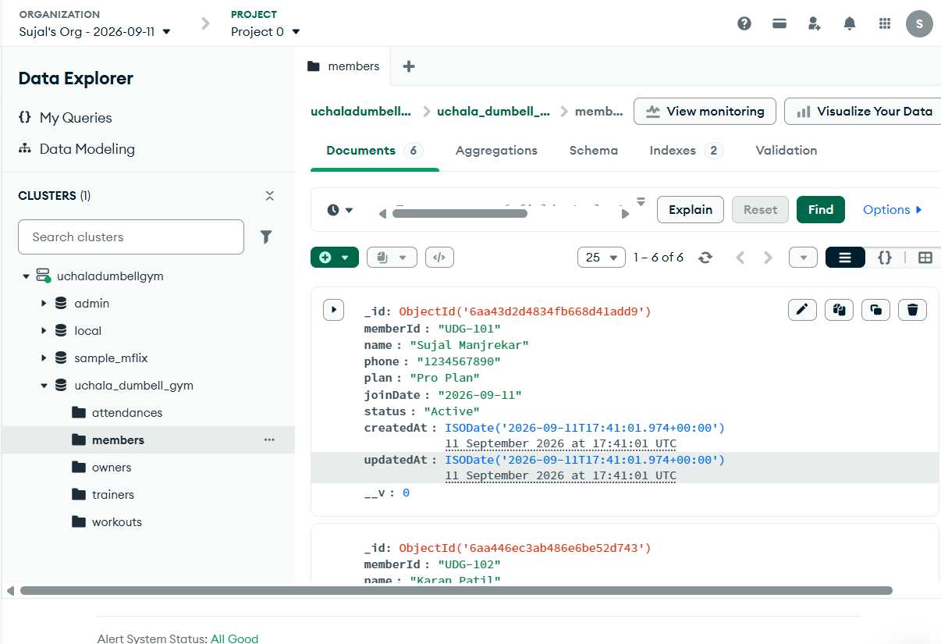
MongoDB Atlas: 'members' Collection (Database: udgym / Collection: members)
Description: Shows documents with fields: _id, memberId ('UDG-101'), name, phone, plan ('Pro Plan'), status ('Active'), createdAt.
(Paste actual application screenshot here)

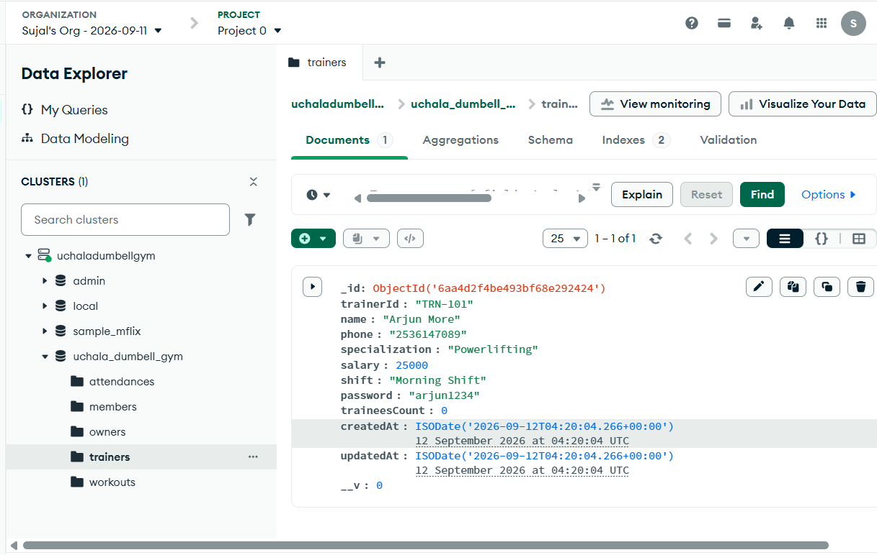
MongoDB Atlas: 'trainers' Collection (Database: udgym / Collection: trainers)
Description: Shows coach documents with fields: _id, trainerId ('TRN-101'), name, specialization, salary (25000), shift ('Morning Shift').
(Paste actual application screenshot here)

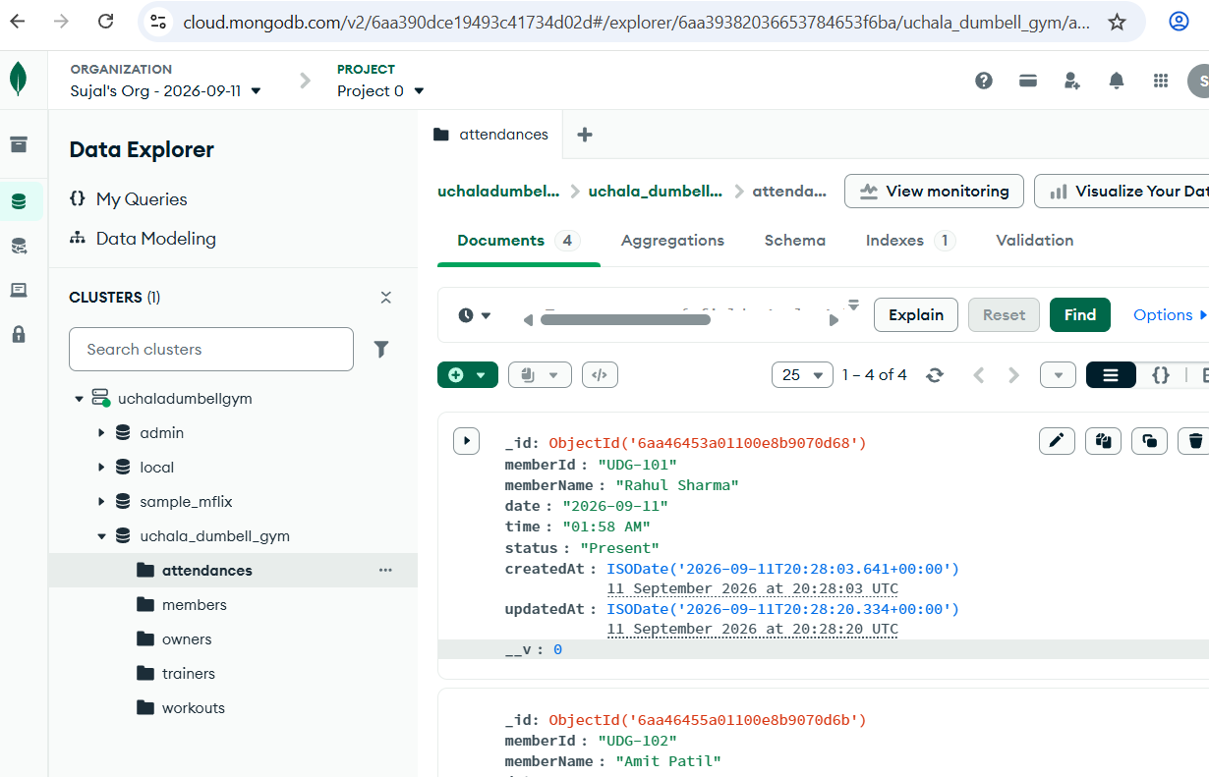MongoDB Atlas: 'attendances' Collection (Database: udgym / Collection: attendances)
Description: Shows check-in records with fields: _id, memberId ('UDG-101'), memberName, date ('2026-09-12'), time ('07:15 AM'), status ('Present').
(Paste actual application screenshot here)

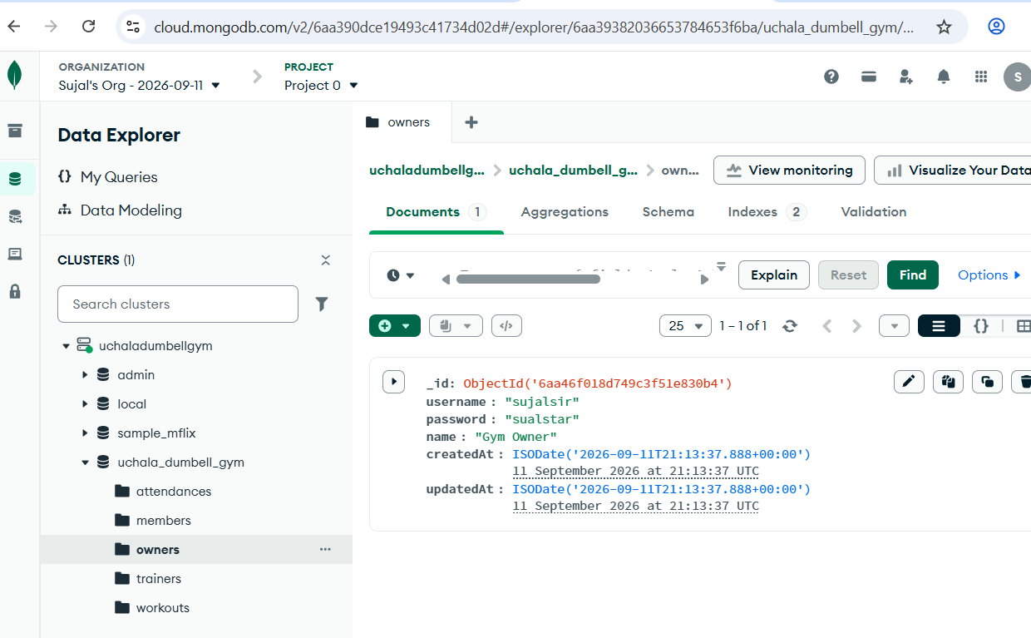
MongoDB Atlas: 'owners' Collection (Database: udgym / Collection: owners)
Description: Shows admin authentication credentials with fields: _id, username ('sujalsir'), password, name ('Gym Owner').
(Paste actual application screenshot here)

➡️ TEST CASES IN PROPER TABULAR FORMAT
Structured software test cases covering functional requirements, business validation rules, security authorization, and database persistence:
Test ID | Scenario | Test Steps | Input Data | Expected Result | Actual Result | Status
TC-01 | Admin Login | Enter valid admin credentials on owner-login.html and click Login. | User: 'sujalsir'  Pass: 'sualstar' | Successful login, HTTP 200, redirect to owner-dashboard.html. | Redirected to dashboard successfully. | PASS
TC-02 | Invalid Login | Enter incorrect password on owner-login.html and submit. | User: 'sujalsir'  Pass: 'wrongpass' | Error alert displayed: 'Invalid credentials', remain on login page. | Alert shown: 'Invalid username or password'. | PASS
TC-03 | Auto Member ID | Owner enrolls new member from members.html with valid inputs. | Name: 'Vikram Singh'  Phone: '9876543210'  Plan: 'Pro Plan' | Auto-computes memberId = 'UDG-101+N', stores record in MongoDB, HTTP 201. | Member 'UDG-104' created and displayed in directory table. | PASS
TC-04 | Empty Field Check | Submit member enrollment form with empty Name and Phone fields. | Name: ''  Phone: '' | Client-side HTML5 validation prevents submission with prompt. | Form submission blocked; tooltip displayed. | PASS
TC-05 | Mark Attendance | Trainer selects member and marks 'Present' for today's session. | memberId: 'UDG-101'  status: 'Present'  time: '07:30 AM' | Creates new attendance document with current date and time. | Attendance document persisted in MongoDB Atlas. | PASS
TC-06 | Prevent Duplicate Attendance | Mark attendance again for the same member on the same date. | memberId: 'UDG-101'  status: 'Present' | Updates existing document instead of creating duplicate entry. | Existing record updated; duplicate avoided. | PASS
TC-07 | Log Workout Routine | Trainer submits workout set for athlete on trainer-workouts.html. | Athlete: 'Rahul Sharma'  Exercise: 'Squat'  Sets: '4x10'  Weight: '80kg' | Saves workout entry to 'workouts' collection, returns HTTP 201. | Workout logged and rendered in today's exercise log. | PASS
TC-08 | Delete Member | Owner clicks delete icon next to member row in members.html. | Click Delete on memberId: 'UDG-102' | Sends DELETE request to /api/members/:id, removes document from DB. | Member deleted from DB; table refreshed dynamically. | PASS
TC-09 | Member Dashboard Access | Member logs into member-login.html with Member ID and password. | ID: 'UDG-101'  Pass: '123456' | Authenticates member and renders personal dashboard with active plan. | Dashboard loaded displaying active Pro Plan. | PASS
TC-10 | Trainer Onboarding | Owner adds new trainer on trainers.html with salary and shift. | Name: 'Karan'  Specialization: 'CrossFit'  Salary: 25000 | Auto-assigns 'TRN-101+N' ID and stores record in trainers collection. | Trainer 'TRN-102' added successfully. | PASS

