Data Collection, Cleaning and Preprocessing for Logistics Analysis
Week 2 Report: Logistics Data Analyst Internship
A step-by-step preprocessing pipeline in Python (pandas, NumPy, Matplotlib)
Submitted by: Sujal Pradeep More
Organization: YuvaIntern (Virtual Internship)
Internship Period: 25 September 2026 to 23 October 2026
GitHub: github.com/sujalmore21/logistics-data-analysis-yuvaintern

1. Introduction
In Week 1 I planned a logistics analytics project for an e-commerce distributor. This week is the step that comes right after planning, and it is probably the step that decides whether the rest of the project works: getting the data ready. A forecasting model or a routing algorithm can only be as good as the table it is given. If delivery dates are stored as text, if one warehouse is written in four different ways, or if a single weight of 574 kg sits in a column where most values are under 30, the output will still look fine on the surface and still be wrong.
This report walks through a complete preprocessing pipeline in Python. I created a raw order file that has the kind of problems real logistics data usually has, and then cleaned it one step at a time. For every step I describe what the problem was, how I found it, what I did, and why I chose that method and not another one. All the counts and statistics in the report come from actually running the code, so they match the script that is uploaded on GitHub.

2. Data Collection (Simulation)

2.1 Reference datasets
As a reference I looked at the structure of two public datasets: the DataCo Smart Supply Chain dataset and the Olist Brazilian E-Commerce dataset, both available on Kaggle. Both have one row per order with order, shipping and delivery dates, shipping mode, region, product information, shipping cost and a delivery status. I used these columns as a guide for what a logistics order table normally contains.
The task asks to simulate the data collection, so I generated a similar table with NumPy and pandas instead of downloading one. The advantage is that I know exactly which problems were put into the file, so I can check at the end whether my cleaning really removed them. The disadvantage is that the data is artificial, so the figures in this report describe how the pipeline behaves and should not be read as the performance of a real company.

2.2 Dataset characteristics
Column | Type (intended) | Description
order_id | Integer | Unique order number (100001 onwards)
order_date, ship_date, delivery_date | Date | When the order was placed, dispatched and delivered
shipping_mode | Category | Standard Class, Second Class, First Class, Same Day
region | Category | West, North, South, East, Central
warehouse | Category | Mumbai, Delhi, Bengaluru, Kolkata
product_category | Category | Electronics, Apparel, Home & Kitchen, Grocery, Books
quantity | Integer | Number of units in the order (1 to 8)
weight_kg | Float | Shipment weight in kilograms
distance_km | Float | Distance from warehouse to customer
transport_cost | Float | Shipping cost of the order in rupees
delivery_status | Category | Delivered On Time or Late Delivery

The raw file has 6,110 rows and 13 columns and covers orders from January to December 2025. Of these rows, 6,000 are unique orders and 110 are repeated copies, which I deliberately added. The first rows of the raw file are shown below. Even in these six rows you can already see problems: "standard class" in lower case, "West " with a trailing space, a missing distance, and a cost written as "Rs. 325.21".
order_id | order_date | shipping_mode | region | warehouse | weight_kg | distance_km | transport_cost
100815 | 2025-06-10 | Standard Class | West | Kolkata | 10.99 | 407.2 | 456.46
102309 | 2025-07-09 | standard class | West | Delhi | 16.44 | NaN | 517.05
103687 | 2025-02-17 | Standard Class | West | Kolkata | 1.32 | 331.9 | Rs. 325.21
103925 | 2025-11-10 | Standard Class | West | Kolkata | 17.73 | 422.5 | 523.53
105334 | 2025-08-06 | Standard Class | South | Bengaluru | 18.05 | 646.6 | 707.66
103952 | 2025-06-12 | Standard Class | North | Delhi | 18.68 | 385.0 | 466.85
Table 1: First six rows of the raw file

3. Initial Data Audit
Before changing anything I audited the file. The idea is to measure the problems first, so that after cleaning I can prove that each one is gone. I used four basic checks: shape, data types, missing values and duplicates.
df = pd.read_csv("raw_logistics_orders.csv")
print(df.shape)
print(df.dtypes)
print(df.isna().sum())
print("Duplicate rows:", df.duplicated().sum())
(6110, 13)
order_id int64
order_date str
ship_date str
delivery_date str
shipping_mode str
region str
warehouse str
product_category str
quantity float64
weight_kg float64
distance_km float64
transport_cost str
delivery_status str

delivery_date 164
region 85
product_category 118
quantity 189
weight_kg 366
distance_km 235
transport_cost 119
Duplicate rows: 110

The data types already tell a story. The three date columns and transport_cost are stored as text, although they should be dates and numbers. The audit found seven kinds of problems, which are summarised below.
Problem | Where | How it was detected | Size
Duplicate orders | All columns | df.duplicated() | 110 rows (1.8%)
Dates stored as text, two formats | order, ship, delivery date | dtype is text; str.contains("/") | 449 / 462 / 471 values in dd/mm/yyyy
Cost stored as text with "Rs." and commas | transport_cost | dtype is text | 724 rows
Inconsistent labels | shipping_mode, region, warehouse, delivery_status | nunique() higher than expected | 20, 25, 20, 10 variants instead of 4, 5, 4, 2
Missing values | 7 columns | isna().sum() | Figure 1
Impossible values | quantity, distance, dates | Boolean filters | 25 negative quantities, 18 zero distances, 15 delivery dates before order or ship date
Outliers | weight_kg, transport_cost | IQR rule, z-score, boxplot | Max weight 574.3 kg, max cost 8,553.61
Table 2: Data quality issues found in the raw file
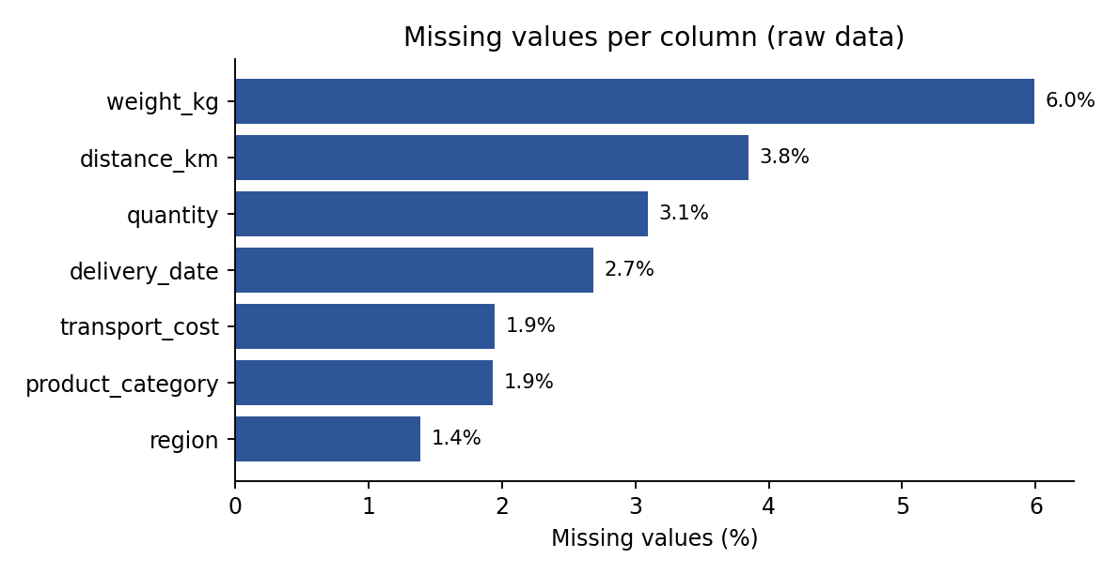
Figure 1: Percentage of missing values per column in the raw data

4. Data Cleaning and Preprocessing
The order of the steps matters. I first remove duplicates and fix data types, because a wrong data type hides other problems (for example, you cannot find outliers in a cost column that is still text). Then I fix labels and impossible values, then handle missing values, then outliers, and only at the end I scale and encode the data.

4.1 Removing duplicate records
I checked full-row duplicates and also duplicates on order_id alone. Both gave 110, which means the extra rows are exact copies and not different orders that share an id. I kept the first occurrence of each. If these rows were left in, the order count would be 1.8% too high, and every total (cost, volume, number of late deliveries) would be inflated for the same reason.
before = len(df)
df = df.drop_duplicates().drop_duplicates(subset="order_id")
print("Removed:", before - len(df))
Removed: 110

4.2 Fixing data types
Dates. The date columns contain two formats mixed together: yyyy-mm-dd and dd/mm/yyyy. A value like 05/03/2025 can be read as 3 May or 5 March, so I did not let pandas guess. I parsed each format with an explicit format string and combined the results. errors="coerce" turns anything that does not fit into NaT, so I can count the failures instead of the code crashing.
def parse_dates(s):
a = pd.to_datetime(s, format="%Y-%m-%d", errors="coerce")
b = pd.to_datetime(s, format="%d/%m/%Y", errors="coerce")
return a.fillna(b)

for c in ["order_date", "ship_date", "delivery_date"]:
df[c] = parse_dates(df[c])
After parsing, order_date and ship_date have no NaT values and delivery_date has 161, which are exactly the originally missing delivery dates (after duplicates were removed). So no valid date was lost in the conversion.
Transport cost. 724 cost values were written like "Rs. 1,234.50". Calling pd.to_numeric directly would turn all of them into NaN, which is about 12.1% of the data. I removed the "Rs." and the commas first and then converted.
df["transport_cost"] = pd.to_numeric(
df["transport_cost"].astype(str)
.str.replace("Rs.", "", regex=False)
.str.replace(",", "", regex=False)
.str.strip(),
errors="coerce")
A small mistake of mine is worth mentioning here. My first version used a regular expression that kept only digits and dots. It left the dot from "Rs." in front of the number, so every text value became NaN. I noticed only because the missing count of transport_cost jumped from 119 to more than 700. After that I made it a rule to compare missing counts before and after every conversion step.

4.3 Standardising categorical labels
Labels such as "West", "west", "WEST" and " West" are the same region, but Python treats them as four different values. A groupby on region would split one region into several groups and every regional total would be wrong. I removed leading and trailing spaces and converted everything to title case.
for c in ["shipping_mode", "region", "warehouse", "delivery_status"]:
df[c] = df[c].str.strip().str.title()
Column | Unique values before | Unique values after
shipping_mode | 20 | 4
region | 25 | 5
warehouse | 20 | 4
delivery_status | 10 | 2
Table 3: Number of distinct labels before and after standardisation

4.4 Handling impossible values
Some values are not just unusual, they cannot be true: a negative quantity (25 rows), a distance of 0 km (18 rows), and a delivery date that is earlier than the order date or the ship date (15 rows). I did not delete these rows, because the other columns in the row are still valid. I replaced the wrong value with NaN so that it is handled together with the other missing values in the next step.
df.loc[df["quantity"] < 0, "quantity"] = np.nan
df.loc[df["distance_km"] == 0, "distance_km"] = np.nan

bad = (df["delivery_date"] < df["order_date"]) | \
(df["delivery_date"] < df["ship_date"])
df.loc[bad, "delivery_date"] = pd.NaT

4.5 Handling missing values
About 19% of the unique rows have at least one missing value in the columns listed below. Dropping all of them would throw away about one row in five, and most of those rows are still mostly good (a row with a missing weight still has a valid date, cost and region). So I imputed instead, and I chose the method for each column separately.
Column | To fill | Method | Why this method
weight_kg | 358 | Median of the product category | Weight is right-skewed, so the median is safer than the mean; weight depends on the type of product
distance_km | 249 | Median of the warehouse | Distance depends on where the order ships from
transport_cost | 117 | Median of the shipping mode | Cost per order is mainly driven by the shipping mode
quantity | 210 | Overall median | Small integer range (1 to 8), no strong group effect
region | 83 | Most frequent value (mode) | Categorical, so a median is not possible
product_category | 117 | Most frequent value (mode) | Categorical, so a median is not possible
delivery_date | 176 | Ship date + typical transit days of that shipping mode | Keeps the date logically after the ship date
Table 4: Imputation strategy for each column (counts include the impossible values from 4.4)
df["weight_missing_flag"] = df["weight_kg"].isna().astype(int)
df["delivery_date_imputed"] = df["delivery_date"].isna().astype(int)

df["weight_kg"] = df["weight_kg"].fillna(
df.groupby("product_category")["weight_kg"].transform("median"))
df["distance_km"] = df["distance_km"].fillna(
df.groupby("warehouse")["distance_km"].transform("median"))
df["transport_cost"] = df["transport_cost"].fillna(
df.groupby("shipping_mode")["transport_cost"].transform("median"))
df["quantity"] = df["quantity"].fillna(df["quantity"].median())
df["region"] = df["region"].fillna(df["region"].mode()[0])

transit = (df["delivery_date"] - df["ship_date"]).dt.days
med = transit.groupby(df["shipping_mode"]).transform("median")
df["delivery_date"] = df["delivery_date"].fillna(
df["ship_date"] + pd.to_timedelta(med, unit="D"))
Two flag columns (weight_missing_flag and delivery_date_imputed) record which values were filled in. Imputed numbers are estimates, so keeping a flag lets me later check whether a result depends on them. After this step the total number of missing values in the core columns is 0.

4.6 Detecting and treating outliers
I used two detection methods. The IQR rule marks values below Q1 minus 1.5 times IQR or above Q3 plus 1.5 times IQR. The z-score marks values more than 3 standard deviations from the mean. The IQR rule is better here because weight and cost are skewed, and the mean and standard deviation (used by z-score) are themselves pulled by the very outliers we want to find.
Column | IQR lower | IQR upper | Flagged by 1.5 x IQR | Extreme (3 x IQR) | Max before / after
weight_kg | -8.12 | 27.21 | 288 | 68 | 574.3 / 40.46
transport_cost | -46.97 | 960.58 | 283 | 76 | 8,553.61 / 1,338.4
distance_km | -52.31 | 692.19 | 129 | not treated | 1,002.8 / unchanged
Table 5: Outlier detection results (z-score > 3 flagged 30 weight values)
The important point is that "flagged" does not mean "wrong". The 1.5 x IQR rule flagged 288 weights and 283 costs, but these columns are naturally right-skewed, so a heavy parcel or a long expensive route is normal. If I deleted everything flagged I would remove real orders and make the data look cleaner than the business really is. So I made three decisions:
- Weight and cost: only the extreme values (beyond 3 x IQR) were capped at the fence value, which is 40.46 kg and 1,338.4 for cost. This affected 68 and 76 rows. Capping (winsorising) keeps the order in the data but limits its influence.
- Distance: 129 values were flagged, but the largest is 1,002.8 km, which is a believable long-haul route, so I left distance unchanged.
- Not deleted: no rows were removed for being outliers.
def iqr_bounds(s, k=1.5):
q1, q3 = s.quantile([0.25, 0.75])
iqr = q3 - q1
return q1 - k * iqr, q3 + k * iqr

for c in ["weight_kg", "transport_cost"]:
lo, hi = iqr_bounds(df[c], k=3.0) # extreme outliers only
df[c] = df[c].clip(lo, hi)
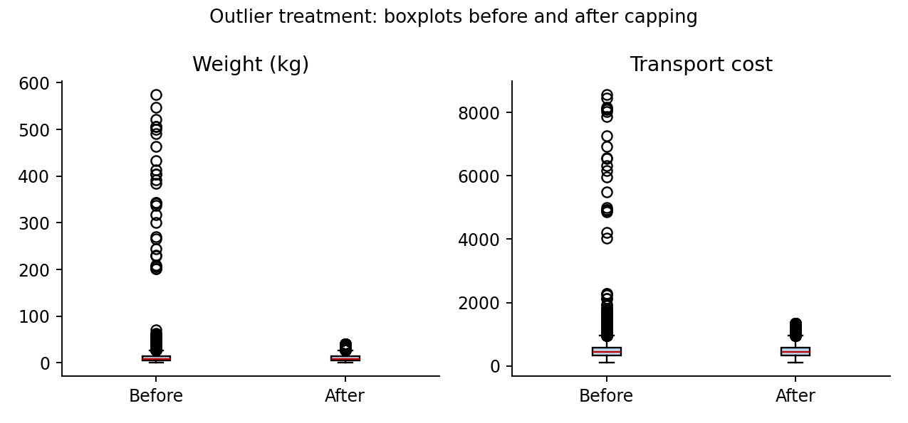
Figure 2: Weight and transport cost before and after capping extreme outliers
The effect on the statistics is large. The mean weight dropped from 12.56 to 10.7 kg and its standard deviation from 27.71 to 7.87. For cost, the mean went from 509 to 487.58 and the standard deviation from 438.92 to 229.28. About 30 wrong weight entries and 22 wrong cost entries were enough to do this. One limit of capping must be admitted: a weight of 574 kg that becomes 40.46 kg is still not the true weight. In a real project I would trace these values back to the source system.

4.7 Creating derived features
With clean dates and numbers I created a few columns that logistics analysis uses directly: transit_days (ship to delivery), total_lead_days (order to delivery), cost_per_km, order_month, and is_late (1 if the delivery status is Late Delivery). These columns also helped me validate the data, because a negative lead time immediately shows a date problem.
df["transit_days"] = (df["delivery_date"] - df["ship_date"]).dt.days
df["total_lead_days"] = (df["delivery_date"] - df["order_date"]).dt.days
df["cost_per_km"] = (df["transport_cost"] / df["distance_km"]).round(3)
df["order_month"] = df["order_date"].dt.month
df["is_late"] = (df["delivery_status"] == "Late Delivery").astype(int)

4.8 Normalisation and scaling
The numeric columns are on very different scales: distance goes up to about 1,000 while quantity only goes from 1 to 8. Distance-based methods (K-Means, KNN) and models with regularisation would let the large-scale column dominate. Tree-based models do not care about scale, but I still scaled the data because later weeks may use both kinds of model. I applied two common methods:
- Min-Max scaling: (x - min) / (max - min), which puts values between 0 and 1. Good when I need a fixed range.
- Z-score standardisation: (x - mean) / std, which gives mean 0 and standard deviation 1. Better when the data has no hard limits.
num = ["weight_kg", "distance_km", "transport_cost", "quantity"]
for c in num:
df[c + "_minmax"] = (df[c] - df[c].min()) / (df[c].max() - df[c].min())
df[c + "_z"] = (df[c] - df[c].mean()) / df[c].std()
Feature | Original range | After Min-Max | After Z-score (mean, std)
weight_kg | 0.12 to 40.46 | 0 to 1 | 0, 1
distance_km | 42.5 to 1,002.8 | 0 to 1 | 0, 1
transport_cost | 102.62 to 1,338.4 | 0 to 1 | 0, 1
quantity | 1 to 8 | 0 to 1 | 0, 1
Table 6: Scale of the numeric features before and after scaling
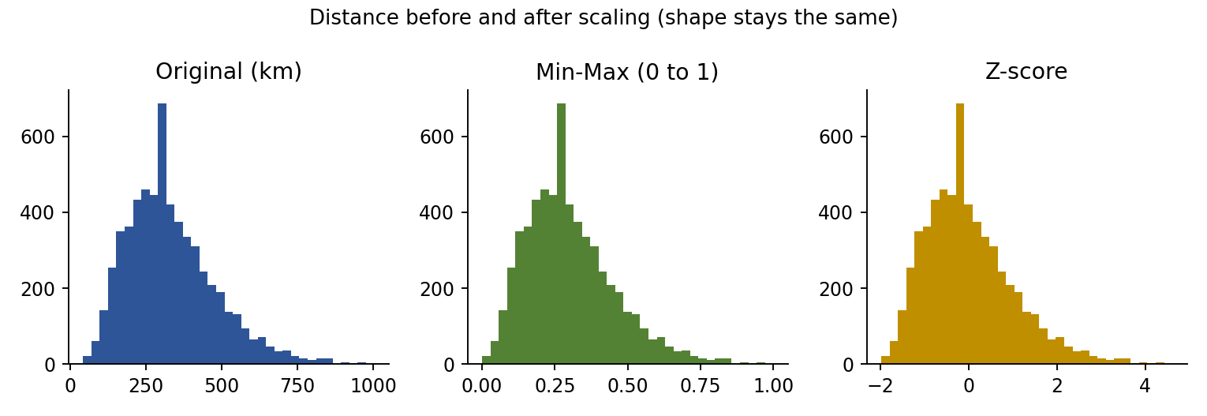
Figure 3: The shape of the distance distribution does not change, only the scale
The order of operations is important here. I scaled after capping the outliers. If I had scaled first, the 574 kg weight would have become 1.0 and almost every normal order would be squeezed into a tiny range near zero. Also, in a real modelling project the scaler should be fitted on the training data only and then applied to the test data, to avoid data leakage. Here I scaled the whole table because the aim is to show the technique.

4.9 Encoding categorical variables
Most machine learning models need numbers. For the four categorical columns I used one-hot encoding with drop_first=True. I did not use label encoding (0, 1, 2...) because that would tell the model that, for example, Mumbai is "less than" Kolkata, which has no meaning. Dropping the first category avoids duplicate information between the dummy columns. This created 14 new columns, and the final table has 6,000 rows and 42 columns.
enc = pd.get_dummies(
df[["shipping_mode", "region", "warehouse", "product_category"]],
drop_first=True, dtype=int)
final = pd.concat([df, enc], axis=1)

5. Validation of the Cleaned Data
Cleaning is not finished until it is verified. I wrote simple assertions that check each problem from Table 2 and confirm it is gone.
Check | Result
No duplicate order_id | PASS
No missing values in core columns | PASS
All quantities positive | PASS
All distances positive | PASS
Delivery date never before order date | PASS
Date columns are datetime64 | PASS
Table 7: Validation checks on the final dataset
A first look at the cleaned file shows the same six rows as in Table 1, now with consistent labels, a filled distance and a numeric cost:
order_id | order_date | shipping_mode | region | warehouse | weight_kg | distance_km | transport_cost
100815 | 2025-06-10 | Standard Class | West | Kolkata | 10.99 | 407.2 | 456.46
102309 | 2025-07-09 | Standard Class | West | Delhi | 16.44 | 309.5 | 517.05
103687 | 2025-02-17 | Standard Class | West | Kolkata | 1.32 | 331.9 | 325.21
103925 | 2025-11-10 | Standard Class | West | Kolkata | 17.73 | 422.5 | 523.53
105334 | 2025-08-06 | Standard Class | South | Bengaluru | 18.05 | 646.6 | 707.66
103952 | 2025-06-12 | Standard Class | North | Delhi | 18.68 | 385.0 | 466.85
Table 8: First six rows of the cleaned file

6. Impact on Analysis
To see why this work matters, I compared simple summary numbers computed from the raw file and from the cleaned file. Using the raw data, the average weight would be overstated by 17.4% and the average transport cost by 4.4%. A planner using the raw average to budget shipping would plan for a cost per order that is not real, and for a weight that no typical order has.
Metric | Raw mean | Clean mean | Raw std | Clean std
Weight (kg) | 12.56 | 10.7 | 27.71 | 7.87
Transport cost | 509 | 487.58 | 438.92 | 229.28
Table 9: Summary statistics before and after cleaning
Now that the dates are correct, I can also compute logistics measures that were not reliable before. The average order-to-delivery time is 1.16 days for Same Day, 4.2 for First Class, 5.14 for Second Class and 6.18 for Standard Class, and 23.4% of the orders were late. In the raw file the wrong delivery dates would have produced negative lead times, and the text dates could not have been subtracted at all.

7. Reflection: Data Quality and Decision-Making in Logistics
Doing this exercise changed how I think about data preparation. Most of the problems were small and boring (a space, a comma, a format), but each of them had a concrete effect on a number that a logistics manager would use.
- Duplicates inflate volume. 1.8% extra rows is small, but it makes demand look higher and every cost total larger, which leads to over-ordering of stock.
- Inconsistent labels break grouping. A regional performance report built on the raw labels would show several "regions" that are really one, and the per-region on-time delivery rate would be wrong for each of them.
- Wrong dates break the KPIs. On-time delivery rate and average lead time, two of the KPIs from my Week 1 plan, depend completely on correct order, ship and delivery dates. A single delivery date before the order date gives a negative lead time and pulls the average down.
- Outliers distort averages. Roughly 50 wrong entries changed the mean weight by 17.4% and the cost by 4.4%. Forecasting, pricing and vehicle load planning all start from such averages.
- Missing data forces a choice. Every imputation is an assumption. Using the median of a group is reasonable, but it is still a guess, which is why I kept flag columns.
In short, models and dashboards do not fix bad data, they just present it more convincingly. In logistics, where decisions about routes, stock and delivery promises are made from these numbers every day, the cost of skipping this step is paid later, in late deliveries and wasted transport spend.

7.1 Limitations
- The dataset is simulated, so the type and size of the errors are known in advance. Real data has errors that are harder to spot.
- Weight was imputed by product category only, although in this data it also depends on quantity. A regression-based imputation could be more accurate.
- Median imputation slightly reduces the variance of a column. This is acceptable here because only 2 to 6 percent of values were affected.
- Capped outliers were not verified against a source system.

8. Conclusion
I built a preprocessing pipeline that takes a raw logistics order file with 6,110 rows and seven kinds of data quality problems and turns it into a validated dataset of 6,000 orders and 42 columns. The steps were: remove duplicates, fix data types, standardise labels, replace impossible values, impute missing values, treat extreme outliers, create derived features, scale the numeric columns and encode the categories. Each step was chosen for a reason and checked with a before-and-after comparison, and the final data passes all validation checks.
The cleaned file is the input for Week 3, where I will do exploratory analysis and visualisation to look for cost drivers and bottlenecks, and then for the predictive modelling in Week 4. The full script, the raw file and the cleaned file are uploaded in the GitHub repository mentioned on the first page.

9. References
- DataCo Smart Supply Chain for Big Data Analysis, Kaggle (used as structural reference).
- Olist Brazilian E-Commerce Public Dataset, Kaggle (used as structural reference).
- pandas documentation: missing data, to_datetime, to_numeric, get_dummies.
- scikit-learn documentation: preprocessing and scaling of data.
- McKinney, W. Python for Data Analysis, O'Reilly Media.

