Advanced Data Analysis and Visualization in Logistics
Week 3 Report: Logistics Data Analyst Internship
Exploratory analysis of cost drivers, delivery performance and bottlenecks (Python: pandas, seaborn, matplotlib, SciPy)
Submitted by: Sujal Pradeep More
Organization: YuvaIntern (Virtual Internship)
Internship Period: 25 September 2026 to 23 October 2026
GitHub: github.com/sujalmore21/logistics-data-analysis-yuvaintern

1. Introduction
In Week 1 I planned the project and chose the KPIs, and in Week 2 I cleaned the raw order data. This week I use the cleaned data to actually look for answers. The questions I started with were simple and are the kind a logistics manager would ask: what makes an order expensive, why are some deliveries late, and is the problem in a particular place (a warehouse or a region) or in the process itself?
To answer them I did an exploratory data analysis (EDA) in Python. That means calculating central tendencies and spread, looking at distributions, comparing groups, measuring correlations, and testing whether the differences I see are real or just noise. I made ten charts. For each chart I explain why I picked that chart type, what it shows, and what I conclude from it. The report ends with the main insights and recommendations. All numbers come from running the script that is uploaded on GitHub.

2. Dataset Definition
The dataset is the hypothetical logistics order table of an e-commerce distributor, the same one I prepared in Week 2: 6,000 unique orders placed between 2025-01-01 and 2025-12-31, shipped from four warehouses to five regions. It is simulated data, so it shows how the analysis works, not the real performance of a company. The key variables are listed below. The last five are derived columns that I created during cleaning or at the start of this analysis.
Variable | Type | Meaning
order_id | Integer | Unique order number
order_date, ship_date, delivery_date | Date | Order placed, dispatched from warehouse, delivered
shipping_mode | Category | Same Day, First Class, Second Class, Standard Class
warehouse, region | Category | Mumbai, Delhi, Bengaluru, Kolkata; West, North, South, East, Central
product_category | Category | Electronics, Apparel, Home & Kitchen, Grocery, Books
quantity, weight_kg | Numeric | Units in the order and shipment weight
distance_km | Numeric | Distance from warehouse to customer
transport_cost | Numeric | Shipping cost of the order (Rs.)
total_lead_days | Derived | Days from order to delivery
transit_days | Derived | Days from dispatch to delivery
ship_delay | Derived | Days from order to dispatch (warehouse handling time)
cost_per_km | Derived | transport_cost divided by distance_km
is_late | Derived | 1 if the delivery status is Late Delivery, else 0

3. Methodology
I followed the same order for every question: describe first, then compare, then measure, then test. This keeps me from jumping to a conclusion from one chart.
- Step 1, describe: mean, median, mode, standard deviation and skewness of the main numeric variables.
- Step 2, visualise distributions: histograms and boxplots, to see shape, spread and outliers.
- Step 3, compare groups: averages and late-delivery rates by shipping mode, warehouse, region, distance band and dispatch delay.
- Step 4, measure relationships: correlation matrix, scatter plot and a multiple linear regression for cost drivers.
- Step 5, test: chi-square tests to check whether late-delivery differences between groups are statistically meaningful.
The libraries are pandas and NumPy for data handling, seaborn and matplotlib for charts, and SciPy for the statistical tests. The analysis starts like this:
import numpy as np, pandas as pd
import seaborn as sns, matplotlib.pyplot as plt
from scipy import stats

df = pd.read_csv("cleaned_logistics_orders.csv",
parse_dates=["order_date", "ship_date", "delivery_date"])
df["ship_delay"] = (df["ship_date"] - df["order_date"]).dt.days

print("Orders:", len(df))
print("Late rate (%):", round(df["is_late"].mean() * 100, 1))
print("Average cost per order:", round(df["transport_cost"].mean(), 2))
print("Total transport cost:", round(df["transport_cost"].sum()))
Orders: 6000
Late rate (%): 23.4
Average cost per order: 487.58
Total transport cost: 2925488

So the baseline is: 1,403 of 6,000 orders (23.4%) were delivered late, the average order costs Rs. 487.58 to ship, and the total transport spend is about Rs. 29,25,488. The rest of the analysis tries to explain these two numbers, cost and lateness.

4. Exploratory Data Analysis

4.1 Central tendency and spread
Variable | Mean | Median | Mode | Std dev | Min | Max | Skew
Quantity | 4.5 | 4 | 4 | 2.26 | 1 | 8 | 0.03
Weight (kg) | 10.7 | 8.72 | 8.64 | 7.87 | 0.12 | 40.46 | 1.5
Distance (km) | 331.6 | 310.4 | 313.8 | 145.49 | 42.5 | 1,002.8 | 0.88
Cost (Rs.) | 487.58 | 437.4 | 1,338.4 | 229.28 | 102.62 | 1,338.4 | 1.4
Cost per km | 1.55 | 1.39 | 1.11 | 0.62 | 0.42 | 17.59 | 5.75
Lead time (days) | 5.22 | 5 | 6 | 1.78 | 0 | 9 | -0.85
Table 1: Descriptive statistics of the main numeric variables
The most useful comparison in this table is mean against median. For transport cost the mean (487.58) is clearly higher than the median (437.4) and the skewness is 1.4, so the distribution has a long right tail: a smaller number of expensive orders pull the average up. The same pattern is visible for weight (skew 1.5) and distance (skew 0.88). For that reason I use the median when I want to describe a typical order. Quantity is almost symmetric (skew 0.03), and lead time is slightly skewed to the left: most orders take 5 to 6 days and a few are very fast (Same Day).
Two numbers in the table need a warning. The mode of transport cost (1,338.4) is not a real "most common cost". It is the value at which I capped extreme outliers in Week 2, and 76 orders were set to exactly that value. The same is true for the maximum weight of 40.46 kg. The cost per km has a maximum of 17.59 against a median of 1.39: very short routes are expensive per kilometre because a part of the cost does not depend on distance.

4.2 Distributions
fig, axes = plt.subplots(2, 2, figsize=(9, 6.2))
for ax, c in zip(axes.ravel(), ["transport_cost", "total_lead_days",
"distance_km", "weight_kg"]):
sns.histplot(df[c], bins=40, kde=True, ax=ax)
ax.axvline(df[c].mean(), color="black", ls="--") # mean
ax.axvline(df[c].median(), color="red") # median
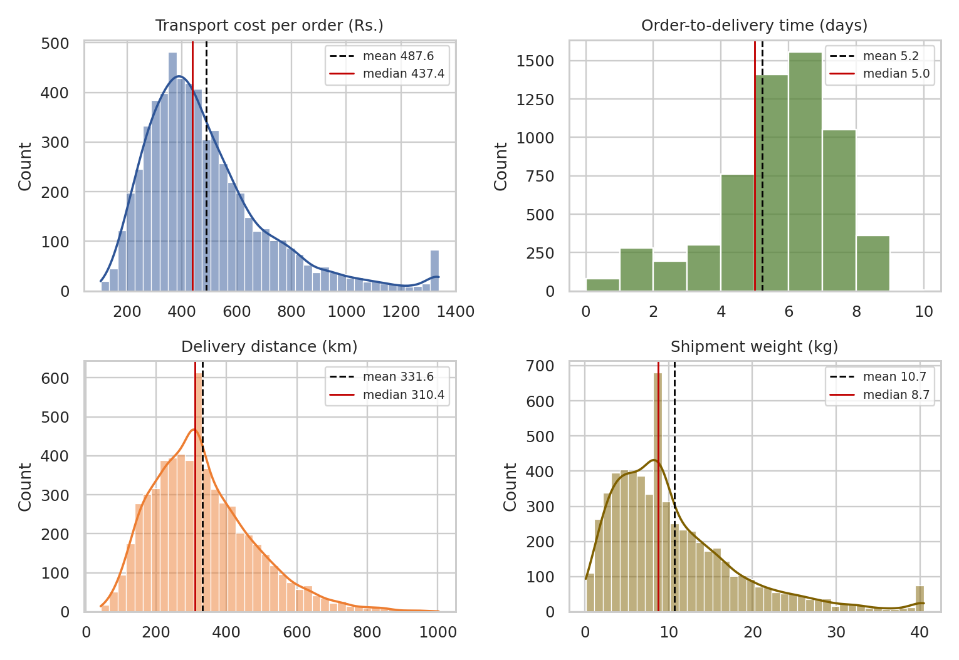
Figure 1: Distribution of transport cost, delivery time, distance and weight
Why this chart. A histogram with a density curve is the right tool for the shape of one numeric variable. A table of averages would hide the skew and the outlier spikes, and I added mean and median lines so the gap between them can be seen directly.
What it shows. Cost, weight and distance all have a long right tail, with the mean (dashed line) to the right of the median. Lead time looks different: it is built from whole days, so it appears as bars, with most orders between 4 and 7 days. The small spikes at the far right of the cost and weight charts are the capped outliers from Week 2, not real clusters of orders.

4.3 Shipping mode: cost and speed
g = df.groupby("shipping_mode").agg(
orders=("order_id", "count"),
avg_cost=("transport_cost", "mean"),
avg_lead=("total_lead_days", "mean"),
late=("is_late", "mean"))
sns.boxplot(data=df, x="shipping_mode", y="transport_cost", order=MODE_ORDER)
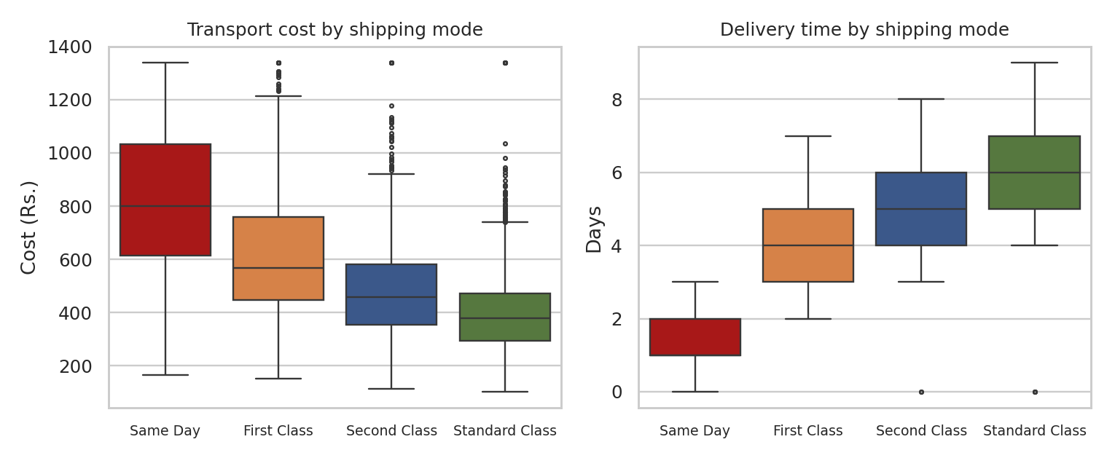
Figure 2: Transport cost and delivery time by shipping mode
Why this chart. A boxplot compares the whole distribution of a variable across groups in one picture: median, spread, and outliers. Putting cost and delivery time side by side makes the trade-off between price and speed visible at once.
Shipping mode | Orders | Share | Avg cost (Rs.) | Cost per km | Avg lead (days) | Late orders
Same Day | 505 | 8.42% | 833.39 | 2.68 | 1.16 | 30.69%
First Class | 1,010 | 16.83% | 614.95 | 1.91 | 4.2 | 40.89%
Second Class | 1,208 | 20.13% | 485.8 | 1.55 | 5.14 | 38.25%
Standard Class | 3,277 | 54.62% | 395.69 | 1.27 | 6.18 | 11.38%
Table 2: Key metrics by shipping mode
Faster modes cost more, as expected. A Same Day order costs about Rs. 833.39 on average, roughly 2.1 times a Standard Class order (Rs. 395.69). Standard Class is 54.62% of the orders and 44.3% of the total transport cost, while Same Day is 8.42% of the orders but 14.4% of the cost. The surprising number is in the last column and I come back to it in section 6: the premium modes are the ones that are late most often.

4.4 Correlation analysis
cc = ["distance_km", "weight_kg", "quantity", "transport_cost",
"cost_per_km", "total_lead_days", "transit_days"]
corr = df[cc].corr()
sns.heatmap(corr, annot=True, fmt=".2f", cmap="RdBu_r", center=0,
vmin=-1, vmax=1)
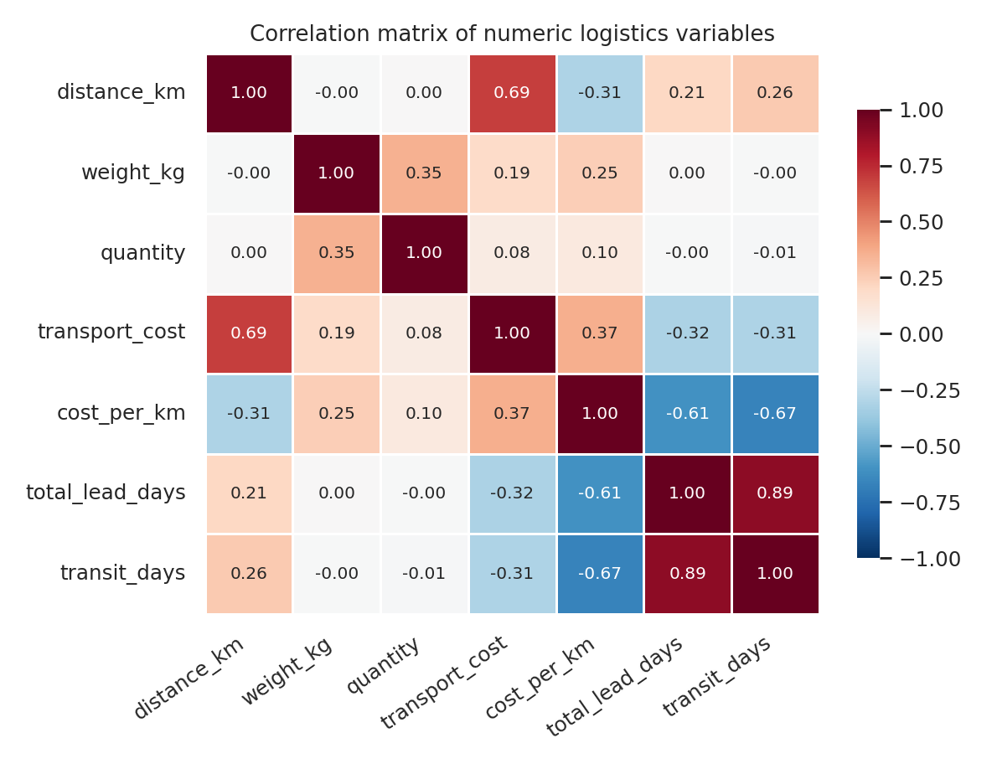
Figure 3: Correlation matrix of the numeric variables
Why this chart. With seven variables there are 21 pairs, which is too many to read from a table. A heatmap with the numbers printed inside shows strength and direction at a glance, and a diverging colour scale (red positive, blue negative) with zero at the centre makes it easy to separate the two.
What it shows. Distance has the strongest link with cost (r = 0.69). Weight (r = 0.19) and quantity (r = 0.08) are weak. Weight and quantity are related to each other (r = 0.35), which is natural, because more units weigh more. Cost has a negative correlation with lead time (r = -0.32). I do not read this as "slower delivery makes things cheaper" by itself; it comes from the shipping mode, because the fast modes are the expensive ones. Cost per km goes down as distance goes up (r = -0.31), which supports the fixed-cost explanation from section 4.1. Correlation only describes association, so I test the cost drivers properly in the next section.

5. Cost Drivers
for m in MODE_ORDER:
s = df[df["shipping_mode"] == m]
ax.scatter(s["distance_km"], s["transport_cost"], s=9, alpha=0.35, label=m)
k, b = np.polyfit(s["distance_km"], s["transport_cost"], 1) # trend line
ax.plot(xs, k * xs + b)
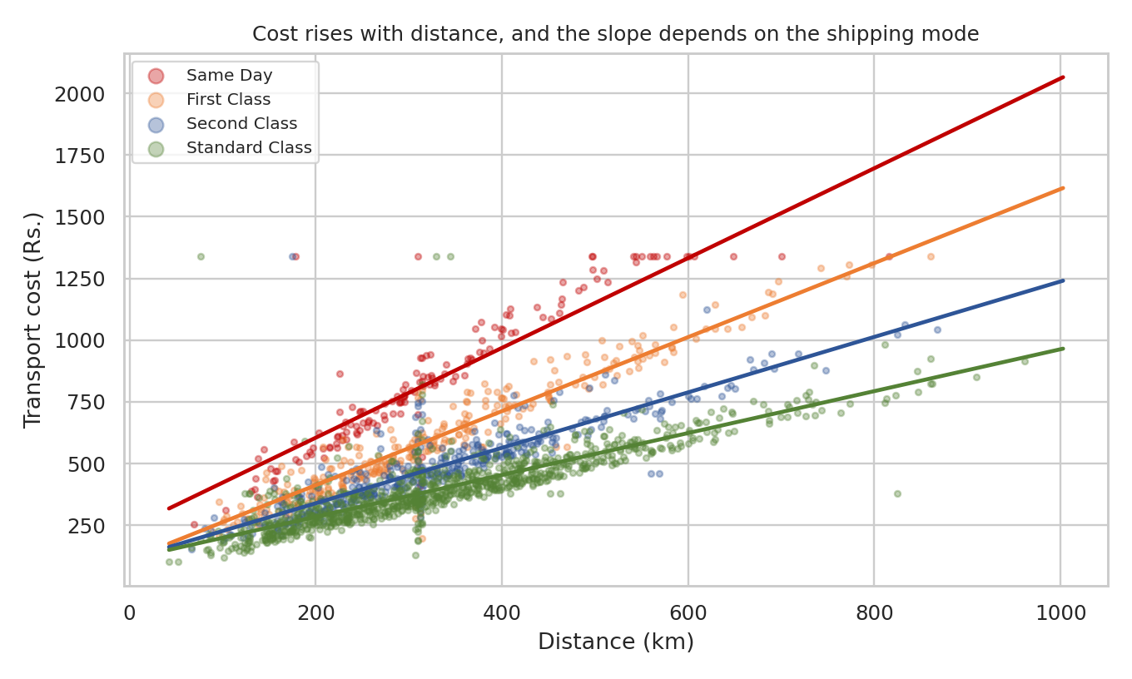
Figure 4: Transport cost against distance, one colour per shipping mode (1,800 sampled orders)
Why this chart. A scatter plot is the standard way to look at the relationship between two continuous variables. Colouring by shipping mode and adding a fitted line per mode shows whether the relationship is the same for every mode. I plotted a random sample of 1,800 orders so the points do not blot out each other, but the lines are fitted on all orders.
Cost grows in a straight line with distance, but the lines have different slopes: about Rs. 1.819 per km for Same Day, 1.499 for First Class, 1.123 for Second Class and 0.849 for Standard Class. So a long route is much more expensive when it is sent by a fast mode than when it is sent by a slow one. The flat line of points at the top of the chart is again the capped cost values.
To measure the importance of each factor at the same time, I fitted a multiple linear regression of cost on distance, weight, quantity and shipping mode. I standardised the variables first (subtract the mean, divide by the standard deviation), so the coefficients are on the same scale and can be compared directly.
X = pd.get_dummies(df[["distance_km", "weight_kg", "quantity", "shipping_mode"]],
columns=["shipping_mode"], drop_first=True, dtype=float)
y = df["transport_cost"]
Xs = (X - X.mean()) / X.std(); ys = (y - y.mean()) / y.std()

A = np.column_stack([np.ones(len(Xs)), Xs.values])
beta, *_ = np.linalg.lstsq(A, ys.values, rcond=None)
pred = A @ beta
r2 = 1 - ((ys - pred) ** 2).sum() / ((ys - ys.mean()) ** 2).sum()
print("R-squared:", round(r2, 3))
R-squared: 0.856
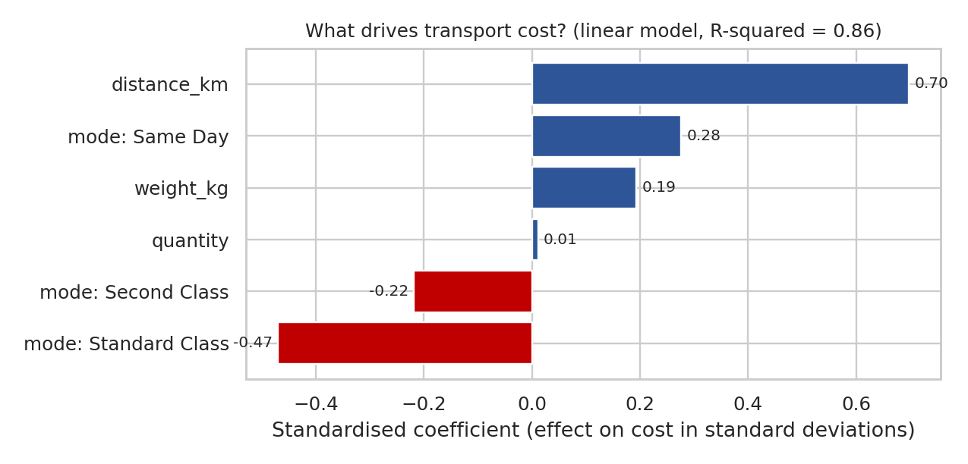
Figure 5: Relative importance of cost drivers (standardised coefficients)
Why this chart. Horizontal bars sorted by size make it easy to rank the drivers, and the colour shows whether a factor raises (blue) or lowers (red) the cost. The reference category for shipping mode is First Class.
The model explains 86% of the variation in cost, so these four factors are most of the story. Distance is the strongest driver (0.698), followed by the shipping mode. Weight has a smaller effect (0.194) and quantity almost none (0.012) once the other factors are included. In rupees, and holding the others fixed, each extra kilometre adds about Rs. 1.1, each extra kilogram about Rs. 5.64, and compared with First Class a Same Day order costs about Rs. 228.33 more while a Standard Class order costs about Rs. 216.45 less. Product category is not a cost driver in this data: the average cost per order is between Rs. 477.58 and Rs. 497.58 across categories, a spread of only about Rs. 20.

6. Delivery Performance and Bottlenecks

6.1 Trend over time
mt = df.groupby("month").agg(orders=("order_id", "count"),
late=("is_late", "mean"))
ax.bar(mt.index, mt["orders"]) # volume
ax2 = ax.twinx()
ax2.plot(mt.index, mt["late"] * 100, marker="o") # late rate
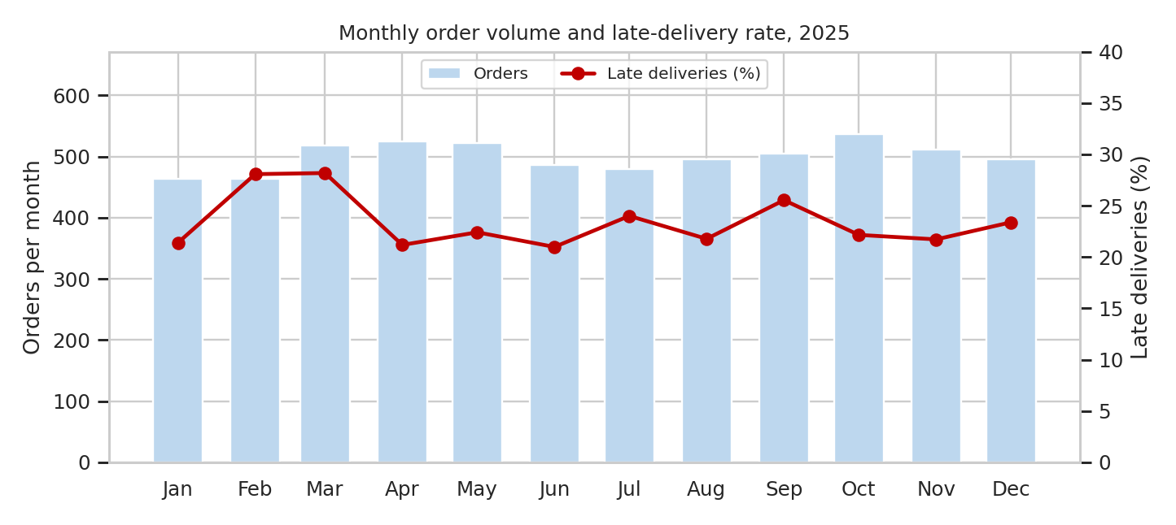
Figure 6: Monthly order volume and late-delivery rate
Why this chart. Time trends are best shown along a time axis. Bars for volume and a line for the late rate on a second axis let me check whether service gets worse when the volume is high, which is a typical capacity problem.
The result is that volume is quite stable: it moves between 463 orders (January) and 537 orders (October) per month, a variation of only 4.8% around the mean, so there is no strong seasonality in this data. The late rate stays between 21% (June) and 28.2% (March) and does not follow the volume. With about 500 orders per month, a swing of a few percentage points can be normal variation, so I would not build a conclusion on the small rise in February and March. The delay problem is therefore not a peak-season capacity problem.

6.2 Where do late deliveries come from?
late_by_mode = df.groupby("shipping_mode")["is_late"].mean() * 100
late_by_wh = df.groupby("warehouse")["is_late"].mean() * 100
late_by_reg = df.groupby("region")["is_late"].mean() * 100

for col in ["shipping_mode", "warehouse", "region"]:
p = stats.chi2_contingency(pd.crosstab(df[col], df["is_late"]))[1]
print(col, "chi-square p-value:", p)
shipping_mode chi-square p-value: < 0.001
warehouse chi-square p-value: 0.718
region chi-square p-value: 0.474

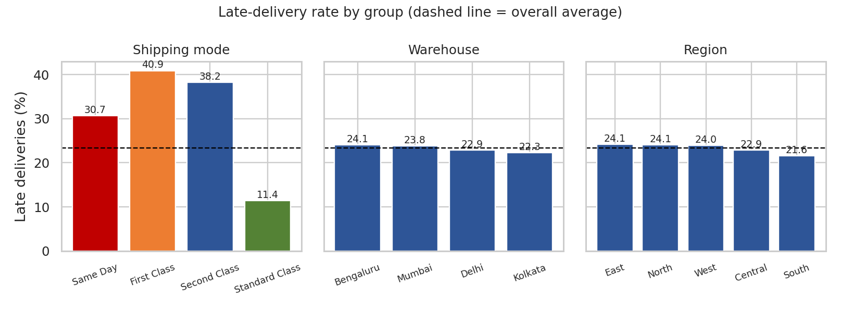
Figure 7: Late-delivery rate by shipping mode, warehouse and region
Why this chart. Bar charts are the natural choice to compare a rate across categories. I put the three groupings side by side on the same y-axis, so the bars are comparable between panels, and added the overall average as a dashed line as a reference.
This is the chart where the answer to "location or process?" appears. Warehouses range only from 22.3% to 24.1% late, and regions from 21.6% to 24.1%, all close to the overall 23.4%. The chi-square tests agree: the differences between warehouses (p = 0.718) and between regions (p = 0.474) are not statistically significant. The shipping mode, on the other hand, is a completely different picture: Standard Class is late only 11.38% of the time, but First Class is late 40.89%, Second Class 38.25% and Same Day 30.69% (p < 0.001). The customers who pay more for speed are the ones who are served worst against the promise.
pt = df.pivot_table(index="warehouse", columns="shipping_mode",
values="is_late", aggfunc="mean")[MODE_ORDER] * 100
sns.heatmap(pt, annot=True, fmt=".1f", cmap="YlOrRd")
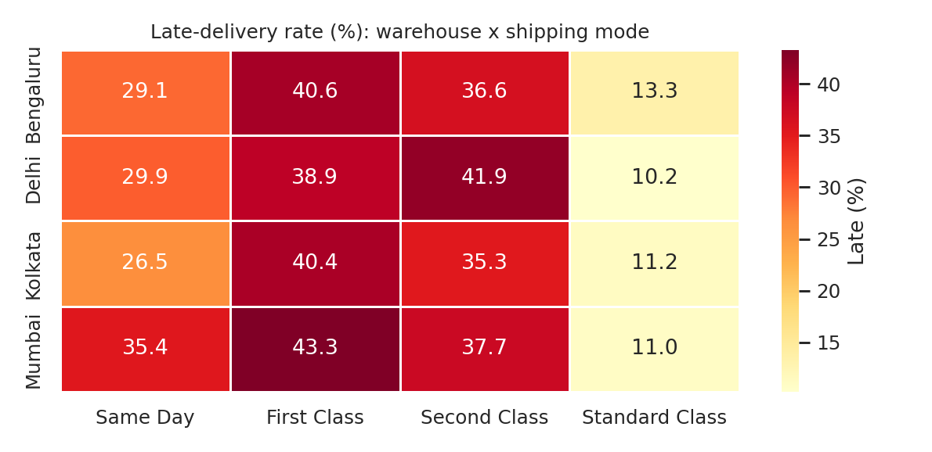
Figure 8: Late-delivery rate (%) by warehouse and shipping mode
Why this chart. A heatmap is a compact way to check two factors together. I wanted to rule out that one warehouse is bad only for one shipping mode.
The pattern is the same in every row: Standard Class is between 10.2% and 13.3% late in all four warehouses, and the other three modes are between about 26.5% and 43.3%. The highest single cell is Mumbai with First Class (43.3%) and Mumbai Same Day is higher than the other warehouses (35.4%), but each cell holds only a couple of hundred orders, so I treat those as something to watch, not as a finding. Again the mode, not the warehouse, is what separates the cells.

6.3 Distance
bins = [0, 200, 400, 600, 800, 2000]
df["band"] = pd.cut(df["distance_km"], bins=bins,
labels=["0-200", "200-400", "400-600", "600-800", "800+"])
bd = df.groupby("band", observed=True).agg(late=("is_late", "mean"),
cpk=("cost_per_km", "mean"))
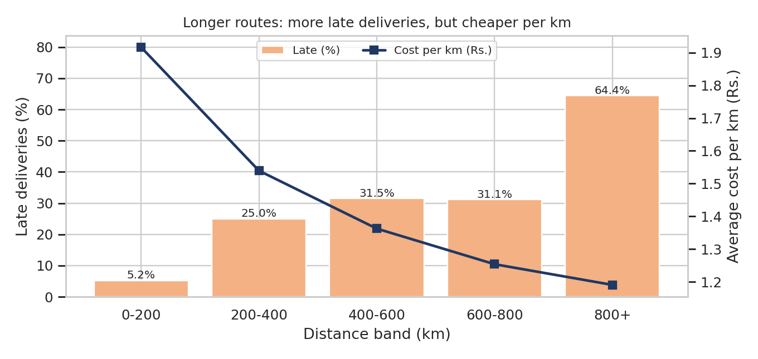
Figure 9: Late-delivery rate and cost per km by distance band
Why this chart. Distance is continuous, so I grouped it into bands to compare service and cost per band. Bars show the late rate and a line on a second axis shows cost per km, which makes the trade-off visible: what we gain in cost per km on long routes we lose in service.
Cost per km falls steadily from Rs. 1.92 on routes under 200 km to Rs. 1.19 above 800 km, so short routes are the most expensive per kilometre (this is the fixed cost effect). The late rate goes the other way, from 5.24% in the shortest band to 31.54% for 400 to 600 km. The last band (800+ km) shows 64.44% late, but it contains only 45 orders, so the number is not stable. A part of the distance effect is a mode effect: Same Day orders are 15.6% late within 300 km but 44.8% late beyond 300 km, and for Standard Class it is 4.8% against 16.7%. The longer the distance, the less room there is in the promised delivery time.

6.4 The dispatch bottleneck
Shipping mode and distance explain part of the lateness, but both are the same for a given order, so I looked for a step in the process that can change. The data has the date on which the warehouse dispatched the order, so I measured the handling time (ship_delay) between order and dispatch. For this analysis I excluded Same Day orders, because they are always dispatched on the same day.
ns = df[df["shipping_mode"] != "Same Day"]
dd = ns.pivot_table(index="ship_delay", columns="shipping_mode",
values="is_late", aggfunc="mean") * 100
print(dd.round(1))
shipping_mode First Class Second Class Standard Class
ship_delay
0 0.3 0.5 0
1 37 33.9 0.5
2 82.4 80.1 33.8

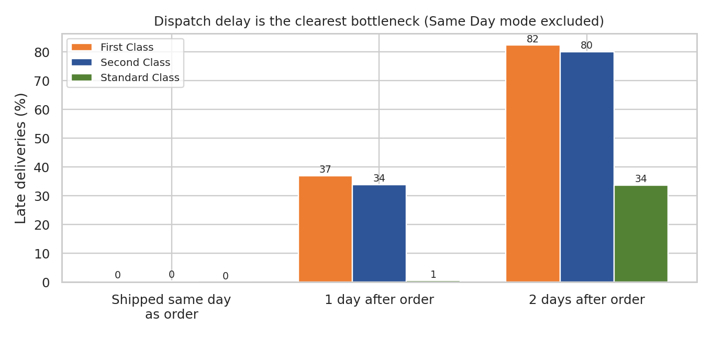
Figure 10: Late-delivery rate by days between order and dispatch
Why this chart. A grouped bar chart lets me compare the three modes at each level of dispatch delay. It isolates one stage of the process (the warehouse) from the transport stage and shows how quickly the late rate grows with each day lost.
This is the strongest result of the analysis. When an order is dispatched on the same day, almost nothing is late (under 1% in every mode). With one day of handling, First Class and Second Class are already 37% and 33.9% late. With two days, they reach 82.4% and 80.1%, and even Standard Class jumps to 33.8%. The orders are spread almost equally over the three groups (32.7%, 33.8% and 33.5%), and 78.4% of all late non-Same-Day orders were dispatched two days after the order. In other words, the time lost in the warehouse before the parcel leaves is the main reason for late delivery, and the transport itself is not.

7. How the Visualizations Support the Analysis
The table summarises why each chart type was chosen and which logistics question it answers.
Fig. | Chart type | Metric it helps interpret | Why this choice
1 | Histogram + density | Cost, lead time, distance, weight | Shows shape, skew and the gap between mean and median
2 | Boxplot | Cost and lead time by mode | Compares medians, spread and outliers across groups
3 | Correlation heatmap | Relationships among 7 variables | 21 pairs readable at a glance; colour shows direction
4 | Scatter + trend lines | Cost against distance | Two continuous variables; line slopes compare modes
5 | Sorted horizontal bars | Cost-driver importance | Standardised effects ranked on one scale
6 | Bar + line (two axes) | Order volume and late rate over time | Trend over time; checks capacity effect
7 | Grouped bars + average line | Late rate by mode, warehouse, region | Compares categories against the overall benchmark
8 | Two-way heatmap | Late rate by warehouse and mode | Rules out an interaction between location and mode
9 | Bar + line (two axes) | Late rate and cost per km by distance | Shows the service-versus-cost trade-off
10 | Grouped bars | Late rate by dispatch delay | Isolates the warehouse stage from transport

8. Key Insights
Insight | Evidence | Meaning for operations
Distance and shipping mode drive cost | R-squared 0.856; distance coefficient 0.698; Rs. 1.819/km (Same Day) vs 0.849/km (Standard) | Cost is predictable; the main lever is the mix of modes and the length of routes
Weight, quantity and category barely matter | Quantity coefficient 0.012; category cost spread only Rs. 20 | Pricing by product type would not add much
Short routes are costly per km | Rs. 1.92/km under 200 km vs Rs. 1.19/km above 800 km | Fixed cost per delivery; batching short routes could help
Lateness is a process issue, not a location issue | Warehouse p = 0.718; region p = 0.474 | No single warehouse or region needs a special fix
Premium modes are late most often | First 40.89%, Second 38.25%, Same Day 30.69%, Standard 11.38% | Customers paying more get the weakest service
Dispatch delay is the main bottleneck | 82.4% late after a 2-day delay vs 0.3% when dispatched same day | Warehouse handling time is the first thing to fix
No seasonal pressure | Monthly volume varies only 4.8% | Capacity can be planned at a steady level

9. Recommendations
- 1. Set and enforce a dispatch time limit. The biggest gain is in the warehouse. About 1,840 non-Same-Day orders waited two days before dispatch. If those orders were late as rarely as the ones dispatched after one day, around 706 late deliveries would be avoided, and the late rate would fall from 23.4% to roughly 11.6%. This is a rough what-if estimate, not a forecast, but it shows the size of the opportunity.
- 2. Prioritise premium orders in the warehouse. First Class, Second Class and Same Day orders should be picked and packed first, with a clear cut-off time, because they have the tightest promise and are the most often late.
- 3. Review the delivery promise of the premium modes. If dispatch cannot be sped up for some routes, the promised delivery time for First Class and Second Class should be made realistic, instead of charging for a speed that is not delivered.
- 4. Limit Same Day to shorter distances. Same Day orders are 15.6% late within 300 km and 44.8% late beyond it. Offering Same Day only inside a radius would protect the service level and the cost (Rs. 833.39 per order).
- 5. Reduce cost on long and short routes differently. For long routes, stocking popular products in a warehouse closer to the customer lowers distance, the main cost driver. For short routes, batching deliveries reduces the high cost per km.
- 6. Do not start location-specific projects yet. The data does not show a problem warehouse or region. Effort is better spent on the process that is common to all of them.

10. Limitations
- The data is simulated. Relationships such as the effect of dispatch delay are built into how the data was generated, so on real data the effects would probably be weaker and noisier. The value of this exercise is the method.
- Correlation and regression show association. A real investigation would need operational information (for example staffing or pick-and-pack times) to confirm why dispatch is delayed.
- Some groups are small (for example 45 orders above 800 km, or about 130 orders per warehouse and Same Day), so their percentages are less reliable.
- The what-if estimate assumes that orders dispatched late would behave like the ones dispatched after one day, which is a simplification.

11. Conclusion
Starting from 6,000 cleaned orders, the analysis answered the original questions. Transport cost is mainly a matter of distance and shipping mode, and it is predictable (R-squared 0.856). Late deliveries (23.4% of orders) do not come from a particular warehouse or region, but from the time orders wait before dispatch, and they hurt the premium shipping modes the most. The ten charts supported this step by step, from the shape of the data to the one stage of the process where the delay appears.
In Week 4 I will use these findings to build a predictive model (for delivery time or late risk) with dispatch delay, distance and shipping mode as the main features, and to propose optimization actions based on it. The script, the cleaned dataset and the figures are uploaded in the GitHub repository.

12. References
- pandas documentation: groupby, pivot_table, cut, corr.
- seaborn documentation: histplot, boxplot, heatmap.
- SciPy documentation: stats.chi2_contingency, stats.skew.
- McKinney, W. Python for Data Analysis, O'Reilly Media.
- Kaggle datasets used as structural reference in Week 2: DataCo Smart Supply Chain, Olist Brazilian E-Commerce.

