Predictive Modeling and Optimization in Logistics Systems
Week 4 Report: Logistics Data Analyst Internship
Forecasting delivery time, predicting late-delivery risk and optimizing dispatch and service decisions (scikit-learn, SciPy)
Submitted by: Sujal Pradeep More
Organization: YuvaIntern (Virtual Internship)
Internship Period: 25 September 2026 to 23 October 2026
GitHub: github.com/sujalmore21/logistics-data-analysis-yuvaintern

1. Introduction
The first three weeks of this project were about understanding the problem. In Week 1 I defined the scenario and the KPIs, in Week 2 I cleaned the data, and in Week 3 I found out what drives cost and where deliveries go wrong. The main result of Week 3 was that late deliveries are not caused by a particular warehouse or region but by the time orders wait in the warehouse before dispatch, and that this hurts the premium shipping modes most.
This week I move from describing to predicting and deciding. I build models that forecast the delivery time of an order, and a second model that estimates the risk that an order will be late. Then I use these predictions as the input of two optimization methods: one that decides which orders the warehouse should dispatch first, and one that decides how far Same Day delivery should be offered. For every part I describe the data, the method, why I chose it, how it was validated, and what I would recommend.

2. Problem Definition and Data

2.1 The prediction problem
The key metric I forecast is the order-to-delivery time in days (total_lead_days). It is the metric customers feel directly, it feeds two of the Week 1 KPIs (average lead time and on-time delivery rate), and it is a numeric target, so regression models can be compared with standard error metrics.
A prediction is only useful if it can be made at a moment when someone can still act on it. For that reason I defined the problem at two prediction points, shown in Figure 1:
- Model A (at order placement): uses only what is known when the order is placed: shipping mode, distance, weight, quantity, warehouse, region, product category and order date. Its use is to give the customer a realistic delivery estimate.
- Model B (at dispatch): uses the same information plus ship_delay, the number of days the order waited before leaving the warehouse. Its use is an early warning for orders that will arrive late.
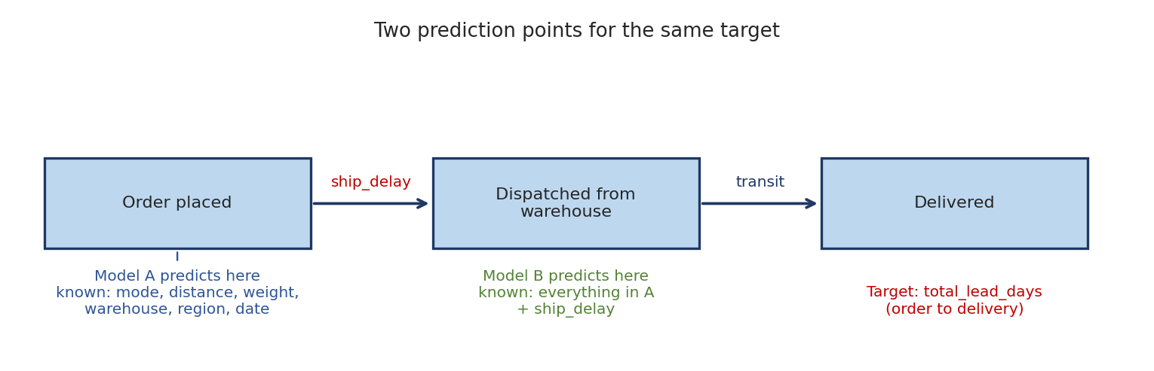
Figure 1: The same target, predicted at two points of the order journey
Comparing A and B also answers a business question: how much of the delivery time is really decided by the dispatch step? This links the modelling directly to the Week 3 finding.

2.2 Dataset and target
The dataset is the cleaned logistics order table from Week 2 (6,000 orders, simulated). In Week 2, 176 delivery dates (2.9%) were missing and I filled them with an estimate. Those rows do not contain a real observation of the target, so training a model on them would mean learning from my own guess. I excluded them from the regression, which leaves 5,824 orders. The target has a mean of 5.22 days, a standard deviation of 1.79 and ranges from 0 to 9 days. The late-risk classifier in section 6 uses all 6,000 orders, because the delivery status is observed for every order.
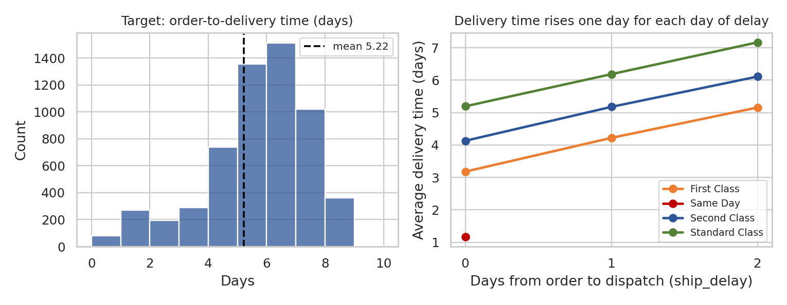
Figure 2: The target (left) and its relationship with dispatch delay (right)
The right-hand chart already explains why Model B should be much better: for every shipping mode, each day of waiting in the warehouse adds almost exactly one day to the delivery time.

2.3 Features and data leakage
Feature | Used in | Comment
shipping_mode, warehouse, region, product_category | A and B | Categorical; one-hot encoded
distance_km, weight_kg, quantity | A and B | Numeric; standardised (matters for the linear model)
order_month, order_dow | A and B | Calendar features to test for seasonality and weekday effects
ship_delay | B only | Known only after the order is dispatched
transit_days, delivery_date, delivery_status, is_late | Never | Leakage: they are computed from the target or contain it

Data leakage deserves a note, because it is the easiest way to get a model with a beautiful score that is useless. transit_days is simply the delivery time minus ship_delay, so using it would give a near-perfect R-squared without learning anything. I excluded every column that contains the outcome, and I only used ship_delay in Model B where it is genuinely known.

3. Methodology: Models, Metrics and Validation

3.1 Model selection and rationale
I compared five models, from the simplest to more flexible ones. Starting with a baseline matters because a complex model is only worth using if it clearly beats a simple rule.
Model | What it does | Why it is in the comparison
Baseline: average of the shipping mode | Predicts the mean delivery time of the order's shipping mode | The simplest sensible rule; the benchmark every model has to beat
Linear Regression | Fits a weighted sum of the features | Fast, interpretable, shows how far a straight-line relationship goes
Decision Tree | Splits the data with if-then rules | Captures steps and thresholds (for example a longer distance adding a day); easy to explain
Random Forest | Averages many decision trees | Reduces the overfitting of a single tree; handles interactions
Gradient Boosting | Builds trees one after another, each correcting the previous errors | Often the strongest model on tabular data

3.2 Evaluation metrics
Metric | Meaning | Why I use it
MAE | Average absolute error in days | Easy to explain to operations: "on average the forecast is off by X days"; main selection metric
RMSE | Square root of the average squared error | Penalises large mistakes more than MAE
R-squared | Share of the variation in delivery time that the model explains | Shows how much better the model is than predicting the overall average
Within 1 day | Percentage of forecasts that are at most 1 day wrong | A practical metric for delivery promises, where one day of error is often acceptable
Accuracy, precision, recall, F1, ROC-AUC | Classification metrics for late-risk | Accuracy alone is misleading with 23% late orders, so I also report precision, recall and AUC

3.3 Validation and hyperparameter tuning
- Train/test split: 80% of the orders (4,659) for training and 20% (1,165) kept aside as a test set that was never used for tuning.
- Cross-validation: 5-fold cross-validation on the training set to compare models and tune parameters. The test set is touched only once, for the final scores.
- Hyperparameter tuning: GridSearchCV for the decision tree (18 combinations of depth and leaf size), and RandomizedSearchCV for Random Forest and Gradient Boosting (6 candidates each from a wider grid), scoring MAE. The search was small on purpose: I only had a single CPU core, and, as the results show, the settings made very little difference.
- Time-based check: a second test where the models are trained on January to September orders and tested on October to December, which is how a forecasting model is used in reality.
The data preparation and tuning code is shown below. Putting the scaling and encoding inside a Pipeline means they are learned only from the training folds, which avoids another form of leakage.
CAT = ["shipping_mode", "warehouse", "region", "product_category"]
NUM_A = ["distance_km", "weight_kg", "quantity", "order_month", "order_dow"]
NUM_B = NUM_A + ["ship_delay"]

def prep(num):
return ColumnTransformer([("num", StandardScaler(), num),
("cat", OneHotEncoder(handle_unknown="ignore"), CAT)])

train, test = train_test_split(obs, test_size=0.2, random_state=42)

pipe = Pipeline([("prep", prep(NUM_B)),
("m", GradientBoostingRegressor(random_state=42))])
grid = {"m__n_estimators": [100, 200, 300], "m__learning_rate": [0.03, 0.05, 0.1],
"m__max_depth": [2, 3, 4], "m__subsample": [0.7, 1.0]}
search = RandomizedSearchCV(pipe, grid, n_iter=6, scoring="neg_mean_absolute_error",
cv=KFold(5, shuffle=True, random_state=42))
search.fit(train[NUM_B + CAT], train["total_lead_days"])

pred = search.best_estimator_.predict(test[NUM_B + CAT])
mae = mean_absolute_error(test["total_lead_days"], pred)
rmse = np.sqrt(mean_squared_error(test["total_lead_days"], pred))
r2 = r2_score(test["total_lead_days"], pred)

The baseline is a small custom estimator, so it goes through exactly the same cross-validation as the other models:
class ModeMeanBaseline(BaseEstimator, RegressorMixin):
def fit(self, X, y):
self.means_ = pd.Series(np.asarray(y), index=X["shipping_mode"].values
).groupby(level=0).mean()
return self
def predict(self, X):
return X["shipping_mode"].map(self.means_).values

4. Results: Forecasting Delivery Time

4.1 Model A: prediction at order placement
Model | MAE | RMSE | R2 | Within 1 day | CV MAE (5-fold) | Best parameters
Baseline | 0.879 | 1.088 | 0.637 | 62.2% | 0.84 +/- 0.016 | -
Linear Regression | 0.819 | 1.012 | 0.685 | 68.2% | 0.799 +/- 0.019 | -
Decision Tree | 0.812 | 0.967 | 0.713 | 70.3% | 0.806 +/- 0.01 | max_depth=4, min_samples_leaf=50
Random Forest | 0.82 | 0.995 | 0.696 | 69.7% | 0.803 +/- 0.009 | n_estimators=150, min_samples_leaf=1, max_features=sqrt, max_depth=None
Gradient Boosting | 0.809 | 0.972 | 0.71 | 69.7% | 0.803 +/- 0.005 | subsample=1, n_estimators=100, max_depth=4, learning_rate=0.1
Table 1: Test-set results for Model A (order-time features only)
The result for Model A is modest, and I think it is worth being honest about this. The baseline that simply uses the average of each shipping mode already reaches an MAE of 0.879 days and R-squared of 0.637. The best model improves the MAE only by about 7%, to 0.819 days. All four models end up very close to each other (test R-squared between 0.685 and 0.713), and the differences in cross-validated MAE (0.799 to 0.806) are smaller than or similar to the fold-to-fold variation. Because of that I selected Linear Regression, the simplest model with the lowest cross-validated error, instead of a more complex one that gives no real gain.
Why can the flexible models not do better? Because the information that matters is not available at order time. The delivery time depends strongly on how long the warehouse takes to dispatch the order, and at the moment the order is placed nobody knows that yet. A more complex algorithm cannot create information that is not in the data.

4.2 Model B: prediction at dispatch
Model | MAE | RMSE | R2 | Within 1 day | CV MAE (5-fold) | Best parameters
Baseline | 0.879 | 1.088 | 0.637 | 62.2% | 0.84 +/- 0.016 | -
Linear Regression | 0.518 | 0.646 | 0.872 | 94.9% | 0.506 +/- 0.006 | -
Decision Tree | 0.517 | 0.588 | 0.894 | 97.4% | 0.507 +/- 0.007 | max_depth=8, min_samples_leaf=20
Random Forest | 0.511 | 0.576 | 0.898 | 98.5% | 0.506 +/- 0.007 | n_estimators=100, min_samples_leaf=1, max_features=0.5, max_depth=None
Gradient Boosting | 0.513 | 0.566 | 0.902 | 98.5% | 0.505 +/- 0.007 | subsample=1, n_estimators=100, max_depth=4, learning_rate=0.1
Table 2: Test-set results for Model B (order-time features plus dispatch delay)
Adding one feature changes the picture completely. The MAE falls from 0.879 days (baseline) to 0.513 days, a reduction of 42%, and R-squared rises to 0.902. Gradient Boosting has the lowest cross-validated MAE (0.505) and the best test RMSE (0.566), so it is my final Model B. 98.5% of its forecasts are within one day of the actual delivery time, against 68.2% for Model A. The linear model is clearly weaker here (R-squared 0.872) than the tree-based models, which makes sense: the effect of distance comes in steps (a long route adds a day) and a straight line cannot follow steps. Random Forest, Decision Tree and Gradient Boosting are practically tied.
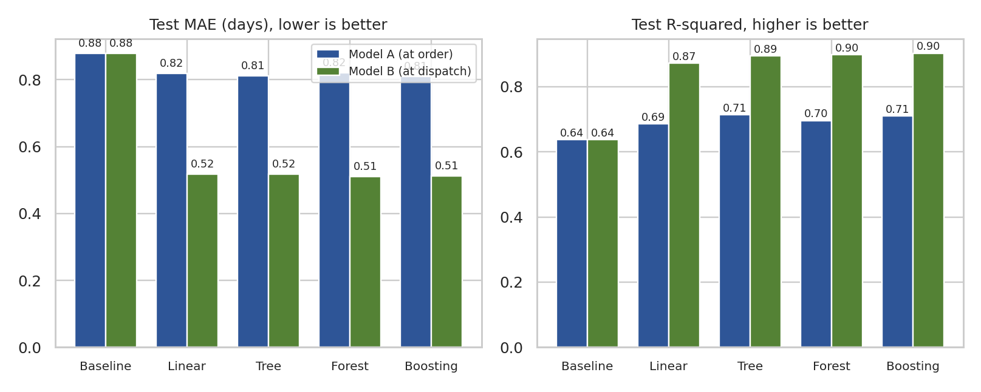
Figure 3: Test MAE and R-squared of all models, at the two prediction points
Why this chart. Grouped bars place Model A and Model B next to each other for every algorithm, so the effect of the extra dispatch information (the green bars) can be separated from the effect of the algorithm choice.

4.3 Validation over time
Model (time split) | MAE | RMSE | R-squared | Within 1 day | Test orders
A: Linear Regression | 0.803 | 0.98 | 0.698 | 68.7% | 1,500
B: Gradient Boosting | 0.503 | 0.525 | 0.913 | 98.9% | 1,500
Table 3: Models trained on January to September and tested on October to December
The scores on the later months (Model A MAE 0.803, Model B MAE 0.503 and R-squared 0.913) are as good as on the random test set. This tells me the models are not just memorising the training orders and that they hold up when applied to a later period. This simulated data has no real seasonality, so a real dataset might behave differently.

4.4 Error analysis
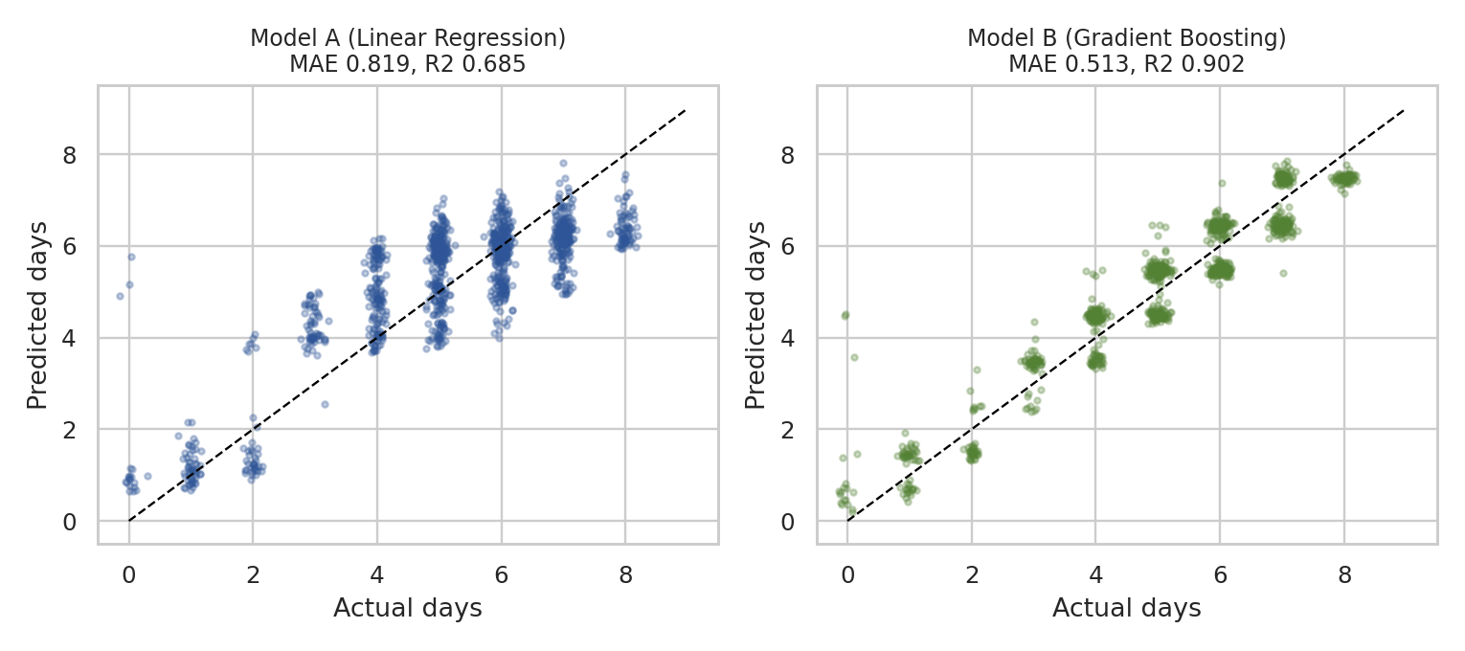
Figure 4: Actual against predicted delivery time on the test set
Model A (left) shows horizontal bands: for an order that really took 5 days the forecast can be anywhere between 4 and 7. This is the effect of the unknown dispatch delay. In Model B (right) the points sit tightly around the diagonal.
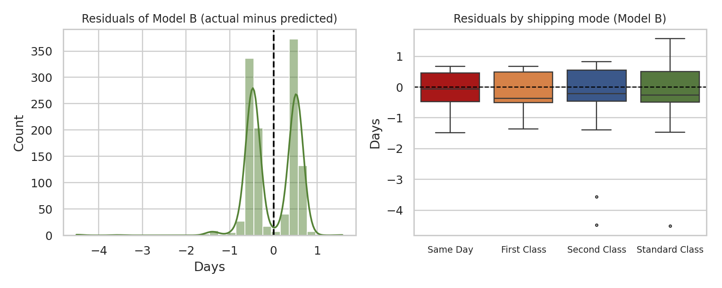
Figure 5: Residuals of Model B, overall and by shipping mode
The residuals of Model B have a mean of -0.022 days, so there is no systematic over- or under-prediction, and the spread is similar across the four shipping modes (the mean absolute error is between 0.488 and 0.528 days in all of them). The histogram has two peaks at about plus and minus half a day. This is typical for a whole-number target: the true delivery time is a whole number of days, and when the model cannot tell if a parcel will take 5 or 6 days, the best forecast is in between, so it is wrong by half a day either way. The remaining error therefore looks like a one-day variation in transit that none of my features can explain (things like traffic, weather or courier availability, which are not in the data). A few outliers at around minus 4 days are the orders for which the model predicted a longer time than the real one, and they are too few to matter.
Shipping mode | Test orders | MAE Model A | MAE Model B | Improvement
Same Day | 102 | 0.524 | 0.488 | 7%
First Class | 167 | 0.818 | 0.497 | 39%
Second Class | 248 | 0.904 | 0.528 | 42%
Standard Class | 648 | 0.833 | 0.515 | 38%
Table 4: Mean absolute error (days) by shipping mode
Same Day is already predictable at order time because those orders are always dispatched on the same day, so the dispatch information adds little there. For the other three modes it reduces the error by roughly 38 to 42 percent.

4.5 Which features matter?
from sklearn.inspection import permutation_importance
pi = permutation_importance(model, test[feats], test["total_lead_days"],
n_repeats=10, scoring="neg_mean_absolute_error",
random_state=42)
importance = pd.Series(pi.importances_mean, index=feats).sort_values()
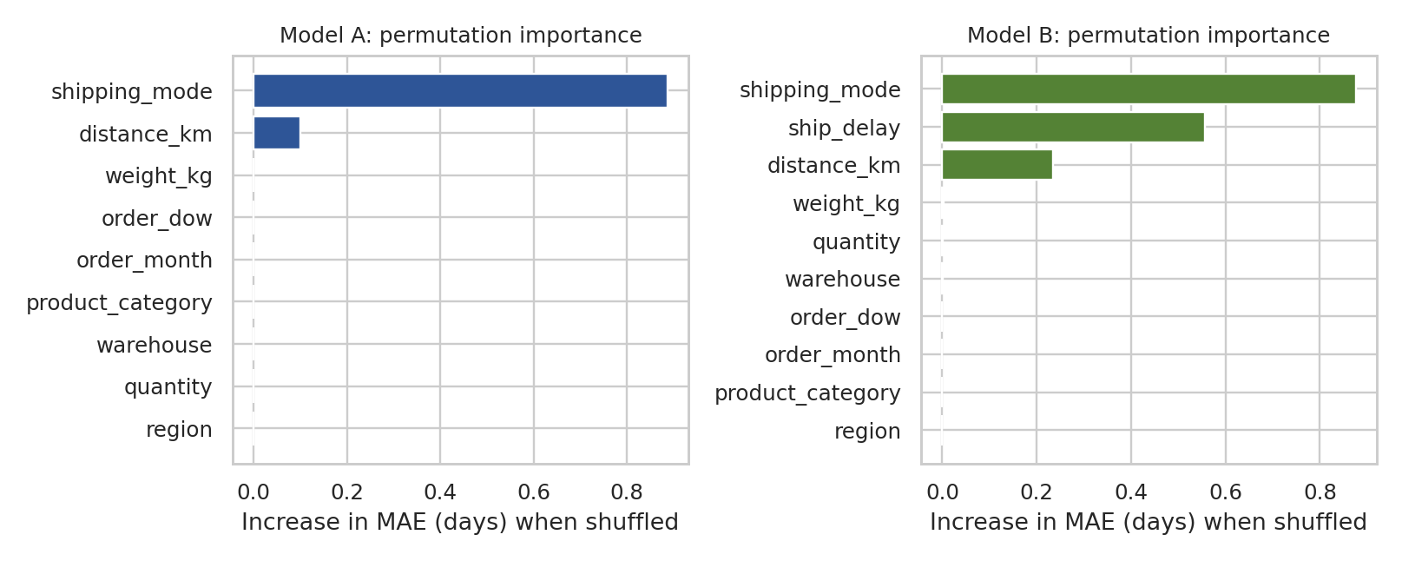
Figure 6: Permutation importance of the features (increase in MAE when a feature is shuffled)
Why this chart. Permutation importance measures what really happens to the test error when one feature is randomly shuffled, so it works for any model and is calculated on unseen data. Horizontal bars sorted by size give a clear ranking.
In both models the shipping mode is the most important feature (shuffling it raises the MAE by about 0.877 days), followed by distance (0.101 days in Model A and 0.234 in Model B). In Model B the dispatch delay comes second with 0.557 days, which confirms the Week 3 finding with a model instead of a chart. Warehouse, region, product category, order month and weekday have practically zero importance. This is useful for operations: the delivery time is a question of the service level and the process, not of where or when the order was placed.

5. Predicting Late-Delivery Risk
Forecasting the number of days is useful, but operations teams act on a yes-or-no question: will this order be late? I trained a classifier for the is_late label, with the same features as Model B, because the intended use is at dispatch. 23.4% of orders are late, so a model that always says "on time" would already be right 76.6% of the time. That is the accuracy any model has to beat, and it is why precision, recall and AUC are reported as well.
clf = Pipeline([("prep", prep(NUM_B)),
("m", GradientBoostingClassifier(random_state=42))])
grid = {"m__n_estimators": [100, 200], "m__learning_rate": [0.05, 0.1],
"m__max_depth": [2, 3, 4], "m__subsample": [0.7, 1.0]}
search = RandomizedSearchCV(clf, grid, n_iter=5, scoring="roc_auc",
cv=StratifiedKFold(5, shuffle=True, random_state=42))
search.fit(Xc_tr, yc_tr) # stratified split keeps 23% late
Model | Accuracy | Precision | Recall | F1 | AUC | CV AUC (5-fold)
Logistic Regression | 0.847 | 0.719 | 0.566 | 0.633 | 0.938 | 0.929 +/- 0.002
Random Forest | 0.848 | 0.832 | 0.441 | 0.577 | 0.935 | 0.936 +/- 0.006
Gradient Boosting | 0.853 | 0.7 | 0.655 | 0.676 | 0.941 | 0.938 +/- 0.008
Table 5: Late-delivery classifiers on the stratified test set (threshold 0.5)
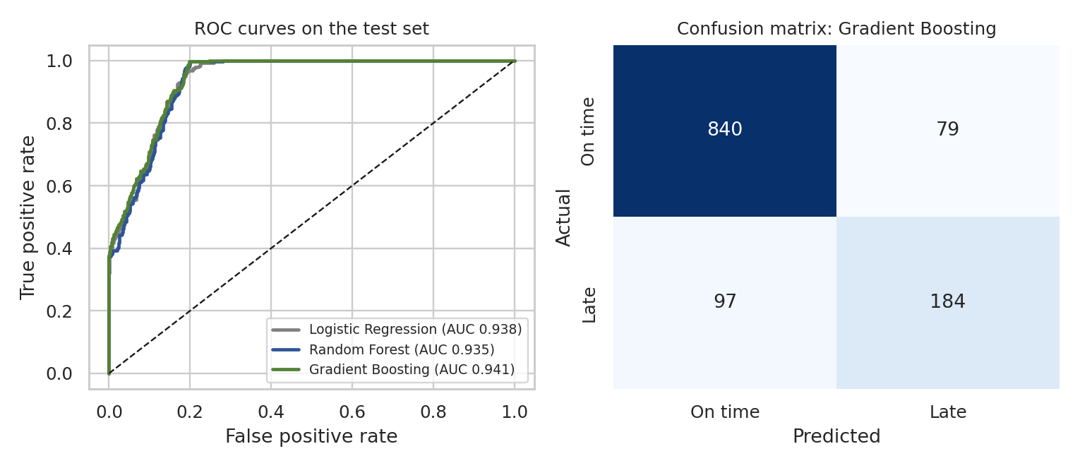
Figure 7: ROC curves of the three classifiers and the confusion matrix of the selected model
All three models separate late from on-time orders well (AUC between 0.935 and 0.941), so the signal is strong. I selected Gradient Boosting, which has the highest AUC and F1. On the test set it reaches 85.3% accuracy against the 76.6% of the "always on time" rule. More important for operations: of the orders it flags as late, 70% really are late (precision), and it catches 65.5% of all late orders (recall). In the confusion matrix this is 184 late orders found, 97 missed and 79 false alarms.
The threshold of 0.5 is a default. A warehouse that treats a late premium order as much more costly than a false alarm would lower the threshold to catch more late orders, at the price of more alerts. I kept 0.5 and did not tune it on the test set, because the right value depends on the cost of an expedited handling, which I do not have in this dataset. The classifier is also the engine of the optimization in the next section.

6. Optimization Strategies
Predictions only create value when they change a decision. Based on the findings of Weeks 3 and 4, I looked at three decisions: in which order the warehouse should dispatch orders, how much dispatch capacity is needed, and how far Same Day delivery should be offered.

6.1 Dispatch prioritisation (resource allocation with linear programming)
The problem. Today, the orders (excluding Same Day) wait 0, 1 or 2 days in the warehouse in almost equal numbers (1,797, 1,858 and 1,840 orders), and the waiting time is statistically unrelated to the shipping mode (chi-square p = 0.84), the distance band (p = 0.86) or the warehouse (p = 0.99), so dispatch order does not take lateness risk into account at all. But an extra day of waiting does not hurt all orders in the same way: a Standard Class order has a long promised window and can absorb a day, while a First Class order cannot. If the warehouse is going to have some orders wait anyway, it should be those that are hurt least.
The model. This is a transportation problem, a classic linear programming structure. I grouped the orders by shipping mode and distance band (short, medium, long), which gives 9 groups. The decision variable x(g,d) is the number of orders of group g that are dispatched d days after the order (d = 0, 1, 2). The cost p(g,d) is the late probability predicted by the classifier for an order of that group when its dispatch delay is set to d. The goal is to minimise the total expected number of late orders:
- Minimise the sum over all groups and delays of p(g,d) x x(g,d).
- Every order must get exactly one delay: the sum over d of x(g,d) equals the number of orders in group g.
- Warehouse capacity is unchanged: the number of orders dispatched at each delay level equals today's numbers.
P[g, d] = mean predicted P(late) of group g when ship_delay is forced to d
c = P.flatten() # cost of each (group, delay) cell
A_eq, b_eq = [], []
for g in range(G): # each order gets exactly one delay
row = np.zeros(G * D); row[g * D:(g + 1) * D] = 1
A_eq.append(row); b_eq.append(n_g[g])
for d in range(D): # same capacity at each delay level
row = np.zeros(G * D); row[d::D] = 1
A_eq.append(row); b_eq.append(cap[d])
sol = linprog(c, A_eq=np.array(A_eq), b_eq=np.array(b_eq),
bounds=(0, None), method="highs")
print("Expected late orders:", round(sol.fun))
Expected late orders: 426

Does the model make sense? Before trusting the optimization I checked the probabilities against reality. Under today's allocation the classifier predicts 1,244 late orders for these 5,495 orders, and the actual number is 1,248 (22.7%). The model reproduces the real total almost exactly, which is a good sign for its calibration at the group level.
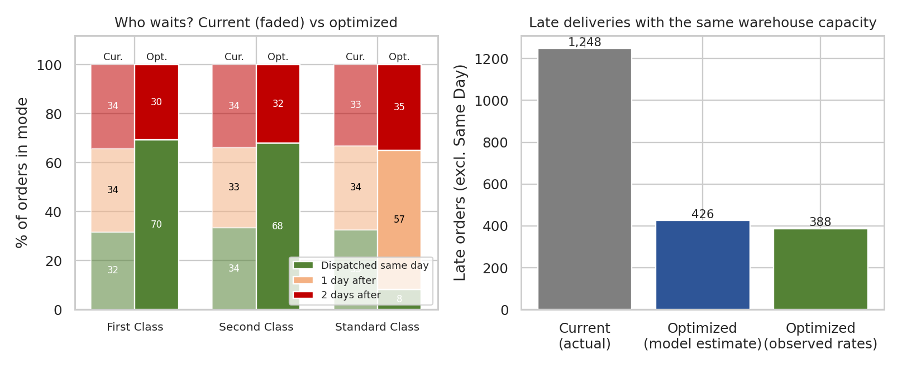
Figure 8: Who waits in the warehouse (left) and the resulting late deliveries (right), with the same total capacity
Result. The optimal plan dispatches about 69.5% of First Class and 68.1% of Second Class orders on the order day, and gives Standard Class the one-day wait (56.7% of Standard orders). Expected late orders fall from 1,248 to 426 (7.8% of orders) by the model, or to 388 (7.1%) if I evaluate the same plan with the late rates actually observed in each group and delay level. That is a reduction of roughly 65 to 69 percent, with no extra warehouse capacity. By mode, the late rate (observed-rate estimate) goes from 40.9% to 14.6% for First Class, from 38.2% to 13.8% for Second Class, and from 11.4% to 2.2% for Standard Class. No mode gets worse.
I also tested a fairness version, with an extra rule that no shipping mode may have more than 25 percent predicted late orders. The solution did not change, which means the optimal plan does not buy its improvement by sacrificing one mode.
The estimate has limits that I want to state clearly. It treats the three delay levels as pools that can be freely assigned, while in a real warehouse the order arrival times, cut-off times and picking capacity restrict which orders can be handled first. So the figures are a measure of the size of the opportunity, and a pilot would be needed to see how much of it can be captured.

6.2 How much same-day dispatch capacity is needed?
The same linear program can answer a capacity planning question. I varied the share of orders the warehouse is able to dispatch on the order day from 20% to 100% (splitting the rest equally between a one-day and two-day wait), and compared two policies: assigning orders without any priority, and assigning them by the optimization.
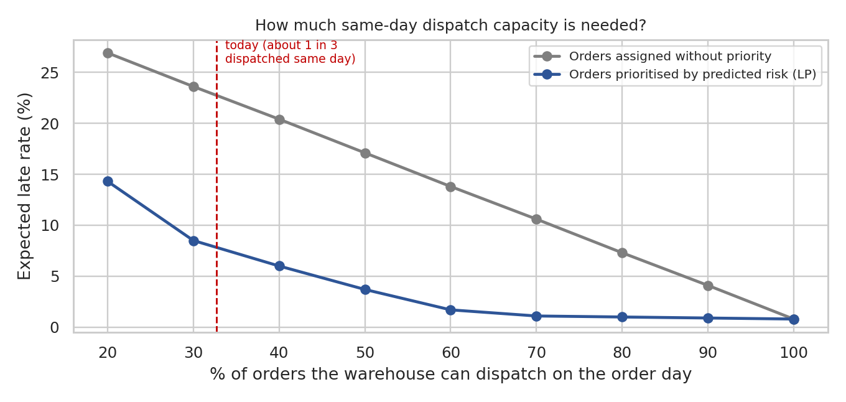
Figure 9: Expected late rate against same-day dispatch capacity, with and without prioritisation
Why this chart. A line chart with both policies on the same axes shows the effect of capacity (the slope of each line) and the effect of prioritisation (the gap between the lines) in one picture.
Today about 32.7% of the orders are dispatched on the same day, and without prioritisation the expected late rate is close to the actual 22.7%. At that same capacity, prioritising by predicted risk gives an expected 8.5%. To get a comparable result without prioritisation the warehouse would have to dispatch about 75 percent of orders on the order day, so smarter ordering is worth more than doubling the same-day capacity. The prioritised curve also flattens: at 50% capacity the expected late rate is already 3.7%, and at 60% it is 1.7%, so after about 60% extra capacity gives very little. Without prioritisation, in contrast, each additional 10 points of capacity removes about 3 points of late rate (17.1% at 50% and 13.8% at 60%).

6.3 Same Day service radius (service-level and cost optimization)
Same Day orders are always dispatched on the order day, so their lateness is not a dispatch problem. In Week 3 I found that their late rate depends strongly on distance. Here I use the data to choose a maximum distance for the Same Day service: for each possible radius I calculated the late rate of the Same Day orders that would remain inside it, and the share of Same Day orders still offered.
for R in range(100, 701, 25):
kept = sd[sd["distance_km"] <= R]
late_rate = kept["is_late"].mean() * 100 # service level inside radius
coverage = len(kept) / len(sd) * 100 # share of Same Day orders kept
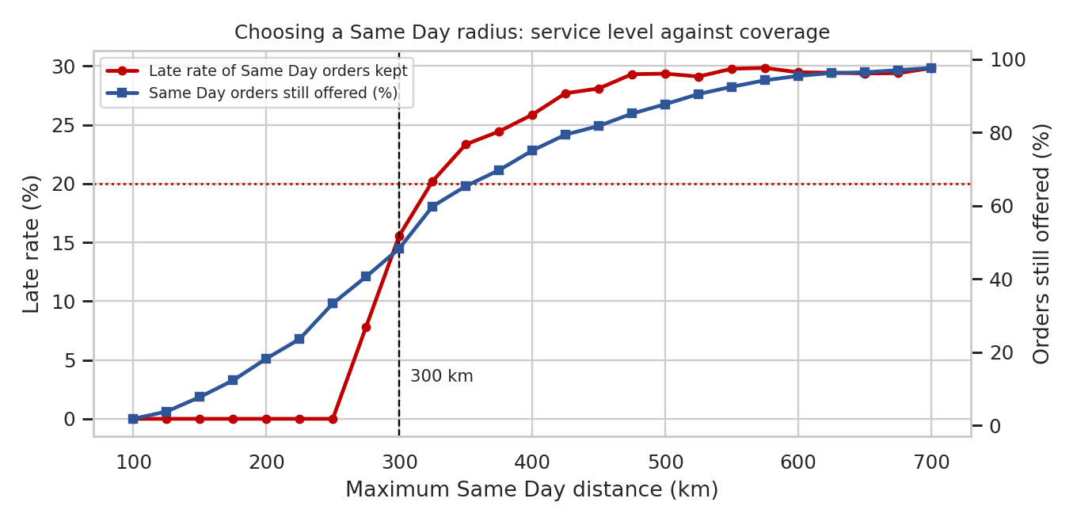
Figure 10: Late rate and coverage for different maximum Same Day distances
Why this chart. Both metrics depend on the same variable (the radius), so a line chart with two axes shows the trade-off directly: the further we go, the more orders we serve, and the worse the service gets. The dotted line is my target of at most 20% late.
The late rate is 0% up to about 250 km and then jumps (15.6% at 300 km, above 20% from 325 km). This shows a physical limit: beyond roughly 250 km a Same Day parcel typically needs an extra day. The overall Same Day late rate is 30.7%. With a 300 km radius, 48.3% of Same Day orders stay in the service, their late rate is 15.6% (the classifier estimates 14.5%, which agrees), and 117 of the 155 late Same Day orders are removed from the Same Day promise. With a radius of 250 km the Same Day service would have no late orders in this data, but it would cover only about a third of the orders (33.3%), so 300 km looks like the better balance, and 250 km is the choice if the service must be reliable above all.
The 261 orders outside a 300 km radius would be offered First Class instead. Based on the per-mode cost lines from Week 3, this lowers the transport cost of those orders by about Rs. 69,383.4 (around Rs. 265.84 per order). This is only the transport cost. I do not have the fees customers pay for Same Day, so the effect on revenue is not included, and the number should not be read as a net profit.

6.4 Cost-focused measures from the cost analysis
Two more measures follow from the cost drivers found in Week 3. They are based on that analysis and are not tested with a model in this report.
- Batch short routes. Cost per km is highest on short routes (about Rs. 1.92 per km under 200 km, against Rs. 1.19 above 800 km), because part of the cost is fixed per delivery. Grouping nearby orders into one trip lowers that fixed share. A vehicle routing solver such as OR-Tools is the natural tool, with the outline below.
- Stock closer to long-distance customers. Distance is the strongest cost driver, and it also raises lateness. Placing fast-moving products in a warehouse closer to the customers of a distant region reduces both.
# Outline of a route-batching model (OR-Tools), not run in this report
1. Take the orders of one warehouse and one dispatch day
2. Build a distance matrix between the warehouse and the delivery points
3. Add vehicle capacity (kg) and a time window from the promised delivery date
4. Objective: minimise total distance (and therefore cost per delivery)
5. Solve (first solution strategy + local search), compare with current trips

7. Recommendations
Action | Evidence from this report | Expected effect
1. Dispatch orders by predicted late risk (premium and risk-sensitive orders first) | LP result with unchanged capacity; model reproduces actual late total (1,244 vs 1,248) | Late orders (excluding Same Day) from 1,248 to about 388 to 426, i.e. roughly a 65 to 69% reduction (upper-bound estimate)
2. Plan same-day dispatch capacity towards about 50 to 60% of orders | Capacity curve (Figure 9) | With prioritisation the expected late rate is 3.7% at 50% and 1.7% at 60% capacity; more capacity adds little
3. Limit Same Day to 250 to 300 km | Late rate 0% up to 250 km, 15.6% at 300 km, 30.7% overall | 117 late Same Day orders removed from the promise; transport cost about Rs. 69,383.4 lower if those orders move to First Class (revenue effect not included)
4. Show customers a predicted delivery time at checkout (Model A) | MAE 0.819 days; 68.2% of forecasts within one day | More honest delivery promises; fewer unpleasant surprises, especially for premium modes
5. Add a dispatch-time late-risk alert (Model B and classifier) | AUC 0.941; precision 70%, recall 66% | Warehouse staff can expedite or reroute flagged orders before the parcel leaves
6. Batch short routes and stock closer to far regions | Cost per km by distance band and distance as top cost driver (Week 3) | Lower cost per delivery; effect not quantified here
7. Monitor and retrain | Models were stable in the time-based test | Track MAE and the late rate monthly and retrain every quarter, or when the error rises

8. Limitations
- The data is simulated, so the strong effect of dispatch delay and the sharp 250 km threshold are partly a result of how the data was built. On real data I would expect weaker and noisier relationships. The value of this report is the method and the way the pieces fit together.
- Model A cannot be much better than a simple rule because the key information (dispatch delay) is not known at order time. The unexplained part of the delivery time (about half a day) would need extra data such as traffic, weather and courier information.
- The hyperparameter searches were small (a single CPU core), and the models are close to each other. A larger search would probably change the scores only in the second decimal.
- The dispatch optimization is based on predicted probabilities and treats delay levels as freely assignable pools. Real constraints (cut-off times, picking capacity, order arrival times) will reduce the achievable gain.
- The Same Day cost saving covers transport cost only and ignores customer fees and demand changes.
- The classifier threshold was kept at the default of 0.5, because the cost of a false alarm versus a missed late order is not known.

9. Conclusion
I formulated delivery time forecasting at two points of the order journey and compared a baseline with four algorithms using cross-validation, hyperparameter tuning, a held-out test set and a time-based check. At order placement, delivery time can be predicted with an error of about 0.819 days; once the dispatch delay is known, the error drops to about 0.513 days (R-squared 0.902), and 98.5% of the forecasts are within one day. A classifier built on the same information flags late deliveries with an AUC of 0.941.
These predictions were turned into decisions. Prioritising dispatch by predicted risk could remove roughly two thirds of the late deliveries without extra capacity, the capacity curve shows that about 50 to 60 percent same-day dispatch is enough once orders are prioritised, and a Same Day radius of 250 to 300 km would bring the Same Day late rate down from 30.7% to 15.6% or less. All of these results rest on simulated data, so the exact numbers will differ in a real company, but the approach would carry over: define the decision, predict what matters for it, and optimise with the predictions.
Looking at the four weeks together, the project went from planning (Week 1), to clean data (Week 2), to understanding (Week 3), to prediction and optimization (Week 4). The scripts, datasets and figures for all four weeks are available in the GitHub repository.

10. References
- scikit-learn documentation: Pipeline, ColumnTransformer, GridSearchCV, RandomizedSearchCV, GradientBoostingRegressor and Classifier, permutation_importance.
- SciPy documentation: scipy.optimize.linprog (HiGHS solver).
- Google OR-Tools documentation: Vehicle Routing Problem.
- Hastie, T., Tibshirani, R., Friedman, J. The Elements of Statistical Learning, Springer.
- Hillier, F. and Lieberman, G. Introduction to Operations Research (transportation problem), McGraw-Hill.
- McKinney, W. Python for Data Analysis, O'Reilly Media.

