Data Source & Size
Indian Kanoon Cases-:
https://www.kaggle.com/datasets/regressingaddict/indian-kanoon-cases/data
This dataset was consisting of 6 csv files.
The final dataset was legal_cases.csv merged & processed with prepare.py

Retrieval Approach
Used FAISS Vector Store via Langchain to store embedding
DeterministicFakeEmbedding from Langchain due to the error occurring while using gemini-embedding-001
Top-K vector Search for retrieval

LLM Used & Prompt Strategy
Model used was gemini-2.5-flash.
Prompt Strategy: Used Langchain Prompt Template 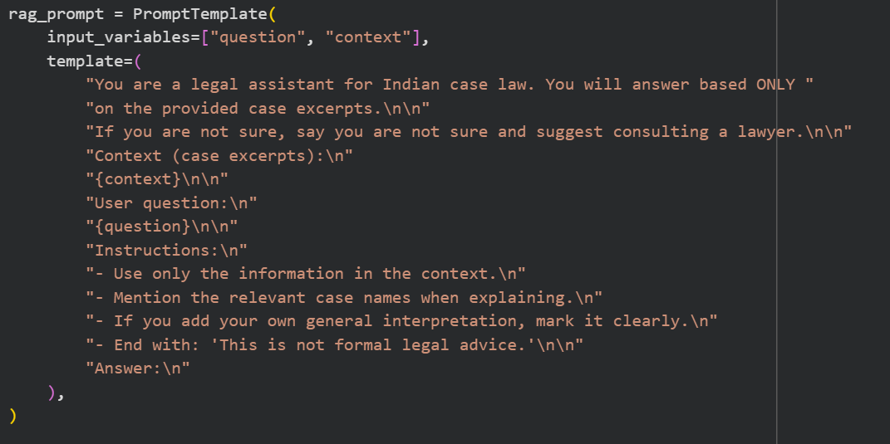
Hallucination Prevented
Context-only rule: In Prompt template I have used “Answer ONLY from the provided case excerpts”

Future Work
Real semantic embeddings
- Replace DeterministicFakeEmbedding with all-MiniLM-L6-v2 or similar via HuggingFaceEmbeddings.
Tune chunk size & overlap for better retrieval

Demo:
