Method in java :
Returntype methodname(parameter ){
//Body
}

Methods call stack
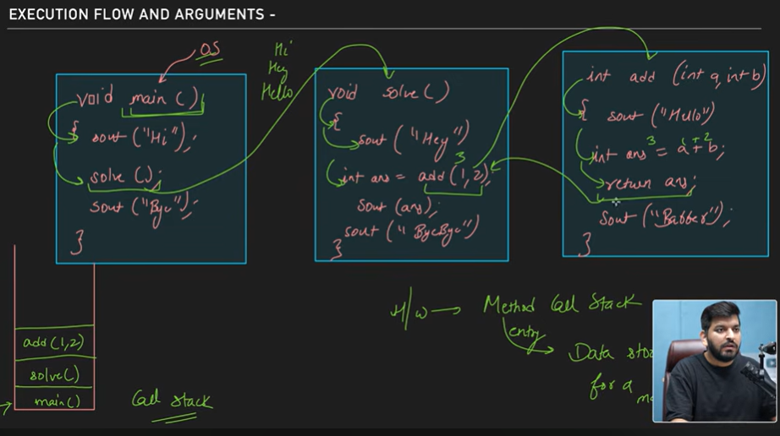
Method overloading :
public class learn {
static int add(int a , int b){
return a+b;
}
static int add (int a , int b , int c){
return a+b+c;
}
public static void main(String[] args) {
System.out.println(add(5,5) + " " + add(5,5,5));
}
}
We can change the number of parameters data type of parameter just overload method to use one name again and again in different different scenarios but we can’t use changing return type of method that will not work appear we have to have some difference between the parameters to method overloading
CALL by value :
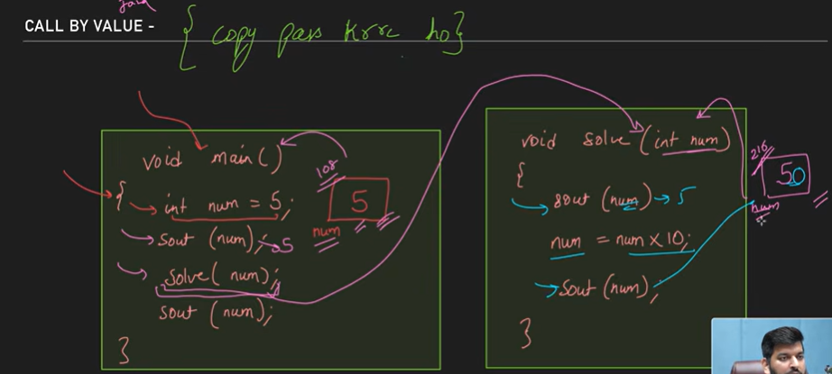
It simply says that suppose we create a value variable Subject one And assign you to number 5 And suppose it’s stored name and location 108 And when we pass it to some function in Java we are not passing actual number PL we are sending or calling by a copy of that variable So when we pass that value Java creates a new block of memory suppose 216 now whatever the changes gonna happen in that function will be done to the memory location 216 and that’s why even after some changes are made to that variable incentive function and and we are going to do some printing and main function It’s still getting though Well you printed on the 108 memory location And this is important
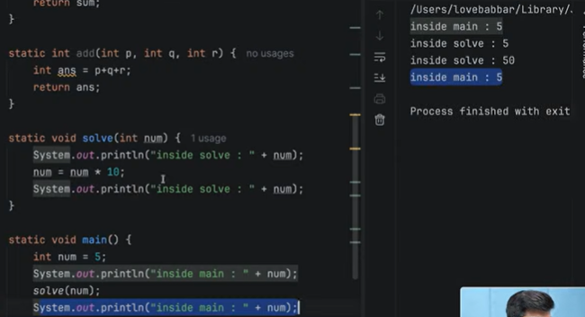
Scope of variable :
We already know very much better that the very very insights for loops or functions or any other book of code expect university or in the main section that will be limited Too bad those curly bracket only And cannot be accessible outside the functions or that unless it is public static or something like that
Arrays :
- Only stores in contiunuos memory location
- Declare : int arr[] ; or int[] arr ;
- Allocation : arr = new int[3];
- Initialization : int arr[] = {1 , 2, 3}
- int arr[] ;
- arr = new int[3];
- int brr[]={1,2,3};
- You can acces by normal way using index and also using normal for loop
- for (int val : brr){
- System.out.println(val);
- }

To take input and print :
for(int i=0;i<3;i++){
arr[i] = sc.nextInt();
}
for (int val : arr){
System.out.println(val);
}

2D array :
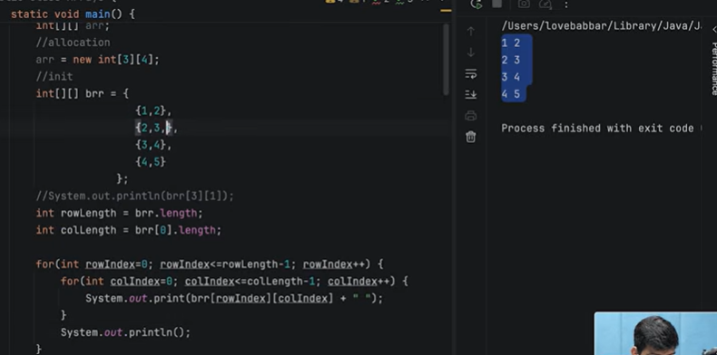

Taking input for 2d array :
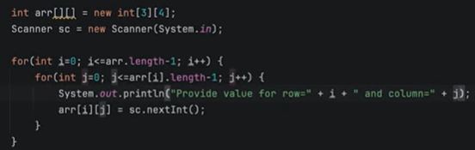
To print 2d array :
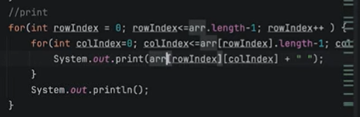
Strings :
Ways to crate strings :
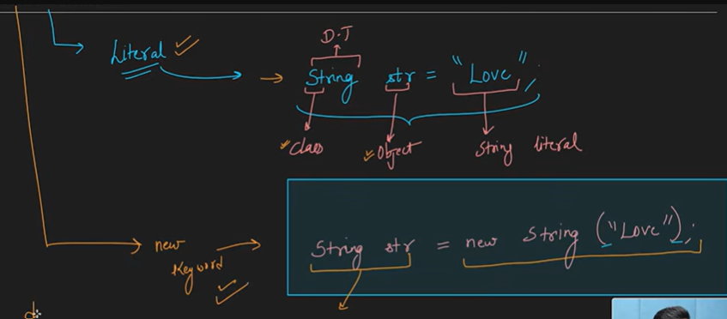
Difference between them :
- Using literal way : we can create the string n allcoate it into the heap : string pool :
- And if we create the new string var with same value/string will not aquire another space :: it will refer to the same memory space
- So in short str and name are stored in stack memory but there stored in heam memory at on place …
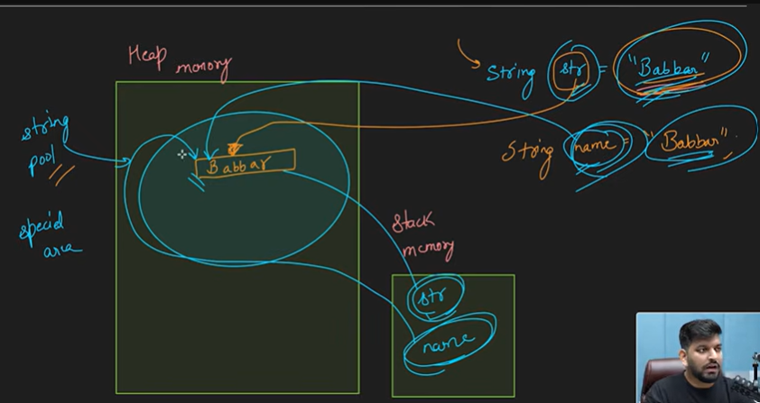
For string object methods :
- Obj.length
- Obj.charAt(index);
- String is IMMUTABLE : it stats that we can update string entirely not internally we can change it by whole string but even this is psbl java doesnot update that same memory location after update java creates or allocate new memory location in memory and just shift the reference …
For Comparing strigns : ( == , .equals() , .equalsIgnore() )
// [ == ] = compares the memory location not by value ;
// [ .equals ] = compare the values :
// [ .equalsIgnoreCase() ] = ignore case sensitivity

String Input : [ next() , nextLine() ]
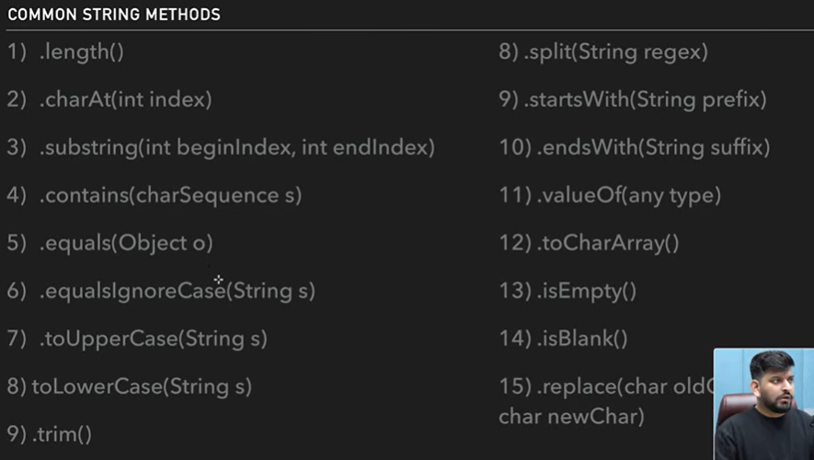

Tip page where small things details defined are :
- Public static void main(String[] args)
Why we declare public static void main function This is because when we are in a class to use class method we have to declare or create the object of that class only when we can access that method using class object right To avoid this we can declare public static void function in a class so that we can use it without creation of any object
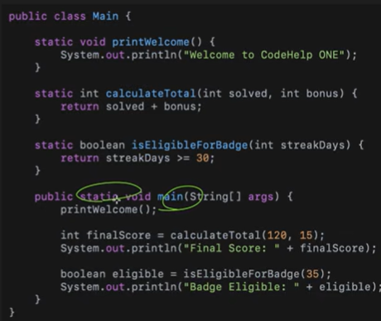
- Scope of variable :
Static function can’t access globally normal declare variable that very well should also be static as we know the static it helps to function as well as vari to be used in different parts of code without bigler or creation of object of class so that same rule applies to the object as well So a static function can access a static variable
static int a = 10;
public static void main(String[] args) {
System.out.println(a);
}

