**PRACTICAL 4**

**AIM:TO STUDY AND PERFORM FULL WAVE RECTIFIER WITH AND WITHOUT FILLER**

**Name :- SUJAL SUTHAR**

**CSE25**

**PART 1S**

**FULL WAVE RECTIFIER WITHOUT FILLER**

**CIRCUIT-**

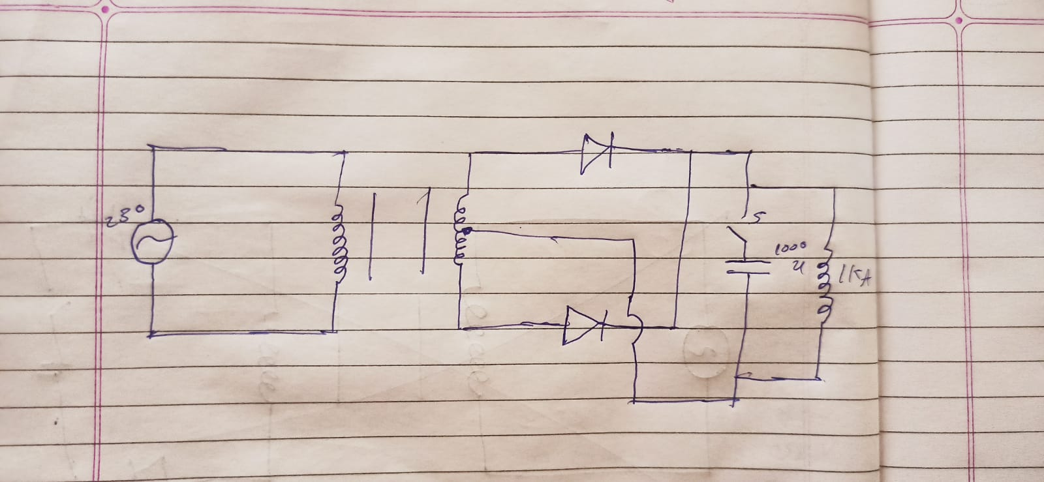 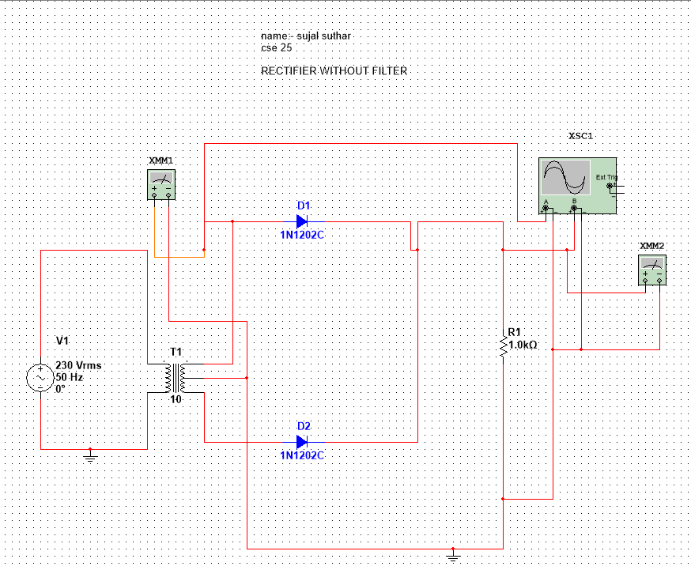

OUTPUT

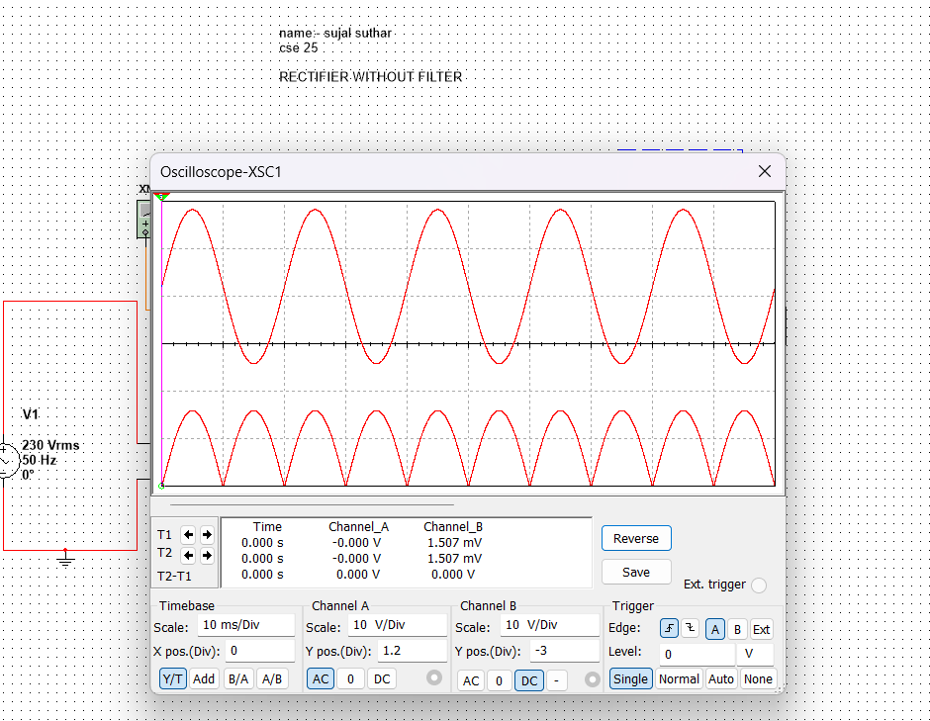**PART 2**

**FULL WAVE RECTIFIER WITH FILTER**

**CIRCUIT-**

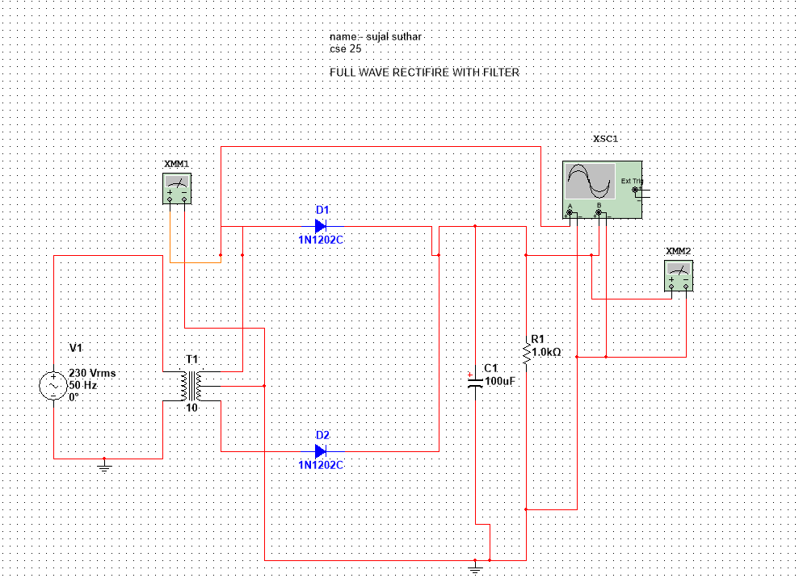

**OUTPUT**

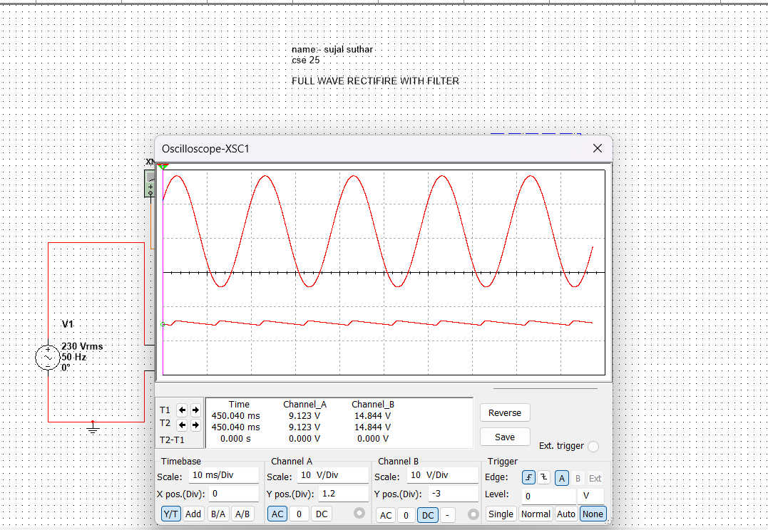

**CALCULATION**

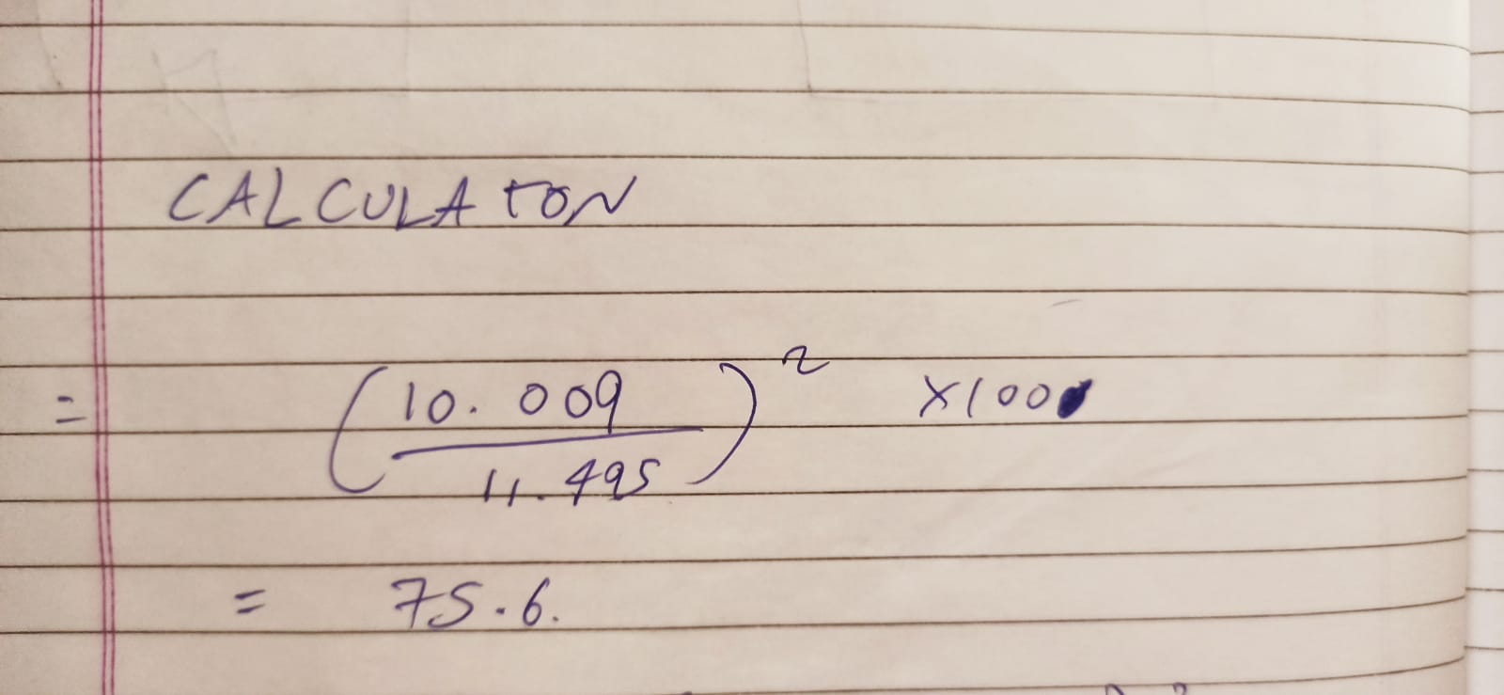

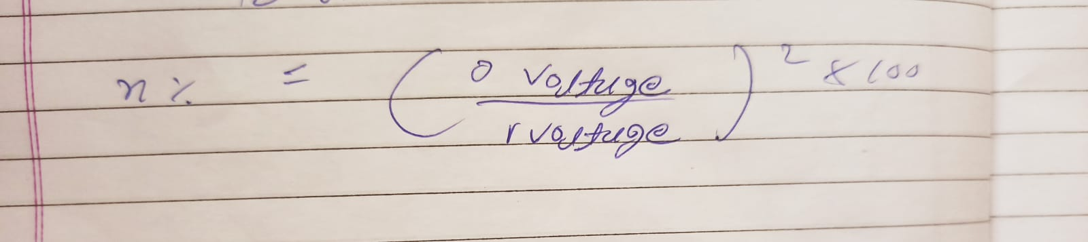

**CONCLUSION: THE REPEL FACTOR IS 0.4956 . THE EFFICIENCY OBTAINED AS 75.6 .SO WE CONCLUDE THAT REPEL FACTOR INCREASES AS EFFICENCY DECREASES BY FULL WAVE RECTIFIER EXPRIMENT**