Practical 4

Aim
Study and implement simple linear regression.
What is Linear Regression?
Linear Regression is a supervised machine learning algorithm used to predict a value based on the relationship between input (independent variable) and output (dependent variable).
It assumes this relationship is linear (a straight line).
Example: Predicting exam score based on hours studied.
Best-Fit Line
Linear regression finds the best-fit straight line that passes closest to all data points.
Equation:
$$y=mx+b$$:
- y: Predicted value.
- x: Input value.
- m : slope (change in y when x changes)
- b : intercept(value of y when x=0)
To minimize the error between actual values and predicted values using the Least Squares Method.
- $\text{SSE}=∑(y_{i}-{\hat{y}}_{i})^{2}$

Using User-define function
Code :-
import kagglehub
path = kagglehub.dataset_download("burnoutminer/heights-and-weights-dataset")
import pandas as pd
import numpy as np
df=pd.read_csv(path + "/SOCR-HeightWeight.csv")
from numpy import sign
def intercept_slop(x,y):
n=len(x)
sig_x=np.sum(x)
sig_y=np.sum(y)
sign_xy=np.sum(x*y)
sig_x2=np.sum(x**2)
m = (n*sign_xy-sig_x*sig_y)/(n*sig_x2-sig_x**2)
c = (sig_y-m*sig_x)/n
return m,c

m,c = intercept_slop(df["Height(Inches)"],df["Weight(Pounds)"])
print(m,c)

Output:-
3.0834764454016637 -82.57574306445234

def predict(x,m,c):
y_pred=m*x+c
y_pred=pd.Series(y_pred,name="Weight(Pounds)")
return y_pred
y_pred=predict(df["Height(Inches)"],m,c)
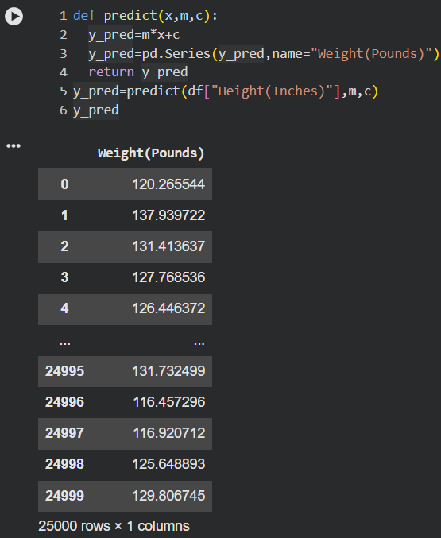
y_pred
Now Using built-in library
Code:-
from sklearn.linear_model import LinearRegression
from sklearn.metrics import r2_score, mean_squared_error
from sklearn.model_selection import train_test_split
X = df[["Height(Inches)"]]
y = df["Weight(Pounds)"]

X_train, X_test, y_train, y_test = train_test_split(
X, y, test_size=0.2, random_state=42
)
model = LinearRegression()
model.fit(X_train, y_train)

y_pred = model.predict(X_test)

print("R2 Score:", r2_score(y_test, y_pred))
print("MSE:", mean_squared_error(y_test, y_pred))

y_newpred = model.predict(X)
print(y_newpred[:100])

