
Academic Year: 2025-26 Name of Student: SUJAL WAFEKAR
Semester: III Moodle ID: 25104066
Class / Branch/ Div: SEIT C Roll No. : 63
Subject: FSJP Lab Date of Submission: 09/10/25
Name of Instructor:

Experiment No.10
AIM: Deploy the application using Docker / Git

Objectives: To deploy the developed application efficiently using Docker and Git by creating containerized environments, managing versions through Git, and ensuring seamless integration and deployment across different platforms.

Steps to Deploy Project on Git:

How to Install Git on Linux
Open Terminal on your Linux machine. Then use your distribution's package manager to install Git.
For example, on Ubuntu, copy and paste the following commands:
sudo apt-get update
sudo apt-get install git
Output:
Reading package lists... Done
Building dependency tree
Reading state information... Done
The following additional packages will be installed:
git-man liberror-perl

Suggested packages:
git-daemon-run git-daemon-sysvinit git-doc git-el git-email git-gui gitk
gitweb git-mediawiki git-arch git-cvs git-svn git-hg

The following NEW packages will be installed:
git git-man liberror-perl
0 upgraded, 3 newly installed, 0 to remove and 0 not upgraded.
Need to get 7,841 kB of archives.
After this operation, 43.8 MB of additional disk space will be used.
To verify the installation, open Terminal (if it's not already open) and type the following command to verify the installation:
git --version

Output:
git version 2.43.0

You should see the installed Git version displayed.
How to Create a GitHub Account
- Go to GitHub and click on "Sign up."
- Follow the instructions to create your account, choose a username and password, and verify your email.
- Once your account is set up, customize your profile with a bio, profile picture, and links to your personal website or social media.
How to Configure Git
Open Terminal and configure Git with the same username and email as your GitHub account:
git config --global user.name "Your GitHub Username"
git config --global user.email "your.email@example.com"
No output will be displayed, but Git will store your credentials for future use.
How to Initialize a Git Repository
Now that you have Git and GitHub set up, let's start by initializing Git in a project. You can use any project of your choice or follow along with our example using the "IP Address Tracker" project.
Step 1: Download and Open Your Project
Download the source code for your chosen project or use the "IP Address Tracker" project from this link. Extract the downloaded ZIP file to a location on your computer. This will provide a concrete example to demonstrate Git concepts.
Step 2: Open the Project in VS Code
Open Visual Studio Code and click on "File" > "Open Folder" to select the folder where you extracted the project.
Step 3: Open the Terminal in VS Code
Click on "Terminal" > "New Terminal" to open the terminal in VS Code, where we'll interact with Git using commands.
Step 4: Initialize a Git Repository
Initialize a Git repository by running the following command:
git init
Output:
Initialized empty Git repository in /Users/spruceemmanuel/Documents/IP Address Tracker/.git/
This command creates a new hidden folder called .git in your project folder, which tracks changes to our project files. When you run git init, Git sets up the necessary files and directories to start versioning our project. This includes:
- A .git folder that stores all the metadata for your repository
- A main branch, which is the default branch for your repository
- A HEAD pointer, which points to the current branch (in this case, main).
By initializing a Git repository, you're telling Git to start tracking changes to your project files. This allows you to version your code, collaborate with others, and maintain a record of changes.
How to Track Changes with Git
Now that we’ve set up Git, it’s ready to keep track of changes in our project.
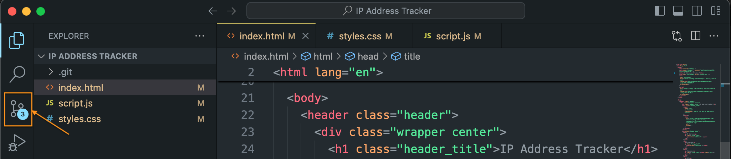
Git notices change in our files, but before we can save these changes, we need to tell Git to do so.
Preparing Changes with git add
To get our changes ready to save, we use the git add command. Here’s how it works:
Adding Individual Files
If you want to add specific files, like index.html, script.js, or styles.css, you can use git add followed by the file name. For example:
git add index.html
Adding All Changes at Once
If you want to add all modified files in the project to the staging area, use:
git add .
Saving Changes with git commit
Once we’ve used git add, we use git commit to save our changes. Here’s how to do it:
git commit -m "Describe your changes here"
Replace "Describe your changes here" with a brief description of what you’ve changed. For example:
git commit -m "Update index.html with new content"

Output:
[master (root-commit) be9b1cd] Update index.html with new content
3 files changed, 386 insertions(+)
create mode 100644 index.html
create mode 100644 script.js
create mode 100644 styles.css
By using git add and git commit, you’re instructing Git to track and save specific versions of your project. This helps you manage changes, collaborate with others, and maintain a record of your progress.
How to Push Your Project to GitHub
Now that we have our changes tracked and committed locally, it’s time to upload our project to GitHub so we can share it with the world.
Step 1: Create a New Repository on GitHub
- Go to GitHub and log in to your account.
- Click the "+" icon in the upper-right corner and select "New repository."
- Fill out the repository name (for example: "ip-address-tracker"), and add a description if you like.
- Choose whether you want the repository to be public or private.
- Do not initialize the repository with a README, gitignore, or license (since we already have a local repository set up).
- Click "Create repository."
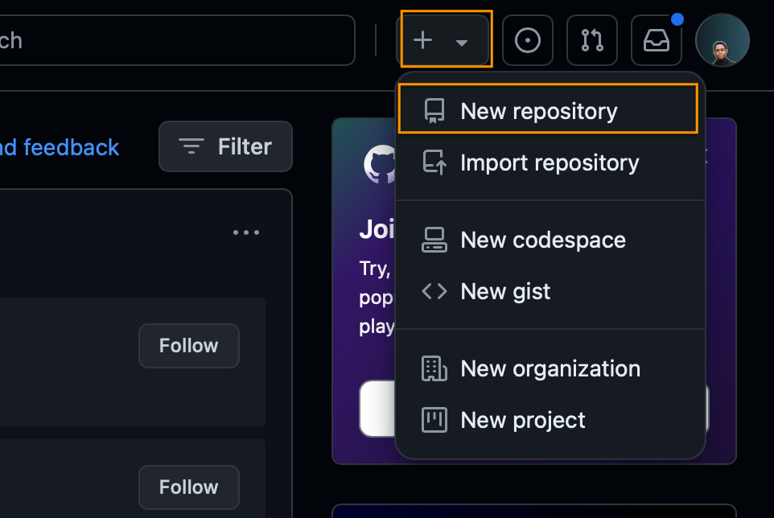
Step 2: Link Your Local Repository to GitHub
To connect your local repository with the new GitHub repository, you need to add a remote origin. Follow these steps:
- Copy the URL of your new GitHub repository. It should look something like this: https://github.com/yourusername/ip-address-tracker.git
- Open Terminal in Visual Studio Code and run the following command:

git branch -M main
git remote add origin https://github.com/yourusername/ip-address-tracker.git
Step 3: Push Your Local Changes to GitHub
Now, push your local commits to the GitHub repository with:
git push -u origin main
Output:
Enumerating objects: 8, done.
Counting objects: 100% (8/8), done.
Compressing objects: 100% (4/4), done.
Writing objects: 100% (6/6), 645 bytes | 645.00 KiB/s, done.
Total 6 (delta 2), reused 0 (delta 0)
To https://github.com/yourusername/ip-address-tracker.git
* [new branch] main -> main
Branch 'main' set up to track remote branch 'main' from 'origin'.
Step 4: Verify Your Repository on GitHub
Go back to your GitHub repository page. You should see all your files and commit history available online.
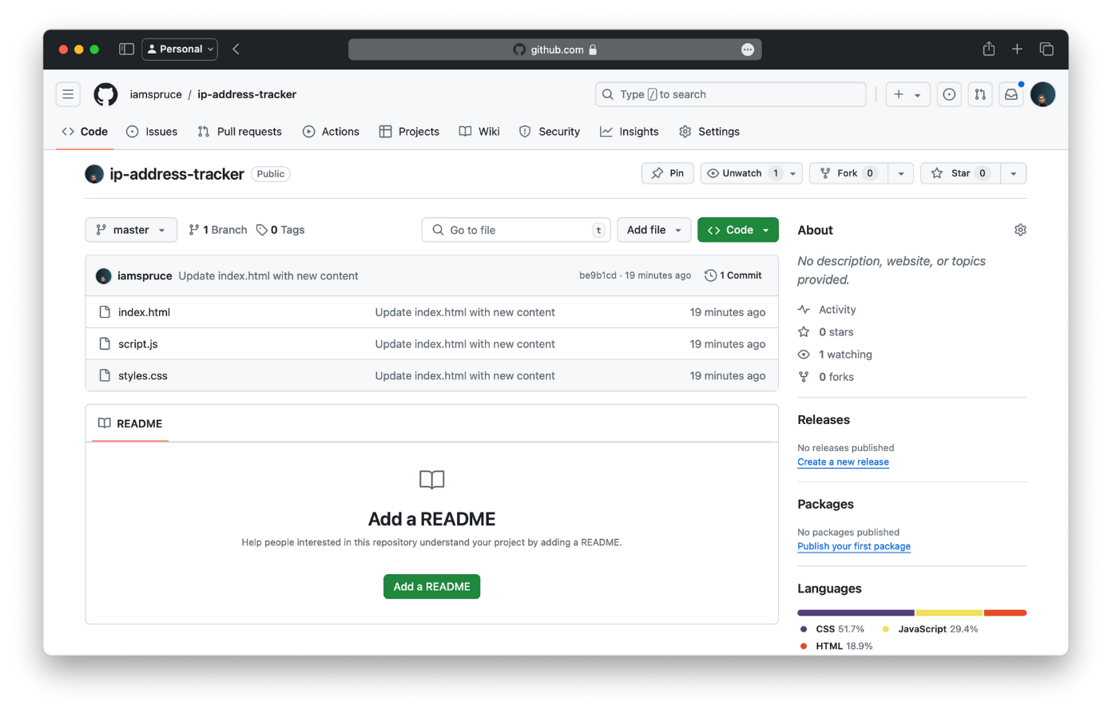

Conclusion:
We have set up Git, created a GitHub account, initialized a Git repository, and hosted your project on GitHub Pages

