Academic Year: 2026-27 Name of Student: Sujal Wafekar
Semester: III Moodle ID: 25104066
Class / Branch / Div: SE IT C Roll No.: 63
Subject: FSJPL Name of Instructor: Ms. Rucha Kulkarni
Experiment No.: 6
Aim
To develop RESTful web services for the SmartChat Memory Manager using Spring Boot and expose endpoints for authenticated memory and chat operations.
Code
MemoryController.java
MemoryController.java
package com.smartchat.memorymanager.controller;

import com.smartchat.memorymanager.dto.MemoryRequest;
import com.smartchat.memorymanager.model.Memory;
import com.smartchat.memorymanager.service.MemoryService;
import org.springframework.http.ResponseEntity;
import org.springframework.web.bind.annotation.*;
import org.springframework.security.core.Authentication;
import java.util.List;

@RestController
@RequestMapping("/api/memories")
public class MemoryController {
private final MemoryService memoryService;

public MemoryController(MemoryService memoryService) {
this.memoryService = memoryService;
}

@GetMapping
public List<Memory> getAll(Authentication authentication) {
return memoryService.getAll(authentication.getName());
}

@PostMapping
public ResponseEntity<Memory> add(@RequestBody MemoryRequest request, Authentication authentication) {
return ResponseEntity.ok(memoryService.add(request, (com.smartchat.memorymanager.model.AppUser) authentication.getPrincipal()));
}

@DeleteMapping("/{id}")
public ResponseEntity<Void> delete(@PathVariable Long id, Authentication authentication) {
return memoryService.delete(id, authentication.getName()) ? ResponseEntity.noContent().build() : ResponseEntity.notFound().build();
}
}

ChatController.java
ChatController.java
package com.smartchat.memorymanager.controller;

import com.smartchat.memorymanager.dto.ChatRequest;
import com.smartchat.memorymanager.dto.ChatResponse;
import com.smartchat.memorymanager.service.ChatService;
import org.springframework.http.ResponseEntity;
import org.springframework.web.bind.annotation.*;
import org.springframework.security.core.Authentication;

@RestController
@RequestMapping("/api/chat")
public class ChatController {
private final ChatService chatService;

public ChatController(ChatService chatService) {
this.chatService = chatService;
}

@PostMapping
public ResponseEntity<ChatResponse> chat(@RequestBody ChatRequest request, Authentication authentication) {
return ResponseEntity.ok(chatService.chat(request.getMessage(), (com.smartchat.memorymanager.model.AppUser) authentication.getPrincipal()));
}
}

MemoryRepository.java
MemoryRepository.java
package com.smartchat.memorymanager.repository;

import com.smartchat.memorymanager.model.Memory;
import com.smartchat.memorymanager.model.MemoryType;
import org.springframework.data.jpa.repository.JpaRepository;
import java.util.List;

public interface MemoryRepository extends JpaRepository<Memory, Long> {
List<Memory> findAllByOwnerUsernameOrderByCreatedAtDesc(String username);
List<Memory> findByOwnerUsernameAndTypeOrderByCreatedAtDesc(String username, MemoryType type);
long deleteByIdAndOwnerUsername(Long id, String username);
}

MemoryService.java
MemoryService.java
package com.smartchat.memorymanager.service;

import com.smartchat.memorymanager.dto.MemoryRequest;
import com.smartchat.memorymanager.model.Memory;
import com.smartchat.memorymanager.model.MemoryType;
import com.smartchat.memorymanager.model.AppUser;
import com.smartchat.memorymanager.repository.MemoryRepository;
import org.springframework.stereotype.Service;
import org.springframework.transaction.annotation.Transactional;
import java.util.List;

@Service
public class MemoryService {
private final MemoryRepository repository;

public MemoryService(MemoryRepository repository) {
this.repository = repository;
}

public List<Memory> getAll(String username) {
return repository.findAllByOwnerUsernameOrderByCreatedAtDesc(username);
}

public Memory add(MemoryRequest request, AppUser owner) {
if (request.getContent() == null || request.getContent().isBlank()) {
throw new IllegalArgumentException("Memory content cannot be empty");
}
MemoryType type = request.getType() == null ? MemoryType.SEMANTIC : request.getType();
double importance = request.getImportance() == null ? 1.0 : Math.max(0.0, Math.min(5.0, request.getImportance()));
return repository.save(new Memory(type, request.getContent().trim(), importance, owner));
}

@Transactional
public boolean delete(Long id, String username) {
return repository.deleteByIdAndOwnerUsername(id, username) > 0;
}
}

Output
The following screenshots show the REST API components implemented for the SmartChat Memory Manager project.
Memory REST Controller
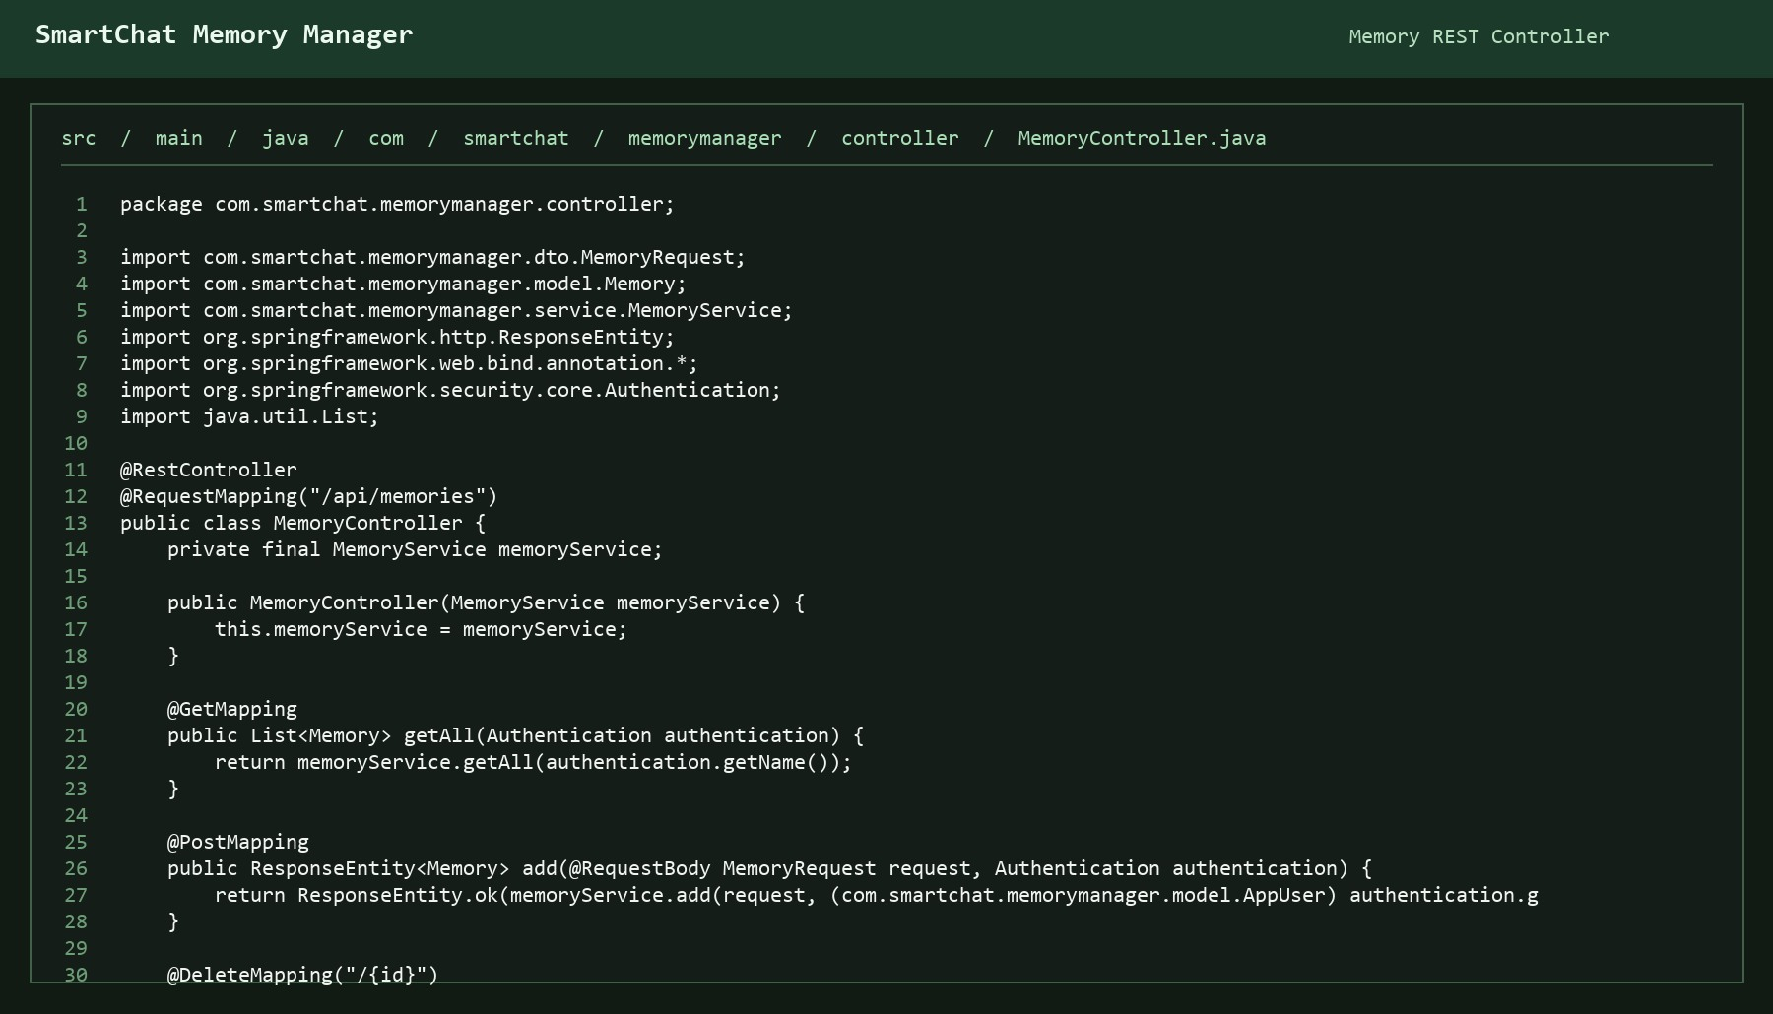

Chat REST Controller
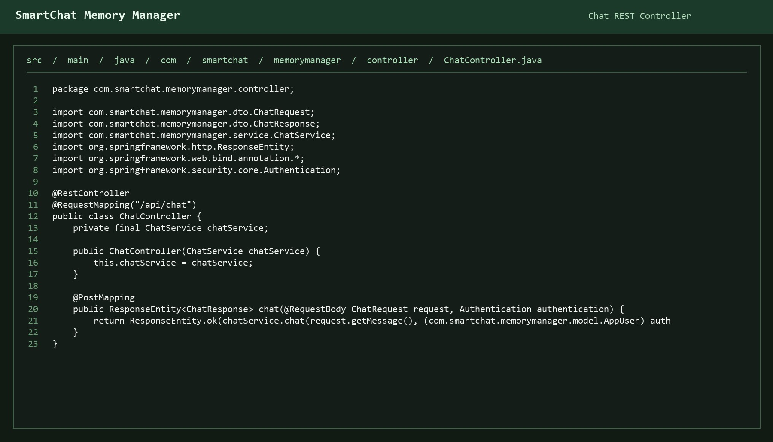

Memory Service
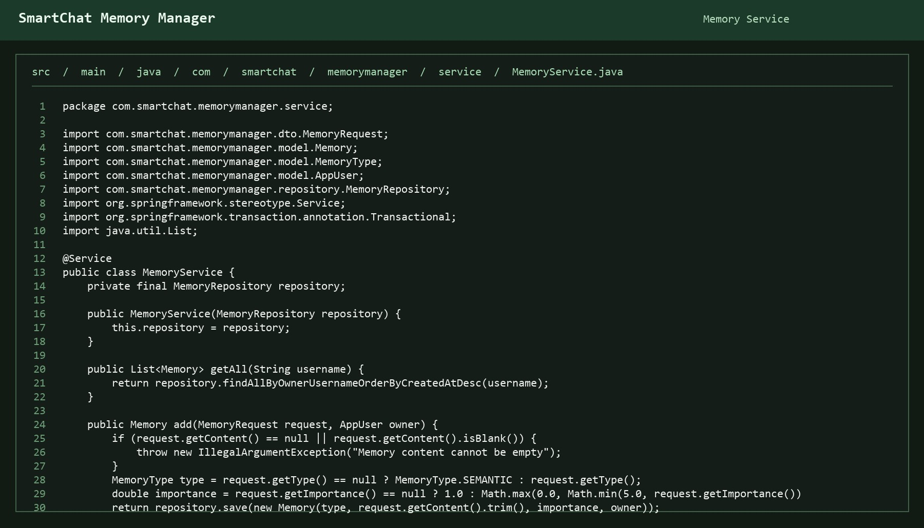

Memory Repository


