Academic Year: 2026-27 Name of Student: Sujal Wafekar
Semester: III Moodle ID: 25104066
Class / Branch/ Div: SE- IT C
Subject: FSJPL Date of Submission: 07/10/2026
Name of Instructor: Ms. Rucha Kulkarni

Experiment No.: 6

AIM: Build a Dynamic Front-End using React.js with API Calls
Completion requirements
CODE:

function App(){
const name="Sujal";
return(
<div>
<h1>Welcome to {name}</h1>
<p>First React Application</p>
</div>
);
}

export default App;

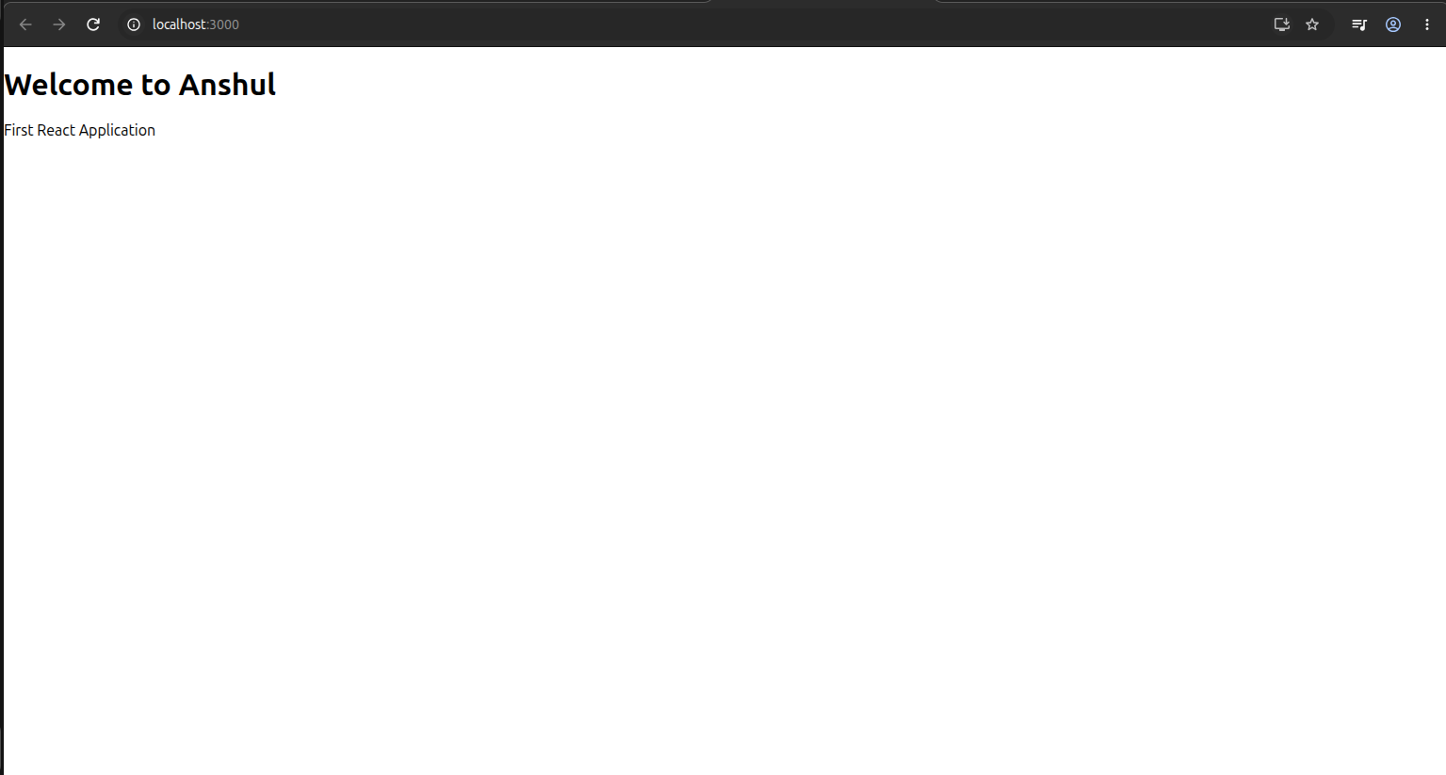

function App(){
const name = "Sujal";
const rno="63";
const branch = "IT";

return(
<div>
<h1>PROFILE</h1>
<p>Name: {name}</p>
<p>ROLL NO.: {rno}</p>
<p>DEPT: {branch}</p>
</div>
);
}
export default App;

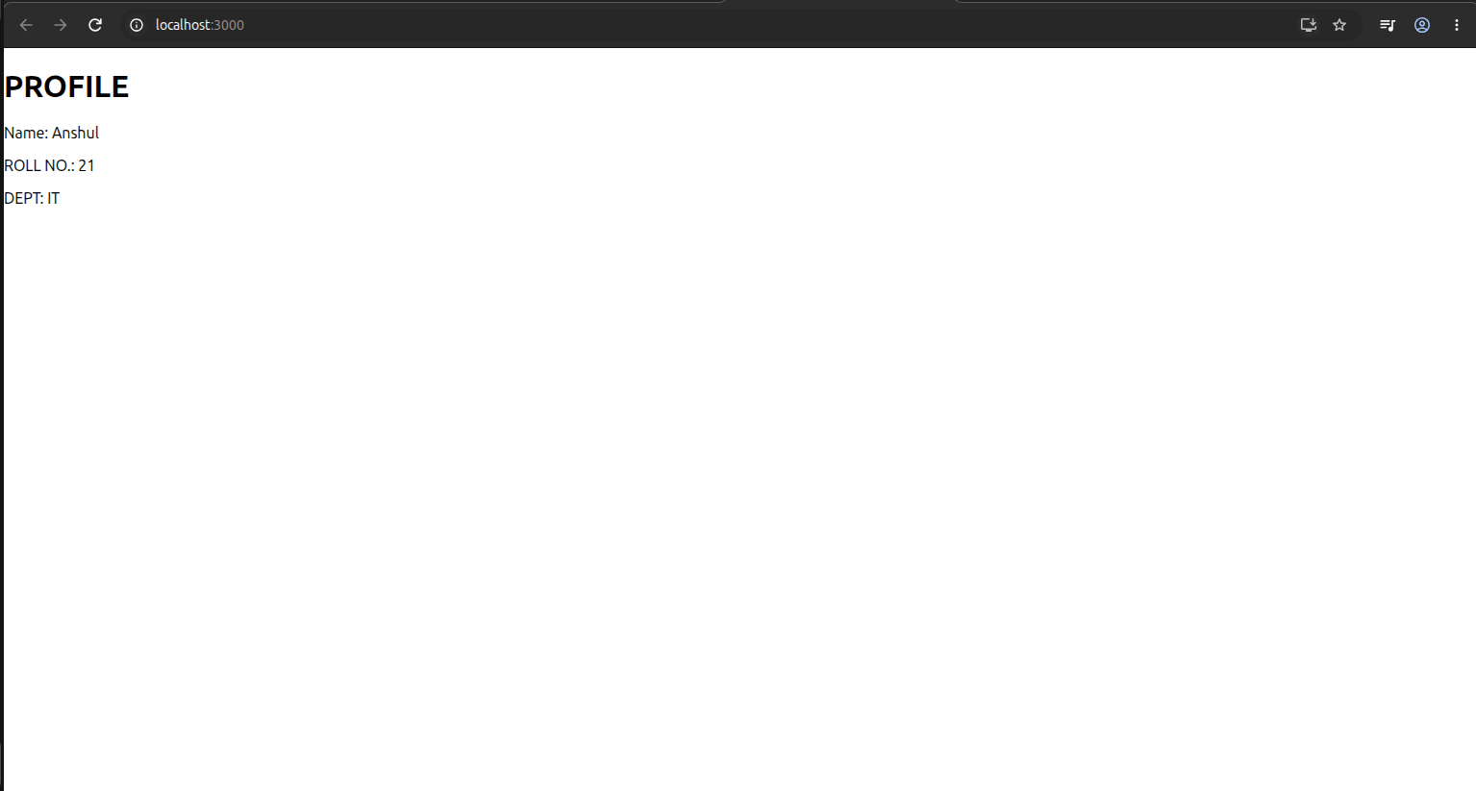
import { useState } from "react";
function App(){
const [count, setCount]= useState(0);
return(
<div>
<h1>COUNT APP</h1>
<h2>Count : {count}</h2>
<button onClick={() => setCount(count+1)}>
+
</button>
<button onClick={() => setCount(count-1)}>
-
</button>
<button onClick={() => setCount(0)}>
RESET
</button>
</div>
);
}
export default App;

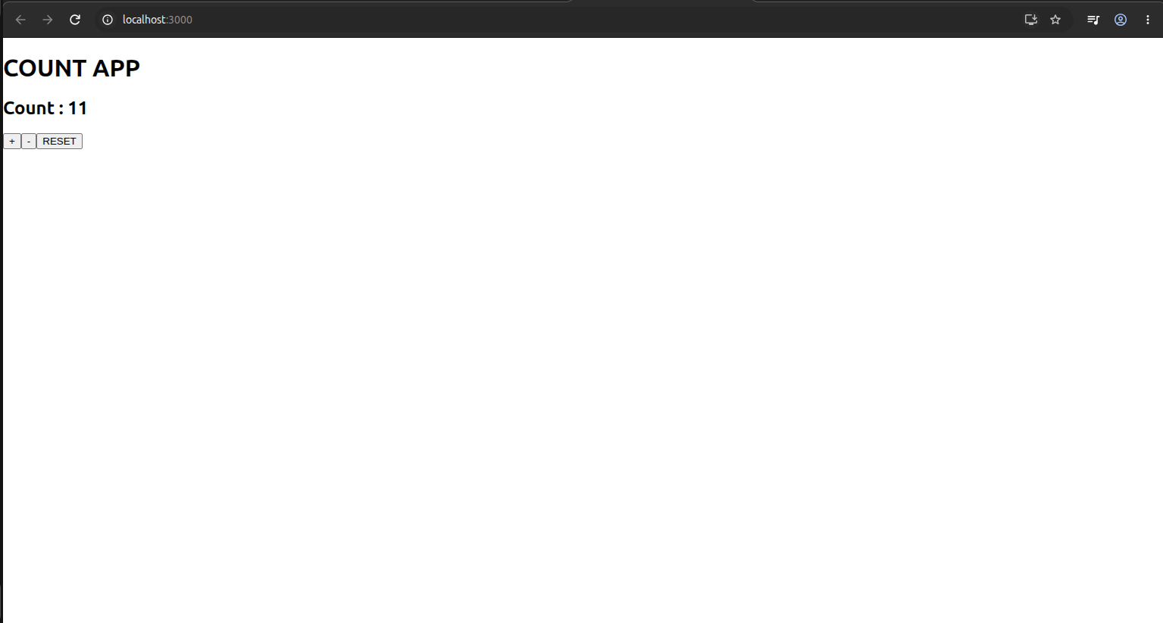
import {useEffect, useState} from "react";
function App(){
const [users, setUsers] = useState([]);
useEffect(()=>{
fetch("https://jsonplaceholder.typicode.com/users")
.then(response=> response.json())
.then(data=> setUsers(data));
}, []);
return(
<div>
<h1>Users</h1>
{users.map(user=>(
<div key={user.id}>
<h3>{user.name}</h3>
<p>{user.email}</p>
</div>
))}
</div>
);
}
export default App;



