
Academic Year: 2025-26 Name of Student: SUJAL WAFEKAR
Semester: III Moodle ID: 25104066
Class / Branch/ Div: SEIT C Roll No. : 63
Subject: FSJP Lab DateofSubmission: 09/10/25Name of Instructor: Ms. Rucha Kulkarni

Experiment No. 9
AIM: Connect React frontend with Spring Boot backend APIs.

Objectives: To establish seamless communication between the React front-end application and the Spring Boot back-end by implementing RESTful APIs for data exchange, enabling efficient client-server interaction and dynamic user interface updates.
IntelliJTheory-
- Setup the SpringBoot Backend

  - Create a SpringBoot project

Youcanuse Spring Initializertogenerate theproject:
    - Dependencies:SpringWeb,SpringBootDevTools,SpringDataJPA(ifusingDB),MySQL Driver (optional), CORS dependency (optional)
    - Packaging:Jar

    - Javaversion:17+(recommended)

  - CreateaRESTController@ RestController @RequestMapping("/api")
@CrossOrigin(origins="http://localhost:3000")//AllowrequestsfromReactapp@GetMapping("/ users")
@PostMapping("/users")
  - Runyourbackend mvnspring-boot:run
Backendwillrunat:http://localhost:8080

- SetuptheReactFrontend

  - CreateaReactapp

npxcreate-react-appfrontend cd frontend
npmstart
Itrunsathttp://localhost:3000

- ConnectReacttoSpringBoot

YoucanusetheFetchAPIorAxiosinReact

npminstallaxios

importReact,{ useEffect,useState} from'react'; import axios from 'axios';
functionApp(){

const [users, setUsers] = useState([]); useEffect(() => {axios.get('http://localhost:8080/ api/users')
.then(response=>setUsers(response.data))
.catch(error=>console.error('Errorfetchingusers:',error));

},[]);

return(

<div>

<h1>UserList</h1>
<ul>

{users.map((u,index) =><likey={index}>{u}</li>)}

</ul>

</div>

); }e x p o r t defaultApp;
- Handle CORS(Cross-OriginResourceSharing)

IfyouseeaCORSerror,addoneofthesefixes:

Option1–Use@CrossOriginannotation(asshownabove) Option 2 – Define a Global CORS Configuration
- TesttheConnection
- StartSpringBootonport8080

- StartReactonport3000

- Visithttp://localhost:3000inyourbrowser

- YoushouldseedatafetchedfromtheSpringBootAPI

Output:
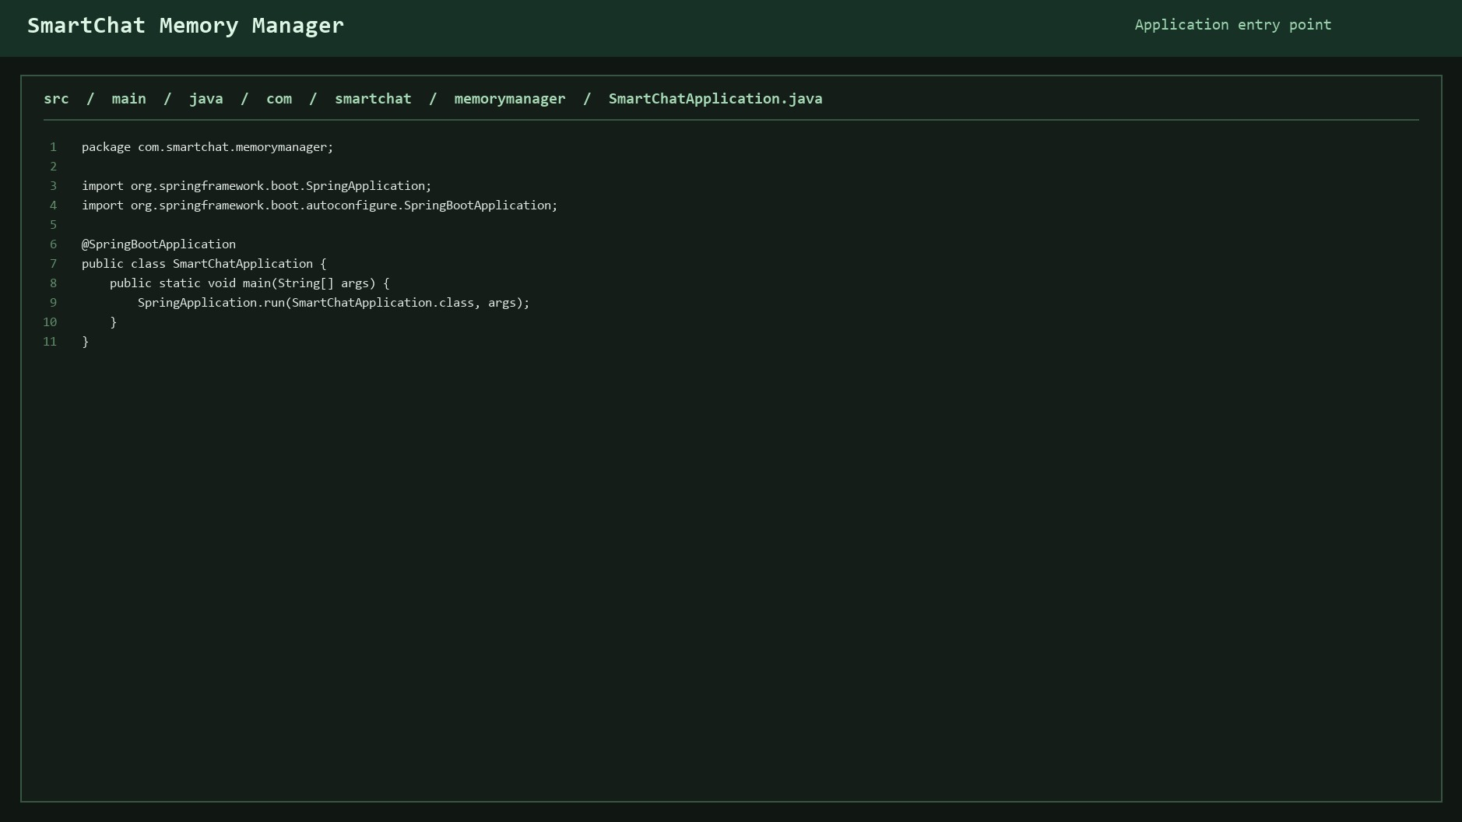
Controller

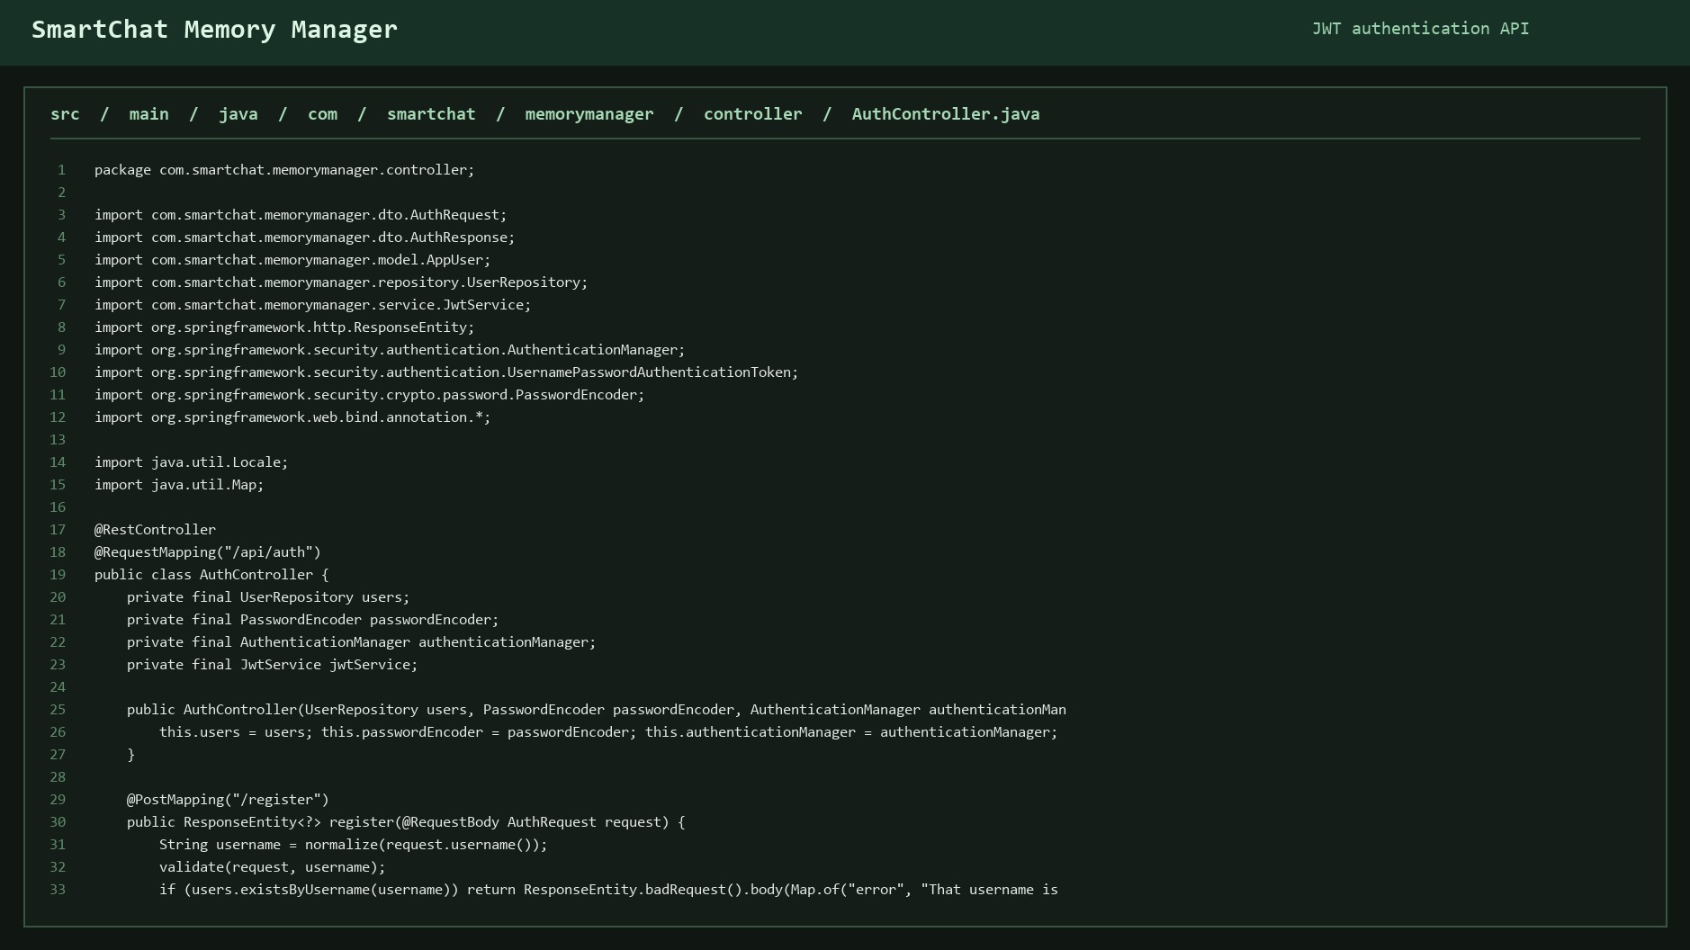
Entity
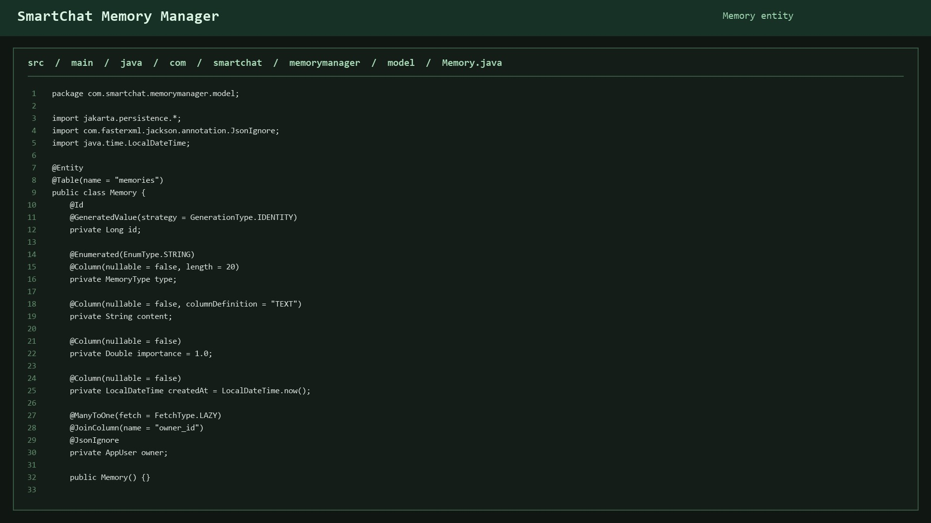

Repository

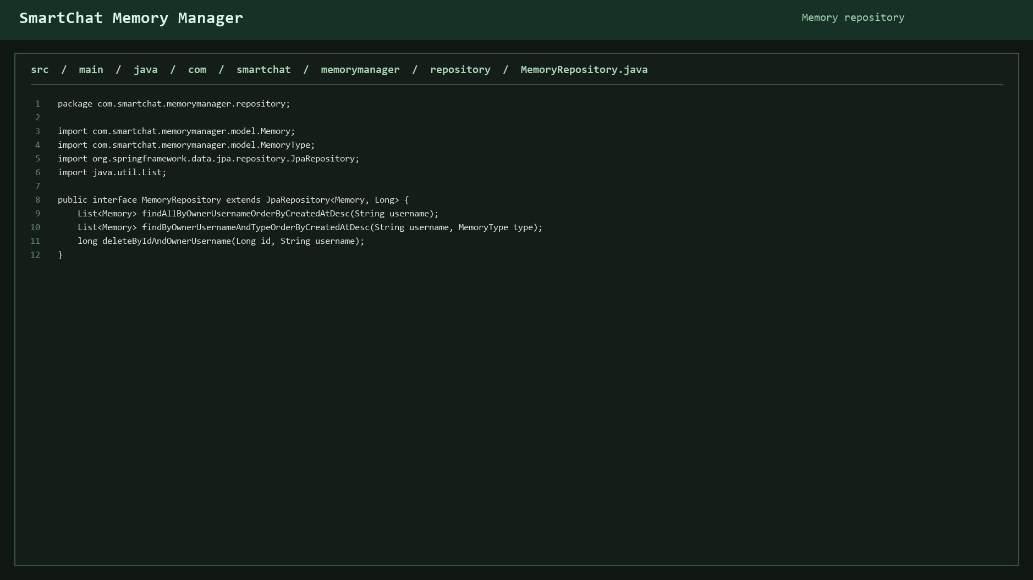
Services
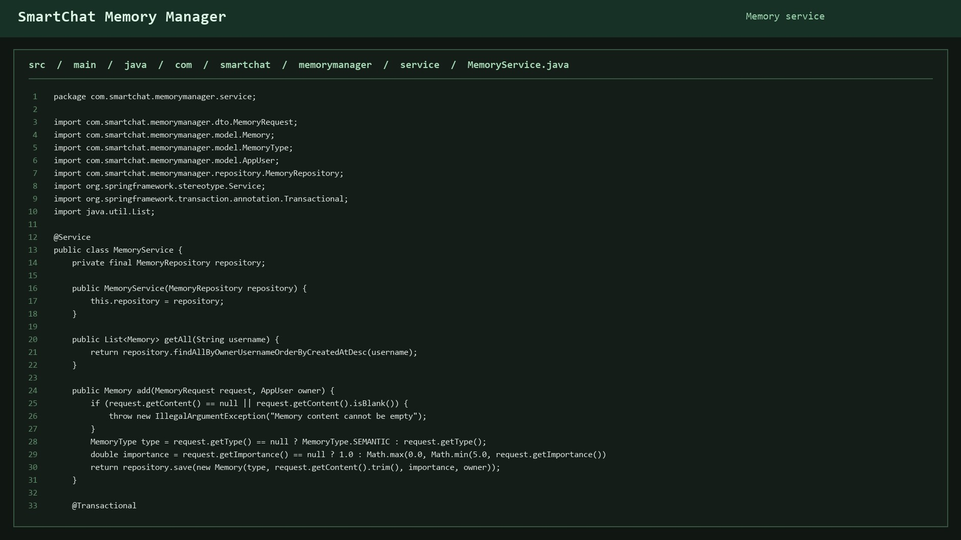

Connectivity
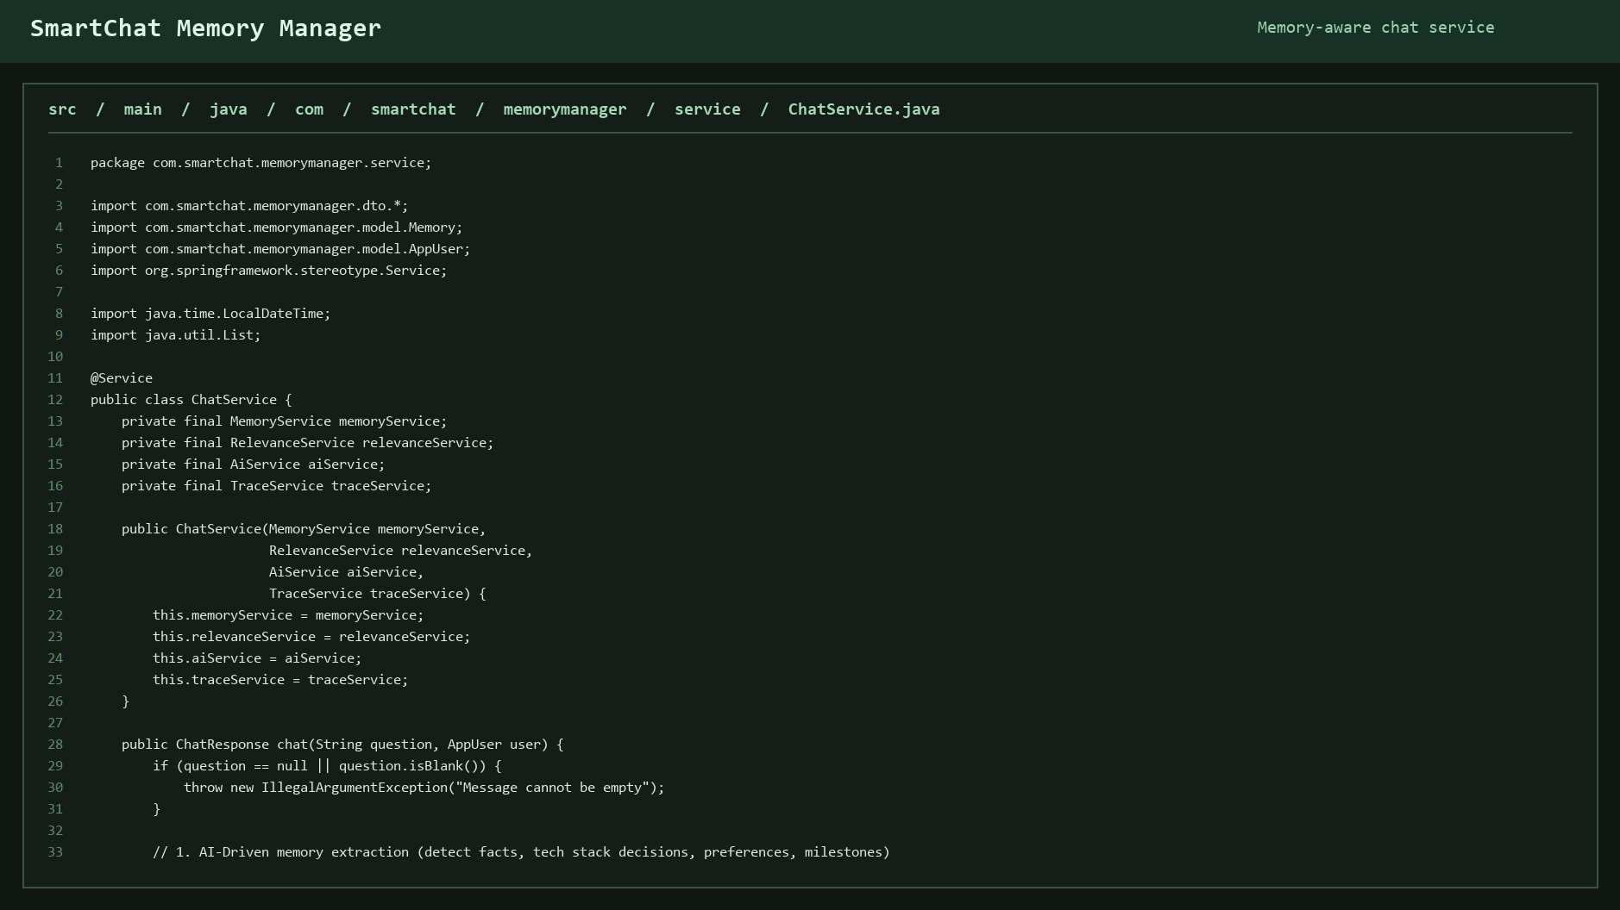

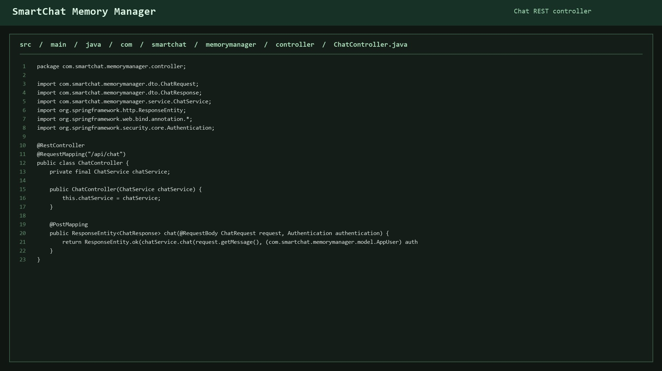

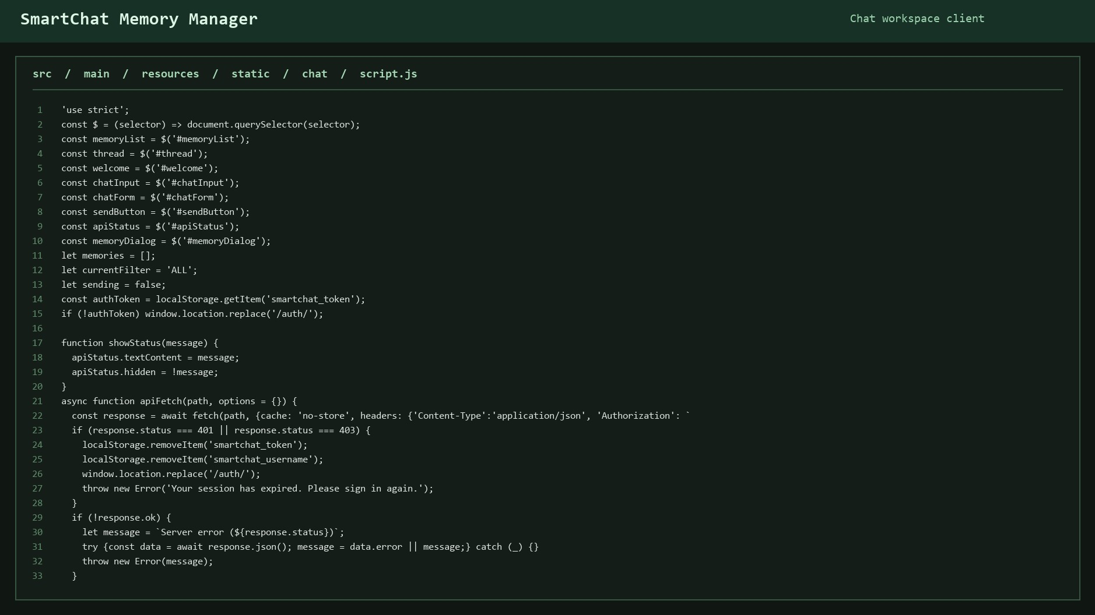
Front End

Conclusion: Successfully Connected Reactfrontend with Spring Boot backend APIs.

