ABC Shoe Factory

Submitted by: Submitted To:

Sujan Basnet Sudeep Bajamiya

Batch: 22C Module Leader

Ncc ID: 00174634

Computing Project

Contents

Chapter 1 2

Introduction 2

1.1 Project Introduction 2

1.2 Project Background 2

1.3 Problem statement 3

1.4 Description of Project 3

1.4.1 Features of Project 3

1.5 Overview of Project 4

Chapter 2 4

Scope of Project 4

2.1 Scope 4

2.2 Limitation 4

2.3 Aims 4

2.4 Objectives 4

2.5 Overview of Scope 5

Chapter 3 5

Development Methodology 5

3.1 Description of Methodology 5

3.2 Design Pattern 6

3.3 Architecture 6

Chapter 4 7

Project Planning 7

4.1 WBS (Work Breakdown Structure) 7

4.2 Milestone 8

4.3 Gantt Chart 9

Chapter 5 11

Risk Management 11

Chapter 6 12

Configuration Management 12

Chapter 7 12

Conclusion 12

# Chapter 1

# Introduction

## 1.1 Project Introduction

My project is about ABC Shoe Factory which deals in making or producing different types of shoes. After shoes are produced we distribute it to many shops and dealers. We don’t deal with customer directly.

This shoe factory produce many design of shoes. They also produce the copy of top brand of shoes like Nike, Adidas etc. I have asked to develop factory official website. Website will contain details of all the shoes that are produce in the factory. This project is only based on Nepal but this website does not have any region restriction so people or shop from any country can visit the site. This project will be focusing on customer satisfaction and advertising the shoe produce in factory not only in Nepal but all over the country.

## 1.2 Project Background

This factory only deals shoes in Nepal but it does not have better information system to advertise its product to Nepal only also. There are many districts in Nepal where many peoples living together. So among them there are some rich people, average peoples and poor people. According to their status they will buy shoes. All people cannot afford the expensive shoes and 90% of people from villages, urban areas definitely cannot afford expensive shoes.

## 1.3 Problem statement

It is a compact portrayal of an issue to be tended to or a condition to be enhanced. So according to place or area this factory should deliver shoes to shop so that the business will get more profit. All people cannot afford the expensive shoes. Cost Price is the biggest problem whenever people go to buy shoes. So before delivering the shoe directly factory should do some analysis of data that how much shoes of that place people can afford so both side factory and shop don’t have suffer any loss.

People from urban areas or in some villages are where there is no internet facility or who don’t know how to use net cannot check the shops respective website or factory own website to see what type of shoes are available and its price. So if they cannot check the details or cost price of shoes shopkeeper might take more money, fool customer etc.

## 1.4 Description of Project

This project is completely based on customer satisfaction so the prestige, profit of ABC Shoe Factory will grow even more. I am making this project so that seller and customers don’t get any kind of problem while selling and buying shoes so that they can earn more profit as well as customer will also get fully satisfied. Details of all deign of shoes that are being produce in this factory will be including in the website clearly so if some shop tries to fool customer they can visit the factory website to do inquiry on shoes.

This project is also based on advertising ABC shoe factory products not only in Nepal but to all country so even people from other country can also see it. This project will also include new feature which helps shop keeper to place order online. New shop who don’t have contract with this product can also place order and make contract by filling online form.

### 1.4.1 Features of Project

* Shop can place the order online.
* Business will earn more profit.
* Customer will be satisfied.
* New design of shoes.
* Very cheap shoes will be available in urban areas.
* Commenting and Rating online or in Paper.
* Customer can directly send the message or mail to factory if they get any negative impact from shoes.
* Even people from another country can visit the website and check the details of shoes.

## 1.5 Overview of Project

This project will be focused on customer satisfaction and gaining more profit. This project will help what kind of shoes they need according to how much they can afford. This project is also about advertising its product all over Nepal as well as to other countries also so that they can check the details of all shoes online.

# Chapter 2

# Scope of Project

## 2.1 Scope

* This project mainly will make the customer satisfy and helps business to earn more profit.
* Shops can place the order online so it will be easy to get what they want.
* Customers can directly visit the factory website to do inquiry so that they don’t get fooled by shopkeeper.
* Trades will be more secure.

## 2.2 Limitation

* Urban areas people can’t visit website.
* Focused only in a country.
* Other countries beside Nepal cannot place any order for now.

## 2.3 Aims

* To make online ordering facility so that they can place order in which design of product they are out of stock.
* To make user friendly website for people to check details of shoes.
* Make the customer fully satisfy.

## 2.4 Objectives

* Administrational login system to add the new product with details.
* Online ordering system will be created by filling online form which will be available in factory official website.
* Creating user friendly website with adding many pictures and icons rather than text.
* Customers can check all the details of shoes in factory website before buying in shops so they will feel secure.
* New shops who don’t have contract with this factory can make contract by filling the online form to place order.

## 2.5 Overview of Scope

This project is only focused for people in Nepal only but other countries people also can visit website for checking. This project will mainly help people who are buying shoes of our company as well as it will help seller too. People will be able check the details and design of shoe of this company via website before buying so they don’t get fooled by shop keeper. But it also have limitation like people from urban areas and who don’t know how to use net cannot check details. I will be using PHP and MYSQL software for developing this project.

# Chapter 3

# Development Methodology

## 3.1 Description of Methodology

There are many different types of methods available in market to develop projects. Among all those methods I have choose waterfall method to develop my project. It is linear, sequential approach to SDLC (Software Development Life Cycle) which emphasizes in logical progression of steps. Development is carried out one step after another. Step cannot be skipped or delayed if it happens project is bound to fail.

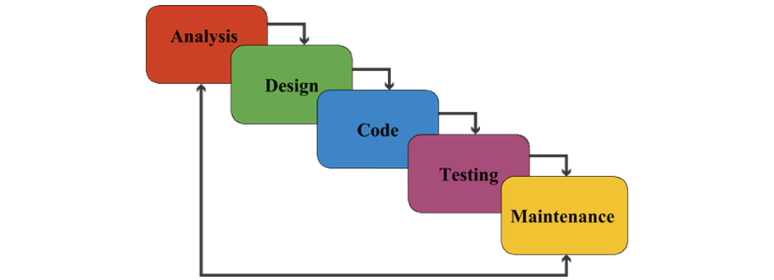

Figure : Waterfall Module

I have choose this method because of following advantages I get in my project:

* It is one of the easy or user friendly method to use.
* While making my project it’s easy to go step by step from start to end.
* We don’t need to take more pressure because one step is done at a time.
* My project is medium so it will work perfectly for me.

## 3.2 Design Pattern

There are many different types of design pattern available in market. Among all those design pattern I have choose MVC which stands for (Model View Controller) design pattern to develop my project. It is comprised with three interconnected parts.

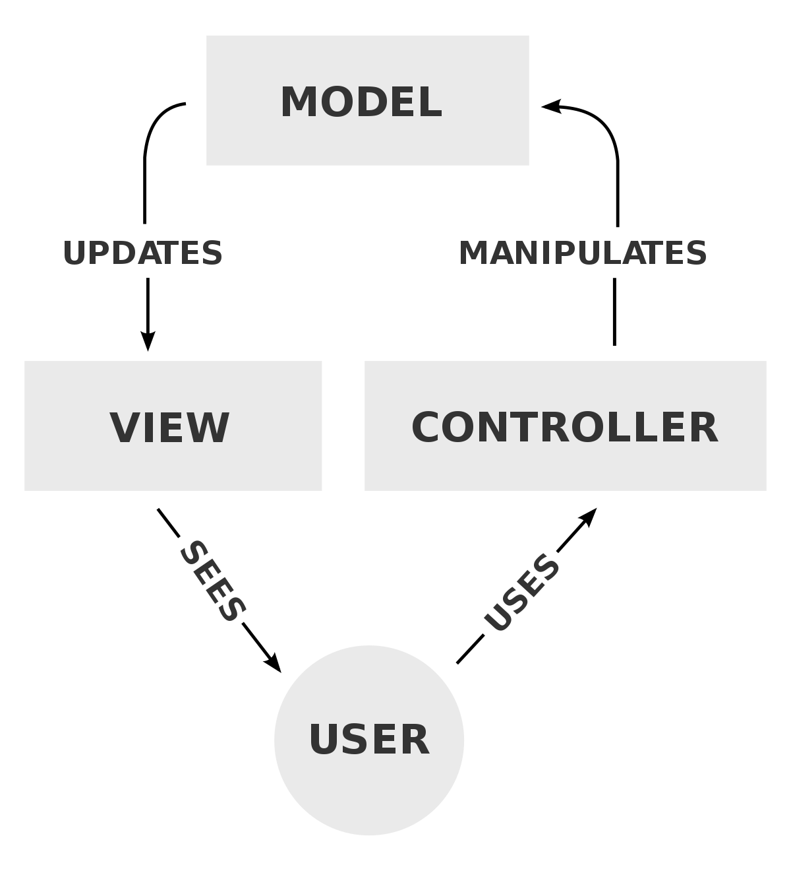

Figure : MVC design pattern

I have choose this pattern because of following benefits in my project:

* It offers support for parallel and rapid development.
* In this model one developer can work on view while other can work on controller so developing will be faster.
* This pattern returns the data without formatting so that it can be used and called for use with any interface.
* Changes can be made easily without affecting the project.

## 3.3 Architecture

We are doing this project in Network Architecture. In network architecture I am using Peer to Peer (P2P) Architecture to do my project. It is commonly used computer networking architecture.

Advantages of the architecture for my project are as follows:

* It is easy to set up and configure the computer in this network.
* Cost is very low to set up P2P network architecture.
* No need of full time system administrator.
* Central dependency is eliminated so it is more reliable.

# Chapter 4

# Project Planning

## 4.1 WBS (Work Breakdown Structure)

WBS is a key of a project that organizes the team work into manageable sections. Projects are called successful when it works well and finished in a given time in given budget. Here we divide the project in different phases and assign the work of a phase to respective group of team. Usually project managers use this method for simplifying the projects. This method is used for any type of projects.

Some benefits of this structure are:

* Facilitates the communication and cooperation between project teams.
* Helps prevent changes.
* Risks are identified by work package.

Diagram : WBS

## 4.2 Milestone

It is the way of knowing how the project is being advancing. After the project divided by WBS into many phases milestone is used to give the required time for that phase according to the deadline of project. It helps to run or continue our project smoothly.

Some benefits of using milestone are:

* Monitoring Deadlines.
* Important dates will be identified easily.
* Identifying Critical path.

Milestone

|  |  |  |  |
| --- | --- | --- | --- |
| S/N | Names | Start Date | End Date |
| 1 | Proposal:  Introduction  Scope  Methodology  Planning  Risk Management  Configuration Management  Conclusion | 3/25/19  3/27/19  3/29/19  4/01/19  4/03/19  4/05/19  4/07/19 | 3/26/19  3/28/19  3/31/19  4/02/19  4/04/19  4/06/19  4/08/19 |
| 2 | Analysis:  Feasibility Study  Elication  Use Case  Architecture | 4/09/19  4/14/19  4/22/19  4/29/19 | 4/13/19  4/21/19  4/28/19  5/06/19 |
| 3 | Design:  Level of Design  Tracing Requirement  UI Design  Database Design | 5/07/19  5/12/19  5/22/19  5/26/19 | 5/11/19  5/21/19  5/25/19  5/31/19 |
| 4 | Implementation:  Coding | 6/01/19 | 6/20/19 |
| 5 | Testing:  Unit Testing  System Testing | 6/21/19  6/25/19 | 6/24/19  6/28/19 |
| 6 | Reporting Project:  Review of Project  User Manual  Final Report | 6/29/19  7/04/19  7/07/19 | 7/03/19  7/06/19  7/09/19 |

Figure : Milestone

I have developed the milestone for my project. I have divided my project into six phases. To complete the whole project I have given 107 day of deadlines from which I have given 15 days Proposal, 28 days for Analysis, 25 days for Design, 20 days for Implementation, 8 days for Testing and 11 days for documentation or reporting the project. Deadline is strict so project must be completed in given days.

## 4.3 Gantt Chart

Gantt chart which is commonly used in projects is one of the most popular and useful ways of showing activities displayed against time. It provides a graphical illustration that helps to plan and track specific tasks in projects. Like in milestone its will also help us to keep the track of time estimated for tasks so that project will be completed in time.

Gantt chart that I have developed for my project is as follows:

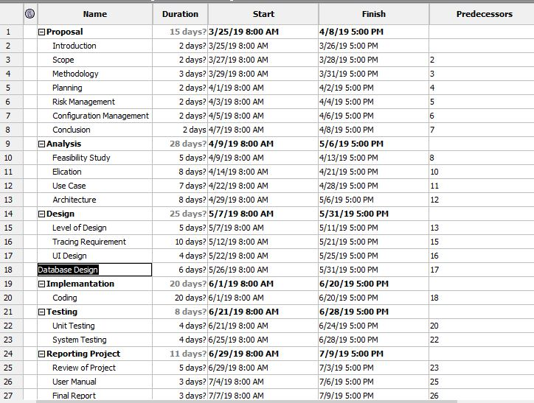

Figure : Gantt chart details

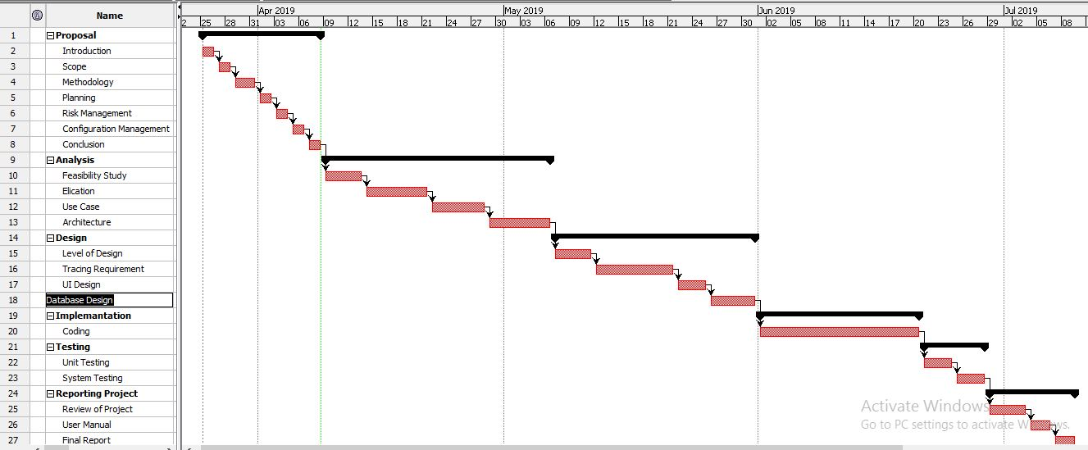

Figure : Gantt Chart

# Chapter 5

# Risk Management

Risk Management is the process of identifying, accessing and controlling threats of organization or company or project etc. Risk can arise from various cause so we must find solution instantly instead of delaying it. There is not anything without risk and it will make impact. So like that my project also have risk but overcome or trying to overcome that risk is called the complete project. We cannot overcome all the risk that arises.

I am going to list some risk that might occur and will give the prevention or solution to minimize or solve the risks through the table below:

First let me give the value for the Probability of risk occurance and impact of that risk.

|  |  |
| --- | --- |
| Probability | Value |
| Very High | 5 |
| High | 4 |
| Medium | 3 |
| Low | 2 |
| Very Low | 1 |

Table : Risk Probability Value

|  |  |
| --- | --- |
| Risk Impact | Value |
| High | 3 |
| Medium | 2 |
| Low | 1 |

Table : Risk Impact Value

Now let’s start the table which will show some risk that might occur and solution for it:

|  |  |  |  |  |
| --- | --- | --- | --- | --- |
| S/N | Risk | Probability | Risk Impact | Prevention OR Solution |
| 1 | Loss Of Data | 2 | 3 | Backing of data in GitHub, cloud, external hardrive etc. |
| 2 | Project Deadline | 3 | 3 | Managing the time according the milestone or gantt chart. |
| 3 | Project Acceptance | 3 | 3 | Making it more user friendly or making full tutorial video. |
| 4 | Team Health Condition | 3 | 2 | Check Up health In a week, keeping of replacement. |

Table : Risk with Solution

# Chapter 6

# Configuration Management

Configuration Management is not the exiting topic but it is most essential for success of the project. It helps in managing, controlling, protecting the projects. It keep or record all the files and document of the project. It helps to keep our data safely.

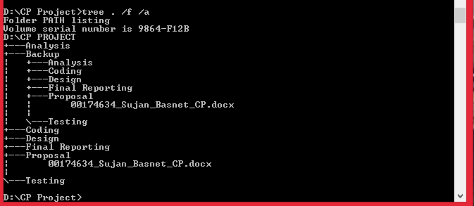

Screenshot: Tree

I have made different folder for the different phase of project to hold. I have also made backup folder which holds all my phases of project in case of any loss of data in future.

# Chapter 7

# Conclusion

This project is all about helping people, advertising the ABC Shoe Factory shoes to all over the country. This project is mainly based on customer’s satisfaction. The estimated time given to complete this project is around 105 days.