# Chapter 5

# Testing

## Introduction

It is the process of checking whether the actual results match the expected results and also to ensure that system is defect free. It also helps in identifying errors or missing requirements to the actual requirements. It can be done with automated tools or manually. In simple terms system testing means Verification of Application under Test (AUT).

## 5.2 Types of Testing

There are different types of testing which have its own good feature. Some types of testing are Unit Testing, White box testing, Black Box testing etc.

### 5.2.1 Black-Box Testing

It is the process of system testing that examines the functionality of the system without peering into internal sources. There are different types of black-box testing like functional testing, non-functional testing and regression testing. I have done some testing on some features:

|  |  |  |  |  |  |
| --- | --- | --- | --- | --- | --- |
| ID | Test Scenario | Test Data | Expected Result | Actual Result | Result(Pass/Fail) |
| t1 | User Register And Data saved In database | Phone Number, Name, Address, Password | If Everything Is Correct Data Register Successful | Registration Successful | Pass |
| t2 | Customer Login | Phone Number, Password | If Data is valid Login Successful | Login Successful | Pass |
| t3 | Edit Profile | Phone Number, Name, Address, Password | Inputted Data valid change data in database | Edit Successful | Pass |
| t4 | Order | Oder Button | If customer clicks on order button shoe must be ordered | Order successful | Pass |
| t5 | View Customer List | All Data Of customer | Show the list of customer | Showing All Data | Pass |
| t6 | View All Orders | All the Orders Made by Customers | Show all the orders | Showing all orders | Pass |
| t7 | Add Shoes | Name, Detail, Image | If data are valid Add successful | Add successful | Pass |
| t8 | Edit Shoes | Name, Detail, Image | If Data are valid change in database | Edit Successful | Pass |
| t9 | Delete Customer | Delete | Delete Customer Data | Delete Successful | Pass |
| t10 | Delete Shoes | Delete | Delete Shoes | Delete Successful | Pass |

# Chapter 6 Issues

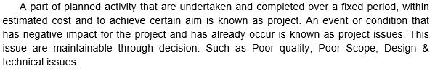

## 6.1 Project Issues

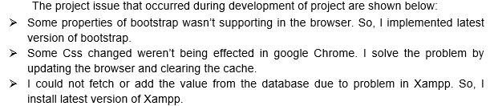

## 6.2 Limitation

* Urban areas people can’t visit website.
* Focused only in a country.
* Other countries beside Nepal cannot place any order for now.

## 6.3 Risk Management

Risk Management is the process of identifying, accessing and controlling threats of organization or company or project etc. Risk can arise from various cause so we must find solution instantly instead of delaying it. There is not anything without risk and it will make impact. So like that my project also have risk but overcome or trying to overcome that risk is called the complete project. We cannot overcome all the risk that arises.

I am going to list some risk that might occur and will give the prevention or solution to minimize or solve the risks through the table below:

First let me give the value for the Probability of risk occurance and impact of that risk.

|  |  |
| --- | --- |
| Probability | Value |
| Very High | 5 |
| High | 4 |
| Medium | 3 |
| Low | 2 |
| Very Low | 1 |

Table : Risk Probability Value

|  |  |
| --- | --- |
| Risk Impact | Value |
| High | 3 |
| Medium | 2 |
| Low | 1 |

Table : Risk Impact Value

Now let’s start the table which will show some risk that might occur and solution for it:

|  |  |  |  |  |  |
| --- | --- | --- | --- | --- | --- |
| S/N | Risk | Probability | Risk Impact | Value (Probability*Risk Impact) | Prevention OR Solution |
| 1 | Loss Of Data | 2 | 3 | 6 | Backing of data in GitHub, cloud, external hardrive etc. |
| 2 | Project Deadline | 3 | 3 | 9 | Managing the time according the milestone or gantt chart. |
| 3 | Project Acceptance | 3 | 3 | 9 | Making it more user friendly or making full tutorial video. |
| 4 | Team Health Condition | 3 | 2 | 6 | Check Up health In a week, keeping of replacement. |

Table : Risk with Solution

## 6.4 Configuration Management

Configuration Management is not the exiting topic but it is most essential for success of the project. It helps in managing, controlling, protecting the projects. (StakeholderMap, 2019) It keep or record all the files and document of the project. It helps to keep our data safely.

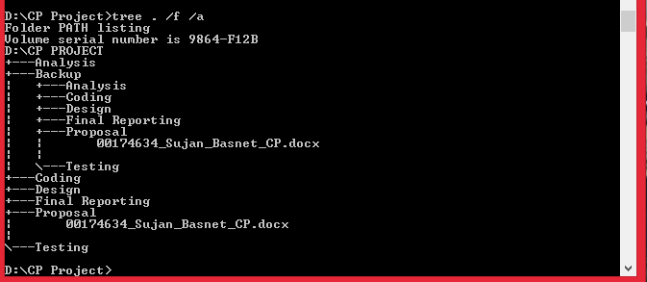

Screenshot: Tree

I have made different folder for the different phase of project to hold. I have also made backup folder which holds all my phases of project in case of any loss of data in future.