1. **Write SQL Query to create following table (Student).**

|  |  |  |  |  |  |  |
| --- | --- | --- | --- | --- | --- | --- |
| **Fields** | **Datatypes** | **Null** | **Key** | **Default** | **Check** | **Extra** |
| student_id | int(11) | No | Primary |  |  | Auto_Increment |
| name | varchar(50) | No |  |  |  | Unique |
| address | varchar(100) | No |  | Birtamode |  |  |
| class_id | int(11) | No | Foreign |  |  |  |
| section | varchar(50) | Yes |  |  |  |  |
| Age | int(11) | No |  | 16 | Age>=15 |  |

**Note:** Foreign key references to (Class) Table.

SQL QUERY:

create database pragati;

create table class (

class_id int primary key

);

create table student

(

student_id int primary key auto_increment,

name varchar (50) NOT NULL,

address varchar (100) default ’Birtamode’ NOT NULL,

class_id int NOT NULL,

section varchar (50),

age int default 16 NOT NULL,

CONSTRAINT st_na_un unique(name),

CONSTRAINT st_ag_ch check(age>=15),

CONSTRAINT st_ci_fk foreign key(class_id) references class(class_id)

);

**Database pragati:**

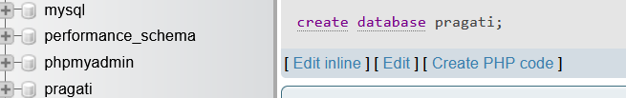

**Table class:**

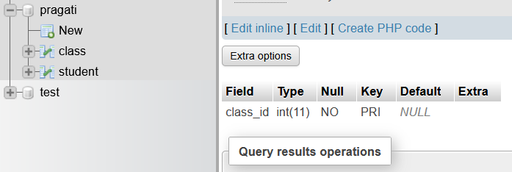

**Table student:**

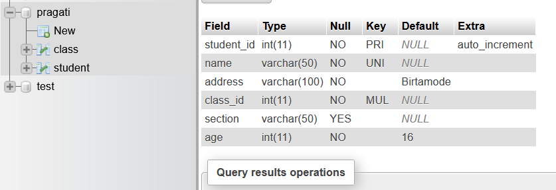

1. **Write SQL query to drop primary key from above table.**

SQL QUERY:

alter table student modify student_id int;

alter table student drop primary key;

**Table after removing auto_increment from student_id:**

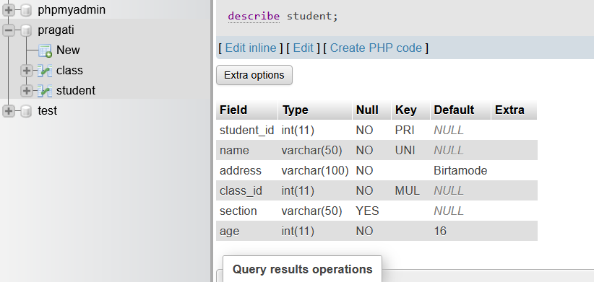

**Table after removing primary key from student_id:**

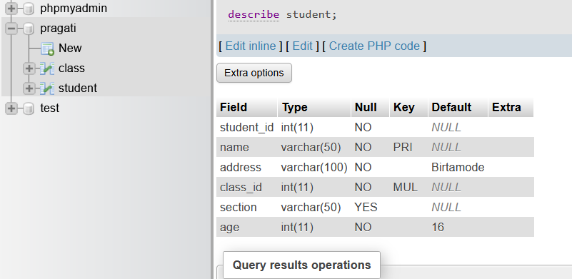

1. **Write SQL query to drop foreign key from above table.**

SQL QUERY:

[alter](http://localhost/phpmyadmin/url.php?url=https://dev.mysql.com/doc/refman/8.0/en/alter-table.html) [table](http://localhost/phpmyadmin/url.php?url=https://dev.mysql.com/doc/refman/8.0/en/alter-table.html) student drop foreign key st_ci_fk;

**Table student after removing foreign key from class_id attribute:**

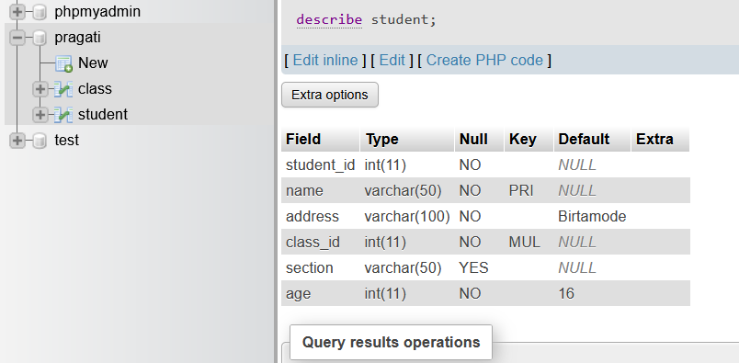

1. **Write SQL query to set student id as primary key.**

SQL QUERY:

alter table student add primary key (student_id);

**Table student after adding primary key to student_id:**

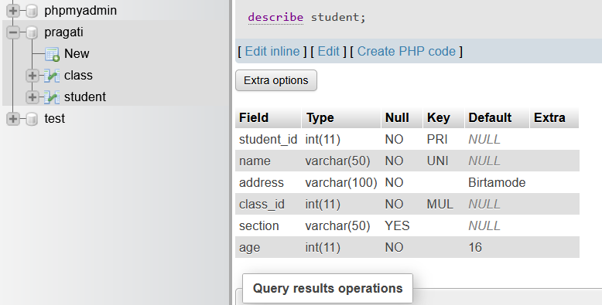

1. **Write SQL query to set class id as foreign key.**

SQL QUERY:

alter table student add foreign key (class_id) references class(class_id);

**Table student after adding foreign key to class id taking reference from class table:**

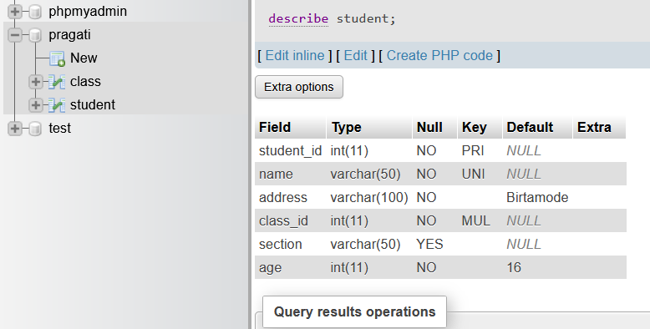

1. **Write SQL query to remove unique constraint from name.**

SQL QUERY:

[alter](http://localhost/phpmyadmin/url.php?url=https://dev.mysql.com/doc/refman/8.0/en/alter-table.html) [table](http://localhost/phpmyadmin/url.php?url=https://dev.mysql.com/doc/refman/8.0/en/alter-table.html) student drop constraint st_na_un;

**Table student after removing unique constraint from name attribute:**

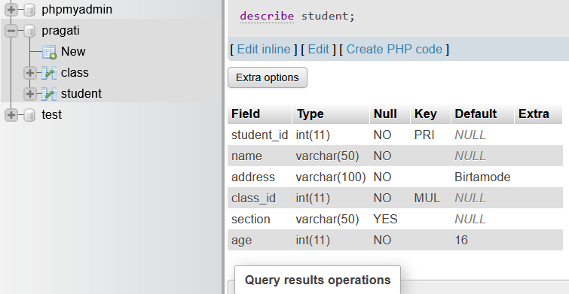

1. **Write SQL query to remove default constraint from age.**

SQL QUERY:

[alter](http://localhost/phpmyadmin/url.php?url=https://dev.mysql.com/doc/refman/8.0/en/alter-table.html) [table](http://localhost/phpmyadmin/url.php?url=https://dev.mysql.com/doc/refman/8.0/en/alter-table.html) student alter column age drop [default](http://localhost/phpmyadmin/url.php?url=https://dev.mysql.com/doc/refman/8.0/en/miscellaneous-functions.html%23function_default);

**Table student after removing default constraint from age:**

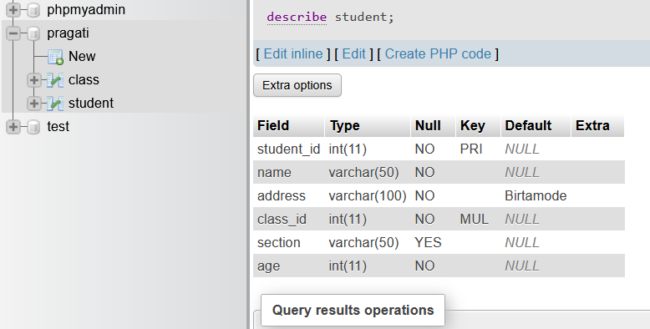

1. **Write SQL query to add unique constraint to section.**

SQL QUERY:

[alter](http://localhost/phpmyadmin/url.php?url=https://dev.mysql.com/doc/refman/8.0/en/alter-table.html) [table](http://localhost/phpmyadmin/url.php?url=https://dev.mysql.com/doc/refman/8.0/en/alter-table.html) student add constraint unique(section);

**Table student after adding unique constraints to section:**

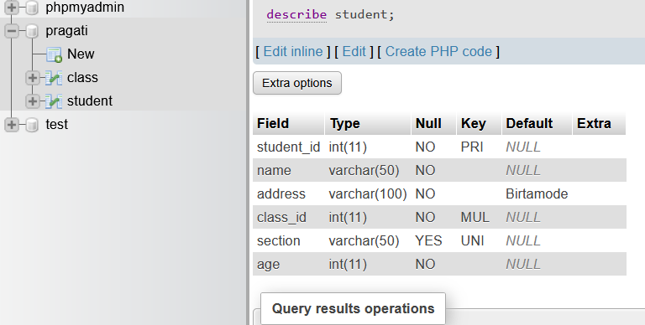

1. **Write SQL query to add default value 18 to age.**

SQL QUERY:

[alter](http://localhost/phpmyadmin/url.php?url=https://dev.mysql.com/doc/refman/8.0/en/alter-table.html) [table](http://localhost/phpmyadmin/url.php?url=https://dev.mysql.com/doc/refman/8.0/en/alter-table.html) student alter column age [set](http://localhost/phpmyadmin/url.php?url=https://dev.mysql.com/doc/refman/8.0/en/set.html) [default](http://localhost/phpmyadmin/url.php?url=https://dev.mysql.com/doc/refman/8.0/en/miscellaneous-functions.html%23function_default) 18;

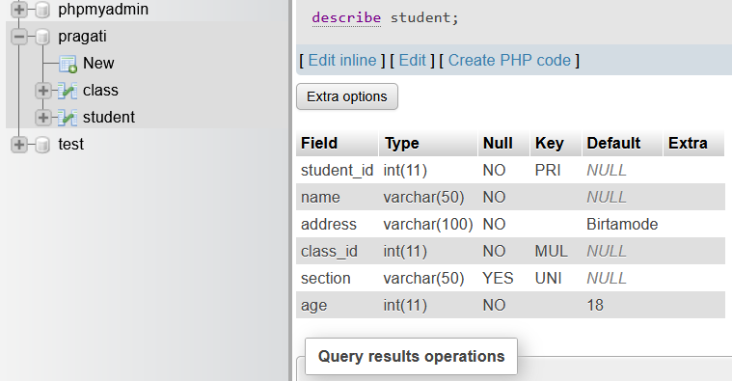**Table student after adding default value 18 to age:**

1. **Write SQL query to change column name address to location.**

SQL QUERY:

alter table student change address location varchar(100);

**Table after changing column name address to location:**

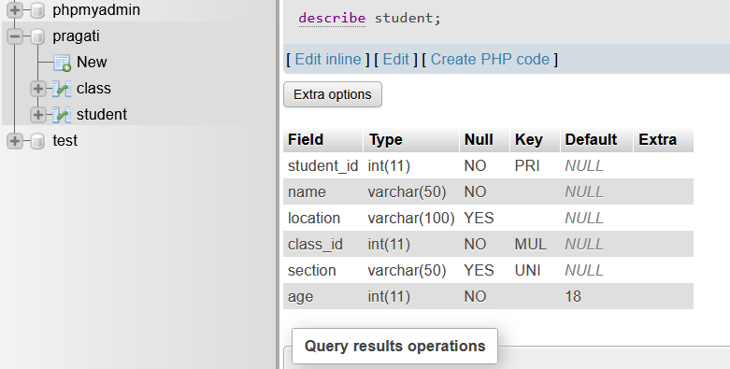

1. **Write SQL query to add new column email and make it not null.**

SQL QUERY:

**Table student after adding email column:**

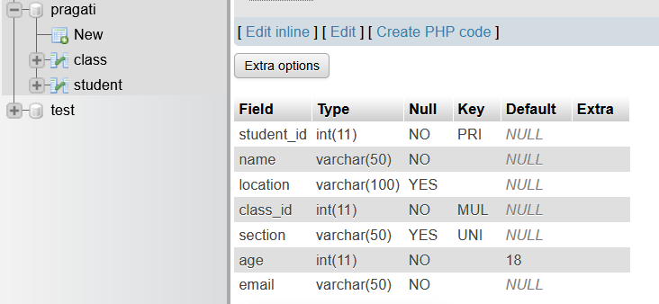

1. **Write SQL query to remove column section from above table.**

SQL QUERY:

**Table student after removing column section:**

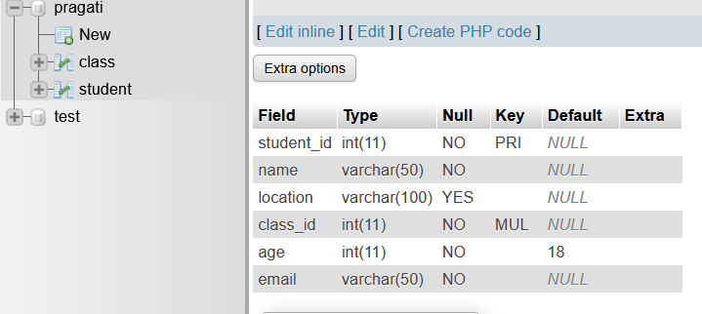

1. **Write SQL query to add new column contact and make data type as integer.**

SQL QUERY:

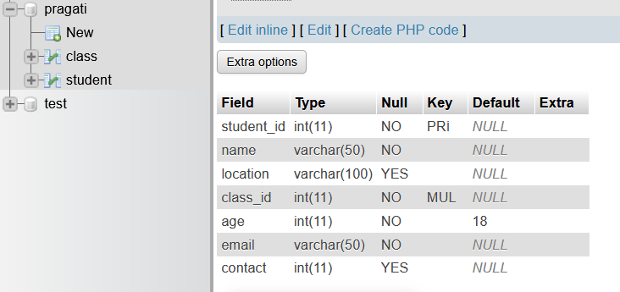**Table student after adding column contact:**

1. **Write SQL query to change data type of column contact to varchar and make it unique.**

SQL QUERY:

**Table student after modifying data type of column contact to varchar:**

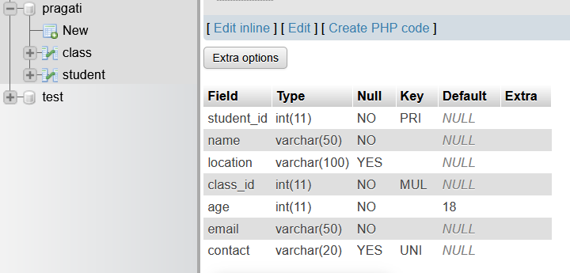

1. **Write SQL query to change default value of address to Kathmandu.**

SQL QUERY:

**Table student after changing default value of the address to Kathmandu:**

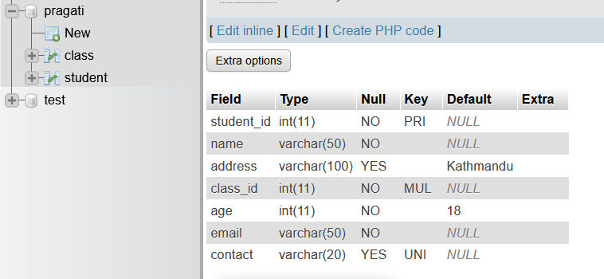

1. **Insert five set of records in above table.**

SQL QUERY:

**Table class after inserting five sets of records:**

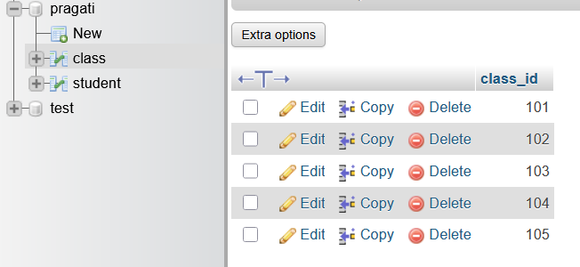

**Table student after inserting five sets of records:**

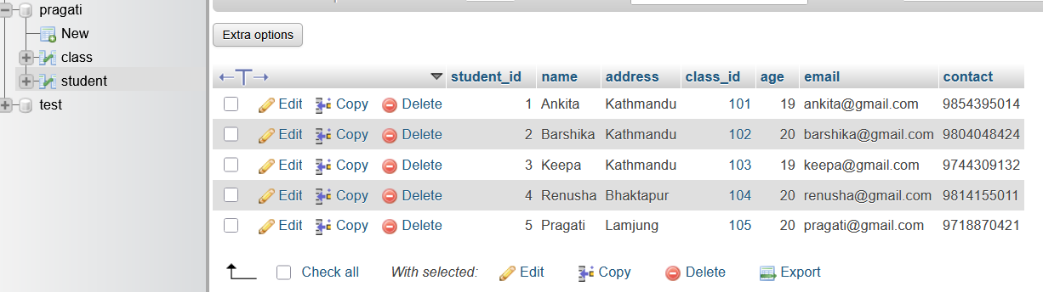

**17. Write SQL query to update name and address of student whose student id is 5.**

SQL QUERY:

**Table student after updating name and address of student having student_id 5:**

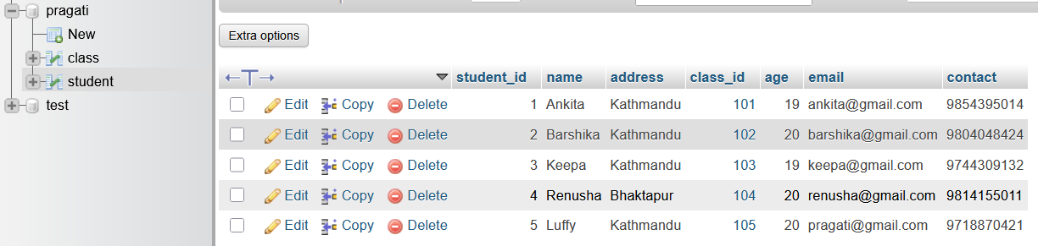

**18. Write SQL query to delete all the records of student having age greater than 20.**

SQL QUERY:

**Table student after removing student having age greater than 20:**

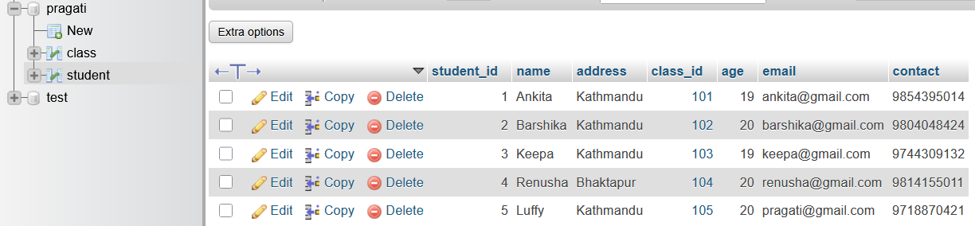

**19. Write SQL query to update age of student having address btm.**

SQL QUERY:

**Table student before upgrading age of student having address btm:**

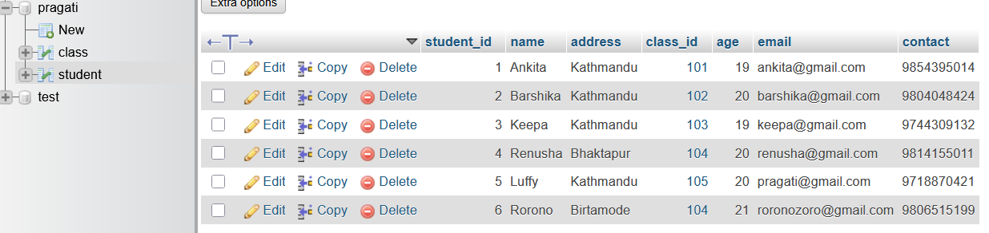

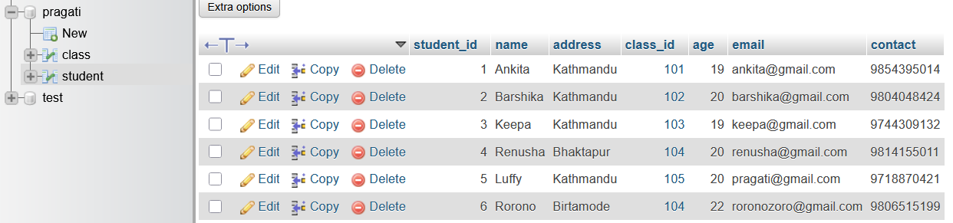**Table student after upgrading age of student having address btm:**

**20. Write SQL query to delete all records of student having student id 1.**

SQL QUERY:

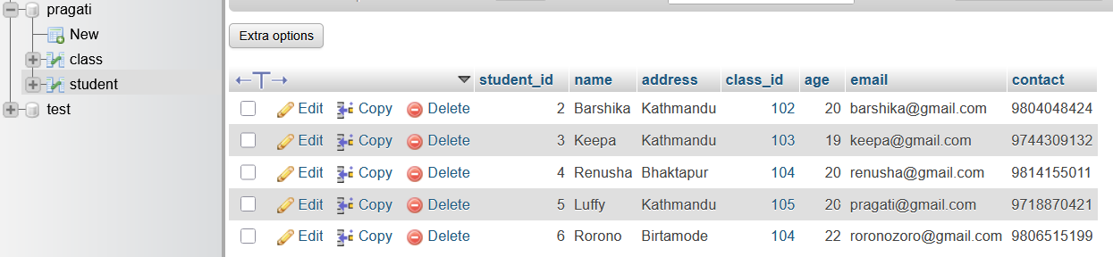 **Table student after deleting all records of student having student id 1:**