|  |  |  |  |  |  |  |
| --- | --- | --- | --- | --- | --- | --- |
| Fields | Datatypes | Null | Key | Default | Check | extra |
| student_id | Int(11) | No | Primary |  |  | Auto_Increment |
| name | varchar(50) | N0 |  |  |  | Unique |
| address | varchar(100) | No |  | Birtamode |  |  |
| class_id | int(11) | No | Foreign |  |  |  |
| section | varchar(50) | Yes |  |  |  |  |
| age | int(11) | No |  | 16 | age>=15 |  |

1. Write SQL Query to create following table(Student).

**Note**: Foreign key reference to (Class) Table.

SQL query:

Database sujan:

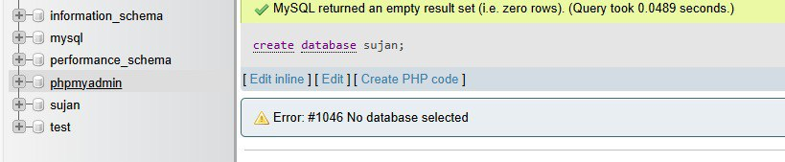

Table class:

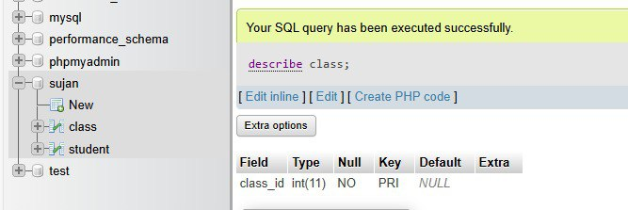

Table student:

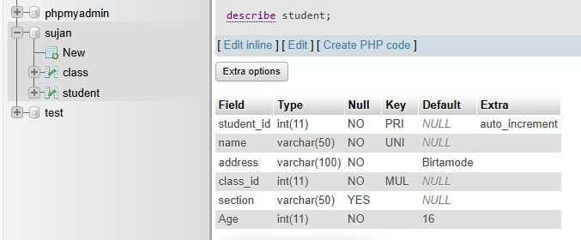

2. Write SQL query to drop primary key from above table.

SQL query:

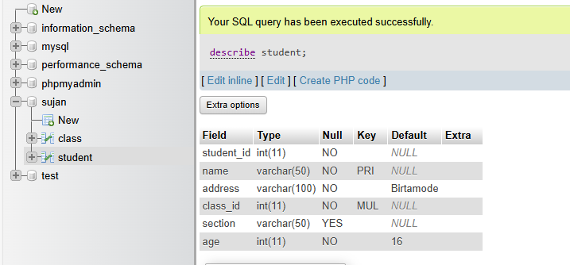

3. Write SQL query to drop foreign key from above table.

SQL query:

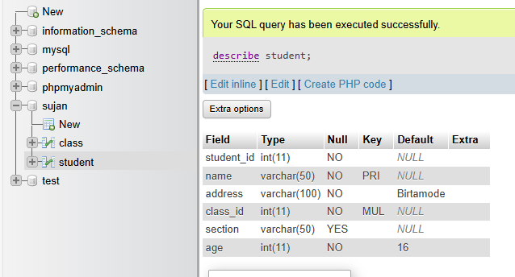

4. Write SQL query to set student id as primary key.

SQL query:

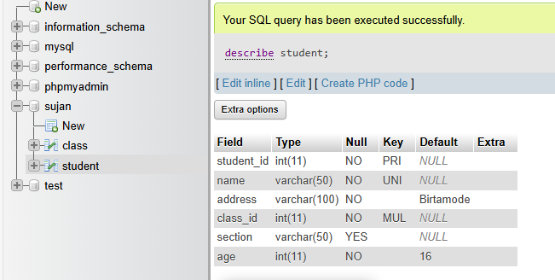

5. Write SQL query to set class id as foreign key.

SQL query:

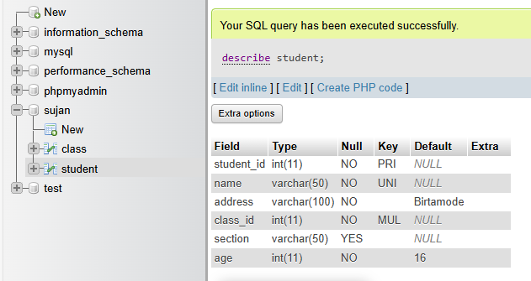

6. Write SQL query to remove unique constraint from name.

SQL query:

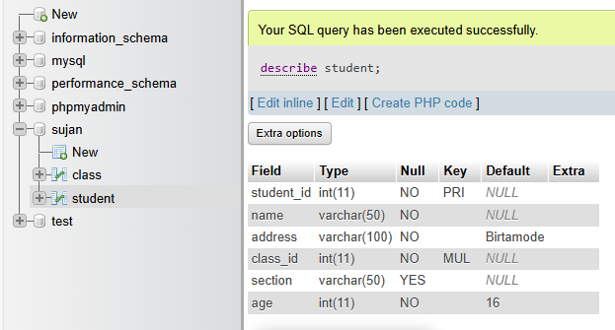

7. Write SQL query to remove default constraint from age.

SQL query:

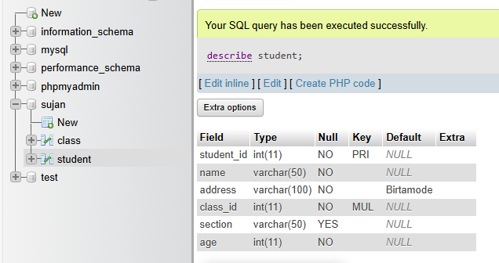

8. Write SQL query to add unique constraint to section.

SQL query:

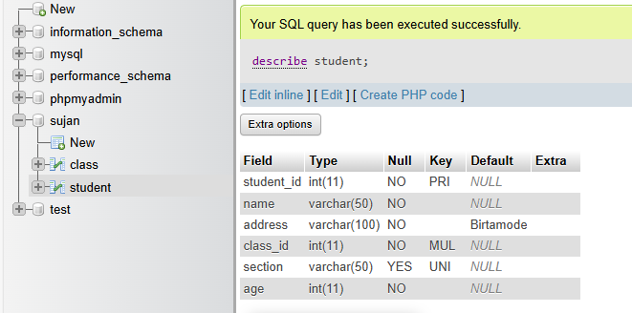

9. Write SQL query to add default value 18 to age.

SQL query:

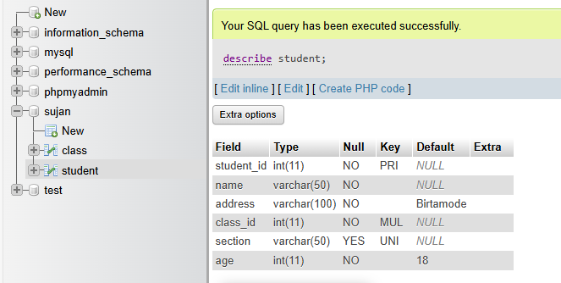

10. Write SQL query to change column name address to location.

SQL query:

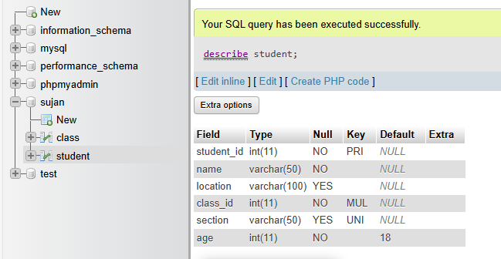

11. Write SQL query to add new column email and make it not null.

SQL query:

alter table student

add email varchar(50) not null;

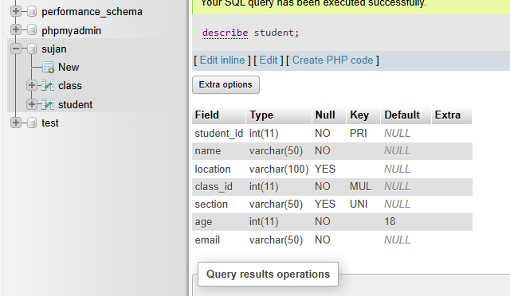

12. Write SQL query to remove column section from above table.

SQL query:

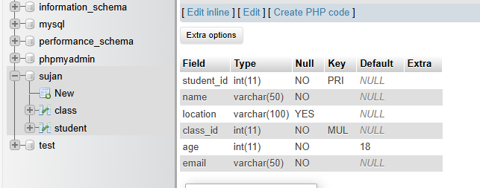

13. Write SQL query to add new column contact and make data type as integer.

SQL query:

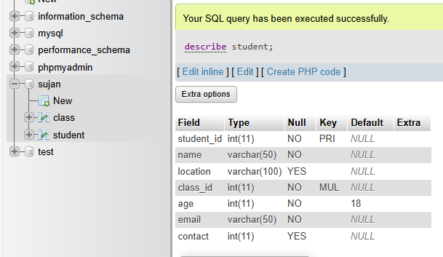

14. Write SQL query to change data type of column contact to varchar and make it unique.

SQL query:

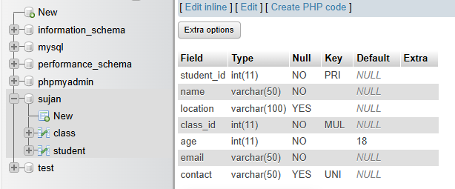

15. Write SQL query to change default value of address to Kathmandu.

SQL query:

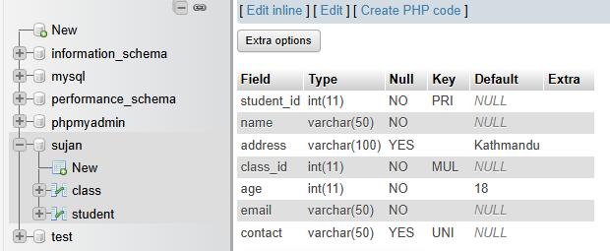

16. Insert five set of records in above table.

SQL query:

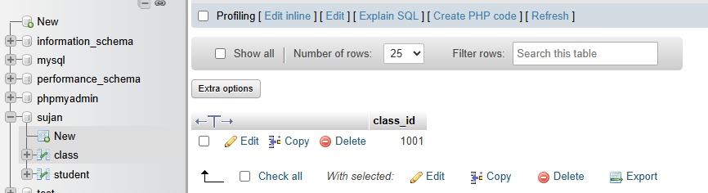

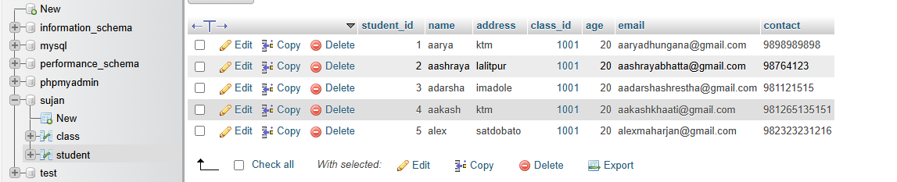

17. Write SQL query to update name and address of student whose student id is 5.

SQL query:

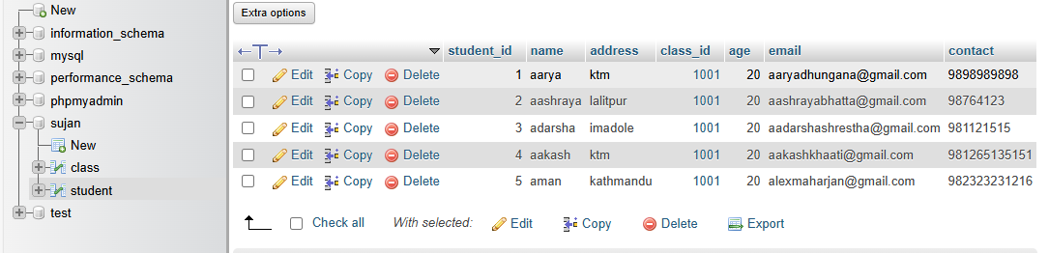

18. Write SQL query to delete all the records of student having age greater than 20.

SQL query:

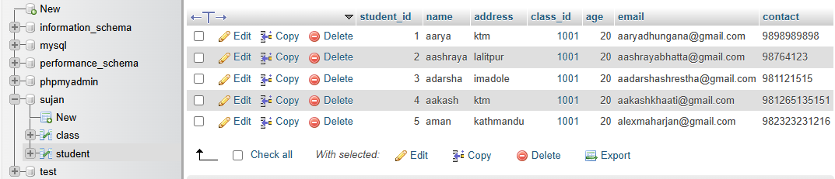

19. Write SQL query to update age of student having address btm.

SQL query:

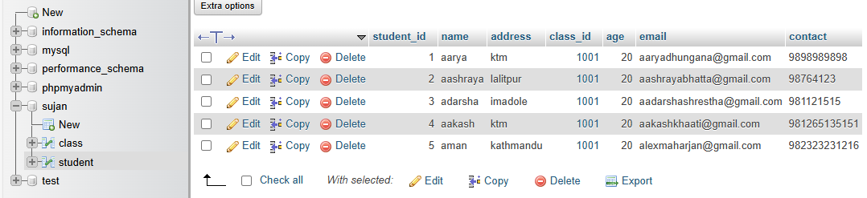

20. Write SQL query to delete all records of student having student id 1.

SQL query:

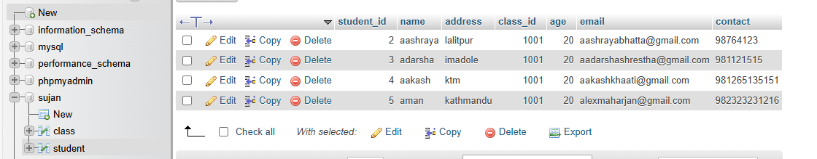

21. Write SQL query to select all records of student.

SQL query:

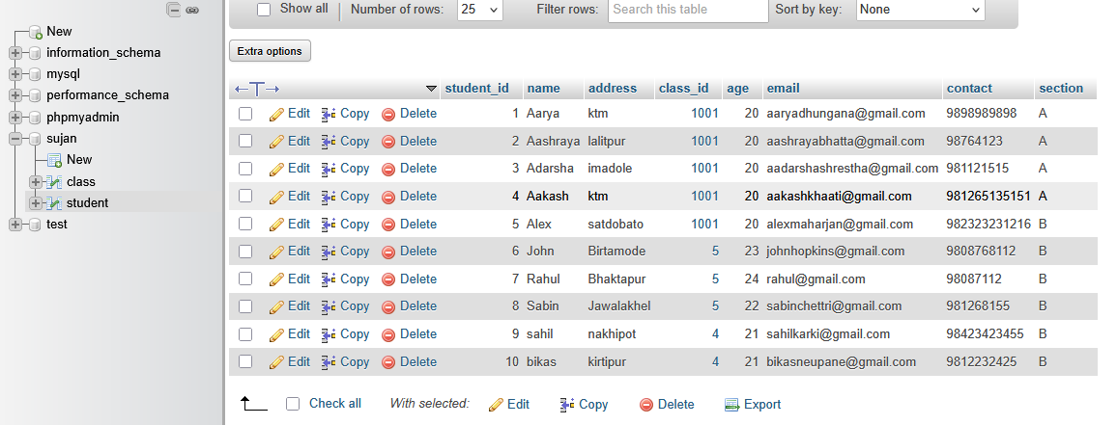

22. Write SQL query to select all records of student having student id 3.

SQL query:

23. Write SQL query to select name and address of students whose age is greater than 21.

SQL query:

24. Write SQL query to select student id and name of students whose address in Birtamode.

SQL query:

25. Write SQL query to select records of students whose class id is 5 and address is Kathmandu.

SQL query:

26. Write SQL query to select maximum age from above table.

SQL query:

27. Write SQL query to select minimum age of students whose address is Birtamode.

SQL query:

28. Write SQL query to find total number of students having class id 5 and age greater than 19.

SQL query:

29. Write SQL query to find average age of students whose class id is 4 and section is B.

SQL query:

30. Write SQL query to select students whose address starts with letter ‘B’.

SQL query:

