|  |  |  |  |  |  |  |
| --- | --- | --- | --- | --- | --- | --- |
| Fields | Datatypes | Null | Key | Default | Check | extra |
| student_id | Int(11) | No | Primary |  |  | Auto_Increment |
| name | varchar(50) | N0 |  |  |  | Unique |
| address | varchar(100) | No |  | Birtamode |  |  |
| class_id | int(11) | No | Foreign |  |  |  |
| section | varchar(50) | Yes |  |  |  |  |
| age | int(11) | No |  | 16 | age>=15 |  |

1. Write SQL Query to create following table(Student).

**Note**: Foreign key reference to (Class) Table.

SQL query:

Database sujan:

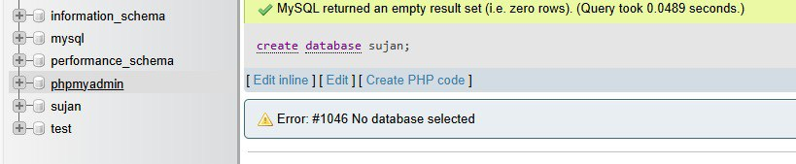

Table class:

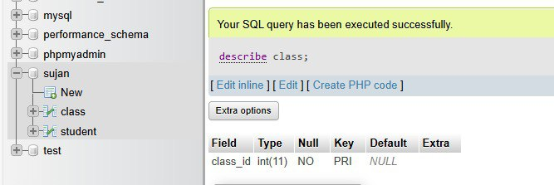

Table student:

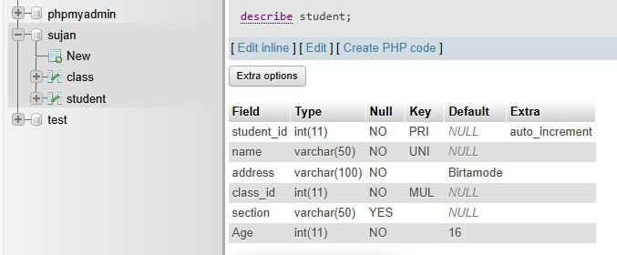

2. Write SQL query to drop primary key from above table.

SQL query:

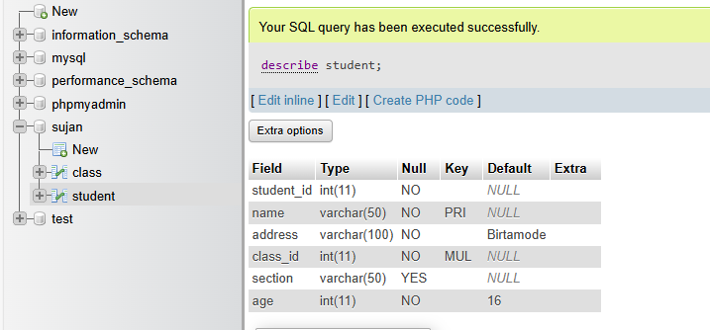

3. Write SQL query to drop foreign key from above table.

SQL query:

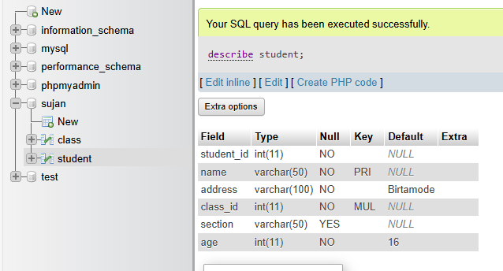

4. Write SQL query to set student id as primary key.

SQL query:

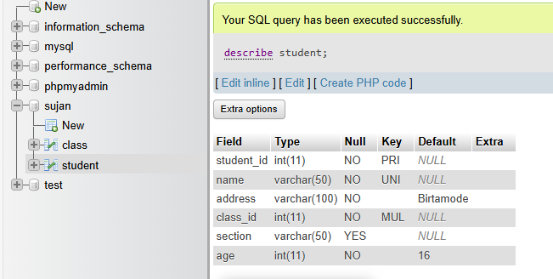

5. Write SQL query to set class id as foreign key.

SQL query:

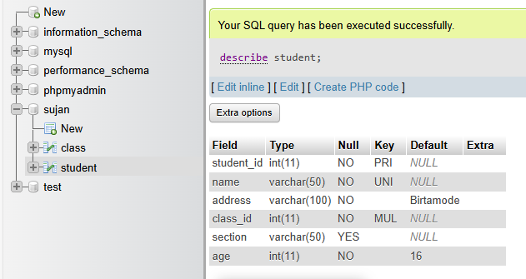

6. Write SQL query to remove unique constraint from name.

SQL query:

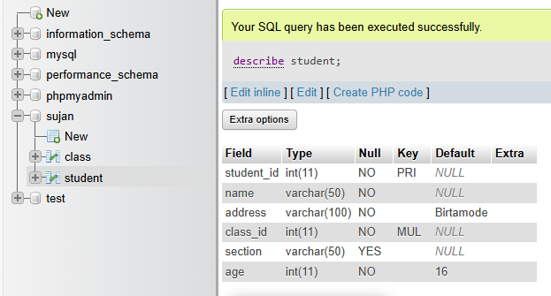

7. Write SQL query to remove default constraint from age.

SQL query:

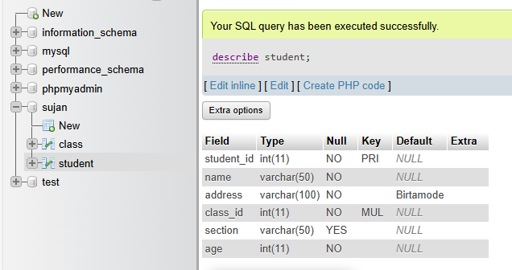

8. Write SQL query to add unique constraint to section.

SQL query:

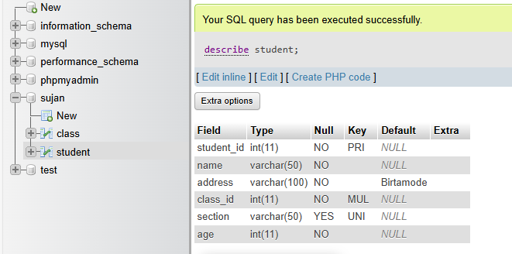

9. Write SQL query to add default value 18 to age.

SQL query:

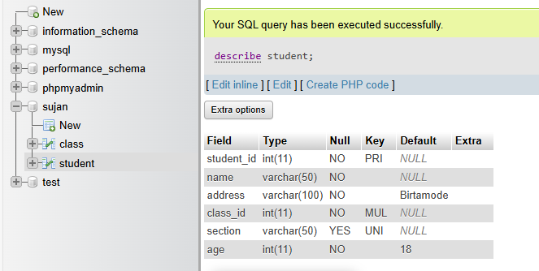

10. Write SQL query to change column name address to location.

SQL query:

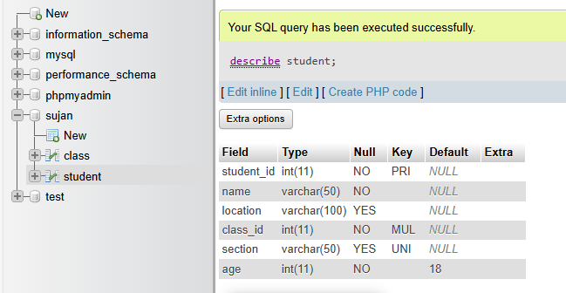

11. Write SQL query to add new column email and make it not null.

SQL query:

alter table student

add email varchar(50) not null;

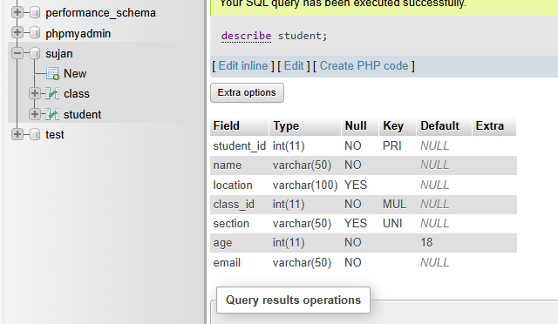

12. Write SQL query to remove column section from above table.

SQL query:

alter table student

drop column section;

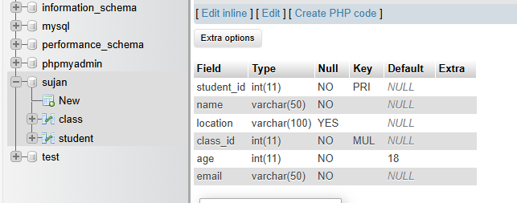

13. Write SQL query to add new column contact and make data type as integer.

SQL query:

[alter](http://localhost:8084/phpmyadmin/url.php?url=https://dev.mysql.com/doc/refman/5.5/en/alter-table.html) [table](http://localhost:8084/phpmyadmin/url.php?url=https://dev.mysql.com/doc/refman/5.5/en/alter-table.html) student

add contact [int](http://localhost:8084/phpmyadmin/url.php?url=https://dev.mysql.com/doc/refman/5.5/en/numeric-types.html)

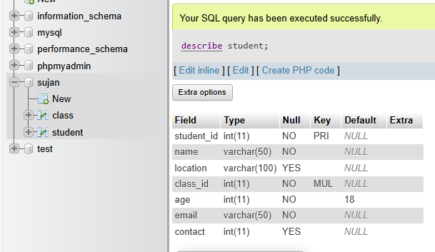

14. Write SQL query to change data type of column contact to varchar and make it unique.

SQL query:

[alter](http://localhost:8084/phpmyadmin/url.php?url=https://dev.mysql.com/doc/refman/5.5/en/alter-table.html) [table](http://localhost:8084/phpmyadmin/url.php?url=https://dev.mysql.com/doc/refman/5.5/en/alter-table.html) student

modify contact [varchar](http://localhost:8084/phpmyadmin/url.php?url=https://dev.mysql.com/doc/refman/5.5/en/string-types.html)(50) unique

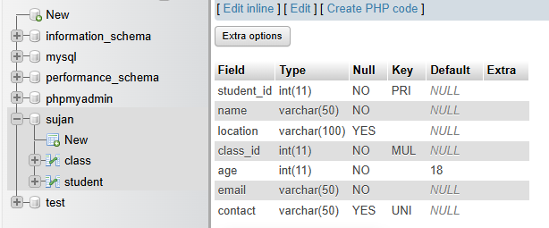

15. Write SQL query to change default value of address to Kathmandu.

SQL query:

[alter](http://localhost:8084/phpmyadmin/url.php?url=https://dev.mysql.com/doc/refman/5.5/en/alter-table.html) [table](http://localhost:8084/phpmyadmin/url.php?url=https://dev.mysql.com/doc/refman/5.5/en/alter-table.html) student

alter column location [set](http://localhost:8084/phpmyadmin/url.php?url=https://dev.mysql.com/doc/refman/5.5/en/set.html) [default](http://localhost:8084/phpmyadmin/url.php?url=https://dev.mysql.com/doc/refman/5.5/en/miscellaneous-functions.html#function_default) 'Kathmandu'

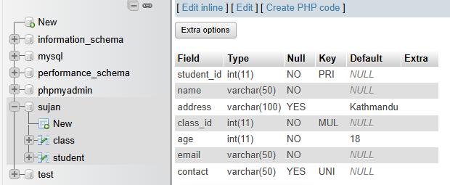

16. Insert five set of records in above table.

SQL query:

insert into class

values(1001);

insert into student

values(1,"aarya","ktm",1001,20,"aaryadhungana@gmail.com","9898989898"),

(2,"aashraya","lalitpur",1001,20,"aashrayabhatta@gmail.com","98764123"),

(3,"adarsha","imadole",1001,20,"aadarshashrestha@gmail.com","981121515"),

(4,"aakash","ktm",1001,20,"aakashkhaati@gmail.com","981265135151"),

(5,"alex","satdobato",1001,20,"alexmaharjan@gmail.com","982323231216");

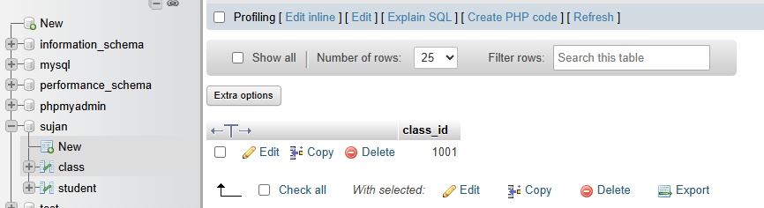

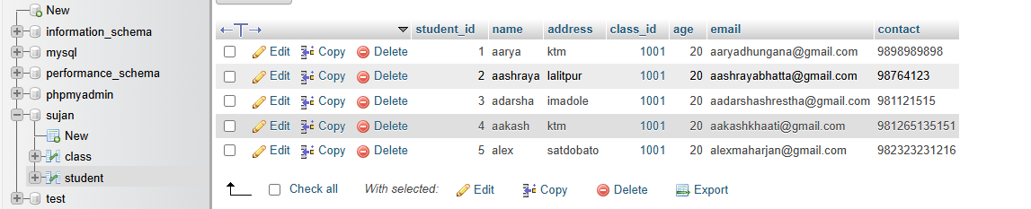

17. Write SQL query to update name and address of student whose student id is 5.

SQL query:

update student

set name="aman", address="kathmandu"

where student_id=5;

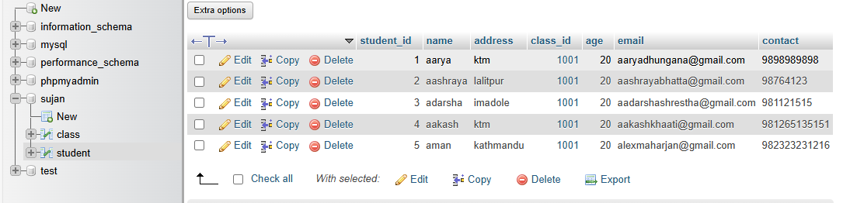

18. Write SQL query to delete all the records of student having age greater than 20.

SQL query:

delete from student

where age>20;

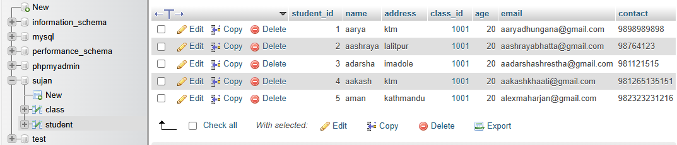

19. Write SQL query to update age of student having address btm.

SQL query:

update student

set age=21

where address=”btm”;

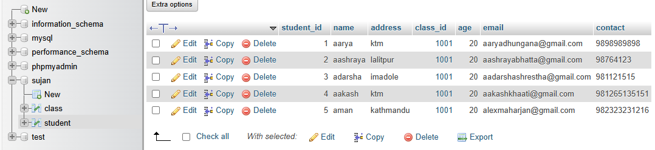

20. Write SQL query to delete all records of student having student id 1.

SQL query:

delete from student

where student_id=1;

