|  |  |  |  |  |  |  |
| --- | --- | --- | --- | --- | --- | --- |
| Fields | Datatypes | Null | Key | Default | Check | extra |
| student_id | Int(11) | No | Primary |  |  | Auto_Increment |
| name | varchar(50) | N0 |  |  |  | Unique |
| address | varchar(100) | No |  | Birtamode |  |  |
| class_id | int(11) | No | Foreign |  |  |  |
| section | varchar(50) | Yes |  |  |  |  |
| age | int(11) | No |  | 16 | age>=15 |  |

1. Write SQL Query to create following table(Student).

**Note**: Foreign key reference to (Class) Table.

SQL query:

Database sujan:

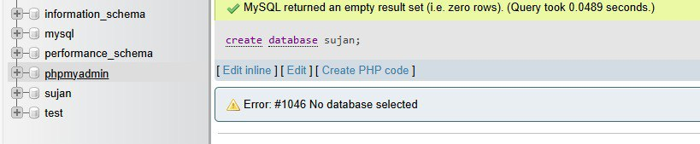

Table class:

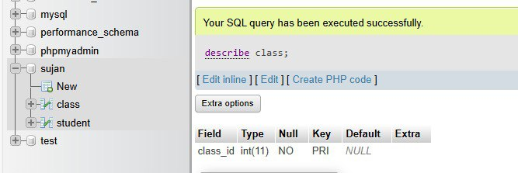

Table student:

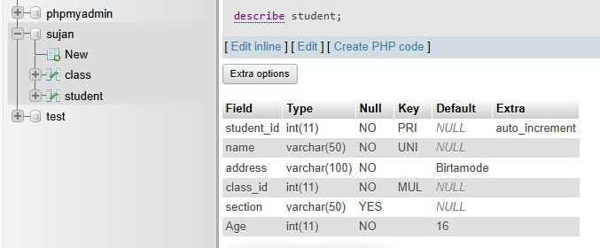

2. Write SQL query to drop primary key from above table.

SQL query:

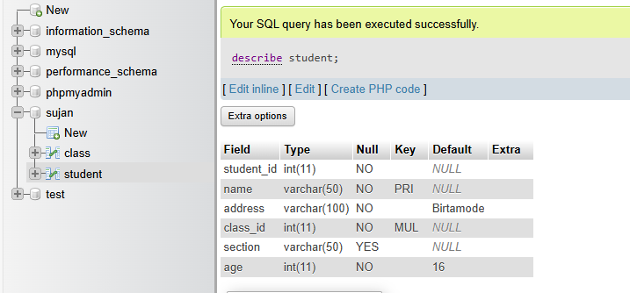

3. Write SQL query to drop foreign key from above table.

SQL query:

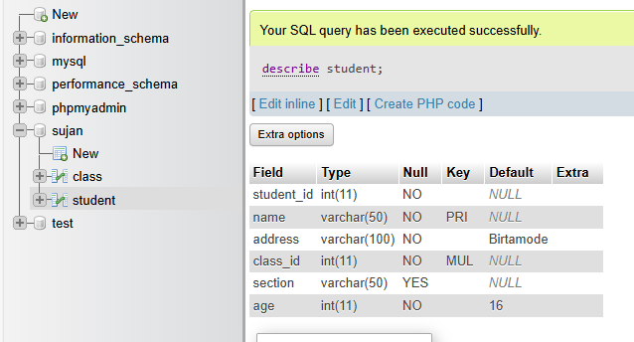

4. Write SQL query to set student id as primary key.

SQL query:

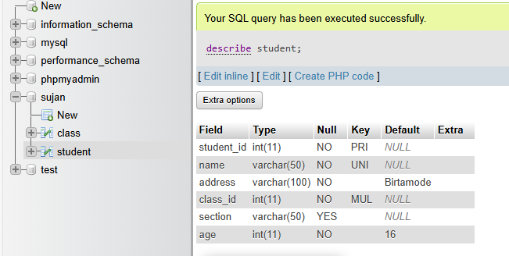

5. Write SQL query to set class id as foreign key.

SQL query:

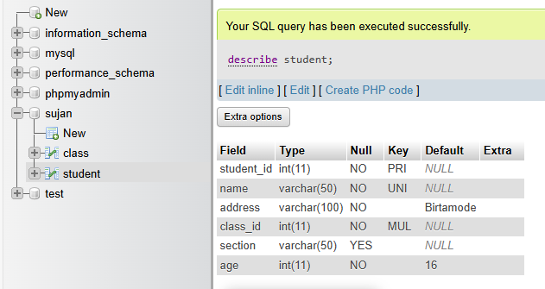

6. Write SQL query to remove unique constraint from name.

SQL query:

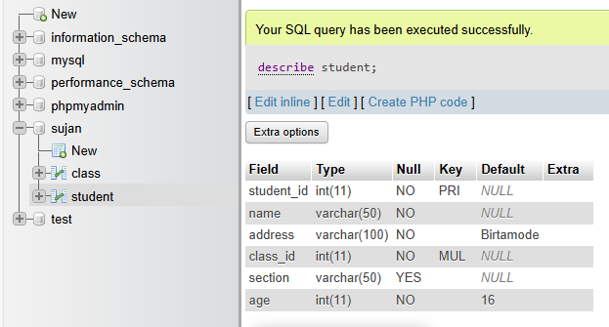

7. Write SQL query to remove default constraint from age.

SQL query:

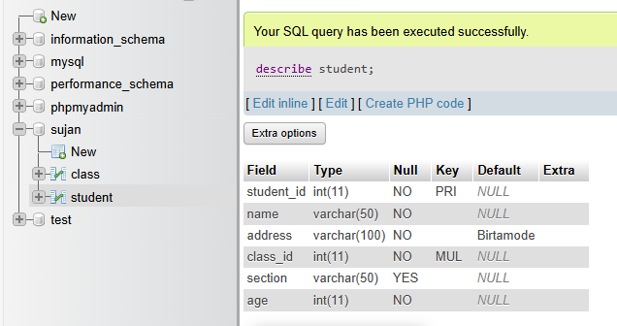

8. Write SQL query to add unique constraint to section.

SQL query:

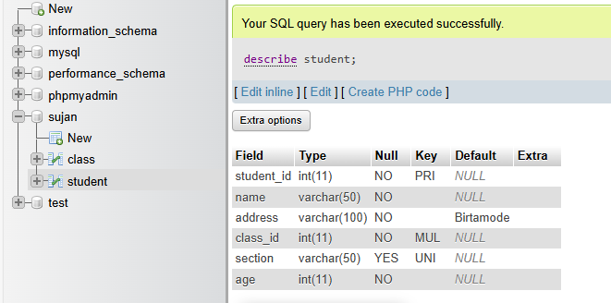

9. Write SQL query to add default value 18 to age.

SQL query:

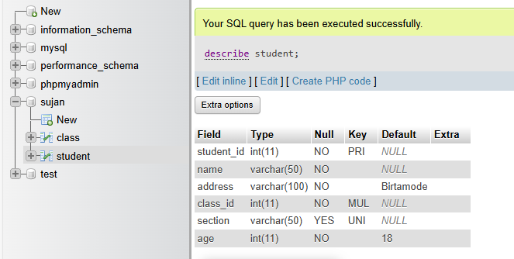

10. Write SQL query to change column name address to location.

SQL query:

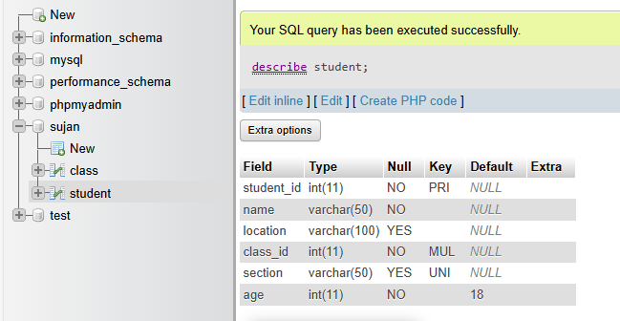

11. Write SQL query to add new column email and make it not null.

SQL query:

alter table student

add email varchar(50) not null;

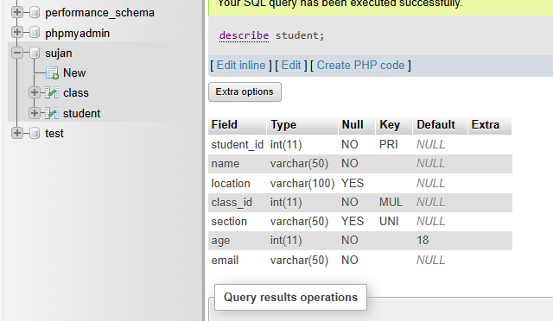

12. Write SQL query to remove column section from above table.

SQL query:

alter table student

drop column section;

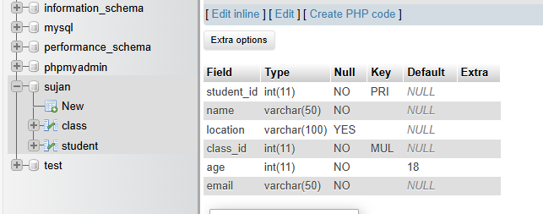

13. Write SQL query to add new column contact and make data type as integer.

SQL query:

[alter](http://localhost:8084/phpmyadmin/url.php?url=https://dev.mysql.com/doc/refman/5.5/en/alter-table.html) [table](http://localhost:8084/phpmyadmin/url.php?url=https://dev.mysql.com/doc/refman/5.5/en/alter-table.html) student

add contact [int](http://localhost:8084/phpmyadmin/url.php?url=https://dev.mysql.com/doc/refman/5.5/en/numeric-types.html)

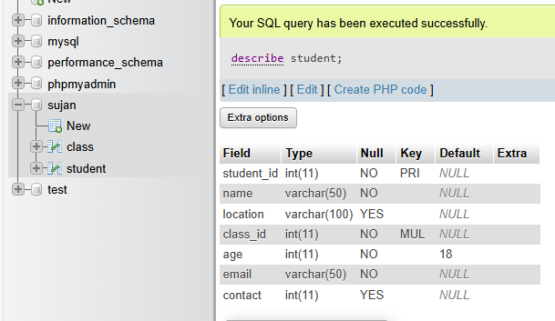

14. Write SQL query to change data type of column contact to varchar and make it unique.

SQL query:

[alter](http://localhost:8084/phpmyadmin/url.php?url=https://dev.mysql.com/doc/refman/5.5/en/alter-table.html) [table](http://localhost:8084/phpmyadmin/url.php?url=https://dev.mysql.com/doc/refman/5.5/en/alter-table.html) student

modify contact [varchar](http://localhost:8084/phpmyadmin/url.php?url=https://dev.mysql.com/doc/refman/5.5/en/string-types.html)(50) unique

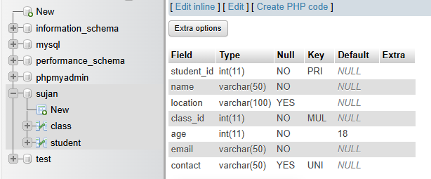

15. Write SQL query to change default value of address to Kathmandu.

SQL query:

[alter](http://localhost:8084/phpmyadmin/url.php?url=https://dev.mysql.com/doc/refman/5.5/en/alter-table.html) [table](http://localhost:8084/phpmyadmin/url.php?url=https://dev.mysql.com/doc/refman/5.5/en/alter-table.html) student

alter column location [set](http://localhost:8084/phpmyadmin/url.php?url=https://dev.mysql.com/doc/refman/5.5/en/set.html) [default](http://localhost:8084/phpmyadmin/url.php?url=https://dev.mysql.com/doc/refman/5.5/en/miscellaneous-functions.html#function_default) 'Kathmandu'

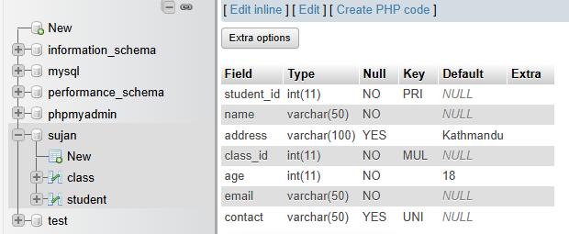

16. Insert five set of records in above table.

SQL query:

insert into class

values(1001);

insert into student

values(1,"aarya","ktm",1001,20,"aaryadhungana@gmail.com","9898989898"),

(2,"aashraya","lalitpur",1001,20,"aashrayabhatta@gmail.com","98764123"),

(3,"adarsha","imadole",1001,20,"aadarshashrestha@gmail.com","981121515"),

(4,"aakash","ktm",1001,20,"aakashkhaati@gmail.com","981265135151"),

(5,"alex","satdobato",1001,20,"alexmaharjan@gmail.com","982323231216");

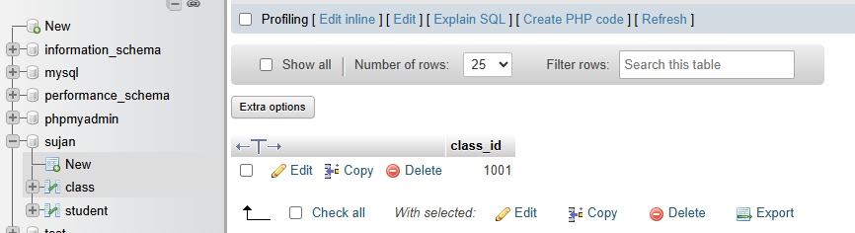

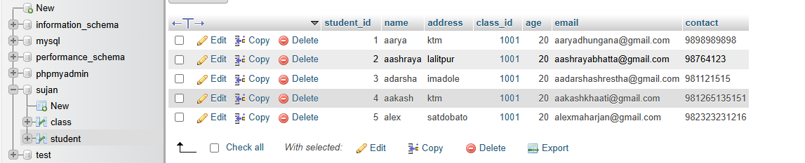

17. Write SQL query to update name and address of student whose student id is 5.

SQL query:

update student

set name="aman", address="kathmandu"

where student_id=5;

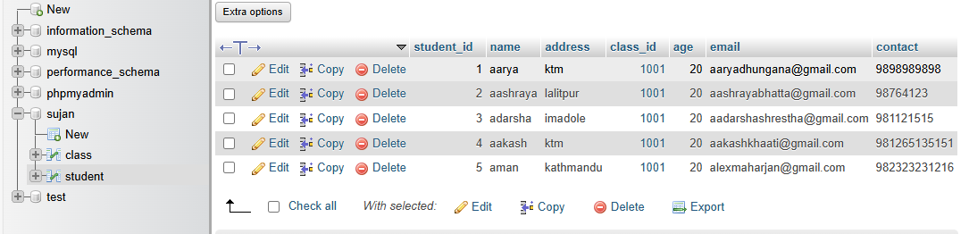

18. Write SQL query to delete all the records of student having age greater than 20.

SQL query:

delete from student

where age>20;

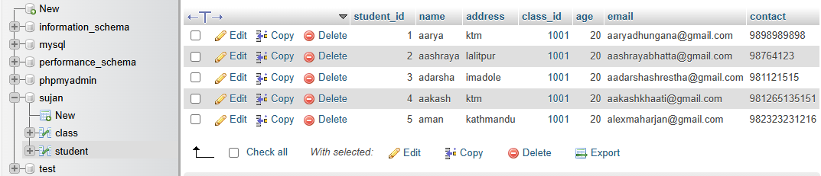

19. Write SQL query to update age of student having address btm.

SQL query:

update student

set age=21

where address=”btm”;

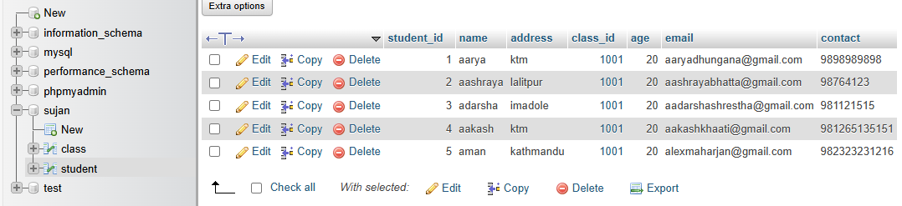

20. Write SQL query to delete all records of student having student id 1.

SQL query:

delete from student

where student_id=1;

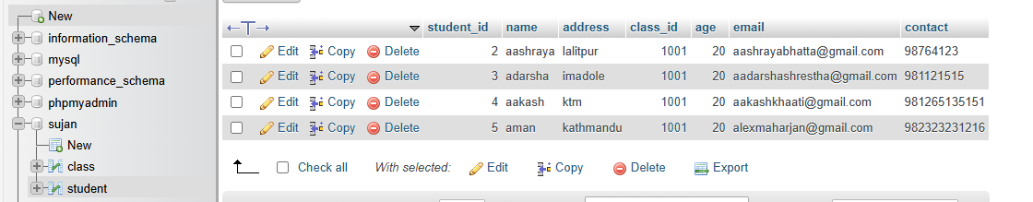

alter table student

add section varchar(50)

insert into class

values(1001),

(5),

(6),

(4)

insert into student

values(1,"Aarya","ktm",1001,20,"aaryadhungana@gmail.com","9898989898","A"),

(2,"Aashraya","lalitpur",1001,20,"aashrayabhatta@gmail.com","98764123","A"),

(3,"Adarsha","imadole",1001,20,"aadarshashrestha@gmail.com","981121515","A"),

(4,"Aakash","ktm",1001,20,"aakashkhaati@gmail.com","981265135151","A"),

(5,"Alex","satdobato",1001,20,"alexmaharjan@gmail.com","982323231216","B"),

(6,"John","Birtamode",5,23,"johnhopkins@gmail.com","9808768112" ,"B"),

(7,"Rahul","Bhaktapur",5,24,"rahul@gmail.com","98087112" ,"B"),

(8,"Sabin","Jawalakhel",5,22,"sabinchettri@gmail.com","981268155" ,"B"),

(9,"sahil","nakhipot",4,21,"sahilkarki@gmail.com","98423423455" ,"B"),

(10,"bikas","kirtipur",4,21,"bikasneupane@gmail.com","9812232425" ,"B")

21. Write SQL query to select all records of student.

SQL query:

Select * from student

where 1;

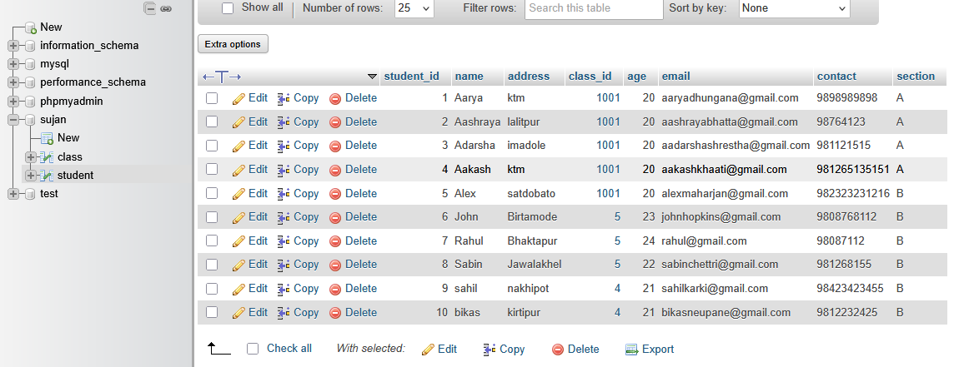

22. Write SQL query to select all records of student having student id 3.

SQL query:

Select * from student

Where student_id=3;

23. Write SQL query to select name and address of students whose age is greater than 21.

SQL query:

Select name, address

From student

Where age>21;

24. Write SQL query to select student id and name of students whose address in Birtamode.

SQL query:

Select student_id, name

From student

Where address= 'Birtamode ';

25. Write SQL query to select records of students whose class id is 5 and address is Kathmandu.

SQL query:

Select * from student

Where class_id=5 AND address=’Kathmandu’

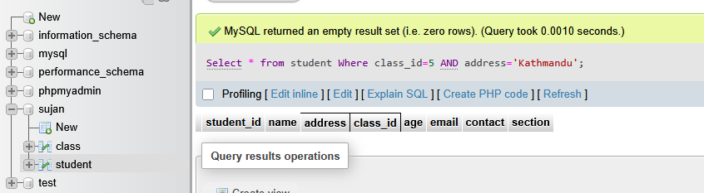

26. Write SQL query to select maximum age from above table.

SQL query:

Select max(age) as max_age

FROM student;

27. Write SQL query to select minimum age of students whose address is Birtamode.

SQL query:

Select min(age) as min_age

From student

Where address= 'Birtamode ';

28. Write SQL query to find total number of students having class id 5 and age greater than 19.

SQL query:

Select count(*) as total_std

From student

Where class_id=5 and age>19;

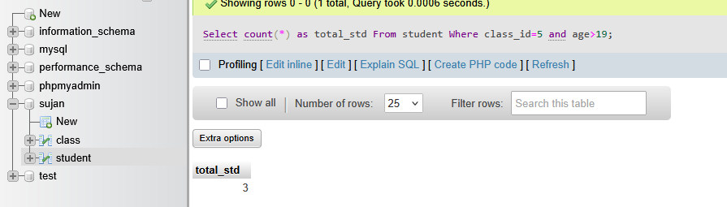

29. Write SQL query to find average age of students whose class id is 4 and section is B.

SQL query:

Select avg(age) as avg_std

From student

Where class_id=4 and section= 'B ';

30. Write SQL query to select students whose address starts with letter ‘B’.

SQL query:

Select * from student

Where address like 'B% ';

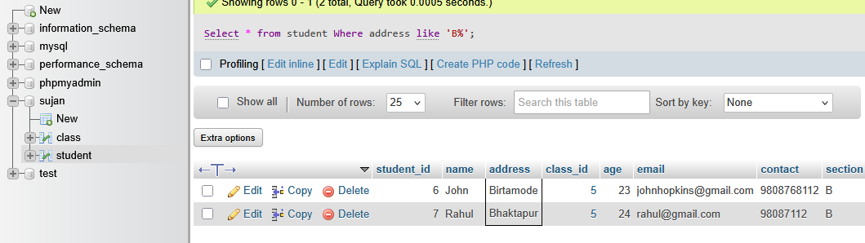

31. Write SQL query to count those students whose name ends with letter ‘R’.

Select * from student

Where name like '%R';

32. Write SQL query to select name and age of students whose having address btm or ktm.

Select name, age

From student

Where address= 'btm' or address=’ktm’;

33. Write SQL query to select sum of age of students having id 1,2 and 3.

Select sum(age) as sum_age

From student

Where student_id between 1 and 3;

34. Write SQL query to select students whose age is between 18 and 22.

Select *

From student

Where age between 18 and 22;

35. Write SQL query to select total students of each age group.

SELECT age, COUNT(*) AS total_students

FROM student

GROUP BY age;

36. Write SQL query to select class id, name and maximum age of students studying in each class.

SELECT class_id, name, max(age) as max_age

FROM student

GROUP BY class_id;

37. Write SQL query to select student’s records by arranging in descending order on the basis of student id.

SELECT *

FROM student

ORDER BY student_id DESC;

38. Write SQL query to select student id and name by of students whose age is greater than 20 after arranging records in alphabetical order on the basis of name.

SELECT student_id, name

FROM student

WHERE age > 20

ORDER BY name ASC;

39. Write SQL query to select records of student whose age is maximum among all the students.

SELECT *

FROM student

WHERE age = (SELECT MAX(age) FROM student);

40. Write SQL query to select student id and name of student whose student id is maximum among all the students.

SELECT student_id, name

FROM student

WHERE student_id = (SELECT MAX(student_id) FROM student);