Program 1:

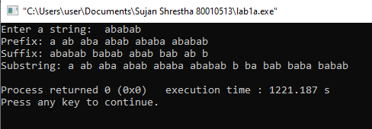

Program 2:

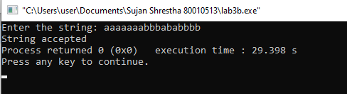

Program 3:

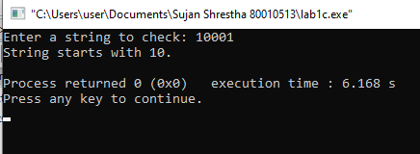

Program 1:

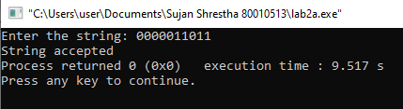

Program 2:

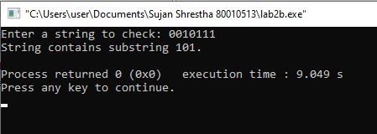

Program 3:

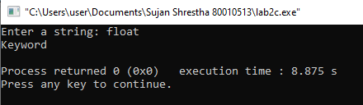

Program 1:

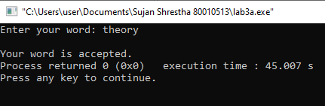

Program 2:

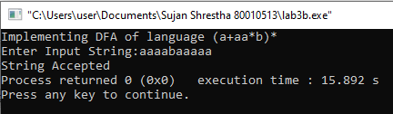

Program 1:

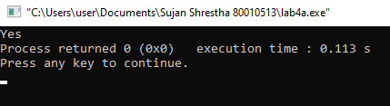

Program 2:

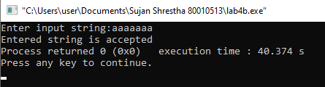

Program 1:

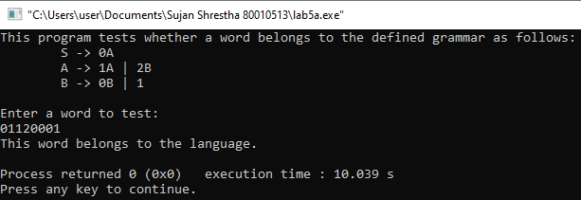

Program 1:

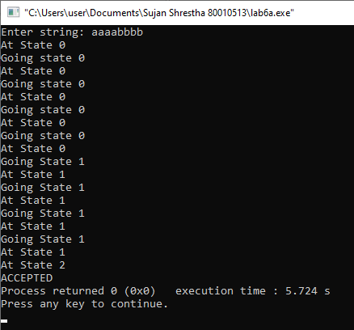

Program 2:

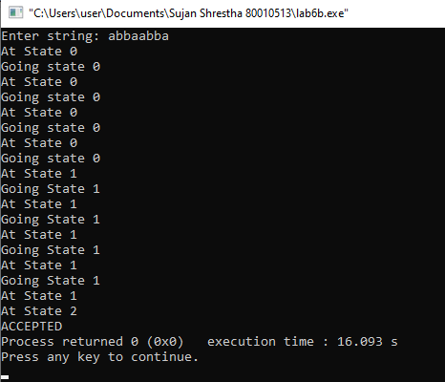

Program 1:

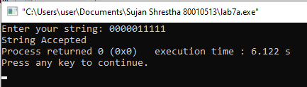

Program 2:

