DermInsight AI: Comparing Class-Imbalance Strategies for Melanoma Detection on a Patient-Level Split of ISIC 2020
Sujan M  School of Computer Science and Engineering  Vellore Institute of Technology  Vellore, India  sujanvsm@gmail.com | Ramachandran Sivasankar  School of Computer Science and Engineering  Vellore Institute of Technology  Vellore, India  [email address] | Alan John Anand  School of Computer Science and Engineering  Vellore Institute of Technology  Vellore, India  [email address] | Krishna Rani Samal  School of Computer Science and Engineering  Vellore Institute of Technology  Vellore, India  [email address]

Abstract—Melanoma makes up about one percent of skin cancers but causes most skin cancer deaths, and survival depends heavily on how early it is found. Screening data contain very few melanomas. In the SIIM-ISIC 2020 training set only 584 of 33,126 dermoscopic images (1.76%) are malignant, so a model that calls every image benign is 98.24% accurate and detects nothing. We built DermInsight AI, an image-only pipeline, and used it to compare five ways of training an ImageNet-pretrained DenseNet201 under this imbalance: weighted binary cross-entropy with a frozen backbone, the same loss with full fine-tuning, a weighted random sampler, focal loss and random oversampling. All five runs share one patient-level split with 1,439, 307 and 310 patients in the training, validation and test sets and no patient in more than one set. Checkpoints and decision thresholds were chosen on validation data, and each model was scored once on the 4,920 test images. Test ROC-AUC ranged from 0.800 to 0.871, with random oversampling highest. The operating points differed far more than the ROC-AUC values. The frozen-backbone baseline found 62 of the 68 test melanomas but also flagged 2,819 benign images, while the three runs with specificity above 98% found only 10 to 15. The weighted sampler gave the most useful balance, with 36.76% sensitivity at 96.85% specificity. Because the test set has only 68 malignant images, the 95% intervals on sensitivity are close to ten points wide on either side, and most differences between strategies fall inside them. Our results suggest that studies on imbalanced skin lesion data should report the confusion matrix and the threshold rule along with ROC-AUC.
Index Terms—melanoma, dermoscopy, deep learning, DenseNet201, class imbalance, ISIC 2020, patient-level split, decision threshold
I. Introduction
Melanoma is the most dangerous common form of skin cancer. According to the American Cancer Society it accounts for only about 1% of skin cancers, yet it is responsible for a large majority of skin cancer deaths [1]. The stage at diagnosis matters a great deal. For people diagnosed between 2015 and 2021, the five-year relative survival was above 99% when the melanoma was still localized, 76% when it had reached nearby tissue and 36% once it had spread to distant organs [2]. A thin, localized lesion can often be treated by excision alone, so the practical aim of screening is to find suspicious lesions before they spread.
Dermatologists examine such lesions with a dermatoscope, which magnifies the skin and reveals structures below the surface such as the pigment network and vessel patterns. Reading these images well takes training and experience. An early melanoma can look very much like an ordinary mole, and many patients show a lesion to a general practitioner before they see a specialist. Several reader studies have found that convolutional neural networks (CNNs) trained on clinical or dermoscopic images can perform at a level comparable to dermatologists on fixed test sets [3]–[5]. This is the main reason automated image analysis is being studied as a support tool for screening.
Most published results, however, come from curated or fairly balanced image sets, and routine screening data look quite different. The SIIM-ISIC 2020 challenge data were collected during skin examinations of 2,056 patients, and only 584 of the 33,126 images are malignant [6]. Data like these create two practical problems. The model has very few positive examples to learn from, and the evaluation has to show clearly how many cancers the model actually finds. A high accuracy or a good ROC-AUC can hide a large number of missed melanomas once a single decision threshold is applied.
In this work we keep the backbone, the data split and the evaluation protocol fixed and change only the way the imbalance is handled. Our contributions are as follows.
1) A patient-level split of all 33,126 ISIC 2020 training images into training, validation and test sets, with a check in code that no patient appears in two sets.
2) A controlled comparison of five imbalance strategies on the same DenseNet201 backbone: weighted binary cross-entropy (BCE) with a frozen backbone, weighted BCE with full fine-tuning, a weighted random sampler, focal loss and random oversampling of the training split.
3) An evaluation protocol in which epochs and thresholds are selected on validation data only and each model touches the test set once. For every model we report the full confusion matrix and a 95% confidence interval on sensitivity.
Section II reviews related work. Section III describes the data, model and training strategies. Section IV presents the results, Section V discusses them along with the limitations of the study, and Section VI concludes the paper.
II. Related Work
A. Deep Learning for Dermoscopic Images
Early computer-aided diagnosis systems followed the rules dermatologists use, such as the ABCD rule and the seven-point checklist. They segmented the lesion, measured hand-crafted shape, colour and texture features and passed them to a classifier such as a support vector machine [7], [8]. These systems were easy to interpret, but their accuracy depended on good segmentation and on consistent imaging conditions. Esteva et al. [3] fine-tuned an Inception-v3 network from ImageNet weights on about 129,000 clinical images and matched board-certified dermatologists on biopsy-proven test cases. Haenssle et al. [4] and Brinker et al. [5] reported similar results on dermoscopic images, and in an open web-based study Tschandl et al. [9] found that the best algorithms did better than most human readers on the same images. All of these studies used fixed image sets. They show what a model can do on that data, and they say much less about how it would behave in a screening clinic.
Medical image collections are small compared with ImageNet [10], and malignant examples are scarcer still. Yosinski et al. [11] showed that features learned in the early layers of a CNN transfer well between tasks, while later layers are more task specific, which is why almost all skin lesion work starts from ImageNet weights. We chose DenseNet201 [12]. Inside a dense block every layer receives the feature maps of all earlier layers, so low-level cues such as edges and colour changes stay available to deeper layers. The network also has fewer parameters than a ResNet [13] of similar depth, which helped on our limited compute budget.
B. Datasets and Data Leakage
Most public dermoscopy benchmarks come from the International Skin Imaging Collaboration (ISIC) archive [14], [15]. HAM10000 [15] has seven diagnostic classes and a fairly high share of melanoma. The SIIM-ISIC 2020 set [6] was gathered from patients with many lesions, every image carries a patient identifier, and the share of melanoma is very low, so it is closer to a real screening population. Cassidy et al. [16] analysed the ISIC datasets and found duplicate images within and across them, including duplicates shared between training and test partitions. When images of one patient land on both sides of a split, a model can pick up that patient's skin, hair, lighting or camera, and the test score becomes optimistic. This is why we split by patient.
C. Class Imbalance and Its Evaluation
Johnson and Khoshgoftaar [17] group imbalance methods into data-level methods, which resample the training set, and algorithm-level methods, which change the loss. Buda et al. [18] found that oversampling the minority class worked best in most of their CNN experiments and did not cause overfitting. SMOTE [19] creates synthetic minority samples by interpolation, but it was designed for feature vectors and is less natural for raw images. At the algorithm level, a positive class weight in cross-entropy raises the cost of missed positives, and focal loss [20] lowers the loss of examples the model already classifies well. On the evaluation side, Saito and Rehmsmeier [21] showed that precision-recall plots tell more than ROC plots when positives are rare, and Davis and Goadrich [22] described how the two curves are related. Guo et al. [23] showed that modern deep networks are often poorly calibrated, so their outputs should not be read directly as probabilities of disease.
Each of these components is well known. What is harder to find is a comparison of them under identical conditions on screening-like data. Imbalance methods are usually reported one at a time, on different splits and at the default threshold of 0.5, and papers rarely say whether the threshold was tuned on validation or on test data. We use a standard backbone and put the effort into a controlled comparison: five strategies, one patient-level split, one test set and one reporting format.
III. Materials and Methods
Fig. 1 gives an overview of the pipeline. Every experiment follows the same path from the raw data to a single scoring of the test set, and the experiments differ only in the training stage.
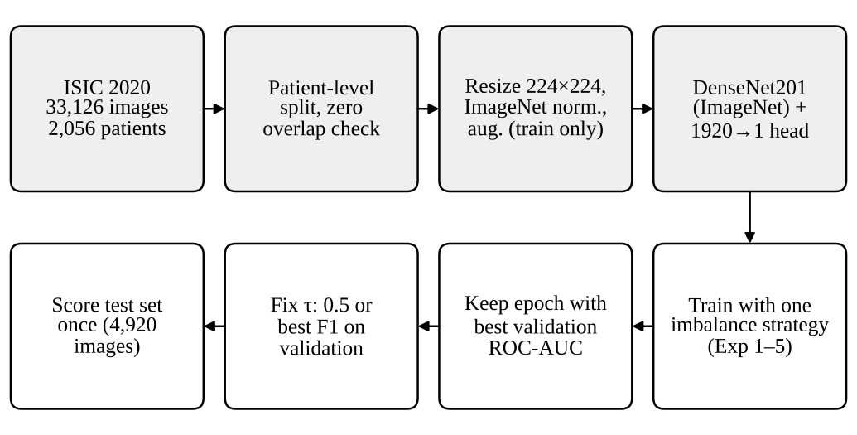
Fig. 1. Overview of the DermInsight AI pipeline. The shaded steps are identical for all five experiments; the imbalance strategy is the only part that changes.
A. Dataset and Patient-Level Split
We used the training portion of the SIIM-ISIC 2020 challenge data [6], because labels for the official test images are not public. The ground-truth file has one row per image, 33,126 rows in total, with the patient and lesion identifiers, sex, approximate age, anatomical site, diagnosis and a binary target. There are 32,542 benign and 584 malignant images from 2,056 patients, a ratio of roughly 56 to 1. Most benign images carry the diagnosis "unknown" (27,124) or "nevus" (5,193).
We grouped the images by patient identifier and placed each patient in exactly one split (Table I). The training script asserts that the three patient sets are disjoint and stops if they are not, and we repeated the check on the saved split files and found zero shared patients for every pair of splits. Because whole patients were moved, the malignant share differs slightly between splits: 1.95% in training, 1.31% in validation and 1.38% in test.
TABLE I
Patient-Level Split of the ISIC 2020 Training Data
Split | Images | Benign | Malignant | Mal. (%) | Patients
Training | 22,787 | 22,342 | 445 | 1.95 | 1,439
Validation | 5,419 | 5,348 | 71 | 1.31 | 307
Test | 4,920 | 4,852 | 68 | 1.38 | 310
Total | 33,126 | 32,542 | 584 | 1.76 | 2,056

B. Preprocessing and Augmentation
Each JPEG image is opened, converted to RGB and resized to 224×224 pixels. Pixel values are scaled to [0, 1] and normalized with the ImageNet channel means (0.485, 0.456, 0.406) and standard deviations (0.229, 0.224, 0.225), since these are the statistics the pretrained weights expect. Training images also receive a random horizontal flip with probability 0.5, a random rotation of up to 15° and a mild colour jitter (brightness, contrast and saturation 0.1, hue 0.05). We kept the augmentation light because colour and texture carry diagnostic information. Validation and test images are only resized and normalized.
C. Model
The backbone is the torchvision DenseNet201 with ImageNet-1K weights [12]. Its 1,000-class classifier is replaced by an identity layer, which leaves the 1,920-dimensional globally pooled feature vector. A single linear layer maps this vector to one logit z, and the predicted probability of malignancy is p̂ = σ(z), where σ is the logistic sigmoid. An image is labelled malignant when p̂ ≥ τ for a decision threshold τ.
D. Imbalance Strategies
Exp 1, baseline with weighted BCE. The baseline uses binary cross-entropy with a weight on the positive class equal to the training class ratio, w₊ = N_{neg} / N_{pos} = 22,342 / 445 = 50.2067:
L = −[ w₊ y log σ(z) + (1 − y) log(1 − σ(z)) ] (1)
Only the linear head was trained in this run, with every backbone parameter frozen. It ran for three epochs on a CPU with a batch size of 32 and the AdamW optimizer [24] (learning rate 10⁻⁴, weight decay 10⁻⁴), and it was tested at τ = 0.5. This baseline therefore already includes loss weighting.
Exp 2, weighted BCE with full fine-tuning. This run starts from the Exp 1 checkpoint and trains all layers with the same weighted loss, a batch size of 64 and the same AdamW settings. A plateau scheduler halves the learning rate when validation ROC-AUC does not improve for one epoch, training is capped at eight epochs, and early stopping ends the run after three epochs without improvement. Training stopped after epoch 6, and the best checkpoint came from epoch 3.
Exp 3, weighted random sampler. Here the loss is left unweighted and the data seen by the model is changed instead. Each training image receives a sampling weight inversely proportional to the size of its class, and the PyTorch WeightedRandomSampler draws batches of 64 with replacement, so the batches are roughly balanced on average. The run lasted five epochs and its best epoch was the second.
Exp 4, focal loss. Focal loss [20] scales the cross-entropy by a factor that shrinks for well-classified examples:
FL(p_{t}) = −α_{t} (1 − p_{t})^{γ} log(p_{t}) (2)
where p_{t} is the probability assigned to the true class. We used α = 0.75 and γ = 2. A benign image that already has p_{t} = 0.99 has its loss multiplied by (1 − 0.99)² = 10⁻⁴, so the thousands of easy benign images cannot dominate the gradient. The run lasted five epochs, and the best epoch was the last one.
Exp 5, random oversampling. Only the 445 malignant training images were oversampled, again through a WeightedRandomSampler applied to the training split, so each malignant image is drawn many times per epoch. The validation and test sets keep their natural prevalence. The loss is plain BCE with AdamW at the settings above. The run lasted five epochs, and the best epoch was the second. Exp 3 and Exp 5 both rely on the sampler and differ mainly in batch size and threshold rule.
Table II lists the settings of all five runs together with their best validation scores. The training scripts of Exp 3 to Exp 5 were not kept, so some of their settings were read from the saved checkpoints and experiment logs.
TABLE II
Training Settings and Best Validation Scores
Setting | Exp 1 | Exp 2 | Exp 3 | Exp 4 | Exp 5
Start weights | ImageNet | Exp 1 | ImageNet | ImageNet | ImageNet
Trained layers | Head | All | All | All | All
Imbalance method | W-BCE | W-BCE | WRS | Focal | ROS
Batch size | 32 | 64 | 64 | 32 | 32
Epochs run / best | 3 / 3 | 6 / 3 | 5 / 2 | 5 / 5 | 5 / 2
Test threshold τ | 0.50 | 0.86 | 0.50 | 0.50 | 0.7296
Val. ROC-AUC | 0.8472 | 0.9188 | 0.9062 | 0.9181 | 0.9082
Val. AP | 0.0811 | 0.1747 | 0.1894 | 0.1800 | 0.2176
W-BCE: weighted binary cross-entropy (w+ = 50.21). WRS: WeightedRandomSampler with unweighted BCE. Focal: α = 0.75, γ = 2. ROS: random oversampling of the training split. All runs used a learning rate and weight decay of 10⁻⁴.
E. Model and Threshold Selection
In every run we kept the checkpoint with the highest validation ROC-AUC. The default threshold of 0.5 does not suit every model. A positive weight of 50.21 pushes many benign images above 0.5, while focal loss squeezes the scores into a narrow, low range. For Exp 2 we scored the 5,419 validation images, tried every threshold from 0.01 to 0.99 in steps of 0.01 and kept the one with the highest F1 score. This gave τ = 0.86, with a validation sensitivity of 30.99%, specificity of 98.50% and F1 of 25.43%. The same best-F1 rule applied to the Exp 5 validation scores gave τ = 0.7296. Exp 1, Exp 3 and Exp 4 were tested at 0.5. In all cases the threshold was fixed before the test set was scored, and each model was run on the test set once.
F. Evaluation Metrics
From the confusion matrix counts we compute sensitivity TP/(TP + FN), specificity TN/(TN + FP), precision TP/(TP + FP), the F1 score and accuracy. ROC-AUC and average precision (AP) are computed from the predicted probabilities with scikit-learn [25] and do not depend on the threshold. For Exp 5 a trapezoidal PR-AUC (0.0975) was also recorded, which is slightly lower than its AP (0.1041); we report AP throughout to keep the runs comparable. Since the test set holds only 68 malignant images, we attach 95% Wilson score intervals [26] to every sensitivity. The pipeline is written in PyTorch [27]. Exp 1 ran on a CPU and the other runs on Google Colab GPU sessions, where one epoch of Exp 3 over the full training split took about ten minutes.
IV. Results
All test results below come from the same 4,920 images of 310 patients (4,852 benign, 68 malignant). None of these patients was used for training or for choosing an epoch or a threshold.
A. Training and Validation Behaviour
The four runs that trained the whole network reached a validation ROC-AUC between 0.906 and 0.919, well above the 0.847 of the frozen-backbone baseline (Table II, Fig. 2). Exp 2 and Exp 4 stayed fairly stable across epochs. Exp 3 and Exp 5 peaked at the second epoch and then fell while their training loss kept dropping (for Exp 3 from 0.209 in the first epoch to 0.025 in the fifth), which points to overfitting on the repeatedly sampled malignant images. Selecting checkpoints by validation ROC-AUC kept these later epochs out of the final models.
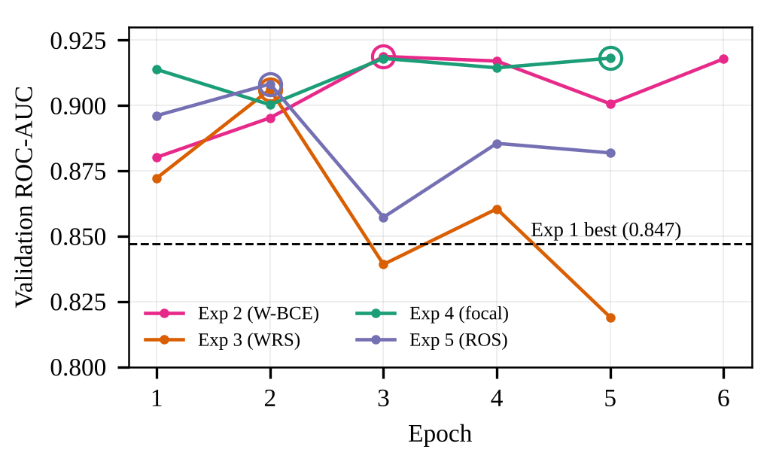
Fig. 2. Validation ROC-AUC per epoch. Open circles mark the checkpoint kept for each run. The dashed line is the best value of the frozen-backbone baseline (Exp 1).
B. Test Performance
Table III summarizes the test results. Ranking quality is moderate across all runs. Test ROC-AUC ranges from 0.800 for Exp 1 to 0.871 for Exp 5, and AP from 0.063 to 0.140, against a base rate of 0.014. The thresholded results differ much more. Exp 1 finds 62 of the 68 melanomas but also flags 2,819 benign images. Exp 2, Exp 4 and Exp 5 keep false positives below 90 but find only 10 to 15 melanomas. Exp 3 sits between these extremes, with 25 melanomas found and 153 false positives (Table IV).
TABLE III
Test Results (N = 4,920; 68 Malignant)
Exp | τ | AUC | AP | Sens. % | Spec. % | Prec. % | F1 % | Acc. %
1 | 0.50 | 0.800 | 0.063 | 91.18 | 41.90 | 2.15 | 4.20 | 42.58
2 | 0.86 | 0.830 | 0.129 | 22.06 | 98.31 | 15.46 | 18.18 | 97.26
3 | 0.50 | 0.822 | 0.129 | 36.76 | 96.85 | 14.04 | 20.33 | 96.02
4 | 0.50 | 0.860 | 0.140 | 14.71 | 99.24 | 21.28 | 17.39 | 98.07
5 | 0.730 | 0.871 | 0.104 | 19.12 | 98.25 | 13.27 | 15.66 | 97.15
AUC: ROC-AUC. AP: average precision. Sens.: sensitivity. Spec.: specificity. Prec.: precision. Acc.: accuracy. τ for Exp 5 is 0.7296.
TABLE IV
Test Confusion Counts and 95% Wilson Intervals on Sensitivity
Exp | TP | FN | FP | TN | Found | 95% CI (%)
1 | 62 | 6 | 2,819 | 2,033 | 62 / 68 | 82.1 to 95.9
2 | 15 | 53 | 82 | 4,770 | 15 / 68 | 13.8 to 33.3
3 | 25 | 43 | 153 | 4,699 | 25 / 68 | 26.3 to 48.6
4 | 10 | 58 | 37 | 4,815 | 10 / 68 | 8.2 to 25.0
5 | 13 | 55 | 85 | 4,767 | 13 / 68 | 11.5 to 30.0

Fig. 3 compares the runs across all thresholds. The curves for Exp 3, Exp 4 and Exp 5 are drawn from their saved per-image test predictions. Exp 1 and Exp 2 did not save per-image predictions, so they appear only as single operating points. The three ROC curves lie close together, with Exp 5 slightly higher over much of the range. In the precision-recall plot, precision falls quickly for every model once recall passes about 0.1, and focal loss keeps the highest precision at low recall. All curves stay well above the 1.38% base rate, but none of them reaches a region where recall and precision are both high.
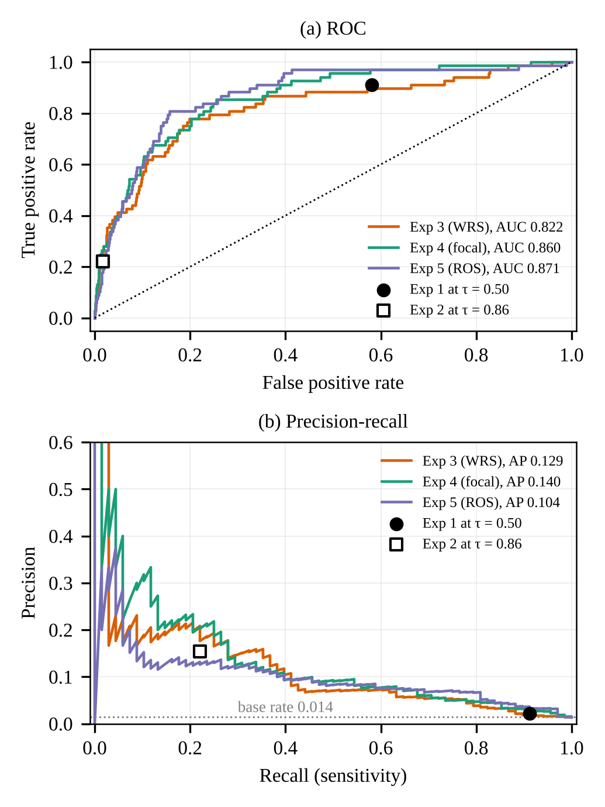
Fig. 3. Test ROC (a) and precision-recall (b) curves for Exp 3 to Exp 5, with the fixed operating points of Exp 1 and Exp 2. The dotted line in (b) is the test prevalence.
C. Effect of the Decision Threshold
Fig. 4 shows how sensitivity and specificity change with τ for the three runs whose test predictions were saved. The plot is descriptive, and no threshold was chosen from it. Exp 3 and Exp 5 push most benign images very close to zero (median benign probabilities of about 5×10⁻⁴ and 9×10⁻⁶), so their specificity stays at or above 90% for any τ from 0.05 upward. Their sensitivity responds slowly to the threshold; Exp 3, for example, finds 29 melanomas at τ = 0.1 and 24 at τ = 0.6. Focal loss behaves very differently. No malignant test image in Exp 4 received a score above 0.73, and the median malignant score was 0.36, so the default cut-off of 0.5 discards most of the cancers. At τ = 0.3 the same model would find 46 of the 68 melanomas at a specificity of 87.35%.
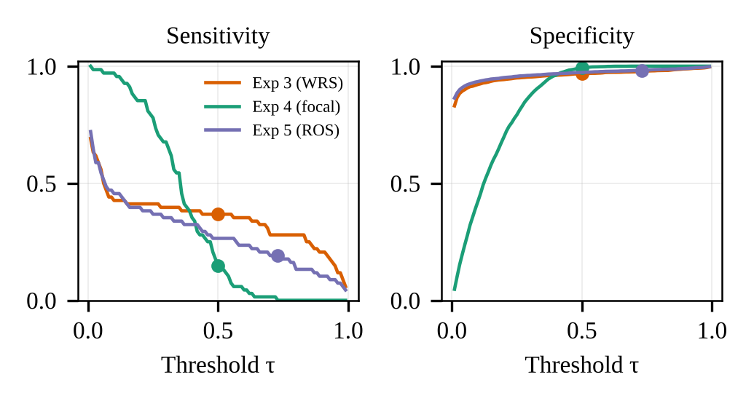
Fig. 4. Test sensitivity and specificity as functions of the threshold τ for Exp 3 to Exp 5. Dots mark the threshold actually used. The curves are shown for illustration; all thresholds were fixed on validation data.
Exp 5 shows the cost of tuning the threshold on a small validation set. At its validation-selected τ = 0.7296 it finds 13 melanomas with 85 false positives. At 0.5 the same model would have found 18 melanomas with 130 false positives (sensitivity 26.47%, specificity 97.32%). The stricter threshold removed 45 false alarms but gave up 5 of the 18 cancers. The validation set holds only 71 malignant images, so the best-F1 threshold can move a long way when a handful of images change sides, and in this run it did not carry over well to the test patients.
V. Discussion
A. Comparison of the Strategies
With a frozen backbone and τ = 0.5, the positive weight of 50.21 pushed most scores above the threshold. The result was high sensitivity and very low specificity. Fine-tuning the whole network with the same loss raised validation ROC-AUC from 0.847 to 0.919, but once the threshold was moved to 0.86 on validation data the test operating point swung to high specificity and low sensitivity. The weighted sampler gave the best balance at the default threshold and the highest F1 score (20.33%), even though its test ROC-AUC (0.822) was not the best. Balanced batches let the model see malignant images often without very large loss weights. Focal loss gave the best AP (0.140) and the highest precision, but at τ = 0.5 it was far too conservative. Random oversampling ranked the test images best (ROC-AUC 0.871), yet its validation-chosen threshold transferred poorly and left it with a sensitivity of 19.12%.
No strategy was best on every measure. In our runs the imbalance methods mostly improved how well the images were ranked, and the final trade-off between cancers found and false alarms was set more by the threshold than by the method. Exp 3 and Exp 5 both use the sampler but also differ in batch size, threshold and possibly other settings we could not confirm, so we do not draw a firm conclusion about sampling versus loss weighting.
B. Accuracy and Uncertainty
Accuracy is a poor guide on data like these. Exp 4 has the highest accuracy of all runs, 98.07%, and still misses 58 of the 68 melanomas. Exp 1 has the lowest accuracy, 42.58%, and misses only 6. A classifier that labels every test image benign would score 98.62%. We therefore compare models by sensitivity, specificity and the confusion matrix and treat accuracy as a secondary figure. The Wilson intervals in Table IV are about ten percentage points wide on either side, and those of Exp 2, Exp 4 and Exp 5 overlap heavily. Exp 1 and Exp 3 clearly found more cancers than the high-specificity runs, but we cannot rank Exp 2, Exp 4 and Exp 5 against each other with any confidence.
C. Limitations
Even the best balanced run misses more than 60% of the cancers at a usable false-alarm rate, which is too low for a screening aid. Test ROC-AUC values (0.80 to 0.87) are also lower than the validation values (0.85 to 0.92). Because epochs and thresholds were chosen on only 71 malignant validation images, part of this gap probably comes from selection on a small set. The duplicate images known to exist in ISIC 2020 were not removed before splitting, and near-identical images of one lesion can still sit within a single patient's split [16]. Per-image predictions were not saved for Exp 1 and Exp 2, the training scripts of Exp 3 to Exp 5 were not preserved, and library versions were not pinned, all of which limit exact reproduction.
All images come from one public dataset. ISIC 2020 has no Fitzpatrick skin type labels, and public dermatology image collections contain few images of darker skin [28], [29], so we cannot say how these models would perform for patients with darker skin. The model sees only the image, while clinicians also weigh age, sex and body site. Finally, the outputs are not calibrated [23], so a score of 0.7 should not be read as a 70% risk. DermInsight AI is a research prototype and is not intended for diagnosis.
VI. Conclusion and Future Work
We built DermInsight AI, an image-only pipeline that labels dermoscopic images as benign or malignant, and used it to compare five class-imbalance strategies on a patient-level split of SIIM-ISIC 2020, where just 1.76% of images are malignant. Every choice of epoch and threshold was made on validation data, and each model was tested once. Training the full network with any of the imbalance strategies raised validation ROC-AUC from 0.847 to between 0.906 and 0.919, and the best test ROC-AUC was 0.871. At the thresholds actually used, the models either found most cancers at the price of thousands of false alarms or kept false alarms low and found only 10 to 25 of the 68 cancers. The weighted sampler gave the best balance, with 36.76% sensitivity at 96.85% specificity. The main lesson for us is that a good ROC-AUC and a high accuracy can both hide a large number of missed cancers, so the threshold rule and the confusion matrix should always be reported. With only 68 malignant test images, most differences between the runs fall within the statistical uncertainty.
In the next phase we plan to choose thresholds against a sensitivity target, such as at least 80% on validation, and to use patient-wise cross-validation so that the chosen threshold is more stable. We also plan to fuse patient metadata (age, sex and anatomical site) with the image features [30], [31], to add Grad-CAM [32] heatmaps that show whether the model attends to the lesion or to artefacts such as rulers and hair, to calibrate the outputs with temperature scaling [23], and to test on an external set such as HAM10000 [15]. Removing duplicate images before splitting [16] and rerunning the main experiments, with every script, prediction file and library version saved, is part of the same plan.
Acknowledgment
The authors thank the School of Computer Science and Engineering (SCOPE), Vellore Institute of Technology, for the facilities used in this project.
References
[1] American Cancer Society, "Key statistics for melanoma skin cancer," 2026. [Online]. Available: https://www.cancer.org/cancer/types/melanoma-skin-cancer/about/key-statistics.html
[2] American Cancer Society, "Survival rates for melanoma skin cancer by stage," 2026. [Online]. Available: https://www.cancer.org/cancer/types/melanoma-skin-cancer/detection-diagnosis-staging/survival-rates-for-melanoma-skin-cancer-by-stage.html
[3] A. Esteva, B. Kuprel, R. A. Novoa, J. Ko, S. M. Swetter, H. M. Blau, and S. Thrun, "Dermatologist-level classification of skin cancer with deep neural networks," Nature, vol. 542, no. 7639, pp. 115-118, 2017.
[4] H. A. Haenssle, C. Fink, R. Schneiderbauer, et al., "Man against machine: Diagnostic performance of a deep learning convolutional neural network for dermoscopic melanoma recognition in comparison to 58 dermatologists," Ann. Oncol., vol. 29, no. 8, pp. 1836-1842, 2018.
[5] T. J. Brinker, A. Hekler, A. H. Enk, et al., "Deep learning outperformed 136 of 157 dermatologists in a head-to-head dermoscopic melanoma image classification task," Eur. J. Cancer, vol. 113, pp. 47-54, 2019.
[6] V. Rotemberg, N. Kurtansky, B. Betz-Stablein, et al., "A patient-centric dataset of images and metadata for identifying melanomas using clinical context," Sci. Data, vol. 8, no. 1, p. 34, 2021.
[7] M. E. Celebi, N. Codella, and A. Halpern, "Dermoscopy image analysis: Overview and future directions," IEEE J. Biomed. Health Inform., vol. 23, no. 2, pp. 474-478, 2019.
[8] A. Adegun and S. Viriri, "Deep learning techniques for skin lesion analysis and melanoma cancer detection: A survey of state-of-the-art," Artif. Intell. Rev., vol. 54, no. 2, pp. 811-841, 2021.
[9] P. Tschandl, N. Codella, B. N. Akay, et al., "Comparison of the accuracy of human readers versus machine-learning algorithms for pigmented skin lesion classification: An open, web-based, international, diagnostic study," Lancet Oncol., vol. 20, no. 7, pp. 938-947, 2019.
[10] J. Deng, W. Dong, R. Socher, L.-J. Li, K. Li, and L. Fei-Fei, "ImageNet: A large-scale hierarchical image database," in Proc. IEEE Conf. Comput. Vis. Pattern Recognit. (CVPR), 2009, pp. 248-255.
[11] J. Yosinski, J. Clune, Y. Bengio, and H. Lipson, "How transferable are features in deep neural networks?" in Adv. Neural Inf. Process. Syst. (NeurIPS), vol. 27, 2014, pp. 3320-3328.
[12] G. Huang, Z. Liu, L. van der Maaten, and K. Q. Weinberger, "Densely connected convolutional networks," in Proc. IEEE Conf. Comput. Vis. Pattern Recognit. (CVPR), 2017, pp. 4700-4708.
[13] K. He, X. Zhang, S. Ren, and J. Sun, "Deep residual learning for image recognition," in Proc. IEEE Conf. Comput. Vis. Pattern Recognit. (CVPR), 2016, pp. 770-778.
[14] N. C. F. Codella, D. Gutman, M. E. Celebi, et al., "Skin lesion analysis toward melanoma detection: A challenge at the 2017 International Symposium on Biomedical Imaging (ISBI), hosted by the International Skin Imaging Collaboration (ISIC)," in Proc. IEEE 15th Int. Symp. Biomed. Imaging (ISBI), 2018, pp. 168-172.
[15] P. Tschandl, C. Rosendahl, and H. Kittler, "The HAM10000 dataset, a large collection of multi-source dermatoscopic images of common pigmented skin lesions," Sci. Data, vol. 5, p. 180161, 2018.
[16] B. Cassidy, C. Kendrick, A. Brodzicki, J. Jaworek-Korjakowska, and M. H. Yap, "Analysis of the ISIC image datasets: Usage, benchmarks and recommendations," Med. Image Anal., vol. 75, p. 102305, 2022.
[17] J. M. Johnson and T. M. Khoshgoftaar, "Survey on deep learning with class imbalance," J. Big Data, vol. 6, no. 1, p. 27, 2019.
[18] M. Buda, A. Maki, and M. A. Mazurowski, "A systematic study of the class imbalance problem in convolutional neural networks," Neural Netw., vol. 106, pp. 249-259, 2018.
[19] N. V. Chawla, K. W. Bowyer, L. O. Hall, and W. P. Kegelmeyer, "SMOTE: Synthetic minority over-sampling technique," J. Artif. Intell. Res., vol. 16, pp. 321-357, 2002.
[20] T.-Y. Lin, P. Goyal, R. Girshick, K. He, and P. Dollár, "Focal loss for dense object detection," in Proc. IEEE Int. Conf. Comput. Vis. (ICCV), 2017, pp. 2980-2988.
[21] T. Saito and M. Rehmsmeier, "The precision-recall plot is more informative than the ROC plot when evaluating binary classifiers on imbalanced datasets," PLoS ONE, vol. 10, no. 3, p. e0118432, 2015.
[22] J. Davis and M. Goadrich, "The relationship between precision-recall and ROC curves," in Proc. 23rd Int. Conf. Mach. Learn. (ICML), 2006, pp. 233-240.
[23] C. Guo, G. Pleiss, Y. Sun, and K. Q. Weinberger, "On calibration of modern neural networks," in Proc. 34th Int. Conf. Mach. Learn. (ICML), 2017, pp. 1321-1330.
[24] I. Loshchilov and F. Hutter, "Decoupled weight decay regularization," in Proc. Int. Conf. Learn. Represent. (ICLR), 2019.
[25] F. Pedregosa, G. Varoquaux, A. Gramfort, et al., "Scikit-learn: Machine learning in Python," J. Mach. Learn. Res., vol. 12, pp. 2825-2830, 2011.
[26] E. B. Wilson, "Probable inference, the law of succession, and statistical inference," J. Amer. Statist. Assoc., vol. 22, no. 158, pp. 209-212, 1927.
[27] A. Paszke, S. Gross, F. Massa, et al., "PyTorch: An imperative style, high-performance deep learning library," in Adv. Neural Inf. Process. Syst. (NeurIPS), vol. 32, 2019, pp. 8024-8035.
[28] R. Daneshjou, K. Vodrahalli, R. A. Novoa, et al., "Disparities in dermatology AI performance on a diverse, curated clinical image set," Sci. Adv., vol. 8, no. 32, p. eabq6147, 2022.
[29] M. Groh, C. Harris, L. Soenksen, et al., "Evaluating deep neural networks trained on clinical images in dermatology with the Fitzpatrick 17k dataset," in Proc. IEEE/CVF Conf. Comput. Vis. Pattern Recognit. Workshops (CVPRW), 2021, pp. 1820-1828.
[30] A. G. C. Pacheco and R. A. Krohling, "An attention-based mechanism to combine images and metadata in deep learning models applied to skin cancer classification," IEEE J. Biomed. Health Inform., vol. 25, no. 9, pp. 3554-3563, 2021.
[31] J. Kawahara, S. Daneshvar, G. Argenziano, and G. Hamarneh, "Seven-point checklist and skin lesion classification using multitask multimodal neural nets," IEEE J. Biomed. Health Inform., vol. 23, no. 2, pp. 538-546, 2019.
[32] R. R. Selvaraju, M. Cogswell, A. Das, R. Vedantam, D. Parikh, and D. Batra, "Grad-CAM: Visual explanations from deep networks via gradient-based localization," in Proc. IEEE Int. Conf. Comput. Vis. (ICCV), 2017, pp. 618-626.

