B.Tech. BCSE497J - Project-I
AN AUTOMATED DEEP LEARNING FRAMEWORK FOR EARLY DETECTION OF SKIN CANCER

Submitted in partial fulfillment of the requirements for the degree of

Bachelor of Technology

in

Computer Science and Engineering

by

23BCB0165 | ALAN JOHN ANAND
23BCE2002 | SUJAN M
23BCE2107 | RAMACHANDRAN SIVASANKAR

Under the Supervision of
Dr. Krishna Rani Samal
Associate Professor
School of Computer Science and Engineering (SCOPE)



October 2026

DECLARATION

We hereby declare that the project entitled An Automated Deep Learning Framework for Early Detection of Skin Cancer submitted by us, for the award of the degree of Bachelor of Technology in Computer Science and Engineering to VIT is a record of bonafide work carried out by us under the supervision of Dr. Krishna Rani Samal.
We further declare that the work reported in this project has not been submitted and will not be submitted, either in part or in full, for the award of any other degree or diploma in this institute or any other institute or university.

Place : Vellore Date :
Signature of the Candidates

CERTIFICATE

This is to certify that the project entitled An Automated Deep Learning Framework for Early Detection of Skin Cancer submitted by ALAN JOHN ANAND (23BCB0165), SUJAN M (23BCE2002) and RAMACHANDRAN SIVASANKAR (23BCE2107), School of Computer Science and Engineering, VIT, for the award of the degree of Bachelor of Technology in Computer Science and Engineering, is a record of bonafide work carried out by them under my supervision during Fall Semester 2026-2027, as per the VIT code of academic and research ethics.

The contents of this report have not been submitted and will not be submitted either in part or in full, for the award of any other degree or diploma in this institute or any other institute or university. The project fulfills the requirements and regulations of the University and in my opinion meets the necessary standards for submission.

Place : Vellore
Date :

Signature of the Guide

Examiner(s)

Head of the Department
B.Tech. Computer Science and Engineering
ACKNOWLEDGEMENTS

We thank the management of Vellore Institute of Technology (VIT) for giving us the chance to do this project and for the learning environment and facilities of the institute, which we used throughout the semester.

We thank Dr. Jaisankar N, Dean of the School of Computer Science and Engineering (SCOPE), for his support and encouragement for student projects in the school.

We are thankful to the Head of the Department of Computer Science and Engineering for the support of the department and for the guidance given to us during the review stages of the project.

We are very grateful to our project guide, Dr. Krishna Rani Samal, for her regular guidance and feedback. Her questions during the reviews made us look again at our evaluation, mainly at how we handled the class imbalance and how we reported the number of missed cancers, and the report is better because of it.

We also thank our friends and families for their support during the project.

Alan John Anand (23BCB0165)
Sujan M (23BCE2002)
Ramachandran Sivasankar (23BCE2107)

TABLE OF CONTENTS

Sl.No | Contents | Page No.
 | Abstract | x
1. | INTRODUCTION | 1
 | 1.1 Background | 1
 | 1.2 Motivations | 1
 | 1.3 Scope of the Project | 1
2. | PROJECT DESCRIPTION AND GOALS | 3
 | 2.1 Literature Review | 3
 | 2.1.1 From hand-crafted features to deep learning | 3
 | 2.1.2 Transfer learning and DenseNet | 3
 | 2.1.3 Datasets and data leakage | 3
 | 2.1.4 Class imbalance and evaluation | 3
 | 2.2 Research Gap | 4
 | 2.3 Objectives | 4
 | 2.4 Problem Statement | 5
 | 2.5 Project Plan | 5
3. | TECHNICAL SPECIFICATION | 6
 | 3.1 Requirements | 6
 | 3.1.1 Functional | 6
 | 3.1.2 Non-Functional | 6
 | 3.2 Feasibility Study | 6
 | 3.2.1 Technical Feasibility | 6
 | 3.2.2 Economic Feasibility | 7
 | 3.2.3 Social Feasibility | 7
 | 3.3 System Specification | 7
 | 3.3.1 Hardware Specification | 7
 | 3.3.2 Software Specification | 7
4. | DESIGN APPROACH AND DETAILS | 8
 | 4.1 System Architecture | 8
 | 4.2 Design | 10
 | 4.2.1 Data Flow Diagram | 10
 | 4.2.2 Use Case Diagram | 11
 | 4.2.3 Class Diagram | 12
 | 4.2.4 Sequence Diagram | 13
5. | METHODOLOGY AND TESTING | 15
 | 5.1 Module Description | 15
 | 5.1.1 Dataset and patient-level split | 15
 | 5.1.2 Preprocessing and augmentation | 16
 | 5.1.3 Model | 16
 | 5.1.4 Experiment 1: baseline with weighted BCE | 17
 | 5.1.5 Experiment 2: fine-tuning with weighted BCE | 17
 | 5.1.6 Experiment 3: WeightedRandomSampler | 17
 | 5.1.7 Experiment 4: focal loss | 18
 | 5.1.8 Experiment 5: random oversampling | 18
 | 5.1.9 Threshold selection | 18
 | 5.1.10 Evaluation metrics | 18
 | 5.2 Testing | 19
6. | PROJECT DEMONSTRATION | 21
 | 6.1 Running an Experiment | 21
 | 6.2 Threshold Selection and Final Test Run | 21
 | 6.3 Output Files | 21
7. | RESULT AND DISCUSSION (COST ANALYSIS) | 23
 | 7.1 Training and Validation Behaviour | 23
 | 7.2 Test Results | 24
 | 7.3 Effect of the Decision Threshold | 27
 | 7.4 Accuracy and Uncertainty | 28
 | 7.5 Comparison of the Strategies | 28
 | 7.6 Discussion | 29
 | 7.7 Cost Analysis | 29
8. | CONCLUSION | 31
9. | REFERENCES | 32
 | APPENDIX A – SAMPLE CODE | 35

List of Figures

Figure No. | Title | Page No.
2.1 | Project plan (semester weeks) | 5
4.1 | System architecture of DermInsight AI (implemented parts and proposed parts) | 9
4.2 | Starting point and main settings of the five experiments | 10
4.3 | Data flow diagram, level 0 (context) | 11
4.4 | Data flow diagram, level 1 | 11
4.5 | Use case diagram (implemented and proposed) | 12
4.6 | Class diagram of the implemented code | 13
4.7 | Sequence diagram of training and evaluation (Exp 2) | 14
5.1 | Class distribution of the ISIC 2020 training data (logarithmic scale) | 15
5.2 | Benign and malignant images in each split | 16
5.3 | Evaluation protocol followed in every experiment | 19
6.1 | Predicted probabilities on the test set, Exp 3 (saved output) | 22
7.1 | Validation ROC-AUC by epoch (circles mark the saved checkpoint) | 23
7.2 | Training and validation loss of Exp 1 (x-axis: epoch index 0 to 2) | 24
7.3 | Test confusion matrices of the five experiments (original saved plots) | 25
7.4 | Test ROC curves (Exp 3–5) and operating points (Exp 1–2) | 26
7.5 | Test precision-recall curves (Exp 3–5) and operating points (Exp 1–2) | 26
7.6 | Sensitivity, specificity, precision and F1 of each experiment on the test set | 27
7.7 | Sensitivity and specificity against the threshold on the test set (descriptive only) | 27
7.8 | Predicted probabilities on the test set, Exp 4 (focal loss) | 28
List of Tables

Table No. Title Page No.
2.1 Summary of the most relevant prior work 4
2.2 Project phases and deliverables 5
3.1 Functional requirements 6
3.2 Non-functional requirements 6
3.3 Hardware used 7
3.4 Software used 7
4.1 Pipeline parts and their files 9
5.1 Patient-level split of the data 15
5.2 Preprocessing and augmentation settings 16
5.3 Training settings of the five experiments 19
5.4 Checks done on the pipeline and the results 19
6.1 Output files of each experiment 22
7.1 Validation results of the five experiments 23
7.2 Results on the test set (N = 4,920; 68 malignant) 24
7.3 Exp 5 on the test set at two thresholds 28
7.4 Test sensitivity with 95% Wilson intervals (68 malignant images) 28
7.5 Cost of the project 30
7.6 Illustrative error cost on the test set (assumed unit costs, not real prices) 30

List of Abbreviations

AdamW Adam optimiser with decoupled weight decay
AP Average Precision
AUC Area Under the Curve
BCE Binary Cross-Entropy
CI Confidence Interval
CNN Convolutional Neural Network
CPU Central Processing Unit
CSV Comma-Separated Values
DFD Data Flow Diagram
Exp Experiment
F1 Harmonic mean of precision and recall
FN False Negative
FP False Positive
GPU Graphics Processing Unit
Grad-CAM Gradient-weighted Class Activation Mapping
ISIC International Skin Imaging Collaboration
JSON JavaScript Object Notation
PR Precision-Recall
ReLU Rectified Linear Unit
ROC Receiver Operating Characteristic
SIIM Society for Imaging Informatics in Medicine
TN True Negative
TP True Positive
UML Unified Modeling Language
VIT Vellore Institute of Technology
W-BCE Weighted Binary Cross-Entropy
WRS WeightedRandomSampler (PyTorch)
Symbols and Notations

x Input image tensor of size 3 × 224 × 224
y True label, 0 = benign, 1 = malignant
z Raw output (logit) of the linear head
p̂ Predicted probability of malignancy, σ(z)
σ(·) Logistic sigmoid function
τ Decision threshold on p̂
w+ Weight on the positive class in W-BCE (50.2067)
N_neg, N_pos Benign and malignant counts in the training split
p_t Predicted probability of the true class (focal loss)
α Class balance factor in focal loss (0.75)
γ Focusing exponent in focal loss (2.0)
η Learning rate (1 × 10⁻⁴)
λ Weight decay in AdamW (1 × 10⁻⁴)
μ, s ImageNet channel mean and standard deviation used for normalisation

ABSTRACT
Melanoma is only about one percent of skin cancers, but it causes most of the deaths from skin cancer [2]. When it is found while still localised, the five-year relative survival is above 99 percent, and it falls to about 36 percent once it has spread to distant organs [3]. So finding it early matters a lot. Deep learning models can score dermoscopic images for malignancy, but real screening data is very imbalanced. In the SIIM-ISIC 2020 dataset that we used, only 584 of the 33,126 images (1.76%) are malignant, so a model that calls every image benign will still be 98.24% accurate.
In this project we built DermInsight AI, an image-only pipeline that classifies a dermoscopic image as benign or malignant. The images were divided by patient into training (22,787 images, 1,439 patients), validation (5,419 images, 307 patients) and test (4,920 images, 310 patients) sets, and no patient is shared between two sets. An ImageNet-pretrained DenseNet201 with a single-output linear head was used in five experiments: a baseline with a frozen backbone and weighted binary cross-entropy, full fine-tuning with weighted binary cross-entropy, a WeightedRandomSampler, focal loss, and random oversampling of the training split. In each run the best epoch was picked by validation ROC-AUC, and where a threshold was tuned, it was tuned on the validation set only.
On the same 4,920 test images, the test ROC-AUC was between 0.800 and 0.871, and the best value came from random oversampling. The results at a fixed threshold were much weaker. The baseline found 62 of the 68 cancers but also flagged 2,819 benign images (specificity 41.90%). The runs with specificity above 98% found only 10 to 15 of the 68 cancers. The WeightedRandomSampler run gave the best balance, with 36.76% sensitivity at 96.85% specificity. With only 68 malignant test images these estimates are uncertain, and the work is a research prototype, not a clinical tool. Metadata fusion, Grad-CAM, probability calibration and external testing are planned for Project-II.
Keywords: melanoma, dermoscopy, deep learning, DenseNet201, class imbalance, ISIC 2020, patient-level split, threshold selection.

CHAPTER 1

1. INTRODUCTION

1.1 Background
Skin cancer is one of the most common cancers, and melanoma is its most dangerous type. According to the American Cancer Society, melanoma is only about 1% of skin cancers, but it causes a large majority of the deaths from skin cancer [2]. The stage at diagnosis decides a lot. For people diagnosed between 2015 and 2021, the five-year relative survival was more than 99% when the melanoma was localised, 76% when it had spread to nearby areas, and 36% when it had reached distant organs [3]. If a suspicious lesion is caught while it is still thin and local, a simple excision is often enough.
Doctors usually look at a lesion with a dermatoscope, which magnifies the skin and uses polarised or immersion light so that pigment networks, dots, streaks and vessel patterns below the surface become visible. Reading these images well takes training and practice. An early melanoma can look very similar to a common mole, and many patients first show a lesion to a general practitioner, not to a dermatologist. Reader studies have shown that convolutional neural networks (CNNs) trained on dermoscopic images can reach a level close to dermatologists on test sets of images [13, 16, 4]. This is the main reason why automated image analysis is being studied as a support tool for screening.
Most of the published work reports good numbers on fairly balanced or curated datasets. Real screening data is different. In the SIIM-ISIC 2020 challenge data, which comes from routine skin examinations of 2,056 patients, only 584 of 33,126 images are malignant [26]. Working with such a dataset brings two practical problems that this project focuses on: the model has to learn from very few positive examples, and the way the model is evaluated has to be honest about how many cancers it actually finds.

1.2 Motivations
- Very few positive examples. With 1.76% malignant images, a classifier that always says benign is 98.24% accurate and finds no cancer. Standard training on such data pushes the model towards the majority class, so imbalance has to be handled on purpose.
- Data leakage between splits. Many patients in ISIC 2020 have several images. If images are split at random, the same person's skin, hair, lighting and camera can appear in both training and test data, and the test score becomes too optimistic [6]. We wanted a split where this cannot happen.
- Ranking is not the same as deciding. A model can rank malignant images above benign ones quite well (good ROC-AUC) and still miss most cancers at the threshold that is finally used. We wanted to measure both and report the exact number of missed cancers.
- Limited compute. The work had to run on free cloud notebooks and a normal laptop, so we needed a pretrained backbone and short training runs that still give comparable results.

1.3 Scope of the Project
The project is a research pipeline for binary classification of dermoscopic images (benign or malignant). The scope of Project-I is the following:
- Audit the SIIM-ISIC 2020 training metadata and divide all 33,126 images into training, validation and test sets by patient, with a code check that no patient appears in two sets.
- Build a PyTorch input pipeline with resizing, ImageNet normalisation and light augmentation for the training images only.
- Use an ImageNet-pretrained DenseNet201 with a single linear output unit as the classifier.
- Run five experiments that differ in the way class imbalance is handled: weighted loss with a frozen backbone, weighted loss with full fine-tuning, a WeightedRandomSampler, focal loss and random oversampling.
- Select the best epoch on the validation set, choose a decision threshold on the validation set where this was done, and evaluate every model once on the same 4,920 test images.
- Save checkpoints, prediction files, metric files and plots for each experiment, and check the reported numbers against these files.
Out of scope for Project-I: the use of patient metadata (age, sex, body site) inside the model, Grad-CAM explanations, probability calibration, testing on data from other hospitals, and any user-facing application. These are planned for Project-II and are shown as proposed parts in the design diagrams.
CHAPTER 2

2. PROJECT DESCRIPTION AND GOALS

2.1 Literature Review
We reviewed work in four areas that directly affected our design: the move from hand-crafted features to CNNs, transfer learning and the DenseNet architecture, the datasets used for skin lesion classification, and methods for handling and evaluating class imbalance. Table 2.1 summarises the studies that we used most.

2.1.1 From hand-crafted features to deep learning
Early computer-aided systems copied the rules that dermatologists use, such as the ABCD rule and the seven-point checklist. They segmented the lesion, measured shape, colour and texture features and passed them to a classifier like an SVM [7, 1]. These systems were easy to explain, but they depended heavily on correct segmentation and on the imaging setup. Esteva et al. [13] trained an Inception-v3 network, starting from ImageNet weights, on about 129,000 clinical images and showed performance on par with board-certified dermatologists on biopsy-proven test images. Haenssle et al. [16] and Brinker et al. [4] reported similar results in reader studies with dermoscopic images, and Tschandl et al. [30] found that the best algorithms in an open web-based study did better than most human readers on the same images. These studies used fixed image sets, so they show what a model can do on that data, not how it behaves in a clinic.

2.1.2 Transfer learning and DenseNet
Medical image datasets are small compared to ImageNet [12], and the number of malignant cases is smaller still. Yosinski et al. [32] showed that features learned in the early layers of a CNN transfer well between tasks, while the later layers are more task-specific. This is why almost all skin lesion work starts from ImageNet weights and fine-tunes. We chose DenseNet201 [18]. In a dense block every layer receives the feature maps of all previous layers, so low-level features such as edges and colour changes stay available to deeper layers and are reused. Compared to a ResNet [17] of similar depth it has fewer parameters, which matters when training time is limited.

2.1.3 Datasets and data leakage
The ISIC archive provides the main public dermoscopy benchmarks [9, 29]. HAM10000 [29] has seven diagnostic classes and a fairly high share of melanoma. The SIIM-ISIC 2020 dataset [26] is different because it was collected from screening of patients with many lesions, and it includes a patient identifier for every image. This makes it closer to a real screening population, with a very low share of melanoma. Cassidy et al. [6] analysed the ISIC datasets and found many duplicate images within and between the datasets, including duplicates between training and test sets. Their work is the reason why we split the data by patient and why we list duplicate images as a remaining limitation.

2.1.4 Class imbalance and evaluation
Buda et al. [5] studied class imbalance in CNNs and found that oversampling the minority class was the best method in most of their settings and that it did not cause overfitting of the CNNs. Johnson and Khoshgoftaar [19] grouped the methods into data-level methods (resampling) and algorithm-level methods (changing the loss). From the first group we used random oversampling and a weighted sampler; SMOTE [8] makes synthetic samples, but it was designed for feature vectors and is less natural for images. From the second group we used a positive class weight in binary cross-entropy and focal loss [21], which reduces the loss of easy examples so that training focuses on hard ones. For evaluation, Saito and Rehmsmeier [27] showed that precision-recall plots are more informative than ROC plots when positives are rare, and Davis and Goadrich [11] explained how the two curves are related. Guo et al. [15] showed that modern deep networks are often poorly calibrated, so a predicted probability should not be read directly as a risk.
Table 2.1: Summary of the most relevant prior work
Ref. | Work | What it shows | Use in this project
[13] | Esteva et al., 2017 | CNN from ImageNet weights matches dermatologists on a fixed test set | Supports transfer learning from ImageNet
[16], [4] | Haenssle 2018; Brinker 2019 | CNNs compare well with dermatologists on dermoscopic images | Motivation for image-based screening support
[18] | Huang et al., 2017 | DenseNet reuses features through dense connections | Backbone of all five experiments
[26] | Rotemberg et al., 2021 | ISIC 2020 dataset with patient IDs, 1.76% melanoma | Dataset and patient-level split
[6] | Cassidy et al., 2022 | Duplicates and train/test overlap in ISIC data | Reason for patient-level split; duplicate limitation
[5], [19] | Buda 2018; Johnson 2019 | Oversampling and loss weighting for imbalance | Exp 1, 2, 3 and 5 design
[21] | Lin et al., 2017 | Focal loss down-weights easy examples | Exp 4 design
[27], [11] | Saito 2015; Davis 2006 | PR analysis is more informative for rare positives | Report AP and PR curves, not only ROC-AUC
[15] | Guo et al., 2017 | Deep networks are often miscalibrated | Do not read p̂ as a risk; future work

2.2 Research Gap
Each part that we used is known from earlier work. The gap is in how the parts are evaluated together on realistic data. From the literature and our own early runs we noted the following points:
- Many studies report accuracy or ROC-AUC at the default threshold of 0.5 on balanced or curated data, and do not show how many cancers are missed when malignant cases are less than 2% of the data.
- Patient-level separation of training and test data is often not stated, even though the ISIC data contains many images per patient and duplicate images [6].
- Imbalance methods are usually reported one at a time, on different splits and with different evaluation rules, so they are hard to compare.
- The choice of decision threshold is rarely described, and sometimes it is not clear whether it was chosen on validation or test data.
Our project does not propose a new network. It compares five imbalance strategies on one fixed patient-level split, with the same backbone, the same test set and the same reporting, and it reports full confusion matrices so that the number of missed cancers is always visible.

2.3 Objectives
- To create a patient-level train, validation and test split of the SIIM-ISIC 2020 data and check in code that no patient is shared between splits.
- To build a DenseNet201-based binary classifier and a reproducible training and evaluation pipeline in PyTorch.
- To compare loss weighting, weighted sampling, focal loss and random oversampling under the same split and test protocol.
- To choose model checkpoints and decision thresholds only on validation data, and test each model once on the held-out test set.
- To report ROC-AUC, average precision, sensitivity, specificity, precision, F1 and the full confusion matrix for every experiment, and to check these numbers against the saved files.
- To record the limitations clearly and plan the next steps for Project-II.

2.4 Problem Statement
Given a dermoscopic image x of a skin lesion, the task is to output a probability p̂ = σ(f(x)) that the lesion is malignant and a decision ŷ = 1 if p̂ ≥ τ, otherwise 0. The model f is learned from the training split, and the threshold τ is fixed before the test set is used. Two conditions make the task difficult. First, the training split has 22,342 benign and only 445 malignant images. Second, all images of one patient must stay in one split, so that the test score reflects new patients. The aim is to find out which imbalance strategy gives the most useful balance between found cancers and false alarms on unseen patients, and to state honestly how far the results are from clinical use.

2.5 Project Plan
The work was planned in four phases over the semester (Fig. 2.1). Each phase ended with files that the next phase needed, and these are listed in Table 2.2.
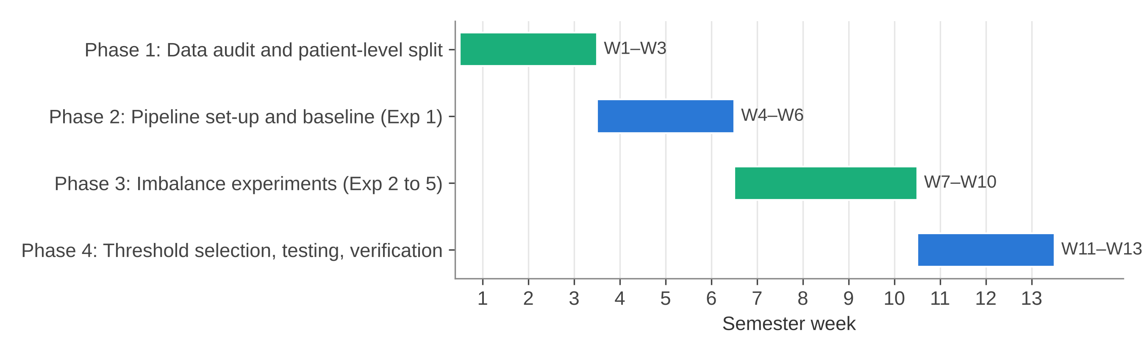
Figure 2.1: Project plan (semester weeks)
Table 2.2: Project phases and deliverables
Phase | Weeks | Work | Deliverable
1 | 1–3 | Download metadata, audit labels and patient IDs, make patient-level split | train.csv, val.csv, test.csv
2 | 4–6 | Dataset class, transforms, DenseNet201 model, baseline training (Exp 1) | densenet201_baseline.py, Exp 1 checkpoint and metrics
3 | 7–10 | Weighted BCE fine-tuning, sampler, focal loss and oversampling runs (Exp 2–5) | Checkpoints, histories and predictions for Exp 2–5
4 | 11–13 | Threshold selection on validation, final test runs, plots, checking of results, report | Metric JSON/CSV files, plots, this report

CHAPTER 3

3. TECHNICAL SPECIFICATION

3.1 Requirements

3.1.1 Functional
Table 3.1: Functional requirements
ID | Requirement | Where it is done
FR1 | Read the split CSV files and load each image by its image_name, with its target label. | DermImageDataset, ISICDataset
FR2 | Stop if any patient ID appears in more than one split. | assert checks in train_model()
FR3 | Resize images to 224 × 224 and normalise with ImageNet mean and standard deviation; augment training images only. | build_transform()
FR4 | Produce one logit per image from a DenseNet201 backbone and a 1920 → 1 linear head. | DermInsightDenseNet201
FR5 | Train with the selected imbalance strategy (loss weight, sampler, focal loss or oversampling). | Experiment scripts and settings
FR6 | Evaluate on the validation set after every epoch and save the checkpoint with the best validation ROC-AUC. | Training loops of Exp 1 and Exp 2; checkpoints of Exp 3–5
FR7 | Select a decision threshold on the validation set when required (best F1 over 0.01 to 0.99). | stage2b_final_evaluation.py; Exp 5 evaluation
FR8 | Compute ROC-AUC, AP, accuracy, precision, sensitivity, specificity, F1 and the confusion matrix on the test set. | calculate_binary_metrics(), evaluation scripts
FR9 | Save metrics as JSON or CSV, predictions as CSV, and plots as PNG files for each experiment. | results/EXP_0x folders

3.1.2 Non-Functional
Table 3.2: Non-functional requirements
ID | Requirement | How it is met
NFR1 | Reproducibility | Seed 42 for Python, NumPy and PyTorch; deterministic cuDNN in the baseline script; fixed split files
NFR2 | No leakage | Patient-level split; validation-only threshold choice; test set used once per model
NFR3 | Traceability | Each experiment has its own folder for code, checkpoint and results; organisation manifest stores SHA-256 hashes of copied files
NFR4 | Low cost | Only open-source software and free cloud notebook runtimes
NFR5 | Modularity | Dataset, model, metric and plotting code are separate functions and classes
NFR6 | Honest reporting | Full confusion matrix and exact counts of missed cancers for every model

3.2 Feasibility Study

3.2.1 Technical Feasibility
All the parts are well supported by existing libraries. PyTorch [24] and torchvision provide DenseNet201 with ImageNet weights, the data loaders, the WeightedRandomSampler and the BCEWithLogitsLoss with a pos_weight option. scikit-learn [25] provides the ROC-AUC, average precision and confusion matrix functions. The input size of 224 × 224 and a batch size of 32 or 64 fit on a free cloud GPU. As an example of the training time, one epoch of Exp 3 over the full training split took about 610 to 620 seconds, as recorded in its training history file.

3.2.2 Economic Feasibility
The project did not need any paid software or hardware. The dataset is public, the libraries are open source, and the training was done on free Google Colab sessions, with the images taken from a public Kaggle copy of the ISIC 2020 data. The only real cost was the team's time. Section 7.7 gives the cost details.

3.2.3 Social Feasibility
A screening aid could help doctors in places where dermatologists are few, by pointing out lesions that need a closer look. At the same time, a wrong result can harm a patient, either by false reassurance or by an unnecessary biopsy. For this reason we treat DermInsight AI only as a research prototype. It is not meant to give a diagnosis, and any future use would need clinical testing, approval and a doctor in the loop.

3.3 System Specification

3.3.1 Hardware Specification
Table 3.3: Hardware used
Item | Detail | Evidence
Exp 1 training | CPU (device recorded as "cpu") | densenet201_baseline_metrics.json
Exp 2–5 training and evaluation | Google Colab runtime with GPU when available; exact GPU model not recorded | Colab paths in scripts and summaries
Local workstation | Windows 11 laptop, used for organising files and writing the report | Project inventory notes
Storage | Google Drive project folder; checkpoints about 70 MB each (Exp 5: 209 MB, includes optimiser state) | models/ folder

3.3.2 Software Specification
Table 3.4: Software used
Software | Version | Use
Python | 3.12 (local); Colab default for training | Programming language
PyTorch, torchvision | 2.x (not pinned) | Model, data loading, training, DenseNet201 weights
scikit-learn | not pinned | ROC-AUC, average precision, confusion matrix, F1
pandas, NumPy | not pinned | Reading CSV files and handling arrays
Pillow (PIL) | not pinned | Opening JPEG images
Matplotlib | not pinned | Loss curves, ROC, PR and confusion matrix plots
Google Colab, Google Drive | web service | GPU runtime and file storage

The project folder does not have a requirements file, so library versions were not recorded. This is noted as a reproducibility limitation in Section 7.6.
CHAPTER 4

4. DESIGN APPROACH AND DETAILS

4.1 System Architecture
Fig. 4.1 shows the architecture of DermInsight AI as it is implemented in Project-I. It has four layers. The data layer holds the ISIC 2020 images and the metadata CSV, and turns the metadata into three patient-level split files. The input pipeline reads the split files, opens each image and applies the transforms. The model layer is the DenseNet201 backbone with a linear head, trained with one of the loss or sampling options. The storage and evaluation layer saves the best checkpoint, scores the validation and test images, applies the threshold and writes the metrics and plots. The grey dashed box at the bottom shows parts that are planned for Project-II and are not built yet.
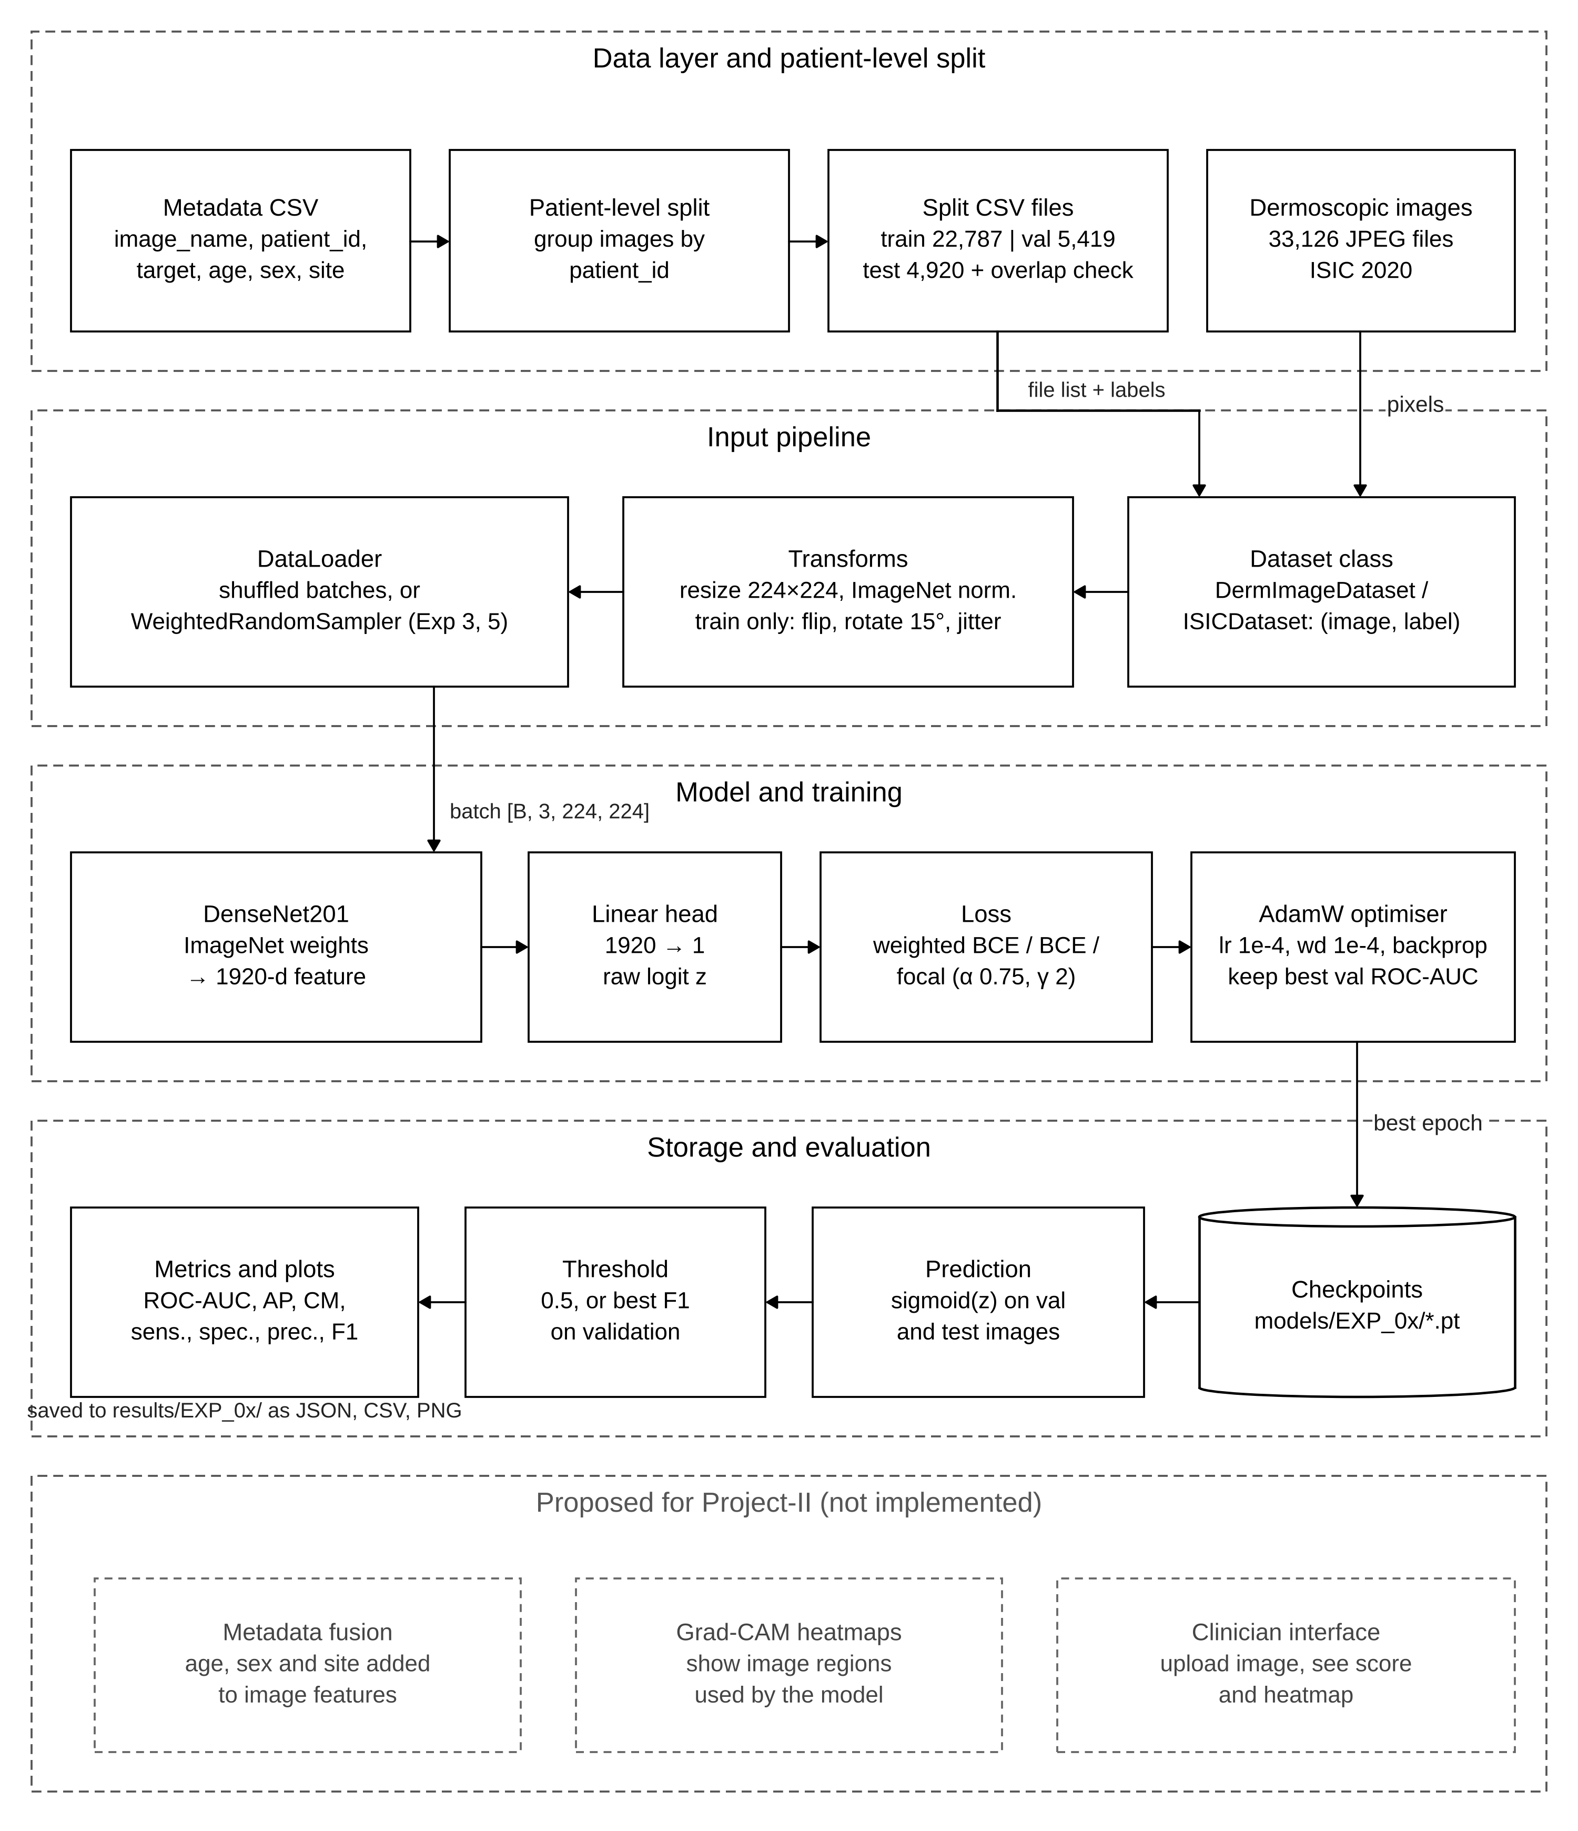
Figure 4.1: System architecture of DermInsight AI (implemented parts and proposed parts)
Table 4.1 links each part of the architecture to the files in the project folder. The five experiments share this structure and differ only in the training choices, as shown in Fig. 4.2. Exp 2 is the only run that starts from another experiment: it loads the Exp 1 checkpoint and trains all layers. The other runs start from the ImageNet weights.
Table 4.1: Pipeline parts and their files
Part | File or folder | Input | Output
Patient split | data/processed/*.csv | ISIC_2020_Training_GroundTruth_v2.csv | train, val and test CSV files
Dataset and transforms | src/EXP_01_BASELINE/densenet201_baseline.py | Split CSV, JPEG images | Tensors [B, 3, 224, 224] and labels
Model | DermInsightDenseNet201 class | Image tensor | Logit z per image
Training | Exp 1 and Exp 2 scripts | Batches, loss settings | Best checkpoint (.pt), history JSON
Threshold and test | stage2b_final_evaluation.py; Exp 5 evaluation files | Checkpoint, val and test sets | Threshold, test metrics JSON or CSV
Plots | plot functions, stage2b_visual_results.py | Predictions, histories | PNG plots

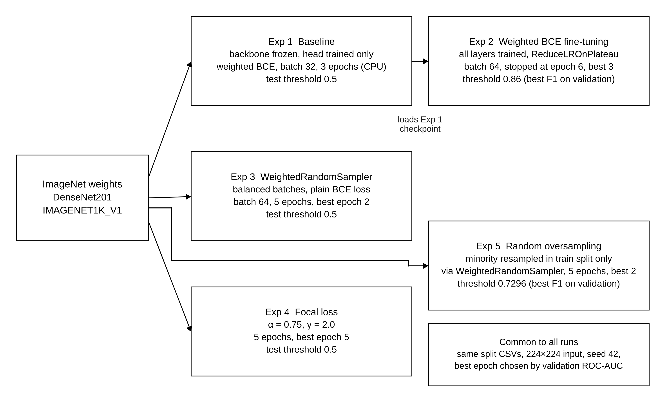
Figure 4.2: Starting point and main settings of the five experiments

4.2 Design

4.2.1 Data Flow Diagram
The context diagram (Fig. 4.3) treats the whole pipeline as one process. It receives images and metadata from the ISIC 2020 dataset and experiment settings from the researcher, and it returns checkpoints, predictions, metrics and plots. The level 1 diagram (Fig. 4.4) opens this process into six steps. Process 1.0 splits the metadata by patient and writes the split files to store D3. Process 2.0 combines the split files with the raw images from D1 and prepares tensor batches. Process 3.0 trains the model and writes the best weights to D4. Process 4.0 uses these weights to score the validation and test sets. Process 5.0 uses only the validation probabilities to choose the threshold, and process 6.0 applies it to the test probabilities and writes the results to D5.
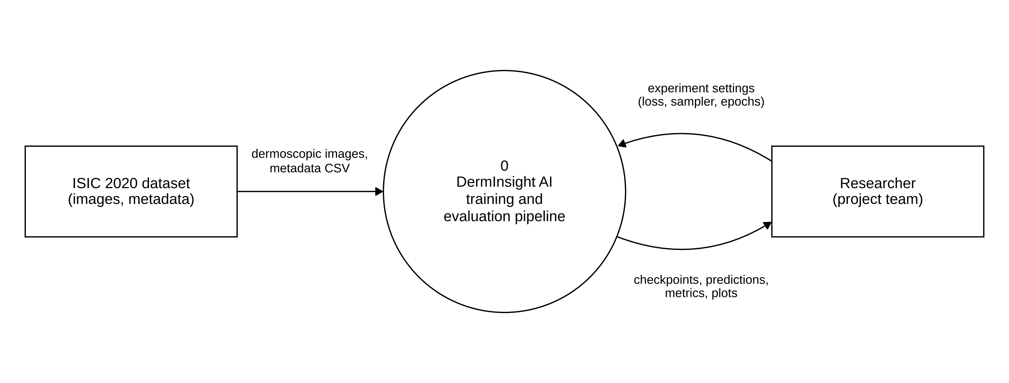
Figure 4.3: Data flow diagram, level 0 (context)
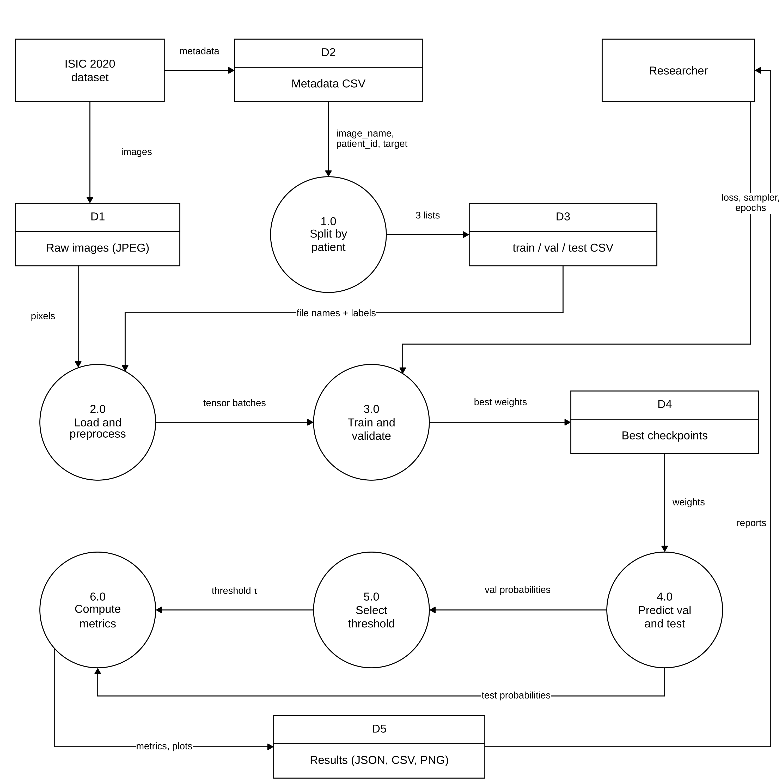
Figure 4.4: Data flow diagram, level 1

4.2.2 Use Case Diagram
In Project-I the only real user is the researcher, that is, a member of our team running the scripts (Fig. 4.5). The researcher prepares the splits, sets up an experiment, trains it, evaluates it and compares the results. Training includes validation after every epoch and saving of the best checkpoint. Test evaluation includes the metric and plot generation, and it is extended by the threshold selection step when a tuned threshold is used. The lower box shows use cases for a future clinician-facing tool. They are kept separate on purpose, because no such tool exists in this project.
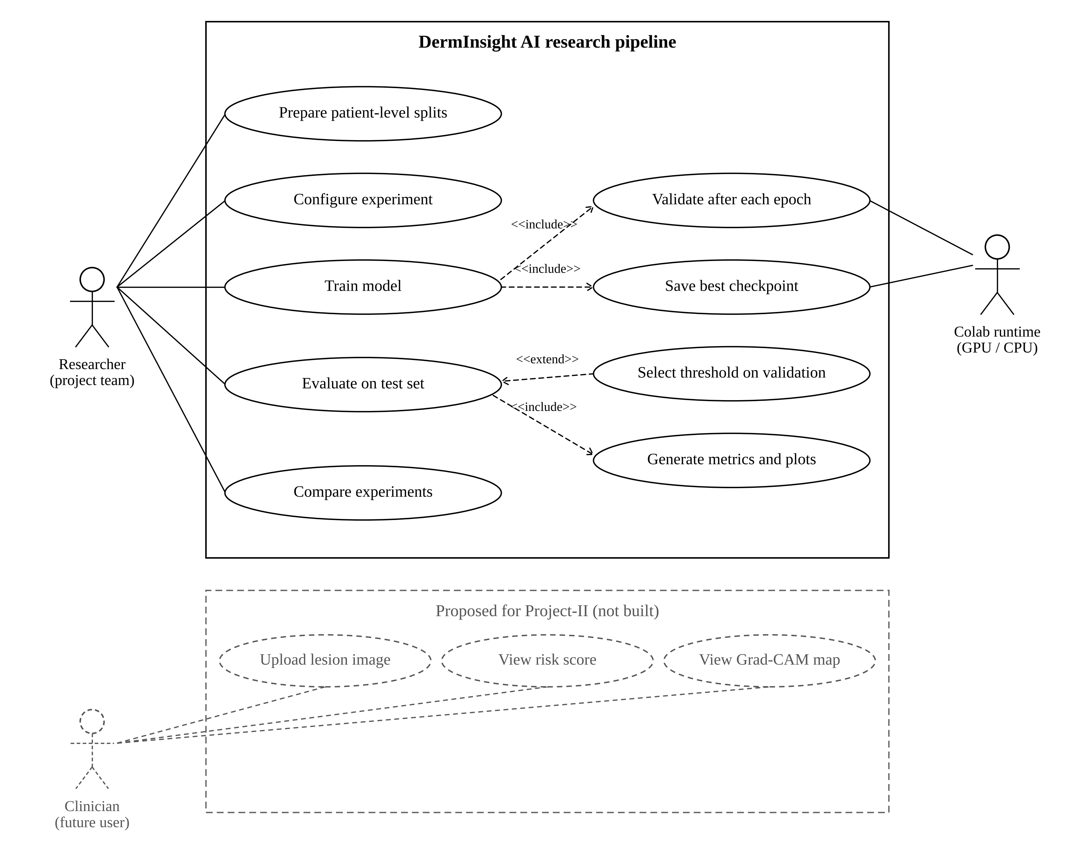
Figure 4.5: Use case diagram (implemented and proposed)

4.2.3 Class Diagram
The code is mostly script based, so Fig. 4.6 shows the real classes together with the main scripts as «module» boxes. DermImageDataset and ISICDataset both extend the PyTorch Dataset class. The first one also returns the image name, which helps when checking predictions. DermInsightDenseNet201 and DenseNet201Baseline both extend nn.Module and have the same two parts, a DenseNet201 backbone with its classifier replaced by an identity layer, and a linear head with one output. The Exp 2 class is created with weights=None because its weights come from the Exp 1 checkpoint. The training scripts for Exp 3, 4 and 5 are not in the project folder. We checked their saved checkpoints, and they hold a DenseNet201 whose classifier is a single 1920 → 1 linear layer, which is the same design.
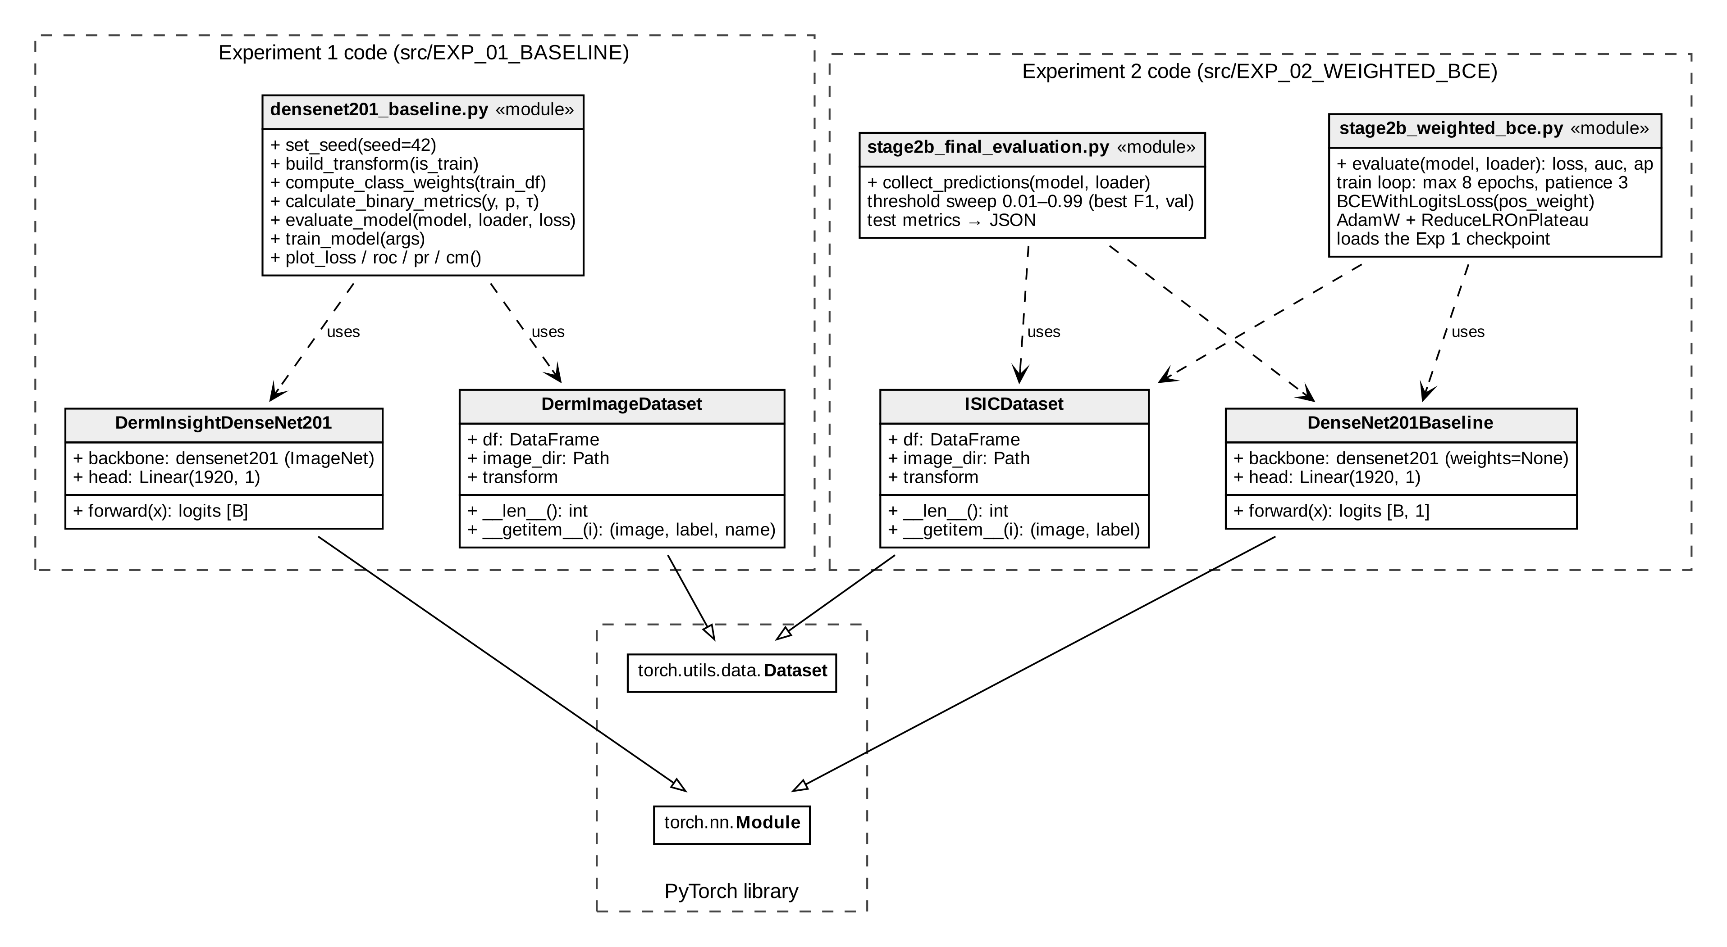
Figure 4.6: Class diagram of the implemented code

4.2.4 Sequence Diagram
Fig. 4.7 follows one complete run of Exp 2, from training to the final test numbers. The training script loads the Exp 1 weights and then runs the epoch loop. Inside each epoch the data loader feeds batches to the model, the weighted BCE loss is computed and AdamW updates the weights. After each epoch the model is scored on the validation set, the learning rate scheduler is updated with the validation ROC-AUC, and the checkpoint is saved only if the ROC-AUC improved. The loop stops after three epochs without improvement. A separate evaluation script then loads the best checkpoint, sweeps the threshold on the validation set, applies the chosen threshold (0.86) once to the test set and writes the result file.
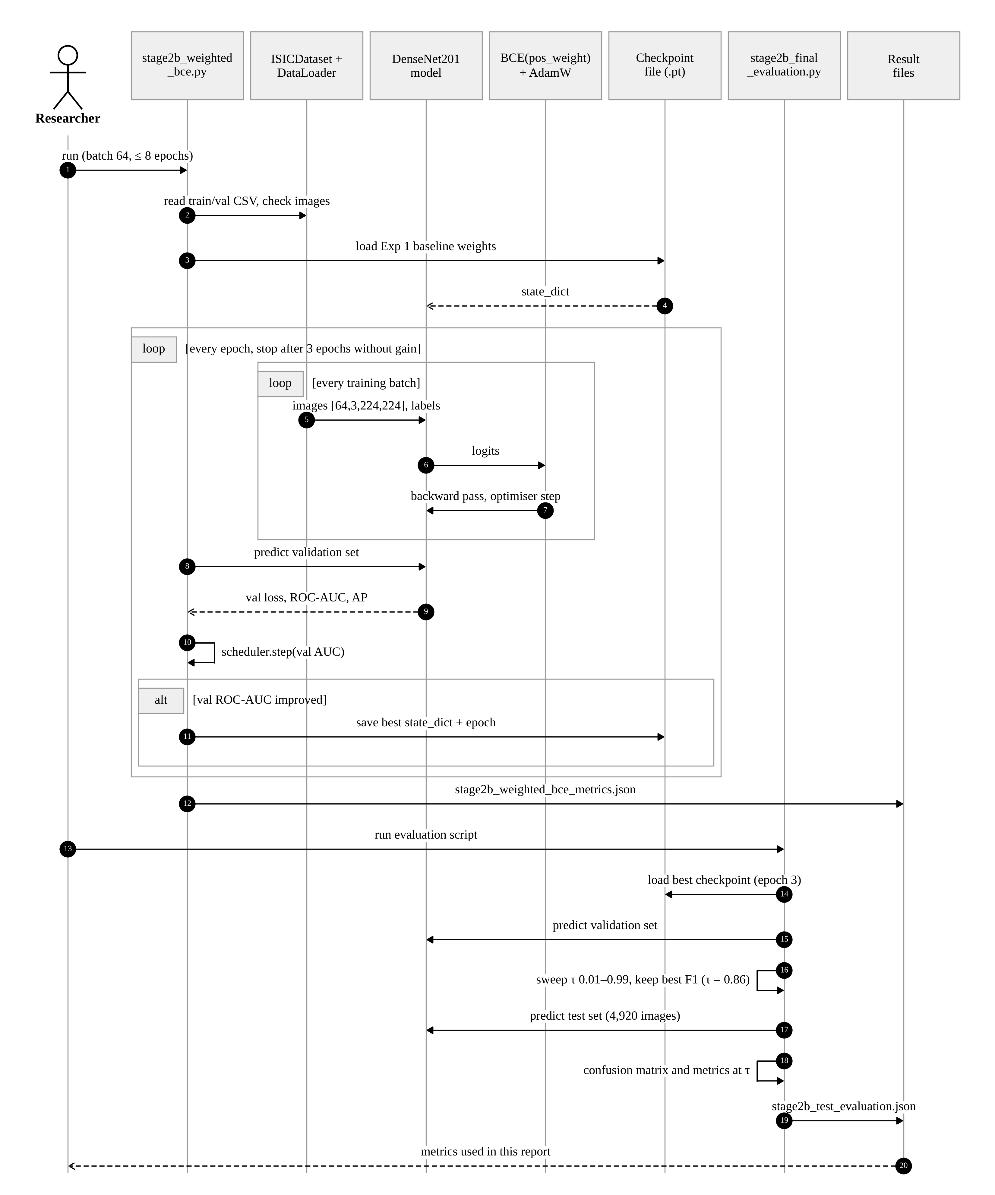
Figure 4.7: Sequence diagram of training and evaluation (Exp 2)
CHAPTER 5

5. METHODOLOGY AND TESTING
All five experiments follow the same protocol (Fig. 5.3). The model is trained on the training split, the epoch with the best validation ROC-AUC is kept, and the decision threshold is either the default 0.5 or the value with the best F1 score on the validation set. The test set is scored once, with the threshold fixed beforehand. The sections below describe each module and then the checks we did to test the pipeline and the reported numbers.

5.1 Module Description

5.1.1 Dataset and patient-level split
We used the training part of the SIIM-ISIC 2020 challenge data [26], since the official test labels are not public. The ground-truth file has 33,126 rows, one per image, with the columns image_name, patient_id, lesion_id, sex, age_approx, anatom_site_general_challenge, diagnosis, benign_malignant and target. There are 32,542 benign and 584 malignant images from 2,056 patients (Fig. 5.1). The label is very skewed: about 56 benign images for every malignant one. Most benign images have the diagnosis "unknown" (27,124) or "nevus" (5,193).
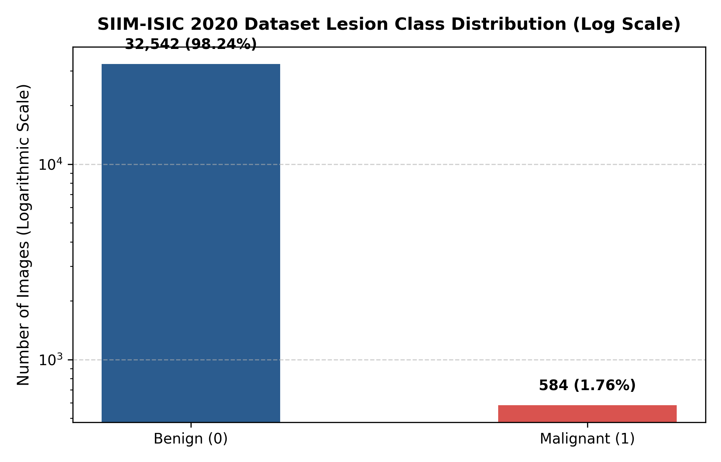
Figure 5.1: Class distribution of the ISIC 2020 training data (logarithmic scale)
The images were grouped by patient_id and every patient was placed in exactly one split. The result is shown in Table 5.1 and Fig. 5.2. The baseline script repeats this check every time it runs, with three assert statements that stop the program if any two splits share a patient. We also checked the three CSV files again for this report and found zero overlap between every pair of splits. The share of malignant images is a little higher in the training split (1.95%) than in validation (1.31%) and test (1.38%), because whole patients were moved together.
Table 5.1: Patient-level split of the data
Split | Images | Benign | Malignant | Malignant % | Patients
Training | 22,787 | 22,342 | 445 | 1.95 | 1,439
Validation | 5,419 | 5,348 | 71 | 1.31 | 307
Test | 4,920 | 4,852 | 68 | 1.38 | 310
Total | 33,126 | 32,542 | 584 | 1.76 | 2,056

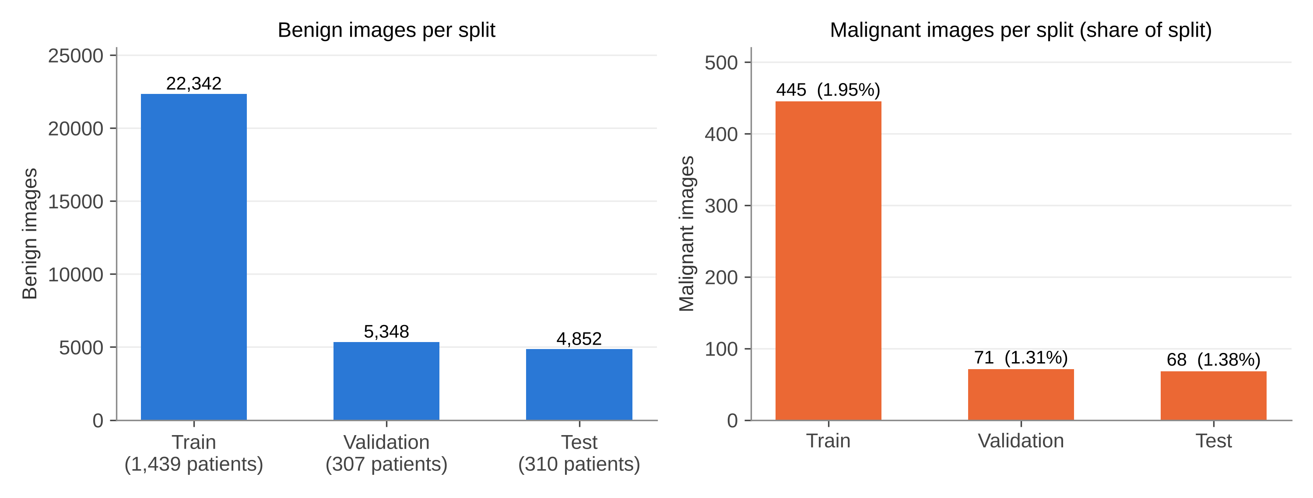
Figure 5.2: Benign and malignant images in each split

5.1.2 Preprocessing and augmentation
Every image is opened with PIL, converted to RGB and resized to 224 × 224 pixels. The pixel values are scaled to the range 0 to 1 and normalised with the ImageNet channel mean and standard deviation, because the backbone was pretrained with these values. Training images also get light random augmentation. We kept the augmentation small so that colour and texture, which carry diagnostic information, are not changed too much. Validation and test images are only resized and normalised (Table 5.2).
Table 5.2: Preprocessing and augmentation settings
Step | Setting | Training | Validation / Test
Resize | 224 × 224 | Yes | Yes
Horizontal flip | probability 0.5 | Yes | No
Rotation | random, up to ±15°, bilinear | Yes | No
Colour jitter | brightness 0.1, contrast 0.1, saturation 0.1, hue 0.05 | Yes | No
Normalisation | mean [0.485, 0.456, 0.406], std [0.229, 0.224, 0.225] | Yes | Yes

5.1.3 Model
The backbone is torchvision's DenseNet201 with ImageNet-1K weights [18]. Its 1,000-class classifier is replaced with an identity layer, so the backbone returns the 1,920-dimensional vector from global average pooling. A linear layer maps this vector to one logit z. The probability of malignancy is p̂ = σ(z) = 1 / (1 + e^(−z)). Listing 5.1 shows the model class from the baseline script.
Listing 5.1: Model class (src/EXP_01_BASELINE/densenet201_baseline.py)
class DermInsightDenseNet201(nn.Module):
def __init__(self):
super().__init__()
weights = DenseNet201_Weights.IMAGENET1K_V1
backbone = models.densenet201(weights=weights)
self.backbone = backbone
in_features = backbone.classifier.in_features
self.backbone.classifier = nn.Identity()
self.head = nn.Linear(in_features, 1)

def forward(self, x):
features = self.backbone(x)
logits = self.head(features)
return logits.squeeze(1)

5.1.4 Experiment 1: baseline with weighted BCE
The baseline uses binary cross-entropy with logits and a weight on the positive class. The weight is taken from the training counts, w+ = N_neg / N_pos = 22,342 / 445 = 50.2067, so each malignant image counts about 50 times as much as a benign one in the loss:
L = − [ w+ · y · log σ(z) + (1 − y) · log(1 − σ(z)) ]
In this first run only the linear head was trained. Listing 5.2 shows how all other parameters were frozen. The run used AdamW [22] (learning rate 1e-4, weight decay 1e-4), batch size 32 and 3 epochs, and it was done on a CPU. The threshold was the default 0.5. Note that this "baseline" already uses a weighted loss, so it is not a plain unweighted model.
Listing 5.2: Freezing the backbone and setting the weighted loss (Exp 1)
pos_weight = compute_class_weights(train_df) # 22342 / 445 = 50.2067
model = DermInsightDenseNet201().to(DEVICE)
for name, param in model.named_parameters():
if "head" not in name:
param.requires_grad = False
criterion = nn.BCEWithLogitsLoss(pos_weight=pos_weight)
optimizer = torch.optim.AdamW(model.parameters(), lr=args.learning_rate,
weight_decay=1e-4)

5.1.5 Experiment 2: fine-tuning with weighted BCE
Exp 2 loads the Exp 1 checkpoint and trains all layers with the same weighted loss. It uses batch size 64, AdamW with learning rate 1e-4 and weight decay 1e-4, and a ReduceLROnPlateau scheduler that halves the learning rate when the validation ROC-AUC does not improve for one epoch. Training runs for at most 8 epochs and stops after 3 epochs without improvement (Listing 5.3). It stopped after epoch 6, and the best checkpoint was from epoch 3. The threshold was then chosen on the validation set as described in Section 5.1.9.
Listing 5.3: Scheduler, model selection and early stopping (Exp 2, condensed)
scheduler = torch.optim.lr_scheduler.ReduceLROnPlateau(
optimizer, mode="max", factor=0.5, patience=1, min_lr=1e-6)
MAX_EPOCHS, EARLY_STOPPING_PATIENCE = 8, 3
for epoch in range(1, MAX_EPOCHS + 1):
... # one pass over train_loader
val_loss, val_auc, val_ap = evaluate(model, val_loader)
scheduler.step(val_auc)
if val_auc > best_auc:
best_auc, best_epoch = val_auc, epoch
torch.save({"state_dict": model.state_dict(), "epoch": epoch,
"auc": best_auc}, STAGE2B_MODEL)
epochs_without_improvement = 0
else:
epochs_without_improvement += 1
if epochs_without_improvement >= EARLY_STOPPING_PATIENCE:
break

5.1.6 Experiment 3: WeightedRandomSampler
Exp 3 changes the data that the model sees instead of the loss. Each training image gets a sampling weight that is inversely proportional to the size of its class, and the PyTorch WeightedRandomSampler draws the batches with replacement using these weights. On average a batch then has about the same number of benign and malignant images, so the plain BCE loss is used without a class weight. The settings stored in the checkpoint are DenseNet201 with ImageNet weights, batch size 64, learning rate 1e-4, weight decay 1e-4 and seed 42. The run lasted 5 epochs, the best epoch was 2, and the test threshold was 0.5.

5.1.7 Experiment 4: focal loss
Focal loss [21] multiplies the cross-entropy by a factor that becomes small for well-classified examples:
FL(p_t) = − α_t · (1 − p_t)^γ · log(p_t)
Here p_t is the predicted probability of the true class, α = 0.75 and γ = 2.0, as stored in the checkpoint. For a benign image that is already scored with p_t = 0.99, the factor (1 − 0.99)² = 0.0001 makes its loss very small, so the many easy benign images have little effect on training. The run lasted 5 epochs, the best epoch was 5, and the test threshold was 0.5. The training script for this run is not in the project folder, so we could not confirm the batch size and optimiser settings from code.

5.1.8 Experiment 5: random oversampling
Exp 5 oversamples the malignant images of the training split only. According to its training summary, it was implemented with a WeightedRandomSampler on the training set, so malignant images are drawn many times per epoch, while the validation and test sets keep their natural class ratio. The plain BCE loss and AdamW (learning rate 1e-4, weight decay 1e-4, confirmed from the saved optimiser state) were used. The run lasted 5 epochs and the best epoch was 2. The threshold 0.7296 was the value with the best F1 score on the validation set. Exp 3 and Exp 5 use the same tool, so the difference between them is mainly in the settings and in the threshold step. Since the Exp 3 and Exp 5 scripts are not in the folder, we cannot list every difference.

5.1.9 Threshold selection
A model trained with a strong positive weight gives high probabilities to many benign images, and a model trained with focal loss tends to give low probabilities to almost everything, so 0.5 is not always a good cut-off. In Exp 2 the evaluation script scores the validation set, tries every threshold from 0.01 to 0.99 in steps of 0.01, and keeps the one with the highest F1 score (Listing 5.4). This gave τ = 0.86. At this value the validation sensitivity was 30.99%, the specificity 98.50% and the F1 score 25.43%. The same rule, best F1 on validation, gave τ = 0.7296 in Exp 5. Exp 1, 3 and 4 were tested at 0.5.
Listing 5.4: Threshold sweep on the validation set (stage2b_final_evaluation.py, condensed)
val_labels, val_probs = collect_predictions(model, val_loader)
best_threshold, best_f1 = 0.5, -1
for threshold in np.arange(0.01, 1.00, 0.01):
preds = (val_probs >= threshold).astype(int)
f1 = f1_score(val_labels, preds, zero_division=0)
if f1 > best_f1:
best_f1, best_threshold = f1, float(threshold)
# the test set is scored only after the threshold is fixed
test_labels, test_probs = collect_predictions(model, test_loader)
test_preds = (test_probs >= best_threshold).astype(int)

5.1.10 Evaluation metrics
From the confusion matrix counts TP, FP, TN and FN we report sensitivity = TP / (TP + FN), specificity = TN / (TN + FP), precision = TP / (TP + FP), F1 = 2 · precision · sensitivity / (precision + sensitivity) and accuracy = (TP + TN) / N. ROC-AUC and average precision (AP) are computed from the probabilities, so they do not depend on the threshold. AP is scikit-learn's average_precision_score. The Exp 2 result file calls this value "PR-AUC", but it is the same AP function. Only Exp 5 also saved a PR-AUC computed with the trapezoidal rule (0.0975), which is a little lower than its AP (0.1041). We show these two values separately and do not mix them.
Table 5.3: Training settings of the five experiments
Setting | Exp 1 | Exp 2 | Exp 3 | Exp 4 | Exp 5
Start weights | ImageNet | Exp 1 checkpoint | ImageNet | ImageNet | ImageNet
Trainable layers | Head only | All | All* | All* | All*
Imbalance method | W-BCE (50.21) | W-BCE (50.21) | WRS + BCE | Focal (α 0.75, γ 2) | Oversampling (WRS) + BCE
Batch size | 32 | 64 | 64 | 32† | 32†
Optimiser / LR | AdamW, 1e-4 | AdamW, 1e-4 + scheduler | lr 1e-4, wd 1e-4 | lr 1e-4† | AdamW, 1e-4
Epochs run / best | 3 / 3 | 6 / 3 | 5 / 2 | 5 / 5 | 5 / 2
Test threshold | 0.5 | 0.86 (val) | 0.5 | 0.5 | 0.7296 (val)

* Assumed from the 70 MB full-model checkpoints; the training scripts are not available. † Taken from the experiment comparison sheet in the project folder, not from code or checkpoints.
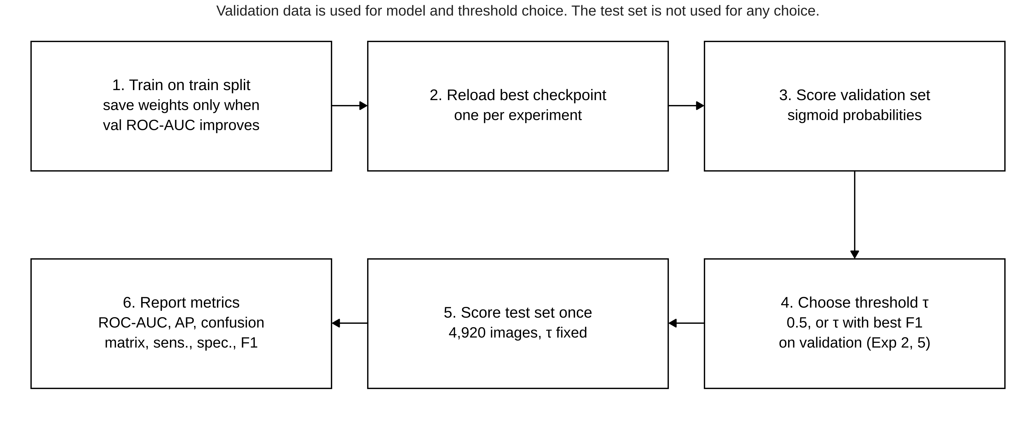
Figure 5.3: Evaluation protocol followed in every experiment

5.2 Testing
The pipeline has no formal unit test suite. Testing was done through checks built into the scripts and through a separate verification of all reported numbers for this report. Table 5.4 lists the checks and their results.
Table 5.4: Checks done on the pipeline and the results
Check | How it was done | Result
Patient overlap | assert statements in train_model(); repeated on the three CSV files | 0 shared patients
Split counts | Counted rows, labels and patients in each CSV | Match Table 5.1
Image files present | Exp 2 script checks every train and validation image path before training | No missing files reported
Forward pass | --sanity-check option runs 4 images through the model and prints shapes, probabilities and loss | Available in baseline script
Test metrics, Exp 3–5 | Recomputed ROC-AUC, AP and confusion matrix from the saved prediction CSVs | Match the saved metric files
Test metrics, Exp 1–2 | Recomputed sensitivity, specificity, precision, F1, accuracy from the saved confusion counts | Match; per-image predictions not saved
Checkpoint contents | Read epoch, best AUC and settings stored in Exp 3–5 checkpoints | Match the history files
Threshold file of Exp 2 | Compared stage2b_validation_threshold_analysis.csv with the evaluation JSON | Do not match; see Section 7.6

The last row needs attention. The saved threshold-analysis CSV for Exp 2, and the threshold plots made from it, do not agree with the validation numbers inside the final evaluation file. For example, at τ = 0.86 the CSV gives 5 true positives on validation, while the evaluation file gives 22. The evaluation file was written by the same script that chose the threshold and scored the test set, so we take it as the correct record and do not use the CSV-based plots in this report.
CHAPTER 6

6. PROJECT DEMONSTRATION
DermInsight AI is a set of Python scripts, so the demonstration is a run of these scripts and a look at the files they produce. There is no graphical interface in Project-I.

6.1 Running an Experiment
The baseline script takes its settings from the command line. It finds the project root from its own location, reads the three split CSV files from data/processed and the images from data/raw/train_images. Listing 6.1 shows the command for the recorded baseline run. The --sanity-check option first pushes four images through the untrained model and prints the tensor shapes, probabilities and loss, which is a quick way to see that the data and model are connected correctly.
Listing 6.1: Command for the baseline run
$ python src/EXP_01_BASELINE/densenet201_baseline.py \
--epochs 3 --batch-size 32 --learning-rate 1e-4 --sanity-check
At the end of training the script reloads the best weights, scores the test set at τ = 0.5, saves four plots and writes two JSON files. Listing 6.2 shows part of the saved test metrics file of Exp 1, exactly as stored (values rounded to four decimals here).
Listing 6.2: Part of results/EXP_01_BASELINE/metrics/densenet201_test_metrics.json
{
"test": {
"accuracy": 0.4258, "precision": 0.0215, "recall": 0.9118,
"specificity": 0.4190, "f1": 0.0420,
"roc_auc": 0.8000, "average_precision": 0.0626
},
"test_loss": 1.0801
}

6.2 Threshold Selection and Final Test Run
For Exp 2 the evaluation is a separate script, which keeps the test set away from all choices made during training. It loads the best checkpoint, chooses the threshold on the validation set and only then scores the test set. Listing 6.3 shows the test block of its output file.
Listing 6.3: Test block of results/EXP_02_WEIGHTED_BCE/final_evaluation/stage2b_test_evaluation.json
"test": {
"roc_auc": 0.8298, "pr_auc": 0.1288, "threshold": 0.86,
"sensitivity": 0.2206, "specificity": 0.9831, "precision": 0.1546,
"f1": 0.1818, "accuracy": 0.9726,
"tn": 4770, "fp": 82, "fn": 53, "tp": 15
},
"test_samples": 4920, "test_positive": 68, "test_negative": 4852

6.3 Output Files
Each experiment writes its outputs to its own folder (Table 6.1). Exp 3, 4 and 5 also saved the probability of every test image, which made it possible to recompute their metrics and to draw the combined ROC and PR curves in Chapter 7. Fig. 6.1 is one of these saved outputs: the histogram of predicted probabilities on the test set for Exp 3. Almost all benign images are near 0, and the malignant images are spread across the whole range.
Table 6.1: Output files of each experiment
Exp | Checkpoint | Main result files | Plots
1 | densenet201_baseline_best.pt | baseline metrics JSON, test metrics JSON | loss, ROC, PR, confusion matrix
2 | densenet201_stage2b_weighted_bce.pt | training metrics JSON, test evaluation JSON, threshold CSV | confusion matrix, threshold plots
3 | densenet201_weighted_sampler_best.pt | history JSON, test metrics JSON, test predictions CSV | loss, val ROC-AUC, ROC, PR, CM, probabilities
4 | densenet201_focal_loss_best.pt | history JSON, test metrics JSON, test predictions CSV | ROC, PR, CM, probabilities
5 | densenet201_random_oversampling_best.pt | history and summary JSON, test metrics JSON/CSV, predictions CSV | ROC, PR, confusion matrix

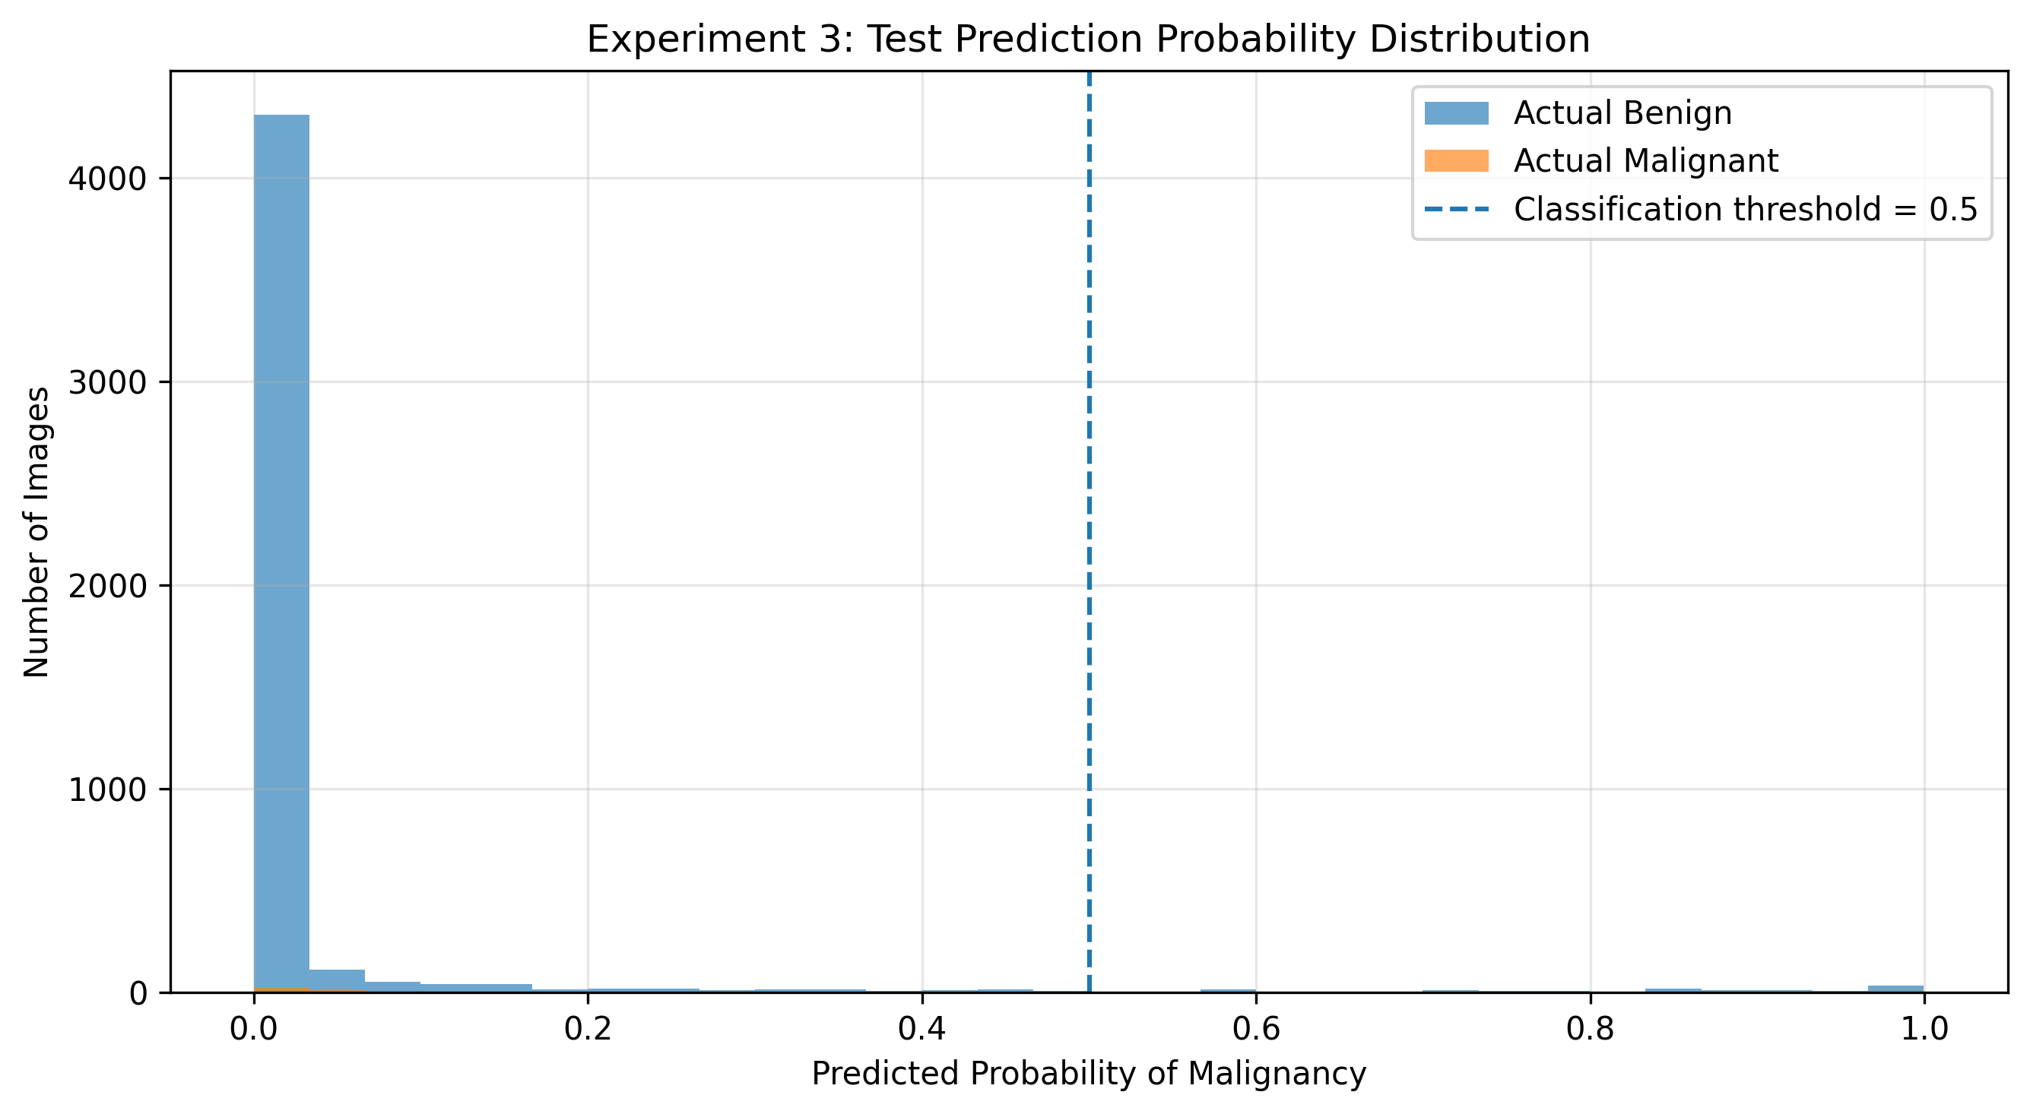
Figure 6.1: Predicted probabilities on the test set, Exp 3 (saved output)
CHAPTER 7

7. RESULT AND DISCUSSION (COST ANALYSIS)
All the test results in this chapter are on the same 4,920 test images from 310 patients (4,852 benign and 68 malignant). None of these patients were used for training or for any choice of epoch or threshold. Validation numbers are always marked as validation.

7.1 Training and Validation Behaviour
Table 7.1 and Fig. 7.1 show the validation ROC-AUC of each run. All four runs after the baseline reached a clearly higher validation ROC-AUC (0.906 to 0.919) than Exp 1 (0.847), which had only the head trained. Exp 2 and Exp 4 stayed fairly stable across epochs. Exp 3 and Exp 5 peaked at epoch 2 and then dropped, while their training loss kept falling, which suggests that the models began to overfit the repeated malignant images. Choosing the checkpoint by validation ROC-AUC protected the final models from these later epochs.
Table 7.1: Validation results of the five experiments
Exp | Strategy | Epochs run | Best epoch | Val ROC-AUC | Val AP
1 | Baseline, frozen backbone, W-BCE | 3 | 3 | 0.8472 | 0.0811
2 | W-BCE, full fine-tuning | 6 | 3 | 0.9188 | 0.1747
3 | WeightedRandomSampler | 5 | 2 | 0.9062 | 0.1894
4 | Focal loss | 5 | 5 | 0.9181 | 0.1800
5 | Random oversampling | 5 | 2 | 0.9082 | 0.2176

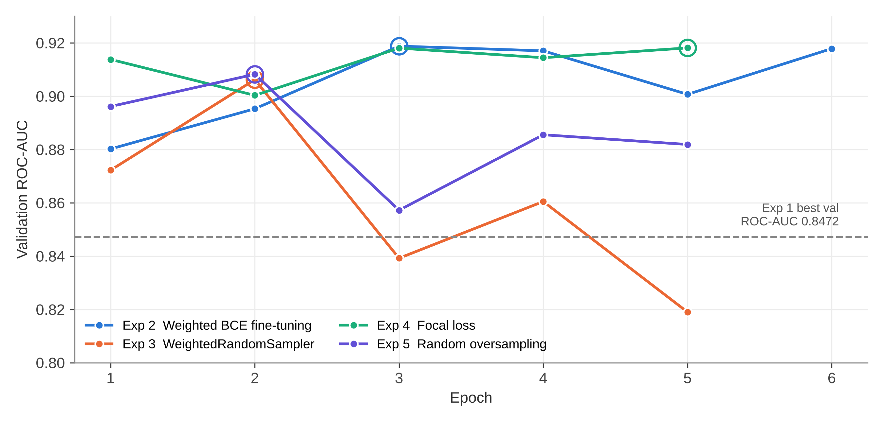
Figure 7.1: Validation ROC-AUC by epoch (circles mark the saved checkpoint)
Fig. 7.2 shows the loss curves of the baseline. Both losses go down steadily over the three epochs, and the validation loss is still falling at the end, so the frozen-backbone model was still learning when training stopped. With only the head trainable and three epochs on a CPU, Exp 1 is best seen as a starting point.
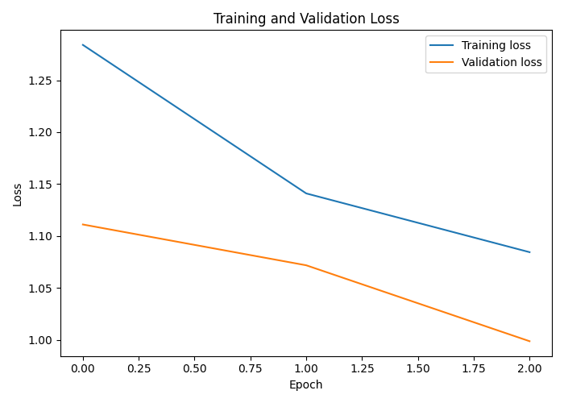
Figure 7.2: Training and validation loss of Exp 1 (x-axis: epoch index 0 to 2)

7.2 Test Results
Table 7.2 gives the full test results and Fig. 7.3 shows the confusion matrices. The ranking metrics are moderate for all runs. Test ROC-AUC is between 0.800 (Exp 1) and 0.871 (Exp 5), and AP is between 0.063 and 0.140, against a base rate of 0.014. The results at the chosen threshold differ much more. Exp 1 finds 62 of 68 cancers but also flags 2,819 benign images. Exp 2, 4 and 5 keep false positives below 90 but find only 10 to 15 cancers. Exp 3 is between the two, with 25 cancers found and 153 false positives.
Table 7.2: Results on the test set (N = 4,920; 68 malignant)
Exp | τ | ROC-AUC | AP | Sens. % | Spec. % | Prec. % | F1 % | Acc. % | TN / FP / FN / TP
1 | 0.50 | 0.8000 | 0.0626 | 91.18 | 41.90 | 2.15 | 4.20 | 42.58 | 2033 / 2819 / 6 / 62
2 | 0.86 | 0.8298 | 0.1288 | 22.06 | 98.31 | 15.46 | 18.18 | 97.26 | 4770 / 82 / 53 / 15
3 | 0.50 | 0.8218 | 0.1286 | 36.76 | 96.85 | 14.04 | 20.33 | 96.02 | 4699 / 153 / 43 / 25
4 | 0.50 | 0.8601 | 0.1402 | 14.71 | 99.24 | 21.28 | 17.39 | 98.07 | 4815 / 37 / 58 / 10
5 | 0.7296 | 0.8708 | 0.1041 | 19.12 | 98.25 | 13.27 | 15.66 | 97.15 | 4767 / 85 / 55 / 13

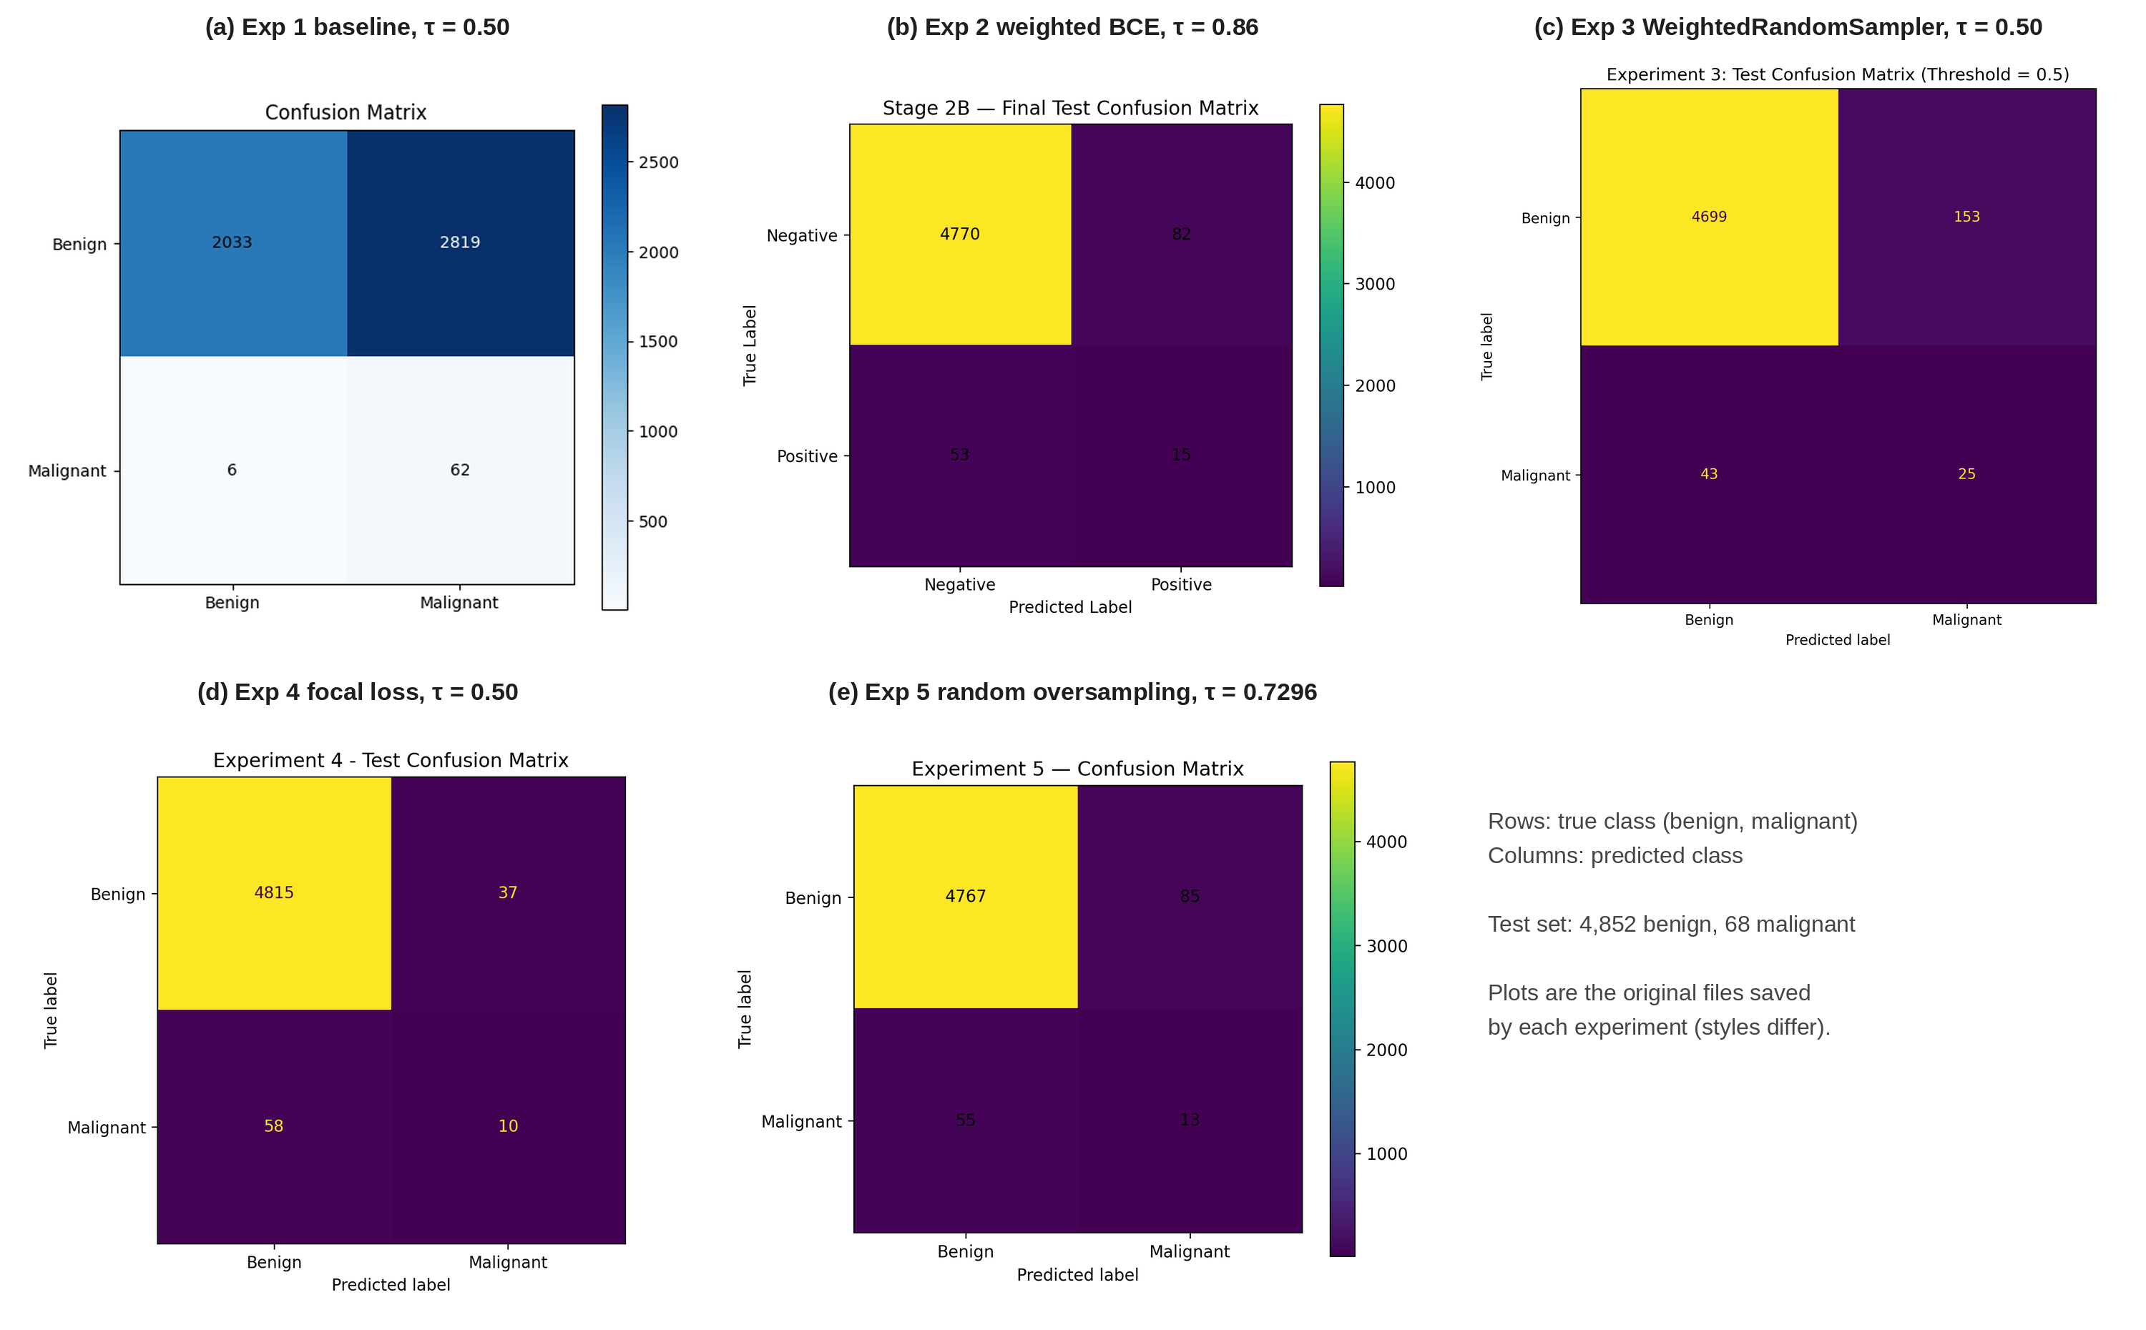
Figure 7.3: Test confusion matrices of the five experiments (original saved plots)
Fig. 7.4 and Fig. 7.5 compare the runs over all thresholds. The curves for Exp 3, 4 and 5 are drawn from their saved test predictions. Exp 1 and Exp 2 did not save per-image predictions, so they appear only as single operating points. In the ROC plot the three curves are close to each other, and Exp 5 is a little higher over most of the range. In the PR plot, precision falls quickly for all models once recall goes above about 0.1, and focal loss (Exp 4) keeps the highest precision at low recall. All curves stay well above the 1.38% base rate, but none of them reaches a region with both high recall and high precision.
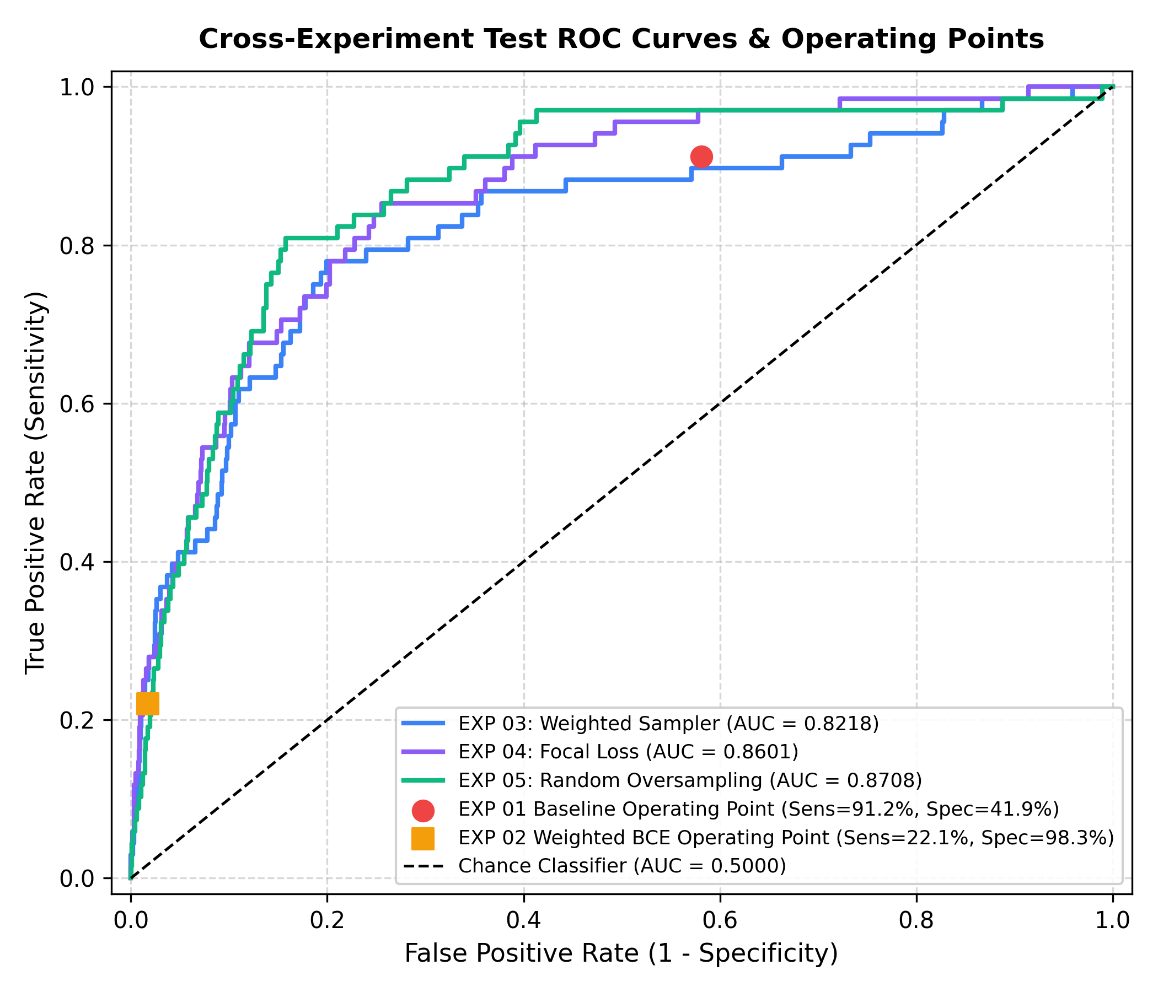
Figure 7.4: Test ROC curves (Exp 3–5) and operating points (Exp 1–2)
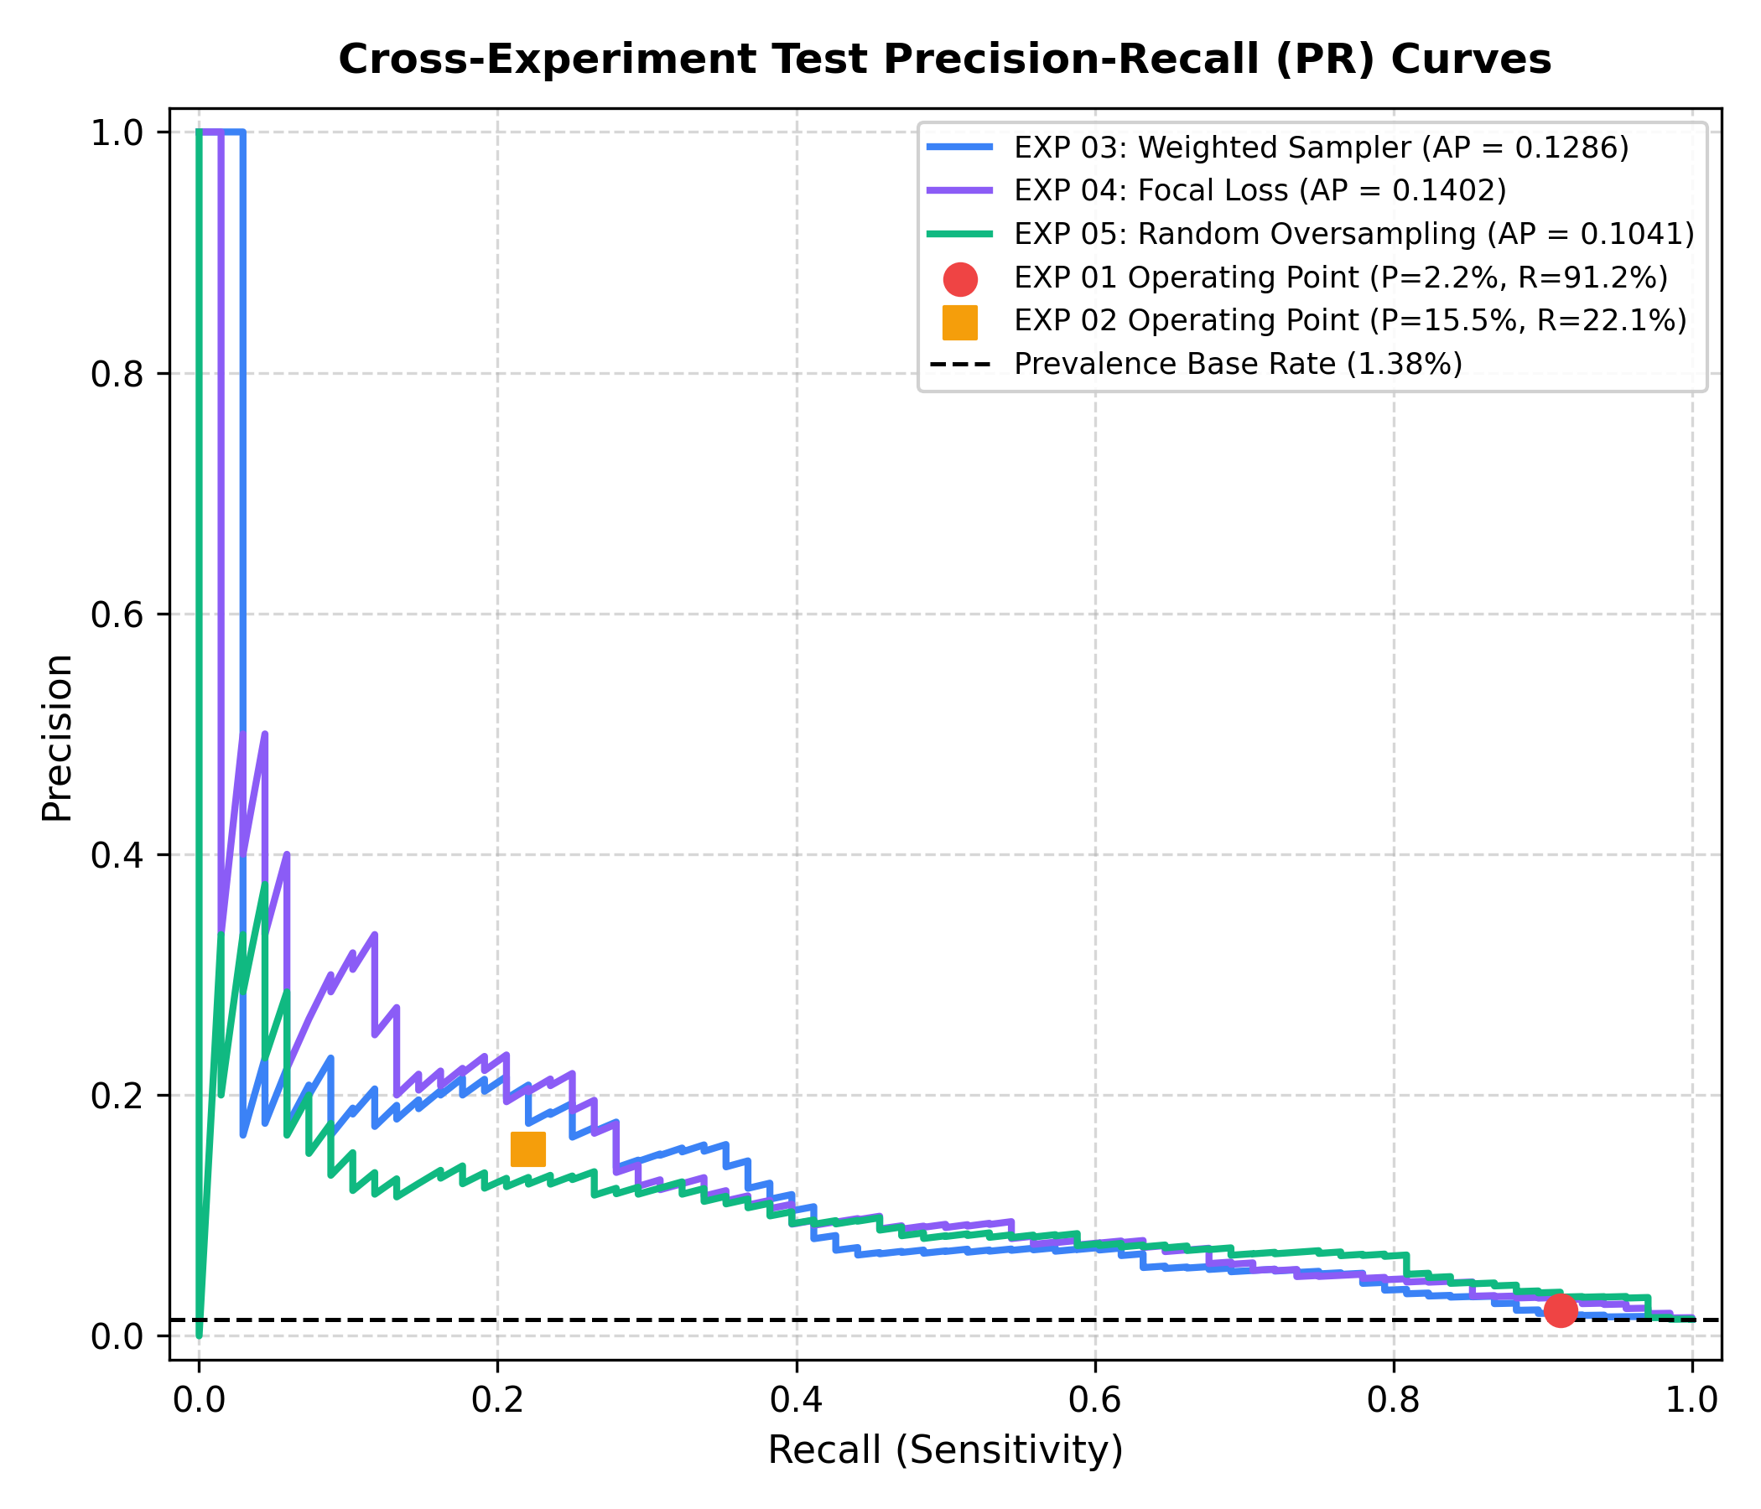
Figure 7.5: Test precision-recall curves (Exp 3–5) and operating points (Exp 1–2)
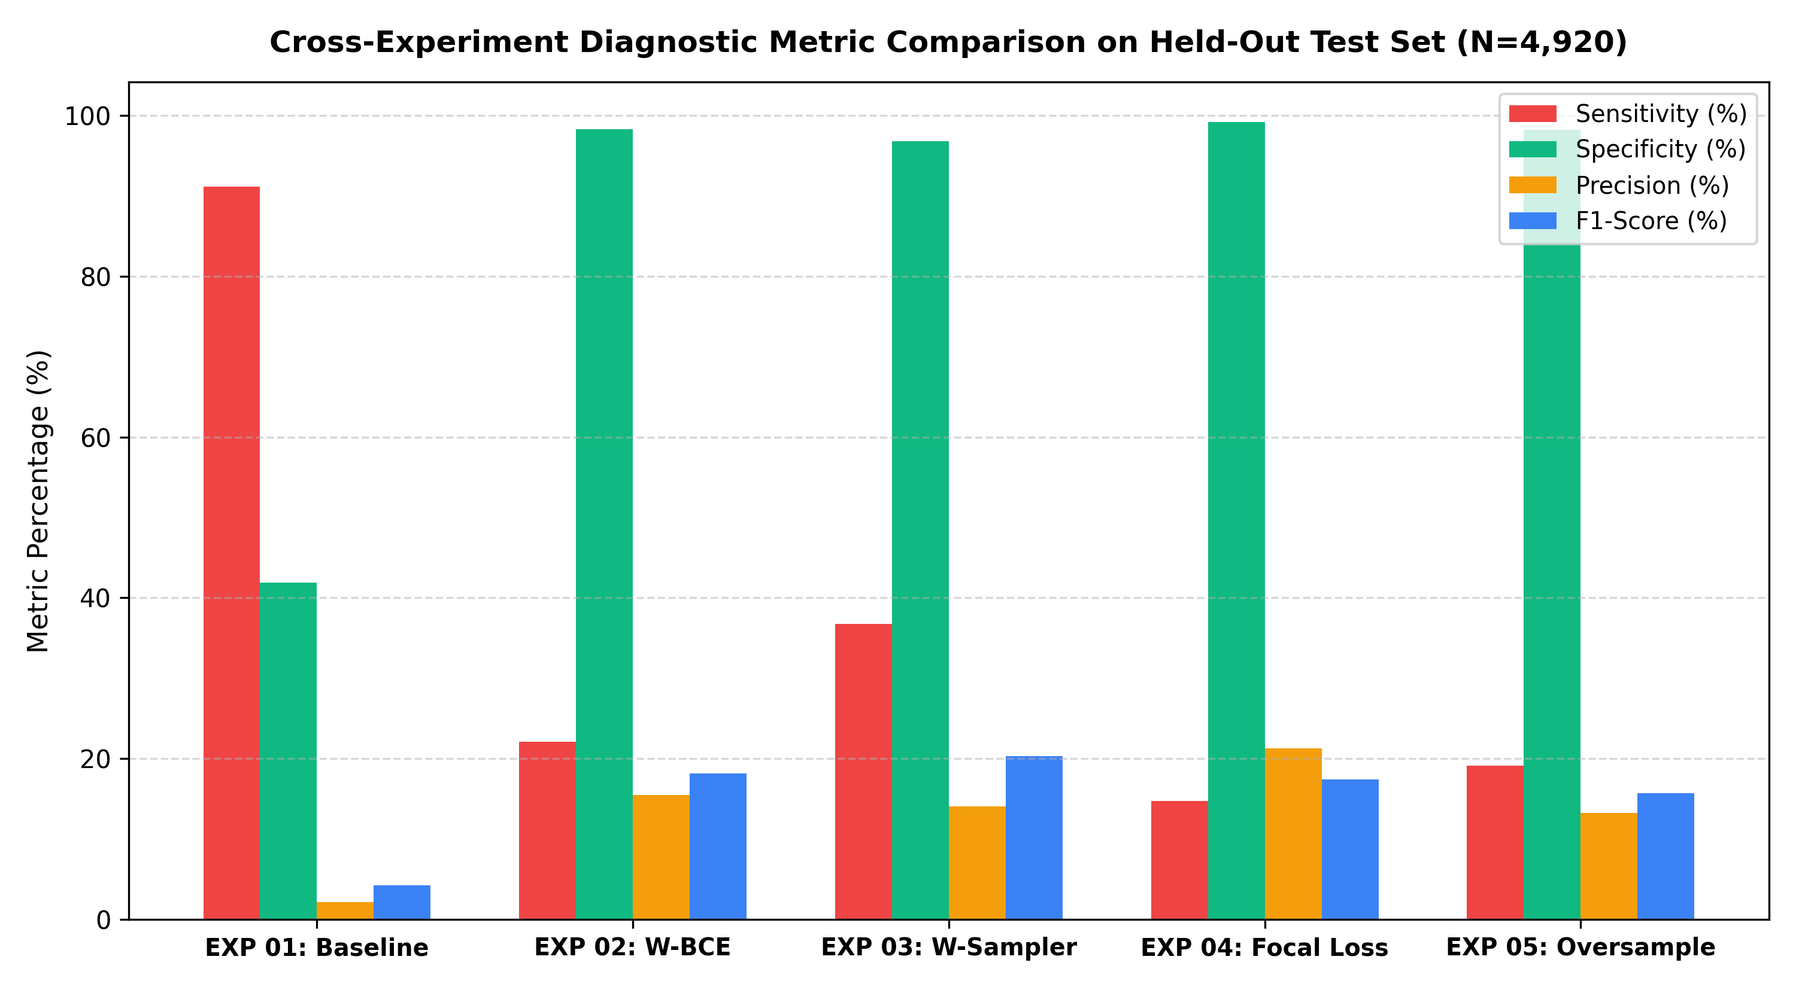
Figure 7.6: Sensitivity, specificity, precision and F1 of each experiment on the test set

7.3 Effect of the Decision Threshold
Fig. 7.7 shows how sensitivity and specificity change with τ for the three runs whose test predictions were saved. This figure only describes the models, and no threshold was chosen from it. First, Exp 3 and Exp 5 push most benign images very close to 0 (median benign probability 0.0005 and almost 0), so their specificity stays above 90% even at low thresholds, but their sensitivity curve is flat between about 0.1 and 0.6. Second, focal loss compresses all the scores. In Exp 4 no malignant test image got a probability above 0.73, and the median malignant score was 0.36, so the default 0.5 cut-off misses most cancers. At τ = 0.3 the same model would find 46 of 68 cancers with a specificity of 87.3%.
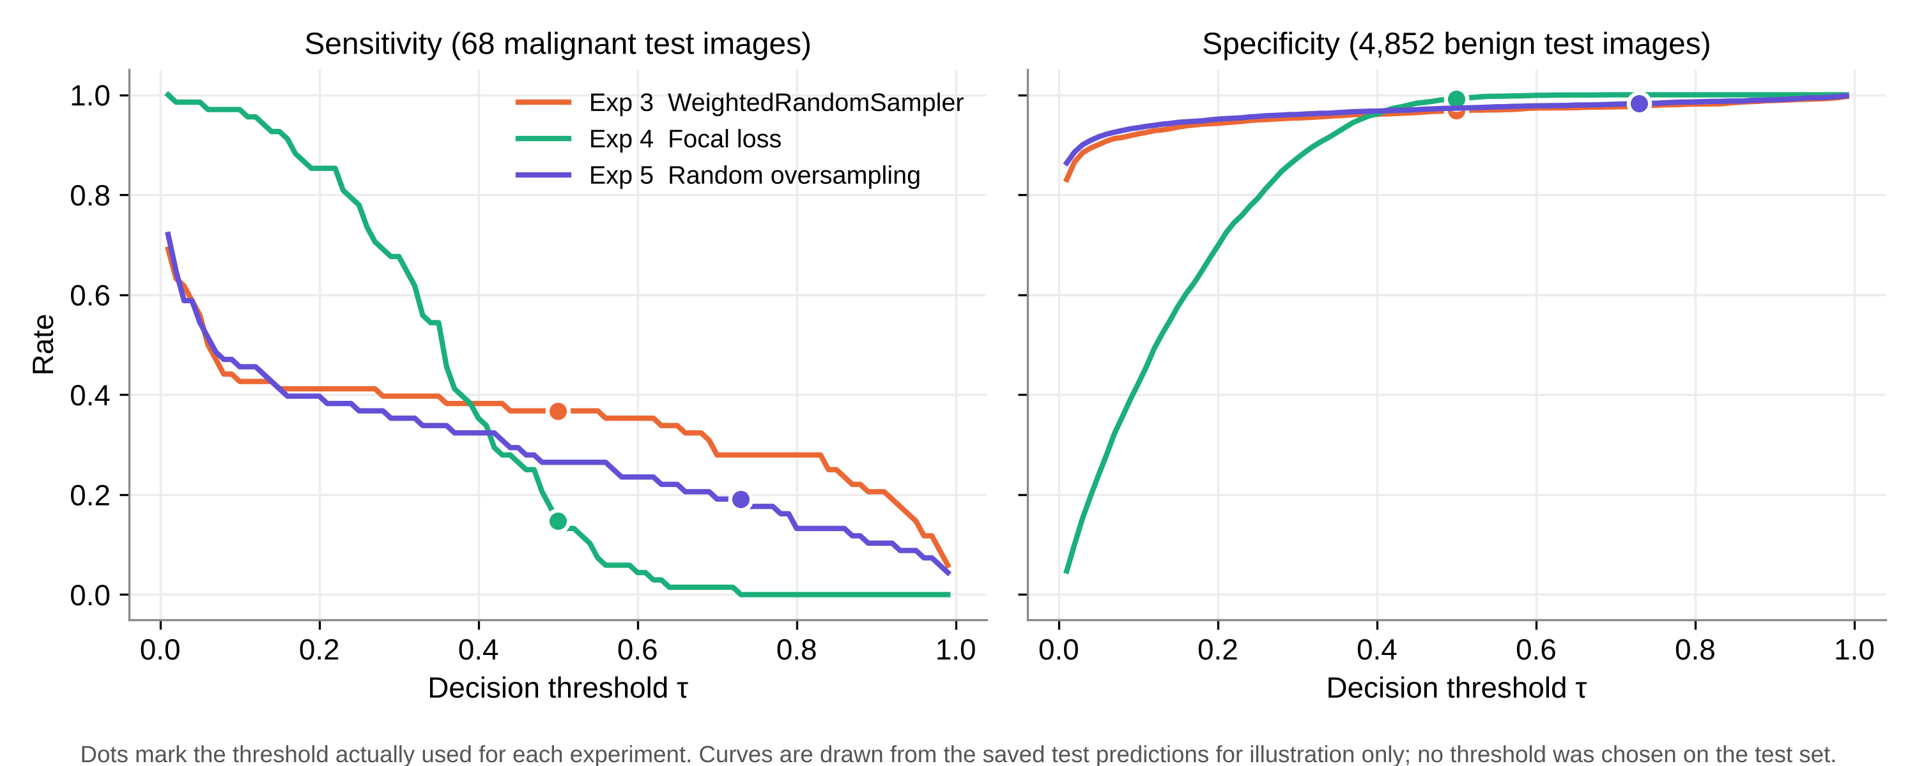
Figure 7.7: Sensitivity and specificity against the threshold on the test set (descriptive only)
Table 7.3 shows the same effect for Exp 5 at two thresholds. The threshold chosen on validation (0.7296) is stricter than 0.5. On the test set it removes 45 false positives but also loses 5 of the 18 cancers that 0.5 would have found. With only 71 malignant validation images, the best-F1 threshold moves a lot with a few images, and in this run it did not carry over well to the test set.
Table 7.3: Exp 5 on the test set at two thresholds
τ | TP | FP | FN | Sens. % | Spec. % | Prec. % | F1 %
0.50 (default) | 18 | 130 | 50 | 26.47 | 97.32 | 12.16 | 16.67
0.7296 (best F1 on validation) | 13 | 85 | 55 | 19.12 | 98.25 | 13.27 | 15.66

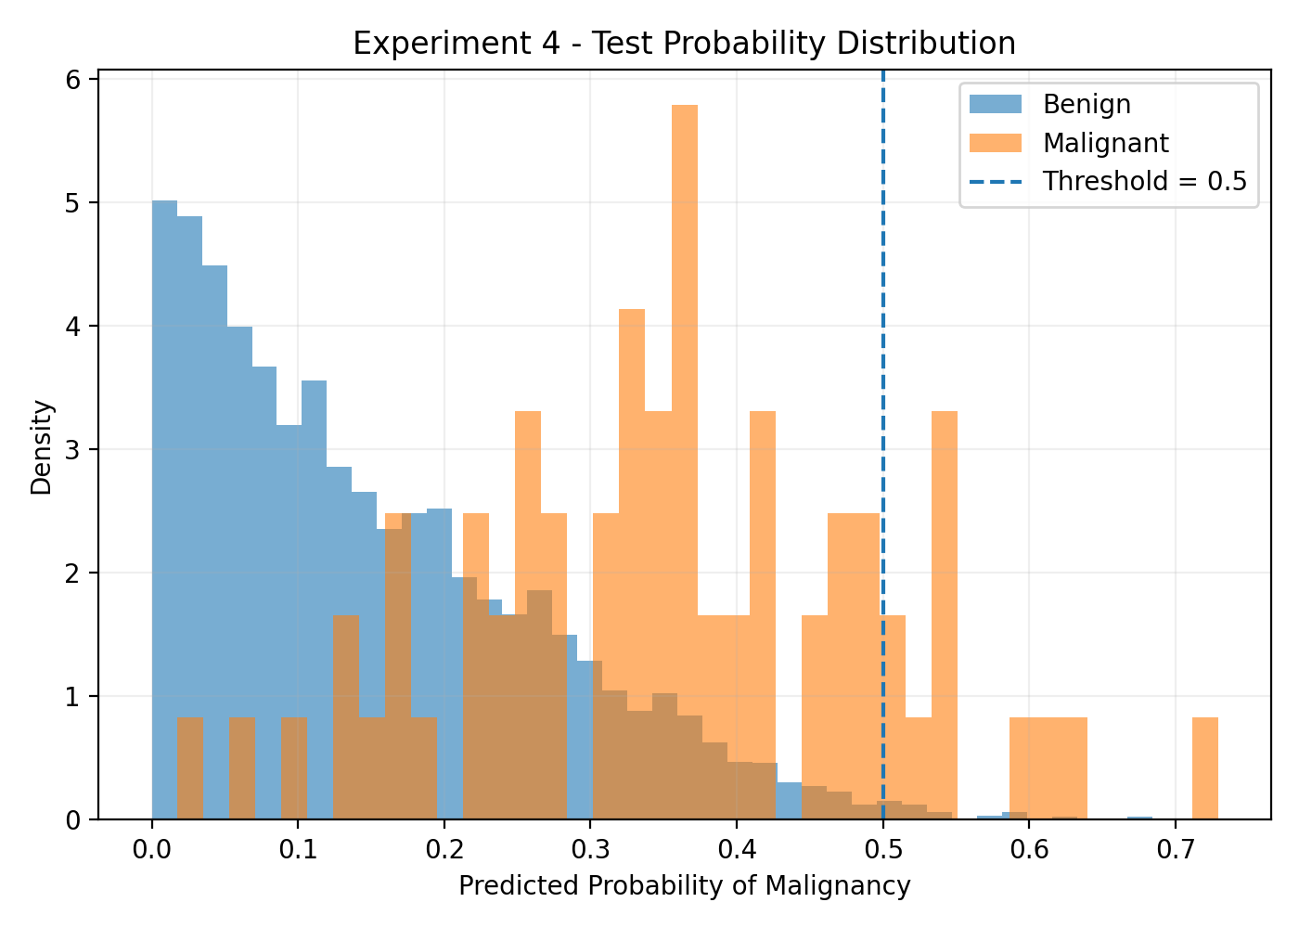
Figure 7.8: Predicted probabilities on the test set, Exp 4 (focal loss)

7.4 Accuracy and Uncertainty
Accuracy is a poor guide here. Exp 4 has the highest accuracy (98.07%) and misses 58 of the 68 cancers, while Exp 1 has the lowest accuracy (42.58%) and misses only 6. A model that always predicts benign would reach 98.62% on this test set. For this reason we compare models by sensitivity, specificity and the confusion matrix, and use accuracy only as a side number.
The positive side of the test set is small. Table 7.4 gives 95% Wilson intervals [31] for the sensitivity of each run. The intervals are wide, about ±10 percentage points, and the intervals of Exp 2, 4 and 5 overlap a lot. So we can say that Exp 1 and Exp 3 found more cancers than the high-specificity runs, but we cannot rank Exp 2, 4 and 5 against each other with confidence.
Table 7.4: Test sensitivity with 95% Wilson intervals (68 malignant images)
Exp | Cancers found | Sensitivity % | 95% interval %
1 | 62 / 68 | 91.18 | 82.1 – 95.9
2 | 15 / 68 | 22.06 | 13.8 – 33.3
3 | 25 / 68 | 36.76 | 26.3 – 48.6
4 | 10 / 68 | 14.71 | 8.2 – 25.0
5 | 13 / 68 | 19.12 | 11.5 – 30.0

7.5 Comparison of the Strategies
- Loss weighting (Exp 1, Exp 2). With the backbone frozen and τ = 0.5, the weight of 50.21 pushed most scores above 0.5, giving high sensitivity and very low specificity. Full fine-tuning raised the validation ROC-AUC from 0.847 to 0.919. After the threshold was moved to 0.86 on validation, the test result became the opposite, with high specificity and low sensitivity.
- Weighted sampling (Exp 3). It gave the best balance at the default threshold and the highest F1 (20.33%), even though its test ROC-AUC (0.822) was not the best. Balanced batches let the model see malignant images often without very large loss weights.
- Focal loss (Exp 4). It gave the best AP (0.140) and the highest precision, but at τ = 0.5 it was too conservative, because the loss pushed the scores into a narrow low range.
- Random oversampling (Exp 5). It gave the highest test ROC-AUC (0.871), so it ranked the images best. The validation-chosen threshold did not transfer well and the final sensitivity was only 19.12%.
No single strategy was best on every measure. The imbalance methods mainly improved the ranking of images, and the final balance between found cancers and false alarms was decided more by the threshold than by the method. Exp 3 and Exp 5 both use sampling, but they differ in batch size, threshold and maybe other settings that we could not confirm, so we do not draw a strong conclusion about sampling versus loss weighting.

7.6 Discussion
Where the results fall short. Even the best run misses more than 60% of the cancers at a usable false-alarm rate. For a screening aid this is too low. The test ROC-AUC values (0.80 to 0.87) are also lower than the validation values (0.85 to 0.92). Since the model and the threshold were chosen on 71 malignant validation images, part of this drop is likely due to selection on a small set.
Incomplete work. Our earlier notes mention an Experiment 6, but no script, checkpoint, log or prediction file for it exists in the project folder. As far as we know, the run was not completed, so we do not report it. The folder results/EXP_01_BASELINE/gradcam is empty, and no Grad-CAM code exists, so explainability is future work.
Problems found while checking the results. The Exp 2 threshold-analysis CSV and its plots do not match the final evaluation file (Section 5.2), so we did not use them. The training scripts of Exp 3, 4 and 5 are missing, so some of their settings come only from the comparison sheet (marked in Table 5.3). Exp 1 and Exp 2 did not save per-image predictions. Library versions were not recorded. The duplicate images listed for ISIC 2020 (425 according to our earlier audit notes) were not removed before splitting, and duplicates of the same lesion can still affect results inside one patient's images [6].
Limits of the data. All images come from one public dataset. ISIC 2020 has no Fitzpatrick skin type labels, and public dermatology image sets contain few images of darker skin [10, 14], so we cannot say how the models work on darker skin. The model uses images only, while doctors also use age, sex and body site. The probabilities are not calibrated [15], so a score of 0.7 should not be read as a 70% risk.

7.7 Cost Analysis
The project had no licence or equipment cost (Table 7.5). The main resource was GPU time on free cloud sessions. For example, the training history of Exp 3 records about 10 minutes per epoch, or about 51 minutes in total for its 5 epochs.
Table 7.5: Cost of the project
Item | Cost | Note
ISIC 2020 data | Free | Public dataset, used under its licence for research
Software (Python, PyTorch, scikit-learn, etc.) | Free | Open source
GPU training (Google Colab) | Free tier | Session limits made long runs difficult
Storage (Google Drive, laptop) | Existing | About 0.5 GB of checkpoints
Total direct cost | ₹ 0 | Team time not counted

The errors of a screening model also have a cost. A false negative can delay the treatment of a cancer, and a false positive leads to an extra visit and maybe a biopsy. We do not have real cost data, so Table 7.6 only gives an illustration with assumed relative costs. One false positive is counted as 1 unit, and one false negative as 10, 50 or 100 units. The 50:1 ratio is close to the class weight used in training.
Table 7.6: Illustrative error cost on the test set (assumed unit costs, not real prices)
Exp | FP | FN | Cost (FN = 10) | Cost (FN = 50) | Cost (FN = 100)
1 | 2,819 | 6 | 2,879 | 3,119 | 3,419
2 | 82 | 53 | 612 | 2,732 | 5,382
3 | 153 | 43 | 583 | 2,303 | 4,453
4 | 37 | 58 | 617 | 2,937 | 5,837
5 | 85 | 55 | 635 | 2,835 | 5,585

Under all three assumptions Exp 3 has the lowest cost, because it misses the fewest cancers among the runs that do not flood the clinic with false positives. Exp 1 is only competitive when a missed cancer is valued at 100 false alarms or more. These numbers depend fully on the assumed ratio and are given only to show why missed cancers must be weighed more heavily than false alarms.
CHAPTER 8

8. CONCLUSION
In this project we built DermInsight AI, an image-only deep learning pipeline for classifying dermoscopic images as benign or malignant, and we tested it on the very imbalanced SIIM-ISIC 2020 data. The 33,126 images were split by patient into training, validation and test sets with no shared patients, and this was checked in code. Five DenseNet201 experiments compared loss weighting, weighted sampling, focal loss and random oversampling under one protocol, with model and threshold choices made on validation data and a single test run per model.
The imbalance methods improved the validation ROC-AUC from 0.847 to between 0.906 and 0.919, and the best test ROC-AUC was 0.871. At the thresholds actually used, the models either found most cancers with very many false alarms (Exp 1) or kept false alarms low and found only 10 to 25 of the 68 cancers. The WeightedRandomSampler run gave the best balance (36.76% sensitivity at 96.85% specificity). The main lesson for us is that a good ROC-AUC and a high accuracy can both hide a large number of missed cancers, so the confusion matrix and the threshold must always be reported. With only 68 malignant test images, the differences between most runs are within the uncertainty. DermInsight AI is a research prototype and not a diagnostic tool.
Future work. The following steps are planned for Project-II:
- Save per-image predictions and full settings for every run, pin library versions, and add the missing Exp 3–5 scripts to the repository.
- Choose thresholds with a sensitivity target (for example at least 80% on validation) instead of best F1, and use cross-validation by patient to make the threshold more stable.
- Add patient metadata (age, sex, body site) to the image features and test whether it improves sensitivity [23, 20].
- Add Grad-CAM [28] heatmaps and check whether the model looks at the lesion and not at rulers, hair or borders.
- Calibrate the probabilities, for example with temperature scaling [15], and test on another dataset such as HAM10000 [29] to measure how well the models generalise.
- Remove duplicate images before splitting, following Cassidy et al. [6], and repeat the main experiments.

CHAPTER 9

9. REFERENCES
- Adegun, A. and Viriri, S., 2021. Deep learning techniques for skin lesion analysis and melanoma cancer detection: a survey of state-of-the-art. Artificial Intelligence Review, 54(2), pp.811–841.
- American Cancer Society, 2026. Key statistics for melanoma skin cancer. [online] Available at: https://www.cancer.org/cancer/types/melanoma-skin-cancer/about/key-statistics.html [Accessed 27 October 2026].
- American Cancer Society, 2026. Survival rates for melanoma skin cancer by stage. [online] Available at: https://www.cancer.org/cancer/types/melanoma-skin-cancer/detection-diagnosis-staging/survival-rates-for-melanoma-skin-cancer-by-stage.html [Accessed 27 October 2026].
- Brinker, T.J., Hekler, A., Enk, A.H. et al., 2019. Deep learning outperformed 136 of 157 dermatologists in a head-to-head dermoscopic melanoma image classification task. European Journal of Cancer, 113, pp.47–54.
- Buda, M., Maki, A. and Mazurowski, M.A., 2018. A systematic study of the class imbalance problem in convolutional neural networks. Neural Networks, 106, pp.249–259.
- Cassidy, B., Kendrick, C., Brodzicki, A., Jaworek-Korjakowska, J. and Yap, M.H., 2022. Analysis of the ISIC image datasets: usage, benchmarks and recommendations. Medical Image Analysis, 75, p.102305.
- Celebi, M.E., Codella, N. and Halpern, A., 2019. Dermoscopy image analysis: overview and future directions. IEEE Journal of Biomedical and Health Informatics, 23(2), pp.474–478.
- Chawla, N.V., Bowyer, K.W., Hall, L.O. and Kegelmeyer, W.P., 2002. SMOTE: synthetic minority over-sampling technique. Journal of Artificial Intelligence Research, 16, pp.321–357.
- Codella, N.C.F., Gutman, D., Celebi, M.E. et al., 2018. Skin lesion analysis toward melanoma detection: a challenge at the 2017 International Symposium on Biomedical Imaging (ISBI), hosted by the International Skin Imaging Collaboration (ISIC). In: IEEE 15th International Symposium on Biomedical Imaging, pp.168–172.
- Daneshjou, R., Vodrahalli, K., Novoa, R.A. et al., 2022. Disparities in dermatology AI performance on a diverse, curated clinical image set. Science Advances, 8(32), p.eabq6147.
- Davis, J. and Goadrich, M., 2006. The relationship between precision-recall and ROC curves. In: Proceedings of the 23rd International Conference on Machine Learning, pp.233–240.
- Deng, J., Dong, W., Socher, R., Li, L.-J., Li, K. and Fei-Fei, L., 2009. ImageNet: a large-scale hierarchical image database. In: IEEE Conference on Computer Vision and Pattern Recognition, pp.248–255.
- Esteva, A., Kuprel, B., Novoa, R.A., Ko, J., Swetter, S.M., Blau, H.M. and Thrun, S., 2017. Dermatologist-level classification of skin cancer with deep neural networks. Nature, 542(7639), pp.115–118.
- Groh, M., Harris, C., Soenksen, L. et al., 2021. Evaluating deep neural networks trained on clinical images in dermatology with the Fitzpatrick 17k dataset. In: Proceedings of the IEEE/CVF Conference on Computer Vision and Pattern Recognition Workshops, pp.1820–1828.
- Guo, C., Pleiss, G., Sun, Y. and Weinberger, K.Q., 2017. On calibration of modern neural networks. In: Proceedings of the 34th International Conference on Machine Learning, pp.1321–1330.
- Haenssle, H.A., Fink, C., Schneiderbauer, R. et al., 2018. Man against machine: diagnostic performance of a deep learning convolutional neural network for dermoscopic melanoma recognition in comparison to 58 dermatologists. Annals of Oncology, 29(8), pp.1836–1842.
- He, K., Zhang, X., Ren, S. and Sun, J., 2016. Deep residual learning for image recognition. In: IEEE Conference on Computer Vision and Pattern Recognition, pp.770–778.
- Huang, G., Liu, Z., van der Maaten, L. and Weinberger, K.Q., 2017. Densely connected convolutional networks. In: IEEE Conference on Computer Vision and Pattern Recognition, pp.4700–4708.
- Johnson, J.M. and Khoshgoftaar, T.M., 2019. Survey on deep learning with class imbalance. Journal of Big Data, 6(1), p.27.
- Kawahara, J., Daneshvar, S., Argenziano, G. and Hamarneh, G., 2019. Seven-point checklist and skin lesion classification using multitask multimodal neural nets. IEEE Journal of Biomedical and Health Informatics, 23(2), pp.538–546.
- Lin, T.-Y., Goyal, P., Girshick, R., He, K. and Dollár, P., 2017. Focal loss for dense object detection. In: IEEE International Conference on Computer Vision, pp.2980–2988.
- Loshchilov, I. and Hutter, F., 2019. Decoupled weight decay regularization. In: International Conference on Learning Representations.
- Pacheco, A.G.C. and Krohling, R.A., 2021. An attention-based mechanism to combine images and metadata in deep learning models applied to skin cancer classification. IEEE Journal of Biomedical and Health Informatics, 25(9), pp.3554–3563.
- Paszke, A., Gross, S., Massa, F., Lerer, A., Bradbury, J., Chanan, G. et al., 2019. PyTorch: an imperative style, high-performance deep learning library. In: Advances in Neural Information Processing Systems 32, pp.8024–8035.
- Pedregosa, F., Varoquaux, G., Gramfort, A., Michel, V., Thirion, B., Grisel, O. et al., 2011. Scikit-learn: machine learning in Python. Journal of Machine Learning Research, 12, pp.2825–2830.
- Rotemberg, V., Kurtansky, N., Betz-Stablein, B. et al., 2021. A patient-centric dataset of images and metadata for identifying melanomas using clinical context. Scientific Data, 8(1), p.34.
- Saito, T. and Rehmsmeier, M., 2015. The precision-recall plot is more informative than the ROC plot when evaluating binary classifiers on imbalanced datasets. PLoS ONE, 10(3), p.e0118432.
- Selvaraju, R.R., Cogswell, M., Das, A., Vedantam, R., Parikh, D. and Batra, D., 2017. Grad-CAM: visual explanations from deep networks via gradient-based localization. In: IEEE International Conference on Computer Vision, pp.618–626.
- Tschandl, P., Rosendahl, C. and Kittler, H., 2018. The HAM10000 dataset, a large collection of multi-source dermatoscopic images of common pigmented skin lesions. Scientific Data, 5, p.180161.
- Tschandl, P., Codella, N., Akay, B.N. et al., 2019. Comparison of the accuracy of human readers versus machine-learning algorithms for pigmented skin lesion classification: an open, web-based, international, diagnostic study. The Lancet Oncology, 20(7), pp.938–947.
- Wilson, E.B., 1927. Probable inference, the law of succession, and statistical inference. Journal of the American Statistical Association, 22(158), pp.209–212.
- Yosinski, J., Clune, J., Bengio, Y. and Lipson, H., 2014. How transferable are features in deep neural networks? In: Advances in Neural Information Processing Systems 27, pp.3320–3328.

APPENDIX A – SAMPLE CODE
A.1 Dataset, transforms and metrics (src/EXP_01_BASELINE/densenet201_baseline.py)
The functions below are copied from the baseline script. Only blank lines were removed.
class DermImageDataset(Dataset):
def __init__(self, dataframe: pd.DataFrame, image_dir: Path, transform=None):
self.df = dataframe.reset_index(drop=True)
self.image_dir = Path(image_dir)
self.transform = transform
def __len__(self) -> int:
return len(self.df)
def __getitem__(self, idx: int):
row = self.df.iloc[idx]
image_name = str(row["image_name"]).strip()
image_path = self.image_dir / f"{image_name}.jpg"
if not image_path.exists():
raise FileNotFoundError(f"Missing image file: {image_path}")
image = Image.open(image_path).convert("RGB")
if self.transform is not None:
image = self.transform(image)
label = float(row["target"])
return image, label, image_name

def build_transform(is_train: bool = False):
if is_train:
return transforms.Compose([
transforms.Resize((224, 224)),
transforms.RandomHorizontalFlip(p=0.5),
transforms.RandomRotation(15, interpolation=InterpolationMode.BILINEAR),
transforms.ColorJitter(brightness=0.1, contrast=0.1, saturation=0.1, hue=0.05),
transforms.ToTensor(),
transforms.Normalize(mean=[0.485, 0.456, 0.406], std=[0.229, 0.224, 0.225])])
return transforms.Compose([
transforms.Resize((224, 224)),
transforms.ToTensor(),
transforms.Normalize(mean=[0.485, 0.456, 0.406], std=[0.229, 0.224, 0.225])])

def compute_class_weights(train_df: pd.DataFrame) -> torch.Tensor:
pos_count = int(train_df["target"].sum())
neg_count = int(len(train_df) - pos_count)
if pos_count == 0 or neg_count == 0:
raise ValueError("Each training split must contain both classes.")
pos_weight = neg_count / pos_count
return torch.tensor([pos_weight], dtype=torch.float32, device=DEVICE)

def calculate_binary_metrics(y_true, y_prob, threshold: float = 0.5):
y_pred = (y_prob >= threshold).astype(int)
tn, fp, fn, tp = confusion_matrix(y_true, y_pred, labels=[0, 1]).ravel()
specificity = tn / (tn + fp) if (tn + fp) > 0 else 0.0
has_both_classes = np.unique(y_true).size > 1
roc_auc = roc_auc_score(y_true, y_prob) if has_both_classes else float("nan")
avg_precision = average_precision_score(y_true, y_prob) if has_both_classes else float("nan")
return {"accuracy": accuracy_score(y_true, y_pred),
"precision": precision_score(y_true, y_pred, zero_division=0),
"recall": recall_score(y_true, y_pred, zero_division=0),
"specificity": specificity,
"f1": f1_score(y_true, y_pred, zero_division=0),
"roc_auc": roc_auc, "average_precision": avg_precision}
A.2 Patient overlap check and training loop (densenet201_baseline.py, train_model)
Lines are copied from train_model(); the progress print inside the batch loop is left out.
train_patients = set(train_df["patient_id"].astype(str))
val_patients = set(val_df["patient_id"].astype(str))
test_patients = set(test_df["patient_id"].astype(str))
assert train_patients.isdisjoint(val_patients), "Patient overlap between train and validation"
assert train_patients.isdisjoint(test_patients), "Patient overlap between train and test"
assert val_patients.isdisjoint(test_patients), "Patient overlap between validation and test"

for epoch in range(args.epochs):
model.train()
epoch_loss = 0.0
for batch_idx, (images, labels, _) in enumerate(train_loader):
images = images.to(DEVICE)
labels = labels.to(DEVICE).float()
optimizer.zero_grad()
logits = model(images)
loss = criterion(logits, labels)
loss.backward()
optimizer.step()
epoch_loss += loss.item() * images.size(0)
train_loss = epoch_loss / len(train_df)
train_losses.append(train_loss)
val_loss, metrics, y_true, y_prob = evaluate_model(model, val_loader, criterion, DEVICE)
val_losses.append(val_loss)
if np.isfinite(metrics["roc_auc"]) and metrics["roc_auc"] > best_auc:
best_auc = metrics["roc_auc"]
best_state = {k: v.detach().clone() for k, v in model.state_dict().items()}
torch.save({"state_dict": best_state, "epoch": epoch + 1, "auc": best_auc},
models_dir / "densenet201_baseline_best.pt")
A.3 Validation threshold sweep and test evaluation (src/EXP_02_WEIGHTED_BCE/stage2b_final_evaluation.py)
The original file writes one argument per line. It is shown here in a shorter layout; the logic is unchanged.
thresholds = np.arange(0.01, 1.00, 0.01)
best_threshold, best_f1 = 0.5, -1
threshold_results = []
for threshold in thresholds:
preds = (val_probs >= threshold).astype(int)
precision = precision_score(val_labels, preds, zero_division=0)
sensitivity = recall_score(val_labels, preds, zero_division=0)
specificity = (((val_labels == 0) & (preds == 0)).sum()
/ max((val_labels == 0).sum(), 1))
f1 = f1_score(val_labels, preds, zero_division=0)
threshold_results.append({"threshold": float(threshold), "sensitivity": float(sensitivity),
"specificity": float(specificity), "precision": float(precision),
"f1": float(f1)})
if f1 > best_f1:
best_f1 = f1
best_threshold = float(threshold)

test_labels, test_probs = collect_predictions(model, test_loader)
test_auc = roc_auc_score(test_labels, test_probs)
test_ap = average_precision_score(test_labels, test_probs)
test_preds = (test_probs >= best_threshold).astype(int)
tn, fp, fn, tp = confusion_matrix(test_labels, test_preds, labels=[0, 1]).ravel()
test_sensitivity = tp / max(tp + fn, 1)
test_specificity = tn / max(tn + fp, 1)

