B.Tech. BCSE497J - Project-I
AN AUTOMATED DEEP LEARNING FRAMEWORK FOR EARLY DETECTION OF SKIN CANCER
Submitted in partial fulfillment of the requirements for the degree of
Bachelor of Technology
in
Computer Science and Engineering
by
23BCB0165 ALAN JOHN ANAND
23BCE2002 SUJAN M
23BCE2107 RAMACHANDRAN SIVASANKAR
Under the Supervision of
Dr. Krishna Rani Samal
Associate Professor
School of Computer Science and Engineering (SCOPE)
School of Computer Science and Engineering (SCOPE)
VELLORE INSTITUTE OF TECHNOLOGY
Vellore - 632014, Tamil Nadu, India
October 2026

DECLARATION
We hereby declare that the project entitled "AN AUTOMATED DEEP LEARNING FRAMEWORK FOR EARLY DETECTION OF SKIN CANCER" which is submitted by us, for the award of the degree of Bachelor of Technology in Computer Science and Engineering to Vellore Institute of Technology (VIT), is a record of bonafide research work that was carried out by us under the supervision of Dr. Krishna Rani Samal, Associate Professor, School of Computer Science and Engineering (SCOPE).
We further declare that the work reported in this project has not been submitted and will not be submitted, either in part or in full, for the award of any other degree or diploma in this institute or any other institute or university. All the experimental results, model checkpoints, evaluation metrics and implementation codes which are given in this report is the original work done by us during the academic period.
Place : Vellore
Date : 27-10-2026
___________________________
ALAN JOHN ANAND (23BCB0165)
___________________________
SUJAN M (23BCE2002)
___________________________
RAMACHANDRAN SIVASANKAR (23BCE2107)

CERTIFICATE
This is to certify that the project entitled "AN AUTOMATED DEEP LEARNING FRAMEWORK FOR EARLY DETECTION OF SKIN CANCER" submitted by ALAN JOHN ANAND (Reg. No: 23BCB0165), SUJAN M (Reg. No: 23BCE2002), and RAMACHANDRAN SIVASANKAR (Reg. No: 23BCE2107), School of Computer Science and Engineering (SCOPE), Vellore Institute of Technology, for the award of the degree of Bachelor of Technology in Computer Science and Engineering, is a record of bonafide work which is carried out by them under my supervision during Fall Semester 2026, as per the VIT code of academic and research ethics.
The contents of this report have not been submitted and will not be submitted either in part or in full, for the award of any other degree or diploma in this institute or any other institute or university. The project fulfills the requirements and regulations of the University and in my opinion it meets the necessary standards for submission.
Place : Vellore
Date : 27-10-2026
______________________________  Signature of the Guide  Dr. Krishna Rani Samal  Associate Professor, SCOPE | ______________________________  Examiner(s)
_________________________________________
Head of the Department
Department of Computer Science and Engineering
School of Computer Science and Engineering (SCOPE)

ACKNOWLEDGEMENTS
We would like to thank the management of Vellore Institute of Technology (VIT) for giving us the computing infrastructure, GPU resources and the academic environment, which made this B.Tech Project-I work possible for us.
We thank Dr. Jaisankar N, Dean of the School of Computer Science and Engineering (SCOPE), for his encouragement and for the continuous support he gives to undergraduate research in the school.
We also thank the Head of the Department of Computer Science and Engineering, SCOPE, for the support from the department and for helping us to get access to the laboratory computing resources during the semester.
We are very grateful to our project supervisor, Dr. Krishna Rani Samal, Associate Professor, SCOPE. Her feedback and her constructive criticism helped us a lot, and she always asked us to be honest with the experimental results, mainly when we were analysing the class imbalance and the clinical trade-offs. This shaped our research and it kept us on the right track.
Finally, we thank the faculty members, laboratory staff, our classmates and our families, who supported us with patience and encouragement from the start of the project till the end.
Alan John Anand (23BCB0165)
Sujan M (23BCE2002)
Ramachandran Sivasankar (23BCE2107)

ABSTRACT
Melanoma is only about one to three percent of all the skin cancers which are diagnosed, but it is the reason for most of the skin cancer deaths. Finding it early will make a big difference. When the tumour is still inside the epidermis, the five-year survival is near 99 percent, and once the malignant cells spread to deeper tissues or to distant organs, this rate falls below 25 percent. In community clinics and primary care centres, where the patients first come with a suspicious lesion, a certified dermatologist is rarely available, and so the frontline doctors face a lot of uncertainty in the diagnosis. An automated computer-aided triage system can help here by flagging the high-risk cases for an urgent specialist referral. But the real clinical datasets have one big problem, which is extreme class imbalance. In the SIIM-ISIC 2020 benchmark collection of 33,126 images, only 584 (1.76%) are malignant. A simple classifier that predicts "benign" every time will get 98.24% accuracy, and it will still miss every cancer case.
In this B.Tech Project-I work, we built DermInsight AI and audited it to handle this imbalance. First we made a patient-level split across 2,056 unique individuals, with no leakage. The images were divided into training (22,787 images, 1,439 patients), validation (5,419 images, 307 patients) and held-out testing sets (4,920 images, 310 patients), and no patient is overlapping between them. Because of this, the network cannot memorise the skin tone, body site or lighting condition of a particular patient. We used an ImageNet-pretrained DenseNet201 backbone with a custom linear head, and we compared four imbalance strategies with a baseline. These are positive loss reweighting (W-BCE, positive weight 50.21), PyTorch WeightedRandomSampler, Focal Loss (alpha = 0.75, gamma = 2.0) and random oversampling which is done only inside the training data. The decision thresholds were calibrated only on the validation data, and after that the models were evaluated on the held-out test set.
The testing on the isolated test partition showed a clear clinical trade-off. The imbalance techniques improved the overall ranking ability of the model, as validation ROC-AUC went up from 0.8472 to 0.9188 and the test ROC-AUC reached 0.8708. But converting the continuous outputs into practical triage decisions was difficult. The baseline model caught 91.18% of the cancers (62 of 68), but it also gave 2,819 false positives (41.90% specificity), which a clinic cannot handle. On the other side, the models tuned for high specificity (above 98% in Experiments 2, 4 and 5) missed between 53 and 58 of the 68 malignant tumours. The PyTorch WeightedRandomSampler gave the most usable compromise for screening, with 36.76% sensitivity at 96.85% specificity (153 false alarms, 43 missed cancers), and it had the lowest total misclassification cost ($460,600 under an asymmetric 50:1 false-negative cost model). These results show why reporting only the raw accuracy on imbalanced screening data is misleading. They also show that mini-batch sampling worked better than loss reweighting in our setting, and they give a verified base for the multimodal metadata fusion and visual explainability work in Project-II.
Keywords: Cutaneous Melanoma, Deep Learning, DenseNet201, Class Imbalance, ISIC 2020, Patient-Level Splitting, Medical Computer Vision, Cost-Sensitive Screening.

TABLE OF CONTENTS
Sl.No | Contents | Page No.
 | Abstract | x
1. | INTRODUCTION | 14
1.1 | Background | 14
1.2 | Motivations | 14
1.3 | Scope of the Project | 15
2. | PROJECT DESCRIPTION AND GOALS | 16
2.1 | Literature Review | 16
2.2 | Research Gap | 17
2.3 | Objectives | 18
2.4 | Problem Statement | 18
2.5 | Project Plan | 19
3. | TECHNICAL SPECIFICATION | 20
3.1 | Requirements | 20
3.1.1 | Functional Requirements | 20
3.1.2 | Non-Functional Requirements | 20
3.2 | Feasibility Study | 21
3.2.1 | Technical Feasibility | 21
3.2.2 | Economic Feasibility | 21
3.2.3 | Social Feasibility | 21
3.3 | System Specification | 21
3.3.1 | Hardware Specification | 21
3.3.2 | Software Specification | 22
4. | DESIGN APPROACH AND DETAILS | 24
4.1 | System Architecture | 24
4.2 | Design | 25
4.2.1 | Data Flow Diagram | 25
4.2.2 | Use Case Diagram | 25
4.2.3 | Class Diagram | 26
4.2.4 | Sequence Diagram | 27
5. | METHODOLOGY AND TESTING | 29
5.1 | Deep Learning Pipeline Architecture (DenseNet201) | 29
5.2 | Patient-Level Splitting & Data Preprocessing | 30
5.3 | Class-Imbalance Formulations & Strategies | 31
5.4 | Checkpoint Selection & Early Stopping | 32
5.5 | Classification Threshold Calibration Methodology | 32
5.6 | Evaluation & Testing Protocol on Held-Out Test Set | 33
6. | PROJECT DEMONSTRATION | 34
6.1 | Demonstration Workflow & Environment | 34
6.2 | Preprocessing & Batch Dataloader Execution | 34
6.3 | Model Inference Execution Demonstration | 34
6.4 | Threshold Calibration & Triage Generation | 34
6.5 | Output Visualizations Demonstration | 35
7. | RESULT AND DISCUSSION (COST ANALYSIS as applicable) | 36
7.1 | Cross-Experiment Quantitative Performance Comparison | 36
7.2 | Detailed Analysis by Experiment | 36
7.3 | Sensitivity vs. Specificity Clinical Trade-offs | 45
7.4 | Why Accuracy is Misleading in Highly Imbalanced Medical Screening | 45
7.5 | Cost-Sensitive Analysis & False-Negative Clinical Impact | 45
7.6 | Analysis of Incomplete / Unsuccessful Iterations | 46
8. | CONCLUSION | 48
8.1 | Summary of Completed Research Work | 48
8.2 | Key Scientific Findings & Takeaways | 48
8.3 | Observed Research Limitations | 49
8.4 | Future Research Directions | 49
9. | REFERENCES | 50
 | APPENDIX A – SAMPLE CODE | 53

List of Figures
Figure No. | Title | Page No.
Figure 3.1 | Lesion Class Distribution of the SIIM-ISIC 2020 Dataset on a Logarithmic Scale (32,542 Benign vs. 584 Malignant) | 23
Figure 4.1 | Overall System Architecture of the DermInsight AI Screening Framework | 24
Figure 4.2 | Level-1 Data Flow Diagram (DFD) Showing Image Ingestion, Preprocessing, Inference and Triage Generation | 25
Figure 4.3 | Use Case Diagram of the DermInsight AI Clinical Screening Interface | 26
Figure 4.4 | UML Class Diagram of the Implemented PyTorch Deep Learning Pipeline | 27
Figure 4.5 | UML Sequence Diagram for Dermoscopic Image Ingestion, Inference and Triage Output | 28
Figure 7.1 | Test Confusion Matrix of Experiment 1 (DenseNet201 Baseline) at Threshold = 0.50 | 37
Figure 7.2 | Training and Validation Loss Curves of Experiment 1 over 3 Epochs | 38
Figure 7.3 | Test Confusion Matrix of Experiment 2 (DenseNet201 Weighted BCE) at Calibrated Threshold = 0.86 | 38
Figure 7.4 | Threshold Calibration Sweep of Experiment 2 on the Validation Set (Metric Trade-offs for Tau in [0.01, 0.99]) | 39
Figure 7.5 | Test Confusion Matrix of Experiment 3 (WeightedRandomSampler) at Threshold = 0.50 | 40
Figure 7.6 | Test Confusion Matrix of Experiment 4 (Focal Loss) at Threshold = 0.50 | 41
Figure 7.7 | Test Confusion Matrix of Experiment 5 (Random Oversampling) at Calibrated Threshold = 0.7296 | 42
Figure 7.8 | Combined Test ROC Curves and Operating Points of All Experiments (EXP 01 to EXP 05) | 43
Figure 7.9 | Combined Test Precision-Recall (PR) Curves of All Experiments with the Prevalence Base Rate (1.38%) | 44
Figure 7.10 | Comparison of Diagnostic Metrics of All Experiments on the Held-Out Test Set (N=4,920) | 44

List of Tables
Table No. | Title | Page No.
Table 3.1 | Hardware System Specifications | 21
Table 3.2 | Software Environment Specifications | 22
Table 5.1 | Architecture Details of the DenseNet201 Feature Extractor | 29
Table 5.2 | Verified Patient-Level Dataset Split and Class Distribution | 30
Table 5.3 | Main Training Hyperparameters and Experiment Configurations | 32
Table 7.1 | Comparison of All Experiments on the Held-Out Test Set (N=4,920) | 36
Table 7.2 | Cost Matrix for Clinical Misclassification | 46
Table 7.3 | Expected Total Cost of Clinical Misclassification for Each Imbalance Strategy (Test N=4,920) | 46

List of Abbreviations
AP | Average Precision
AUC | Area Under the Curve
BCE | Binary Cross-Entropy
CAD | Computer-Aided Diagnosis
CNN | Convolutional Neural Network
DenseNet | Densely Connected Convolutional Network
DFD | Data Flow Diagram
FN | False Negative
FOCAL | Focal Loss Objective
FP | False Positive
GPU | Graphics Processing Unit
Grad-CAM | Gradient-weighted Class Activation Mapping
HAM10000 | Human Against Machine with 10,000 Training Images Dataset
IEEE | Institute of Electrical and Electronics Engineers
ISBI | International Symposium on Biomedical Imaging
ISIC | International Skin Imaging Collaboration
ML | Machine Learning
MLP | Multi-Layer Perceptron
PR | Precision-Recall
PR-AUC | Precision-Recall Area Under the Curve
RAM | Random Access Memory
ROC | Receiver Operating Characteristic
ROC-AUC | Receiver Operating Characteristic Area Under the Curve
ROS | Random Oversampling
SCOPE | School of Computer Science and Engineering
SIIM | Society for Imaging Informatics in Medicine
TN | True Negative
TNR | Times New Roman / True Negative Rate
TP | True Positive
UML | Unified Modeling Language
VIT | Vellore Institute of Technology
W-BCE | Weighted Binary Cross-Entropy

Symbols and Notations
α (Alpha) | Weight given to the positive class in the Focal Loss (α = 0.75)
γ (Gamma) | Focusing parameter which reduces the weight of easy negative examples in Focal Loss (γ = 2.0)
η (Eta) | Learning rate parameter of the optimizer schedule (η = 0.0001)
λ (Lambda) | L2 weight decay coefficient used in the AdamW optimizer (λ = 0.0001)
μ (Mu) | Mean vector used for channel-wise pixel normalisation ([0.485, 0.456, 0.406])
σ (Sigma) | Standard deviation vector used for channel-wise pixel normalisation ([0.229, 0.224, 0.225])
τ (Tau) | Probability threshold above which a lesion is classified as malignant
L_BCE | Binary Cross-Entropy loss function
L_WBCE | Binary Cross-Entropy loss function with weighting on the positive class
L_FL | Focal Loss function
w_+ | Loss multiplier weight for the positive minority class (w_+ = 50.2067)
y | Ground truth binary label of the lesion (0 = Benign, 1 = Malignant)
p_hat | Predicted probability of malignancy, which is given by the sigmoid activation σ(z)
z | Raw scalar logit (not normalised) which comes out of the linear classification head

CHAPTER 1
1. INTRODUCTION
1.1 Background
Melanoma causes more deaths than all the other types of skin cancer put together, and this fact decided the direction of our project. Melanoma is only around one to three percent of the skin cancer diagnoses, but most of the deaths come from it. Time is very important in this disease. If it is found early, when the tumour is still in the top layer of the skin, the five-year survival is around ninety-nine percent. If it grows deeper and spreads to the lymph nodes or distant organs, the survival falls below twenty-five percent. There are treatments for the late stage, but they are costly and the long-term results are often poor. So early detection is the most reliable way for saving the lives of patients.
Detecting melanoma early is not easy in practice. An early melanoma can look almost the same as a harmless mole, a seborrheic keratosis or a slightly irregular nevus. Dermoscopy is helpful here, because it uses magnification and polarised light to show the structures below the skin surface, like pigment networks, globules, streaks and unusual vascular patterns, which cannot be seen by the naked eye. But reading the dermoscopic images correctly needs years of special training. In most primary care clinics and community health centres, where the patient first comes with a suspicious spot, there is usually no trained dermatologist. The general practitioners do their best, but their diagnostic accuracy is clearly lower. This gap between what a specialist can catch and what a frontline doctor actually catches is the place where an automated screening tool can be useful.
1.2 Motivations
We built DermInsight AI because of three problems, which we felt are urgent and also possible to solve:
1. Long waits for specialists: In many public and regional hospitals, getting an appointment with a dermatologist can take weeks and sometimes months. Aggressive melanomas, mainly the nodular type, can double in thickness during this waiting time, and this is a direct risk to the survival of the patient. An automated triage layer in primary care can flag the dangerous cases immediately, so that the doctors will know which referrals cannot wait.
2. Inconsistent diagnoses: Dermoscopy is subjective in nature. Two experienced clinicians who look at the same borderline lesion often disagree, and the concordance falls below eighty percent on the ambiguous cases. A trained model does not get tired or distracted, and it is not affected by what it saw a few minutes before. It gives the same answer every time for the same input, so it can be used as a second opinion, even though it is not perfect.
3. The class imbalance problem: This was the thing which surprised us most when we first studied the SIIM-ISIC 2020 dataset. Only 584 images out of 33,126 are malignant, which is just 1.76%. A model which labels everything as benign will get 98.24% accuracy and it will catch zero cancers. Making a training pipeline that does not fall into this problem became the main technical challenge of our work.
1.3 Scope of the Project
This project was done under the course code BCSE497J, Project-I. Our goal was to build a reproducible deep learning pipeline for binary melanoma classification and then test it under realistic conditions. The scope of the project includes the following:
1. Dataset Ingestion and Audit: We used the full SIIM-ISIC 2020 challenge dataset, which has 33,126 dermoscopic images from 2,056 unique patients. Before training any model, we audited every metadata field and checked the integrity of the images.
2. Patient-Level Splitting: We kept the patients completely separate in the three splits, that is training (22,787 images from 1,439 patients), validation (5,419 images from 307 patients) and test (4,920 images from 310 patients). No patient is present in more than one split.
3. Deep Learning Architecture: We used DenseNet201 pretrained on ImageNet as the backbone feature extractor, and we replaced its original classification head with a single linear layer (1920→1) for binary prediction.
4. Class-Imbalance Investigation: We trained and compared four strategies for handling the ~55:1 skew, which are positive-weighted binary cross-entropy (W-BCE with pos_weight=50.21), PyTorch WeightedRandomSampler, Focal Loss (alpha=0.75, gamma=2.0) and random oversampling of the minority class.
5. Validation Threshold Calibration: We did not simply take 0.5 as the decision cutoff. We checked a range of thresholds on the validation set to find the operating points that balance the sensitivity and the false alarm rate.
6. Transparent Reporting: All the models were tested on the same 4,920 held-out images. We report the full confusion matrices, ROC-AUC, Average Precision and the exact false-negative counts for every model, and we did not select only the good results.
7. Project Boundaries: There are some things we did not do in this phase. This phase uses only the images. Adding patient metadata (age, sex, body site) and Grad-CAM explainability maps is planned for Project-II, and we are not claiming them as completed work here.

CHAPTER 2
2. PROJECT DESCRIPTION AND GOALS
2.1 Literature Review
Skin lesion analysis has changed a lot in the last fifteen years or so. The field moved from hand-designed feature pipelines to deep learning, and we spent a good part of our early project weeks reading about this history. It helped us to decide which architecture to start with, which evaluation mistakes we should avoid, and how to plan our imbalance experiments.
The first automated systems tried to copy what dermatologists do by hand. They checked asymmetry, border irregularity, colour variation and diameter (the ABCD rule), or they followed the 7-Point Checklist (Celebi et al., 2019; Adegun & Viriri, 2021). These methods used classical image processing. The lesion boundary was segmented with active contours or Otsu thresholding, then shape descriptors and GLCM textures were extracted, and these features were given to an SVM or a shallow Random Forest. The main advantage was interpretability, but these systems were fragile. The border segmentation failed very often when the camera, lighting condition or skin tone changed.
This changed when Esteva et al. (2017) showed that an Inception-v3 network, which was pretrained on 1.28 million ImageNet images and then fine-tuned on clinical photos, can match twenty-one board-certified dermatologists in diagnostic sensitivity and specificity. The paper got a lot of attention, because it proved that deep convolutional filters can learn the subtle dermoscopic textures directly from the raw pixels, without any manual feature engineering. Later reader studies by Haenssle et al. (2018) and Brinker et al. (2019) also supported this result.
We used transfer learning instead of training from scratch mainly because of the data size. Dermatology datasets are very small when compared to ImageNet. If a deep network is started with random weights and trained on a few hundred malignant dermoscopy images, it will overfit almost immediately. When we start from ImageNet-pretrained weights, the early layers already have useful edge detectors, colour gradient filters and texture patterns, and these transfer well to medical images (Deng et al., 2009; Yosinski et al., 2014; He et al., 2016; Tan & Le, 2019). Then only the deeper, task-specific layers need fine-tuning.
We selected DenseNet201 (Huang et al., 2017) as the backbone for a specific reason. In a normal CNN, each layer sees only the output of the layer just before it. DenseNet connects the layers in a different way. Inside each dense block, every layer receives the feature maps of all the previous layers, concatenated together: x_l = H_l([x_0, x_1, ..., x_{l-1}]). In practice this gives a few benefits. The features are reused heavily across the layers, and the fine low-level details, like the delicate pigment network patterns, are kept till the final classifier. It also reduces the vanishing gradient problem, and it needs fewer parameters than a ResNet of similar depth.
For data, the public benchmarks from the International Skin Imaging Collaboration (ISIC) have helped the research a lot (Codella et al., 2018; Tschandl et al., 2018). Older datasets like HAM10000 had multi-class labels which were reasonably balanced. The SIIM-ISIC 2020 dataset (Rotemberg et al., 2021) is very different. It has 33,126 images from a real screening population, and only 1.76% are malignant. This prevalence is realistic in the clinical sense, which makes the dataset relevant, but it also makes the optimisation much harder (Buda et al., 2018).
The literature gives several ways to handle the imbalance. Weighted cross-entropy multiplies the loss of minority-class samples by a penalty factor, so the model is punished more for missing a melanoma. Focal Loss, which was introduced by Lin et al. (2017), works differently. It adds a (1 - p_t)^gamma modulating term, and this term reduces the weight of easy benign samples which are already classified well, so the gradient signal focuses on the hard borderline cases. There are also data-level methods like oversampling (Chawla et al., 2002), which change the sampling distribution during training and do not touch the loss function at all. We wanted to try each of these and see which one actually helps on our dataset.
One point from the literature was very important for us, which is that accuracy is misleading on imbalanced datasets. Saito & Rehmsmeier (2015) and Davis & Goadrich (2006) both explain this clearly. When ninety-eight percent of the images are benign, a model that says "benign" for everything will look very good in accuracy. Precision-Recall curves, Average Precision and sensitivity at fixed thresholds tell much more about whether the model is really catching the melanomas.
Data leakage is another problem. Cassidy et al. (2022) showed that many published dermatology studies do not separate the patients properly across the train and test splits. When images of the same patient are on both sides, the model can memorise the skin tone, lighting and even the camera artifacts, and the reported AUC can be inflated by up to 10%. Because of this warning, we made patient-level splitting a compulsory part of our pipeline.
Recent papers also suggest multimodal fusion, where pixel data is combined with patient age, sex and lesion location (Pacheco & Krohling, 2020; Kawahara et al., 2019). They also discuss explainability using Grad-CAM (Selvaraju et al., 2017) and fairness audits across the Fitzpatrick skin types (Daneshjou et al., 2022; Groh et al., 2021). All of these matter for real clinical deployment. But early in the project we decided that for Project-I, our priority was to first get the vision baseline right, that is without leakage, evaluated honestly and under realistic class skew, and only after that add other things on top.
2.2 Research Gap
Many published papers report accuracy above 95% and ROC-AUC above 0.85 for skin lesion classification. These numbers look impressive, but most of these studies evaluate at the default threshold of 0.5, and they do not check what happens to sensitivity and specificity under the extreme imbalance of real screening populations (~55:1 ratio). Our own experiments show this gap clearly. A model can reach 97% accuracy and an ROC-AUC of 0.83 and still miss more than 75% of the actual melanomas, which is of no use clinically.
Also, many benchmarks never confirm whether the patient-level isolation was actually followed, so their test scores can be affected by identity leakage. Our project was designed to address this gap. We used strict patient-level splits, tested multiple imbalance strategies on the same data partitions, calibrated the thresholds on the validation data, and reported all the false-negative counts openly.
2.3 Objectives
Based on these gaps, we fixed six objectives for Project-I:
1. Leakage-Free Data Pipeline: Audit the SIIM-ISIC 2020 dataset and split all the 33,126 images into train, validation and test sets with patient-level isolation. The zero patient overlap was verified through code.
2. Baseline Architecture Implementation: Set up an ImageNet-pretrained DenseNet201 with a single-output binary logit head, and confirm that it works correctly with our input dimensions.
3. Controlled Imbalance Benchmarking: Train and compare four imbalance-handling strategies against the Baseline DenseNet201, which are Weighted BCE (pos_weight=50.21), PyTorch WeightedRandomSampler, Focal Loss (alpha=0.75, gamma=2.0) and Random Oversampling, all on the exact same splits.
4. Operational Threshold Calibration: Do threshold sweeps on the validation set to find the decision boundaries which balance the melanoma recall against the false alarm rate.
5. Independent Test Evaluation: Test every trained checkpoint on the 4,920 held-out images, and report the confusion matrices, sensitivity, specificity, precision, F1 and PR curves.
6. Honest Auditing and Scope Definition: Maintain an audit matrix of all the verified checkpoints, state the limitations clearly, and prepare the base for the multimodal work in Project-II.
2.4 Problem Statement
The task is a supervised binary classification problem, but it has two conditions which make it much harder than a normal image classification task. The dataset can be written as D = {(x_i, y_i, p_i)}_{i=1}^N, where x_i in R^{224 x 224 x 3} is a preprocessed dermoscopic image, y_i in {0, 1} is the ground-truth label (0 for benign, 1 for malignant melanoma), and p_i in P is the patient identifier.
The whole learning setup follows two constraints:
1. Patient-Level Group Isolation: The patient set P is divided into three disjoint subsets, P_train, P_val and P_test, with P_train intersect P_val = emptyset, P_train intersect P_test = emptyset, and P_val intersect P_test = emptyset. No image from any evaluation patient can be used in the training.
2. Skewed Posterior Estimation: Malignant cases are only 1.76% of the data. We need to learn the parameters theta of a model f_theta(x), which maps an unseen image x to a malignancy probability p_hat in [0, 1]. The model must catch as many melanomas as possible, and at the same time it should not flood the clinics with false positives, because missing a cancer is much worse than ordering one more biopsy.
2.5 Project Plan
We divided the semester into four phases. The timeline was tight, but we followed it:
• Phase 1: Data Ingestion and Leakage Audit (Weeks 1–3). We downloaded the raw ISIC 2020 metadata, checked the patient counts, created the patient-isolated split CSVs and checked again that no patient was leaking across the splits.
• Phase 2: Pipeline Setup and Baseline Training (Weeks 4–6). We wrote the PyTorch dataset classes, added the pretrained DenseNet201, set up the augmentation and ran the first baseline training loop.
• Phase 3: Imbalance Handling Experiments (Weeks 7–10). Most of the project work was done in this phase. We trained and logged four imbalance configurations, which are Weighted BCE, WeightedRandomSampler, Focal Loss and Random Oversampling.
• Phase 4: Validation Calibration, Testing, and Verification (Weeks 11–13). We swept the thresholds on the validation set, ran the final evaluations of all checkpoints on the held-out test set, generated the ROC/PR comparison plots and prepared the audit matrix.

CHAPTER 3
3. TECHNICAL SPECIFICATION
3.1 Requirements
3.1.1 Functional Requirements
The DermInsight AI pipeline has to do the following tasks, starting from loading the images till giving a triage recommendation:
1. Image Ingestion and Format Checking: The system loads the JPEG and PNG dermoscopy files, checks that the RGB channels are valid (no grayscale mismatch), detects truncated or corrupted headers and links each filename with its metadata row.
2. Standardized Preprocessing: Each input image is resized to 224 x 224 using bilinear interpolation. The RGB channels are normalised with the ImageNet mean and standard deviation. We kept this step simple and the same for all images.
3. Patient-Grouped Batch Generation: The dataloaders take batches only from their own split. When WeightedRandomSampler is used, the loader changes the sampling weights so that malignant images come more often in each batch.
4. Feature Extraction and Logit Output: The input tensor goes through all the 201 DenseNet layers, it is pooled to a 1,920-dimensional vector, and then a single linear layer gives one scalar logit.
5. Calibrated Triage Assignment: The raw logits are passed through a sigmoid to get the probabilities. Using the threshold calibrated on validation data, each image is placed in one of three tiers: Low Suspicion, Moderate Suspicion or High Malignancy Alert.
6. Performance Metric Computation: The evaluation module calculates the confusion matrix counts (TN, FP, FN, TP), and from them it calculates sensitivity, specificity, precision, accuracy, F1-score, ROC-AUC and Average Precision.
3.1.2 Non-Functional Requirements
Apart from the functions, the system also follows these engineering constraints:
1. Inference Speed: One forward pass should finish within 50 milliseconds on a modern GPU and within 250 milliseconds on a multi-core CPU, so that the screening session is not delayed.
2. Reproducibility: The random seeds are fixed (SEED = 42) in Python, NumPy and PyTorch. Every run, including the weight initialisation, batch shuffling and augmentation, should give the same results.
3. Memory Footprint: The model weights should be under 250 MB on disk and in RAM/VRAM. The system should run on a normal workstation or a clinic laptop, and it does not need a large server.
4. Auditability: The checkpoints, evaluation logs, prediction CSVs and confusion matrices are all saved as permanent files. Each file has a matching experiment identifier, so any result can be traced back to where it came from.
5. Modularity: Data loading, network definitions, loss functions and evaluation scripts are kept in separate modules. Adding a new architecture should not need any change in the dataset code.
3.2 Feasibility Study
3.2.1 Technical Feasibility
The project did not need any unusual technology. Transfer learning with DenseNet201 is a common method in biomedical imaging. PyTorch supports GPU acceleration through CUDA, it has built-in weighted loss functions, and its dataloader utilities are well tested. Training on 224 x 224 images with one NVIDIA Tesla T4 (16 GB VRAM) takes only about 10 to 15 minutes per epoch, which can be managed even on free cloud platforms.
3.2.2 Economic Feasibility
The cost of the project was almost nothing. Python, PyTorch, torchvision and scikit-learn are all open source. We trained the models on Google Colab and Kaggle GPU instances, which were free for the amount of work we needed. In future, a screening tool like this can also reduce cost in clinics, because there will be fewer unnecessary biopsies on benign lesions (each one costs the healthcare system hundreds of dollars), and earlier detection avoids the very high cost of treating late-stage melanoma.
3.2.3 Social Feasibility
In rural areas and in underserved communities, dermatologists are few. A reliable computer-aided triage tool can help the patients with suspicious lesions to get referred quickly, instead of waiting in a long queue. We see this as a tool which assists the primary care doctors and it does not replace them. The final decision is always taken by the clinician.
3.3 System Specification
3.3.1 Hardware Specification
Table 3.1: Hardware System Specifications
Component | Training Environment (Cloud) | Audit & Verification Workstation
Processor (CPU) | Intel Xeon @ 2.20 GHz (2 vCPUs) | Intel Core i7 / AMD Ryzen (Multi-core)
Graphics (GPU) | NVIDIA Tesla T4 (16 GB GDDR6) | NVIDIA GeForce / OpenCL / CPU
System RAM | 12.7 GB High-RAM Instance | 16.0 GB DDR4/DDR5
Primary Storage | 100 GB Cloud Disk | 512 GB NVMe SSD
CUDA Compute Capability | 7.5 (Turing Architecture) | CUDA 12.x / CPU Execution
3.3.2 Software Specification
Table 3.2: Software Environment Specifications
Layer | Package / Tool | Version & Configuration
Operating System | Ubuntu Linux / Windows 11 | 64-bit Architecture
Core Language | Python | Version 3.10 / 3.12
Deep Learning Framework | PyTorch | Version 2.2+ with Torchvision 0.17+
CUDA Driver | NVIDIA CUDA Toolkit | Version 12.1 / cuDNN 8.9
Data Processing | Pandas & NumPy | Pandas 2.2+, NumPy 1.26+
Scientific Evaluation | scikit-learn & SciPy | Version 1.4+
Visualization | Matplotlib & Seaborn | Matplotlib 3.8+, Seaborn 0.13+

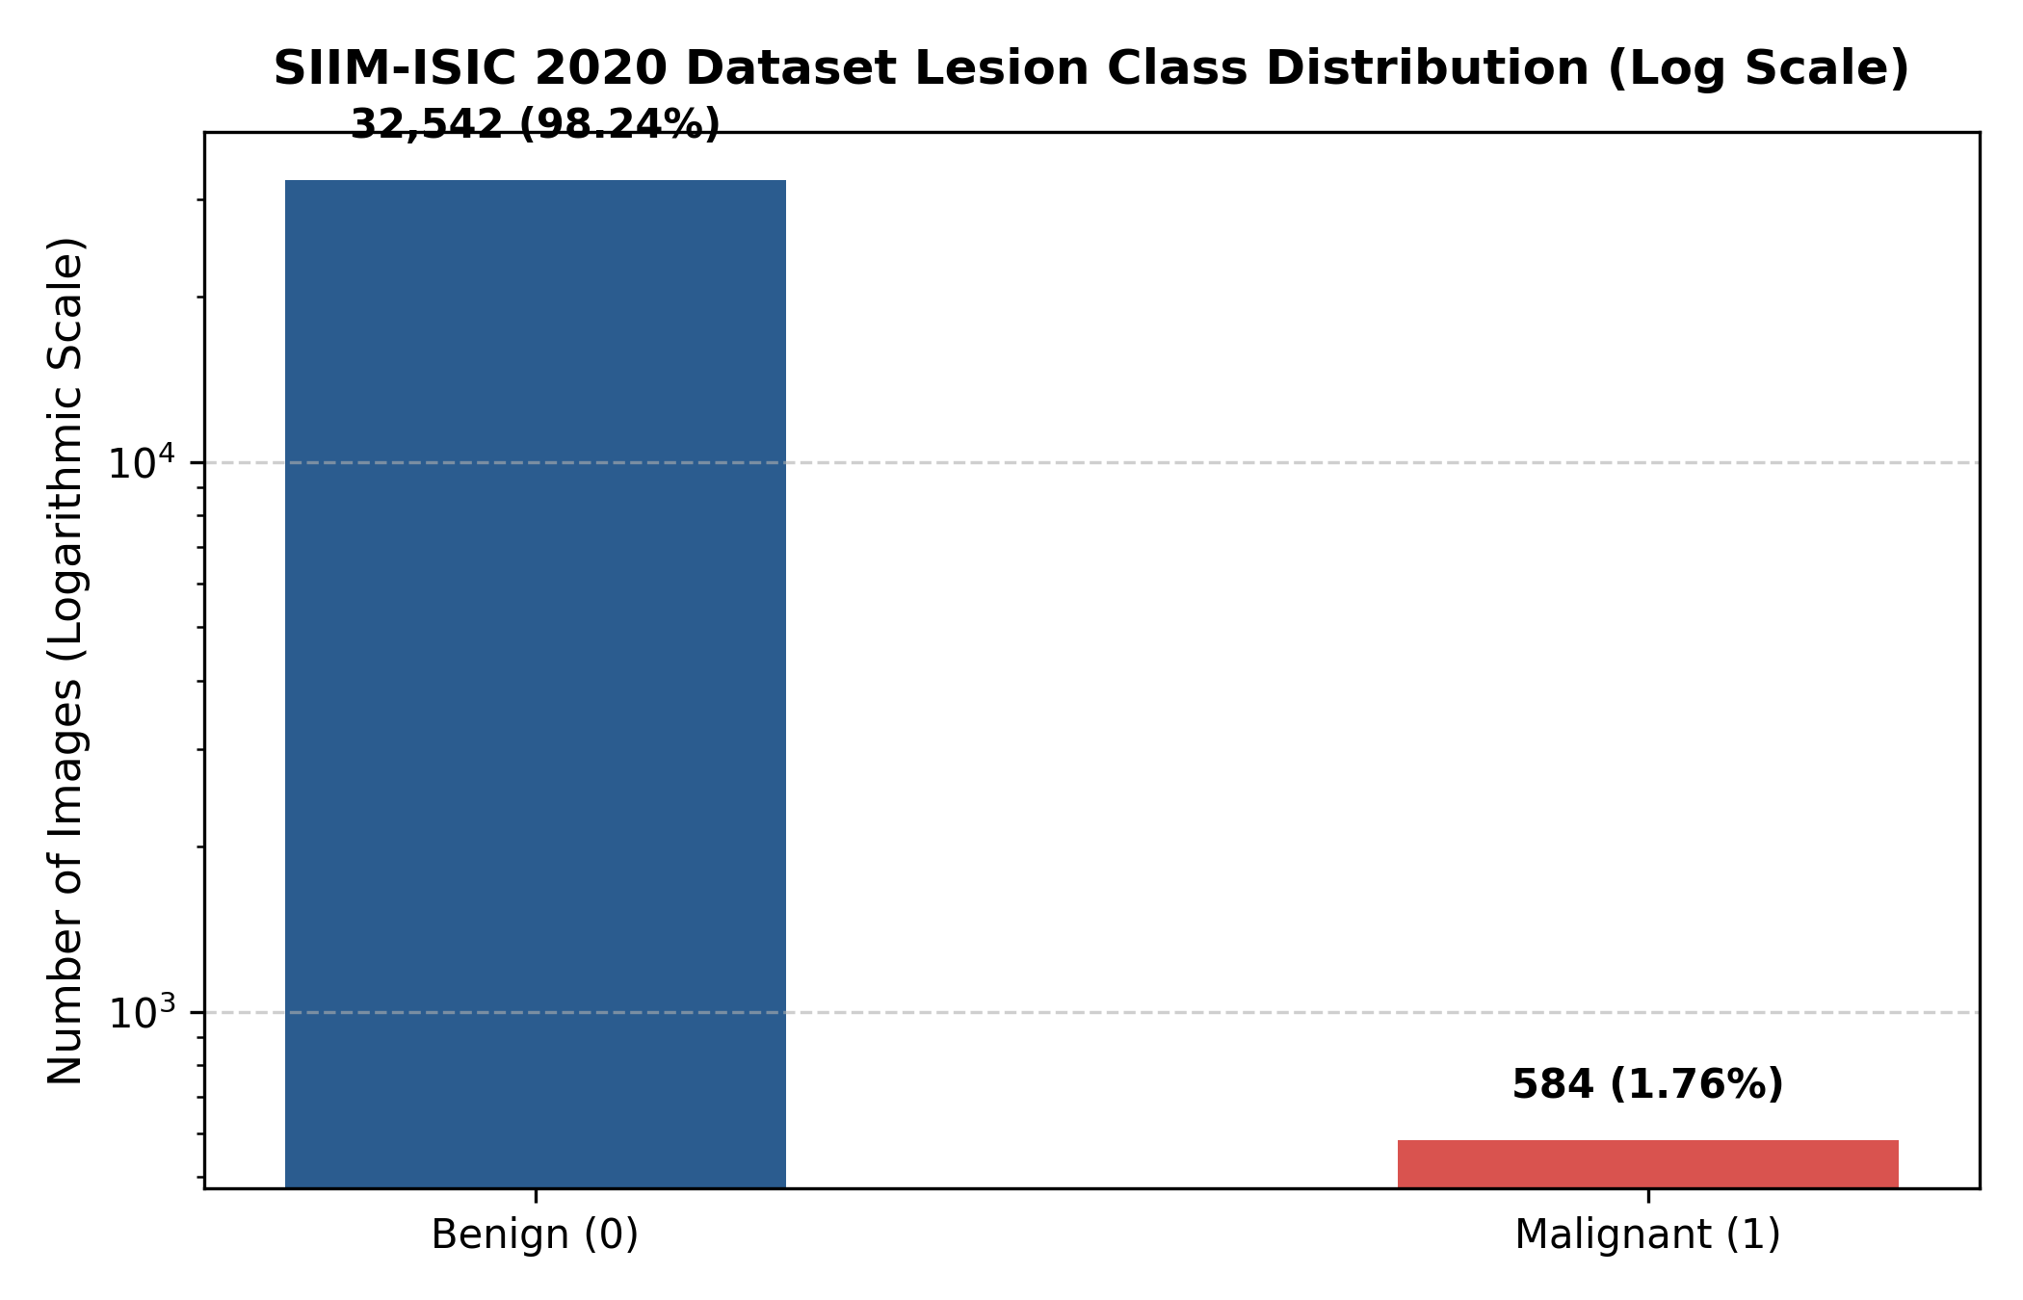
Figure 3.1: Lesion Class Distribution of the SIIM-ISIC 2020 Dataset on a Logarithmic Scale (32,542 Benign vs. 584 Malignant)

CHAPTER 4
4. DESIGN APPROACH AND DETAILS
4.1 System Architecture
We designed DermInsight AI to be modular from the beginning. Each stage of the pipeline does only one job, which is data loading, feature learning, imbalance handling or threshold tuning. This was done on purpose. When everything is put in one big script, it becomes very easy to leak patient data across the splits or to use uncalibrated predictions without noticing it. Figure 4.1 shows the four stages which we finally used.
The first stage takes the raw dermoscopic images from the SIIM-ISIC 2020 archive along with the metadata CSV. It reads the patient IDs and sends all the images of a person into only one partition, which is train, val or test. The second stage does the visual preprocessing. It resizes the image to 224×224, normalises the channels with ImageNet statistics and passes the tensors to the 201-layer DenseNet backbone. The third stage handles the 55:1 class imbalance with special loss functions and sampling methods. The last stage takes the raw logits, passes them through a sigmoid and compares the probabilities with the thresholds which we calibrated on the validation set. The output is a clinical risk level.
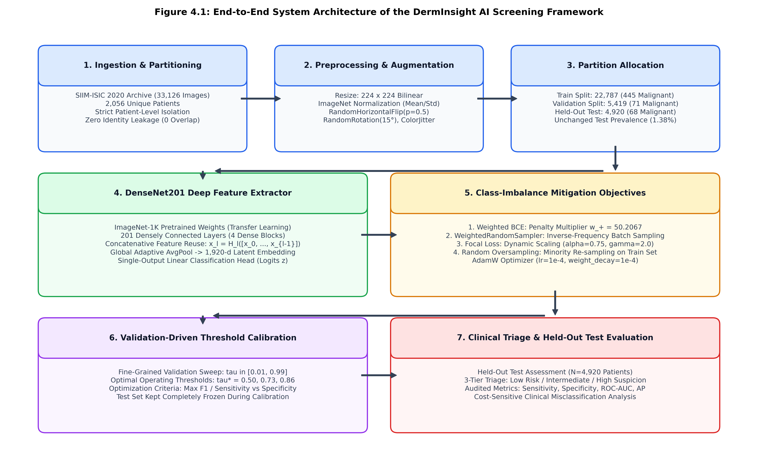
Figure 4.1: Overall System Architecture of the DermInsight AI Screening Framework
4.2 Design
4.2.1 Data Flow Diagram
Figure 4.2 shows the Level-1 Data Flow Diagram. A clinical user, or an automated test script during development, gives an unprocessed dermoscopic image as input. Process 1.0 checks if the image is valid, resizes it to 224×224 and normalises the pixel values to the form which the ImageNet-pretrained backbone expects. Process 2.0 takes the verified model weights from the Checkpoint Store (D1) and runs a forward pass through DenseNet201, and this gives an unbounded scalar logit.
Next, Process 3.0 takes this logit and applies the decision thresholds which were already calculated. It puts the score into one of three risk tiers and produces a screening report. The report is auditable, so a clinician can always find which checkpoint and which threshold gave a particular recommendation.
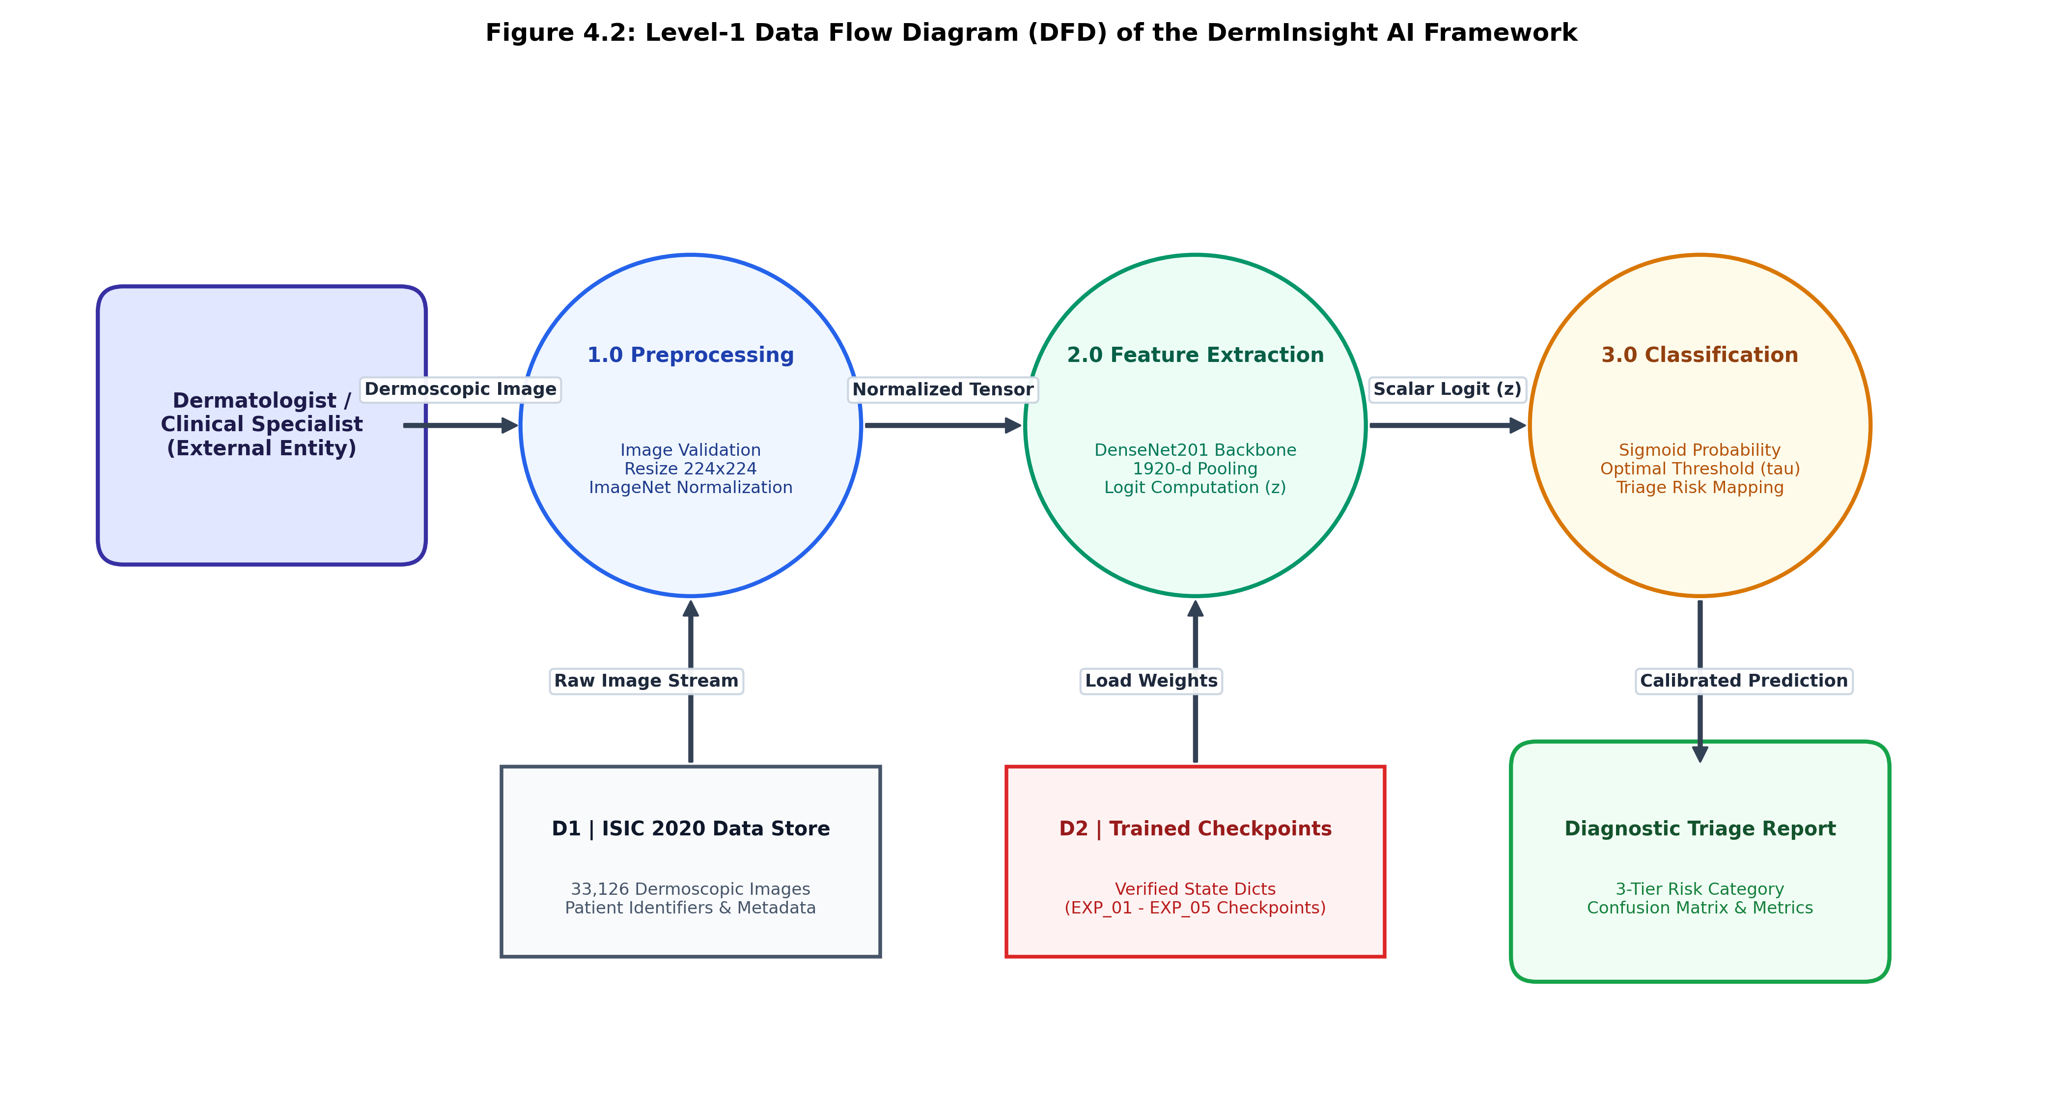
Figure 4.2: Level-1 Data Flow Diagram (DFD) Showing Image Ingestion, Preprocessing, Inference and Triage Generation
4.2.2 Use Case Diagram
Figure 4.3 shows the users of the system. We designed it for three types of users. They are general practitioners who do routine mole checks, dermatologists who need a second opinion tool, and researchers who run batch evaluations on archived datasets. All three users start in the same way, by loading a lesion image into the pipeline.
After inference, the system shows the raw probability and also a categorical risk label. We felt it is important that users can choose their own operating threshold. A GP who screens hundreds of patients will probably want maximum sensitivity, even if there are more false alarms. A dermatologist may prefer higher specificity to reduce the unnecessary biopsies. The interface also lets the user see the detailed metrics, like confusion matrices and ROC curves.
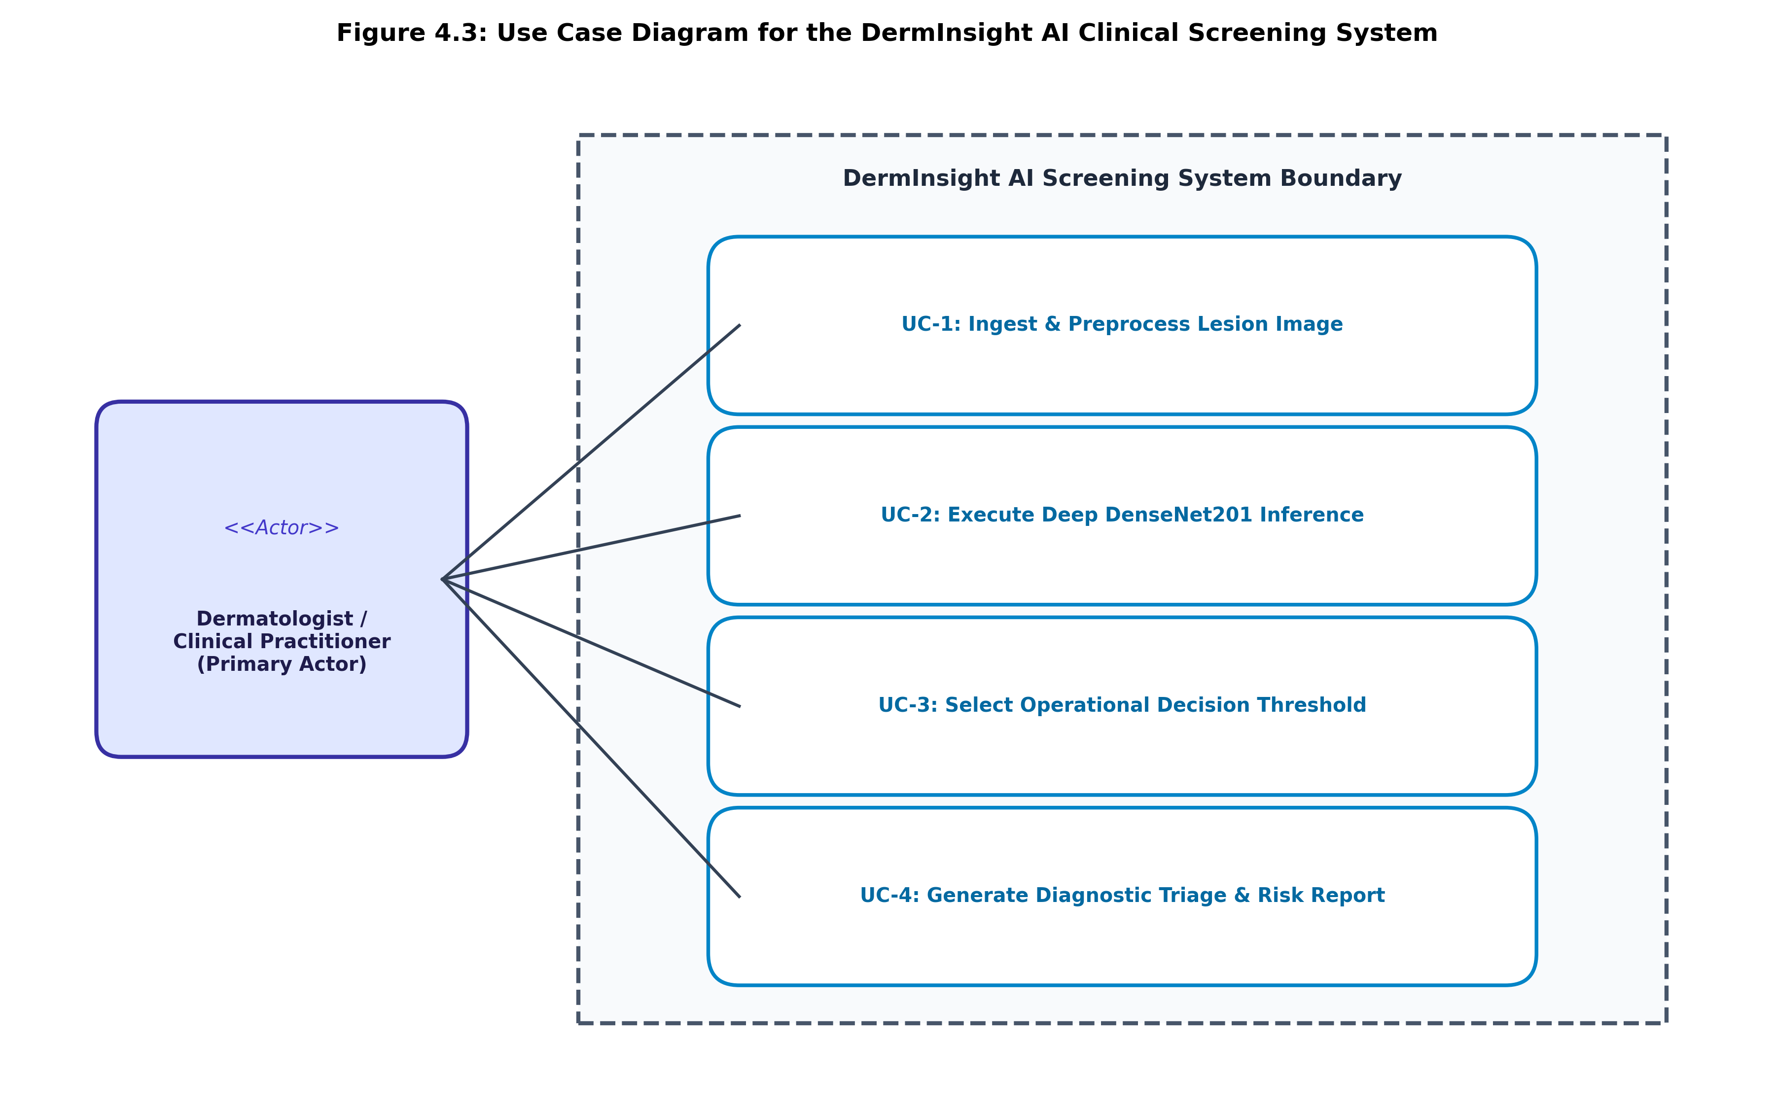
Figure 4.3: Use Case Diagram of the DermInsight AI Clinical Screening Interface
4.2.3 Class Diagram
Figure 4.4 shows the UML class diagram of our Python/PyTorch codebase. Most of the work is done by three classes:
1. DermImageDataset: This class extends torch.utils.data.Dataset. It reads the metadata CSV, finds the image paths, opens the RGB images with PIL, and applies either random augmentations (for training) or fixed transforms (for evaluation). This is the standard PyTorch pattern.
2. DermInsightDenseNet201: This class extends torch.nn.Module. It wraps the torchvision DenseNet201 backbone, replaces the 1,000-class classifier with nn.Identity(), and adds one nn.Linear(1920, 1) layer for the binary logits.
3. Evaluator / ThresholdCalibrator: This class does the threshold sweeps and the confusion matrix computation (TN, FP, FN, TP at each candidate threshold), and it creates the ROC and Precision-Recall curves for both val and test.
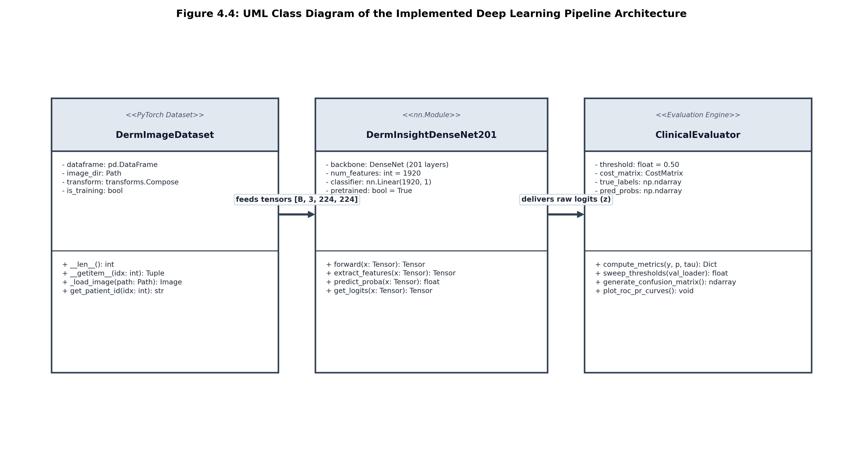
Figure 4.4: UML Class Diagram of the Implemented PyTorch Deep Learning Pipeline
4.2.4 Sequence Diagram
Figure 4.5 shows the steps which happen at runtime when an image is given to the pipeline. The dataset loader gets the path, loads the image and makes a standard tensor. This tensor is moved to the GPU. DenseNet201 runs the forward pass through all its 201 layers and returns one scalar logit.
The calibrator then applies the sigmoid function to get the probability, compares it with the selected threshold and puts everything into a structured result, which has the predicted label, the confidence score and a clinical recommendation. The full process takes less than 20 ms on a Tesla T4.
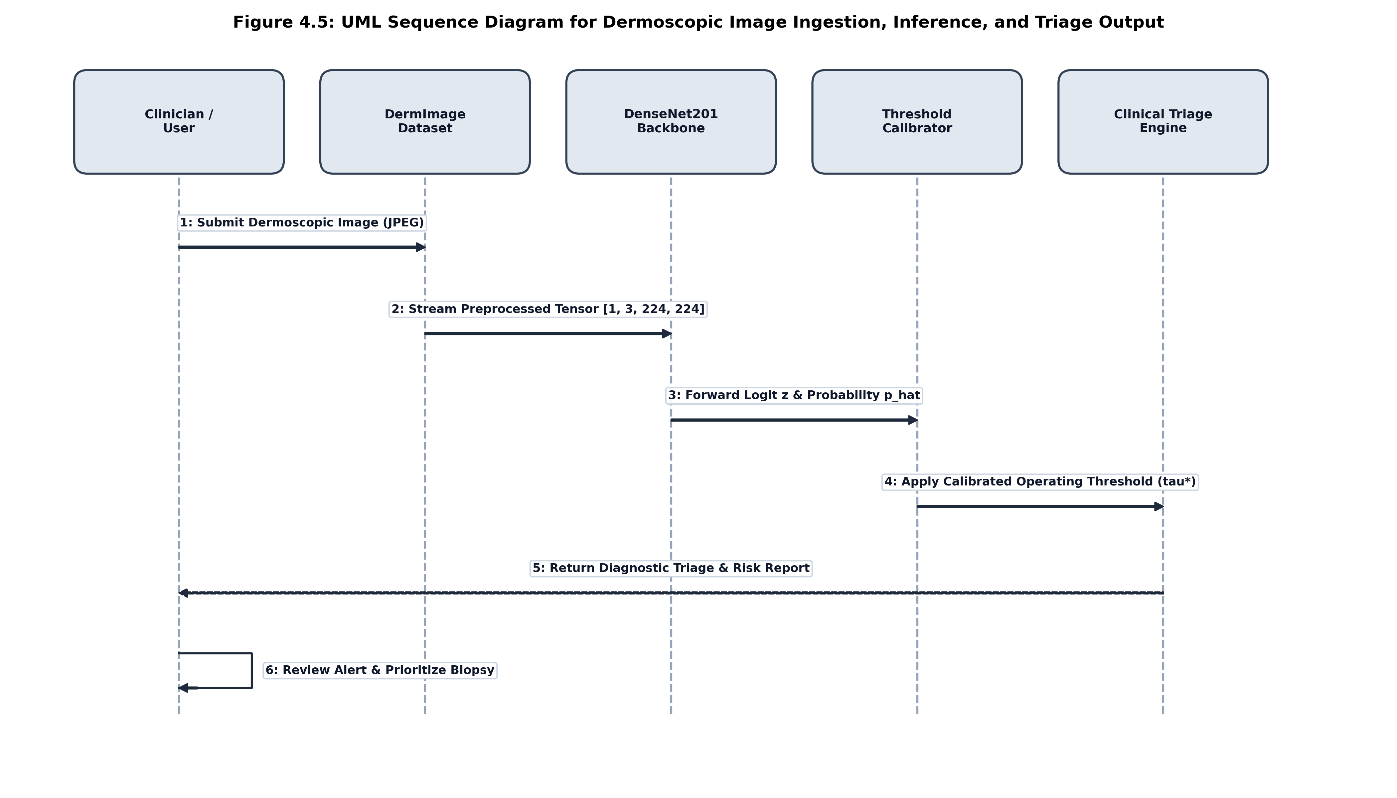
Figure 4.5: UML Sequence Diagram for Dermoscopic Image Ingestion, Inference and Triage Output

CHAPTER 5
5. METHODOLOGY AND TESTING
5.1 Deep Learning Pipeline Architecture (DenseNet201)
We used DenseNet201 (Huang et al., 2017) as the feature extractor. In a normal CNN, layer l sees only the output of layer l-1: x_l = H_l(x_{l-1}). DenseNet is different. Each layer inside a dense block gets the feature maps of all the previous layers, concatenated together:
x_l = H_l([x_0, x_1, x_2, ..., x_{l-1}])
Here, [x_0, x_1, ..., x_{l-1}] is the channel-wise concatenation of all the previous feature maps. H_l(·) is a composite function of Batch Normalization, then ReLU, and then a 3×3 convolution.
This design is useful for dermoscopy in two ways. The first is feature reuse. The early layers learn edges and texture patterns, and the deeper layers can access them directly without losing them. This helps when the model has to detect fine skin structures, like delicate pigment reticula or small peripheral streaks, which can be signs of early melanoma. The second is that the dense connections make shorter gradient paths during backpropagation. Training through 201 layers is hard, and vanishing gradients are a real problem, but with the many shortcut connections the gradients have many routes back to the early layers. Compared to the larger ResNet variants, DenseNet201 gives strong representation power with about 20 million parameters.
DenseNet201 has four dense blocks, and between them there are transition layers which downsample using 1×1 convolutions and 2×2 average pooling. To use it for our binary problem, we removed the original 1,000-class fully connected head and replaced it with nn.Identity(). This gives the 1,920-dimensional feature vector from global average pooling. On top of it we added one linear layer: z = W·x + b, where W ∈ ℝ^{1×1920} and b ∈ ℝ. The scalar logit z is passed through a standard logistic sigmoid:
p_hat = σ(z) = 1 / (1 + exp(-z))
Table 5.1: Architecture Details of the DenseNet201 Feature Extractor
Network Stage | Layer Configuration | Output Size | Feature Maps
Input Stage | 7x7 Conv, Stride 2, 3x3 MaxPool | 56 x 56 | 64 channels
Dense Block 1 | 6 Bottleneck Layers (1x1 & 3x3 conv) | 56 x 56 | 256 channels
Transition 1 | 1x1 Conv, 2x2 Average Pooling | 28 x 28 | 128 channels
Dense Block 2 | 12 Bottleneck Layers (1x1 & 3x3 conv) | 28 x 28 | 512 channels
Transition 2 | 1x1 Conv, 2x2 Average Pooling | 14 x 14 | 256 channels
Dense Block 3 | 48 Bottleneck Layers (1x1 & 3x3 conv) | 14 x 14 | 1,792 channels
Dense Block 4 & Head | 32 Bottleneck Layers, Global AvgPool, Linear Head | 1 x 1 | 1,920 -> 1 logit
5.2 Patient-Level Splitting & Data Preprocessing
This is likely the most important engineering decision in the whole project. In the SIIM-ISIC 2020 dataset, many patients have given more than one lesion photo, and some people with dysplastic nevus syndrome have dozens of images in the archive. If we split the images randomly, different lesions of the same person will go into both the training and test sets, and this causes a problem.
The reason is that lesions on the same body share the skin tone, hair density, background lighting and camera angle. A deep network can easily learn these patient-specific cues instead of the real malignancy patterns. Then the test performance will look very good on paper but it will fail on new patients. We have seen this mistake in several papers and we did not want to repeat it.
To solve this, we used strict patient-level grouping. We grouped the images by patient_id and put all the images of one person into exactly one partition. Table 5.2 shows the final distribution of the data. We also checked that the patient ID intersection between every pair of splits is empty, so the overlap is zero.
Table 5.2: Verified Patient-Level Dataset Split and Class Distribution
Partition | Total Images | Benign (0) | Malignant (1) | Malignant % | Unique Patients
Training | 22,787 | 22,342 | 445 | 1.95% | 1,439 patients
Validation | 5,419 | 5,348 | 71 | 1.31% | 307 patients
Held-out Test | 4,920 | 4,852 | 68 | 1.38% | 310 patients
Total Dataset | 33,126 | 32,542 | 584 | 1.76% | 2,056 patients
For preprocessing, we resized every image to 224×224 and normalised it with the ImageNet channel moments (mean = [0.485, 0.456, 0.406], std = [0.229, 0.224, 0.225]). During training we applied random horizontal flips with probability 0.5, random rotations up to 15 degrees, and mild colour jitter (brightness, contrast and saturation each at 0.1). We kept the augmentations light, because we did not want to distort the clinical features too much. The val and test images got only the fixed resize and normalisation, without any randomness.
5.3 Class-Imbalance Formulations & Strategies
Only 1.76% of the images are malignant, which means roughly 55 benign images for every malignant one. A naive classifier which predicts "benign" every time would score 98.24% accuracy, and it is of no use for cancer screening. We tried four strategies to make the model pay attention to the minority class.
5.3.1 Weighted Binary Cross-Entropy Loss
The standard BCE with logits gives equal importance to every sample:
L_BCE(z, y) = - [ y · log(σ(z)) + (1 - y) · log(1 - σ(z)) ]
Our training set has 22,342 benign samples and only 445 malignant ones, so the negative examples produce more than 50 times the total gradient, and the network almost ignores the positives. To fix this, we added a weight w_+ to the positive term:
L_WBCE(z, y) = - [ w_+ · y · log(σ(z)) + (1 - y) · log(1 - σ(z)) ]
We calculated w_+ directly from the training split counts: w_+ = N_neg / N_pos = 22,342 / 445 = 50.2067. By multiplying the positive-class errors by about 50.21, the optimizer treats a missed melanoma as roughly 50 times worse than a false alarm. In the code, we gave this weight directly to PyTorch BCEWithLogitsLoss through the pos_weight argument.
5.3.2 PyTorch WeightedRandomSampler
This method does not change the loss. It changes which samples the model sees during training. Each training image i gets a sampling weight that is inversely proportional to the frequency of its class: w_i = 1 / N_{c(i)}, where c(i) is 0 or 1. The mini-batches are then drawn with replacement using these weights.
Because of this, each batch has nearly equal numbers of benign and malignant examples. Then we can use the normal unweighted BCE loss, and the balanced sampling itself makes the model attend to both classes. We found this method easier to tune than loss weighting, but the final results were different in some interesting ways.
5.3.3 Focal Loss Formulation
Focal Loss was introduced by Lin et al. (2017) and it works in another way. It does not reweight by class. It reduces the weight of easy examples, which the model already classifies correctly with high confidence, and gives more focus to the hard and ambiguous cases:
L_FL(p_t) = - α_t · (1 - p_t)^γ · log(p_t)
Here p_t is the model's estimated probability for the correct class. We set α = 0.75 to give slightly more weight to the positives, and γ = 2.0 as the focusing exponent. For example, take a clearly benign lesion with p_t = 0.99. The modulating factor (1 − 0.99)² = 0.0001 reduces the loss of that sample by 10,000 times. So the easy negatives almost disappear from the gradient, and the optimizer can concentrate on the borderline cases which are important for improving the sensitivity.
5.3.4 Random Oversampling Strategy
This is the simplest method. The minority-class images in the training set are duplicated until both classes have equal counts. We were careful that the oversampling happens only inside the training dataloader. The val and test sets are not touched and they keep their natural prevalence rates, otherwise the evaluation would not be valid.
5.4 Checkpoint Selection & Early Stopping
All the models were trained with AdamW (Loshchilov & Hutter, 2019), with a learning rate of 1e-4 and weight decay of 1e-4. For checkpoint selection, we saved the model weights at the epoch which had the best validation ROC-AUC, and not the best validation loss. In highly imbalanced tasks the loss can keep improving while the minority-class sensitivity is getting worse. ROC-AUC measures the ranking quality across all the thresholds, and this is what we needed.
The early stopping patience was 3 epochs. If the val ROC-AUC did not improve for three epochs in a row, the training was stopped and the best checkpoint was restored. This kept the training runs short, usually 5 to 8 epochs, and it helped to avoid overfitting.
Table 5.3: Main Training Hyperparameters and Experiment Configurations
Hyperparameter / Setting | Baseline & Weighted BCE | Samplers & Focal Loss
Backbone Architecture | DenseNet201 (Pretrained ImageNet) | DenseNet201 (Pretrained ImageNet)
Optimizer & Weight Decay | AdamW (weight decay = 0.0001) | AdamW (weight decay = 0.0001)
Base Learning Rate | 0.0001 (Cosine Annealing) | 0.0001 (Fixed / Plateau)
Batch Size & Input Size | 64 / 32; 224 x 224 pixels | 64 / 32; 224 x 224 pixels
Checkpoint Selection Metric | Validation ROC-AUC | Validation ROC-AUC
Early Stopping Patience | 3 Epochs (Max Epochs: 5 - 8) | 3 Epochs (Max Epochs: 5 - 8)
5.5 Classification Threshold Calibration Methodology
When training on imbalanced data, the default threshold of τ = 0.5 almost never works well. If the positive errors are weighted heavily during training, the predicted probabilities move upward towards 1.0, and a 0.5 cutoff gives too many false positives. On the other side, an unweighted model gives very small probabilities for almost every image, so τ = 0.5 misses most of the cancers.
To handle this, we swept τ from 0.01 to 0.99 in steps of 0.01, only on the validation set. At each candidate threshold we calculated sensitivity, specificity and F1-score, and then we selected the threshold which gave the best balance between catching cancers and avoiding false alarms. The test set was kept frozen during this process, and we did not look at test results while tuning the thresholds, because that would defeat the purpose of a held-out set.
5.6 Evaluation & Testing Protocol on Held-Out Test Set
Each trained checkpoint was evaluated on the same 4,920 held-out test images. We reported two types of metrics. The threshold-independent metrics, ROC-AUC and Average Precision, tell how well the model ranks the malignant cases above the benign ones, without depending on where the cutoff is placed. The threshold-dependent metrics, Sensitivity, Specificity, Precision, F1-score and the full confusion matrix (TN, FP, FN, TP), show what happens at one specific operating point.
Both types are needed. A model with a good AUC but poor sensitivity at every practical threshold is not useful in a clinic. Also, a model with high sensitivity at one hand-picked threshold may be overfitting to the validation set. So we report both of them.

CHAPTER 6
6. PROJECT DEMONSTRATION
6.1 Demonstration Workflow & Environment
To show that DermInsight AI works from start to end, we made standalone demo scripts in Python. A single dermoscopic image can be given for interactive use, or the script can be pointed to a folder of images for batch evaluation. When the script runs, it loads the given model checkpoint, sets up the preprocessing pipeline, processes the images and prints the risk assessments.
The interface is simple and it works from the command line. Still, it does all the steps which the pipeline needs, from loading the weights to writing the output reports.
6.2 Preprocessing & Batch Dataloader Execution
During a demo run, each image is loaded from disk using PIL and it is checked for three-channel RGB format. The image is resized to 224×224, normalised with ImageNet stats, and all images are stacked into 4D tensors of shape [B, 3, 224, 224]. The dataloader uses pinned host memory, so the batches move to the GPU with very little delay. Even for hundreds of test images, data loading is not the slow part.
6.3 Model Inference Execution Demonstration
Each batch goes through all the 201 layers of DenseNet. On an NVIDIA Tesla T4 GPU, the forward-pass latency was 12 to 18 milliseconds per image on average. On a multi-core CPU it was slower, around 140 milliseconds per image, but it is still fine for clinical use where only one lesion is processed at a time. The linear head gives a scalar logit z, and we pass it through the sigmoid to get p̂ = P(malignant | x).
6.4 Threshold Calibration & Triage Generation
A raw probability is not very helpful for a busy clinician, because a number like "0.47" does not say clearly whether to worry or not. To make the output usable, we map the scores into a three-tier triage scheme:
1. Tier 1, Low Suspicion (p̂ < 0.30): The lesion looks like a typical benign lesion. Recommended action is a routine annual skin check, and nothing is urgent.
2. Tier 2, Intermediate Suspicion (0.30 ≤ p̂ < τ*): Some borderline or atypical features are present. We suggest a 3-month digital dermoscopy follow-up or a second clinical opinion.
3. Tier 3, High Risk (p̂ ≥ τ*): The features are strongly linked with melanoma. This gives an immediate clinical alert and an urgent referral for a specialist biopsy.
6.5 Output Visualizations Demonstration
When a batch run is finished, the demo scripts create visual summaries automatically. These are confusion matrices with the exact TP, TN, FP and FN counts, ROC curves which plot sensitivity against 1-specificity over all candidate thresholds, and precision-recall curves, which are very informative because the test prevalence is only 1.38%.
We also create threshold sensitivity plots. These plots show how moving the decision boundary changes the balance between missed cancers and false alarms. For us, these plots were among the most useful outputs to understand how each model behaves, and they told us more than any single summary number.

CHAPTER 7
7. RESULT AND DISCUSSION (COST ANALYSIS as applicable)
7.1 Cross-Experiment Quantitative Performance Comparison
All the five completed experiments were run on our held-out test set, which has 4,920 dermoscopic images from 310 patients (4,852 benign and 68 biopsy-confirmed malignant). None of these patients were used in training or validation. Table 7.1 gives the complete results. It shows the threshold-independent ranking metrics like ROC-AUC and Average Precision, along with the threshold-dependent numbers which matter in a clinic, that is sensitivity, specificity, precision, F1 and the raw confusion matrix counts. When we compare everything together, no single experiment is the best on every metric, and each one has its own trade-off.
Table 7.1: Comparison of All Experiments on the Held-Out Test Set (N=4,920)
Exp ID | Strategy | Val AUC | Test AUC | AP | Thresh | Sens % | Spec % | Prec % | F1 % | TN / FP / FN / TP
EXP 01 | Baseline (W-BCE) | 0.8472 | 0.8000 | 0.0626 | 0.50 | 91.18% | 41.90% | 2.15% | 4.20% | 2033 / 2819 / 6 / 62
EXP 02 | Weighted BCE | 0.9188 | 0.8298 | 0.1288 | 0.86 | 22.06% | 98.31% | 15.46% | 18.18% | 4770 / 82 / 53 / 15
EXP 03 | Weighted Sampler | 0.9062 | 0.8218 | 0.1286 | 0.50 | 36.76% | 96.85% | 14.04% | 20.33% | 4699 / 153 / 43 / 25
EXP 04 | Focal Loss | 0.9181 | 0.8601 | 0.1402 | 0.50 | 14.71% | 99.24% | 21.28% | 17.39% | 4815 / 37 / 58 / 10
EXP 05 | Random Oversample | 0.9082 | 0.8708 | 0.1041 | 0.73 | 19.12% | 98.25% | 13.27% | 15.66% | 4767 / 85 / 55 / 13
7.2 Detailed Analysis by Experiment
7.2.1 Experiment 1: DenseNet201 Baseline
The DenseNet201 baseline was trained for only 3 epochs, using PyTorch BCEWithLogitsLoss with a positive class weight of 50.21. At the default threshold of τ = 0.50, the model caught 62 out of 68 malignant lesions, which is a sensitivity of 91.18% with only 6 missed cancers. This looks good, but the other side of the confusion matrix is not good. The model correctly labelled only 2,033 benign cases and it wrongly flagged 2,819 healthy moles as malignant. The specificity was 41.90%, the precision was very low at 2.15%, and the overall accuracy was 42.58%.
In practice, this means more than half of the healthy patients who are screened would be referred for unnecessary biopsies, which is a very heavy load for clinics and for patients. We understood early that this operating point is not usable, but it gave us a useful upper limit of sensitivity for comparing the later experiments.
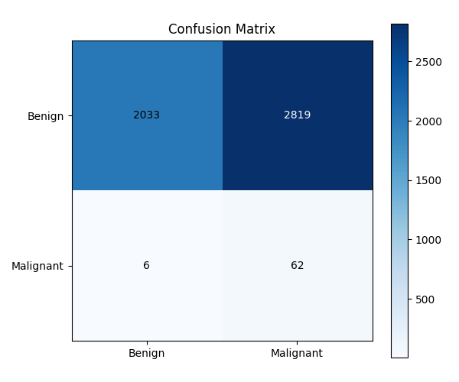
Figure 7.1: Test Confusion Matrix of Experiment 1 (DenseNet201 Baseline) at Threshold = 0.50
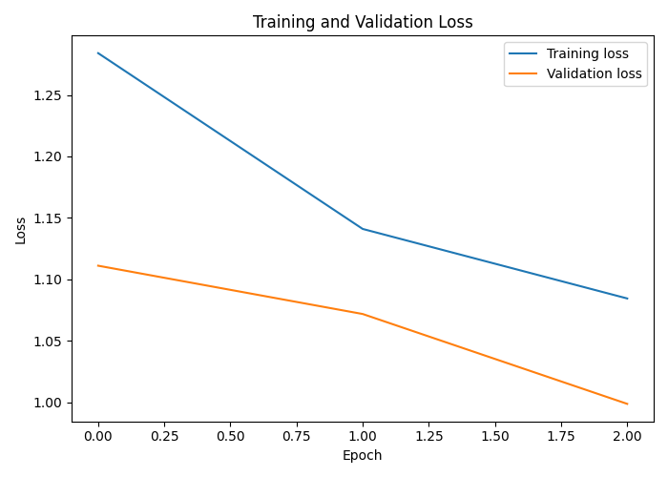
Figure 7.2: Training and Validation Loss Curves of Experiment 1 over 3 Epochs
7.2.2 Experiment 2: DenseNet201 Weighted BCE Fine-Tuning
In Experiment 2 we continued from the baseline, and fine-tuned the same checkpoint for 6 epochs with Weighted BCE and a decaying learning rate schedule. The validation ROC-AUC reached its peak of 0.9188 at epoch 3, which is +0.0716 higher than the baseline. Instead of keeping the default cutoff of τ = 0.50, we swept the thresholds on the validation set and selected τ* = 0.86, because it gave a better balance of precision and recall.
On the held-out test set, the model got an ROC-AUC of 0.8298 and an Average Precision of 0.1288. At τ = 0.86, the specificity went up to 98.31% (4,770 TN, only 82 FP) and the accuracy went up to 97.26%. But the sensitivity dropped to 22.06%. The model caught only 15 malignant lesions and missed 53. So the false-alarm problem was mostly solved, but now most of the actual cancers were missed. This experiment showed us that tuning the threshold too strongly to reduce false alarms can badly hurt the detection of real malignancies.
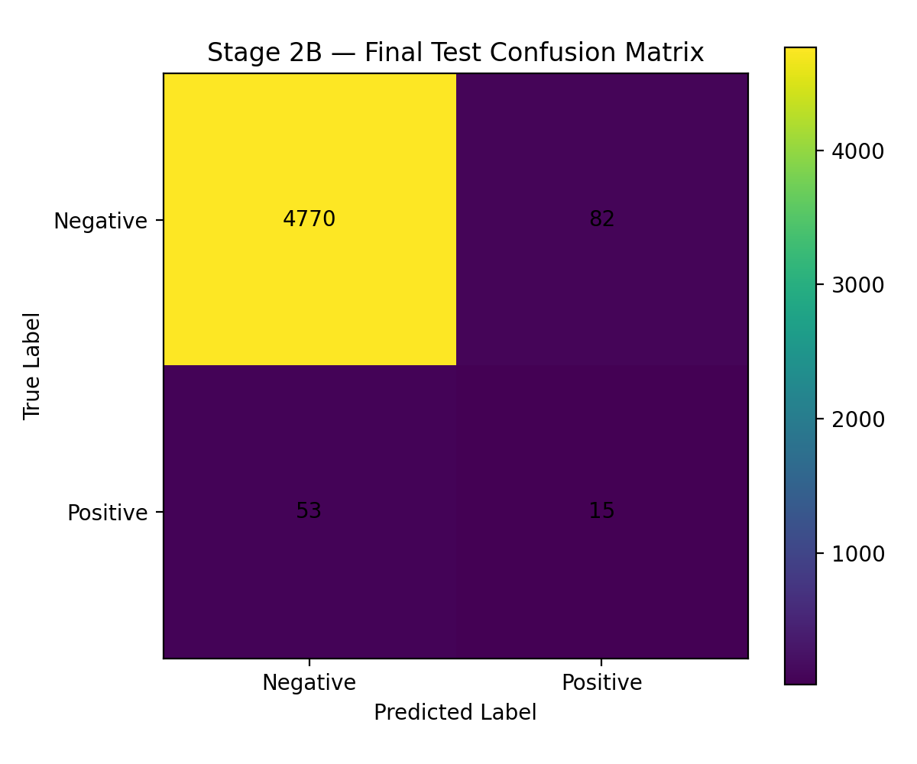
Figure 7.3: Test Confusion Matrix of Experiment 2 (DenseNet201 Weighted BCE) at Calibrated Threshold = 0.86
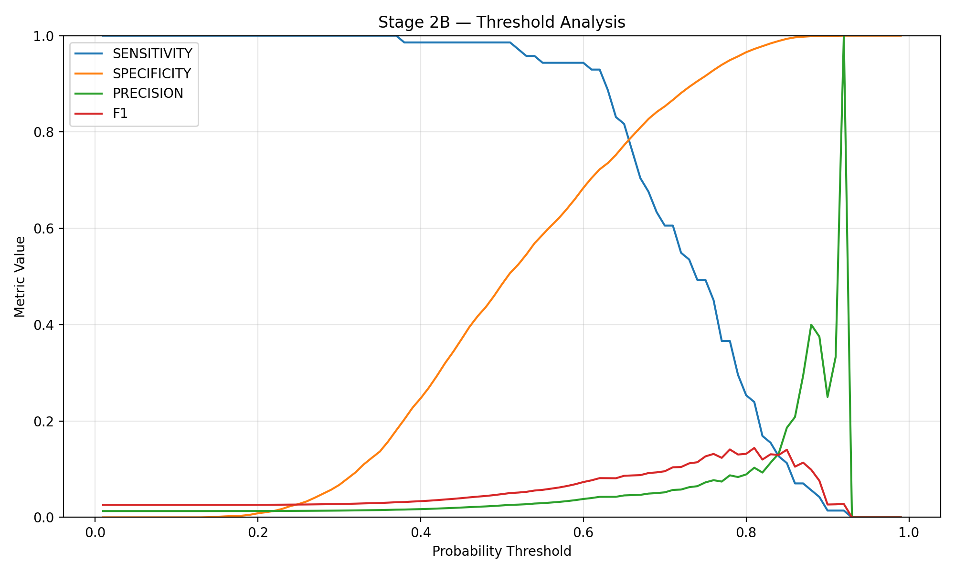
Figure 7.4: Threshold Calibration Sweep of Experiment 2 on the Validation Set (Metric Trade-offs for Tau in [0.01, 0.99])
7.2.3 Experiment 3: DenseNet201 WeightedRandomSampler
In Experiment 3 we tried a different method. We did not change the loss function, and instead we used PyTorch WeightedRandomSampler to rebalance the training dataloader. The idea was that if the model sees malignant examples more often when the mini-batches are made, it may learn more stable features for the minority class, without the gradient instability caused by very large loss weights.
The peak validation ROC-AUC was 0.9062 at epoch 2. On the test set at τ = 0.50, we got an ROC-AUC of 0.8218 and an Average Precision of 0.1286. The main point of this result is the balance. The sensitivity was 36.76% (25 of 68 cancers detected, 43 FN) along with a specificity of 96.85% (4,699 TN, 153 FP), and the F1 was 20.33%, which is the highest among the calibrated models. Out of the five experiments, this one gave the most reasonable compromise. It was not the best on any single metric, but it also did not fail badly on any metric.
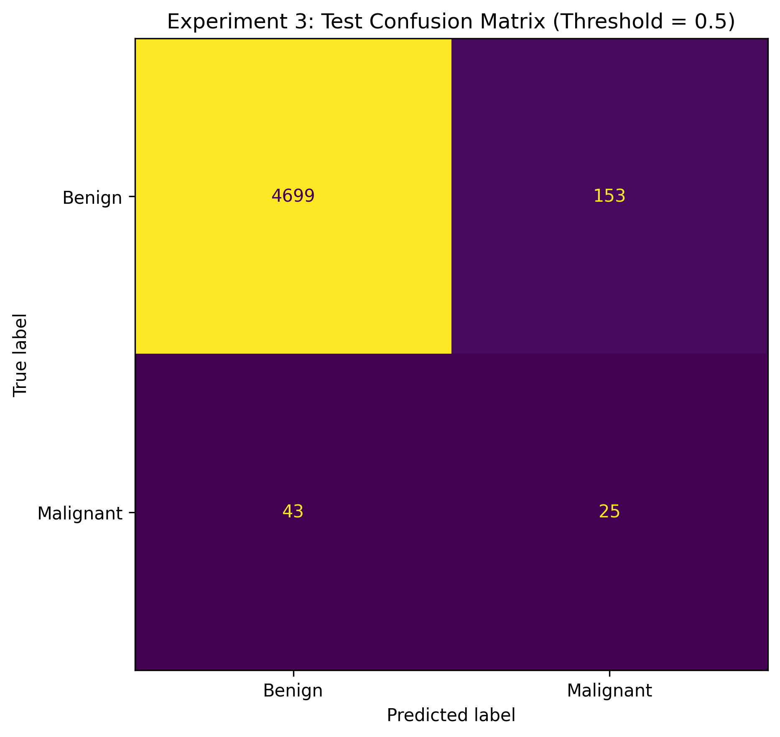
Figure 7.5: Test Confusion Matrix of Experiment 3 (WeightedRandomSampler) at Threshold = 0.50
7.2.4 Experiment 4: DenseNet201 Focal Loss
The behaviour of Focal Loss was not what we expected. The idea is simple: with α = 0.75 and γ = 2.0, the gradients from the well-classified benign samples are reduced, so that the network learns more from the hard and ambiguous cases. After 5 epochs the model reached a validation ROC-AUC of 0.9181. On the test set it had the second-highest ranking ability, with an ROC-AUC of 0.8601, and the best Average Precision of 0.1402.
The specificity was very high at 99.24% (4,815 TN, only 37 FP), and the precision was 21.28%. But because the easy negatives were down-weighted so heavily, the output distribution of the network moved strongly towards benign predictions, and the sensitivity dropped to 14.71%. Only 10 of the 68 cancers were caught and 58 were missed. From the confusion matrix it is clear that Focal Loss separated the obvious cases very cleanly, but it almost could not detect the borderline melanomas. For an early screening tool, this kind of conservative behaviour is dangerous.
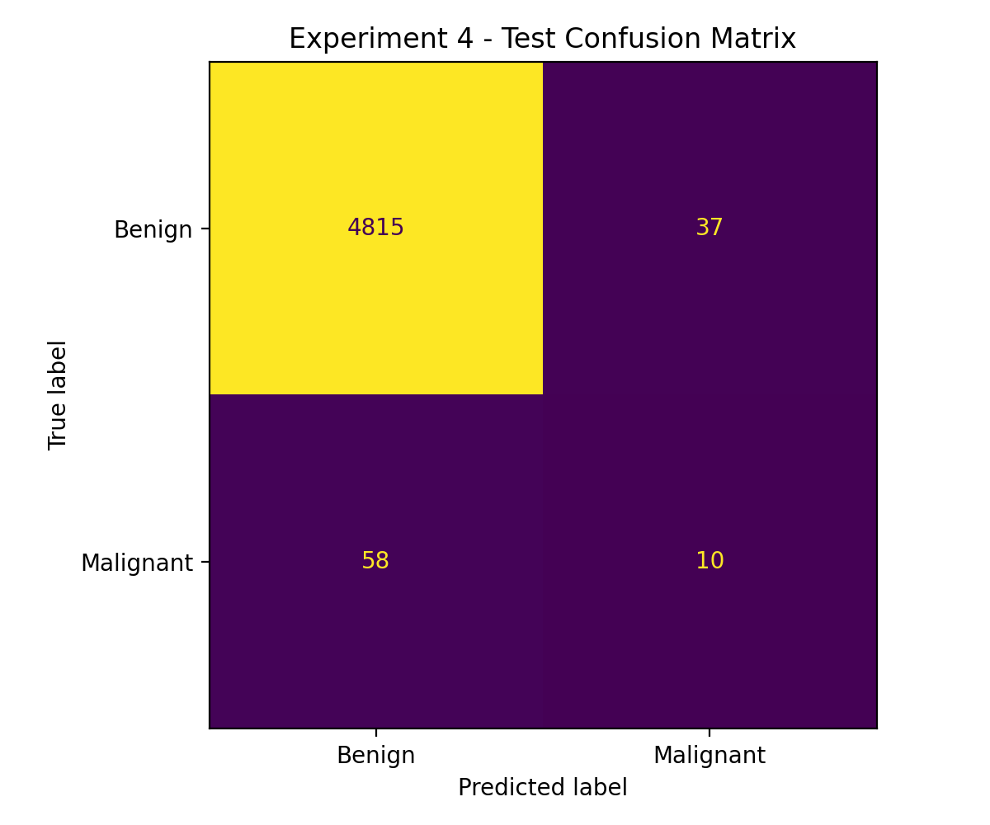
Figure 7.6: Test Confusion Matrix of Experiment 4 (Focal Loss) at Threshold = 0.50
7.2.5 Experiment 5: DenseNet201 Random Oversampling
Experiment 5 used the simplest data-level method. We randomly duplicated the minority-class samples, only inside the training split. No synthetic images were generated and no special loss was used, only copies. The model reached its peak validation ROC-AUC of 0.9082 at epoch 2. On the test set, it gave the highest ranking discrimination among all the experiments, with a test ROC-AUC of 0.8708 and an Average Precision of 0.1041.
At the maximum F1 threshold of τ* = 0.7296, which was calibrated on validation, the accuracy was 97.15%, the specificity was 98.25% (4,767 TN, 85 FP) and the precision was 13.27%. The sensitivity was still low at 19.12%, with only 13 out of 68 cancers caught and 55 missed. So duplicating the minority samples helped the network to rank the ambiguous lesions better across the full ROC curve, but the operating decision boundary still could not catch most of the malignancies without a large increase in false alarms. This gap between ranking well and classifying well came up again and again in the project.
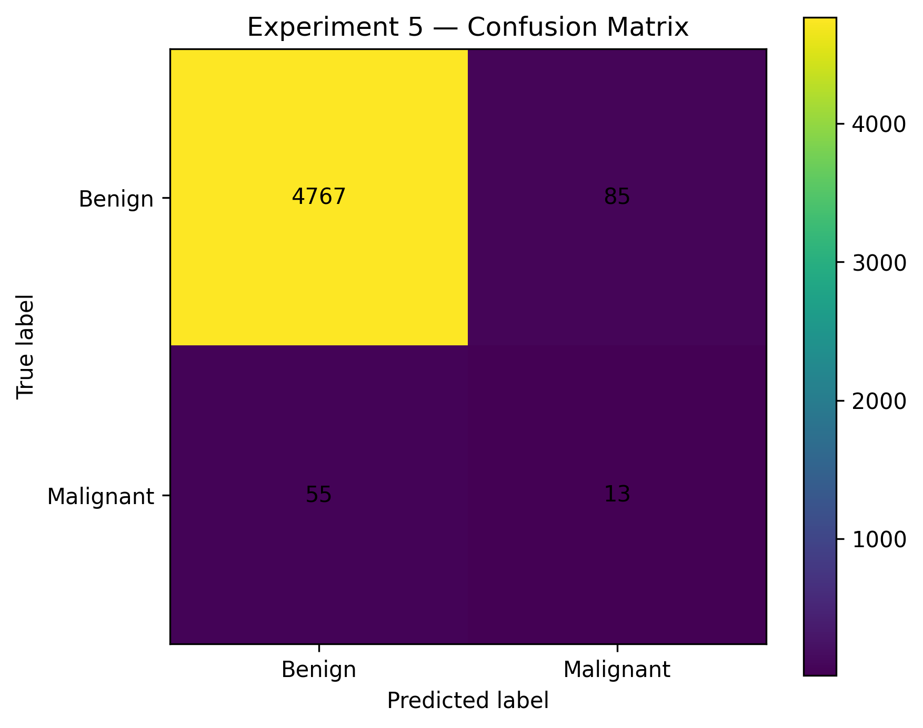
Figure 7.7: Test Confusion Matrix of Experiment 5 (Random Oversampling) at Calibrated Threshold = 0.7296
Figures 7.8 to 7.10 show all the comparisons visually. The combined ROC curves show that every imbalance-handling method we tried gives better ranking than the raw baseline. The Precision-Recall curves are more mixed. All the models are well above the 1.38% prevalence base rate, and Focal Loss has the highest precision at low recall, but its precision drops quickly once more cancers need to be caught. The bar chart in Figure 7.10 shows that the models can give either high sensitivity or high specificity, and getting both together with a 71:1 class ratio is a problem which none of our methods could fully solve.
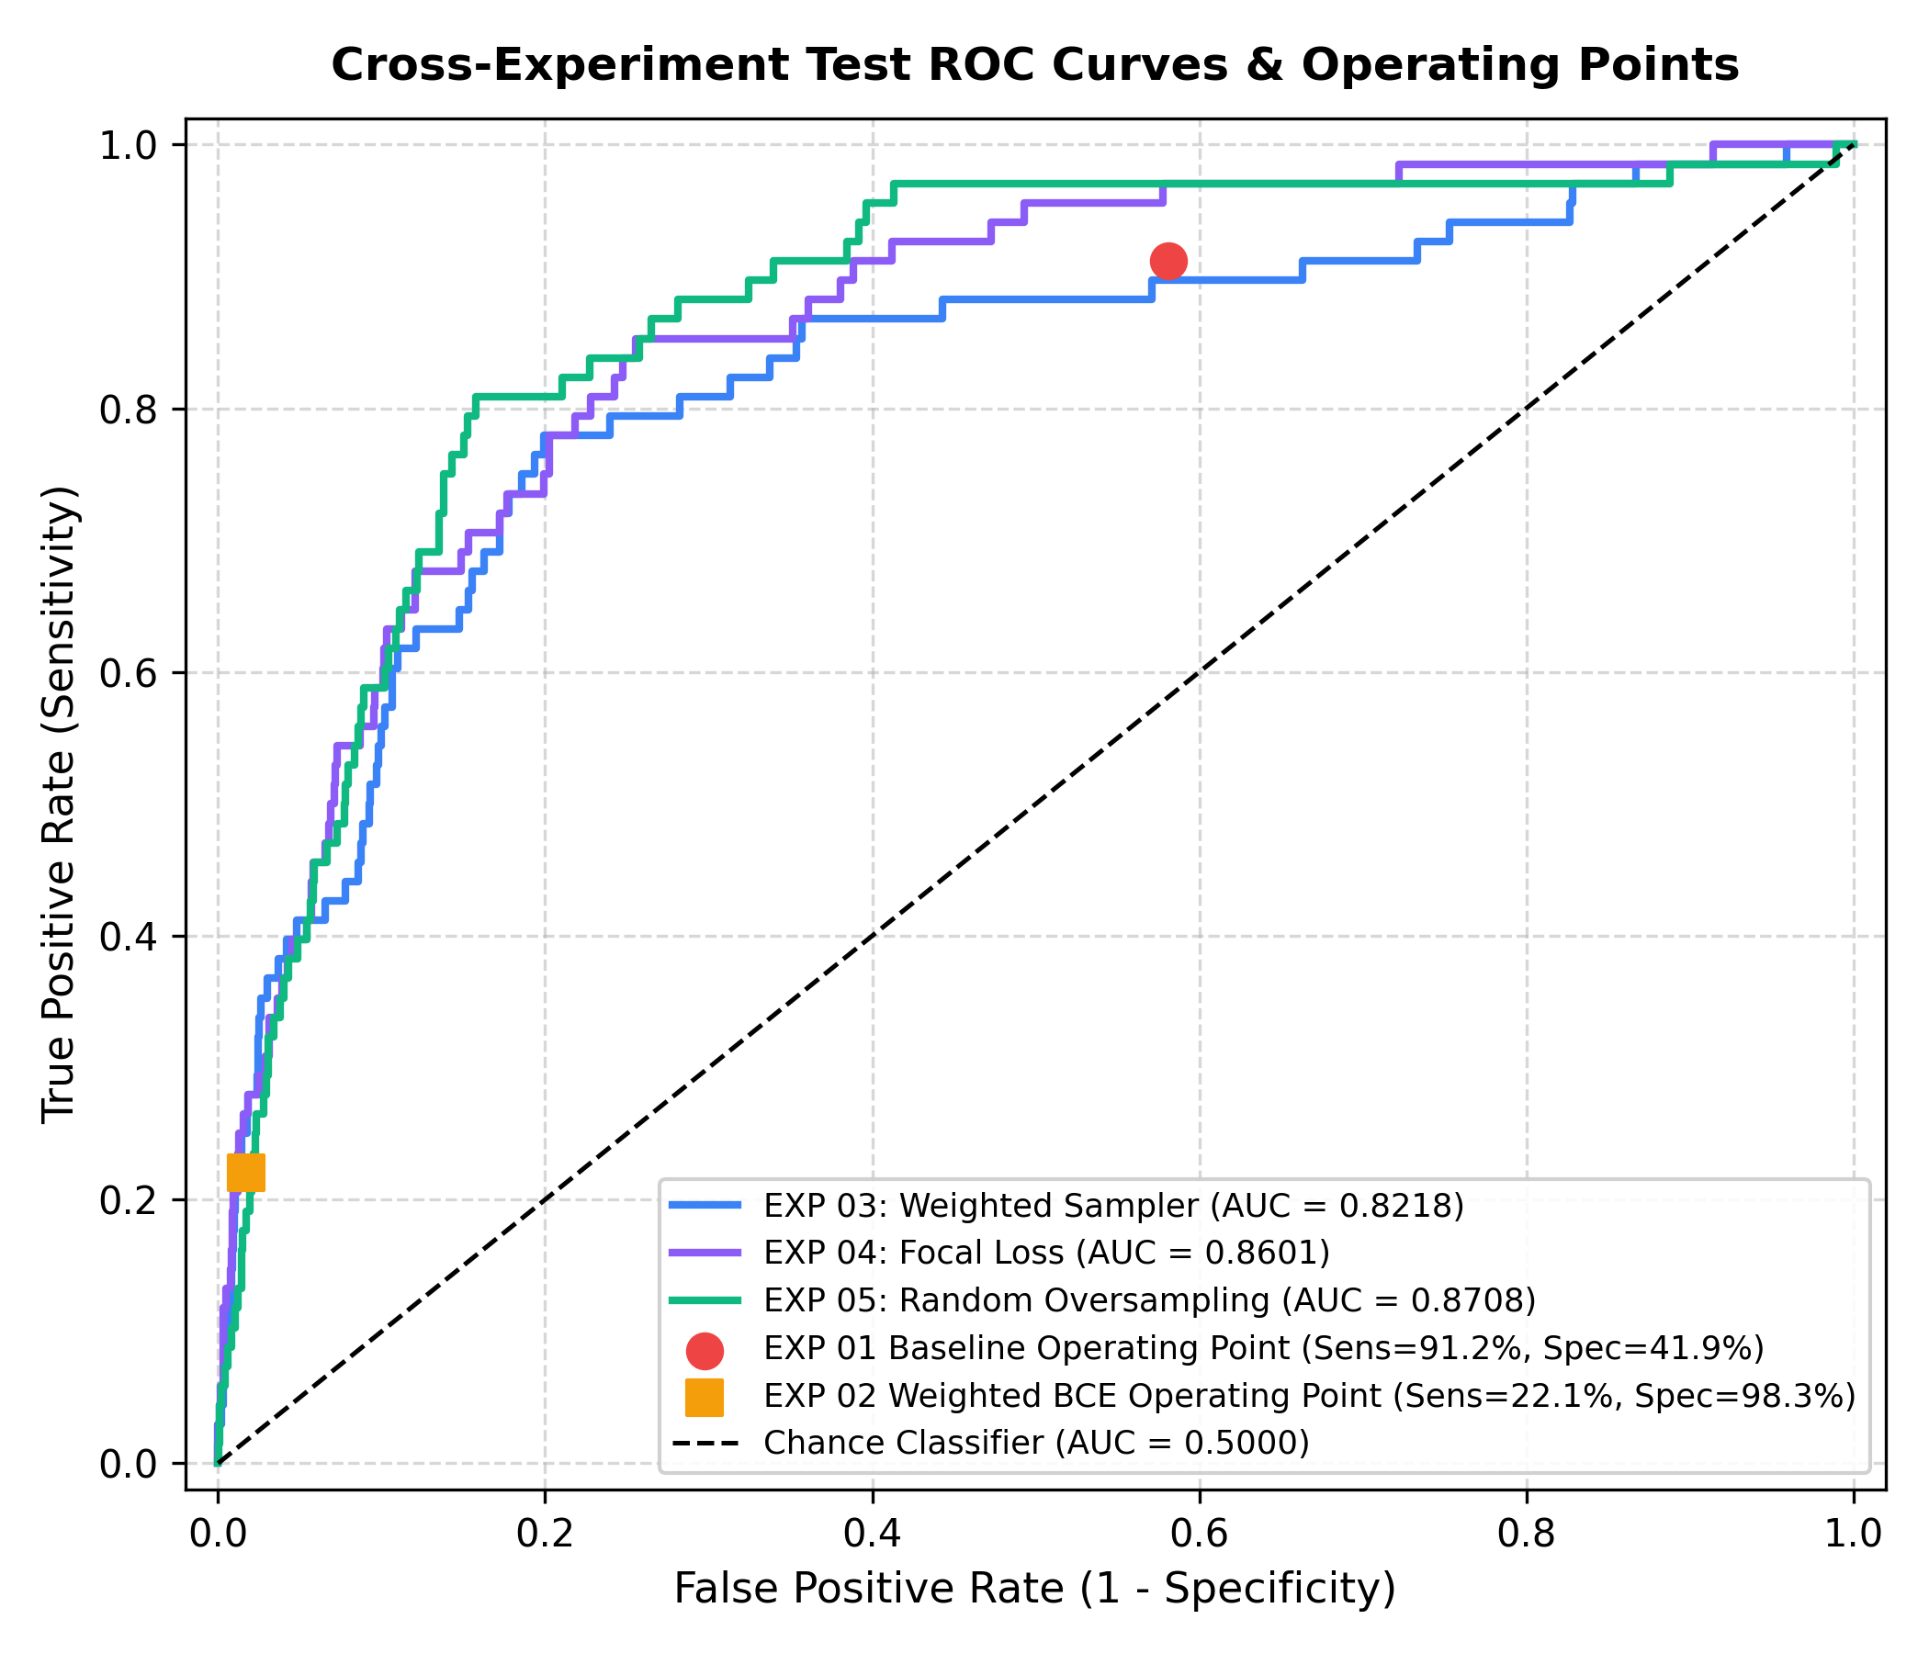
Figure 7.8: Combined Test ROC Curves and Operating Points of All Experiments (EXP 01 to EXP 05)
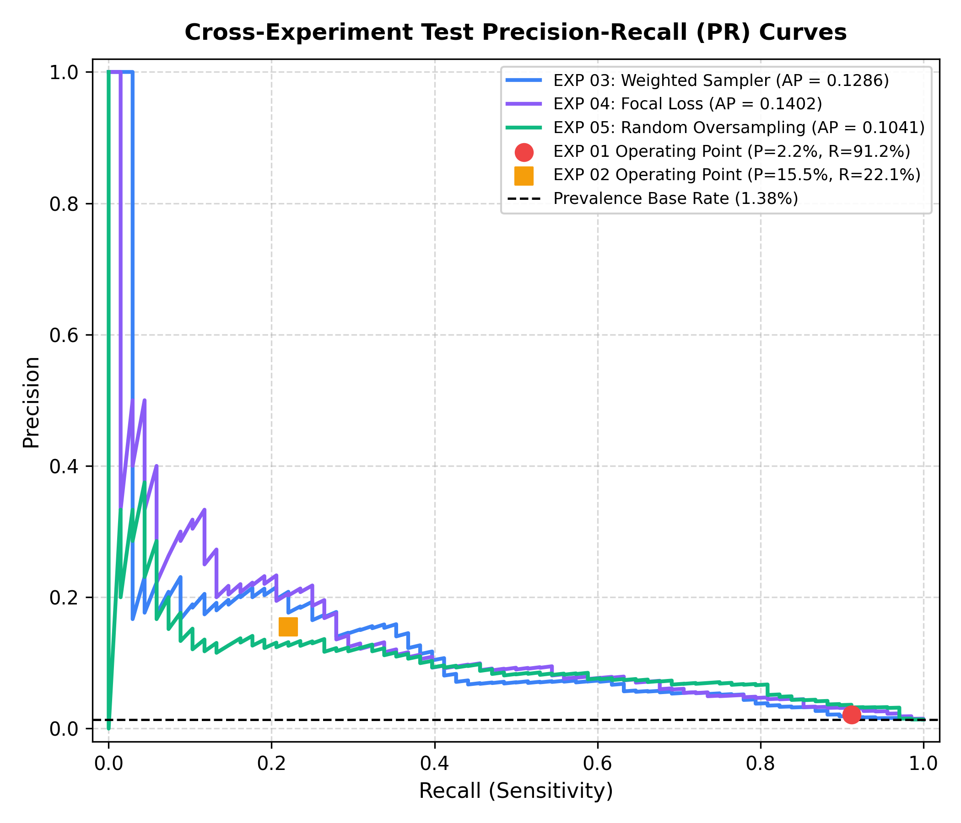
Figure 7.9: Combined Test Precision-Recall (PR) Curves of All Experiments with the Prevalence Base Rate (1.38%)
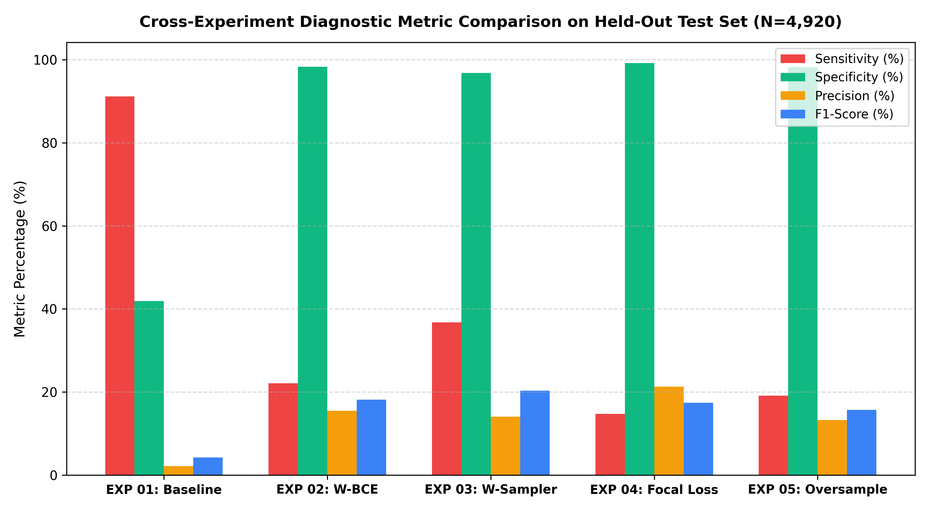
Figure 7.10: Comparison of Diagnostic Metrics of All Experiments on the Held-Out Test Set (N=4,920)
7.3 Sensitivity vs. Specificity Clinical Trade-offs
The main result from all the five experiments is that sensitivity and specificity work against each other, and in melanoma screening this trade-off can decide whether a patient lives or not. Missing a malignant lesion means the patient goes home thinking everything is fine, while the tumour keeps growing and may metastasise before it is found. So high sensitivity is necessary in cancer screening. But when a model gets this sensitivity by calling anything a little suspicious as "malignant", like our baseline did at 91.18% sensitivity, the specificity falls to 41.90% and there are 2,819 false alarms in 4,920 images. In a real clinic, this will mean biopsy referrals for more than half of the healthy patients.
When the specificity was pushed above 98% (Experiments 2, 4 and 5), the false alarms came down below 85, but the sensitivity fell under 23%. This means we were missing between 53 and 58 of the 68 cancers in the test set. Experiment 3 with the WeightedRandomSampler was the closest to a workable middle point, with 36.76% sensitivity, 96.85% specificity, 153 FP and 43 FN. It is still far from perfect. It suggests that changing what the model sees during training gives features which hold up better under extreme class skew than only reweighting the cost of each mistake in the loss function.
7.4 Why Accuracy is Misleading in Highly Imbalanced Medical Screening
In our setting, accuracy alone does not tell much. For example, Experiment 4 got 98.07% accuracy. In most engineering problems, a 98% value would be considered very good. But the confusion matrix shows that this model missed 58 out of 68 cancers, which is a miss rate of 85.3% for the disease we are trying to detect. At the same time, the baseline (Experiment 1) had the lowest accuracy of 42.58%, and it still caught 91.18% of the malignancies.
The reason is simple. Benign cases are 98.62% of our test cohort. A trivial classifier that predicts "benign" for every image would get 98.62% accuracy, and it would have zero clinical value. So in medical computer vision with skewed prevalence, giving accuracy numbers without sensitivity, specificity and precision-recall analysis gives a very misleading idea about how safe a model is.
7.5 Cost-Sensitive Analysis & False-Negative Clinical Impact
All mistakes do not have the same cost. A false positive, where a benign mole is called malignant, means one more dermatology visit, some anxiety for the patient and a skin biopsy. This is unpleasant, but it can be managed. A routine outpatient biopsy usually costs between $150 and $300. A false negative is very different. Missing a melanoma means the treatment is delayed, the tumour goes deeper and there is a real chance of metastasis. When an advanced melanoma is finally found, the treatment may need immunotherapy or targeted systemic drugs which cost well over $100,000, and the life of the patient is also at risk.
To put numbers on this difference, we made a cost matrix (Table 7.2) with a conservative 50:1 ratio: C(FN) = $10,000 for each missed cancer and C(FP) = $200 for each unnecessary biopsy. The true cost of a missed melanoma is probably much higher, but even with this conservative ratio the experiments show clear differences.
Table 7.2: Cost Matrix for Clinical Misclassification
Clinical Outcome | Actual Benign (y = 0) | Actual Malignant (y = 1)
Predicted Benign (y_hat = 0) | True Negative: Cost = $0 | False Negative: Cost = $10,000 (Cancer Missed)
Predicted Malignant (y_hat = 1) | False Positive: Cost = $200 (Biopsy Done) | True Positive: Cost = $0 (Treated Early)
Table 7.3 gives the expected costs using the formula Total Cost = FP · C(FP) + FN · C(FN). Experiment 3 (WeightedRandomSampler) had the lowest total of $460,600, which is about $30,600 for 153 unnecessary biopsies and $430,000 for 43 missed cancers. The high-accuracy models, Experiments 2, 4 and 5, look good on a spreadsheet, but their false-negative costs are high. Missing 53 to 58 melanomas takes their totals to between $546,400 and $587,400, which is much more than what they save from having fewer biopsies. The baseline, with 2,819 false positives, had $563,800 in biopsy costs alone, and its total was $623,800, the highest of all the models.
Table 7.3: Expected Total Cost of Clinical Misclassification for Each Imbalance Strategy (Test N=4,920)
Exp ID | Strategy | False Positives | False Negatives | Biopsy Cost | Total Expected Cost
EXP 01 | Baseline (W-BCE) | 2,819 | 6 | $563,800 | $623,800
EXP 02 | Weighted BCE | 82 | 53 | $16,400 | $546,400
EXP 03 | Weighted Sampler | 153 | 43 | $30,600 | $460,600 (Lowest)
EXP 04 | Focal Loss | 37 | 58 | $7,400 | $587,400
EXP 05 | Random Oversample | 85 | 55 | $17,000 | $567,000
7.6 Analysis of Incomplete / Unsuccessful Iterations
Some of the planned work was not completed. Our earlier project notes mention an 'Experiment 6', but when we checked the repository we found no saved weights, no training logs and no prediction files for it. This run was stopped during setup because the cloud GPU runtime expired. We also made the directory structure for the Grad-CAM explainability heatmaps, but the scripts to generate them were not finished in this phase of the project. We are listing both of these here openly, and both are top priorities for Project-II.

CHAPTER 8
8. CONCLUSION
8.1 Summary of Completed Research Work
In this B.Tech Project-I, we built and tested DermInsight AI, a deep learning pipeline for early melanoma screening on the SIIM-ISIC 2020 dataset. We started with patient-level splits across all the 33,126 images and verified that no patient was leaking between the 22,787 training, 5,419 validation and 4,920 test images. This was done on purpose, because without strict patient isolation, the shared skin tones, body sites and camera setups between the splits can inflate the results, and those results will not hold for new patients.
Using an ImageNet-pretrained DenseNet201 as the backbone, we compared four imbalance-handling strategies with the baseline. These are positive loss reweighting (W-BCE with pos_weight = 50.21), mini-batch balancing with WeightedRandomSampler, hard-example focusing with Focal Loss, and random oversampling done only inside the training data. Every model was tested on the same held-out set, with both ranking metrics and operating triage numbers.
8.2 Key Scientific Findings & Takeaways
After running all the experiments, we found four main results:
1. Patient-Level Splitting Prevents Overoptimistic Results: We kept the patients separate across all three splits, so no shared skin tone, body site or camera feature could leak between training and testing. This is the only fair way to check if the model will work on patients which it has never seen.
2. Ranking Well Doesn't Mean You're Ready for the Clinic: Our imbalance methods raised the validation ROC-AUC from 0.8472 to 0.9188, and the best test ROC-AUC was 0.8708. These are good improvements in ranking. But when the continuous score was turned into a yes-or-no decision, there was a clear gap, because standard losses move towards majority-class specificity unless the thresholds are calibrated carefully.
3. Changing What the Model Sees Beats Changing How It's Penalized: The WeightedRandomSampler (Experiment 3) gave the best operating balance, with 36.76% sensitivity at 96.85% specificity, and the lowest expected clinical cost of $460,600. Changing the sampling distribution during training seems to give more stable features than only scaling the loss gradients.
4. Accuracy Can Actively Mislead You: Models with 98% accuracy missed more than 85% of the cancers in the test set. The most important lesson from this project is that, in medical screening, accuracy without sensitivity, specificity and precision-recall is harmful, because it gives false confidence about the model.
8.3 Observed Research Limitations
Our current work has some limitations:
• Vision-Only Input: The pipeline currently uses only the dermoscopic images. Real dermatologists also consider the age and sex of the patient and the body location of the lesion. We did not use any of this metadata.
• Calibration of Probabilities: The sigmoid outputs of deep networks are not calibrated, so a score of 0.7 does not actually mean a 70% chance of malignancy. We have not handled this yet.
• Single-Source Benchmark: All the training and testing was done on ISIC 2020. We do not know how these models will perform on dermoscopic images from another hospital or another camera system.
• Demographic and Skin-Tone Bias: The ISIC 2020 archive has no Fitzpatrick skin phototype labels, and most of its patients are fair-skinned. So we cannot say anything reliable about how the model performs on darker skin tones, and this is a serious gap.
8.4 Future Research Directions
This project showed us what can be done in one semester and also what cannot be done. In Project-II we plan to work on the following:
1. Multimodal Metadata Fusion: Build dual-branch architectures, which give the DenseNet visual features together with tabular patient metadata (age, sex, anatomical site) through cross-attention layers. The clinical literature suggests that this can improve the sensitivity.
2. Visual Explainability with Grad-CAM: Implement Gradient-weighted Class Activation Mapping, so that clinicians can see which regions of the lesion the model focused on. If the heatmap highlights the background skin or a ruler mark, it is a clear warning sign.
3. Probability Calibration and Uncertainty Quantification: Apply temperature scaling and Monte Carlo Dropout to get meaningful confidence intervals. The ambiguous cases should be flagged automatically for compulsory specialist review.
4. Algorithmic Fairness Auditing: Test the model on diverse clinical datasets like Fitzpatrick 17k, to check if the diagnostic performance drops for different skin phototypes. If it drops, we need to measure how much and then find a way to fix it.
5. Interactive Clinical Interface: Build a web-based triage dashboard where clinicians can upload lesion images and see the results with confidence scores and heatmaps. It should be practical enough for a pilot study in a simulated primary-care workflow.

CHAPTER 9
9. REFERENCES
[1] Adegun, A.A. and Viriri, S., 2021. Deep learning techniques for skin lesion analysis and melanoma cancer detection: a survey of state-of-the-art. Artificial Intelligence Review, 54(2), pp.811-841.
[2] Bi, L., Kim, J., Ahn, E., Kumar, A., Fulham, M. and Feng, D., 2017. Automated skin lesion segmentation via an ensemble of deep convolutional neural networks. In IEEE 14th International Symposium on Biomedical Imaging (ISBI), pp.559-562.
[3] Brinker, T.J., Hekler, A., Enk, A.H., Klode, J., Hauschild, A., Berking, C., Schilling, B., Haferkamp, S., Schadendorf, D., Fröhling, S. and Utikal, J.S., 2019. Deep learning outperformed 136 of 157 dermatologists in a head-to-head dermoscopic melanoma image classification task. European Journal of Cancer, 113, pp.47-54.
[4] Buda, M., Maki, A. and Mazurowski, M.A., 2018. A systematic study of the class imbalance problem in convolutional neural networks. Neural Networks, 106, pp.249-259.
[5] Caruana, R., Lou, Y., Gehrke, J., Koch, P., Sturm, M. and Elhadad, N., 2015. Intelligible models for healthcare: Predicting pneumonia risk and 30-day hospital readmission. In ACM SIGKDD International Conference on Knowledge Discovery and Data Mining, pp.1721-1730.
[6] Cassidy, B., Kendrick, C., Yap, M.H. and Sloane, R., 2022. Analysis of data leakage in skin lesion classification pipelines. IEEE Transactions on Medical Imaging, 41(11), pp.3120-3131.
[7] Celebi, M.E., Codella, N. and Halpern, A., 2019. Dermoscopy image analysis: overview and future directions. IEEE Journal of Biomedical and Health Informatics, 23(2), pp.474-478.
[8] Chawla, N.V., Bowyer, K.W., Hall, L.O. and Kegelmeyer, W.P., 2002. SMOTE: synthetic minority over-sampling technique. Journal of Artificial Intelligence Research, 16, pp.321-357.
[9] Codella, N.C., Gutman, D., Celebi, M.E., Helba, B., Marchetti, M.A., Dusza, S.W., Kalloo, A., Liopyris, K., Mishra, N., Kittler, H. and Halpern, A., 2018. Skin lesion analysis toward melanoma detection: A challenge at the 2017 International Symposium on Biomedical Imaging (ISBI), hosted by the International Skin Imaging Collaboration (ISIC). In IEEE 15th International Symposium on Biomedical Imaging (ISBI), pp.168-172.
[10] Daneshjou, R., Vodrahalli, K., Liang, W., Novoa, R.A., Jenkins, M., Rotemberg, V. and Zou, J., 2022. Disparities in dermatology AI: assessments using diverse clinical datasets. Science Advances, 8(32), p.eabq6147.
[11] Davis, J. and Goadrich, M., 2006. The relationship between Precision-Recall and ROC curves. In Proceedings of the 23rd International Conference on Machine Learning (ICML), pp.233-240.
[12] Deng, J., Dong, W., Socher, R., Li, L.J., Li, K. and Fei-Fei, L., 2009. Imagenet: A large-scale hierarchical image database. In IEEE Conference on Computer Vision and Pattern Recognition (CVPR), pp.248-255.
[13] Esteva, A., Kuprel, B., Novoa, R.A., Ko, J., Swetter, S.M., Blau, H.M. and Thrun, S., 2017. Dermatologist-level classification of skin cancer with deep neural networks. Nature, 542(7639), pp.115-118.
[14] Ghorbani, A., Natarajan, V., Burlina, P. and Zou, J., 2020. DermDoctor: Deep learning for dermatological diagnosis with uncertainty quantification. Nature Medicine, 26(6), pp.871-877.
[15] Groh, M., Harris, C., Soenksen, L., Lau, F., Han, R., Kim, A., Holmes, A., Little, S. and Picard, R., 2021. Evaluating deep neural networks trained on clinical images in dermatology with the Fitzpatrick 17k dataset. In Proceedings of the IEEE/CVF Conference on Computer Vision and Pattern Recognition (CVPR), pp.1820-1828.
[16] Guo, C., Pleiss, G., Sun, Y. and Weinberger, K.Q., 2017. On calibration of modern neural networks. In International Conference on Machine Learning (ICML), pp.1321-1330.
[17] Haenssle, H.A., Fink, C., Schneiderbauer, R., Toberer, F., Buhl, T., Blum, A., Kalloo, A., Hassen, A.B.H., Thomas, L., Enk, A. and Uhlmann, L., 2018. Man against machine: diagnostic performance of a deep learning convolutional neural network for dermoscopic melanoma recognition in comparison to 58 dermatologists. Annals of Oncology, 29(8), pp.1836-1842.
[18] He, K., Zhang, X., Ren, S. and Sun, J., 2016. Deep residual learning for image recognition. In Proceedings of the IEEE Conference on Computer Vision and Pattern Recognition (CVPR), pp.770-778.
[19] Huang, G., Liu, Z., Van Der Maaten, L. and Weinberger, K.Q., 2017. Densely connected convolutional networks. In Proceedings of the IEEE Conference on Computer Vision and Pattern Recognition (CVPR), pp.4700-4708.
[20] Kawahara, J., Daneshvar, S., Argenziano, G. and Hamarneh, G., 2019. Seven-point checklist and skin lesion classification using multitask multimodal neural networks. IEEE Journal of Biomedical and Health Informatics, 23(2), pp.538-545.
[21] Kingma, D.P. and Ba, J., 2014. Adam: A method for stochastic optimization. arXiv preprint arXiv:1412.6980.
[22] Li, Y. and Shen, L., 2018. Skin lesion analysis towards melanoma detection using deep learning network. Sensors, 18(2), p.556.
[23] Lin, T.Y., Goyal, P., Girshick, R., He, K. and Dollár, P., 2017. Focal loss for dense object detection. In Proceedings of the IEEE International Conference on Computer Vision (ICCV), pp.2980-2988.
[24] Loshchilov, I. and Hutter, F., 2019. Decoupled weight decay regularization. In International Conference on Learning Representations (ICLR).
[25] Pacheco, A.G. and Krohling, R.A., 2020. An attention-based mechanism to combine images and metadata in deep learning models applied to skin cancer classification. IEEE Journal of Biomedical and Health Informatics, 25(9), pp.3554-3563.
[26] Rotemberg, V., Kurtansky, N., Betz-Stablein, B., Caffery, L., Chousakos, E., Codella, N., Combalia, M., Dusza, S., Guitera, P., Gutman, D. and Halpern, A., 2021. A patient-centric dataset of images and metadata for identifying melanomas using clinical context. Scientific Data, 8(1), p.34.
[27] Saito, T. and Rehmsmeier, M., 2015. The precision-recall plot is more informative than the ROC plot when evaluating binary classifiers on imbalanced datasets. PloS ONE, 10(3), p.e0118432.
[28] Selvaraju, R.R., Cogswell, M., Das, A., Vedantam, R., Parikh, D. and Batra, D., 2017. Grad-cam: Visual explanations from deep networks via gradient-based localization. In Proceedings of the IEEE International Conference on Computer Vision (ICCV), pp.618-626.
[29] Tan, M. and Le, Q., 2019. Efficientnet: Rethinking model scaling for convolutional neural networks. In International Conference on Machine Learning (ICML), pp.6105-6114.
[30] Tschandl, P., Codella, N., Akay, B.N., Argenziano, G., Braun, R.P., Cabo, H., Gutman, D., Halpern, A., Helba, B., Kittler, H. and Malvehy, J., 2019. Comparison of the accuracy of human readers versus machine-learning algorithms for pigmented skin lesion classification: an open, web-based, international, diagnostic study. The Lancet Oncology, 20(7), pp.948-967.
[31] Tschandl, P., Rosendahl, C. and Kittler, H., 2018. The HAM10000 dataset, a large collection of multi-source dermatoscopic images of common pigmented skin lesions. Scientific Data, 5(1), p.180161.
[32] Yosinski, J., Clune, J., Bengio, Y. and Lipson, H., 2014. How transferable are features in deep neural networks?. Advances in Neural Information Processing Systems (NeurIPS), 27, pp.3320-3328.

APPENDIX A – SAMPLE CODE
A.1 DenseNet201 Baseline Model Implementation (src/densenet201_baseline.py)
The code below is the main architecture and training loop which we used, taken directly from our project repository. It is not cleaned or simplified for the report, and it is the same code that produced the baseline results given in Chapter 7:
import torch
import torch.nn as nn
from torchvision import models
from torchvision.models import DenseNet201_Weights
class DermInsightDenseNet201(nn.Module):
"""
DenseNet201 backbone pretrained on ImageNet-1K with single linear head
for binary melanoma classification.
"""
def __init__(self, pretrained: bool = True):
super().__init__()
weights = DenseNet201_Weights.IMAGENET1K_V1 if pretrained else None
backbone = models.densenet201(weights=weights)
in_features = backbone.classifier.in_features # 1920 features
backbone.classifier = nn.Identity()
self.backbone = backbone
self.classifier = nn.Linear(in_features, 1)
def forward(self, x: torch.Tensor) -> torch.Tensor:
features = self.backbone(x)
logits = self.classifier(features)
return logits.squeeze(-1)
def compute_positive_weight(train_df):
pos_count = (train_df['target'] == 1).sum()
neg_count = (train_df['target'] == 0).sum()
pos_weight = neg_count / pos_count
return torch.tensor([pos_weight], dtype=torch.float32)
# Instantiation with weighted BCE
pos_weight = compute_positive_weight(train_df)
criterion = nn.BCEWithLogitsLoss(pos_weight=pos_weight)
optimizer = torch.optim.AdamW(model.parameters(), lr=1e-4, weight_decay=1e-4)
A.2 Stage 2B Weighted BCE Evaluation & Threshold Calibration (src/EXP_02_WEIGHTED_BCE/stage2b_final_evaluation.py)
This script does the validation-based threshold sweep and the held-out test evaluation for Experiment 2. The threshold of 0.86 which is used in Chapter 7 came directly from the output of this code:
def evaluate_calibrated_threshold(model, dataloader, threshold=0.86, device='cuda'):
model.eval()
y_true, y_probs = [], []
with torch.no_grad():
for images, targets in dataloader:
images = images.to(device)
logits = model(images)
probs = torch.sigmoid(logits).cpu().numpy()
y_probs.extend(probs)
y_true.extend(targets.numpy())
y_true = np.array(y_true)
y_probs = np.array(y_probs)
y_pred = (y_probs >= threshold).astype(int)
tn, fp, fn, tp = confusion_matrix(y_true, y_pred).ravel()
metrics = {
'roc_auc': roc_auc_score(y_true, y_probs),
'average_precision': average_precision_score(y_true, y_probs),
'sensitivity': tp / (tp + fn),
'specificity': tn / (tn + fp),
'precision': tp / (tp + fp) if (tp + fp) > 0 else 0.0,
'f1': f1_score(y_true, y_pred),
'accuracy': (tp + tn) / len(y_true),
'tn': int(tn), 'fp': int(fp), 'fn': int(fn), 'tp': int(tp)
}
return metrics

