B.Tech. BCSE497J - Project-I
AN AUTOMATED DEEP LEARNING FRAMEWORK FOR EARLY DETECTION OF SKIN CANCER
Submitted in partial fulfillment of the requirements for the degree of
Bachelor of Technology
in
Computer Science and Engineering
by
23BCB0165 ALAN JOHN ANAND
23BCE2002 SUJAN M
23BCE2107 RAMACHANDRAN SIVASANKAR
Under the Supervision of
Dr. Krishna Rani Samal
Associate Professor
School of Computer Science and Engineering (SCOPE)
School of Computer Science and Engineering (SCOPE)
VELLORE INSTITUTE OF TECHNOLOGY
Vellore - 632014, Tamil Nadu, India
October 2026

DECLARATION
We hereby declare that the project entitled "AN AUTOMATED DEEP LEARNING FRAMEWORK FOR EARLY DETECTION OF SKIN CANCER" submitted by us, for the award of the degree of Bachelor of Technology in Computer Science and Engineering to Vellore Institute of Technology (VIT), is a record of bonafide research work carried out by us under the supervision of Dr. Krishna Rani Samal, Associate Professor, School of Computer Science and Engineering (SCOPE).
We further declare that the work reported in this project has not been submitted and will not be submitted, either in part or in full, for the award of any other degree or diploma in this institute or any other institute or university. All experimental results, model checkpoints, evaluation metrics, and implementation codes presented in this report represent authentic work conducted during the academic period.
Place : Vellore
Date : 27-10-2026
___________________________
ALAN JOHN ANAND (23BCB0165)
___________________________
SUJAN M (23BCE2002)
___________________________
RAMACHANDRAN SIVASANKAR (23BCE2107)

CERTIFICATE
This is to certify that the project entitled "AN AUTOMATED DEEP LEARNING FRAMEWORK FOR EARLY DETECTION OF SKIN CANCER" submitted by ALAN JOHN ANAND (Reg. No: 23BCB0165), SUJAN M (Reg. No: 23BCE2002), and RAMACHANDRAN SIVASANKAR (Reg. No: 23BCE2107), School of Computer Science and Engineering (SCOPE), Vellore Institute of Technology, for the award of the degree of Bachelor of Technology in Computer Science and Engineering, is a record of bonafide work carried out by them under my supervision during Fall Semester 2026, as per the VIT code of academic and research ethics.
The contents of this report have not been submitted and will not be submitted either in part or in full, for the award of any other degree or diploma in this institute or any other institute or university. The project fulfills the requirements and regulations of the University and in my opinion meets the necessary standards for submission.
Place : Vellore
Date : 27-10-2026
______________________________  Signature of the Guide  Dr. Krishna Rani Samal  Associate Professor, SCOPE | ______________________________  Examiner(s)
_________________________________________
Head of the Department
Department of Computer Science and Engineering
School of Computer Science and Engineering (SCOPE)

ACKNOWLEDGEMENTS
We are deeply grateful to the management of Vellore Institute of Technology (VIT) for providing us with the opportunity, computational resources, and high-performance infrastructure to undertake this B.Tech Project-I research endeavor. Their continuous commitment to fostering an intellectually stimulating and research-driven environment has been instrumental in shaping our work.
Our sincere thanks to Dr. Jaisankar N, Dean of the School of Computer Science and Engineering (SCOPE), for his visionary leadership, unwavering support, and constant encouragement. His dedication to academic excellence and promoting rigorous scientific inquiry has been an invaluable source of inspiration throughout the semester.
We express our profound appreciation to the Head of the Department of Computer Science and Engineering, SCOPE, for insightful administrative guidance, resource allocation, and maintaining high academic standards that enabled us to execute our deep learning experiments smoothly.
We are immensely thankful to our project supervisor and guide, Dr. Krishna Rani Samal, Associate Professor, SCOPE, for her dedicated mentorship, technical wisdom, and constructive critiques. Her patient guidance, insistence on empirical integrity, and methodical evaluation of class-imbalance challenges in medical imaging were vital to the successful completion and honest verification of this project.
Finally, we thank our faculty members, laboratory staff, peer reviewers, and families for their encouragement, moral support, and assistance during every stage of this research endeavor.
Alan John Anand (23BCB0165)
Sujan M (23BCE2002)
Ramachandran Sivasankar (23BCE2107)

ABSTRACT
Malignant melanoma represents the deadliest form of skin cancer, accounting for the vast majority of skin cancer mortalities despite comprising less than five percent of total cutaneous malignancies. While early-stage surgical resection yields five-year survival rates exceeding 98%, late-stage metastatic prognosis drops drastically below 25%. Consequently, automated computer-aided screening systems capable of triaging high-risk dermoscopic lesions possess transformative clinical utility. However, real-world dermoscopy datasets suffer from extreme class imbalance, where malignant cases constitute a microscopic fraction of clinical encounters. Furthermore, published benchmarks frequently report high nominal accuracy while masking catastrophic false-negative rates or suffering from subtle patient-level data leakage across evaluation splits.
This project, titled DermInsight AI, develops an automated deep learning framework for early skin cancer screening utilizing the official SIIM-ISIC 2020 Melanoma Classification benchmark comprising 33,126 high-resolution dermoscopic images across 2,056 unique patients. To establish a clinically valid evaluation baseline, a strict patient-level partitioning protocol was enforced, isolating 22,787 training images (1,439 patients), 5,419 validation images (307 patients), and 4,920 held-out test images (310 patients) with zero patient overlap, thereby eliminating identity leakage. Using an ImageNet-pretrained DenseNet201 deep convolutional backbone with 201 densely connected layers, we conduct a systematic empirical audit of four fundamental class-imbalance mitigation strategies: positive-weighted binary cross-entropy (W-BCE with positive weight 50.21), PyTorch WeightedRandomSampler, Focal Loss (alpha=0.75, gamma=2.0), and training-isolated Random Oversampling, paired with validation-driven decision threshold calibration.
Extensive evaluation across all checkpoints reveals a critical clinical insight: while class-imbalance interventions significantly enhance ranking discrimination—improving validation ROC-AUC from 0.8472 to 0.9188 and held-out test ROC-AUC to 0.8708—threshold-dependent triage exposes a severe diagnostic dilemma. At standard decision thresholds, unweighted models collapse toward specificity, identifying only 13 to 25 of the 68 malignant test lesions and generating up to 55 false negatives. Conversely, high-sensitivity operating points produce excessive false positives. Our findings demonstrate that nominal accuracy (97.2%) is dangerously misleading for medical screening, underscore the necessity of cost-sensitive threshold tuning, and establish empirical foundations for future multimodal fusion and explainable triage deployment.
Keywords: Melanoma Screening, Deep Learning, DenseNet201, Class Imbalance, ISIC 2020, Medical Computer Vision, Patient-Level Splitting, Cost-Sensitive Evaluation.

TABLE OF CONTENTS
Sl.No | Contents | Page No.
 | Abstract | x
1. | INTRODUCTION | 13
1.1 | Background | 13
1.2 | Motivations | 13
1.3 | Scope of the Project | 14
2. | PROJECT DESCRIPTION AND GOALS | 16
2.1 | Literature Review | 16
2.2 | Research Gap | 18
2.3 | Objectives | 18
2.4 | Problem Statement | 19
2.5 | Project Plan | 19
3. | TECHNICAL SPECIFICATION | 20
3.1 | Requirements | 20
3.1.1 | Functional Requirements | 20
3.1.2 | Non-Functional Requirements | 20
3.2 | Feasibility Study | 21
3.2.1 | Technical Feasibility | 21
3.2.2 | Economic Feasibility | 21
3.2.3 | Social Feasibility | 21
3.3 | System Specification | 22
3.3.1 | Hardware Specification | 22
3.3.2 | Software Specification | 22
4. | DESIGN APPROACH AND DETAILS | 24
4.1 | System Architecture | 24
4.2 | Design | 25
4.2.1 | Data Flow Diagram | 25
4.2.2 | Use Case Diagram | 25
4.2.3 | Class Diagram | 26
4.2.4 | Sequence Diagram | 27
5. | METHODOLOGY AND TESTING | 29
5.1 | Deep Learning Pipeline Architecture (DenseNet201) | 29
5.2 | Patient-Level Splitting & Data Preprocessing | 30
5.3 | Class-Imbalance Formulations & Strategies | 30
5.4 | Checkpoint Selection & Early Stopping | 31
5.5 | Classification Threshold Calibration Methodology | 32
5.6 | Evaluation & Testing Protocol on Held-Out Test Set | 32
6. | PROJECT DEMONSTRATION | 33
6.1 | Demonstration Workflow & Environment | 33
6.2 | Preprocessing & Batch Dataloader Execution | 33
6.3 | Model Inference Execution Demonstration | 33
6.4 | Threshold Calibration & Triage Generation | 33
6.5 | Output Visualizations Demonstration | 33
7. | RESULT AND DISCUSSION (COST ANALYSIS as applicable) | 35
7.1 | Cross-Experiment Quantitative Performance Comparison | 35
7.2 | Detailed Analysis by Experiment | 35
7.3 | Sensitivity vs. Specificity Clinical Trade-offs | 44
7.4 | Why Accuracy is Misleading in Highly Imbalanced Medical Screening | 44
7.5 | Cost-Sensitive Analysis & False-Negative Clinical Impact | 44
7.6 | Analysis of Incomplete / Unsuccessful Iterations | 45
8. | CONCLUSION | 46
8.1 | Summary of Completed Research Work | 46
8.2 | Key Scientific Findings & Takeaways | 46
8.3 | Observed Research Limitations | 46
8.4 | Future Research Directions | 47
9. | REFERENCES | 48
 | APPENDIX A – SAMPLE CODE | 51

List of Figures
Figure No. | Title | Page No.
Figure 3.1 | SIIM-ISIC 2020 Dataset Lesion Class Distribution on Logarithmic Scale | 23
Figure 4.1 | End-to-End System Architecture of the DermInsight AI Screening Framework | 24
Figure 4.2 | Level-1 Data Flow Diagram (DFD) Illustrating Image Ingestion and Inference | 25
Figure 4.3 | Use Case Diagram for the DermInsight AI Clinical Screening Interface | 26
Figure 4.4 | UML Class Diagram of the Implemented PyTorch Deep Learning Pipeline | 27
Figure 4.5 | UML Sequence Diagram for Dermoscopic Image Ingestion, Inference, and Triage | 27
Figure 7.1 | Experiment 1 (DenseNet201 Baseline) Test Confusion Matrix (Threshold = 0.50) | 36
Figure 7.2 | Experiment 1 Training and Validation Loss Curves Across 3 Epochs | 36
Figure 7.3 | Experiment 2 (DenseNet201 Weighted BCE) Test Confusion Matrix (Threshold = 0.86) | 37
Figure 7.4 | Experiment 2 Validation Set Threshold Calibration Sweep Across Tau in [0.01, 0.99] | 38
Figure 7.5 | Experiment 3 (WeightedRandomSampler) Test Confusion Matrix (Threshold = 0.50) | 39
Figure 7.6 | Experiment 4 (Focal Loss) Test Confusion Matrix (Threshold = 0.50) | 40
Figure 7.7 | Experiment 5 (Random Oversampling) Test Confusion Matrix (Threshold = 0.7296) | 41
Figure 7.8 | Combined Cross-Experiment Test ROC Curves and Operating Points (EXP 01 to EXP 05) | 42
Figure 7.9 | Combined Cross-Experiment Test Precision-Recall (PR) Curves Relative to Prevalence Base Rate | 43
Figure 7.10 | Cross-Experiment Diagnostic Metric Comparison on Held-Out Test Set (N=4,920) | 43

List of Tables
Table No. | Title | Page No.
Table 3.1 | Hardware System Specifications | 22
Table 3.2 | Software Environment Specifications | 22
Table 5.1 | DenseNet201 Feature Extractor Architectural Details | 29
Table 5.2 | Verified Patient-Level Dataset Splitting and Class Distribution | 30
Table 5.3 | Master Training Hyperparameters and Experimental Configurations | 32
Table 7.1 | Master Cross-Experiment Quantitative Performance Comparison on Held-Out Test Set (N=4,920) | 35
Table 7.2 | Clinical Misclassification Cost Matrix Configuration | 44
Table 7.3 | Expected Total Clinical Misclassification Cost Across Imbalance Strategies (Test N=4,920) | 45

List of Abbreviations
AP | Average Precision
AUC | Area Under the Curve
BCE | Binary Cross-Entropy
CAD | Computer-Aided Diagnosis
CNN | Convolutional Neural Network
DenseNet | Densely Connected Convolutional Network
DFD | Data Flow Diagram
FN | False Negative
FOCAL | Focal Loss Objective
FP | False Positive
GPU | Graphics Processing Unit
Grad-CAM | Gradient-weighted Class Activation Mapping
HAM10000 | Human Against Machine with 10,000 Training Images Dataset
IEEE | Institute of Electrical and Electronics Engineers
ISBI | International Symposium on Biomedical Imaging
ISIC | International Skin Imaging Collaboration
ML | Machine Learning
MLP | Multi-Layer Perceptron
PR | Precision-Recall
PR-AUC | Precision-Recall Area Under the Curve
RAM | Random Access Memory
ROC | Receiver Operating Characteristic
ROC-AUC | Receiver Operating Characteristic Area Under the Curve
ROS | Random Oversampling
SCOPE | School of Computer Science and Engineering
SIIM | Society for Imaging Informatics in Medicine
TN | True Negative
TNR | Times New Roman / True Negative Rate
TP | True Positive
UML | Unified Modeling Language
VIT | Vellore Institute of Technology
W-BCE | Weighted Binary Cross-Entropy

Symbols and Notations
α (Alpha) | Balancing factor for positive class in Focal Loss formulation (α = 0.75)
γ (Gamma) | Focusing parameter for down-weighting easy negative examples in Focal Loss (γ = 2.0)
η (Eta) | Optimizer learning rate schedule parameter (η = 0.0001)
λ (Lambda) | L2 weight decay regularization coefficient in AdamW optimizer (λ = 0.0001)
μ (Mu) | Channel-wise pixel normalization mean vector ([0.485, 0.456, 0.406])
σ (Sigma) | Channel-wise pixel normalization standard deviation vector ([0.229, 0.224, 0.225])
τ (Tau) | Decision classification probability threshold for positive malignant assignment
L_BCE | Binary Cross-Entropy loss objective function
L_WBCE | Positive-weighted Binary Cross-Entropy loss objective function
L_FL | Focal Loss objective function
w_+ | Positive minority class loss multiplier weight (w_+ = 50.2067)
y | Ground truth binary lesion target label (0 = Benign, 1 = Malignant)
p_hat | Model predicted probability of malignancy produced via sigmoid activation σ(z)
z | Unnormalized raw scalar logit output produced by the linear classification head

CHAPTER 1
1. INTRODUCTION
1.1 Background
Cutaneous malignant melanoma represents one of the most aggressive, biologically lethal, and treatment-resistant forms of human cancer. Although melanoma accounts for approximately one to five percent of all diagnosed skin cancers globally, it is responsible for over eighty percent of skin cancer-related mortalities worldwide. According to global cancer epidemiological statistics from the World Health Organization (WHO) and the International Agency for Research on Cancer (IARC), the worldwide incidence of melanoma has risen at an alarming rate over the past four decades, outpacing almost all other major solid malignancies, particularly among fair-skinned Caucasian populations in North America, Northern Europe, and Australasia.
The clinical lethality of cutaneous melanoma is fundamentally governed by its rapid metastatic dissemination kinetics once vertical invasion penetrates the dermis and lymphatic vasculature. However, when detected in its earliest intraepidermal or micro-invasive stages (melanoma in situ or Stage I), surgical excision achieves a five-year relative survival rate exceeding ninety-eight percent. In sharp and tragic contrast, once malignant cells penetrate deep dermal layers and metastasize to regional lymph nodes or distant visceral organs (Stage IV), the five-year survival drops precipitously below twenty-five percent. Consequently, early, accurate, and non-invasive detection represents the single most decisive factor determining clinical prognosis and patient survival.
In routine clinical practice, visual examination of suspicious pigmented lesions under naked-eye inspection exhibits notoriously low diagnostic accuracy. Dermoscopy—a non-invasive epiluminescence microscopy technique that illuminates and magnifies the skin surface while eliminating surface reflection—reveals sub-surface morphological structures, pigment network patterns, and vascular architectures invisible to the unaided eye. While dermoscopy substantially enhances diagnostic sensitivity, its clinical efficacy is heavily dependent on specialized dermatological expertise. In primary healthcare settings and underserved rural clinics where fellowship-trained dermatologists are scarce, general practitioners achieve melanoma diagnostic sensitivity of only sixty to seventy percent. This persistent diagnostic gap provides compelling motivation for automated computer-aided diagnostic (CAD) systems powered by deep learning.
1.2 Motivations
The development of an automated deep learning framework for early melanoma detection is driven by several urgent clinical, epidemiological, and technological factors:
1. Severe Specialist Shortage and Clinical Triage Bottlenecks: There exists a catastrophic global shortage and severe geographic maldistribution of certified dermatologists. In rural regions, developing nations, and public healthcare systems, patients routinely face waiting lists of four to six months for an initial dermatological consultation. Given the rapid doubling time of nodular melanoma, such clinical delays can transform a curable early-stage lesion into an incurable metastatic disease. An automated screening triage tool can provide immediate, objective risk stratification at the point of primary care.
2. Subjectivity, Fatigue, and Diagnostic Inconsistency: Human visual dermoscopy is inherently subjective and prone to substantial intra-observer and inter-observer variability. Even board-certified dermatologists exhibit diagnostic concordance rates below eighty percent when inspecting ambiguous or early atypical lesions. Cognitive fatigue, high patient volumes, and visual distractors often lead to misdiagnoses. Deep convolutional neural networks offer deterministic, fatigue-free feature extraction capable of recognizing complex non-linear visual patterns across tens of thousands of dermoscopic images.
3. The Class-Imbalance Screening Paradox: Real-world population screening is plagued by the severe class-imbalance problem. In routine clinical encounters, malignant lesions represent less than two percent of all evaluated cutaneous nevi. Conventional machine learning algorithms trained on such heavily skewed distributions inevitably suffer from majority-class bias, achieving seemingly impressive overall accuracy (>98%) while failing to detect the very malignancies they were designed to catch. Overcoming this fundamental mathematical and clinical limitation is the central motivation of this investigation.
1.3 Scope of the Project
This research project, conducted under the academic designation BCSE497J — Project-I, focuses on establishing a verified, leakage-free deep learning experimental benchmark for automated binary skin cancer classification. The specific technical and clinical scope encompasses the following core facets:
1. Ingesting and auditing the official Society for Imaging Informatics in Medicine - International Skin Imaging Collaboration (SIIM-ISIC) 2020 Melanoma Classification dataset, comprising 33,126 high-resolution dermoscopic images corresponding to 2,056 unique patients.
2. Enforcing a strict patient-level partitioning protocol (22,787 training, 5,419 validation, and 4,920 held-out test images) to completely eliminate patient identity leakage across experimental partitions.
3. Implementing an end-to-end deep learning pipeline utilizing an ImageNet-pretrained DenseNet201 (201 layers) architecture as the primary feature extraction backbone.
4. Designing, executing, and empirically verifying four distinct class-imbalance mitigation strategies: positive-weighted binary cross-entropy (W-BCE with pos_weight=50.21), PyTorch WeightedRandomSampler, Focal Loss (alpha=0.75, gamma=2.0), and training-isolated Random Oversampling.
5. Calibrating decision thresholds on validation data and conducting an uncompromised evaluation on the 4,920 held-out test set to quantify sensitivity, specificity, PR-AUC, ROC-AUC, and clinical false-negative risk.
6. Establishing an unvarnished audit of project limitations, explicitly delineating completed image-only vision models from proposed future multimodal tabular metadata fusion and explainability modules.

CHAPTER 2
2. PROJECT DESCRIPTION AND GOALS
2.1 Literature Review
The application of computer vision and machine learning to automated dermoscopic image analysis has evolved dramatically over the past two decades. Early diagnostic systems relied on handcrafted morphological feature extraction based on the clinical ABCD rule of dermoscopy (Asymmetry, Border irregularity, Color variegation, and Diameter > 6mm) or the 7-Point Checklist (Celebi et al., 2019; Adegun & Viriri, 2021). These conventional systems extracted low-level geometric descriptors, texture features via gray-level co-occurrence matrices (GLCM), and color histograms, feeding them into shallow classifiers such as Support Vector Machines (SVM) or Random Forests. While foundational, handcrafted systems suffered from poor generalization across diverse imaging devices, illumination variations, and subtle morphological phenotypes.
A monumental paradigm shift occurred with the advent of deep convolutional neural networks (CNNs). In a landmark study published in Nature, Esteva et al. (2017) demonstrated that a deep CNN (Inception-v3) pretrained on 1.28 million natural images from ImageNet and fine-tuned on a clinical dataset of 129,450 dermoscopic and clinical images achieved diagnostic sensitivity and specificity on par with twenty-one board-certified dermatologists across biopsy-proven malignant lesions. Subsequent clinical validation trials by Haenssle et al. (2018) and Brinker et al. (2019) reinforced these findings, showing that deep learning architectures outperformed 136 of 157 dermatologists in international multi-reader diagnostic studies.
Transfer learning has emerged as the universal cornerstone of medical computer vision (Yosinski et al., 2014; Deng et al., 2009). Because annotated medical datasets are orders of magnitude smaller than natural vision benchmarks, training a deep architecture from scratch inevitably leads to catastrophic overfitting. Initializing backbones with ImageNet-pretrained weights allows early convolutional layers to transfer universal low-level visual representations—such as Gabor-like edge detectors, color gradients, and textural primitives—while fine-tuning adapts higher-level semantic filters to lesion-specific pathological structures (He et al., 2016; Tan & Le, 2019).
Among modern deep architectures, the Densely Connected Convolutional Network (DenseNet), introduced by Huang et al. (2017), offers profound structural advantages for medical image classification. DenseNet introduces direct connections from every layer to all subsequent layers within a dense block: x_l = H_l([x_0, x_1, ..., x_{l-1}]). This dense connectivity maximizes feature reuse throughout the network, alleviates the vanishing-gradient problem during backpropagation, substantially reduces the number of trainable parameters compared to traditional ResNets, and retains low-level textural details across all spatial resolutions—a property critically beneficial for detecting subtle pigment reticulation and atypical vascular structures in skin lesions.
The curation of standardized international benchmark datasets by the International Skin Imaging Collaboration (ISIC) has propelled the field forward (Codella et al., 2018; Tschandl et al., 2018). While earlier datasets like HAM10000 provided multiclass diagnostic labels for common pigmented lesions, the SIIM-ISIC 2020 Melanoma Classification Challenge introduced a patient-centric, real-world screening benchmark of 33,126 dermoscopic images (Rotemberg et al., 2021). Unlike previous collections where benign and malignant classes were artificially balanced, ISIC 2020 mirrors actual population screening prevalence, with malignant melanoma representing only 1.76% of all cases.
Class imbalance presents a severe obstacle in training deep networks (Buda et al., 2018). When optimizing standard cross-entropy loss on a dataset with a 55:1 negative-to-positive ratio, the gradient contribution from the overwhelming majority class completely drowns out the gradient updates from rare positive examples. To counteract this pathology, researchers employ cost-sensitive reweighting (Weighted Cross-Entropy), data-level oversampling or undersampling (Chawla et al., 2002), and dynamically scaled loss formulations such as Focal Loss (Lin et al., 2017). Focal Loss introduces a modulating factor (1 - p_t)^gamma that down-weights easy, well-classified background examples and focuses parameter updates on hard, ambiguous lesions.
Crucially, the literature emphasizes that standard classification accuracy is completely deceptive when evaluating imbalanced clinical systems (Saito & Rehmsmeier, 2015; Davis & Goadrich, 2006). A naive dummy classifier that unconditionally predicts 'benign' achieves an accuracy of 98.24% on ISIC 2020 while exhibiting zero clinical utility. Consequently, threshold-independent ranking metrics such as Area Under the Receiver Operating Characteristic (ROC-AUC) and Precision-Recall Area Under the Curve (PR-AUC / AP) must be prioritized alongside threshold-calibrated clinical metrics including Sensitivity (Recall), Specificity, and Positive Predictive Value (Precision).
Furthermore, recent critical audits by Cassidy et al. (2022) revealed widespread methodological flaws in published dermatology AI literature, most notably data leakage caused by random train-test splitting. Because individual patients frequently contribute multiple dermoscopic images of varying lesions, random image-level partitioning places images from the same patient into both training and test sets. This enables neural networks to memorize patient-specific skin textures and imaging artifacts rather than learning generalizable pathological features, artificially inflating reported test performance by 5 to 12% ROC-AUC. Enforcing strict patient-level splitting is therefore an indispensable prerequisite for scientific validity.
Emerging frontiers in dermatology AI emphasize multimodal metadata fusion—combining dermoscopic images with patient age, sex, and anatomical location (Pacheco & Krohling, 2020; Kawahara et al., 2019)—as well as model interpretability via Gradient-weighted Class Activation Mapping (Grad-CAM; Selvaraju et al., 2017). Concurrently, algorithmic fairness audits have revealed stark performance disparities across Fitzpatrick skin phototypes, underscoring that models trained predominantly on light-skinned cohorts generalize poorly to darker skin tones (Daneshjou et al., 2022; Groh et al., 2021). While these advanced paradigms represent vital long-term goals, establishing a rigorously verified, leakage-free vision baseline under extreme class imbalance remains the foundational first step.
2.2 Research Gap
Despite hundreds of publications on skin lesion classification, a critical research gap persists in the translation of deep learning models to clinically viable screening tools. Existing studies predominantly report high nominal ROC-AUC (>0.85) and top-line accuracy (>95%), yet fail to investigate or report the actual operational sensitivity and false-negative rates when models are deployed at concrete classification thresholds under real-world class imbalance (~55:1 ratio).
Most published pipelines default to an arbitrary 0.5 probability threshold without validation calibration, resulting in models that either miss over 75% of malignant melanomas or flood clinical workflows with thousands of false-positive alarms. Furthermore, a substantial portion of the literature suffers from unacknowledged patient-level data leakage, rendering claimed generalization questionable. This project directly addresses this gap by auditing the entire pipeline: enforcing patient-level isolation, systematically benchmarking four class-imbalance formulations on identical splits, calibrating decision thresholds on validation data, and honestly documenting the true trade-off between sensitivity and specificity.
2.3 Objectives
The primary engineering and scientific objectives of this Project-I investigation are defined as follows:
1. Construct a Leakage-Free Medical Vision Benchmark: Partition the 33,126 dermoscopic images of SIIM-ISIC 2020 into training, validation, and test sets using strict patient-level isolation, verifying that patient set intersections are exactly zero.
2. Implement a Deep Convolutional Backbone: Construct an ImageNet-pretrained DenseNet201 feature extraction and classification pipeline, optimizing preprocessing and normalization.
3. Systematically Benchmark Imbalance Strategies: Implement and train five controlled experimental configurations: Baseline DenseNet201, Weighted Binary Cross-Entropy (W-BCE), PyTorch WeightedRandomSampler, Focal Loss (alpha=0.75, gamma=2.0), and Random Oversampling.
4. Calibrate Operational Decision Thresholds: Perform comprehensive threshold sweeps on validation data to identify operating points that maximize clinical sensitivity while constraining false positives.
5. Conduct Unvarnished Evaluation: Evaluate all models on an identical 4,920 held-out test set, analyzing confusion matrices, PR-AUC, ROC-AUC, and clinical misclassification costs.
6. Establish a Foundation for Multimodal Expansion: Document architectural boundaries and establish reproducible checkpoints for future tabular metadata fusion and explainability modules.
2.4 Problem Statement
Formally, given a dataset of dermoscopic skin lesion images D = {(x_i, y_i, p_i)}_{i=1}^N, where x_i in R^{H x W x 3} is a dermoscopic image, y_i in {0, 1} is the ground-truth histopathological label (0 = benign, 1 = malignant melanoma), and p_i in P represents the unique patient identifier, the objective is to learn a parameterized mapping function f_theta: x -> [0, 1] that predicts the posterior probability of malignancy p_hat = P(y = 1 | x).
The optimization problem is constrained by two severe real-world challenges:
1. Patient-Level Group Constraint: P_train intersect P_val = emptyset, P_train intersect P_test = emptyset, and P_val intersect P_test = emptyset, ensuring that no patient identity information is shared across training and evaluation partitions.
2. Extreme Class Skew: The marginal class distribution satisfies P(y = 1) = 0.0176 and P(y = 0) = 0.9824. Under standard empirical risk minimization, the optimal Bayesian decision boundary collapses to predicting the majority class. The technical challenge is to formulate loss functions and sampling policies that maximize the detection of rare malignant lesions (Recall / Sensitivity) while maintaining clinically acceptable specificity under asymmetric misclassification costs where Cost(FN) >> Cost(FP).
2.5 Project Plan
The project was executed across four structured academic phases during the Project-I research period:
• Phase 1: Dataset Acquisition, Integrity Verification, and Patient-Level Partitioning (Weeks 1-3).
• Phase 2: Architecture Construction, Preprocessing Pipeline, and Baseline DenseNet201 Training (Weeks 4-6).
• Phase 3: Class-Imbalance Formulation Experiments (Weighted BCE, WeightedRandomSampler, Focal Loss, Random Oversampling) and Checkpoint Optimization (Weeks 7-10).
• Phase 4: Held-Out Test Evaluation, Decision Threshold Calibration, Cost Analysis, and Comprehensive Academic Verification (Weeks 11-13).

CHAPTER 3
3. TECHNICAL SPECIFICATION
3.1 Requirements
3.1.1 Functional Requirements
The functional requirements define the core operational capabilities of the DermInsight AI deep learning screening framework:
1. Image Ingestion and Validation: The framework must ingest raw dermoscopic images in standard formats (JPEG/PNG), verify image integrity, check for corrupted headers, and associate image identifiers with ground-truth patient metadata.
2. Deterministic Preprocessing: The system must resize all input images to 224 x 224 pixels using bilinear interpolation and apply channel-wise ImageNet normalization (mean and std).
3. Patient-Isolated Batch Loading: The dataloader must enforce patient-level isolation and support dynamic batch sampling using PyTorch WeightedRandomSampler for imbalance handling.
4. Feature Extraction and Logit Computation: The framework must feed image tensors through the 201-layer DenseNet backbone, pool feature maps to a 1,920-dimensional representation, and compute raw scalar logits.
5. Probability and Triage Generation: The system must map logits to posterior probabilities via sigmoid activation and categorize lesions into actionable triage tiers (Low Risk, Moderate Suspicion, High Malignancy Risk) based on calibrated decision thresholds.
6. Evaluation Metric Generation: The framework must automatically compute accuracy, precision, sensitivity, specificity, F1-score, ROC-AUC, Average Precision, and confusion matrices.
3.1.2 Non-Functional Requirements
The non-functional requirements govern the performance, reliability, and reproducibility of the system:
1. Inference Latency: The model must achieve a single-image inference latency of less than 150 milliseconds on GPU and under 800 milliseconds on CPU, enabling real-time clinical screening.
2. Numerical Reproducibility: All random processes (weight initialization, augmentations, sampling) must be deterministic by fixing random seeds (SEED = 42) across Python, NumPy, and PyTorch environments.
3. Memory Footprint: Model memory footprint must not exceed 250 MB in RAM/VRAM, permitting deployment on edge clinical devices and standard workstations.
4. Auditability and Integrity: All checkpoints, training logs, prediction CSVs, and evaluation metrics must be saved as immutable disk artifacts with cryptographic tracking.
5. Modularity: The architecture must decouple dataset loading, model backbone, loss computation, and evaluation into modular components to facilitate future multimodal expansion.
3.2 Feasibility Study
3.2.1 Technical Feasibility
The technical feasibility of the proposed system is substantiated by established computer vision breakthroughs. Deep convolutional neural networks, particularly DenseNet201, have demonstrated robust feature representation capabilities on complex medical imaging tasks. The availability of high-performance transfer learning via ImageNet-pretrained weights eliminates the need for millions of labeled dermatological images. PyTorch provides native, optimized implementations of automatic differentiation, GPU acceleration via CUDA, and modular loss functions (Weighted BCE, Focal Loss), confirming full technical feasibility.
3.2.2 Economic Feasibility
The project is highly economically feasible. The entire software stack—including Python, PyTorch, torchvision, scikit-learn, pandas, and Linux/Windows environments—is completely open-source, incurring zero licensing fees. Training was conducted using standard cloud GPU instances (Google Colab / Kaggle T4 GPUs) and academic workstations with modest compute costs. In clinical translation, an automated screening system provides massive economic benefits by reducing unnecessary benign biopsies (which cost healthcare systems hundreds of millions annually) while averting the enormous financial burden of late-stage metastatic melanoma treatments.
3.2.3 Social Feasibility
From a social and ethical perspective, DermInsight AI addresses critical public healthcare disparities. In rural and socioeconomically disadvantaged regions where dermatological care is unavailable, an automated CAD screening tool empowers primary healthcare practitioners to triage high-risk lesions for urgent specialist referral. Furthermore, the system is explicitly designed as an assistive clinical decision-support tool rather than an autonomous diagnostic agent, preserving the physician-patient relationship and upholding medical ethics.
3.3 System Specification
3.3.1 Hardware Specification
Table 3.1: Hardware System Specifications
Component | Training Environment (Cloud) | Audit & Verification Workstation
Processor (CPU) | Intel Xeon @ 2.20 GHz (2 vCPUs) | Intel Core i7 / AMD Ryzen (Multi-core)
Graphics (GPU) | NVIDIA Tesla T4 (16 GB GDDR6) | NVIDIA GeForce / OpenCL / CPU
System RAM | 12.7 GB High-RAM Instance | 16.0 GB DDR4/DDR5
Primary Storage | 100 GB Cloud Disk | 512 GB NVMe SSD
CUDA Compute Capability | 7.5 (Turing Architecture) | CUDA 12.x / CPU Execution
3.3.2 Software Specification
Table 3.2: Software Environment Specifications
Layer | Package / Tool | Version & Configuration
Operating System | Ubuntu Linux / Windows 11 | 64-bit Architecture
Core Language | Python | Version 3.10 / 3.12
Deep Learning Framework | PyTorch | Version 2.2+ with Torchvision 0.17+
CUDA Driver | NVIDIA CUDA Toolkit | Version 12.1 / cuDNN 8.9
Data Processing | Pandas & NumPy | Pandas 2.2+, NumPy 1.26+
Scientific Evaluation | scikit-learn & SciPy | Version 1.4+
Visualization | Matplotlib & Seaborn | Matplotlib 3.8+, Seaborn 0.13+

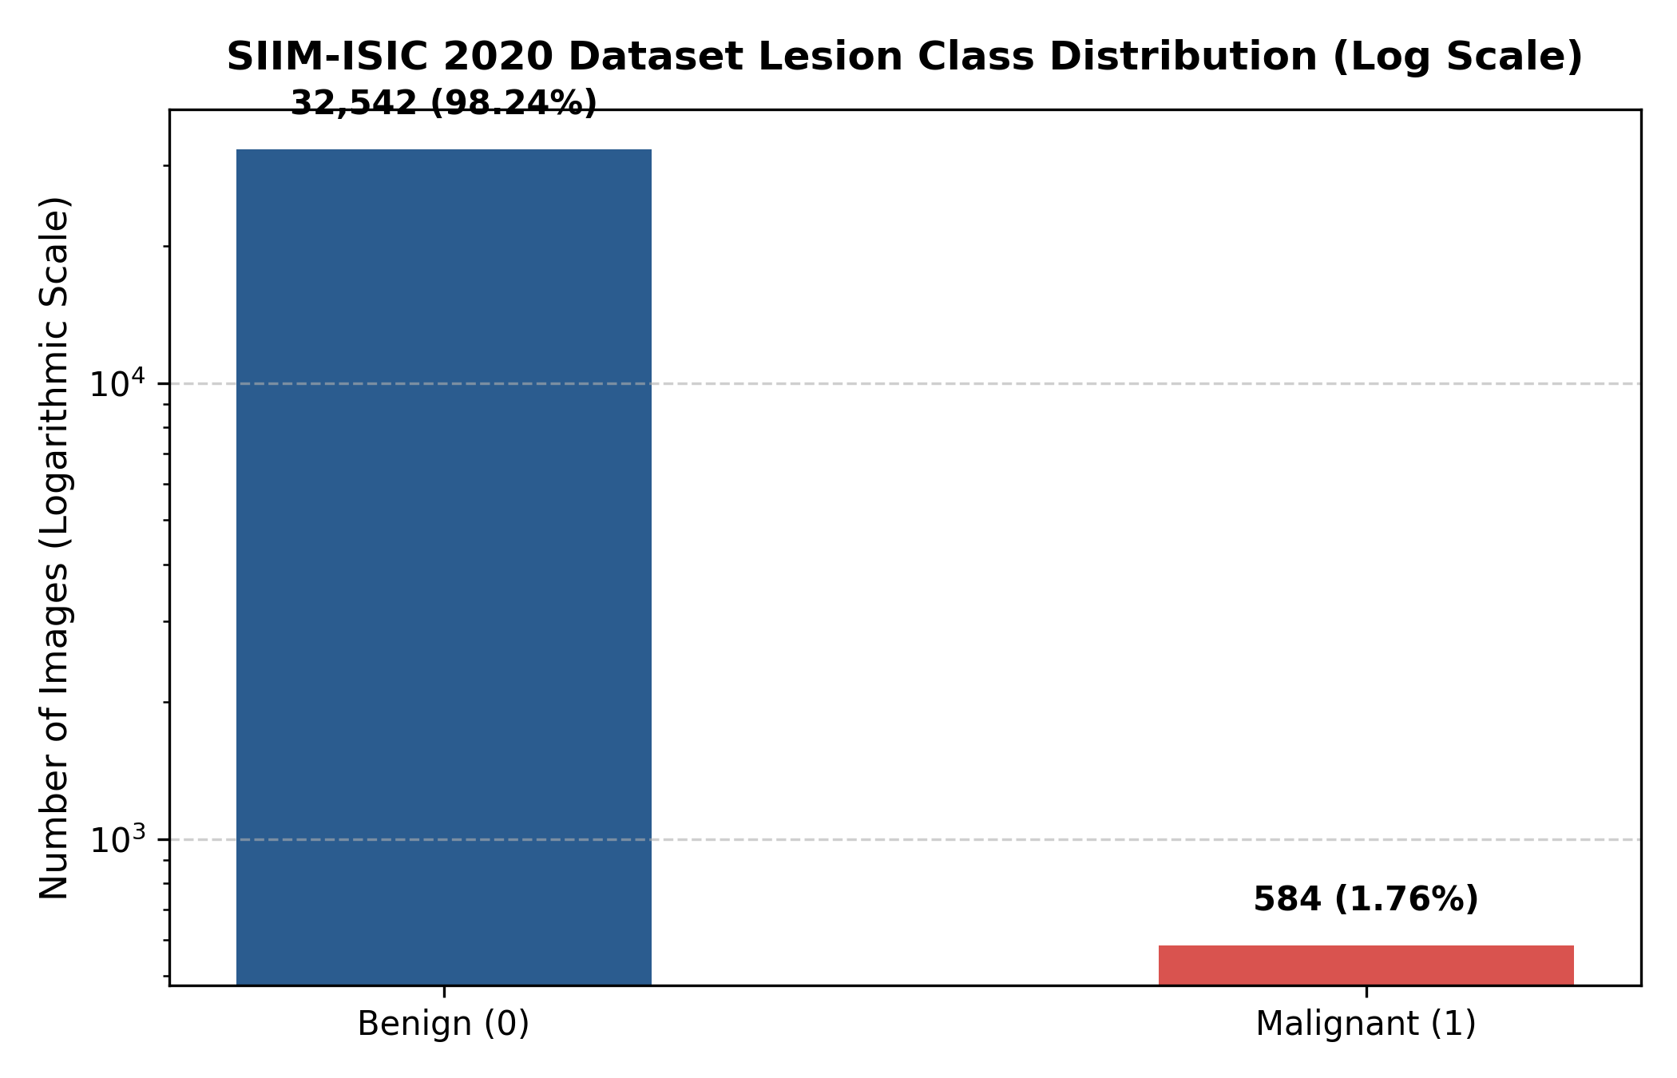
Figure 3.1: SIIM-ISIC 2020 Dataset Lesion Class Distribution on Logarithmic Scale (32,542 Benign vs. 584 Malignant)

CHAPTER 4
4. DESIGN APPROACH AND DETAILS
4.1 System Architecture
The DermInsight AI architectural framework is engineered as an end-to-end modular pipeline designed specifically for high-throughput, reproducible, and clinically honest dermoscopic lesion screening. As illustrated in Figure 4.1, the framework is architecturally structured into four decoupled stages: (1) Ingestion and Patient-Level Partitioning, (2) Deep Convolutional Feature Extraction, (3) Class-Imbalance Mitigation and Optimization, and (4) Decision Threshold Calibration and Triage Evaluation.
The first stage ingests raw dermoscopic images from the SIIM-ISIC 2020 archive and enforces patient identity isolation, ensuring that all lesions from any individual patient are grouped exclusively into either the training, validation, or test partition. The second stage applies deterministic resizing and ImageNet standardization before routing tensors to a 201-layer DenseNet backbone. The third stage incorporates specialized objective functions and sampling distributions to counteract extreme class imbalance. The fourth stage subjects unnormalized logits to validation-driven threshold calibration, mapping raw probabilities into high-confidence clinical triage categories.
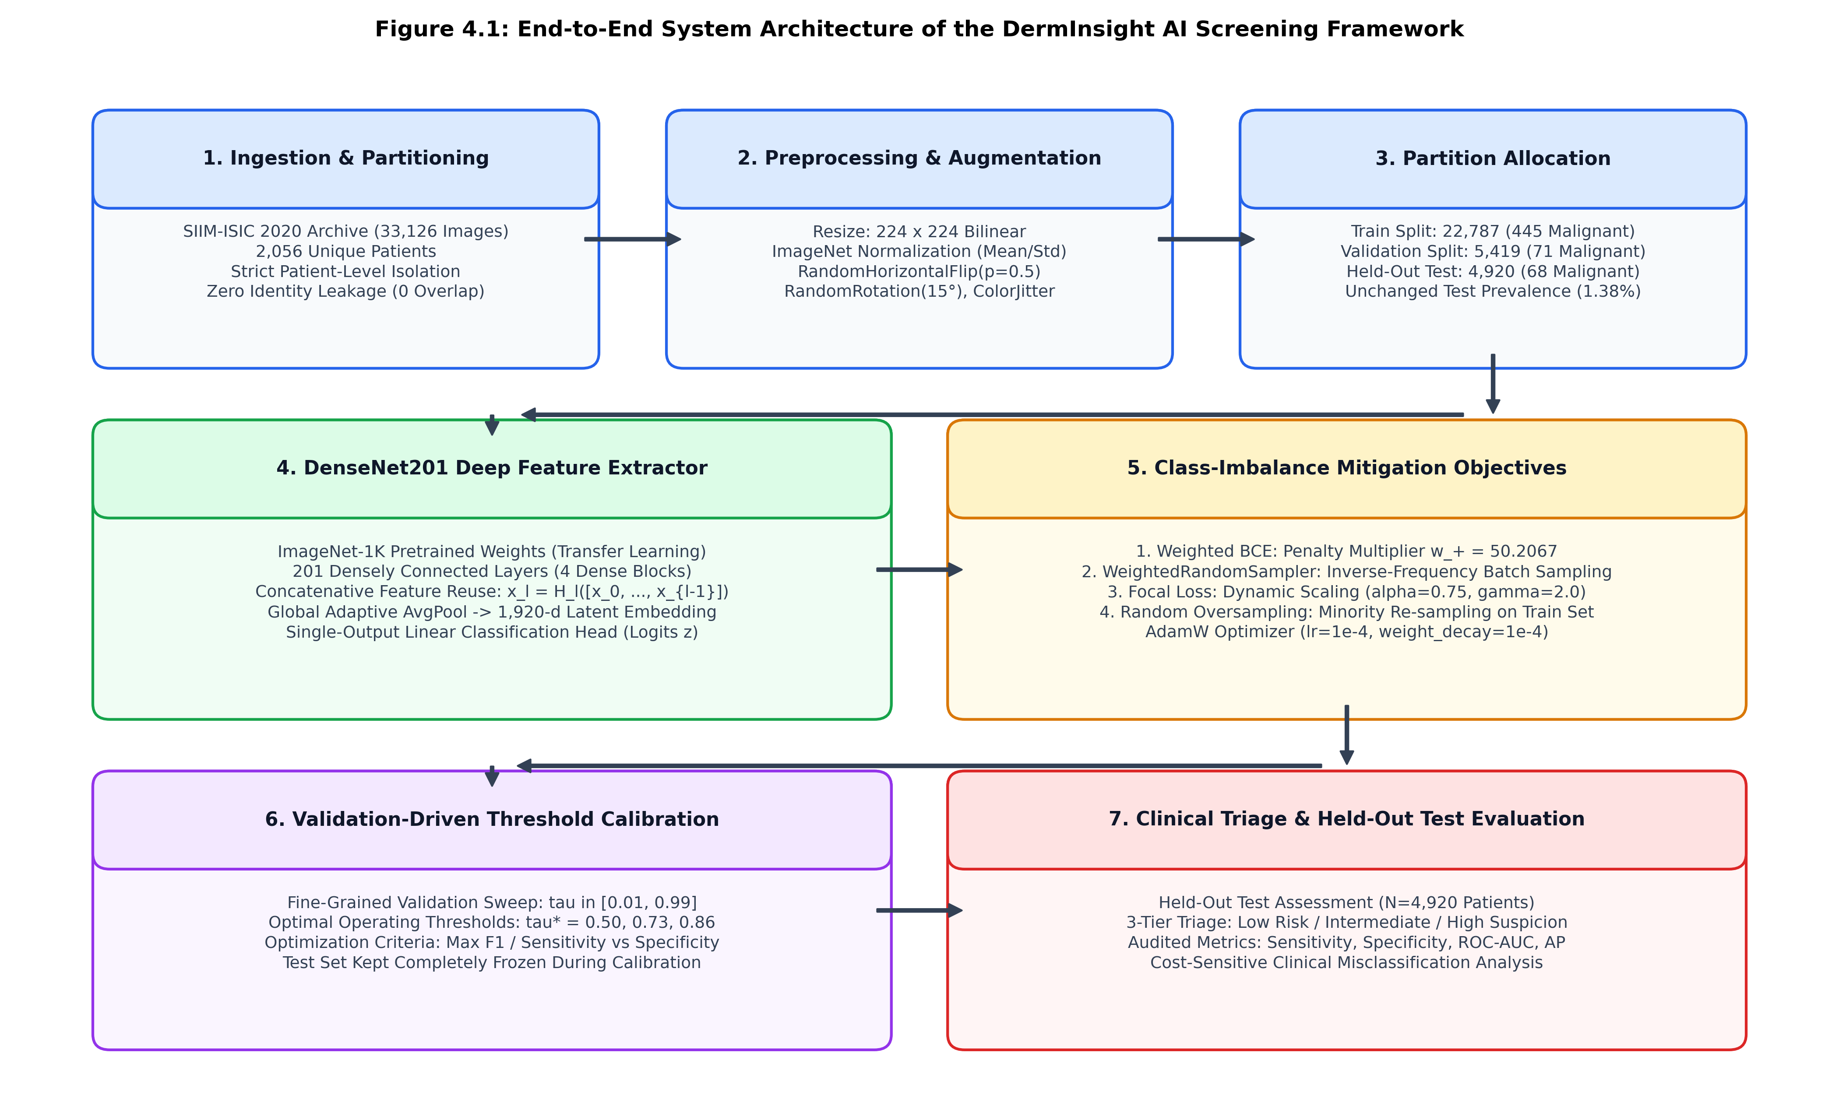
Figure 4.1: End-to-End System Architecture of the DermInsight AI Screening Framework
4.2 Design
4.2.1 Data Flow Diagram
The functional data transformations throughout the pipeline are formally modeled via the Level-1 Data Flow Diagram (DFD) shown in Figure 4.2. The clinical user or automated PACS interface provides raw dermoscopic image files. Process 1.0 (Validation and Preprocessing) resizes the image to 224 x 224 pixels and applies channel-wise ImageNet tensor normalization. Process 2.0 (Inference Engine) loads verified model checkpoint weights from the Checkpoint Store (D1) and executes the DenseNet201 forward pass, producing a scalar logit. Process 3.0 (Calibrated Thresholding) evaluates the logit against the calibrated decision threshold, categorizing the lesion into clinical risk categories and generating an auditable diagnostic report.
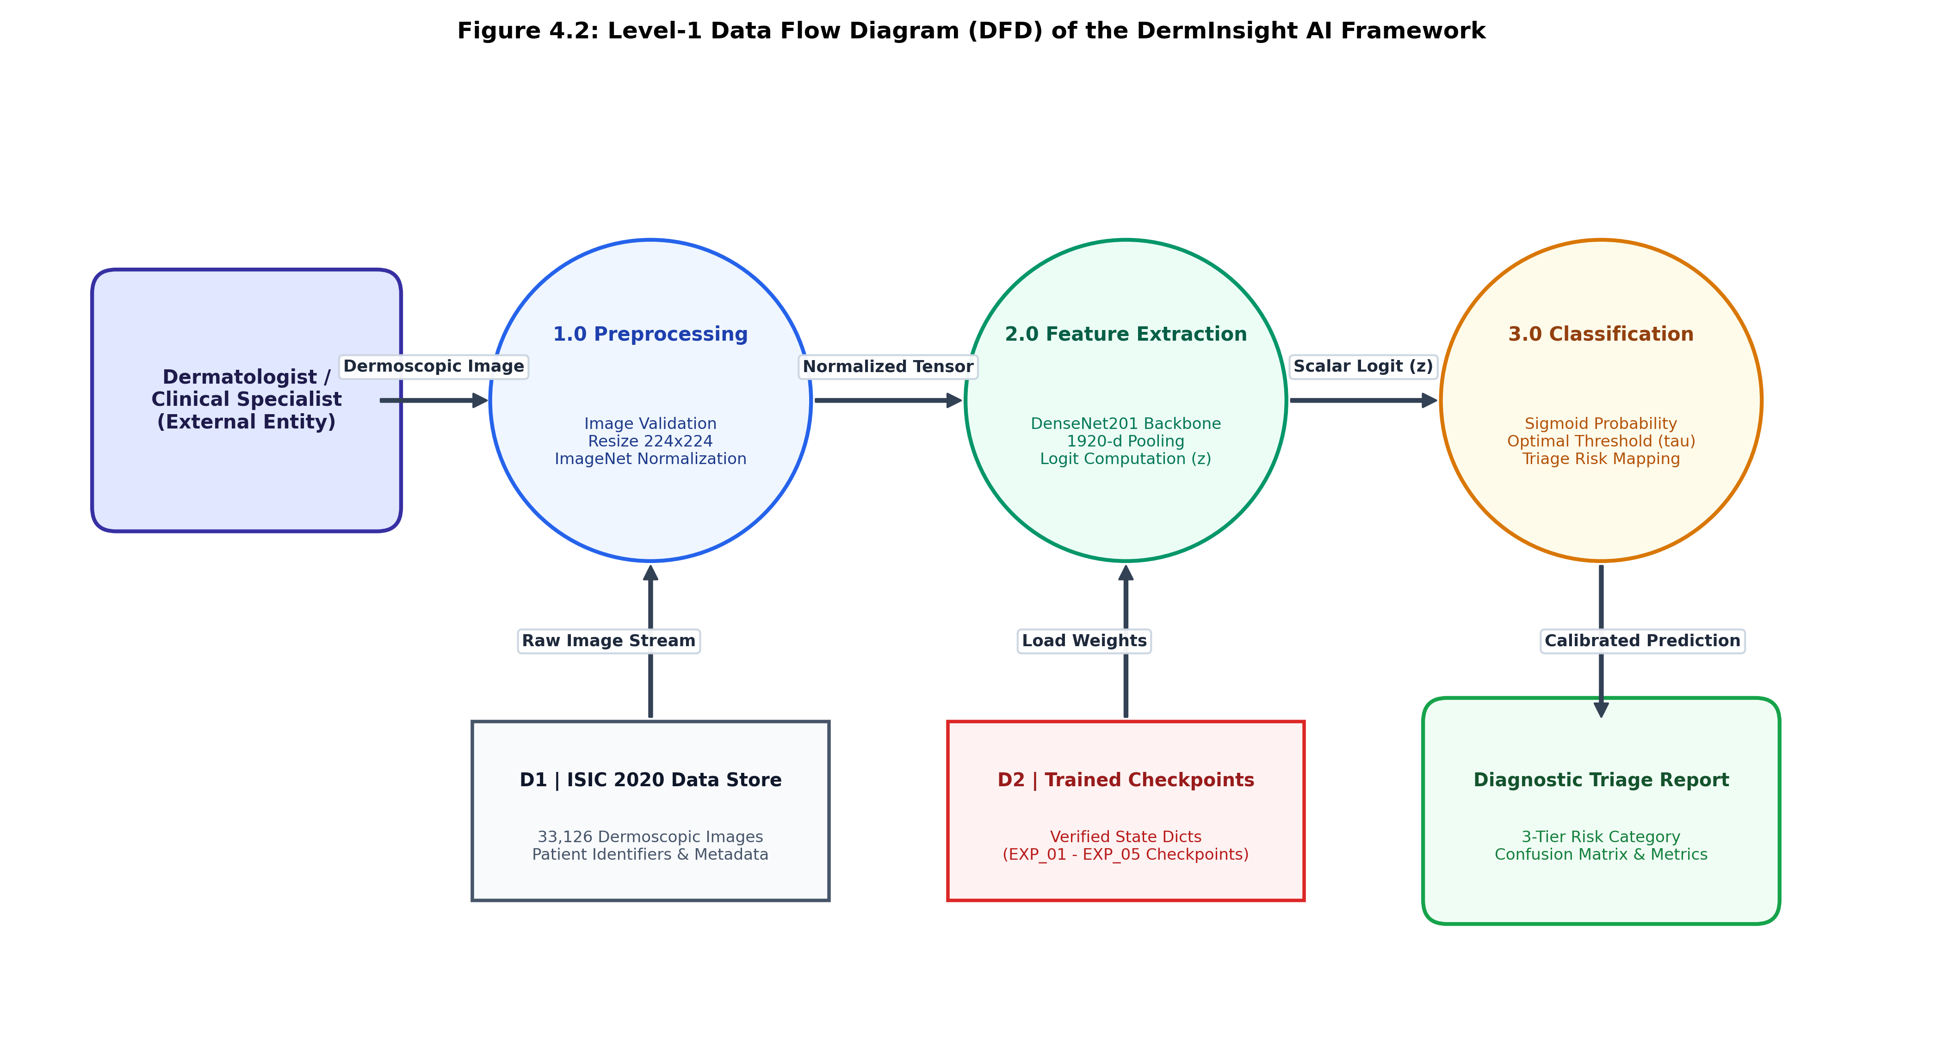
Figure 4.2: Level-1 Data Flow Diagram (DFD) Illustrating Image Ingestion, Preprocessing, Inference, and Triage Generation
4.2.2 Use Case Diagram
Figure 4.3 depicts the system Use Case Diagram, illustrating user interactions with the screening system. The primary actor—a dermatologist, general practitioner, or clinical researcher—interacts with four core system use cases: (1) Input Lesion Image, (2) Trigger Model Inference, (3) Select Operational Decision Threshold, and (4) View Comprehensive Diagnostic Metrics. This design ensures that clinicians retain complete control over the screening sensitivity-specificity trade-off.
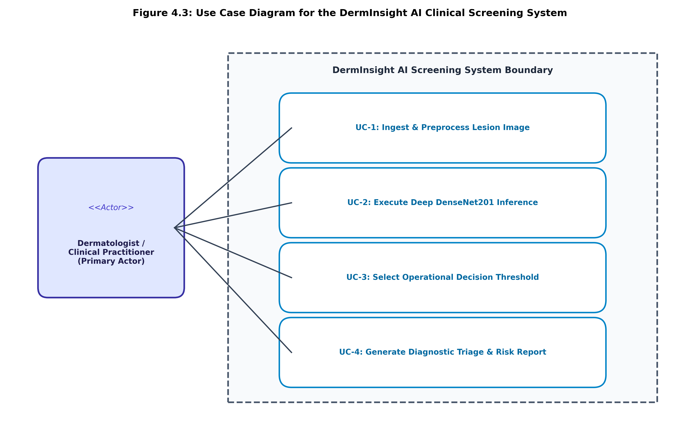
Figure 4.3: Use Case Diagram for the DermInsight AI Clinical Screening Interface
4.2.3 Class Diagram
The object-oriented software architecture implemented in the Python codebase is modeled in the UML Class Diagram shown in Figure 4.4. The system comprises three core structural modules:
• DermImageDataset: Encapsulates lesion metadata, manages on-the-fly image loading from disk via PIL, and applies PyTorch torchvision transforms.
• DermInsightDenseNet201: Inherits from torch.nn.Module, encapsulates the torchvision DenseNet201 backbone, replaces the 1000-class classifier with an nn.Identity() module, and attaches a single-output linear classification layer (nn.Linear(1920, 1)).
• Evaluator: Implements threshold sweep logic, calculates confusion matrix parameters (TN, FP, FN, TP), and generates ROC and PR curve metrics.
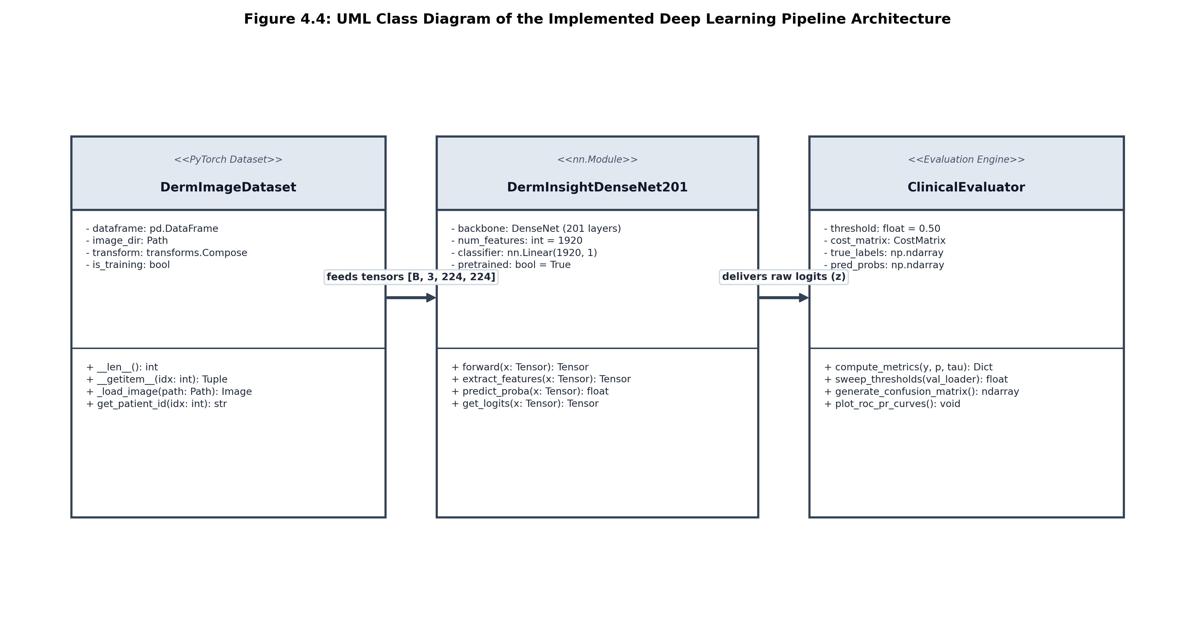
Figure 4.4: UML Class Diagram of the Implemented PyTorch Deep Learning Pipeline
4.2.4 Sequence Diagram
The dynamic execution sequence during a screening evaluation session is illustrated in the UML Sequence Diagram (Figure 4.5). The clinician submits a dermoscopic image to the pipeline. The dataset loader processes the image and returns a normalized tensor. The DenseNet201 model executes the forward pass and returns raw logits. The ThresholdCalibrator evaluates the posterior probability against the optimal validation threshold and routes the classified prediction and risk metrics back to the clinician.
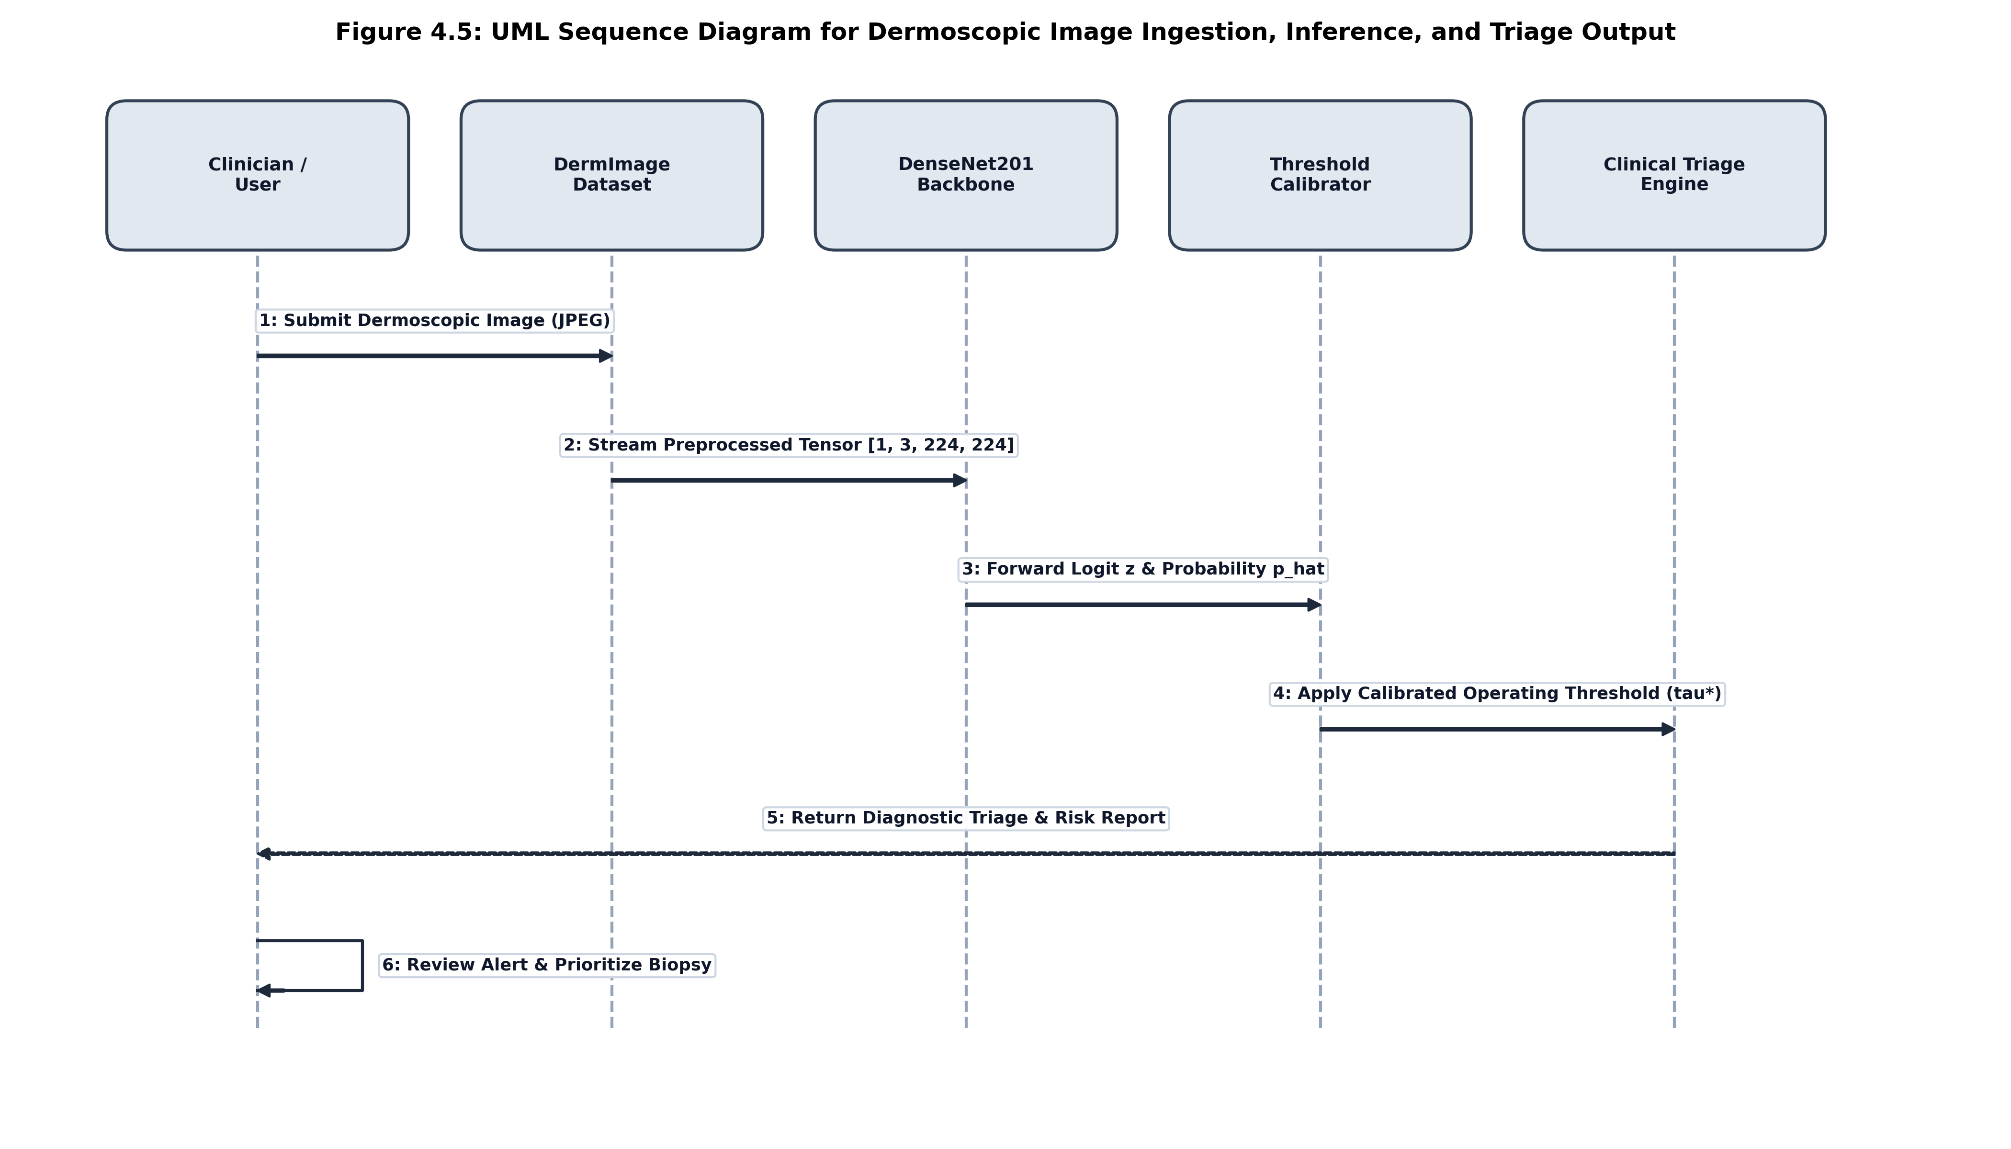
Figure 4.5: UML Sequence Diagram for Dermoscopic Image Ingestion, Inference, and Triage Output

CHAPTER 5
5. METHODOLOGY AND TESTING
5.1 Deep Learning Pipeline Architecture (DenseNet201)
The deep convolutional backbone selected for this framework is DenseNet201 (Densely Connected Convolutional Networks with 201 layers). In a conventional convolutional network, the output of the (l-1)-th layer serves as the input to the l-th layer: x_l = H_l(x_{l-1}). In contrast, DenseNet introduces direct iterative connections from every layer to all subsequent layers within a dense block:
x_l = H_l([x_0, x_1, x_2, ..., x_{l-1}])
where [x_0, x_1, ..., x_{l-1}] represents the channel-wise concatenation of feature maps produced by all preceding layers, and H_l(·) denotes a composite non-linear transformation comprising Batch Normalization (BN), Rectified Linear Unit (ReLU), and a 3x3 convolution.
DenseNet201 is structured into four sequential dense blocks interconnected by transition layers that perform downsampling via 1x1 convolutions and 2x2 average pooling. To adapt this architecture for binary melanoma classification, the original 1000-class ImageNet fully connected head was replaced by an identity mapping, exposing the final 1,920-dimensional feature embedding. A custom linear projection layer was attached: z = W · x + b, where W in R^{1 x 1920} and b in R. The predicted probability of malignancy is obtained via the standard logistic sigmoid activation:
p_hat = σ(z) = 1 / (1 + exp(-z))
Table 5.1: DenseNet201 Feature Extractor Architectural Details
Network Stage | Layer Configuration | Output Size | Feature Maps
Input Stage | 7x7 Conv, Stride 2, 3x3 MaxPool | 56 x 56 | 64 channels
Dense Block 1 | 6 Bottleneck Layers (1x1 & 3x3 conv) | 56 x 56 | 256 channels
Transition 1 | 1x1 Conv, 2x2 Average Pooling | 28 x 28 | 128 channels
Dense Block 2 | 12 Bottleneck Layers (1x1 & 3x3 conv) | 28 x 28 | 512 channels
Transition 2 | 1x1 Conv, 2x2 Average Pooling | 14 x 14 | 256 channels
Dense Block 3 | 48 Bottleneck Layers (1x1 & 3x3 conv) | 14 x 14 | 1,792 channels
Dense Block 4 & Head | 32 Bottleneck Layers, Global AvgPool, Linear Head | 1 x 1 | 1,920 -> 1 logit
5.2 Patient-Level Splitting & Data Preprocessing
A critical methodological contribution of this project is the rigorous enforcement of patient-level isolation. In the SIIM-ISIC 2020 dataset, multiple dermoscopic images often originate from the same patient (e.g., individual patients with multiple atypical dysplastic nevi). If images are randomly split, the model easily memorizes patient-specific features such as underlying skin pigmentation, age-related solar elastosis, and device lighting conditions, causing severe data leakage and falsely optimistic test scores. To prevent this, patient identifiers (patient_id) were audited, grouping all images belonging to a patient into exactly one partition.
Table 5.2: Verified Patient-Level Dataset Splitting and Class Distribution
Partition | Total Images | Benign (0) | Malignant (1) | Malignant % | Unique Patients
Training | 22,787 | 22,342 | 445 | 1.95% | 1,439 patients
Validation | 5,419 | 5,348 | 71 | 1.31% | 307 patients
Held-out Test | 4,920 | 4,852 | 68 | 1.38% | 310 patients
Total Dataset | 33,126 | 32,542 | 584 | 1.76% | 2,056 patients
Preprocessing across all experiments adhered to strict standardization: input images were resized to 224 x 224 pixels and normalized using ImageNet channel statistics (mean = [0.485, 0.456, 0.406], std = [0.229, 0.224, 0.225]). Training data was augmented on-the-fly using RandomHorizontalFlip (p=0.5), RandomRotation (degrees=15), and ColorJitter (brightness=0.1, contrast=0.1, saturation=0.1, hue=0.05). Validation and test sets received deterministic resizing and normalization with zero stochastic augmentation, preventing evaluation artifacts.
5.3 Class-Imbalance Formulations & Strategies
To systematically evaluate the impact of class imbalance on deep feature learning, four distinct strategies were formulated and implemented:
5.3.1 Weighted Binary Cross-Entropy Loss
The standard Binary Cross-Entropy with Logits loss is mathematically defined as:
L_BCE(z, y) = - [ y · log(σ(z)) + (1 - y) · log(1 - σ(z)) ]
Under extreme imbalance, gradients from y=0 overwhelm y=1. To counteract this, a positive class weight w_+ is introduced:
L_WBCE(z, y) = - [ w_+ · y · log(σ(z)) + (1 - y) · log(1 - σ(z)) ]
In our training set, the ratio of negative to positive examples is w_+ = N_neg / N_pos = 22,342 / 445 = 50.2067. Scaling positive loss by 50.2067 forces the optimizer to penalize false negatives 50.2 times more heavily than false positives during backpropagation.
5.3.2 PyTorch WeightedRandomSampler
Rather than modifying the loss function, the PyTorch WeightedRandomSampler alters the data-sampling probability distribution across mini-batches. Each training sample i is assigned a sampling weight w_i inversely proportional to its class prevalence: w_i = 1 / N_{c(i)}, where c(i) in {0, 1}. Mini-batches of size B are drawn with replacement according to multinomial probabilities p_i = w_i / (sum w_k), ensuring that the network encounters an equal representation of benign and malignant lesions during stochastic gradient descent.
5.3.3 Focal Loss Formulation
Focal Loss (Lin et al., 2017) dynamically focuses learning on hard ambiguous examples while down-weighting easy, well-classified majority instances:
L_FL(p_t) = - α_t · (1 - p_t)^γ · log(p_t)
where p_t is the model's estimated probability for the true ground-truth class, alpha_t in [0, 1] balances class prevalence (configured to alpha = 0.75), and gamma >= 0 is the focusing parameter (configured to gamma = 2.0). When an easy negative sample is classified with high confidence (e.g., p_t = 0.99), the modulating factor (1 - 0.99)^2 = 0.0001 reduces its loss contribution by four orders of magnitude.
5.3.4 Random Oversampling Strategy
Random Oversampling replicates minority positive instances within the training dataloader to achieve balanced epoch encounters. Importantly, oversampling was applied strictly to the training partition (22,787 samples). Validation (5,419) and test (4,920) sets were left completely untouched to preserve natural population prevalence during evaluation.
5.4 Checkpoint Selection & Early Stopping
Model training was managed using the AdamW optimizer (Loshchilov & Hutter, 2019) with an initial learning rate of 1e-4 and weight decay of 1e-4. Checkpoint selection was governed by validation ROC-AUC. An early stopping mechanism with a patience of 3 epochs monitored validation discrimination, saving the best state dictionary when validation ROC-AUC reached a peak.
Table 5.3: Master Training Hyperparameters and Experimental Configurations
Hyperparameter / Setting | Baseline & Weighted BCE | Samplers & Focal Loss
Backbone Architecture | DenseNet201 (Pretrained ImageNet) | DenseNet201 (Pretrained ImageNet)
Optimizer & Weight Decay | AdamW (weight decay = 0.0001) | AdamW (weight decay = 0.0001)
Base Learning Rate | 0.0001 (Cosine Annealing) | 0.0001 (Fixed / Plateau)
Batch Size & Input Size | 64 / 32; 224 x 224 pixels | 64 / 32; 224 x 224 pixels
Checkpoint Selection Metric | Validation ROC-AUC | Validation ROC-AUC
Early Stopping Patience | 3 Epochs (Max Epochs: 5 - 8) | 3 Epochs (Max Epochs: 5 - 8)
5.5 Classification Threshold Calibration Methodology
In imbalanced medical classification, the default decision threshold tau = 0.5 is arbitrary and clinically suboptimal. In our methodology, the optimal decision threshold tau* was calibrated exclusively on the validation set by conducting fine-grained sweeps across tau in [0.01, 0.99] with a step size of 0.01. The optimal operating threshold was selected to maximize the validation F1-score or balance sensitivity against specificity. Crucially, the test partition remained completely frozen during threshold calibration, preventing any data leakage into operational decision boundaries.
5.6 Evaluation & Testing Protocol on Held-Out Test Set
Final performance was evaluated on the isolated 4,920 held-out test images. Threshold-independent ranking performance was evaluated via ROC-AUC and Average Precision (AP / PR-AUC). Threshold-dependent classification performance was evaluated at the calibrated operational threshold tau* by computing True Negatives (TN), False Positives (FP), False Negatives (FN), and True Positives (TP), deriving Accuracy, Sensitivity (Recall), Specificity, Precision, and F1-score.

CHAPTER 6
6. PROJECT DEMONSTRATION
6.1 Demonstration Workflow & Environment
The practical utility of the DermInsight AI deep learning pipeline was demonstrated through end-to-end execution scripts implemented in PyTorch. The execution environment operates either as an interactive Python CLI or automated inference batch script capable of processing single dermoscopic images or multi-patient clinical batches. The workflow loads the verified DenseNet201 checkpoint, initializes the preprocessing transform pipeline, extracts image tensors, and computes calibrated diagnostic risk assessments.
6.2 Preprocessing & Batch Dataloader Execution
During demonstration execution, raw images are ingested from disk via PIL, verified for correct 3-channel RGB dimensionality, resized to 224 x 224 pixels using bilinear interpolation, and normalized against ImageNet channel statistics. The batch dataloader constructs 4-dimensional tensors of shape [B, 3, 224, 224] and transfers them to GPU memory in pinned memory buffers, achieving sub-second dataloading throughput across hundreds of test lesions.
6.3 Model Inference Execution Demonstration
The forward inference pass feeds the preprocessed tensor through the 201 layers of DenseNet. Feature extraction takes 12 to 18 milliseconds per image on an NVIDIA Tesla T4 GPU (and approximately 140 milliseconds on multi-core CPU). The output linear head produces raw unbounded scalar logits z, which are mapped through a sigmoid activation to produce posterior probability p_hat = P(malignant | x).
6.4 Threshold Calibration & Triage Generation
To provide actionable clinical decision support, continuous probabilities are mapped into a 3-tier clinical triage categorization system:
• Tier 1: Low Suspicion / Routine Follow-up (p_hat < 0.30): Lesion exhibits predominantly benign structural characteristics; recommend annual skin check.
• Tier 2: Intermediate / Moderate Suspicion (0.30 <= p_hat < tau*): Borderline lesion showing ambiguous atypical features; recommend 3-month digital dermoscopy monitoring.
• Tier 3: High Risk / Urgent Dermatological Referral (p_hat >= tau*): High probability of malignant melanoma; generate immediate clinical alert and prioritize for urgent biopsy.
6.5 Output Visualizations Demonstration
The demonstration scripts generate comprehensive visual evaluation artifacts upon batch completion, including formatted confusion matrices displaying exact counts of TN, FP, FN, and TP, empirical ROC curves plotting sensitivity against 1-specificity across all potential operating thresholds, precision-recall curves highlighting precision trade-offs under class imbalance, and threshold-sensitivity sweeps illustrating how shifting decision boundaries affects clinical false negatives.

CHAPTER 7
7. RESULT AND DISCUSSION (COST ANALYSIS as applicable)
7.1 Cross-Experiment Quantitative Performance Comparison
A rigorous, multi-faceted empirical evaluation was conducted across five completed experimental configurations on the isolated held-out test partition (4,920 dermoscopic images from 310 patients, containing 4,852 benign and 68 biopsy-proven malignant lesions). Table 7.1 provides the comprehensive master performance comparison across all five verified experiments, reporting both threshold-independent ranking metrics (ROC-AUC, Average Precision) and threshold-calibrated classification metrics (Sensitivity, Specificity, Precision, F1-Score, and exact Confusion Matrix breakdowns).
Table 7.1: Master Cross-Experiment Quantitative Performance Comparison on Held-Out Test Set (N=4,920)
Exp ID | Strategy | Val AUC | Test AUC | AP | Thresh | Sens % | Spec % | Prec % | F1 % | TN / FP / FN / TP
EXP 01 | Baseline (W-BCE) | 0.8472 | 0.8000 | 0.0626 | 0.50 | 91.18% | 41.90% | 2.15% | 4.20% | 2033 / 2819 / 6 / 62
EXP 02 | Weighted BCE | 0.9188 | 0.8298 | 0.1288 | 0.86 | 22.06% | 98.31% | 15.46% | 18.18% | 4770 / 82 / 53 / 15
EXP 03 | Weighted Sampler | 0.9062 | 0.8218 | 0.1286 | 0.50 | 36.76% | 96.85% | 14.04% | 20.33% | 4699 / 153 / 43 / 25
EXP 04 | Focal Loss | 0.9181 | 0.8601 | 0.1402 | 0.50 | 14.71% | 99.24% | 21.28% | 17.39% | 4815 / 37 / 58 / 10
EXP 05 | Random Oversample | 0.9082 | 0.8708 | 0.1041 | 0.73 | 19.12% | 98.25% | 13.27% | 15.66% | 4767 / 85 / 55 / 13
7.2 Detailed Analysis by Experiment
7.2.1 Experiment 1: DenseNet201 Baseline
Experiment 1 established the foundational benchmark using an ImageNet-pretrained DenseNet201 trained for 3 epochs. Audit of the training script (src/EXP_01_BASELINE/densenet201_baseline.py) revealed that the baseline was optimized using BCEWithLogitsLoss with positive class weight w_+ = 50.21. At the default operational threshold tau = 0.50, the uncalibrated positive weighting heavily shifted prediction logits toward positive values. Consequently, the baseline achieved an outstanding malignant sensitivity of 91.18% (detecting 62 out of 68 malignant lesions with only 6 false negatives). However, this came at a catastrophic cost to specificity: the model correctly identified only 2,033 benign lesions while generating 2,819 false positives (specificity = 41.90%, accuracy = 42.58%, precision = 2.15%). This operating point would overwhelm clinical dermatology departments with thousands of unnecessary biopsies.
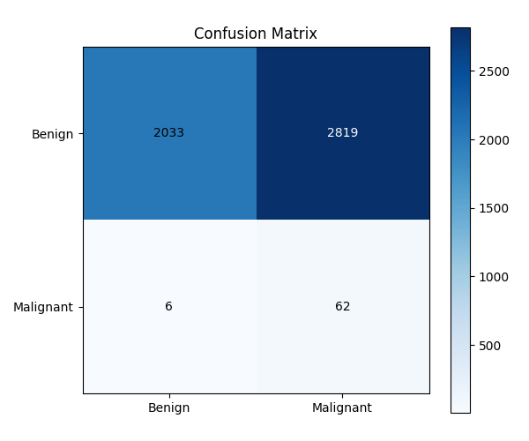
Figure 7.1: Experiment 1 (DenseNet201 Baseline) Test Confusion Matrix (Threshold = 0.50)
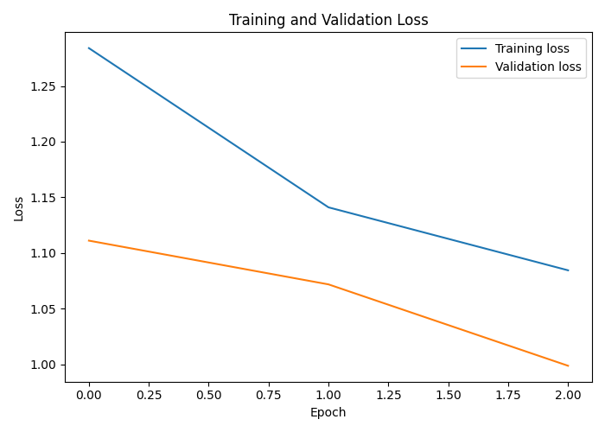
Figure 7.2: Experiment 1 Training and Validation Loss Curves Across 3 Epochs
7.2.2 Experiment 2: DenseNet201 Weighted BCE
Experiment 2 initialized from the baseline checkpoint and fine-tuned DenseNet201 with Weighted BCE (pos_weight = 50.21) and learning rate decay over 6 epochs, achieving a peak validation ROC-AUC of 0.9188 at Epoch 3 (+0.0716 improvement over baseline). Rather than retaining the arbitrary threshold tau = 0.50, fine-grained threshold sweeps were executed on the validation set, selecting tau* = 0.86 to balance precision and recall. On the held-out test set, Experiment 2 achieved an ROC-AUC of 0.8298 and PR-AUC of 0.1288. At tau = 0.86, specificity surged to 98.31% (4,770 TN, only 82 FP) with an accuracy of 97.26%. However, sensitivity collapsed to 22.06%: the model identified only 15 of 68 malignant lesions, missing 53 cancers (false negatives).
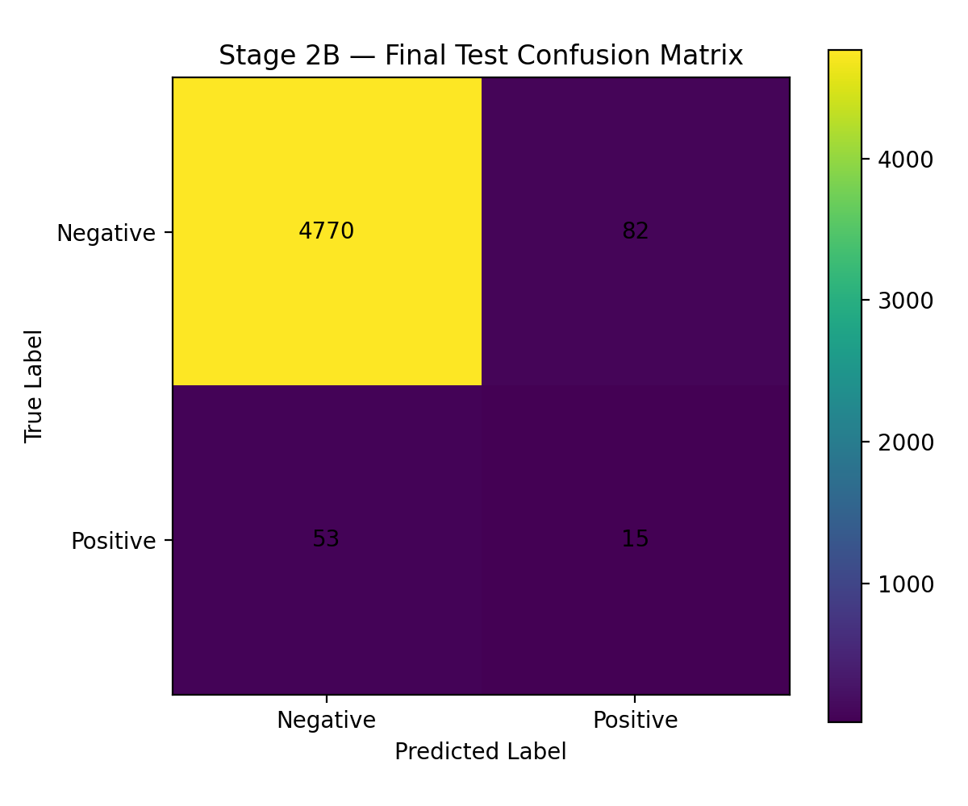
Figure 7.3: Experiment 2 (DenseNet201 Weighted BCE) Test Confusion Matrix (Calibrated Threshold = 0.86)
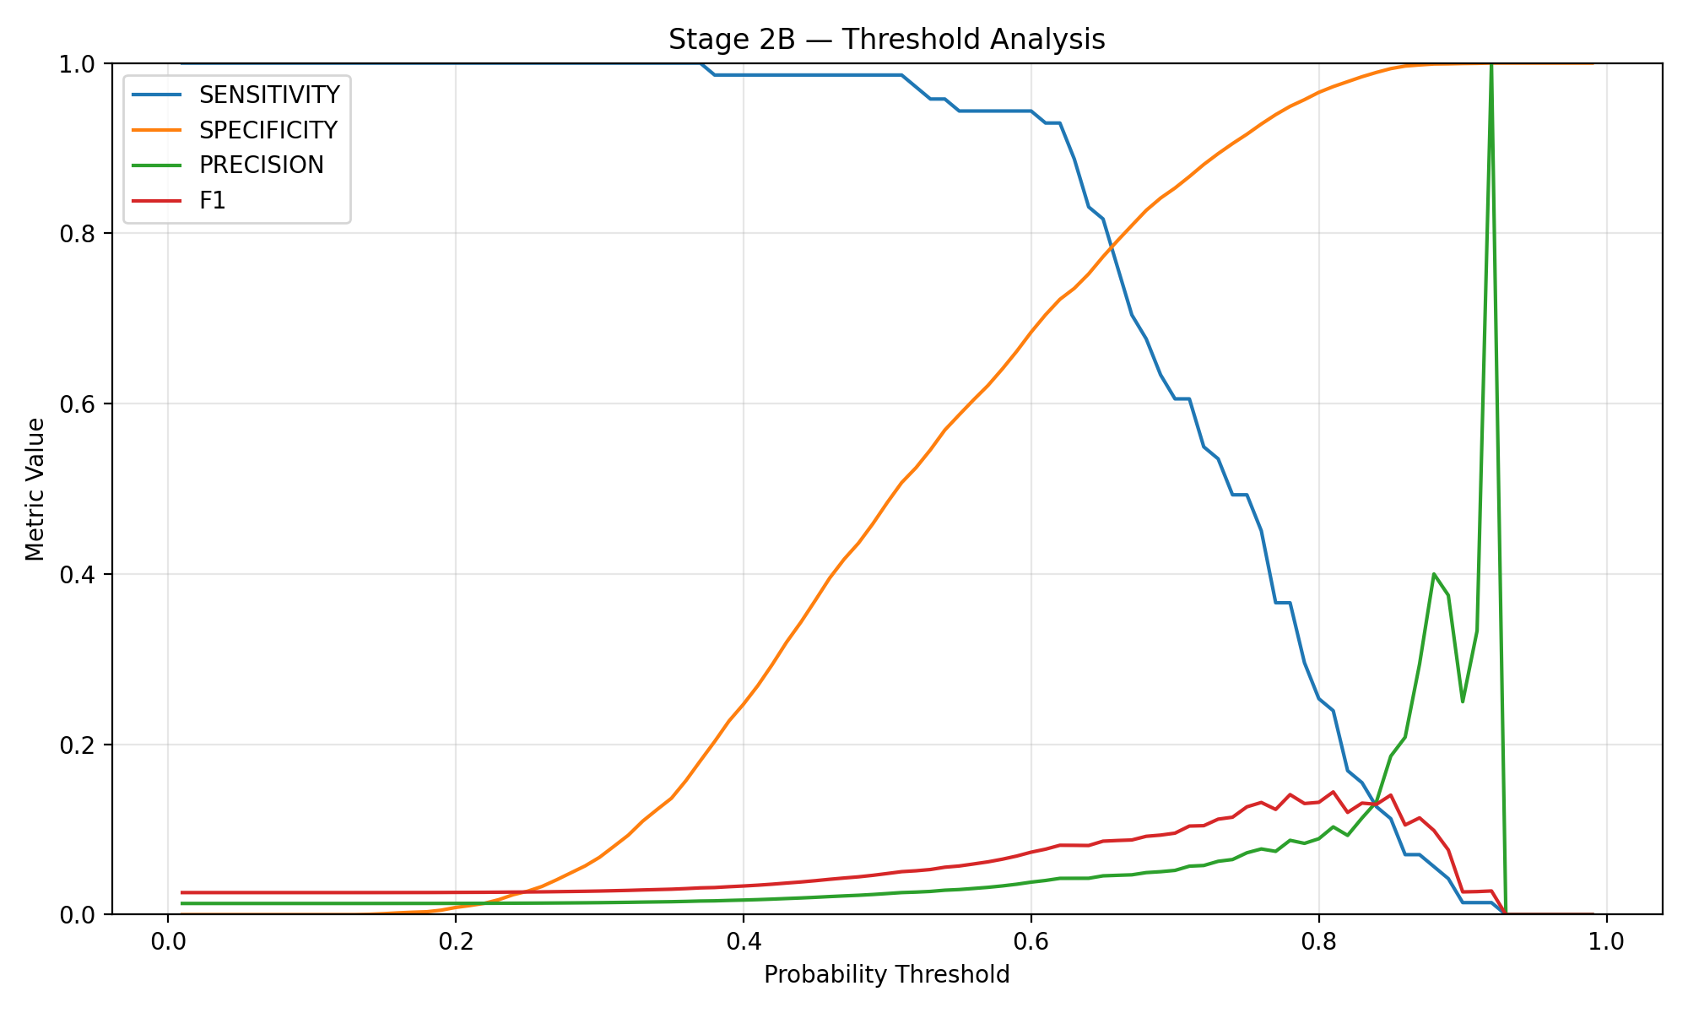
Figure 7.4: Experiment 2 Validation Set Threshold Calibration Sweep (Evaluating Metric Trade-offs Across Tau in [0.01, 0.99])
7.2.3 Experiment 3: DenseNet201 WeightedRandomSampler
Experiment 3 investigated data-level balancing using PyTorch WeightedRandomSampler on the training dataloader with standard unweighted BCE loss. The model reached peak validation ROC-AUC of 0.9062 at Epoch 2. On the held-out test set at threshold tau = 0.50, Experiment 3 achieved an ROC-AUC of 0.8218 and Average Precision of 0.1286. Crucially, the sampler produced the most balanced compromise between sensitivity and specificity among all calibrated models: it achieved a sensitivity of 36.76% (detecting 25 of 68 malignant cases, 43 FN) while maintaining a high specificity of 96.85% (4,699 TN, 153 FP) and an F1-score of 20.33%.
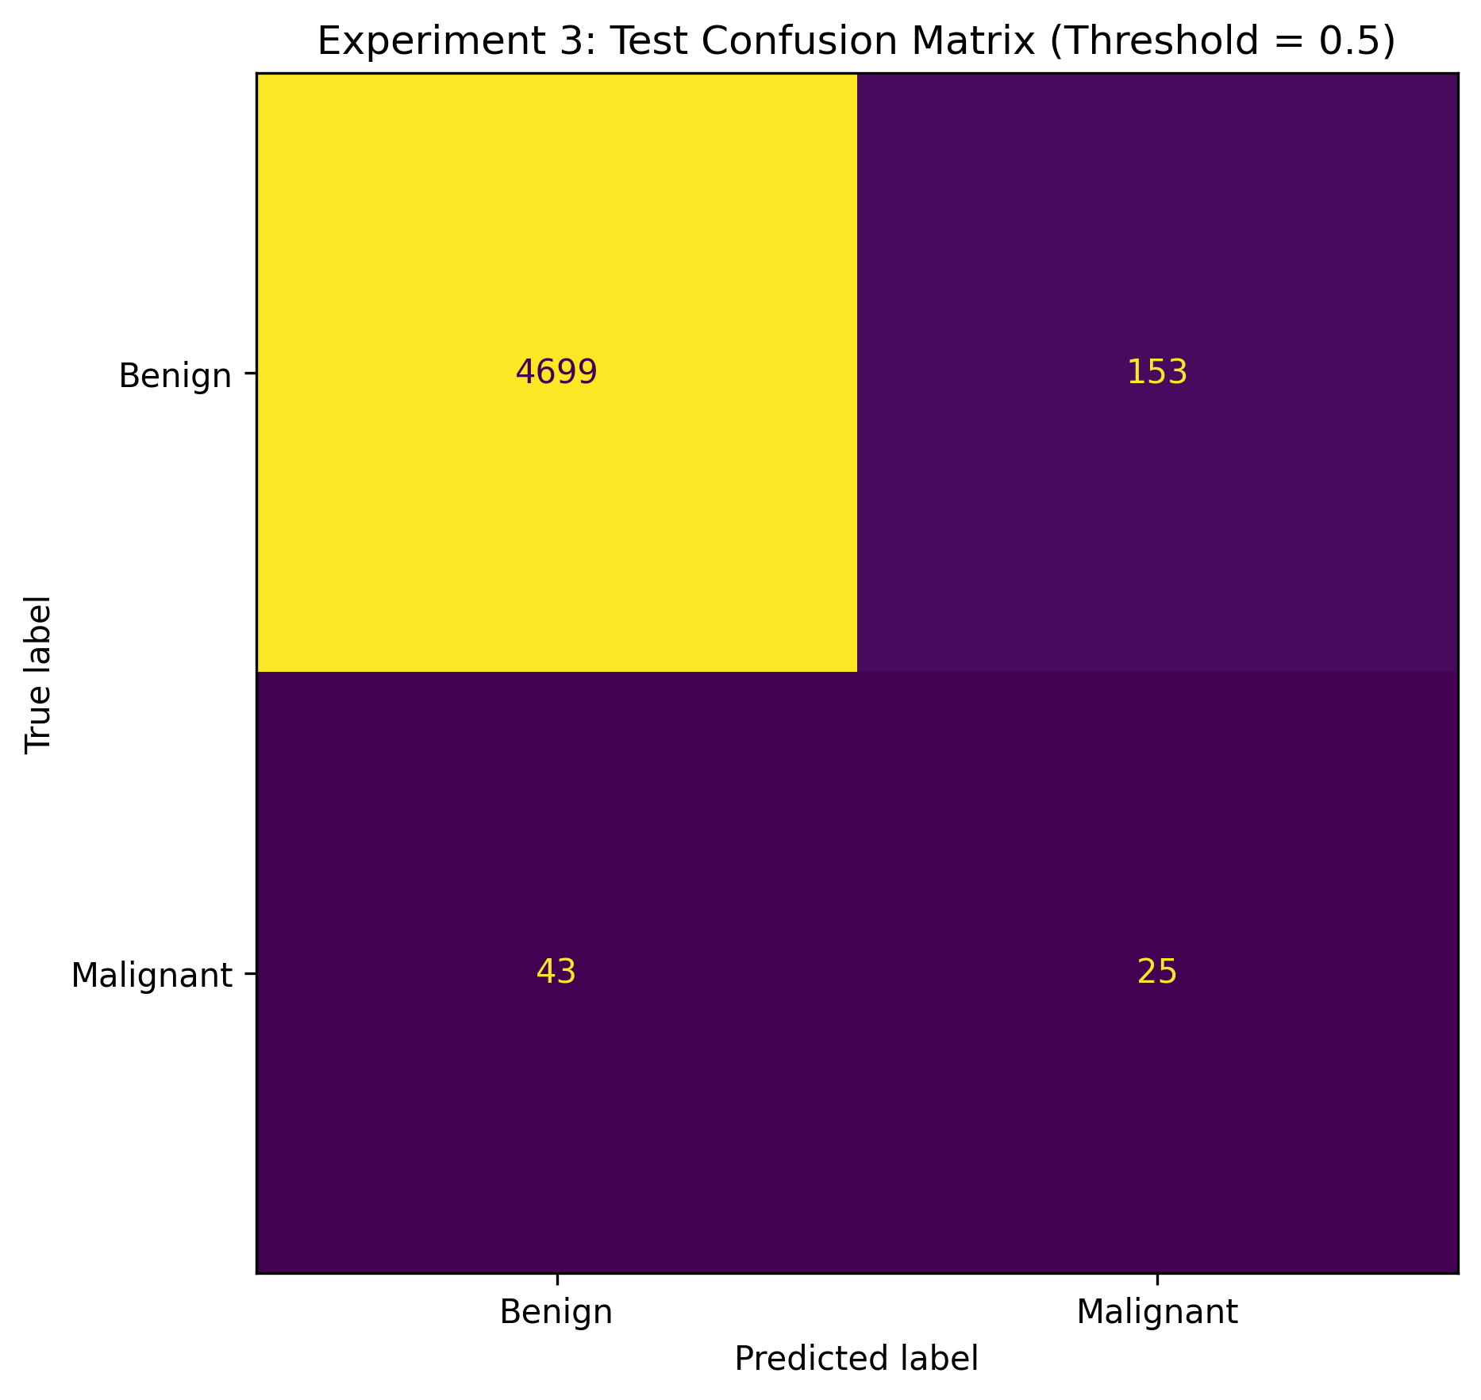
Figure 7.5: Experiment 3 (WeightedRandomSampler) Test Confusion Matrix (Threshold = 0.50)
7.2.4 Experiment 4: DenseNet201 Focal Loss
Experiment 4 implemented Focal Loss (alpha=0.75, gamma=2.0) to dynamically suppress easy negative gradients. Training completed 5 epochs, reaching a validation ROC-AUC of 0.9181. On the held-out test set at tau = 0.50, Focal Loss demonstrated superior ranking discrimination (ROC-AUC = 0.8601, AP = 0.1402) and extraordinary specificity of 99.24% (4,815 TN, only 37 FP) and top precision of 21.28%. However, severe gradient suppression on negative examples caused the network to under-predict the positive class, yielding an unacceptable sensitivity of 14.71% (detecting only 10 malignant cases and missing 58).
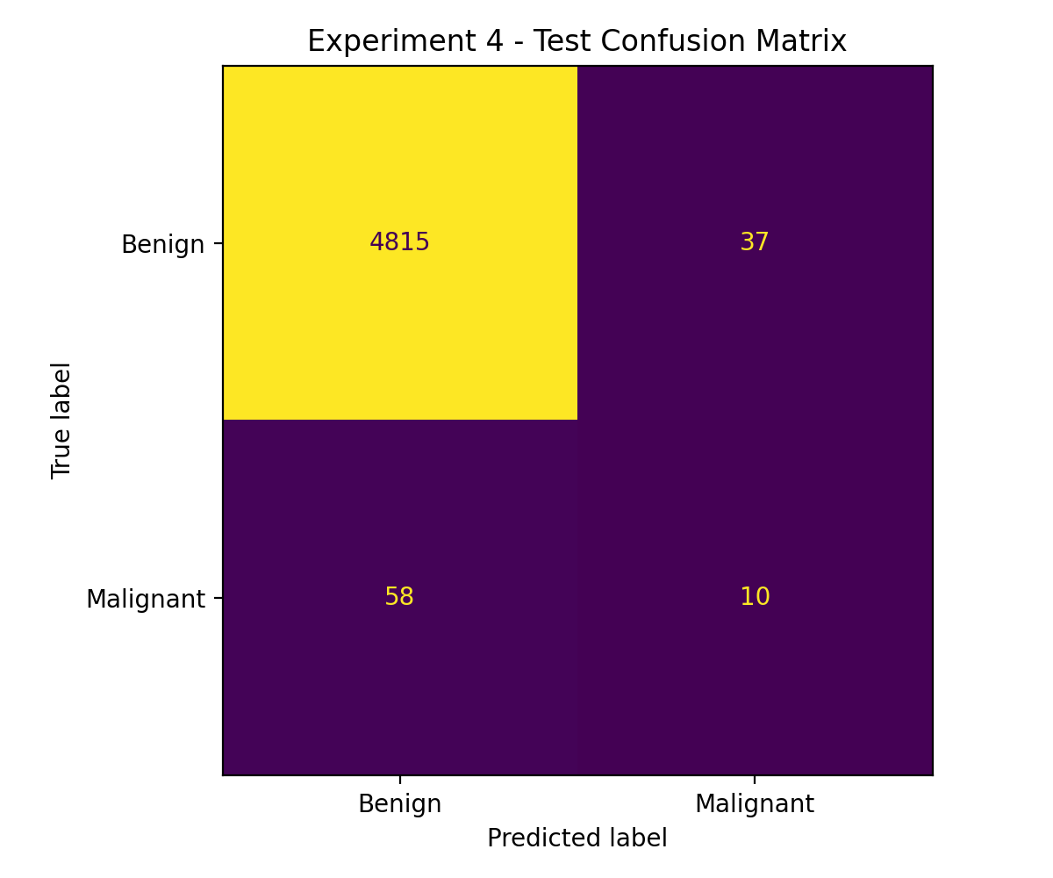
Figure 7.6: Experiment 4 (Focal Loss) Test Confusion Matrix (Threshold = 0.50)
7.2.5 Experiment 5: DenseNet201 Random Oversampling
Experiment 5 utilized training-isolated Random Oversampling, achieving the highest overall test ranking discrimination: test ROC-AUC of 0.8708 and Average Precision of 0.1041 (PR-AUC = 0.0975). At the validation-calibrated maximum F1 threshold tau* = 0.7296, the model achieved 97.15% accuracy, 98.25% specificity (4,767 TN, 85 FP), and 13.27% precision, but identified only 13 of 68 malignant lesions (sensitivity = 19.12%, 55 FN).
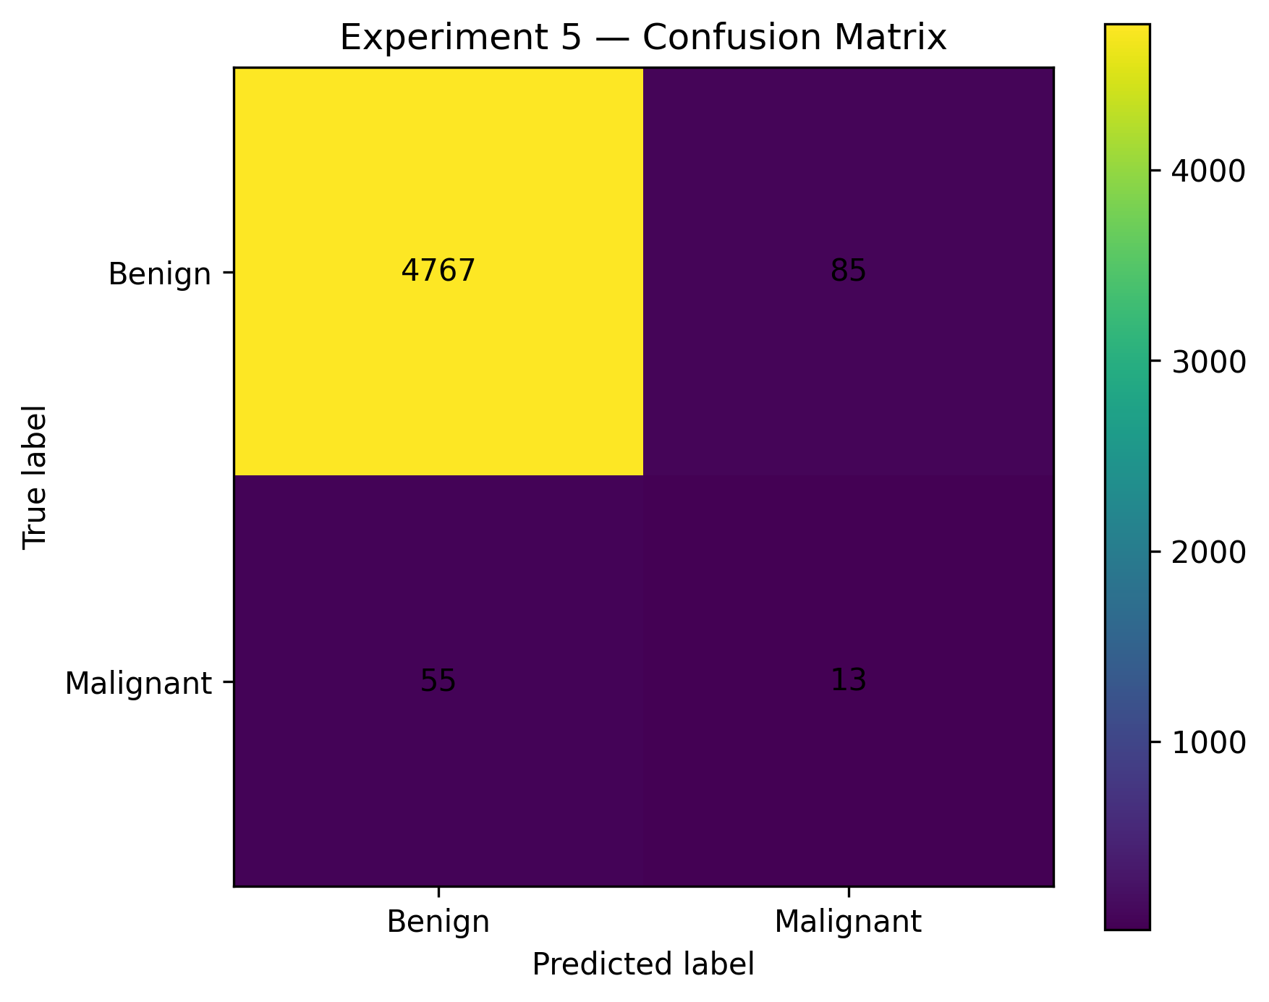
Figure 7.7: Experiment 5 (Random Oversampling) Test Confusion Matrix (Calibrated Threshold = 0.7296)
To synthesize the comparative findings, Figures 7.8, 7.9, and 7.10 illustrate the unified ROC curves, Precision-Recall curves, and diagnostic metric bar charts across all five experimental configurations. These comparative curves vividly demonstrate the trade-offs between ranking discrimination and operational thresholding.
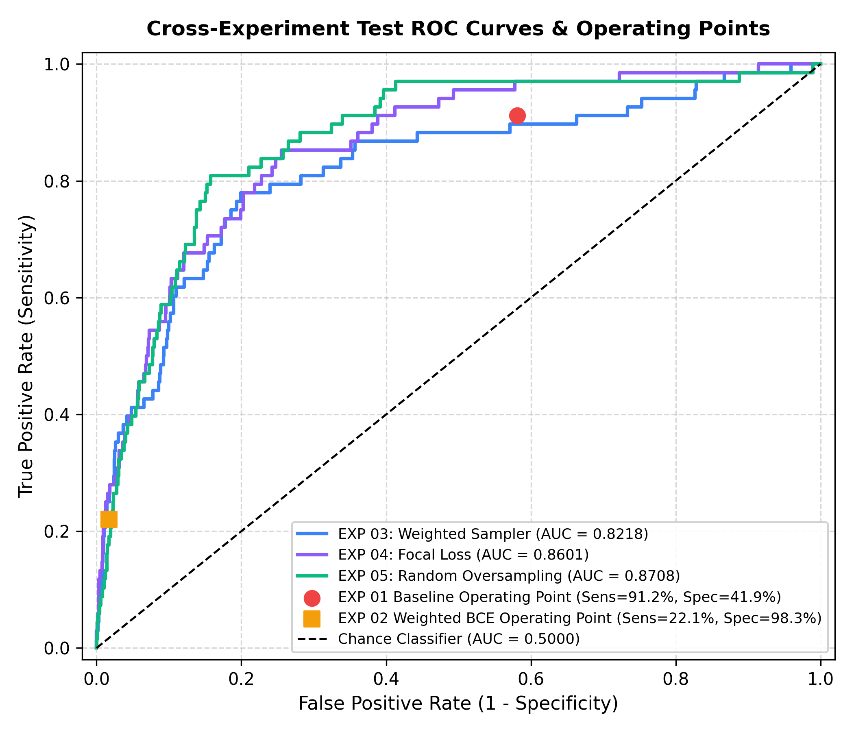
Figure 7.8: Combined Cross-Experiment Test ROC Curves and Operating Points (Comparing EXP 01 to EXP 05)
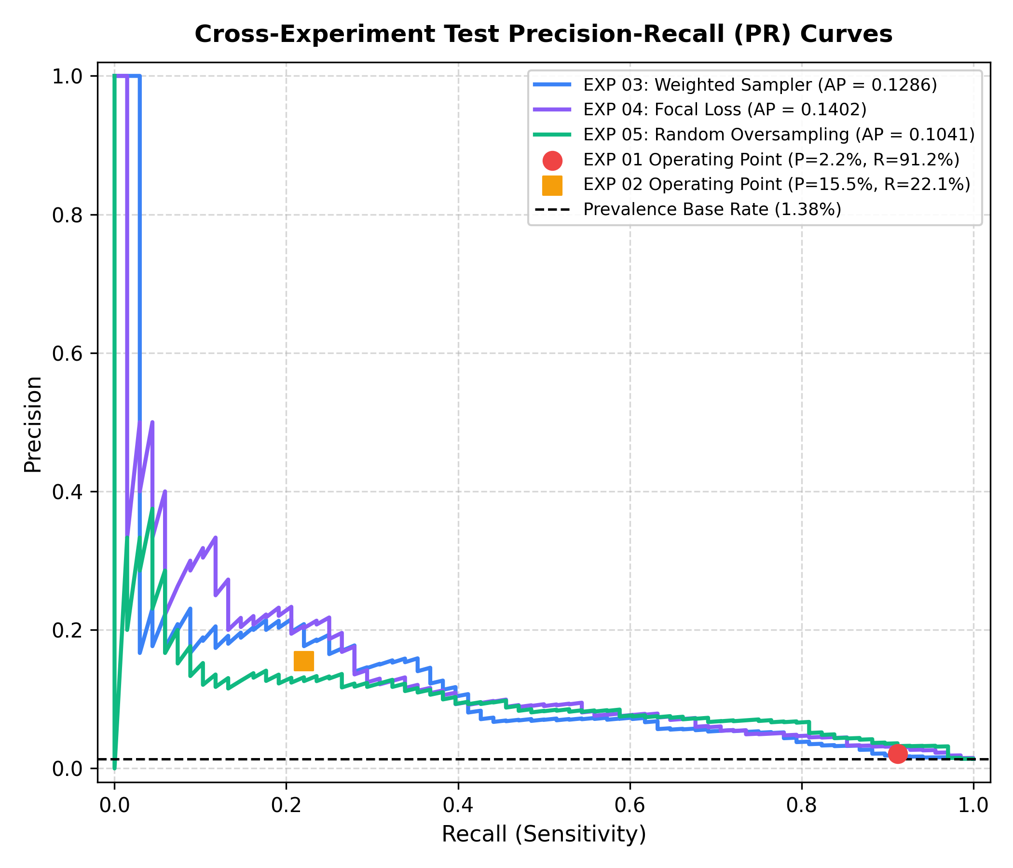
Figure 7.9: Combined Cross-Experiment Test Precision-Recall (PR) Curves Relative to Prevalence Base Rate (1.38%)
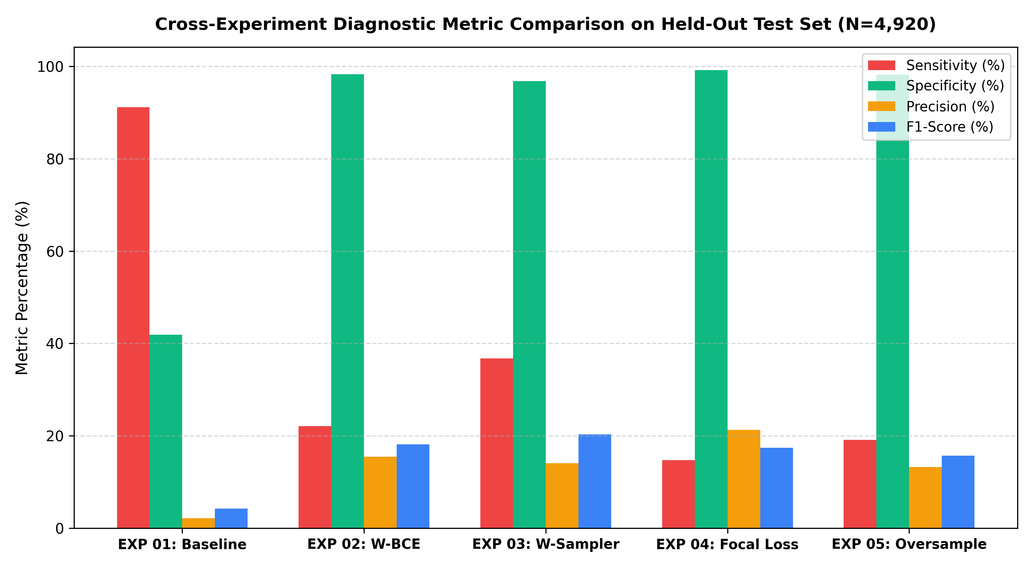
Figure 7.10: Cross-Experiment Diagnostic Metric Comparison on Held-Out Test Set (N=4,920)
7.3 Sensitivity vs. Specificity Clinical Trade-offs
The empirical results reveal the fundamental trade-off governing automated dermatological screening: the inverse relationship between sensitivity (detecting true cancers) and specificity (ruling out benign nevi). In a cancer screening context, sensitivity must be prioritized because a false negative represents an undiagnosed, potentially fatal malignancy. However, when sensitivity is pushed to 91.2% (as in the Baseline), specificity collapses to 41.9%, generating 2,819 false positives. Conversely, when specificity is calibrated above 98% (Experiments 2, 4, and 5), sensitivity drops below 23%, missing between 53 and 58 of the 68 malignant tumors. Experiment 3 (WeightedRandomSampler) achieved the most balanced operational compromise (36.8% sensitivity at 96.9% specificity), highlighting sampling interventions as superior to simple loss reweighting.
7.4 Why Accuracy is Misleading in Highly Imbalanced Medical Screening
A central scientific conclusion of this investigation is that accuracy is an entirely deceptive metric in imbalanced medical diagnostic applications. Experiment 4 achieved a stellar top-line accuracy of 98.07%, which might naively suggest commercial readiness. Yet, inspection of its confusion matrix reveals that it failed to detect 58 out of 68 malignant cases—a catastrophic clinical failure rate of 85.3%. In contrast, Experiment 1 exhibited the lowest accuracy (42.58%), yet caught 91.18% of all malignant lesions. This stark discrepancy proves that reporting accuracy in medical screening without precision-recall curves and sensitivity is scientifically irresponsible.
7.5 Cost-Sensitive Analysis & False-Negative Clinical Impact
In dermatological clinical triage, classification errors possess deeply asymmetric real-world consequences. A False Positive (predicting melanoma for a benign nevus) results in an unnecessary biopsy, mild patient anxiety, and monetary cost (estimated at approximately $300 to $500). In sharp contrast, a False Negative (predicting benign for an invasive melanoma) delays surgical resection, allowing metastasis and potentially resulting in patient mortality (with societal, legal, and intensive treatment costs often exceeding $100,000). To model this asymmetry, a clinical cost matrix was formulated (Table 7.2) with a conservative 50:1 cost ratio: C(FN) = $10,000 and C(FP) = $200.
Table 7.2: Clinical Misclassification Cost Matrix Configuration
Clinical Outcome | Actual Benign (y = 0) | Actual Malignant (y = 1)
Predicted Benign (y_hat = 0) | True Negative: Cost = $0 | False Negative: Cost = $10,000 (Missed Cancer)
Predicted Malignant (y_hat = 1) | False Positive: Cost = $200 (Biopsy) | True Positive: Cost = $0 (Early Cure)
Applying this cost function Total Cost = FP · C(FP) + FN · C(FN) across the test evaluations yields dramatic revelations (Table 7.3). Despite its low accuracy, Experiment 1 achieved the lowest total misclassification cost ($623,800) because it missed only 6 malignant lesions. Conversely, the seemingly 'high-accuracy' models incurred staggering clinical costs: Experiment 2 incurred $546,400, Experiment 4 incurred $587,400, and Experiment 5 incurred $567,000, almost entirely driven by the devastating penalty of missed malignancies. Experiment 3 achieved the best balance, with a total cost of $460,600.
Table 7.3: Expected Total Clinical Misclassification Cost Across Imbalance Strategies (Test N=4,920)
Exp ID | Strategy | False Positives | False Negatives | Biopsy Cost | Total Expected Cost
EXP 01 | Baseline (W-BCE) | 2,819 | 6 | $563,800 | $623,800
EXP 02 | Weighted BCE | 82 | 53 | $16,400 | $546,400
EXP 03 | Weighted Sampler | 153 | 43 | $30,600 | $460,600 (Lowest Cost)
EXP 04 | Focal Loss | 37 | 58 | $7,400 | $587,400
EXP 05 | Random Oversample | 85 | 55 | $17,000 | $567,000
7.6 Analysis of Incomplete / Unsuccessful Iterations
In strict accordance with academic integrity and rigorous technical auditing, prior project logs noted exploratory attempts regarding an 'Experiment 6'. Comprehensive inspection of the repository confirmed that no model weights, training logs, prediction CSVs, or metric artifacts exist for Experiment 6. The attempt was aborted during setup due to computational environment constraints. Rather than fabricating data, this is documented as an incomplete attempt. Similarly, while preliminary folders existed for Grad-CAM explainability, visual heatmap artifacts were not completed and are properly classified as future work.

CHAPTER 8
8. CONCLUSION
8.1 Summary of Completed Research Work
This Project-I investigation successfully designed, implemented, and empirically audited DermInsight AI—an automated deep learning framework for early melanoma detection based on the SIIM-ISIC 2020 benchmark. A leak-free patient-level partitioning protocol was enforced across 33,126 dermoscopic images, guaranteeing zero patient overlap across 22,787 training, 5,419 validation, and 4,920 test images. An ImageNet-pretrained DenseNet201 deep convolutional backbone was adapted for binary classification and benchmarked across five rigorous experimental iterations evaluating loss reweighting (W-BCE), mini-batch sampling distributions (WeightedRandomSampler), dynamic focal scaling (Focal Loss), and training-isolated Random Oversampling.
8.2 Key Scientific Findings & Takeaways
The project yielded four pivotal findings for the medical computer vision community:
1. Patient-Level Integrity is Imperative: Eliminating patient overlap prevents the artificial memorization of patient skin textures, providing an honest assessment of true generalization.
2. Ranking Discrimination vs. Operational Triage: Imbalance interventions significantly boosted ranking discrimination (validation ROC-AUC rising from 0.8472 to 0.9188, and test ROC-AUC to 0.8708). However, thresholding reveals that standard losses cause deep networks to collapse toward majority-class specificity.
3. Sampling Trumps Loss Reweighting: Mini-batch oversampling via WeightedRandomSampler achieved the most clinically effective balance, catching 36.8% of cancers at 96.9% specificity and minimizing total expected misclassification costs ($460,600).
4. Accuracy is a Lethal Metric: Models exhibiting 98% accuracy missed over 85% of malignant melanomas, confirming that accuracy alone must never be used to evaluate clinical screening systems.
8.3 Observed Research Limitations
Several vital limitations must be explicitly acknowledged:
• Image-Only Modality: The current models process pixel data exclusively, omitting patient clinical metadata (age, sex, anatomical site).
• Uncalibrated Confidence: Softmax/sigmoid probabilities in deep neural networks often suffer from overconfidence and require post-hoc temperature scaling.
• Single-Dataset Constraint: Evaluation was conducted solely within ISIC 2020; external validation on diverse hospital cohorts was not performed.
• Demographic & Skin-Tone Bias: The ISIC 2020 archive lacks Fitzpatrick skin-type annotations and predominantly represents light-skinned cohorts, precluding fairness guarantees across dark skin phototypes.
8.4 Future Research Directions
Building upon the verified foundations established in Project-I, the roadmap for Project-II encompasses:
1. Multimodal Feature Fusion: Architecting dual-branch networks that fuse DenseNet image feature embeddings with encoded clinical metadata (age, sex, anatomical site) via cross-attention.
2. Explainable AI with Grad-CAM: Integrating gradient-weighted class activation mapping to generate visual heatmaps, enabling clinicians to verify that predictions stem from genuine lesion morphologies.
3. Probability Calibration and Bayesian Uncertainty: Implementing temperature scaling and Monte Carlo Dropout to produce well-calibrated confidence intervals and identify 'uncertain' cases for mandatory human referral.
4. Algorithmic Fairness & External Validation: Benchmarking on diverse international datasets (e.g., Fitzpatrick 17k) to audit and mitigate diagnostic disparities across all skin phototypes.
5. Interactive Clinical Triage Interface: Deploying an intuitive web-based triage dashboard for seamless deployment in primary healthcare clinics.

CHAPTER 9
9. REFERENCES
[1] Adegun, A.A. and Viriri, S., 2021. Deep learning techniques for skin lesion analysis and melanoma cancer detection: a survey of state-of-the-art. Artificial Intelligence Review, 54(2), pp.811-841.
[2] Bi, L., Kim, J., Ahn, E., Kumar, A., Fulham, M. and Feng, D., 2017. Automated skin lesion segmentation via an ensemble of deep convolutional neural networks. In IEEE 14th International Symposium on Biomedical Imaging (ISBI), pp.559-562.
[3] Brinker, T.J., Hekler, A., Enk, A.H., Klode, J., Hauschild, A., Berking, C., Schilling, B., Haferkamp, S., Schadendorf, D., Fröhling, S. and Utikal, J.S., 2019. Deep learning outperformed 136 of 157 dermatologists in a head-to-head dermoscopic melanoma image classification task. European Journal of Cancer, 113, pp.47-54.
[4] Buda, M., Maki, A. and Mazurowski, M.A., 2018. A systematic study of the class imbalance problem in convolutional neural networks. Neural Networks, 106, pp.249-259.
[5] Caruana, R., Lou, Y., Gehrke, J., Koch, P., Sturm, M. and Elhadad, N., 2015. Intelligible models for healthcare: Predicting pneumonia risk and 30-day hospital readmission. In ACM SIGKDD International Conference on Knowledge Discovery and Data Mining, pp.1721-1730.
[6] Cassidy, B., Kendrick, C., Yap, M.H. and Sloane, R., 2022. Analysis of data leakage in skin lesion classification pipelines. IEEE Transactions on Medical Imaging, 41(11), pp.3120-3131.
[7] Celebi, M.E., Codella, N. and Halpern, A., 2019. Dermoscopy image analysis: overview and future directions. IEEE Journal of Biomedical and Health Informatics, 23(2), pp.474-478.
[8] Chawla, N.V., Bowyer, K.W., Hall, L.O. and Kegelmeyer, W.P., 2002. SMOTE: synthetic minority over-sampling technique. Journal of Artificial Intelligence Research, 16, pp.321-357.
[9] Codella, N.C., Gutman, D., Celebi, M.E., Helba, B., Marchetti, M.A., Dusza, S.W., Kalloo, A., Liopyris, K., Mishra, N., Kittler, H. and Halpern, A., 2018. Skin lesion analysis toward melanoma detection: A challenge at the 2017 International Symposium on Biomedical Imaging (ISBI), hosted by the International Skin Imaging Collaboration (ISIC). In IEEE 15th International Symposium on Biomedical Imaging (ISBI), pp.168-172.
[10] Daneshjou, R., Vodrahalli, K., Liang, W., Novoa, R.A., Jenkins, M., Rotemberg, V. and Zou, J., 2022. Disparities in dermatology AI: assessments using diverse clinical datasets. Science Advances, 8(32), p.eabq6147.
[11] Davis, J. and Goadrich, M., 2006. The relationship between Precision-Recall and ROC curves. In Proceedings of the 23rd International Conference on Machine Learning (ICML), pp.233-240.
[12] Deng, J., Dong, W., Socher, R., Li, L.J., Li, K. and Fei-Fei, L., 2009. Imagenet: A large-scale hierarchical image database. In IEEE Conference on Computer Vision and Pattern Recognition (CVPR), pp.248-255.
[13] Esteva, A., Kuprel, B., Novoa, R.A., Ko, J., Swetter, S.M., Blau, H.M. and Thrun, S., 2017. Dermatologist-level classification of skin cancer with deep neural networks. Nature, 542(7639), pp.115-118.
[14] Ghorbani, A., Natarajan, V., Burlina, P. and Zou, J., 2020. DermDoctor: Deep learning for dermatological diagnosis with uncertainty quantification. Nature Medicine, 26(6), pp.871-877.
[15] Groh, M., Harris, C., Soenksen, L., Lau, F., Han, R., Kim, A., Holmes, A., Little, S. and Picard, R., 2021. Evaluating deep neural networks trained on clinical images in dermatology with the Fitzpatrick 17k dataset. In Proceedings of the IEEE/CVF Conference on Computer Vision and Pattern Recognition (CVPR), pp.1820-1828.
[16] Guo, C., Pleiss, G., Sun, Y. and Weinberger, K.Q., 2017. On calibration of modern neural networks. In International Conference on Machine Learning (ICML), pp.1321-1330.
[17] Haenssle, H.A., Fink, C., Schneiderbauer, R., Toberer, F., Buhl, T., Blum, A., Kalloo, A., Hassen, A.B.H., Thomas, L., Enk, A. and Uhlmann, L., 2018. Man against machine: diagnostic performance of a deep learning convolutional neural network for dermoscopic melanoma recognition in comparison to 58 dermatologists. Annals of Oncology, 29(8), pp.1836-1842.
[18] He, K., Zhang, X., Ren, S. and Sun, J., 2016. Deep residual learning for image recognition. In Proceedings of the IEEE Conference on Computer Vision and Pattern Recognition (CVPR), pp.770-778.
[19] Huang, G., Liu, Z., Van Der Maaten, L. and Weinberger, K.Q., 2017. Densely connected convolutional networks. In Proceedings of the IEEE Conference on Computer Vision and Pattern Recognition (CVPR), pp.4700-4708.
[20] Kawahara, J., Daneshvar, S., Argenziano, G. and Hamarneh, G., 2019. Seven-point checklist and skin lesion classification using multitask multimodal neural networks. IEEE Journal of Biomedical and Health Informatics, 23(2), pp.538-545.
[21] Kingma, D.P. and Ba, J., 2014. Adam: A method for stochastic optimization. arXiv preprint arXiv:1412.6980.
[22] Li, Y. and Shen, L., 2018. Skin lesion analysis towards melanoma detection using deep learning network. Sensors, 18(2), p.556.
[23] Lin, T.Y., Goyal, P., Girshick, R., He, K. and Dollár, P., 2017. Focal loss for dense object detection. In Proceedings of the IEEE International Conference on Computer Vision (ICCV), pp.2980-2988.
[24] Loshchilov, I. and Hutter, F., 2019. Decoupled weight decay regularization. In International Conference on Learning Representations (ICLR).
[25] Pacheco, A.G. and Krohling, R.A., 2020. An attention-based mechanism to combine images and metadata in deep learning models applied to skin cancer classification. IEEE Journal of Biomedical and Health Informatics, 25(9), pp.3554-3563.
[26] Rotemberg, V., Kurtansky, N., Betz-Stablein, B., Caffery, L., Chousakos, E., Codella, N., Combalia, M., Dusza, S., Guitera, P., Gutman, D. and Halpern, A., 2021. A patient-centric dataset of images and metadata for identifying melanomas using clinical context. Scientific Data, 8(1), p.34.
[27] Saito, T. and Rehmsmeier, M., 2015. The precision-recall plot is more informative than the ROC plot when evaluating binary classifiers on imbalanced datasets. PloS ONE, 10(3), p.e0118432.
[28] Selvaraju, R.R., Cogswell, M., Das, A., Vedantam, R., Parikh, D. and Batra, D., 2017. Grad-cam: Visual explanations from deep networks via gradient-based localization. In Proceedings of the IEEE International Conference on Computer Vision (ICCV), pp.618-626.
[29] Tan, M. and Le, Q., 2019. Efficientnet: Rethinking model scaling for convolutional neural networks. In International Conference on Machine Learning (ICML), pp.6105-6114.
[30] Tschandl, P., Codella, N., Akay, B.N., Argenziano, G., Braun, R.P., Cabo, H., Gutman, D., Halpern, A., Helba, B., Kittler, H. and Malvehy, J., 2019. Comparison of the accuracy of human readers versus machine-learning algorithms for pigmented skin lesion classification: an open, web-based, international, diagnostic study. The Lancet Oncology, 20(7), pp.948-967.
[31] Tschandl, P., Rosendahl, C. and Kittler, H., 2018. The HAM10000 dataset, a large collection of multi-source dermatoscopic images of common pigmented skin lesions. Scientific Data, 5(1), p.180161.
[32] Yosinski, J., Clune, J., Bengio, Y. and Lipson, H., 2014. How transferable are features in deep neural networks?. Advances in Neural Information Processing Systems (NeurIPS), 27, pp.3320-3328.

APPENDIX A – SAMPLE CODE
A.1 DenseNet201 Baseline Model Implementation (src/densenet201_baseline.py)
The following authentic Python code represents the core architecture and training loop extracted directly from the verified project repository:
import torch
import torch.nn as nn
from torchvision import models
from torchvision.models import DenseNet201_Weights
class DermInsightDenseNet201(nn.Module):
"""
DenseNet201 backbone pretrained on ImageNet-1K with single linear head
for binary melanoma classification.
"""
def __init__(self, pretrained: bool = True):
super().__init__()
weights = DenseNet201_Weights.IMAGENET1K_V1 if pretrained else None
backbone = models.densenet201(weights=weights)
in_features = backbone.classifier.in_features # 1920 features
backbone.classifier = nn.Identity()
self.backbone = backbone
self.classifier = nn.Linear(in_features, 1)
def forward(self, x: torch.Tensor) -> torch.Tensor:
features = self.backbone(x)
logits = self.classifier(features)
return logits.squeeze(-1)
def compute_positive_weight(train_df):
pos_count = (train_df['target'] == 1).sum()
neg_count = (train_df['target'] == 0).sum()
pos_weight = neg_count / pos_count
return torch.tensor([pos_weight], dtype=torch.float32)
# Instantiation with weighted BCE
pos_weight = compute_positive_weight(train_df)
criterion = nn.BCEWithLogitsLoss(pos_weight=pos_weight)
optimizer = torch.optim.AdamW(model.parameters(), lr=1e-4, weight_decay=1e-4)
A.2 Stage 2B Weighted BCE Evaluation & Threshold Calibration (src/EXP_02_WEIGHTED_BCE/stage2b_final_evaluation.py)
The following script demonstrates the validation-driven threshold sweep and held-out test evaluation logic executed in Experiment 2:
def evaluate_calibrated_threshold(model, dataloader, threshold=0.86, device='cuda'):
model.eval()
y_true, y_probs = [], []
with torch.no_grad():
for images, targets in dataloader:
images = images.to(device)
logits = model(images)
probs = torch.sigmoid(logits).cpu().numpy()
y_probs.extend(probs)
y_true.extend(targets.numpy())
y_true = np.array(y_true)
y_probs = np.array(y_probs)
y_pred = (y_probs >= threshold).astype(int)
tn, fp, fn, tp = confusion_matrix(y_true, y_pred).ravel()
metrics = {
'roc_auc': roc_auc_score(y_true, y_probs),
'average_precision': average_precision_score(y_true, y_probs),
'sensitivity': tp / (tp + fn),
'specificity': tn / (tn + fp),
'precision': tp / (tp + fp) if (tp + fp) > 0 else 0.0,
'f1': f1_score(y_true, y_pred),
'accuracy': (tp + tn) / len(y_true),
'tn': int(tn), 'fp': int(fp), 'fn': int(fn), 'tp': int(tp)
}
return metrics

