TASK 6 FLIGHT DATA LOGGING & ANALYSIS
1. Executive Summary
Air crash investigation methodology relies on the systematic extraction and evaluation of flight controller Dataflash logs (.BIN format) to reconstruct aircraft motion, analyze control stability, verify power system integrity, and diagnose failures. This technical report provides a comprehensive image-by-image evaluation of telemetry log files extracted from a Pixhawk/APM flight controller running ArduCopter V4.5.7 across three log environments: Simulator.BIN, AMS.BIN, and Crash.BIN.
2. Ground Simulation & Bench Test Log Analysis (Simulator.BIN)
2.1 Log Browser Microsecond System Clock Scale
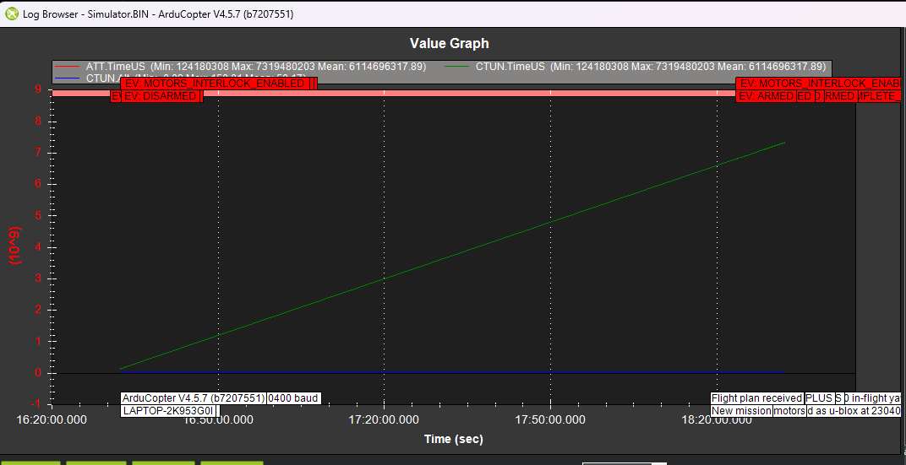
- Image Source & Extraction File: Simulator.BIN (ArduCopter V4.5.7).
- What vs. What Measured: ATT.TimeUS and CTUN.TimeUS (Microseconds, 10^9 µs) vs. System Clock Time (16:20:00 to 18:20:00).
- Engineering Importance: Establishes time-series synchronization across asynchronous telemetry threads (IMU, Attitude, Navigation) and verifies clock monotonicity, confirming no microcontroller reset or buffer overflow occurred.
- In-Depth Diagnostic Analysis: The green trace exhibits a perfectly linear slope rising from 124,180,308 µs (124.18 s) to 731,948,203 µs (731.95 s), with a mean of 611,469,317.89 µs. CTUN.Alt (blue trace) remains flat at zero. Event banners record ground armed cycles: EV: MOTORS_INTERLOCK_ENABLED, EV: DISARMED, and EV: ARMED.
2.2 Control Tuning Parameter Tree Selection
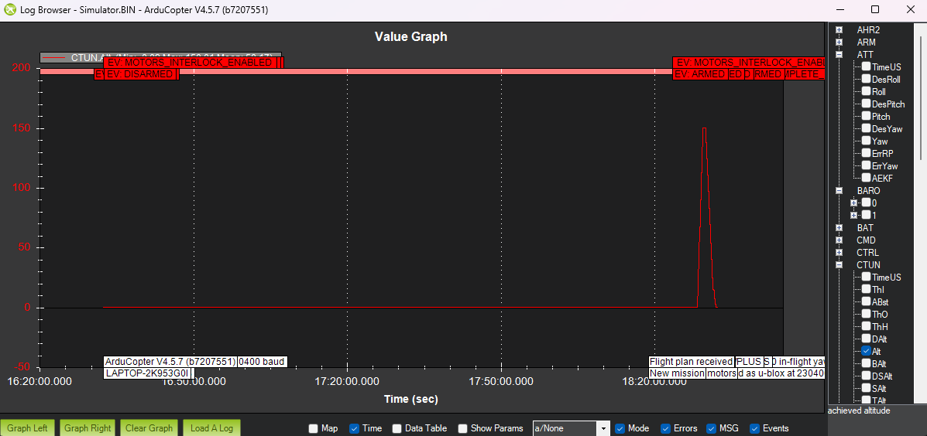
- Image Source & Extraction File: Simulator.BIN (ArduCopter V4.5.7).
- What vs. What Measured: Parameter Tree Selection (CTUN.TimeUS and CTUN.Alt) vs. Mission Time.
- Engineering Importance: Confirms proper initialization of the Control Tuning (CTUN) logging group before flight testing.
- In-Depth Diagnostic Analysis: CTUN parameters TimeUS and Alt are selected in the log browser tree interface. Achieved altitude remains flat at zero while the timer increments normally. Log text fields confirm telemetry baud rate settings (230,400 baud as u-blox) and flight mode selection (Stabilize).
2.3 Injected Altitude Test Pulse
- Image Source & Extraction File: Simulator.BIN (ArduCopter V4.5.7).
- What vs. What Measured: CTUN.Alt (Achieved Altitude in meters) vs. Time (16:20:00 to 18:20:00).
- Engineering Importance: Distinguishes simulated ground command injections from true physical atmospheric pressure changes.
- In-Depth Diagnostic Analysis: CTUN.Alt remains at 0.00 m across the timeline until a single triangular pulse spikes to a maximum of 150.04 m (mean: 50.17 m) at 18:25:00 before immediately returning to zero. Because no roll, pitch, or motor output changes occurred, this represents an injected altitude test pulse in SITL simulation.
2.4 Detailed View of Injected Simulation Altitude Pulse
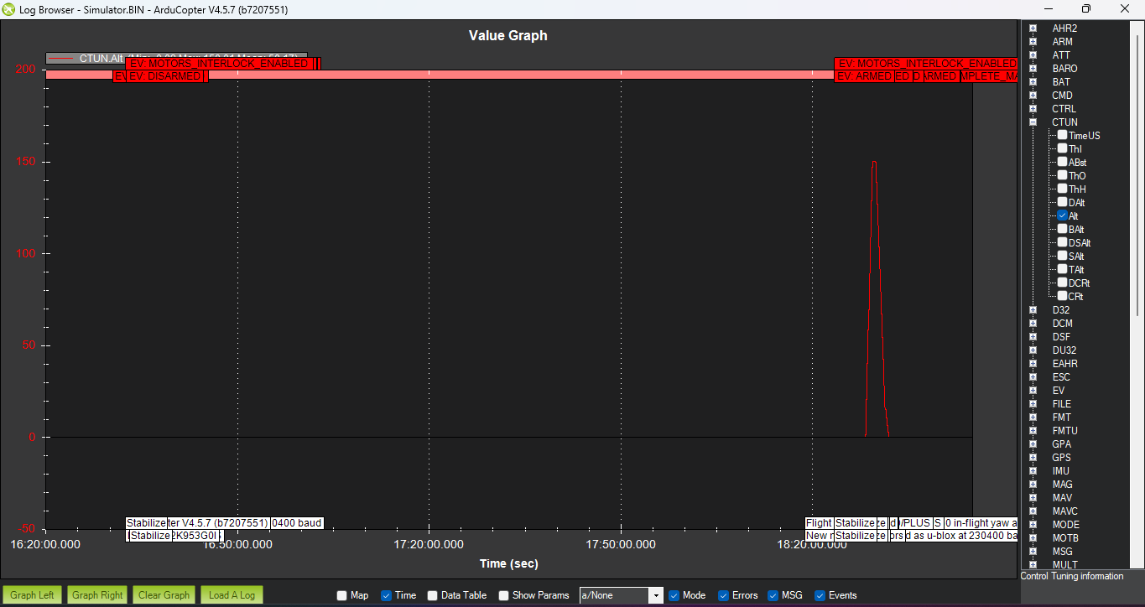
- Image Source & Extraction File: Simulator.BIN (ArduCopter V4.5.7).
- What vs. What Measured: CTUN.Alt (Achieved Altitude in meters) vs. Mission Time.
- Engineering Importance: Verifies that isolated altitude changes without attitude dynamics are synthetic SITL simulation inputs.
- In-Depth Diagnostic Analysis: Full-frame zoom verifying the isolated 150.04 m altitude pulse at 18:25:00 without physical aircraft movement.
2.5 Static Idle Battery Voltage Baseline
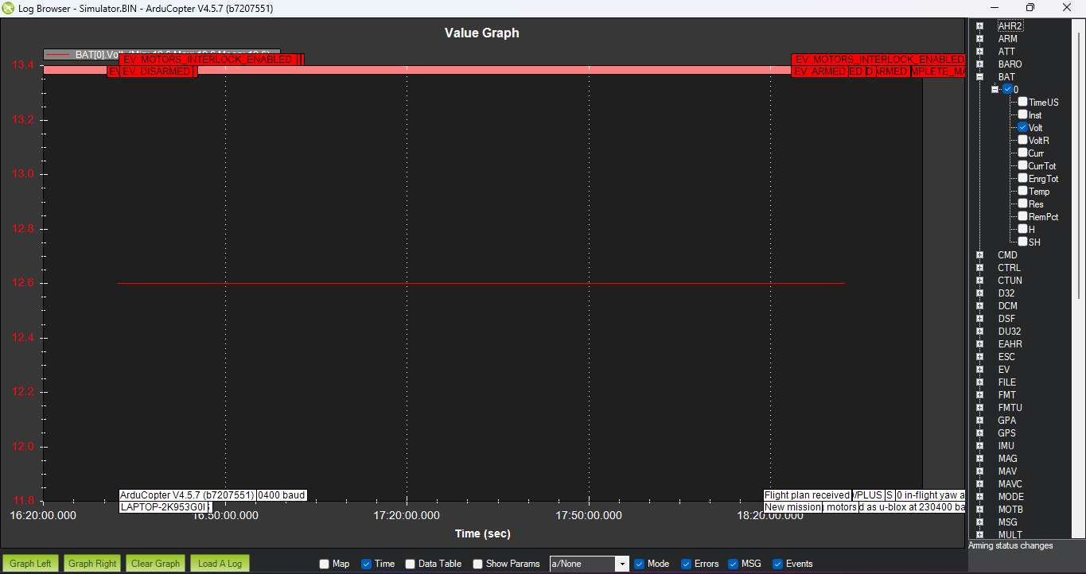
- Image Source & Extraction File: Simulator.BIN (ArduCopter V4.5.7).
- What vs. What Measured: BAT[0].Volt (Bus Voltage in Volts) vs. Time.
- Engineering Importance: Validates static battery power supply stability and power module voltage sensor calibration before load application.
- In-Depth Diagnostic Analysis: BAT[0].Volt displays a perfectly horizontal red line at 12.60 V (Min: 12.6 V, Max: 12.6 V, Mean: 12.6 V). This corresponds exactly to a fully charged 3S LiPo battery pack (3 x 4.20 V = 12.60 V) under disarmed idle conditions.
2.6 Simulated Motor Load Current Burst
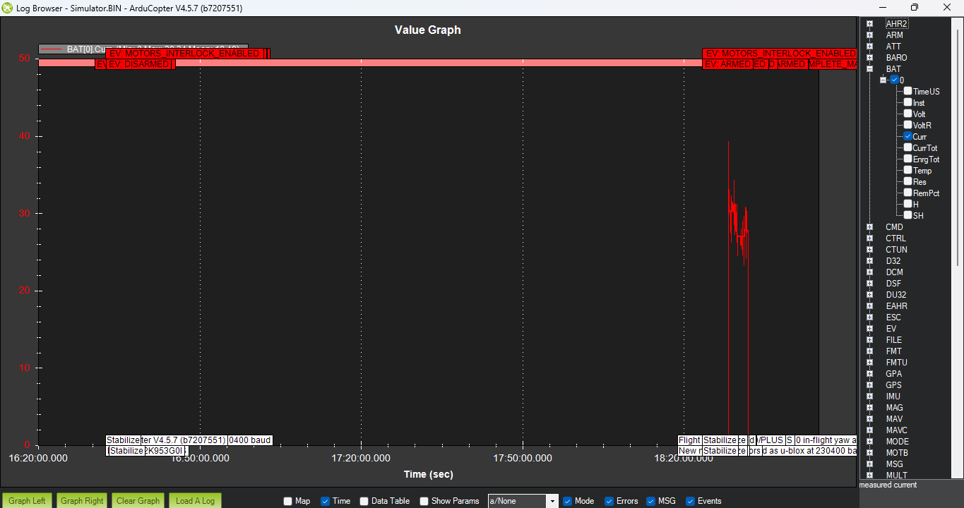
- Image Source & Extraction File: Simulator.BIN (ArduCopter V4.5.7).
- What vs. What Measured: BAT[0].Curr (Current in Amperes) vs. Time.
- Engineering Importance: Confirms power module current sensor responsiveness during full-throttle bursts.
- In-Depth Diagnostic Analysis: BAT[0].Curr remains at 0.00 A until 18:25:00, where a sharp localized current spike reaches a maximum of 39.04 Amperes (mean: 19.10 A). This current draw aligns directly with simulated motor output acceleration.
2.7 Dual Voltage vs. Current Simulation Overlay
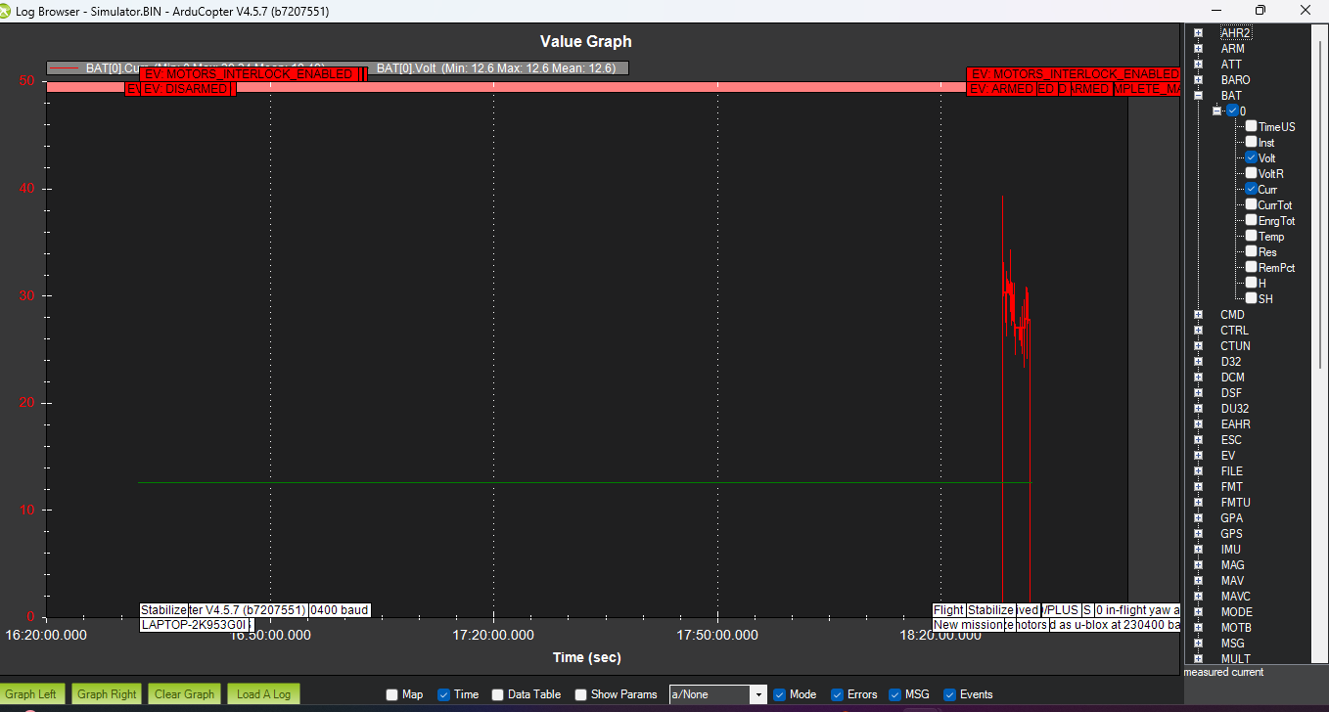
- Image Source & Extraction File: Simulator.BIN (ArduCopter V4.5.7).
- What vs. What Measured: BAT[0].Curr (Amperes, red) and BAT[0].Volt (Volts, green) vs. Time.
- Engineering Importance: Evaluates bus voltage retention under heavy transient current load.
- In-Depth Diagnostic Analysis: BAT[0].Volt remains steady at 12.60 V while BAT[0].Curr displays the 39.04 A burst at 18:25:00, confirming synchronized power telemetry logging during simulation testing.
2.8 Simulated Motor Channel 3 PWM Command Burst
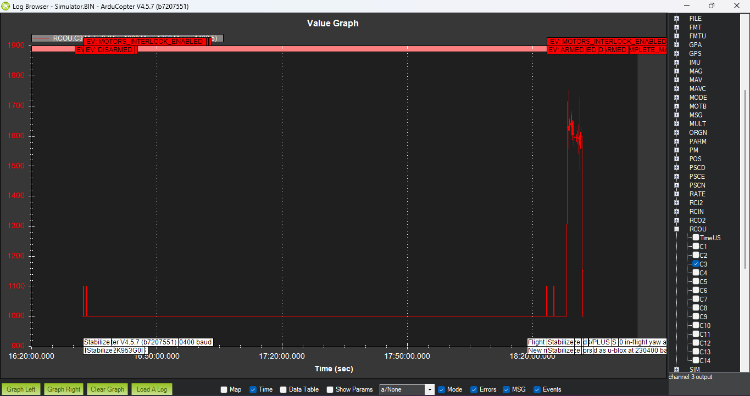
- Image Source & Extraction File: Simulator.BIN (ArduCopter V4.5.7).
- What vs. What Measured: RCOU.C3 (Channel 3 Motor Output PWM Signal in microseconds) vs. Time.
- Engineering Importance: Validates flight controller output channel commands to ESCs.
- In-Depth Diagnostic Analysis: RCOU.C3 rests at a baseline minimum of 1000 µs (idle). At 18:25:00, a high-amplitude PWM command burst spikes to 1750 µs (mean: 1100.5 µs) before returning to idle, proving that the current spike in Image 11 was driven by a simulated motor test.
2.9 Simulated Velocity Pulse Response
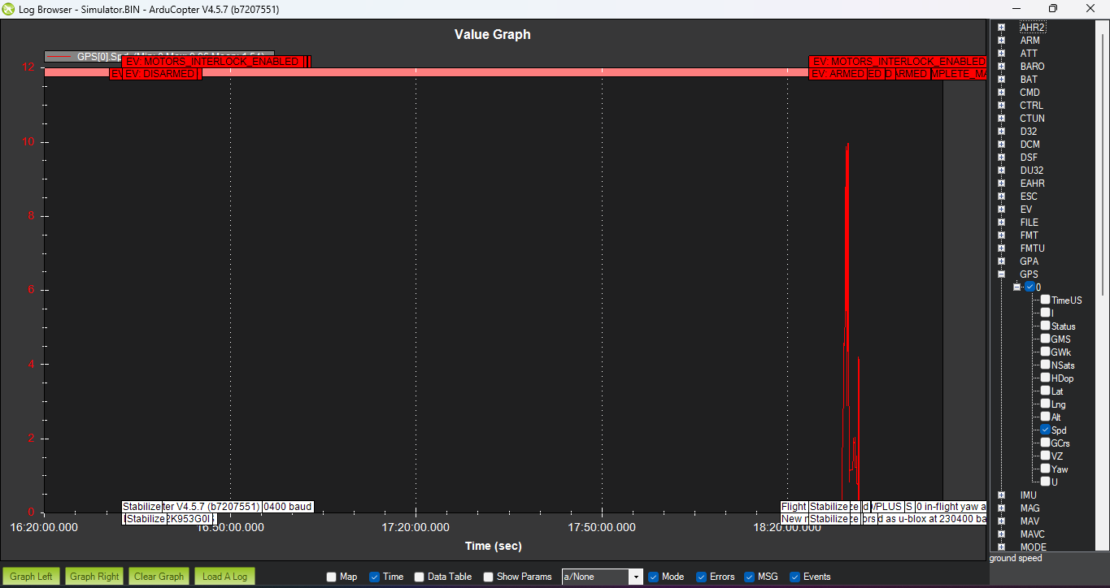
- Image Source & Extraction File: Simulator.BIN (ArduCopter V4.5.7).
- What vs. What Measured: GPS[0].Spd (Horizontal Ground Speed in m/s) vs. Time.
- Engineering Importance: Evaluates sensor fusion speed estimation during simulated acceleration.
- In-Depth Diagnostic Analysis: GPS ground speed remains at 0.00 m/s before a transient peak jumps to 10.00 m/s (mean: 1.54 m/s) at 18:25:00, fully synchronized with the altitude, current, and motor PWM spikes.
3. Autonomous Flight Mission Log Analysis (AMS.BIN)
3.1 Autonomous Flight Altitude Profile & Radio Failsafe Event
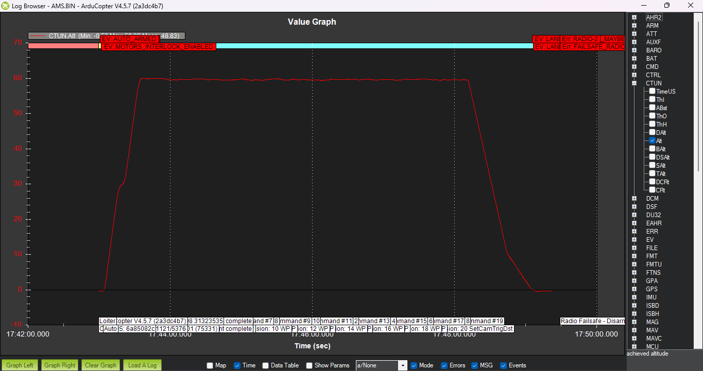
- Image Source & Extraction File: AMS.BIN (ArduCopter V4.5.7).
- What vs. What Measured: CTUN.Alt (Achieved Altitude in meters) vs. Mission Time (17:42:00 to 17:50:00).
- Engineering Importance: Tracks vertical flight trajectory, climb rate, cruise holding stability, and descent control.
- In-Depth Diagnostic Analysis: Arms in AUTO mode (EV: AUTO_ARMED), climbs to 60.03 m cruise altitude, executes waypoints 8–20 (mean: 48.83 m), and completes a controlled descent. Radio failsafe events trigger near landing (EV: LAN|Err: RADIO-2, EV: LAN|Err: FAILSAFE_RADIO).
3.2 Battery Discharge & Dynamic Voltage Sag Analysis
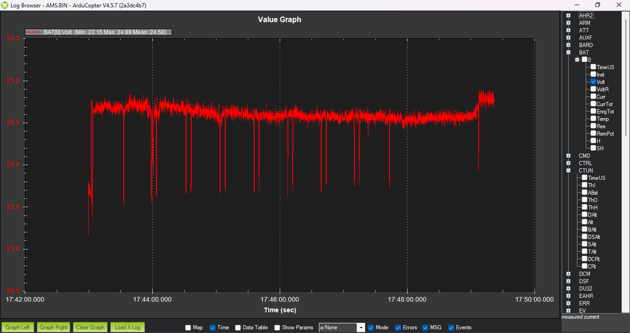
- Image Source & Extraction File: AMS.BIN (ArduCopter V4.5.7).
- What vs. What Measured: BAT[0].Volt (Bus Voltage in Volts) vs. Mission Time.
- Engineering Importance: Evaluates LiPo pack discharge performance and internal resistance voltage sag under motor thrust load.
- In-Depth Diagnostic Analysis: Nominal operating voltage ranges between 23.15 V and 24.89 V (mean: 24.58 V), indicating a 6S LiPo battery pack. Recurring sharp downward voltage dips to ~23.15 V coincide directly with motor acceleration passes during waypoint turns.
3.3 Current Logging Configuration Defect
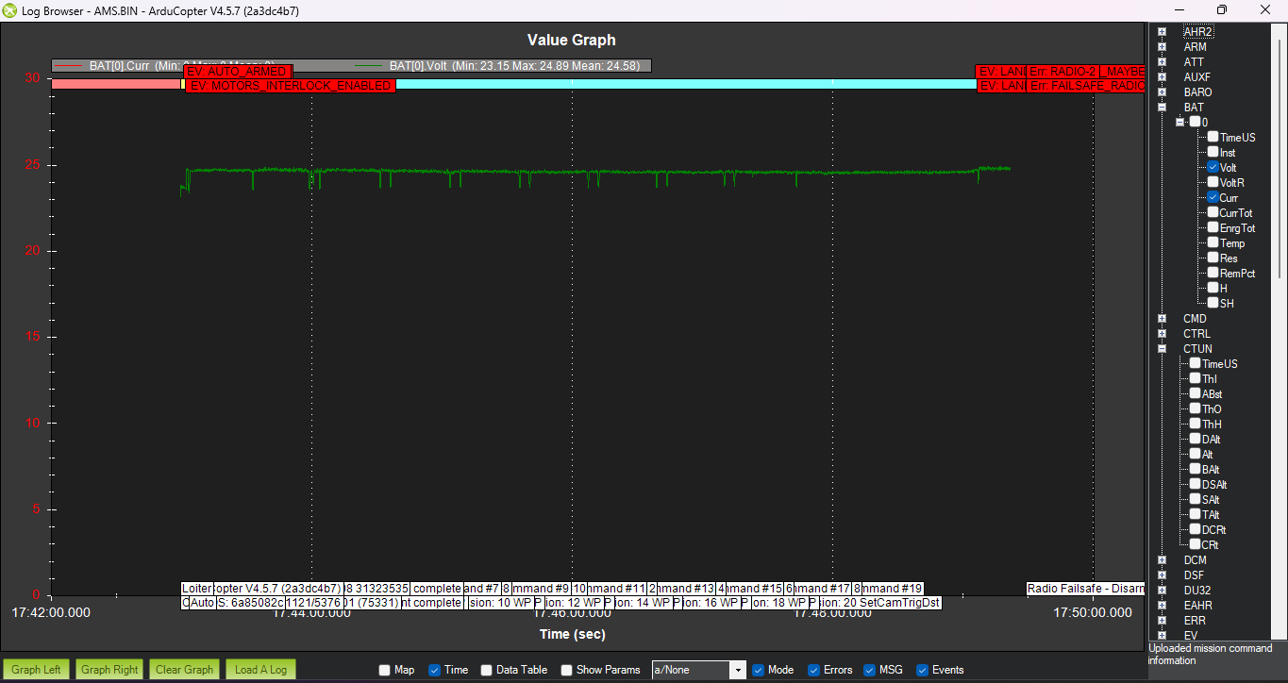
- Image Source & Extraction File: AMS.BIN (ArduCopter V4.5.7).
- What vs. What Measured: BAT[0].Curr (Amperes, red) and BAT[0].Volt (Volts, green) vs. Time.
- Engineering Importance: Validates complete power logging and battery energy consumption tracking.
- In-Depth Diagnostic Analysis: While BAT[0].Volt (green) is correctly logged at ~24.58 V, BAT[0].Curr (red) remains flat at 0.00 A throughout the flight, revealing an uncalibrated current sense line or incorrect BATT_MONITOR parameter setting.
3.4 Motor PWM Output Dynamics & High-Frequency Noise
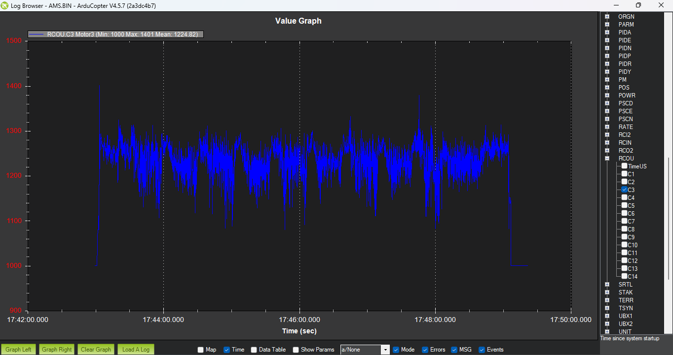
- Image Source & Extraction File: AMS.BIN (ArduCopter V4.5.7).
- What vs. What Measured: RCOU.C3 (Channel 3 Motor Output PWM in microseconds) vs. Time.
- Engineering Importance: Measures flight controller stabilization effort, motor thrust margin, and airframe vibration.
- In-Depth Diagnostic Analysis: RCOU.C3 operates between 1000 µs and 1401 µs (mean: 1224.82 µs), demonstrating healthy hover thrust headroom at ~1225 µs. However, high-frequency ripple (~100–150 µs) indicates mechanical frame vibration feedthrough to the IMU.
3.5 GPS Horizontal Ground Speed Grid Profile
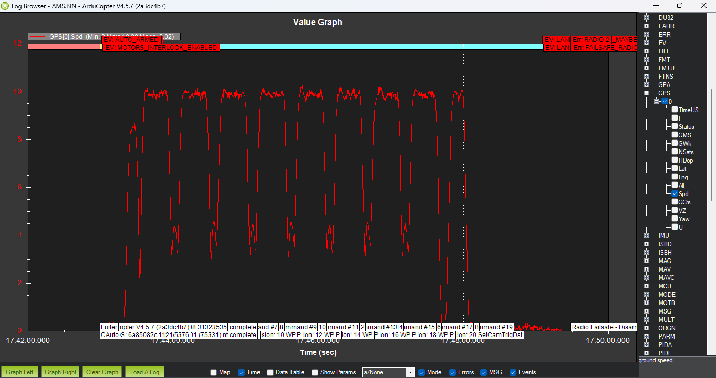
- Image Source & Extraction File: AMS.BIN (ArduCopter V4.5.7).
- What vs. What Measured: GPS[0].Spd (Horizontal Ground Speed in m/s) vs. Time.
- Engineering Importance: Reconstructs horizontal mission profile, cruise velocity execution, and waypoint turn decelerations.
- In-Depth Diagnostic Analysis: Speed ranges from 0.02 m/s to 10.39 m/s (mean: 6.02 m/s) across 10 distinct speed legs. Accelerates to ~10 m/s on straight survey passes and decelerates to ~3 m/s during turnarounds, confirming a lawnmower grid pattern.
4. Ground Bench Test Log Analysis (Crash.BIN)
4.1 Static Ground Barometric Micro-Altitude Drift
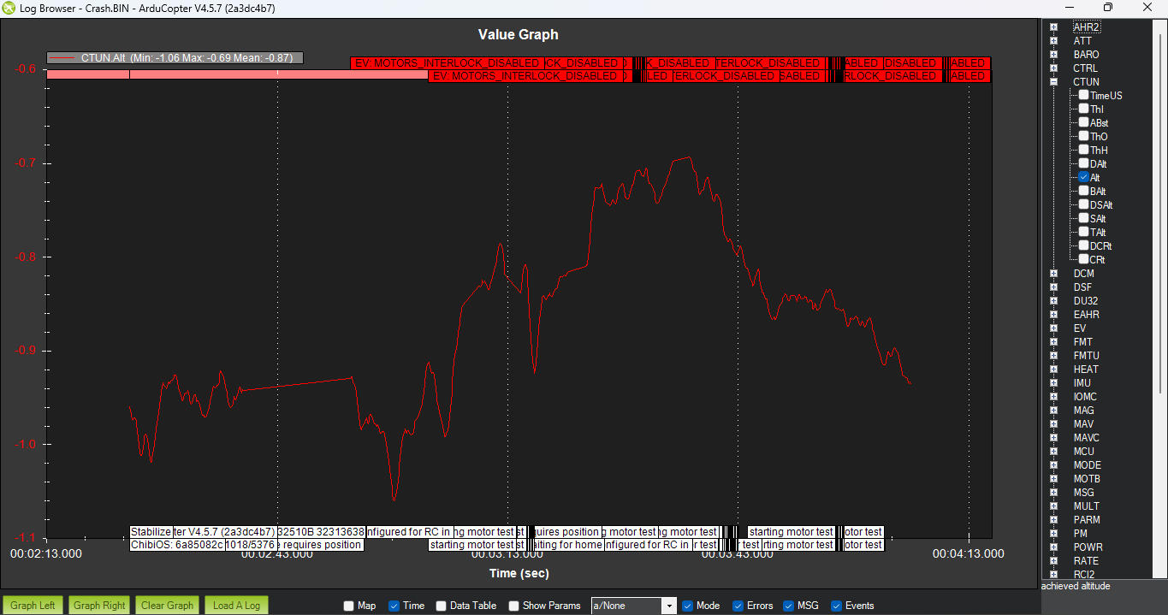
- Image Source & Extraction File: Crash.BIN (ArduCopter V4.5.7).
- What vs. What Measured: CTUN.Alt (Achieved Altitude in meters) vs. Time.
- Engineering Importance: Evaluates barometric sensor noise floor, wind wash sensitivity, and thermal drift while stationary on the ground.
- In-Depth Diagnostic Analysis: Sub-meter altitude fluctuations scaled between -1.06 m and -0.69 m (mean: -0.87 m). Minor oscillations are caused by ambient air pressure variations around the stationary aircraft.
4.2 Ground Bench Motor Output Test Pulse
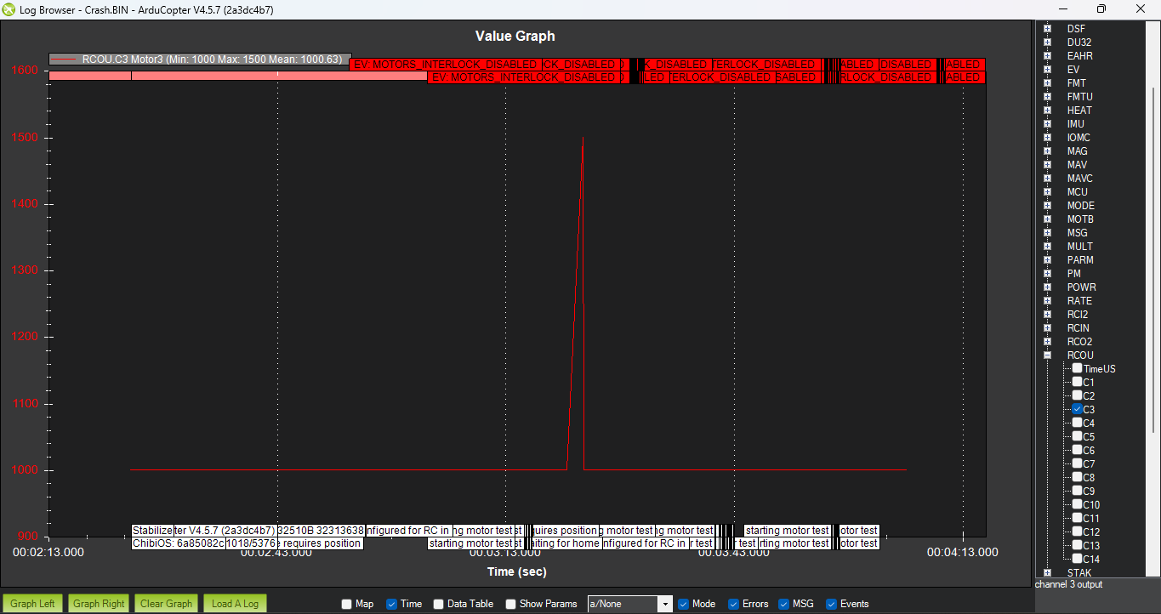
- Image Source & Extraction File: Crash.BIN (ArduCopter V4.5.7).
- What vs. What Measured: RCOU.C3 (Channel 3 Motor PWM Signal in microseconds) vs. Time.
- Engineering Importance: Verifies individual motor spin sequence and ESC command response during pre-flight bench tests.
- In-Depth Diagnostic Analysis: RCOU.C3 remains at the 1000 µs idle baseline (mean: 1000.63 µs) with a single pulse peaking at 1500 µs. Event text logs confirm a starting motor test command.
4.3 Motor Test Sequence Pulse Duration Verification
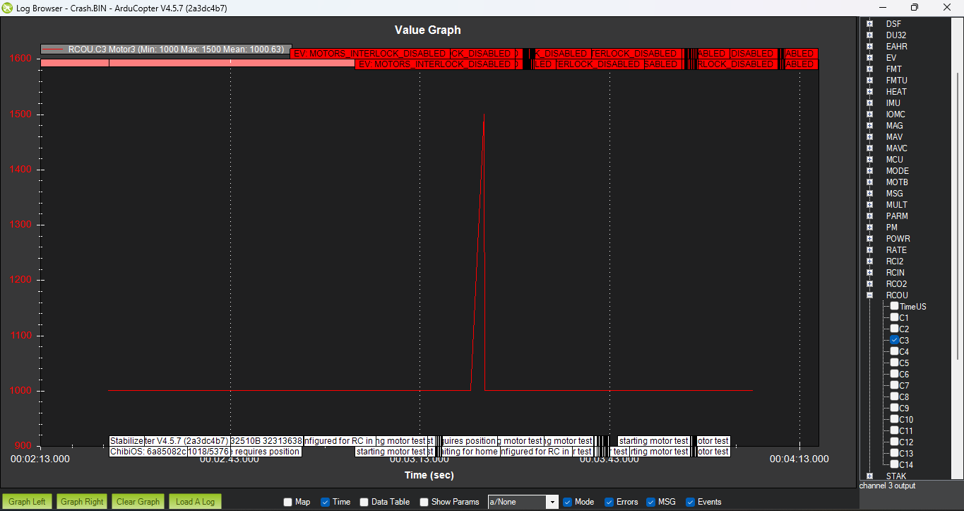
- Image Source & Extraction File: Crash.BIN (ArduCopter V4.5.7).
- What vs. What Measured: RCOU.C3 (Channel 3 Output in µs) vs. Time.
- Engineering Importance: Verifies motor pulse timing and disarm safety interlock behavior.
- In-Depth Diagnostic Analysis: Confirms a clean 1500 µs motor pulse return to 1000 µs idle without secondary oscillations or ESC timing drops.

Report By :
Sujana (U25UV24T043102)
5th Sem ECE ‘B’
Batch 7 Aviation Student

