

**TRIBHUVAN UNIVERSITY**

**INSTITUTE OF ENGINEERING**

**HIMALAYA COLLEGE OF ENGINEERING**

**[CT-707]**

A

FINAL YEAR MAJOR PROJECT PROPOSAL

ON

**NEPALI VIRTUAL ASSISTANT**

BY:

Ajay Maharjan (HCE075BCT006)

Ashish Rai (HCE075BCT042)

Nibendra Bajracharya (HCE075BCT015)

Sujan Maharjan (HCE075BCT037)

A PROJECT SUBMITTED TO DEPARTMRENT OF

ELECTRONICS AND COMPUTER ENGINEERING IN PARTIAL FULFILLMENT OF THE REQUIREMENT FOR BACHELOR’S

DEGREE OF COMPUTER ENGINEERING

HIMALAYA COLLEGE OF ENGINEERING

LALITPUR,NEPAL

June, 2022

**NEPALI VIRTUAL ASSISTANT**

BY:

Ajay Maharjan (HCE075BCT006)

Ashish Rai (HCE075BCT042)

Nibendra Bajracharya (HCE075BCT015)

Sujan Maharjan (HCE075BCT037)

A report submitted for partial fulfillment of the requirements for the degree of Bachelor in Computer Engineering

Department of Electronics and Computer Engineering

HIMALAYA COLLEGE OF ENGINEERING

Tribhuvan University

Lalitpur, Nepal

June, 2022

# ACKNOWLEDGEMENT

We take this occasion to thank our parents for their consistent support and encouragement. We are immensely thankful to our college, **Himalaya College of Engineering**, for including the project in the syllabus. We are also very grateful for the college for providing us with this opportunity. Furthermore, we extend our sincere and heartfelt thanks to our **Head of Department, Er. Ashok GM,** for providing us with the right guidance and for showing us the right way. We would like to express our deep gratitude towards **Er. Narayan Adhikari Chhetri** as well as other faculty membersfor their proper guidance and inspiration. Finally, we would like to give special thanks to acknowledge all the people who have helped us towards the development of this proposal.

**Group Members**

Ajay Maharjan (HCE075BCT006)

Ashish Rai (HCE075BCT042)

Nibendra Bajracharya (HCE075BCT015)

Sujan Maharjan (HCE075BCT037)

# ABSTRACT

This paper approaches the use of a Virtual Assistant using neural networks for recognition of commonly used words. The main purpose is to facilitate the users’ daily lives by sensing the voice and interpreting it into action. The virtual assistant is implemented based on four main techniques: Hot word detection, Voice to Text conversion, Intent recognition, and Text to Voice conversion. JavaScript (TensorFlow) is chosen as a development language due to its capabilities and compatibility with various APIs and libraries, which are deemed necessary for the project. The virtual assistant will be required to communicate with IoT devices. In addition, a speech recognition system is created in order to recognize the significant technical words. An artificial neural network (ANN) with different structure networks and training algorithms is utilized to increase the identification rate effectively and find the optimal performance.

***Keywords****: Virtual Assistant, Speech Recognition, Text-to-Speech, Natural Language Processing, Intent recognition, TensorFlow.*

# TABLE OF CONTENTS

*Contents*

ACKNOWLEDGEMENT i

ABSTRACT ii

LIST OF FIGURES iii

LIST OF ABBREVIATIONS iv

CHAPTER 1. INTRODUCTION 1

1.1. Introduction 1

1.2. Problem Statement 3

1.3. Objectives 3

1.4. Scope and Application 4

CHAPTER 2. LITERATURE REVIEW 5

CHAPTER 3. REQUIREMENT ANALYSIS 7

3.1. Functional Requirements 7

3.2. Non-Functional Requirements 8

3.3. Feasibility Analysis 10

3.3.1. Technical Feasibility 10

3.3.2. Operational Feasibility 10

3.3.3. Economic Feasibility 10

CHAPTER 4. SYSTEM DESIGN 11

4.1. Software Development Approach 11

4.2. System Models 12

CHAPTER 5. METHODOLOGY 14

5.1. Implementation 14

5.2. Project Tools 22

REFERENCES 23

# LIST OF FIGURES

Figure 1: Representation of incremental model 20

Figure 2: Hierarchy of real estate registration offices 23

Figure 3: Parameters within a block for a user 24

Figure 4: Block level details for multiple users 25

Figure 5: Real estate transaction flow in blockchain 26

Figure 6: Specialized case of real estate transaction where only a portion is transferred 27

# LIST OF ABBREVIATIONS

* DB : DataBase
* JS : JavaScript
* PoW : Proof of Work

# CHAPTER 1. INTRODUCTION

## Introduction

In today’s era almost all tasks are digitalized. We can use virtual assistants to help us in various specialized task such as booking a flight, or finding cheapest book online from various e-commerce sites. Virtual assistants are software programs that help you ease your day to day tasks, such as showing weather report, creating reminders, making shopping lists etc. They can take commands via text (online chat bots) or by voice. Voice based intelligent assistants need an invoking word or wake word to activate the listener, followed by the command. We have many virtual assistants that have been in use, such as Apple’s Siri, Amazon’s Alexa and Microsoft’s Cortana. Personal assistant software improves user productivity by managing routine tasks of the user and by providing information from online sources to the user. Voice searches have dominated over text search. Web searches conducted via mobile devices have only just overtaken those carried out using a computer and the analysts are already predicting that 50% of searches will be via voice by 2020. Virtual assistants are turning out to be smarter than ever. Allow your intelligent assistant to make email work for you. Detect intent, pick out important information, automate processes, and deliver personalized responses. This project was started on the premise that there is sufficient amount of openly available data and information on the web that can be utilized to build a virtual assistant that has access to making intelligent decisions for routine user activities.

## Problem Statement

Currently the entire process of real estate registry maintenance is too tedious since it involves safekeeping of large volumes of registers in written form. The main issue with the above-mentioned method of real estate registry maintenance is that any future reference that needs to be taken from these hard copies will involve too much labor. This process is time consuming. The existing system is not secure since majority of the process is not transparent, system is slow, and selling a property more than once needs to be recorded accurately.

Currently, registration oﬃcers and other third party who get involved in a real estate transaction deal often tend to make monetary benefits from the clients who are planning to sell the property. The oﬄine method of initiating a real estate transaction often leads to issues like double spending. Blockchain helps mitigate the interference from third parties by oﬀering a secure platform by means of transaction timestamp, stored within the block.

## Objectives

* To replace outdated paper deeds with true digital assets and tracks changes on an immutable ledger that acts as secure shared source of truth for documents between multiple parties and organization.
* To enable transaction and property ownership records to be more accessible.
* To make the process of real estate registration resilient and decrease the cases of fraud in the process.

## Scope and Application

With blockchain technology becoming more and more in demand in industries, Blockchain technology, in a variety of ways offers a new means for buyers and seller to connect with one another. It can be used to cut intermediaries out of real estate registry, therefore reducing costs. Blockchain facilitates secure data sharing, streamlines rental collections and payments to property owners, and also provides premium due diligence across the portfolio.

# CHAPTER 2. LITERATURE REVIEW

Bassam A, Raja N. et al, written about statement and speech which is most significant. In the communication between human and machine arrangement was done through analog signal which is converted by speech signal to digital wave. This technology is massively utilized, it has limitless uses and permit machines to reply appropriately and consistently to user voices, also offers useful and appreciated facilities. Speech Recognition System (SRS) is rising gradually and has indefinite applications. The research has revealed the summary of the procedure; it is a simple model [1].

In the analysis paper of J. B. Allen et al, described about the Language that’s the utmost vital significant means of communication and speech is its major interface. The interface for human to machine, speech signal was regenerate into analog and digital wave form as a machine understood. [2].

In the analysis paper of B. S. Atal and L. R. Rabiner et al, explained regarding speech analysis, and results regularly completed in together with pitch analysis. The analysis described a pattern recognition technique for determining whether a given slice of a speech signal should be categorized as voiced speech, unvoiced speech, or silence, counting on dimensions finished on signal. The main restriction of the technique is the demand for exercise the algorithmic on precise set of dimensions picked, and for the precise recording circumstances [3].

In the analysis paper of Deny Nancy (2019) et al. within the Era of fast paced technology we are able to do things which we never thought we tend to may do before however, to achieve and accomplish these thought s there’s a desire for a platform which can automate all our tasks with ease and luxury. Thus, we humans developed applications like Personal Voice Assistant having the ability to inter act with the surroundings simply by one of the materialistic forms of human inter action i.e. .Human Voice [4].

V. Radha and C. Vimala et al, explained that most general mode of communication among human beings is speech. As this is the utmost technique, human beings would identical to utilize speech to interrelate with machines too. Because of this, autonomous speech identification has got a lot of reputation. Most techniques for speech recognition be like Dynamic Time Warping (DTW), HMM. For the feature mining

of speech Mel Frequency Cepstrum Coefficients (MFCC) has been utilized which offers a group of characteristic vectors of speech waveform. Prior study has exposed MFCC to be more precise and real than rest characteristic mining approaches in the speech recognition. The effort has been completed on MATLAB and investigational outcomes depict that system is capable of identifying words at satisfactorily great accuracy [5]

# CHAPTER 3. REQUIREMENT ANALYSIS

## Functional Requirements

The functionalities that the system should provide in order to satisfy the needs and requirements of the users are as listed below:

**Use Case Diagram**

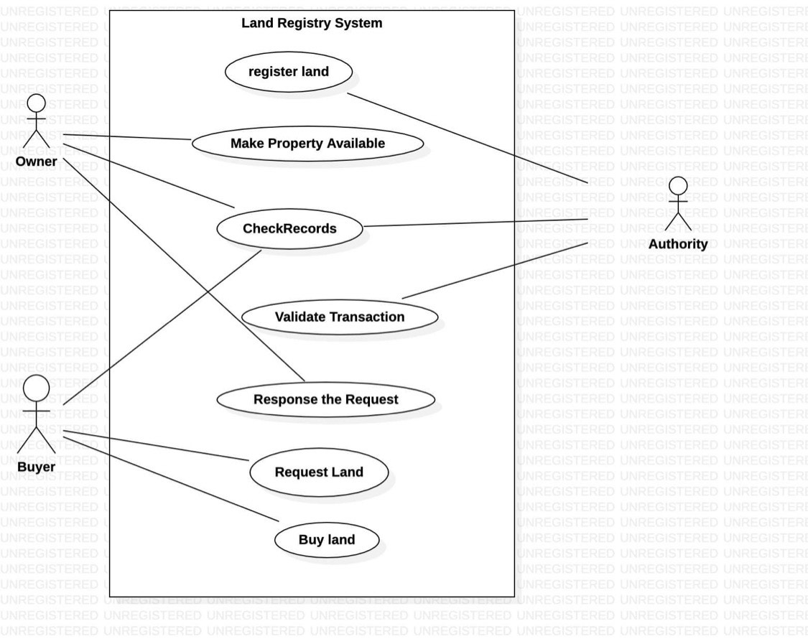

* + 1. **Login/Register**The users must be able to register and login to access full functionality of the system.
    2. **Browse products**

The users can browse different products with an option to filter items based on different categories. The system should sort the list of products based on ratings, popularity.

* + 1. **View description of products**

The users should be able to view the descriptions of the products. The descriptions include specifications of the products.

* + 1. **Add/Remove from cart**

The system should provide users with an option to add products into their virtual cart which can later be checked out. The users can remove items from the cart later on.

* + 1. **Recommend products**

The system must recommend different products to the users based on their interest. The recommended products should be based on the purchase records of others users.

* + 1. **Rate products**

The users can provide ratings to each product.

* + 1. **Search products**

The user can search for products and find products that match the searched keyword.

## Non-Functional Requirements

* + 1. **Reliability**The system has to be reliable by properly handling unwanted actions or exceptions.
    2. **Availability**The system should have uptime to the maximum level.
    3. **Performance**The User Interface should be interactive by responding to the actions fast.
    4. **Scalability**The system should be capable of supporting the growth and address the concurrent actions.
    5. **Maintainability**The system should be maintainable after the deployment.
    6. **Security**The system should store the users’ credentials securely.
    7. **Usability**The user interface should be simple and easily adaptable for the users to operate the system with ease.

## Feasibility Analysis

### Technical Feasibility

The application uses software technologies and tools which are freely available. The technical skills required can be easily manageable. There are many research papers for analysis. The hardware technology required for operation is easy to obtain since the application can run on any computer with a web browser and an internet connection. So, the hardware and software technicalities are within accessible boundaries.

### Operational Feasibility

Since, the application is interactive, the user can easily be familiarized with the software system. This system highly focuses on parameters like reliability, maintainability, supportability, usability, sustainability, etc. that fits into the operating functions of the project. As the system is accessible with a web browser, it can be easily operated the desired functionalities, both by the user and the administrator.

### Economic Feasibility

Economic feasibility attempts to weigh the costs of developing and implementing a new system, against the benefits that would increase from having the new system in place. This feasibility study gives the top management the economic justification for the new system. There could be various types of intangible benefits on account of automation. The objectives may be achieved with a little investment and some periodic maintenance of the system which will prove beneficial to the organization in the long run.

# CHAPTER 4. SYSTEM DESIGN

## Software Development Approach

The project will implement the **Incremental Software Model** in its SDLC.It will be developed in multiple increments. In each successive increment, certain portion of the system will be developed. After completion of each increments, testing will be performed to ensure quality of the system.

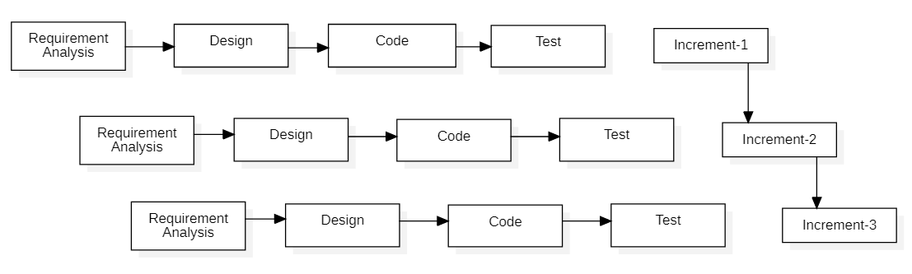

Figure 1: Representation of incremental model

## System Models

# 

Figure 2: DFD Level 0

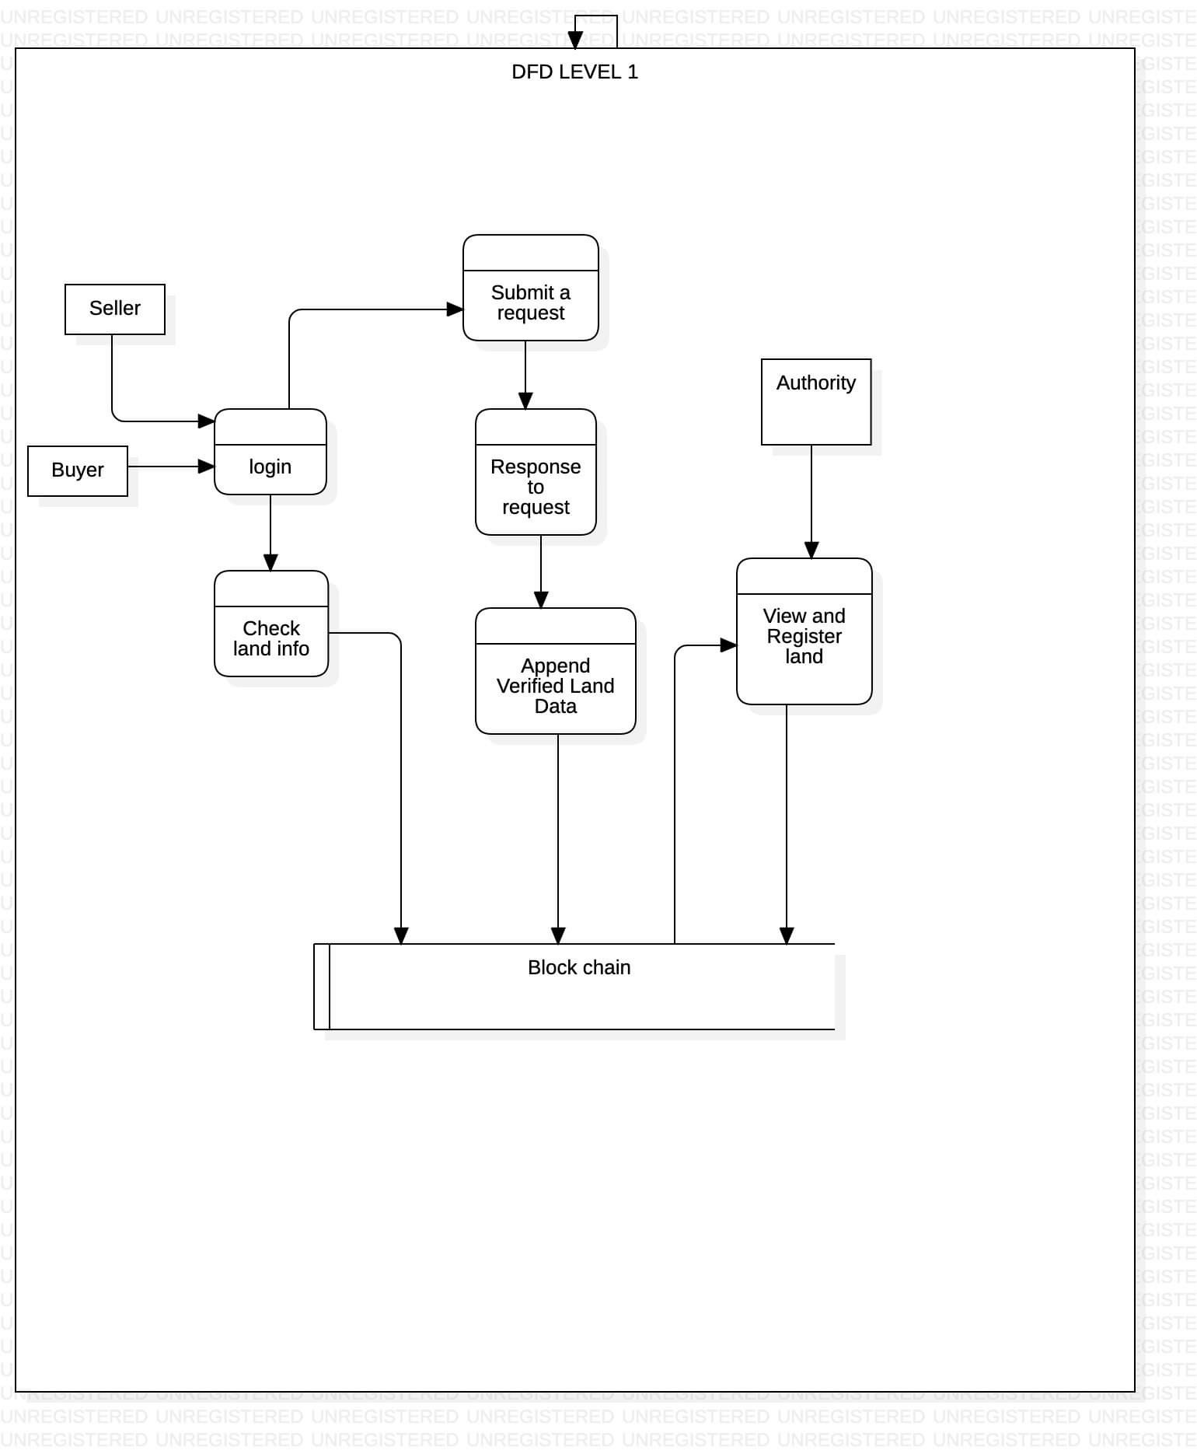

Figure 3: DFD Level 1

# CHAPTER 5. METHODOLOGY

## Implementation

The hierarchy involved in organizations involving real estate-based transactions is shown in Fig. 3, which includes one main registration oﬃce and associated sub-register oﬃces. Main registration oﬃce is linked to the sub-register oﬃces by using previous hash. Main registration oﬃce holds data related to original quantity of real estate present before sale while sub-register oﬃces have data regarding amount of real estate which has undergone transaction and the remaining real estate that is available after a particular deal. Users having multiple real estates in multiple states are also kept track oﬀ in the chain who are also linked with their respective real estate. Thereby it forms a chain of users with basic transaction related details like the previous and present owner of the property, actual price and selling price of the property along with property size.

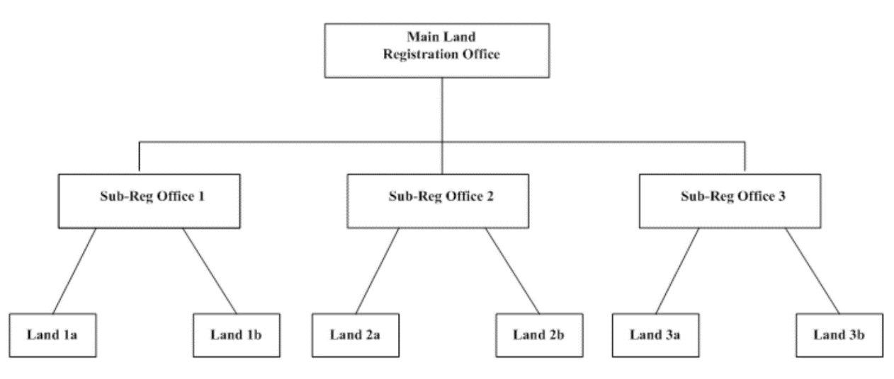

Figure 2: Hierarchy of real estate registration offices

The network is a single main chain, which has multiple blocks linked using hash. Each transaction is verified using Merkle tree. Fig. 4 shows the parameters available within a block associated with an individual user. Parameters at the input and output are used to track our transactions. Input is the point from which all transactions are derived and output is the defined as to whom we are selling the real estate.

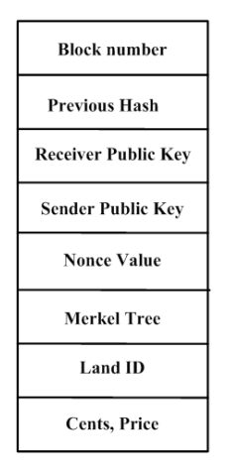

Figure 3: Parameters within a block for a user

Fig. 5 shows the block level details pertaining to multiple users. Public key of each user will be available throughout the network in a distributed manner. Private key will be used by individuals to login to their platform so as to decide on how much real estate must be put to sale and how much money must be transferred to the customers involved. During a transaction, public key will be sent throughout the network for consensus while the private key ensures that the user involved will be able to perform the transaction in a secure manner.

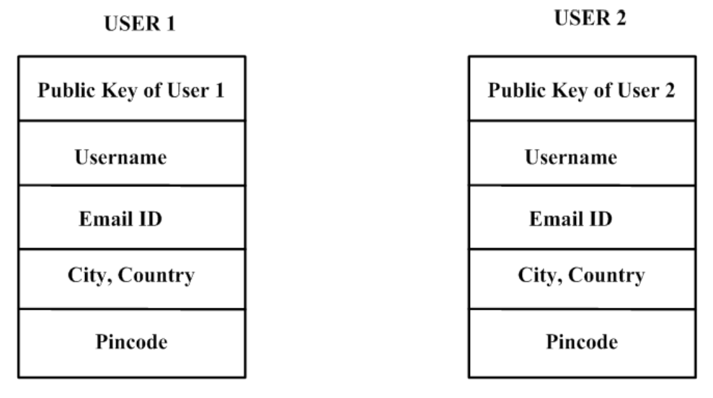

Figure 4: Block level details for multiple users

Fig. 6 shows a real estate transaction that takes place between two users in a blockchain environment. The public key associated with the seller block will be available to the buyer in order to validate the authenticity of the transaction. Private key will be used by individual users to access their data within individual blocks which cannot be accessed by any other person. Fig. 7 shows the case in which only a certain portion of real estate needs to be sold oﬀ. The remaining property details remains intact within the user block which ensures reliability. In case of a property which is having more than one owner, transaction happens only when consensus from all the owners are collected. This avoids unnecessary hassle during a real estate deal.

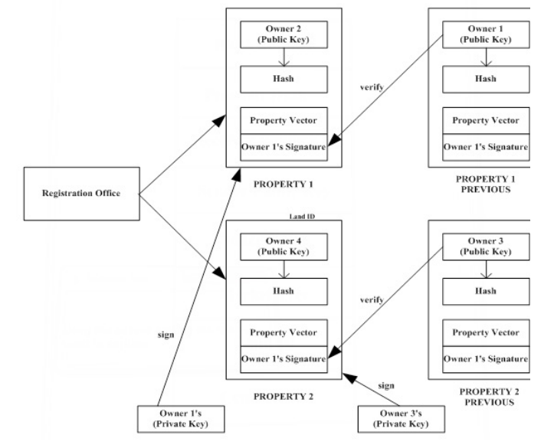

Figure 5: Real estate transaction flow in blockchain

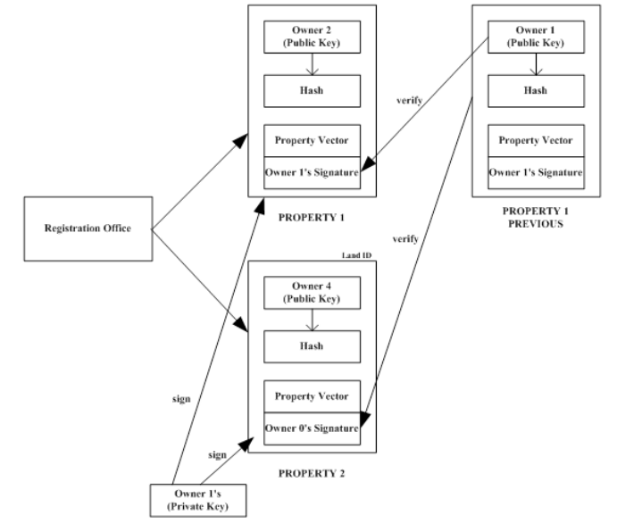

Figure 6: Specialized case of real estate transaction where only a portion is transferred

**Algorithm 1 : Algorithm to sell and split real estate**

1: function SendRealEstateAlgorithm(senderPrvtKey, estateId, cents, receiverPubKey, price)

2: inputs = get all transaction pointing to the old real estate from the blockchain

3: Find the specific real estate from the blockchain

4: oldRealEstate = getRealEstate(estateId,chain)

5: create new Transaction t( PrvtKeySender, PubKeyreceiver,newreal estate, oldreal estate, inputs)

6: sign the Transaction using the eliptic curve Algorithm for ed25519

st = EdDSA(t,SenderPvtKey)

7: check to see if the transaction was signed by the owner of the real estate itself.

8: distribute the signed real estate for verification to the entire network

9: if (st==signed by owner of real estate) then

10: assert(verifyTranction(t.signature, real estate.owners)

11: else

12: return False

13: end if

14: if (user have real estate to sell) then

15: newRealEstate=split(oldRealEstate,cents)

16: compute hash for new real estate

17: add real estate to blockchain by poW(newRealEstate,3)

18: end if

19: end function

**Algorithm 2 : Algorithm for Proof Of Work**

1: function ProofOfWork(block, di f f iculty)

2: diﬃculty factor is 3 zeros in hash value)

3: n = diﬃculty

4: while (hash(block) != n) do

1. increment nonce value by 1

2. recompute hash

5: repeat step 4

6: end while

7: Otherwise return the block with nonce value

8: end function

**Algorithm 3 : Algorithm to add new peer**

1: function AddPeer(port)

2: try to connect to a instance on the given port

3: if (connection == TRUE) then

add connection to peer list

4: return True

5: else

6: return False

7: end if

8: end function

**Algorithm 4 : Algorithm to transfer data to node**

Input the eventtype indicating what event it is, message a JSON string representing the contents.

1: function broadcastmsg(eventtype, message)

2: try to connect to a instance on the given port

3: if (connection == TRUE) then

4: for (for all peer in the peerlist) do

send (eventype,msg) to the peer

5: end for

6: else

7: return False

**Algorithm 5 : Algorithm to process message**

1: Algorithm processmessage (eventtype, message)

2: if the eventtype is connection check to see if connected node has a larger chain if so broadcast(REQUESTCHAIN, null) to connected peer

3: if the eventype is REQUESTCHAIN Create a JSON representation of the blockchain and transmit it to the peer as broadcast(CHAIN, JSON data)

4: if the eventtype is CHAIN convert JSON data to object and check to see if the given chain is valid if the given chain is valid. Then replace the existing chain with new chain

5: if the eventtype is BLOCK download the given block and check to see if all transactions in it are valid by checking the signature against the private- publickeyestate

6: else return false

## Project Tools

The following tools are going to be utilized for the development of this system.

* ReactJS
* NodeJS
* MongoDB
* Solidity
* IPFS

# REFERENCES

|  |  |
| --- | --- |
| [1] | Sajana P, M. Sindhu, and M Sethumadhavan, "On Blockchain Application: Hyperledger Fabric and Ethereum," International Journal, 2018. |
| [2] | Greeshma Sarath and S.H, M. Lal, "Privacy Preservation and Content Protection in Location Based Queries," International Conference on Contemporary Computing (IC3), 2015. |
| [3] | B. Venugopal and Greeshma Sarath, "A Novel Approach for Preserving Numerical Ordering in Encrypted Data," International Conference on Information Technology (ICIT), 2016. |
| [4] | Christo, Mary Subaja and Sarathy, Partha and Priyanka, C and Kumari, Raj and others, "An Efficient Data Security in Medical Report using Block Chain Technology," International Conference on Communication and Signal Processing (ICCSP), IEEE, 2019. |
| [5] | Nakamoto, Satoshi and others, "Bitcoin: A peer-to-peer electronic cash system," Citeseer, 2008. |
| [6] | Norta, Alex, Chad Fernandez, and Stefan Hickmott, "On Blockchain Application: Hyperledger Fabric and Ethereum," International Joint Conference on Neural Networks (IJCNN), IEEE, 2018. |
| [7] | Muhamed Turkanović, Marko Hölbl, Kristjan Košič, Marjan Hericko and Aida Kamisalic, "EduCTX: A blockchain-based higher education credit platform," IEEE, 2019. |
| [8] | Sankar, Lakshmi Siva, M. Sindhu, and M. Sethumadhavan, "Survey of consensus protocols on blockchain applications," International Conference on Advanced Computing and Communication Systems (ICACCS), IEEE, 2017. |