

**TRIBHUVAN UNIVERSITY**

**INSTITUTE OF ENGINEERING**

**HIMALAYA COLLEGE OF ENGINEERING**

**[CT-707]**

A

FINAL YEAR MAJOR PROJECT PROPOSAL

ON

**IMAGE COLORIZATION AND RESTORATION**

BY:

Ajay Maharjan (HCE075BCT006)

Ashish Rai (HCE075BCT042)

Nibendra Bajracharya (HCE075BCT015)

Sujan Maharjan (HCE075BCT037)

A PROJECT SUBMITTED TO DEPARTMRENT OF

ELECTRONICS AND COMPUTER ENGINEERING IN PARTIAL FULFILLMENT OF THE REQUIREMENT FOR BACHELOR’S

DEGREE OF COMPUTER ENGINEERING

HIMALAYA COLLEGE OF ENGINEERING

LALITPUR,NEPAL

June, 2022

**IMAGE COLORIZATION AND RESTORATION**

BY:

Ajay Maharjan (HCE075BCT006)

Ashish Rai (HCE075BCT042)

Nibendra Bajracharya (HCE075BCT015)

Sujan Maharjan (HCE075BCT037)

A report submitted for partial fulfillment of the requirements for the degree of Bachelor in Computer Engineering.

Department of Electronics and Computer Engineering

HIMALAYA COLLEGE OF ENGINEERING

Tribhuvan University

Lalitpur, Nepal

June, 2022

# ACKNOWLEDGEMENT

We take this occasion to thank our parents for their consistent support and encouragement. We are immensely thankful to our college, **Himalaya College of Engineering**, for including the project in the syllabus. We are also very grateful for the college for providing us with this opportunity. Furthermore, we extend our sincere and heartfelt thanks to our **Head of Department, Er. Ashok GM,** for providing us with the right guidance and for showing us the right way. We would like to express our deep gratitude towards **Er. Narayan Adhikari Chhetri** as well as other faculty membersfor their proper guidance and inspiration. Finally, we would like to give special thanks to acknowledge all the people who have helped us towards the development of this proposal.

**Group Members**

Ajay Maharjan (HCE075BCT006)

Ashish Rai (HCE075BCT042)

Nibendra Bajracharya (HCE075BCT015)

Sujan Maharjan (HCE075BCT037)

# ABSTRACT

In the era, where colors and style fascinate everyone, more emphasis is given on aesthetics and beauty. This research paper proposes a deep learning method based on Convolutional Neural Network (CNN) to develop an application for converting images into artistic style, colorization of the image, and inpainting of image. The proposed method combines all the two applications into a single web-based application. Here, colorization is performed by GAN, image inpainting is obtained by Generative Adversarial Network (GAN) and VAEs. Specifically, two variational autoencoders (VAEs) are trained respectively to transform old photos and clean photos into two latent spaces. And the translation between these two latent spaces is learned with synthetic paired data. This translation generalizes well to real photos.

***Keywords****: CNN, Deep Learning, Image Colorization, Image Inpainting, GAN, RELU, feed forward network, variational autoencoders.*

# TABLE OF CONTENTS

Contents

ACKNOWLEDGEMENT i

ABSTRACT ii

LIST OF FIGURES iii

LIST OF ABBREVIATIONS iv

CHAPTER 1. INTRODUCTION 1

1.1. Introduction 1

1.2. Problem Statement 3

1.3. Objectives 3

1.4. Scope and Application 4

CHAPTER 2. LITERATURE REVIEW 5

CHAPTER 3. REQUIREMENT ANALYSIS 7

3.1. Functional Requirements 7

3.2. Non-Functional Requirements 8

3.3. Feasibility Analysis 10

3.3.1. Technical Feasibility 10

3.3.2. Operational Feasibility 10

3.3.3. Economic Feasibility 10

CHAPTER 4. SYSTEM DESIGN 11

4.1. Software Development Approach 11

4.2. System Models 12

CHAPTER 5. METHODOLOGY 14

5.1. Implementation 14

5.2. Project Tools 22

REFERENCES 23

# LIST OF FIGURES

Figure 1: Representation of incremental model 20

Figure 2: Hierarchy of real estate registration offices 23

Figure 3: Parameters within a block for a user 24

Figure 4: Block level details for multiple users 25

Figure 5: Real estate transaction flow in blockchain 26

Figure 6: Specialized case of real estate transaction where only a portion is transferred 27

# LIST OF ABBREVIATIONS

|  |  |
| --- | --- |
| DB | Database |
| JS | JavaScript |
| IoT | Internet of Things |

# CHAPTER 1. INTRODUCTION

## Introduction

Currently, image processing using a deep learning technique is an emerging area and is gaining greater popularity especially in improving the quality of digital images. Transferring Style from one image to the other is one of the major concerns in texture transfer. In texture transfer, the main motive is to combine a texture feature from an input image to the expected image. This is done by preserving the semantics of the target image. They synthesize the real like natural textures by resampling the pixels of a designated source texture. Inpainting is a procedure in which is used to recover the lost fragments of an image and to recreate them. Image inpainting is applied for restoring old images, damaged films, and to edit an image in order to eliminate undesired image content. Currently, deep learning and neural networks have obtained a lot of recognition among researchers in the area of image processing. CNNs, GAN, VAEs have proved to be a successful method in image recognition, color recognition, image sharpening and restoration, pattern recognition, and image generation

## Problem Statement

Adding color to photographs by hand is a tedious process, which requires that the artist segment the image and then assign colors to each segment. The aim of our project is to design an algorithm and interactive system that automatically colorizes a monochrome image with human guidance. The algorithm takes a grayscale image and some color scribbles drawn by a human and produces a fully colorized image that is both consistent with the scribble and the image semantics. As time passes by, some part of the image may suffer from corrosion and it is unable for the human to restore the real part of the image in such a way that the inpainted region cannot be detected by a casual observer.

## Objectives

* To colorize the grayscale images and compare the accuracy of output colorized image with real image.
* To reconstruct damaged parts or missing parts of image VAEs and GANs..

## Scope and Application

# CHAPTER 2. LITERATURE REVIEW

Colorization basically involves assigning realistic colors to grey-scale image. Convolutional neural networks are specif- ically designed to deal with image data. Many authors have done promising work on this idea. Domonkos Varga [1] proposed the idea of automatic coloring of cartoon images, since they are very different from natural images, they pose a difficulty as their colors depend on artist to artist. So, the data-set was specifically trained for cartoon images, about 100000 images, 70% of which were used in training and rest for validation. But unfortunately, the color uncertainty in cartoons is much higher than in natural images and evaluation is subjective and slow. Shweta Salve [2] proposed another similar approach, employ- ing the use of Google’s image classifier, Inception ResNet V2. The system model is divided into 4 parts, Encoder, Feature extractor, Fusion layer and Decoder. The system is able to produce acceptable outputs, given enough resources, CPU, Memory, and large data-set. This is mainly proof of concept implementation. Yu Chen [3] proposed a approach to mainly address the problem of coloring Chinese films from past time. They used existing data-set with their data-set of Chinese images, fine- tuning the overall model. The network makes use of multi- scale convolution kernels, combining low and middle features extracted from VGG-16. V.K. Putri [4] proposed a method to convert plain sketches into colorful images. It uses sketch inversion model and color prediction in CIELab color space. This approach is able to handle hand-drawn sketches including various geometric transformations. The limitation found was that, data-set is very limited but it works well for uncontrolled conditions. Richard Zhang [5] has proposed a optimized solution by using huge data-set and single feed-forward pass in CNN. Their main focus lies on training part. They used human subjects to test the results and were able to fool 32% of them. can have various number of neurons. The various attempts used various architectures . In some papers, generally number of neurons is same as the dimension of the feature descriptor extracted from each pixel coordinates in a gray-scale image

**Image Inpainting**

Inpainting is the process of completing or recovering the missing region in the image or removing some objects added to it. To handle this, many methods have been proposed including sequential algorithms or deep learning techniques. For that, we categorize the existing methods for images inpainting into three categories: sequential-based approaches, CNN-based approaches, and GAN-based Approaches. Recently, the strong potential of deep convolutional networks (CNNs) is being exhibited inall computer vision tasks, especially in image inpainting. CNNs are used speciﬁcally in orderto improve the expected results in this ﬁeld using large-scale training data. The sequential-based methods succeed in some parts of image inpainting like ﬁlling texture details withpromising results, yet the problem of capturing the global structure is still a challengingtask [46]. Several methods have been proposed for image inpainting using convolutionalneural networks (CNNs) or encoder-decoder network based on CNN. Shift-Net based onU-Net architecture is one of these methods that recover the missing block with good accu-racy in terms of structure and ﬁne-detailed texture [46]. In the same context, Weerasekeraet al. [47] use depth map of the image as input of the CNN architecture, whereas Zhao etal. [48] use the proposed architecture for inpainting X-ray medical images. VORNet [49]is another CNN-based approach for video inpainting for object removal. Most image inpaint-ing methods know the reference of damaged pixels of blocks. Cai et al. [50] proposed a blind image inpainting method named (BICNN). Based on convolutional neural networks (CNNs) using encoder-decoder network structure many works have been proposed for image inpainting. Zhu et al. [51] proposed a patch-based inpainting method for forensics images.Using the same technique of encoder-decoder network, Sidorov and Hardeberg [52]pro-posed an architecture for denoising, inpainting, and super-resolution for noised, inpaintedand low-resolution images, respectively. Zeng et al. [53] built a pyramidal-context archi-tecture called PEN-NET for high-quality image inpainting. Liu et al. [54] proposed a layer to the encoder-decoder network called coherent semantic attention (SCA) layer for image inpainting method. This proposed architecture is presented in Fig. 3. Further, Pathak et al [55] proposed encoder-decoder model for image inpainting. In order to ﬁll the gap between

lines drawing in an image, Sasaki et al. [56] used an encoder-decoder-based model. This

work can be helpful for scanned data that can miss some parts. For the UAV data that can

be affected in terms of resolution or containing some blindspots, Hsu et al. [57] proposed a

solution using VGG architecture. Also, for removing some text from the images Nakamura

et al. [58] proposed a text erasing method using CNN. In order to enhance the images of the

damaged artwork, Xiang et al. [59] also proposed a CNN-based method. In the same context

as [59] and using GRNN neural network, Alilou and Yaghmaee [60] proposed a non-texture image inpainting method.

The much-used technique nowadays, was introduced for image generation in 2014 in [70].

Generative adversarial networks (GANs) are a framework which contains two feed-forward

networks, a generator G and a discriminator D. The generative network, G, is trained to

create a new image which is indistinguishable from real images, whereas a discriminative

network, D is trained to differentiate between real and generated images. This relation can

be considered as a two-player min-max game in which G and D compete. To this end, the G

(D) tries to minimize (maximize) the loss function, i.e. adversarial loss, as follows:

MinGmax DEx∼Pdata(x)log D(x)+Ez∼Pz(z)log(1−D(G(z)))(1)

where z and x denote a random noise vector and a real image sampled from the noise Pz(z) and

real data distribution Pdata(x), respectively. Recently, the GAN has been applied to several

semantic inpainting techniques in order to complete the hole region naturally.

GANs are a framework that contains two feed-forward networks, a generator G and a

discriminator D, as shown in Fig. 4. The generator takes random noise z as input and

generates some fake samples similar to real ones; while the discriminator has to learn to

determine whether samples are real or fake. At present, Generative Adversarial Network

(GAN) becomes the most used technique in all computer vision applications. GAN-based

approaches use a coarse-to-ﬁne network and contextual attention module gives good perfor-

mance and is proven to be helpful for inpainting [71–75]. Existing image inpainting methods

based on GAN are generally a few. Out of these, we ﬁnd that in [71], Chen and Hu proposed a

GAN-based semantic image inpainting method, named progressive inpainting, where a pyra-

mid strategy from a low-resolution image to a higher one is performed for repairing the image.

For handwritten images, Li et al. [72] proposed a method for inpainting and recognition of

occluded characters. The methods use improved GoogLeNet and deep convolutional gener-

ative adversarial network (DCGAN). In an image inpainting method named PEPSI [76]the

authors unify the two-stage cascade network of the coarse-to-ﬁne network into a single-stage

encoder-decoder network. Where PEPSI++ is the extended version of PEPSI [73]. In [74]

the authors used Encoder-decoder network and multi-scale GAN for image inpainting. The

samecombinationisusedin[75] for image inpainting and image-to-image transformation

purposes. On the RBG-D images, Dhamo et al. [77] used CNN and GAN model to generate

the background of a scene by removing the object in the foreground image as performed by

many methods of motion detection using background subtraction [78,79]. In order to com-

plete the missing regions in the image, Vitoria et al. [80] proposed an improved version of the

Wasserstein GAN with the incorporation of Discriminator and Generator architecture. In the

same context, but on sea surface temperature (SST) images, the Dong et al. [81] proposed a

deep convolutional generative adversarial network (DCGAN) for ﬁling the missing parts of

the images. Also, Lou et al. [82] exploit a modiﬁer GAN architecture for image inpainting

whereas, Salem et al. [83] proposed a semantic image inpainting method using adversarial

loss and self-learning encoder-decoder model. A good image restoration method requires

preserving structural consistency and texture clarity. For this reason, Liu et al. [84] proposed

a GAN-based method for image inpainting on face images. FiNet [85] is another approach

found in the literature for fashion image inpainting that consists of completing the missing

parts in fashion images.

Recently, several approaches are proposed by combining some additional techniques

(GAN, CNN,…) for inpainting the images. Jiao et al. [86] combined an encoder-decoder,

multi-layer convolutions layers and GAN for restoring the images. The authors in [87]pro-

posed a two-stage adversarial model named EdgeConnect by providing a generator for edge

followed by an image inpainting model. The ﬁrst model attempt to provide an edge com-

pletion component and the second one, inpaint the RGB image. According to the fact that

GAN-based image inpainting models do not care out to the consistency of the structural

and textural values between the inpainted region and their neighboring, the authors in [88]

attempts to handle this limitation by providing a GAN model for learning the alignment

between the block around the restored region and the original region. For the same reason

as [88], taking into consideration the semantic consistency between restored images and

original images, Li et al. [89] provided a boosted GAN model comprising an inpainting net-

work and a discriminative network. When the inpainting network discovers the segmentation

information of the input images, the discriminative network discovers the regularizations of

the overall realness and segmentation consistency with the originals images. In the same

context and using GAN-based models for images inpainting, each work provides some prior

processing on GAN networks to get the best inpainting results for different types of images

including medical images [90], face images [91] or scenes images [92].

The GAN-based methods give a good addition to the performance of image inpainting

algorithms, but the speed of training is lower and needs very good performance machines,

and this is due to computational resources requirements including network parameters and

convolution operations.

[1]In the analysis paper of J. B. Allen et al, described about the Language that’s the utmost vital significant means of communication and speech is its major interface. The interface for human to machine, speech signal was regenerate into analog and digital wave form as a machine understood [2]. [2]In the analysis paper of B. S. Atal and L. R. Rabiner et al, explained regarding speech analysis, and results regularly completed in together with pitch analysis. The analysis described a pattern recognition technique for determining whether a given slice of a speech signal should be categorized as voiced speech, unvoiced speech, or silence, counting on dimensions finished on signal. The main restriction of the technique is the demand for exercise the algorithmic on precise set of dimensions picked, and for the precise recording circumstances [3]. [3]. In the analysis paper of Deny Nancy (2019) et al. within the Era of fast paced technology we are able to do things which we never thought we tend to may do before however, to achieve and accomplish these thought s there’s a desire for a platform which can automate all our tasks with ease and luxury. Thus, we humans developed applications like Personal Voice Assistant having the ability to inter act with the surroundings simply by one of the materialistic forms of human inter action i.e. .Human Voice [4][4]V. Radha and C. Vimala et al, explained that most general mode of communication among human beings is speech. As this is the utmost technique, human beings would identical to utilize speech to interrelate with machines too. Because of this, autonomous speech identification has got a lot of reputation. Most techniques for speech recognition be like Dynamic Time Warping (DTW), HMM. For the feature mining of speech Mel Frequency Cepstrum Coefficients (MFCC) has been utilized which offers a group of characteristic vectors of speech waveform. Prior study has exposed MFCC to be more precise and real than rest characteristic mining approaches in the speech recognition. The effort has been completed on MATLAB and investigational outcomes depict that system is capable of identifying words at satisfactorily great accuracy [5]. [5].

# CHAPTER 3. REQUIREMENT ANALYSIS

## Functional Requirements

The functionalities that the system should provide in order to satisfy the needs and requirements of the users are as listed below:

**Use Case Diagram**

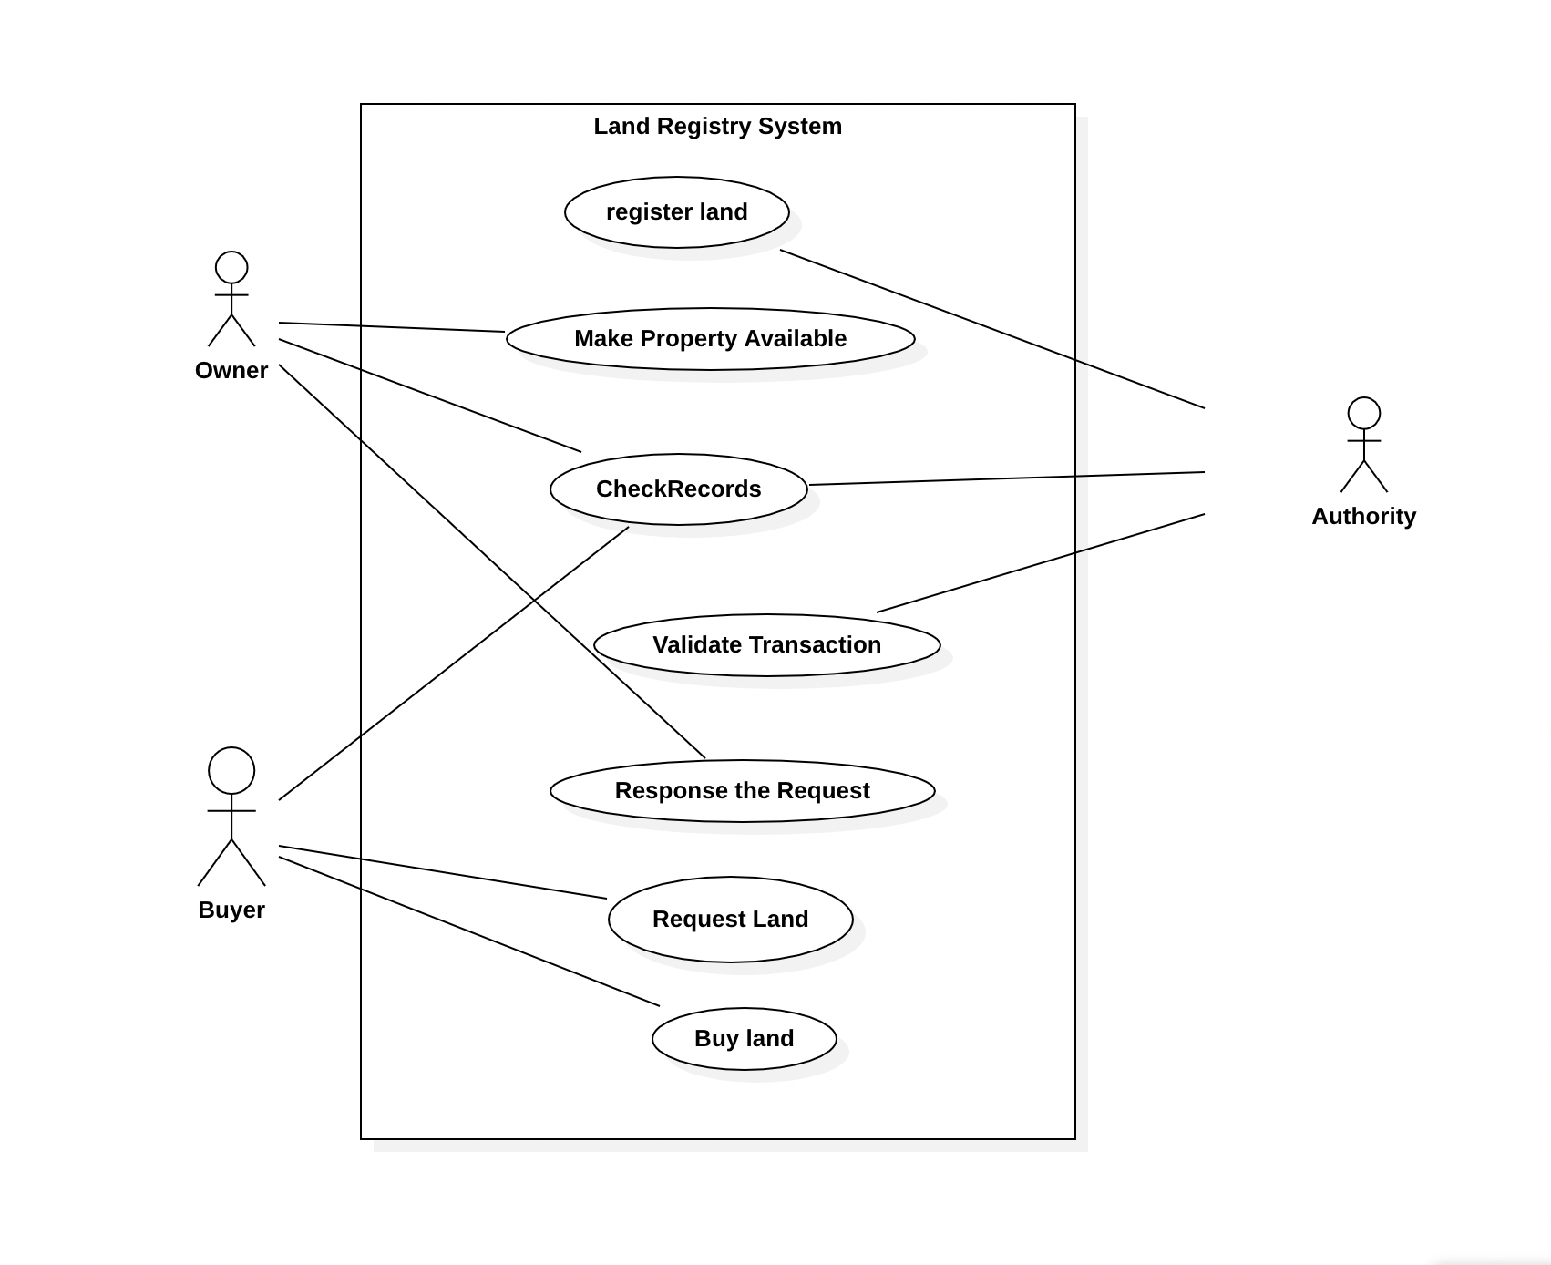



## Non-Functional Requirements

* + 1. **Reliability**The system has to be reliable by properly handling unwanted actions or exceptions.
    2. **Availability**The system should have uptime to the maximum level.
    3. **Performance**The User Interface should be interactive by responding to the actions fast.
    4. **Scalability**The system should be capable of supporting the growth and address the concurrent actions.
    5. **Maintainability**The system should be maintainable after the deployment.
    6. **Security**The system should store the users’ credentials securely.
    7. **Usability**The user interface should be simple and easily adaptable for the users to operate the system with ease.

## Feasibility Analysis

### Technical Feasibility

The application uses software technologies and tools which are freely available. The technical skills required can be easily manageable. There are many research papers for analysis. The hardware technology required for operation is easy to obtain since the application can run on any computer with a web browser and an internet connection. So, the hardware and software technicalities are within accessible boundaries.

### Operational Feasibility

Since, the application is interactive, the user can easily be familiarized with the software system. This system highly focuses on parameters like reliability, maintainability, supportability, usability, sustainability, etc. that fits into the operating functions of the project. As the system is accessible with a web browser, it can be easily operated the desired functionalities, both by the user and the administrator.

### Economic Feasibility

Economic feasibility attempts to weigh the costs of developing and implementing a new system, against the benefits that would increase from having the new system in place. This feasibility study gives the top management the economic justification for the new system. There could be various types of intangible benefits on account of automation. The objectives may be achieved with a little investment and some periodic maintenance of the system which will prove beneficial to the organization in the long run.

# CHAPTER 4. SYSTEM DESIGN

## Software Development Approach

The project will implement the **Incremental Software Model** in its SDLC.It will be developed in multiple increments. In each successive increment, certain portion of the system will be developed. After completion of each increments, testing will be performed to ensure quality of the system.

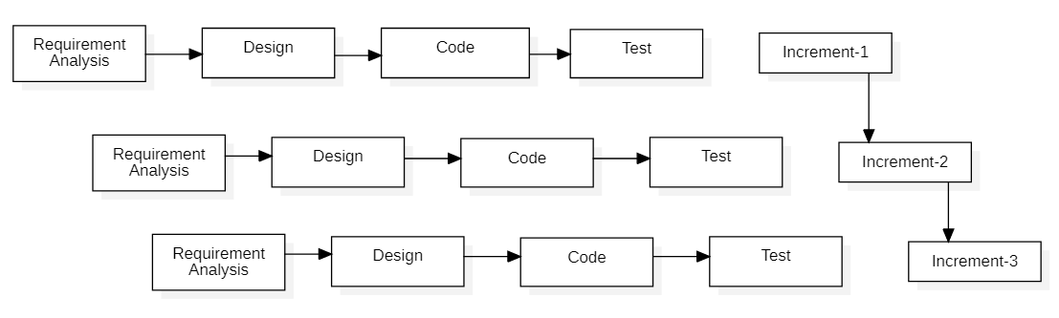

Figure 1: Representation of incremental model

## System Models

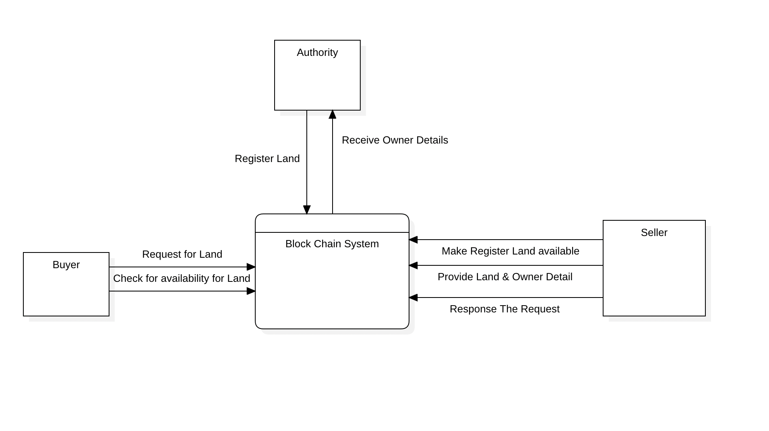

Figure 2: DFD Level 0

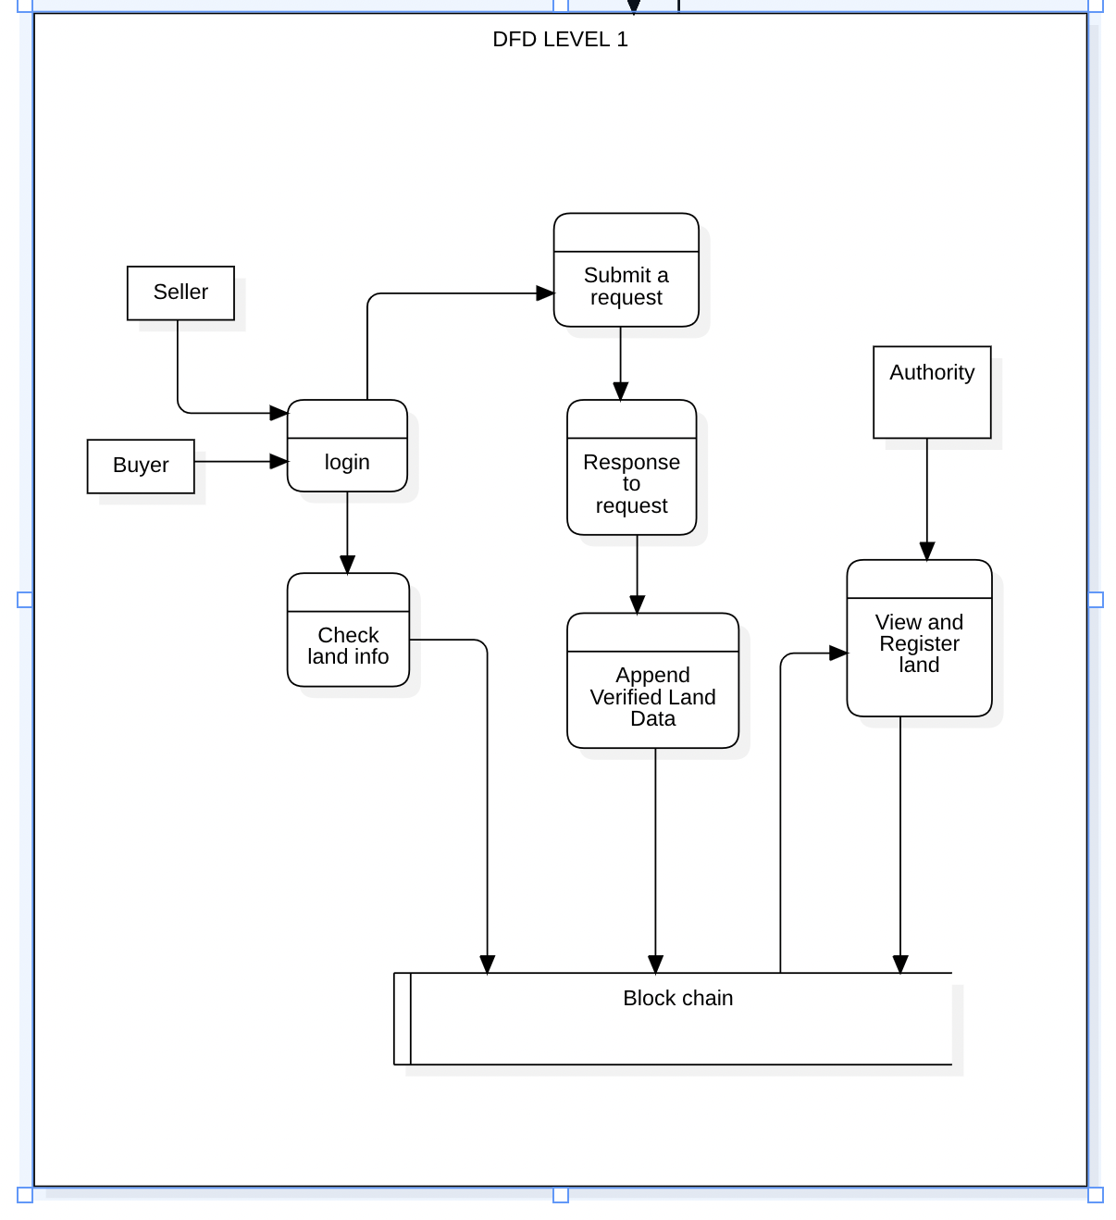

Figure 3: DFD Level 1

# CHAPTER 5. METHODOLOGY

## Implementation

The hierarchy involved in organizations involving real estate-based transactions is shown in Fig. 3, which includes one main registration oﬃce and associated sub-register oﬃces. Main registration oﬃce is linked to the sub-register oﬃces by using previous hash. Main registration oﬃce holds data related to original quantity of real estate present before sale while sub-register oﬃces have data regarding amount of real estate which has undergone transaction and the remaining real estate that is available after a particular deal. Users having multiple real estates in multiple states are also kept track oﬀ in the chain who are also linked with their respective real estate. Thereby it forms a chain of users with basic transaction related details like the previous and present owner of the property, actual price and selling price of the property along with property size.

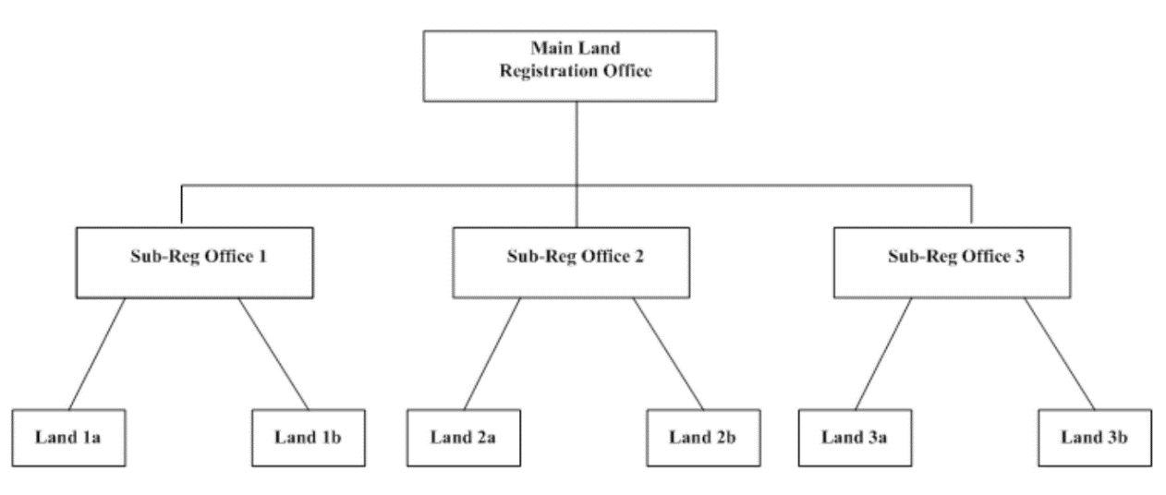

Figure 2: Hierarchy of real estate registration offices

The network is a single main chain, which has multiple blocks linked using hash. Each transaction is verified using Merkle tree. Fig. 4 shows the parameters available within a block associated with an individual user. Parameters at the input and output are used to track our transactions. Input is the point from which all transactions are derived and output is the defined as to whom we are selling the real estate.

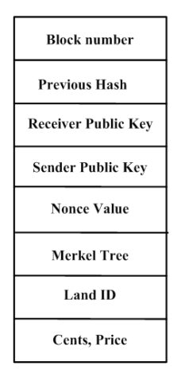

Figure 3: Parameters within a block for a user

Fig. 5 shows the block level details pertaining to multiple users. Public key of each user will be available throughout the network in a distributed manner. Private key will be used by individuals to login to their platform so as to decide on how much real estate must be put to sale and how much money must be transferred to the customers involved. During a transaction, public key will be sent throughout the network for consensus while the private key ensures that the user involved will be able to perform the transaction in a secure manner.

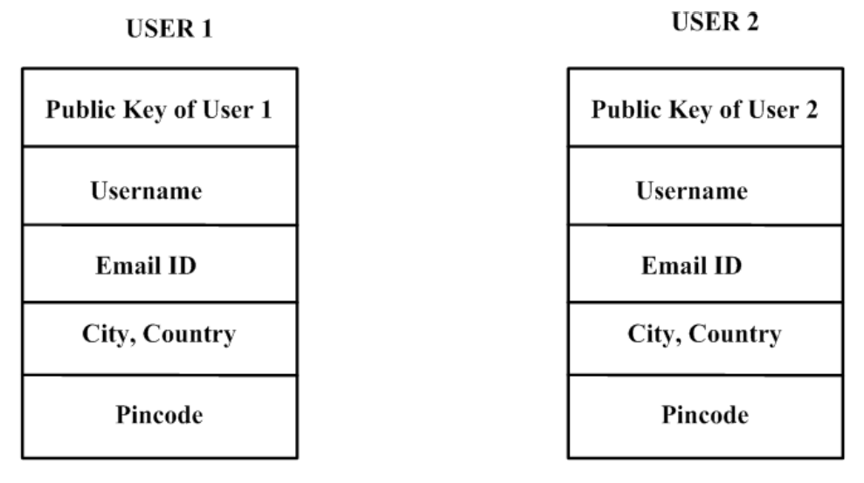

Figure 4: Block level details for multiple users

Fig. 6 shows a real estate transaction that takes place between two users in a blockchain environment. The public key associated with the seller block will be available to the buyer in order to validate the authenticity of the transaction. Private key will be used by individual users to access their data within individual blocks which cannot be accessed by any other person. Fig. 7 shows the case in which only a certain portion of real estate needs to be sold oﬀ. The remaining property details remains intact within the user block which ensures reliability. In case of a property which is having more than one owner, transaction happens only when consensus from all the owners are collected. This avoids unnecessary hassle during a real estate deal.

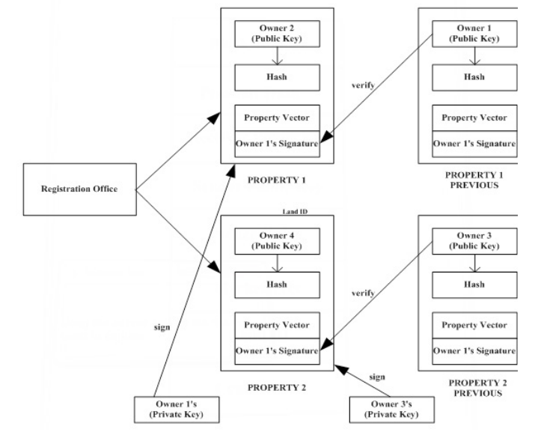

Figure 5: Real estate transaction flow in blockchain

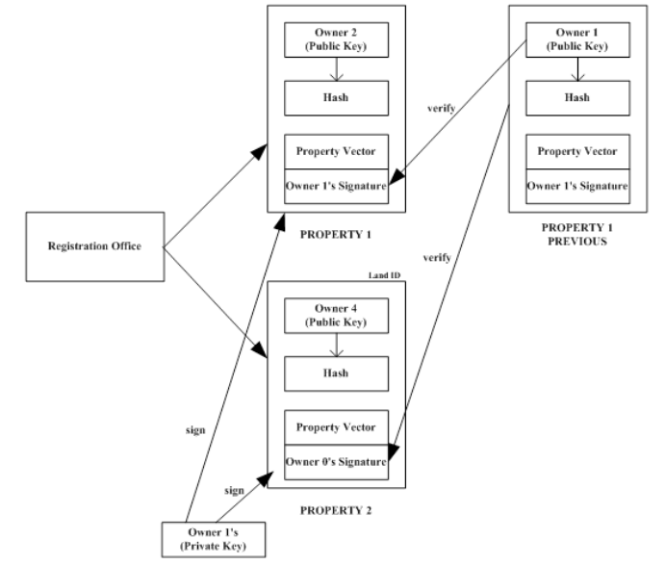

Figure 6: Specialized case of real estate transaction where only a portion is transferred

**Algorithm 1 : Algorithm to sell and split real estate**

1: function SendRealEstateAlgorithm(senderPrvtKey, estateId, cents, receiverPubKey, price)

2: inputs = get all transaction pointing to the old real estate from the blockchain

3: Find the specific real estate from the blockchain

4: oldRealEstate = getRealEstate(estateId,chain)

5: create new Transaction t( PrvtKeySender, PubKeyreceiver,newreal estate, oldreal estate, inputs)

6: sign the Transaction using the eliptic curve Algorithm for ed25519

st = EdDSA(t,SenderPvtKey)

7: check to see if the transaction was signed by the owner of the real estate itself.

8: distribute the signed real estate for verification to the entire network

9: if (st==signed by owner of real estate) then

10: assert(verifyTranction(t.signature, real estate.owners)

11: else

12: return False

13: end if

14: if (user have real estate to sell) then

15: newRealEstate=split(oldRealEstate,cents)

16: compute hash for new real estate

17: add real estate to blockchain by poW(newRealEstate,3)

18: end if

19: end function

**Algorithm 2 : Algorithm for Proof Of Work**

1: function ProofOfWork(block, di f f iculty)

2: diﬃculty factor is 3 zeros in hash value)

3: n = diﬃculty

4: while (hash(block) != n) do

1. increment nonce value by 1

2. recompute hash

5: repeat step 4

6: end while

7: Otherwise return the block with nonce value

8: end function

**Algorithm 3 : Algorithm to add new peer**

1: function AddPeer(port)

2: try to connect to a instance on the given port

3: if (connection == TRUE) then

add connection to peer list

4: return True

5: else

6: return False

7: end if

8: end function

**Algorithm 4 : Algorithm to transfer data to node**

Input the eventtype indicating what event it is, message a JSON string representing the contents.

1: function broadcastmsg(eventtype, message)

2: try to connect to a instance on the given port

3: if (connection == TRUE) then

4: for (for all peer in the peerlist) do

send (eventype,msg) to the peer

5: end for

6: else

7: return False

**Algorithm 5 : Algorithm to process message**

1: Algorithm processmessage (eventtype, message)

2: if the eventtype is connection check to see if connected node has a larger chain if so broadcast(REQUESTCHAIN, null) to connected peer

3: if the eventype is REQUESTCHAIN Create a JSON representation of the blockchain and transmit it to the peer as broadcast(CHAIN, JSON data)

4: if the eventtype is CHAIN convert JSON data to object and check to see if the given chain is valid if the given chain is valid. Then replace the existing chain with new chain

5: if the eventtype is BLOCK download the given block and check to see if all transactions in it are valid by checking the signature against the private- publickeyestate

6: else return false

## Project Tools

The following tools are going to be utilized for the development of this system.

* ReactJS
* NodeJS
* MongoDB
* Solidity
* IPFS

[1] C. A. S. Domonkos Varga and T. Szirfffdfffdnyi, Auto- matic cartoon colorization based on convolutional neuralnetwork ,<https://core.ac.uk/download/pdf/94310076.pdf>, 2017.

[2] S. Salve, T. Shah, V. Ranjane, and S. Sadhukhan, Au- tomatization of coloring grayscale images using convolu- tional neural network, Apr. 2018. DOI: 10.1109/ICICCT. 2018.8473259.

[3] Automatic colorization of images from chinese black and white films based on cnn, 2018. DOI: 10.1109/ICALIP. 2018.8455654.

[4] V. K. Putri and M. I. Fanany, “Sketch plus colorization deep convolutional neural networks for photos generation from sketches,” in 2017 4th International Conference on Electrical Engineering, Computer Science and Informat- ics (EECSI), Sep. 2017, pp. 1–6. DOI: 10.1109/EECSI. 2017.8239116.

[5] R. Zhang, P. Isola, and A. A. Efros, “Colorful image colorization,” in ECCV, 2016.

# REFERENCES

|  |  |
| --- | --- |
| [1] | M. Bapat, H. Gune, and P. Bhattacharyya, "A paradigm-based finite state morphological analyzer for marathi," Workshop on South and Southeast Asian Natural Language Processing (WSSANLP), 2010. |
| [2] | H. H. Monson, Statistical Digital Signal Processing and Modeling, John Wiley & Sons Inc., 1996. |
| [3] | Proakis John G., Manolakis Dimitris G., Digital Signal Processing, principles, algorithms, and applications, 3rd ed., New Jersey. |
| [4] | "http://www.microsoft.com/MSDN/speech.html," 2012. |
| [5] | V.Radha and C. Vimala, "A review on speech recognition challenges and approaches," vol. 2, no. 1, pp. 1-7, 2012. |