Azure Data Engineering End-to-End Hands-On Assignment
Project Title: AWS S3 to Azure Data Platform Migration and Data Transformation Project
1. Project Overview
Business Scenario
ABC Retail Corporation currently stores daily sales files in AWS S3. The organization is migrating its analytics platform to Microsoft Azure.
The Data Engineering team has been asked to:
- Extract CSV files from AWS S3.
- Migrate data into Azure Data Lake Storage Gen2.
- Transform and cleanse data.
- Convert CSV files into Parquet format.
- Load transformed data into Azure SQL Database.
- Build automated pipelines.
- Configure event-based triggers for file arrival.
- Monitor pipeline executions.
This project simulates a real-world enterprise migration scenario.
2. Solution Architecture
AWS S3 Bucket
↓
Azure Data Factory
↓
Azure Data Lake Gen2 (Raw Zone)
↓
Azure Data Factory Mapping Data Flow
↓
Azure Data Lake Gen2 (Processed Zone - Parquet)
↓
Azure SQL Database
↓
Power BI / Reporting Layer
Trigger Flow:
New File Arrives in S3
↓
ADF Trigger
↓
Migration Pipeline
↓
Transformation Pipeline
↓
Load Pipeline
↓
Notification & Monitoring
3. Azure Resources to Create
Resource Group
Name: RG-Retail-DataEngineering-Dev
Purpose: Container for all Azure resources.
Storage Account
Name: stretaildev001
Enable:
- Hierarchical Namespace
- ADLS Gen2
Containers:
- raw
- processed
- curated
- archive
- error
Azure Data Factory
Name: ADF-Retail-Dev
Purpose: Pipeline orchestration.
Azure SQL Database
Server: sql-retail-dev
Database: RetailDW
Purpose: Store transformed sales data.
Azure Key Vault
Name: KV-Retail-Dev
Purpose: Store AWS Access Key, AWS Secret Key, SQL Password, Storage Account Keys
Log Analytics Workspace
Name: LAW-Retail-Dev
Purpose: Monitoring and diagnostics.
4. Create Source Datasets
Dataset 1: sales_data.csv
Columns:
- OrderID
- CustomerID
- ProductID
- Quantity
- UnitPrice
- OrderDate
- Country
- SalesChannel
Dataset 2: customer_data.csv
Columns:
- CustomerID
- CustomerName
- Email
- Country
- CustomerSegment
Dataset 3: product_data.csv
Columns:
- ProductID
- ProductName
- Category
- CostPrice
- SellingPrice
5. Sample Sales Data
sales_data.csv
OrderID | CustomerID | ProductID | Quantity | UnitPrice | OrderDate | Country | SalesChannel
1001 | C101 | P001 | 2 | 500 | 2026-01-01 | USA | Online
1002 | C102 | P002 | 1 | 1200 | 2026-01-02 | Canada | Store
1003 |  | P003 | 5 | 50 | 2026-01-03 | USA | Online
1004 | C104 | P004 | -1 | 250 | 2026-01-04 | UK | Store
1005 | C105 | P005 | 3 | 400 | 2026-01-05 | India | Online
1005 | C105 | P005 | 3 | 400 | 2026-01-05 | India | Online

6. Linked Services Configuration
AWS S3 Linked Service
Authentication: Access Key
Secret Key
Bucket: retail-sales-data
ADLS Linked Service
Authentication: Managed Identity
Azure SQL Linked Service
Authentication: SQL Authentication
Azure Key Vault Linked Service
Authentication: Managed Identity
7. Data Migration Pipeline
Pipeline Name: PL_S3_To_ADLS
Purpose: Move CSV files from AWS S3 into ADLS Raw Zone.
Activities:
- Get Metadata
- Validation
- Copy Activity
- Logging
- Error Handling
Pipeline Flow:
S3 Source
↓
Copy Activity
↓
ADLS Raw Zone
8. Create Datasets in ADF
Dataset Name: DS_S3_Sales_CSV
Format: Delimited Text

Dataset Name: DS_ADLS_Raw_Sales
Format: CSV

Dataset Name: DS_ADLS_Parquet
Format: Parquet

Dataset Name: DS_SQL_SalesFact
Format: Azure SQL Table

9. Data Transformation Requirements
Pipeline Name: PL_Sales_Transformation
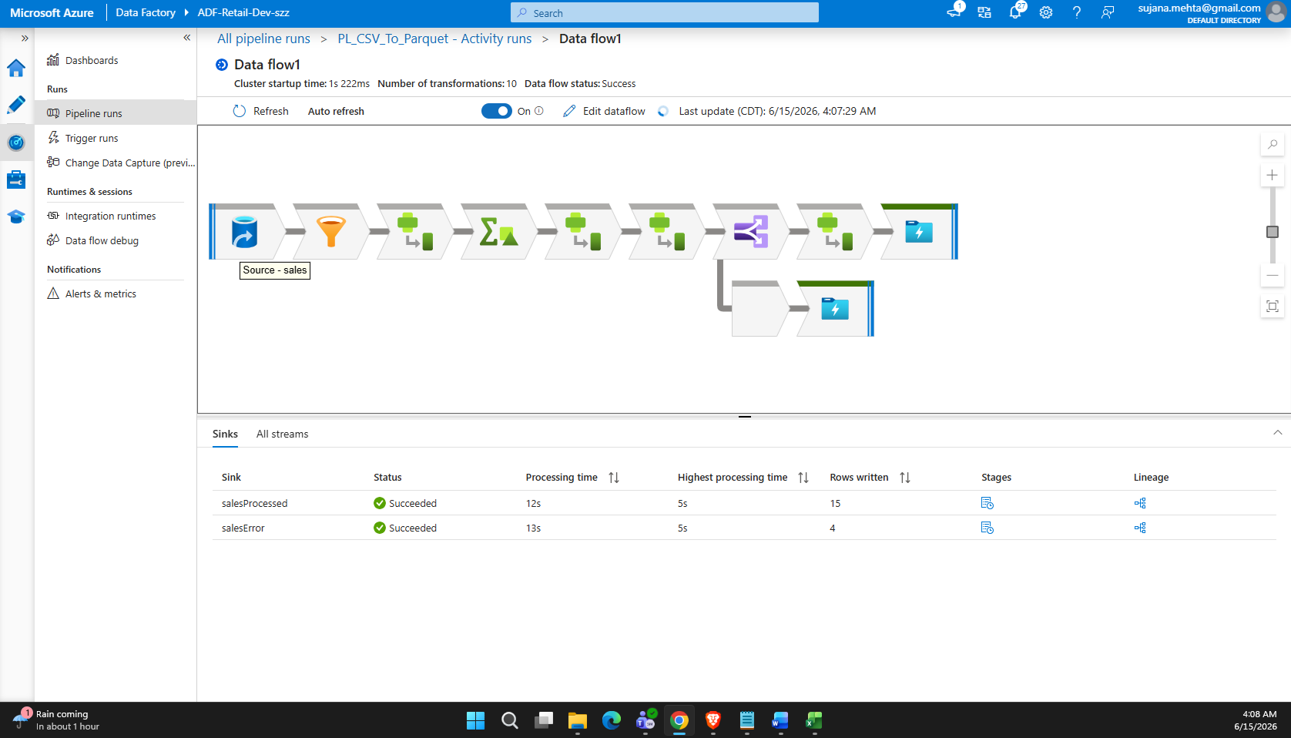
Data Flow Name: DF_Sales_Cleansing
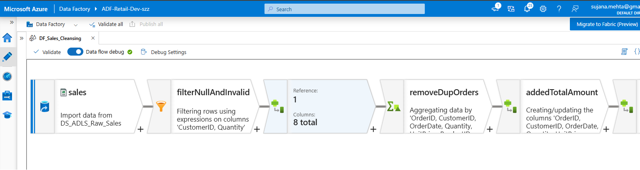
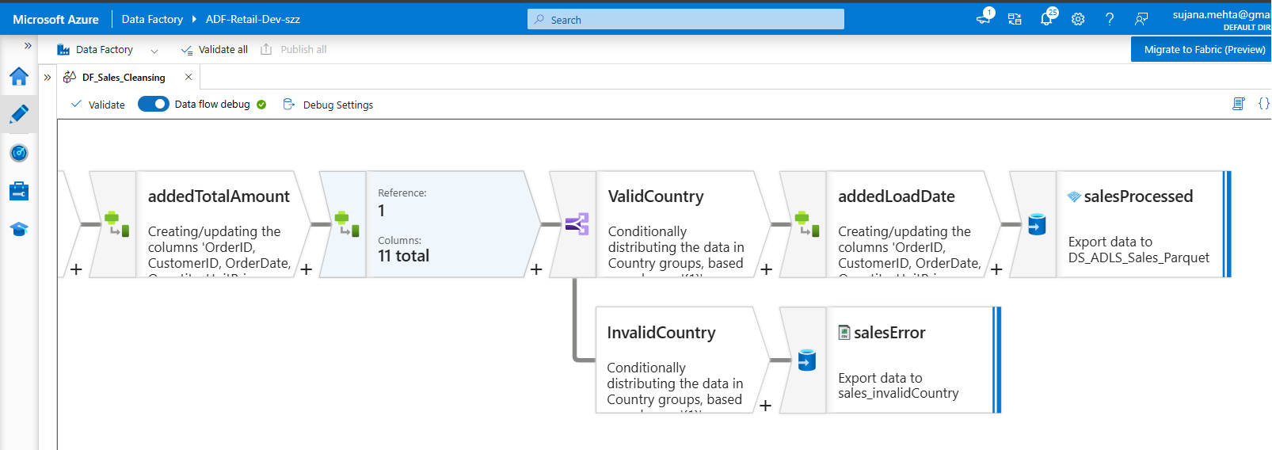
10. CSV to Parquet Conversion Pipeline
Pipeline Name: PL_CSV_To_Parquet
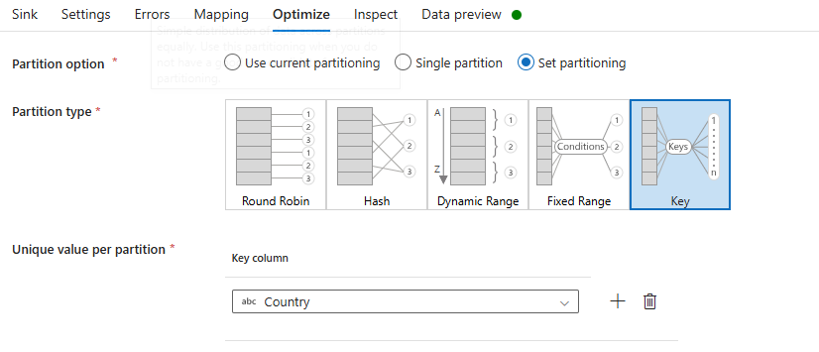
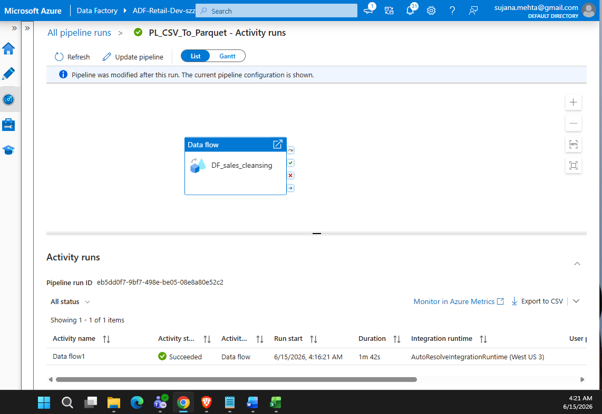

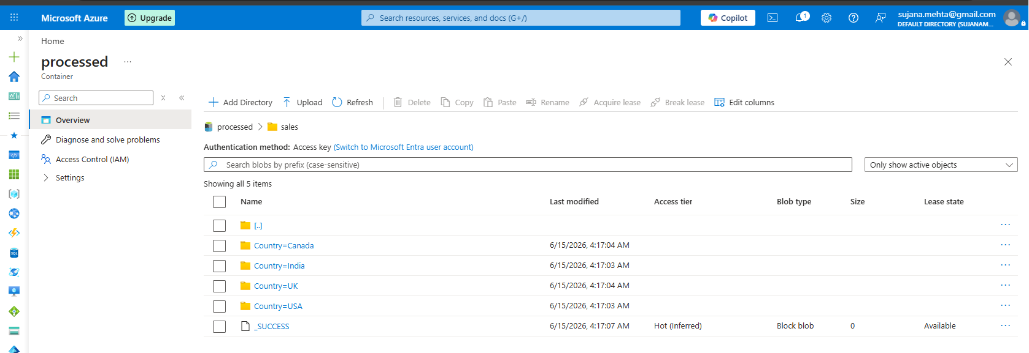
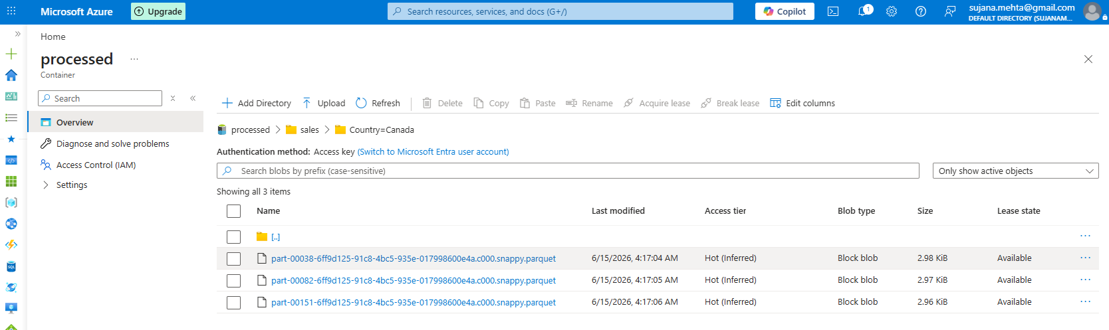

11. SQL Database Table
Table Name: FactSales
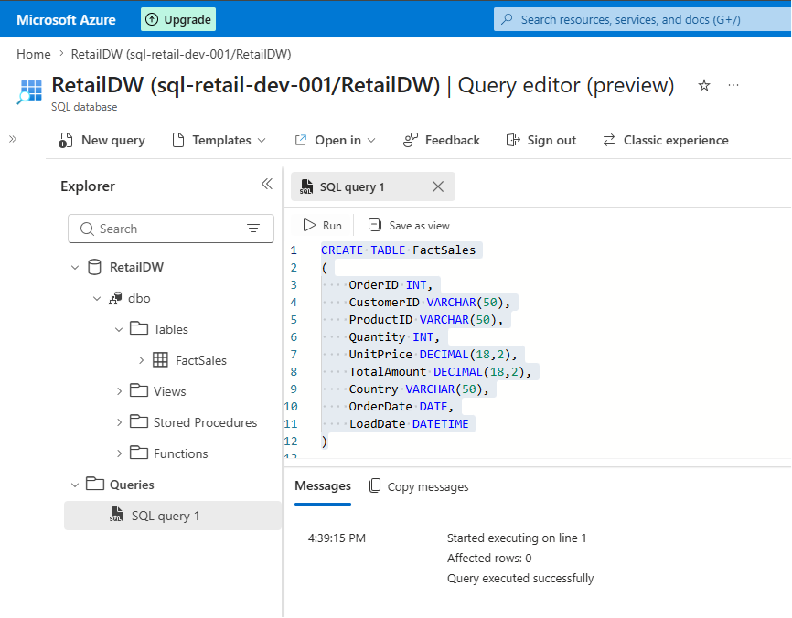
12. Loading Data into SQL Database
Pipeline Name: PL_Parquet_To_SQL
Activities:
Read Parquet
↓
Validate Schema
↓
Insert into FactSales
↓
Audit Logging
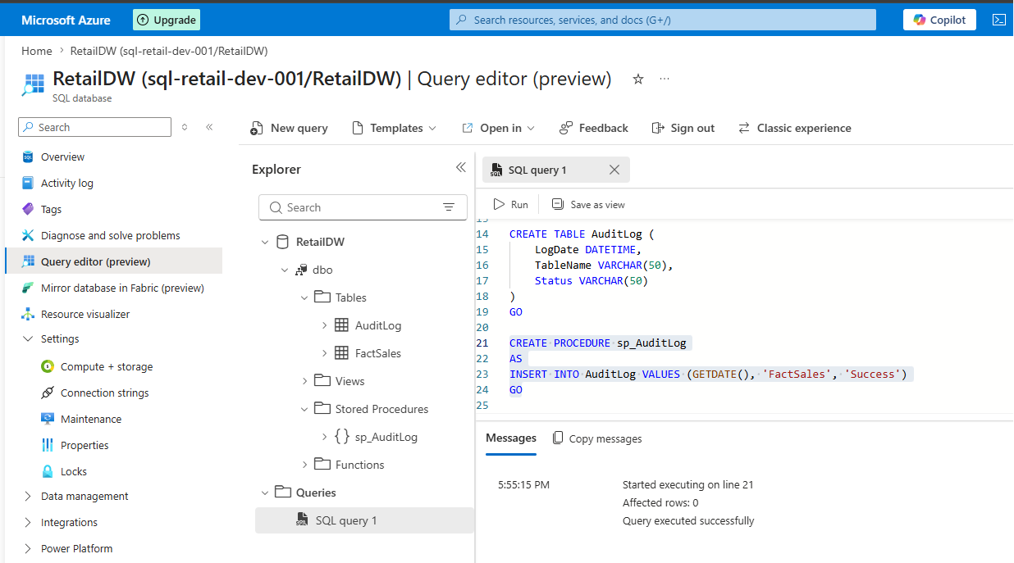
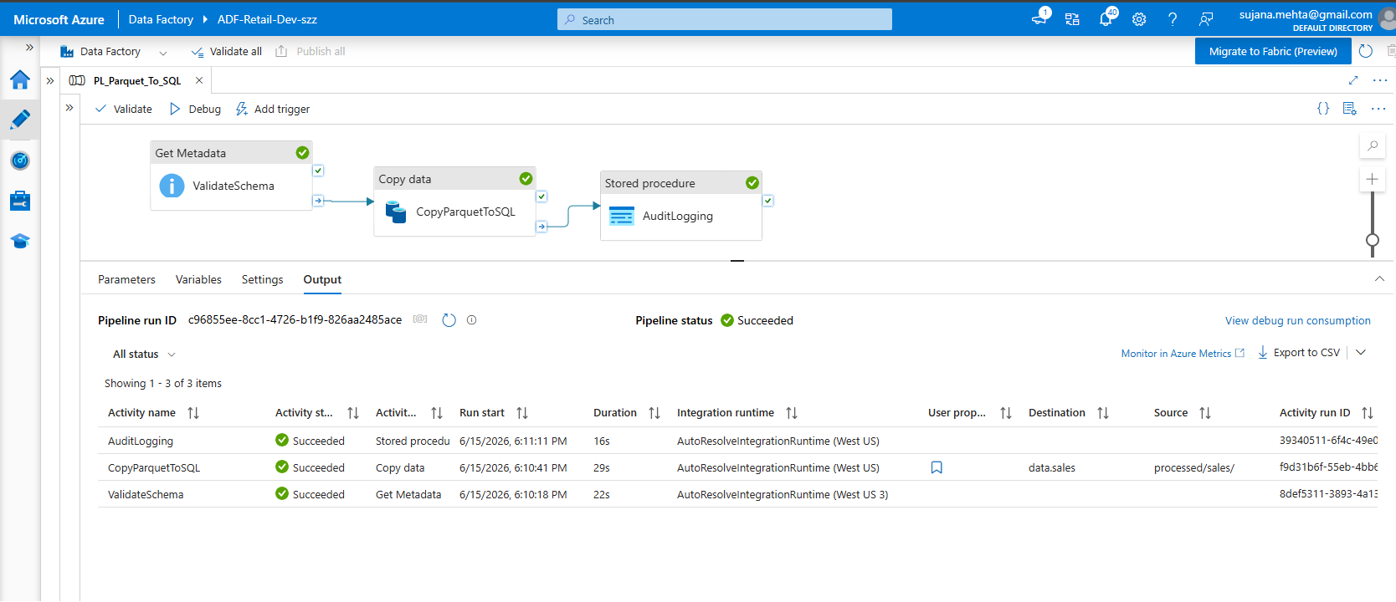

13. Trigger Configuration
Trigger Name: TRG_S3_FileArrival
Process:
New CSV File Uploaded
↓
ADF Trigger Starts
↓
Migration Pipeline
↓
Transformation Pipeline
↓
Parquet Conversion
↓
SQL Load
↓
Success Notification
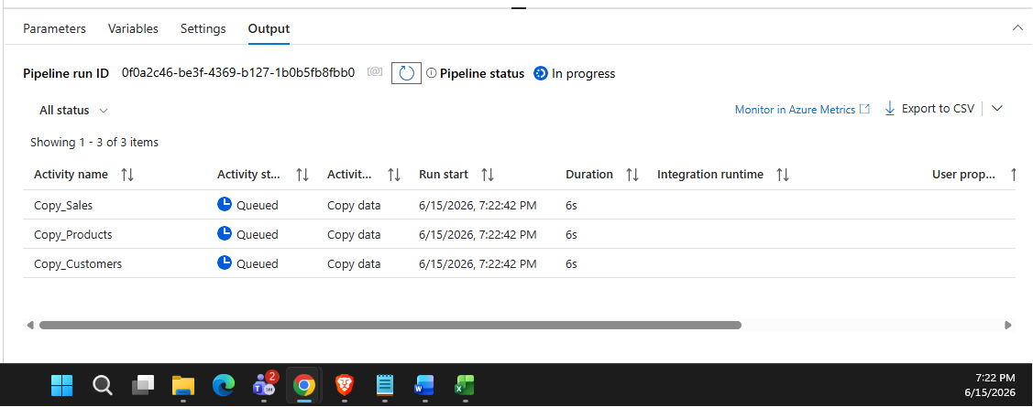
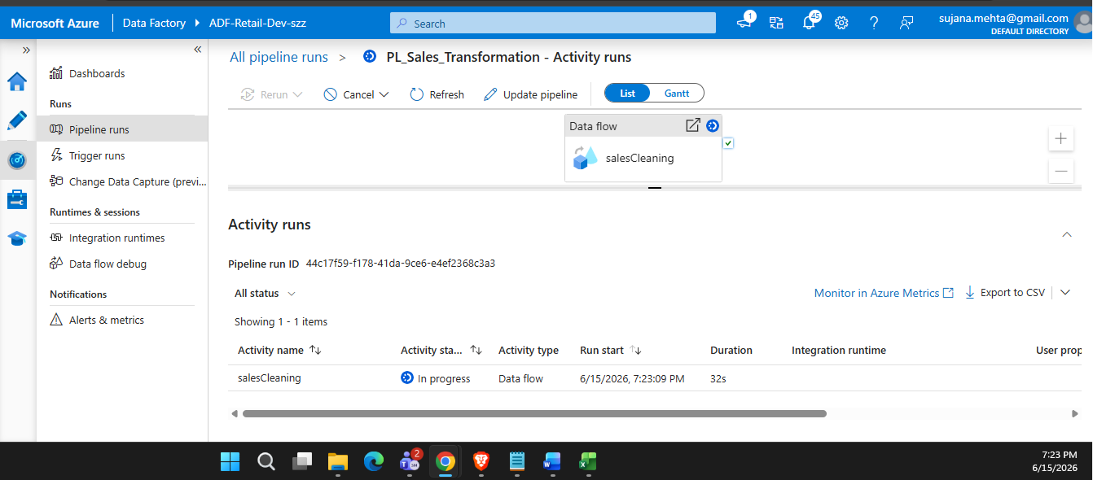
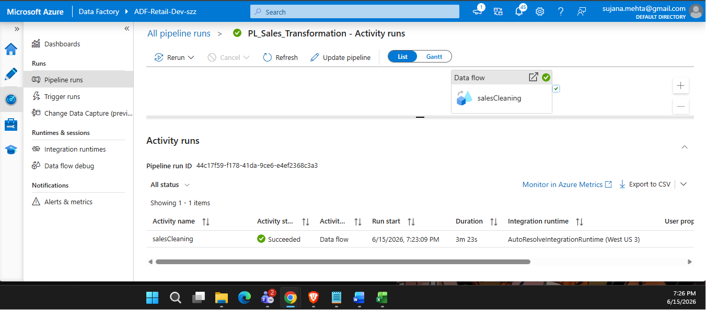

14. Monitoring Requirements
Monitor:
- Pipeline Success Rate
- Pipeline Failures
- Execution Duration
- Rows Processed
- Rows Rejected
- Storage Consumption
- SQL Load Performance
15. Error Handling
Create Error Folder: error/
Store:
- Invalid Country Records
- Null Customer Records
- Negative Quantity Records
- Schema Mismatch Records
16. Naming Convention Standards
Component / Asset Type | Standard Naming Applied
Resource Group | RG-Retail-DataEngineering-Dev
Storage Account | stretaildev001
Data Factory | ADF-Retail-Dev
SQL Server | sql-retail-dev
Database | RetailDW
Pipeline | PL_S3_To_ADLS  PL_Sales_Transformation  PL_CSV_To_Parquet  PL_Parquet_To_SQL
Trigger | TRG_S3_FileArrival

17. Bonus Tasks
Task 1: Parameterize pipelines.
Task 2: Create incremental load process.
Task 3: Add watermark column.
Task 4: Implement Slowly Changing Dimension Type 2.
Task 5: Create email notification on failure.
Task 6: Implement Azure Monitor Alerts.
18. Expected Deliverables
- Complete Azure Architecture Diagram.
- Screenshots of all resources.
- Linked Services.
- Datasets.
- Pipelines.
- Mapping Data Flows.
- Trigger Configuration.
- SQL Tables.
- Monitoring Dashboard.
- Successful End-to-End Execution.
- Error Handling Demonstration.
- Documentation of Findings.
Estimated Completion Time: 8-12 Hours
Difficulty Level: Intermediate to Advanced Azure Data Engineering

