1️⃣ Create the Resource Group first (everything else goes inside it)
- Azure Portal → search "Resource Groups" → Create
- Name: RG-Retail-DataEngineering-Dev
- Region: pick one and stick with it for everything (e.g. East US)
2️⃣ Create Storage Account & 5 containers
- Name: stretaildev001
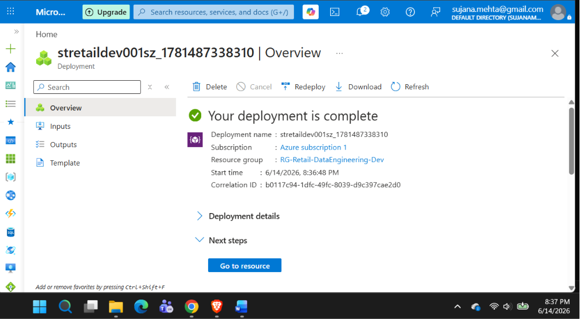
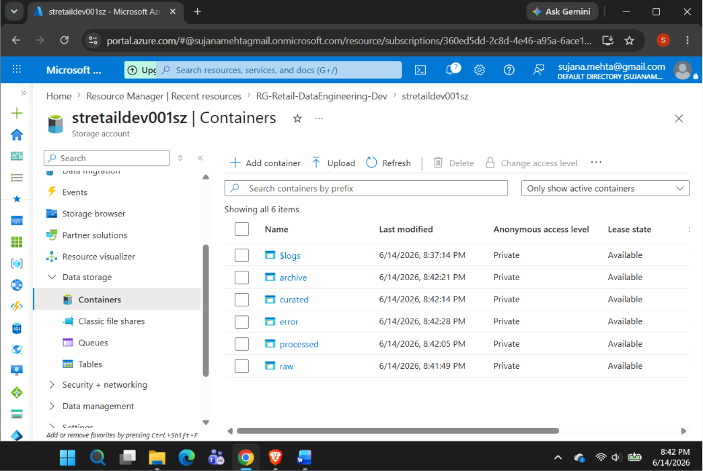

3️⃣ Create Azure Data Factory
- Name: ADF-Retail-Dev
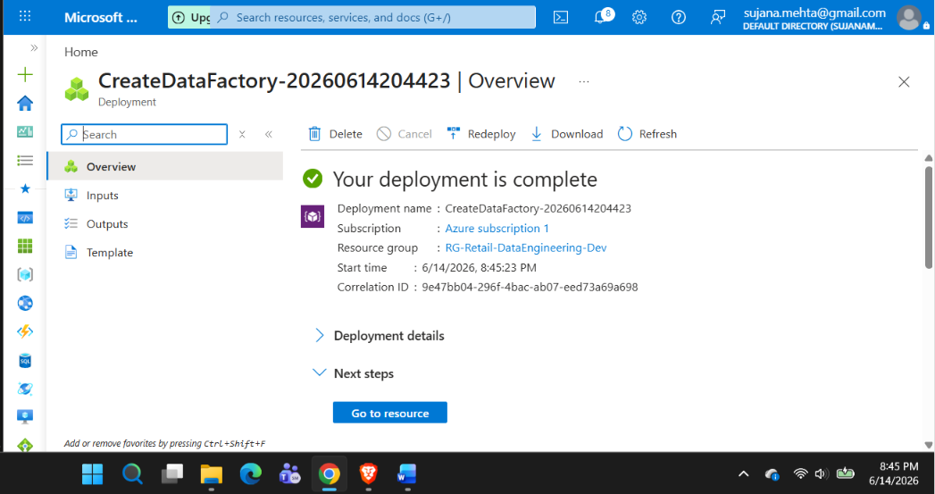

4️⃣ Create Azure SQL Database
- Server name: sql-retail-dev
- Database name: RetailDW
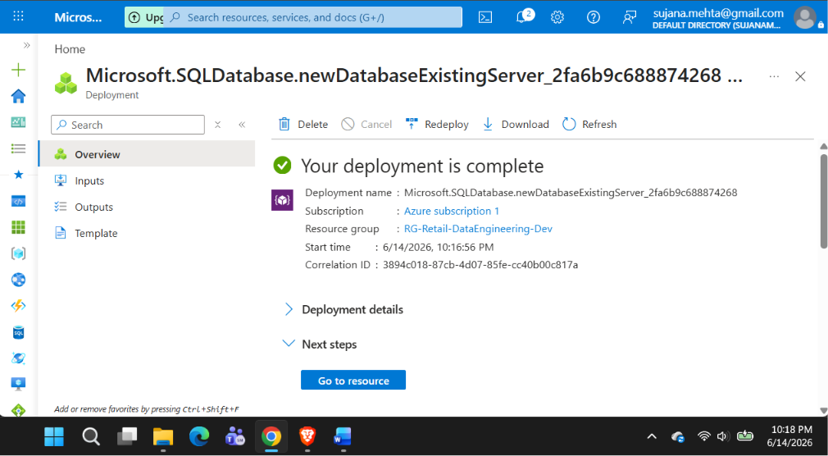

5️⃣ Create Azure Key Vault
- Name: KV-Retail-Dev
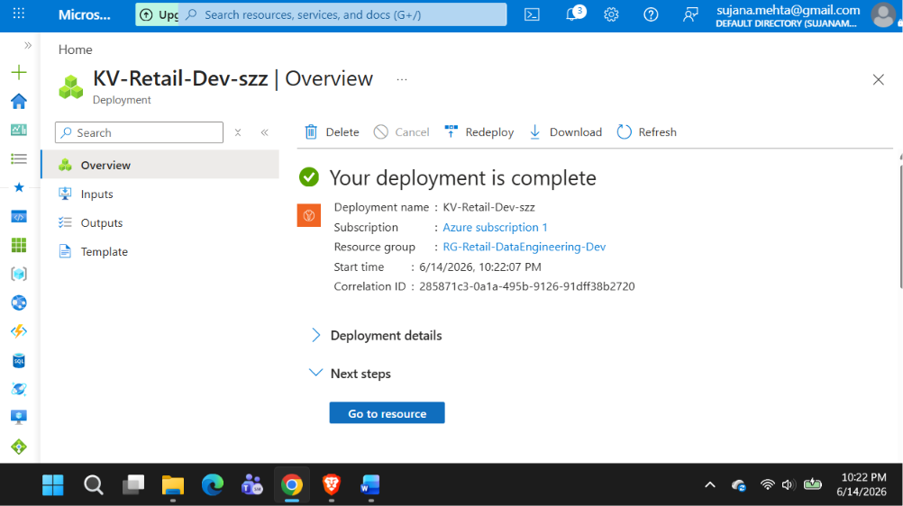

6️⃣ Create Log Analytics Workspace
Name: LAW-Retail-Dev
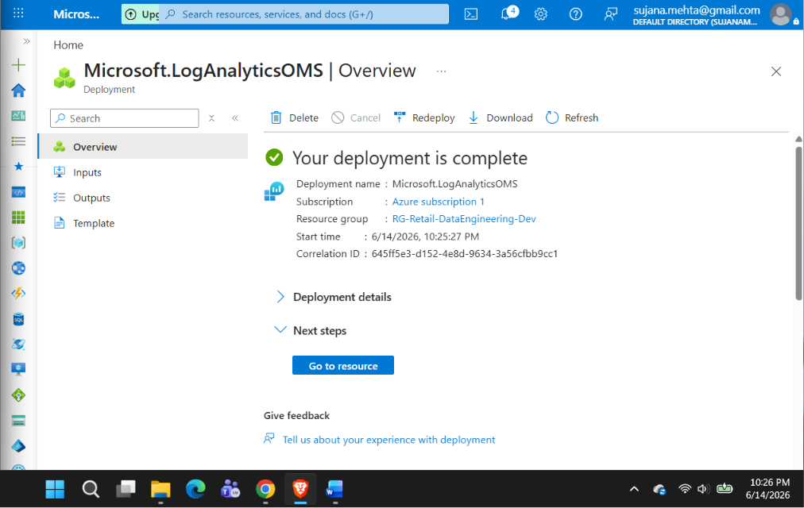

Step 2 Complete — 3 CSV Files + S3 Upload Script

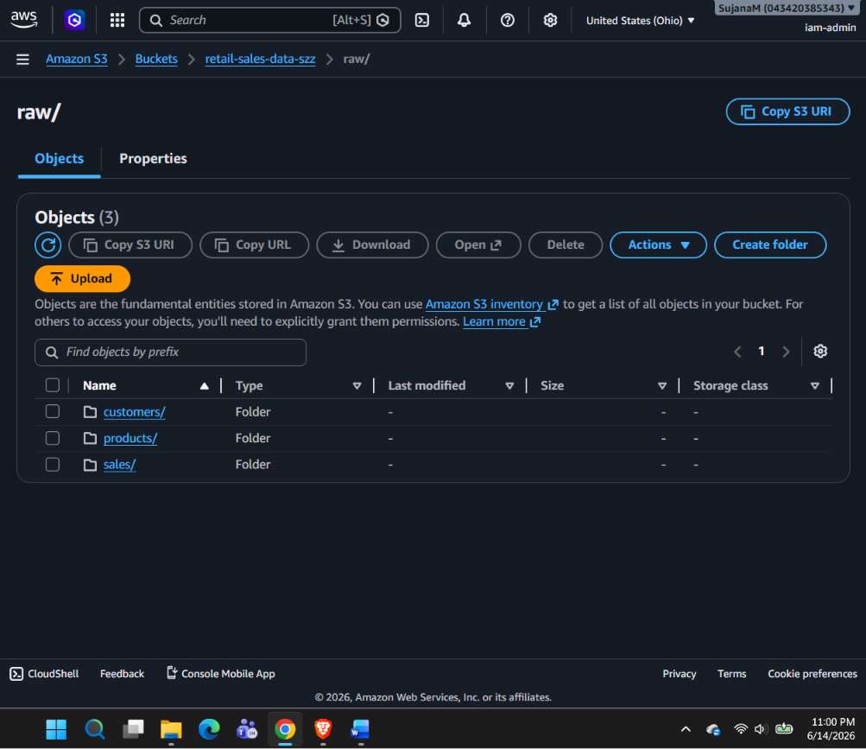

Step 3 — Configure Linked Services in ADF.
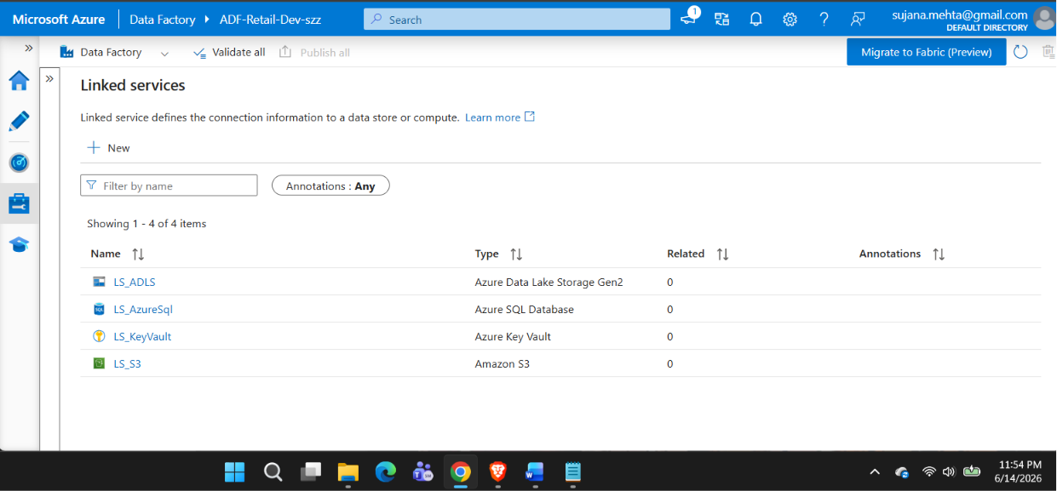

Step 4: Build the Migration Pipeline
