SV INTERIORS

Interior Design Application

**Presented by:** Sujana Sri Maddela – 2394738

Kuldeep Sai Salavadi – 2397449

**Description:**

The project goal is to design the interiors, also book for an interior designer via interior designer website. This is an online application that empowers users to visualize, plan, and execute their dream interior designs with ease. With this application, interior design enthusiasts, homeowners, and professionals alike can unleash their creativity, streamline the design process, and transform their spaces into personalized havens of style and comfort. Whether you're a novice decorator or a seasoned design aficionado, this application is your ultimate companion for achieving stunning interior transformations with ease. Browse this website today and start designing the home of your dreams! This helps to organize and track your interior design projects with built-in project management tools. Set project timelines, milestones, and budgets to stay on track and within scope. Keep all design ideas, product selections, and project notes in one centralized location for easy reference. Visualize how furniture and decor items will look in your space using augmented reality technology. Experience a realistic preview of colors, textures, and dimensions before making a purchase.

**Scope:**

The scope of an interior design application encompasses a wide range of features and functionalities aimed at providing users with a comprehensive and intuitive platform for designing and visualizing interior spaces. Here's a breakdown of the key components within the scope. A user-friendly interface that facilitates easy navigation and interaction across various features and tools. Intuitive design elements that enable users to access inspiration, plan rooms, browse products, and manage projects seamlessly. Tools for creating and customizing 2D and 3D room layouts, including options to adjust room dimensions, wall colors, flooring materials, and furniture arrangements. Real-time rendering capabilities to provide users with instant visual feedback as they make design changes. By encompassing these features and functionalities, this application aims to provide users with a comprehensive interior design solution that empowers them to bring their design visions to life effectively and efficiently.

**Panel:**

The user and designer panels of an interior design application serve distinct purposes and cater to different sets of users. Here's an overview of what each panel entails. By providing distinct user and designer panels, this application aims to deliver a seamless and efficient experience for both users and administrators, enabling users to design and visualize their dream spaces while empowering administrators to manage and enhance the application effectively.

**User Panel:**

The user panel is designed to provide a seamless and intuitive experience for individuals who are using the application to plan, design, and decorate their interior spaces. Key features of the user panel include:

**User Registration/Login**: Users can create accounts or log in using existing credentials to access the application's features and functionalities.

**Dashboard**: A personalized dashboard that provides an overview of recent activity, saved designs, shopping lists, and recommendations.

**Inspiration Gallery**: Access to a curated collection of interior design inspirations, categorized by style, room type, color scheme, etc.

**Product Catalog**: Browse and search for furniture, lighting, decor items, and accessories from various brands and designers.

**Design Collaboration**: Share designs with friends, family, or collaborators for feedback and collaboration.

**Project Management**: Organize and track design projects, including setting timelines, budgets, and milestones.

**Personalized Recommendations**: Receive tailored design recommendations based on user preferences, browsing history, and purchase behavior.

**Designer Panel:**

The designer panel is designed to manage and oversee the application's operations, content, users, and functionality. Key features of the designer panel include:

**User Management:** Manage user accounts, including registration, authentication, and access control.

**Content Management:** Curate and update the inspiration gallery, product catalog, and other content within the application.

**Product Management:** Add, edit, and remove products from the catalog, including product descriptions, images, and pricing.

**Design Management:** Monitor and moderate user-generated designs, comments, and collaborations.

**Analytics and Reporting:** Track user activity, engagement metrics, and performance indicators to gain insights into user behavior and preferences.

**Integration Management:** Maintain relationships with affiliated retailers and e-commerce platforms for seamless shopping integration.

**Customer Support:** Provide support and assistance to users, including responding to inquiries, troubleshooting issues, and addressing feedback.

**Security and Compliance:** Ensure the security, privacy, and compliance of user data and transactions in accordance with relevant regulations and best practices.

**Functional Requirements:**

Functional requirements outline the specific features and functionalities that an interior design application must possess to meet the needs of its users. Here's a breakdown of the functional requirements:

**User Requirements:**

Users should be able to register, log in, and manage their profiles.

Profile management includes updating personal information, preferences, and saved designs.

A curated collection of interior design inspirations sorted by style, room type, color scheme, etc.

Users should be able to browse, search, and save inspirational images.

A comprehensive database of furniture, lighting, decor items, and accessories from various brands and designers.

Search and filtering options to help users find products based on category, style, price range, etc.

**Designer Requirements:**

By fulfilling these functional requirements, this app aims to provide users with a comprehensive and intuitive platform for designing, visualizing, and executing their interior design projects effectively and efficiently.

Accessibility features to ensure the application is usable by individuals with disabilities.

Localization supports multiple languages and regions to accommodate diverse user bases.

**Non-Functional Requirements:**

Usability

Performance

Reliability

Maintainability

**User-Story as a Designer:**

|  |  |  |  |  |
| --- | --- | --- | --- | --- |
| Designer ID | As a | I want to | So that | Priority |
| ID01 | Designer | See the list of ongoing projects | I can have a plan for site visits. | High |
| ID02 | Designer | Display 3D images of the designs of the false ceiling, cupboards, cots, sofa, side tables, dining table, modular kitchen, balcony makeovers and so on. | I can grab client's attention | High |
| ID03 | Designer | Showing off previous work images. | I can grab client's attention | Medium |
| ID04 | Designer | Update the status of the project. | It would be easy to track the work. | Medium |
| ID05 | Designer | Update the final quotation of the project. | To main transparency. | High |

**User-Story as a User:**

|  |  |  |  |  |
| --- | --- | --- | --- | --- |
| User ID | As a | I want to | So that | Priority |
| ID01 | User | Login to my project | I can have all access to the data of the project. | High |
| ID02 | User | Go through the 3D designs and previous work. | I can finalise the designs accordingly to each part of the house. | High |
| ID03 | User | Update my requirements in the project | Designer is aware of my needs. | Medium |

**Use Case Diagram:**

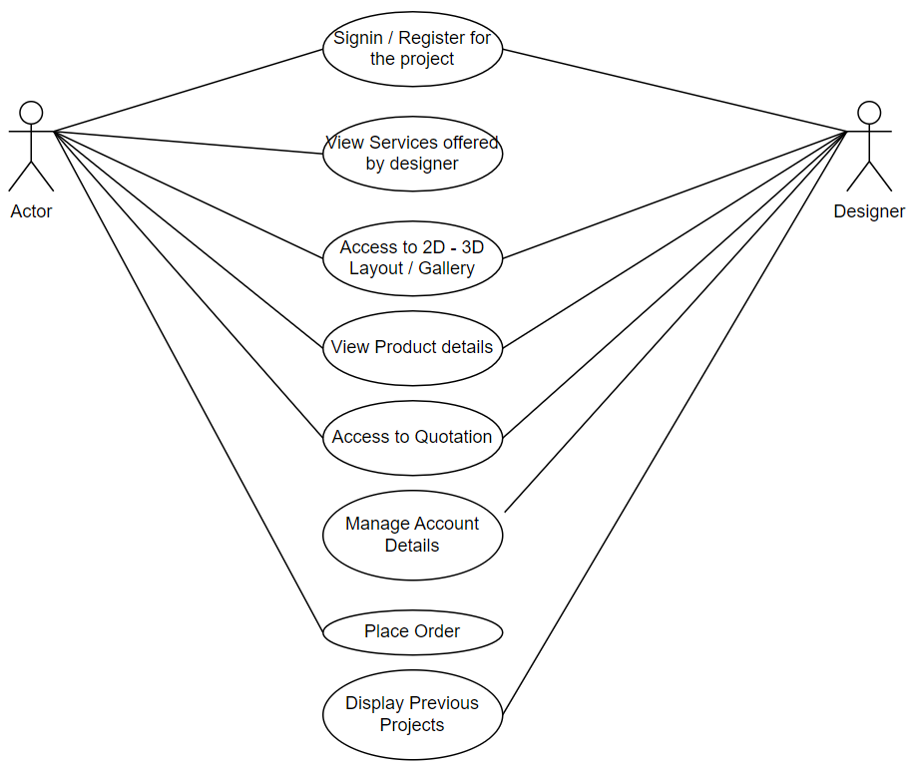

**User Activity Diagram:**

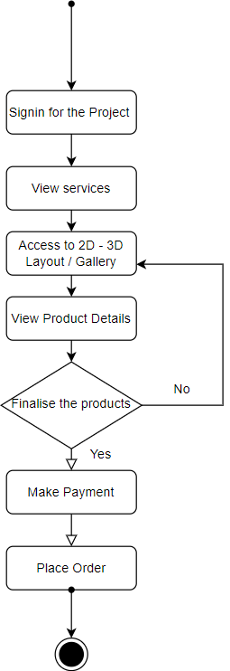

**Designer Activity Diagram:**

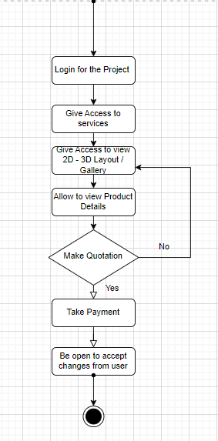

**User Sequence Diagram:**

**Designer Sequence Diagram:**

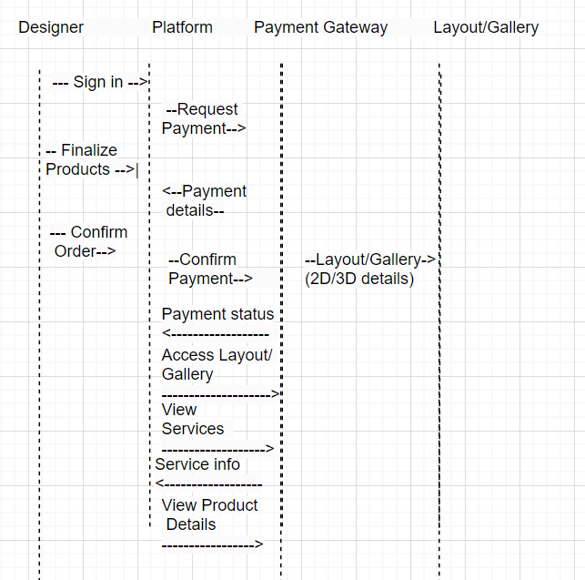

**Mockups:**

