MYCELIUM
An Autonomous Agent Network for Closed Loop Industrial Symbiosis in Indian Manufacturing Clusters
Abstract
Project Title and SDG Alignment
MYCELIUM is aligned with Sustainable Development Goal 12, Responsible Consumption and Production, and specifically with Target 12.5, which asks every nation to substantially reduce waste generation through prevention, reduction, recycling and reuse by 2030. It is further supported by Target 12.4 on the environmentally sound management of industrial wastes. SDG 12 is the correct frame because the waste addressed here is not a failure of chemistry. It is a failure of production systems to exchange what one factory discards and another factory buys. Every tonne of byproduct kept in circulation is a tonne of virgin material that is never quarried, fired or hauled across the country.
Target Persona and Context
The core end user is the plant head or environment, health and safety manager of a small or medium manufacturing unit in an Indian industrial cluster such as Peenya, Hosur, Tiruppur, Jamshedpur, Bellary or Mundra. Each month this manager pays to truck away slag, ash, sludge or spent grain, while a facility a few kilometres away pays full price for the very virgin input that residue could replace. The two have never met, share no trusted channel to price the exchange, and cannot afford a consultant to confirm that the trade is lawful. These units form the backbone of Indian manufacturing, yet they have the least capacity to find such partners on their own.
Core Problem Statement
India generated more than 340 million tonnes of fly ash in the year ending March 2025 and still carries a legacy stock of about 1.6 billion tonnes in ash ponds that consume land, leach into groundwater and periodically breach. Only 15 to 20 per cent of steel slag finds productive use, and slag generation is projected to reach 60 million tonnes a year by 2030. Industry also produces close to 8 million tonnes of hazardous waste annually. The science that turns these streams into cement, road base, bricks, feed and fuel is well established. The bottleneck is coordination. No system tells facility A that facility B exists, what a fair price is, whether freight erodes the margin, or whether the Fly Ash Notification or the Hazardous Waste Rules forbid the trade. Kalundborg in Denmark, the global reference for industrial symbiosis, needed close to four decades of personal relationship building to mature, and today it avoids around 635,000 tonnes of CO2 each year. India does not have four decades. Target 12.5 falls due in 2030, and each year of delay adds another landfill cell and another ash pond.
Technical Solution Architecture
MYCELIUM gives factories a nervous system. A deterministic core maps every facility output against every facility input, computes road distance, freight cost and carbon, and searches the resulting graph for direct pairs, three party cascades and closed cycles in which A feeds B, B feeds C and C feeds back to A. A compliance agent then encodes Indian regulation, including the 300 km mandatory use radius of the MoEFCC Fly Ash Notification and the licensing duties of the Hazardous and Other Wastes Rules, 2016, and vetoes any match that is chemically sound but legally barred, citing the exact rule. For every surviving match, autonomous negotiation agents, one per facility, each holding a private reservation price, a persona and a memory of past dealings, bargain live under a package viability gate, so that a closed loop closes only when every leg is independently profitable. A human manager signs off on every deal, and a shock console lets policymakers alter diesel prices or landfill taxes and watch the entire network rescore and renegotiate.
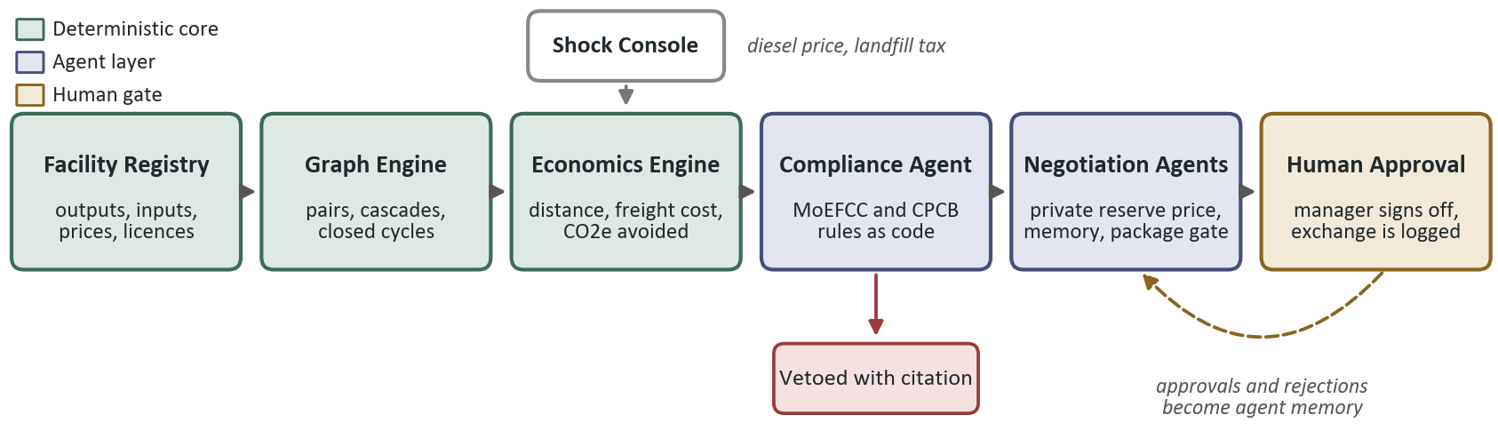
Figure 1. High level data flow of MYCELIUM, from facility registry to a signed, compliant exchange.
North Star Metric
Tonnes of industrial byproduct diverted each month from disposal into verified, compliance cleared and human approved reuse. This single figure measures Target 12.5 directly, and because each tonne is tied to a known material and route, it converts transparently into rupees saved and CO2e avoided. In a pilot model of 24 representative facilities across six real Indian clusters, built on synthesised but publicly calibrated economics, the engine evaluated 35 candidate exchanges, vetoed 11 on regulatory grounds and matched about 6,725 tonnes a month, or 93 per cent of available byproduct, worth nearly ₹19.5 crore and 63,000 tonnes of CO2e avoided every year. That is roughly ten thousand tonnes of CO2e per cluster. Replicated across one hundred Indian clusters, the same logic points to about one million tonnes of CO2e avoided annually, together with land reclaimed from dumps and ash ponds, less quarrying of limestone and aggregate, and new income for small manufacturers. The Ellen MacArthur Foundation estimates that a circular pathway could deliver India annual benefits of ₹40 lakh crore by 2050 and lower greenhouse gas emissions by 44 per cent. MYCELIUM is built to make that pathway operational, one cluster, one exchange and one signed agreement at a time.

