MICT802 – Development of Advanced Applications

Assessment 3 – Group Project

Student Performance Tracking and Decision Support System
Course: Master of Information and Communication Technology
Unit Code: MICT802
Unit Title: Development of Advanced Applications
Assessment: Assessment 3 – Group Project + Presentation + Individual Viva
Project Title: Student Performance Tracking and Decision Support System
Programming Language: Python

Group Members:
Sujan Bhujel
Samarpan Kharel
Anshu Chaudhary
Samyog Bajgain

Table of Contents
MICT802 – Development of Advanced Applications 1
Assessment 3 – Group Project 1
Student Performance Tracking and Decision Support System 1
Executive Summary 4
1. Introduction and Context 4
1.1 Background 4
1.2 Problem Definition 5
1.3 Project Aim 5
1.4 System Requirements 6
1.5 Scope 6
2. Data Description and Assumptions 7
2.1 Dataset Description 7
2.2 Data Structures 7
List 8
Dictionary 8
Set 8
Tuple 8
2.3 Assumptions 8
2.4 Data Validation 9
3. System Architecture and Class Design 10
3.1 Architecture Overview 10
3.2 Student Class 11
3.3 StudentPerformanceSystem Class 12
3.4 OOP Design Justification 12
4. Fully Executable Python Program 13
Suggested screenshot placement 44
5. Algorithms, Logic and Statistical Methods 47
5.1 Overall Mark Calculation 47
5.2 Descriptive Statistics 47
5.3 Classification Algorithm 48
5.4 At-Risk Algorithm 49
5.5 Recommendation Algorithm 49
6. Analytics and Recommendations 50
6.1 Overall Dataset Analysis 50
6.2 Performance Classification 50
6.3 Highest and Lowest Performance 51
6.4 Course Analysis 51
6.5 Students Requiring Academic Support 52
6.6 Decision-Support Recommendations 52
7. Evaluation and Design Justification 52
7.1 Effectiveness of Classification Rules 52
7.2 Effectiveness of Recommendations 53
7.3 Design Justification 53
7.4 Strengths 53
7.5 Ethical Considerations 54
8. Limitations and Future Enhancements 55
8.1 Current Limitations 55
8.2 Future Enhancements 55
9. Version Control and Collaboration 56
Complete Student Performance System Program Flow 58
10. Conclusion 58
References 59

Executive Summary
Student Performance Tracking and Decision Support System is a Python application used for data analysis and making education decisions. There are various categories of student data held by educational institutions such as assessment outcomes, exam scores, presence, study habits. Manually reviewing this information may be challenging to recognise performance trends and pupils who need more academic help or support.

The developed application solves this problem by keeping the students' records in storage and computing the overall academic performance automatically. It takes into consideration the marks obtained in assignment, quiz/exam, attendance and weekly study hours. The system provides descriptive statistical analysis, categorization of students into performance levels and individual and system level recommendations.

The software was programmed with Object-Oriented Programming and Python data structures such as list, dictionary, tuple and set. Checks for data validity and exception handling have been added to ensure that the analysis is not affected by invalid data. To give a general picture of student performance, statistical measures like minimum, maximum, mean, median and standard deviation are used.

This data set consists of 24 student records in two course categories, namely MICT and MIT. The average overall mark obtained from the data at hand is about 71.80 and the range of the overall marks is from 45.90 to 95.10. The system also identifies students who might need academic support, according to their overall performance, attendance, and examination results.

The application shows the potential of the Python language to process the basic student data and make it more valuable, which can be used by the teacher and educational institutions to identify the patterns of student performance and provide timely support to students.

1. Introduction and Context

1.1 Background
Educational institutions collect a massive amount of data from students that comes from assignments, quizzes, exams, attendance records and other learning activities. This information is valuable but its greatest contribution is in analyzing the information and then applying it to making educational decisions (Siemens and Long, 2011; Romero and Ventura, 2020).
A number of factors impact student performance. Students' grades on the final examination may not give a full picture of a student's academic status. Other information, including assignment performance, quiz scores, attendance and study habits, can be used in addition to the scores on these formative assessments to help identify students who are performing well or struggling academically (Black and Wiliam, 1998; Macfadyen and Dawson, 2010).
The assessment demands that a Python-embedded analytics and decision-support system be developed to process the records, carry out descriptive analysis, classify records following rule-based logic and make recommendations.
The group chose the application domain of Student Performance Analysis for this project. This application is known as Student Performance Tracking and Decision Support System.

1.2 Problem Definition
One of the big challenges with student performance management is that information about students can be found in a variety of metrics. A lecturer might be provided with marks from assignments, quiz tests, and exams and attendance reports for each student; if he is to consider these marks manually for numerous students, this can be time consuming (Macfadyen and Dawson, 2010).
This can create several practical problems:
- students requiring assistance may not be identified early;
- performance differences between courses may be difficult to recognise;
- academic staff may spend considerable time calculating statistics manually;
- decisions may rely too heavily on individual assessment marks;
- recommendations may not be consistently applied; and
- patterns in attendance and academic results may be overlooked (Credé, Roch and Kieszczynka, 2010).
The proposed application seeks to solve these problems by offering a well-structured approach to the storage, validation, processing and analysis of student performance information.

1.3 Project Aim
The primary goal of the project is to create a Python application to analyze student academic performance and provide valuable information for informed decision-making.
The system is designed to answer questions such as:
How well is each student performing overall?
Which students require additional academic support?
What is the average performance of the student cohort?
How does performance vary between courses?
Which academic areas should an individual student improve?

1.4 System Requirements
The functional requirements identified for the application are:
- Store and manage student performance records.
- Validate student identifiers, names, courses and numerical data.
- Reject invalid or duplicate records.
- Calculate weighted overall academic marks.
- Calculate descriptive statistics.
- Classify individual students according to performance.
- Generate personalised recommendations.
- identify students requiring academic support.
- Produce performance summaries by course.
- Generate overall decision-support recommendations.
- Allow users to search for individual students.
- Display results through an interactive menu.
These requirements closely align with the assessment specification, which requires data validation, OOP, descriptive analytics, record classification and a rule-based recommendation engine.

1.5 Scope
The present version is an analytical application using Python (console version). It is not geared towards predictive machine learning, but rather descriptive analytics and rule-based decision support.
The system analyses:
- assignment marks;
- quiz marks;
- examination marks;
- attendance percentage;
- weekly study hours;
- course;
- calculated overall mark; and
- performance classification.
This scope is appropriate because the assessment specifically states that machine learning is not required.

2. Data Description and Assumptions

2.1 Dataset Description
The application uses a sample dataset containing 24 student records.
Each student record contains eight original attributes:
Attribute | Description | Data Type
Student ID | Unique student identifier | String
Name | Student name | String
Course | Student's course | String
Assignment Mark | Assignment result from 0–100 | Float
Quiz Mark | Quiz result from 0–100 | Float
Exam Mark | Examination result from 0–100 | Float
Attendance | Attendance percentage | Float
Study Hours | Weekly independent study hours | Float
There are therefore more than 20 records in the dataset, meeting the requirement for assessing the dataset's size. The brief must also include a unique identifier, name/title, category, at least four numerical attributes and an attribute to be classified.
The application derives two additional attributes:
Overall Mark – calculated from assignment, quiz and examination marks.
Performance Classification – generated from the calculated overall mark.

2.2 Data Structures
Four major Python data structures are deliberately incorporated.
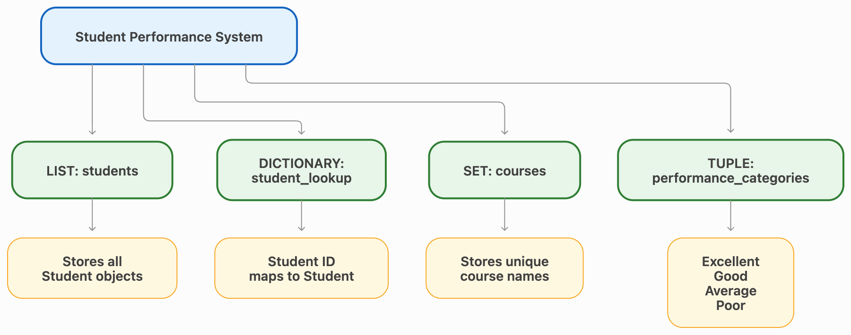

List
A list called students stores all valid Student objects.
This structure was chosen because the size of the list is variable, lists can be iterated and it can be added to and processed sequentially (Python Software Foundation, no date b).

Dictionary
The student_lookup dictionary uses the student ID as a key and the corresponding Student object as its value.
This helps in filtering the data and allows for direct access to the search without having to go through the entire set of data (Python Software Foundation, no date b).

Set
A set called courses stores unique course names.
A set is proper because duplicate names of course is not necessary when creating course level summaries (Python Software Foundation, no date b).

Tuple
The performance categories are stored in a tuple:
("Excellent", "Good", "Average", "Poor")
A tuple is appropriate, as these are static properties that aren't likely to change during execution of the application (Lutz, 2013; Python Software Foundation, no date b).
These are some of the decisions made to meet requirements for lists, dictionaries, tuples and sets.

2.3 Assumptions
There are several assumptions that were made when developing the system.
First, all of the values for assignment, quiz, examination and attendance are measured on a scale of 0-100.
Secondly, study hours are approximate weekly independent study hours.
Third, the sample data is intended to be used to prove the analytical capability of the application, and cannot be considered official academic records.
Fourth, overall performance is calculated using the weighting:
Overall Mark = (Assignment × 30%) + (Quiz × 20%) + (Exam × 50%)
The weighting is the greatest for the examination followed in order by the assignment and the quiz.
Fifth, Students are not awarded any marks for attendance or study hours. Rather, they are used as references to help determine the recommendation and identification of at-risk students..

2.4 Data Validation
The importance of data quality lies in the fact that inaccurate numerical data can result in inaccurate statistics and recommendations (Wang and Strong, 1996).
Marks are checked for validity as being numeric and within the 0-100 range. Study hours also are certified. Student ID, name and Course names must not be blank.
If two students are entered with the same student ID, then it will be rejected as each ID should be unique to each student only.
In the code, the use of except and try blocks helps to handle the incorrect data. If any invalid information is found the warning is presented and the record is not processed and the application does not crash (Python Software Foundation, no date c).
This helps with the requirement of assessment to validate numeric values, handle and jump over invalid records and to give some warning.
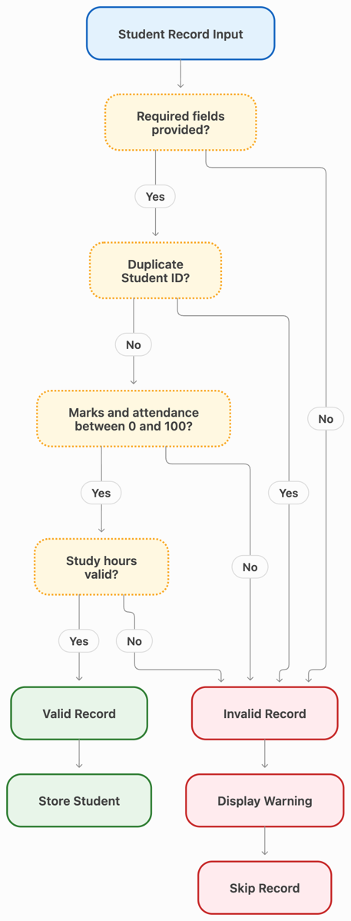
Figure: Student Data Validation Process

3. System Architecture and Class Design

3.1 Architecture Overview
The application follows a simple layered structure:
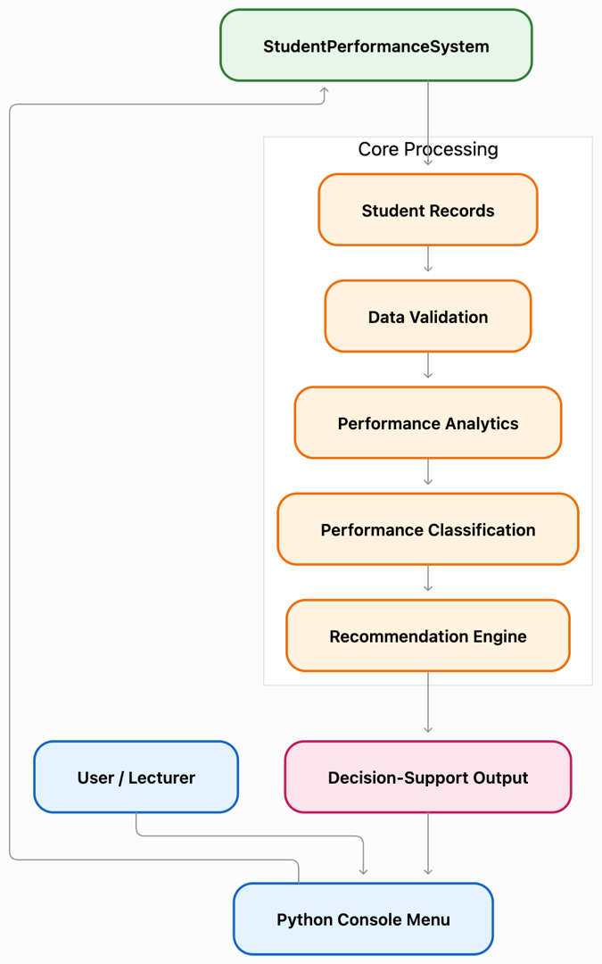
Fig: System Architecture
The menu provides the interface between the user and the system. User requests are processed by the StudentPerformanceSystem, which manages student records and analytical operations.
Individual student behaviour is encapsulated inside the Student class.

3.2 Student Class
The Student class represents one student.
Its main attributes are:
- student_id
- name
- course
- assignment_mark
- quiz_mark
- exam_mark
- attendance
- study_hours
The class also provides three important analytical behaviours:
calculate_overall_mark() calculates the weighted overall result.
classify_performance() determines the student's performance category.
generate_recommendations() generates personalised recommendations based on academic results, attendance and study behaviour.
This means that every student object is given the data that it stores as well as the methods that it uses to analyse the data; thus giving an effective application of OOP (Lutz, 2013; Python Software Foundation, no date a).

3.3 StudentPerformanceSystem Class
The second major class, StudentPerformanceSystem, manages the entire collection of students.
de
Its responsibilities include:
- adding students;
- validating records;
- storing students;
- searching for students;
- displaying student details;
- calculating descriptive analytics;
- generating classification summaries;
- generating course summaries;
- identifying students at risk; and
- producing system-level recommendations.
Individual student behaviour is more easily separated from system wide operations to make maintainability and readability easier (Martin, 2008).

3.4 OOP Design Justification
OOP was selected because student information naturally represents an object-based problem (Lutz, 2013).
Instead of maintaining separate lists for names, marks and attendance, each student's information is encapsulated within one Student object. This helps to minimize potential mismatches of records and ease the application's extensibility (Martin, 2008).
At least one domain-appropriate class that stores attributes and methods for analysis, classification and generation of recommendations are explicitly specified in the assessment.
The developed Student class directly satisfies these requirements.

4. Fully Executable Python Program
SOURCE CODE:
# ================================================================
# MICT802 - Assessment 3
# Student Performance Tracking and Decision Support System
# ================================================================

from statistics import mean, median, stdev

# ================================================================
# STUDENT CLASS
# ================================================================

class Student:
"""Represents one student and provides performance analysis."""

def __init__(self, student_id, name, course,
assignment_mark, quiz_mark, exam_mark,
attendance, study_hours):

self.student_id = student_id
self.name = name
self.course = course
self.assignment_mark = assignment_mark
self.quiz_mark = quiz_mark
self.exam_mark = exam_mark
self.attendance = attendance
self.study_hours = study_hours

# ------------------------------------------------------------
# Calculate weighted overall mark
# Assignment = 30%, Quiz = 20%, Exam = 50%
# ------------------------------------------------------------

def calculate_overall_mark(self):

return (
self.assignment_mark * 0.30
+ self.quiz_mark * 0.20
+ self.exam_mark * 0.50
)

# ------------------------------------------------------------
# Rule-Based Performance Classification
# ------------------------------------------------------------

def classify_performance(self):

mark = self.calculate_overall_mark()

if mark >= 85:
return "Excellent"

elif mark >= 75:
return "Good"

elif mark >= 60:
return "Average"

else:
return "Poor"

# ------------------------------------------------------------
# Rule-Based Recommendation Engine
# ------------------------------------------------------------

def generate_recommendations(self):

recommendations = []

overall = self.calculate_overall_mark()

if overall < 50:

recommendations.append(
"Academic support is strongly recommended."
)

if self.assignment_mark < 60:

recommendations.append(
"Improve assignment preparation and submission quality."
)

if self.quiz_mark < 60:

recommendations.append(
"Revise weekly topics and practise more quiz questions."
)

if self.exam_mark < 60:

recommendations.append(
"Increase exam revision and practise past questions."
)

if self.attendance < 75:

recommendations.append(
"Improve class attendance."
)

if self.study_hours < 5:

recommendations.append(
"Increase weekly independent study hours."
)

if overall >= 85 and self.attendance >= 85:

recommendations.append(
"Maintain the current excellent performance."
)

if not recommendations:

recommendations.append(
"Continue current study habits and monitor progress."
)

return recommendations

# ------------------------------------------------------------
# Convert Student Object into Dictionary
# ------------------------------------------------------------

def to_dictionary(self):

return {
"Student ID": self.student_id,
"Name": self.name,
"Course": self.course,
"Assignment": self.assignment_mark,
"Quiz": self.quiz_mark,
"Exam": self.exam_mark,
"Attendance": self.attendance,
"Study Hours": self.study_hours,
"Overall": round(self.calculate_overall_mark(), 2),
"Classification": self.classify_performance()
}

# ================================================================
# STUDENT PERFORMANCE TRACKING SYSTEM
# ================================================================

class StudentPerformanceSystem:

def __init__(self):

# List data structure
self.students = []

# Dictionary data structure
# Student ID is used as the key
self.student_lookup = {}

# Set data structure
# Stores unique courses
self.courses = set()

# Tuple data structure
# Stores fixed performance categories
self.performance_categories = (
"Excellent",
"Good",
"Average",
"Poor"
)

# ------------------------------------------------------------
# Validate Numeric Marks
# ------------------------------------------------------------

@staticmethod
def validate_mark(value, field_name):

try:

value = float(value)

if value < 0 or value > 100:

raise ValueError(
f"{field_name} must be between 0 and 100."
)

return value

except (ValueError, TypeError):

raise ValueError(
f"Invalid value for {field_name}."
)

# ------------------------------------------------------------
# Validate Study Hours
# ------------------------------------------------------------

@staticmethod
def validate_study_hours(value):

try:

value = float(value)

if value < 0 or value > 100:

raise ValueError(
"Study hours must be between 0 and 100."
)

return value

except (ValueError, TypeError):

raise ValueError(
"Invalid study hours."
)

# ------------------------------------------------------------
# Add Student Record
# ------------------------------------------------------------

def add_student(self, student_id, name, course,
assignment, quiz, exam,
attendance, study_hours):

try:

student_id = str(student_id).strip()
name = str(name).strip()
course = str(course).strip()

# Check empty Student ID
if not student_id:

raise ValueError(
"Student ID cannot be empty."
)

# Check empty name
if not name:

raise ValueError(
"Student name cannot be empty."
)

# Check empty course
if not course:

raise ValueError(
"Course cannot be empty."
)

# Check duplicate Student ID
if student_id in self.student_lookup:

raise ValueError(
f"Student ID {student_id} already exists."
)

# Validate numerical values
assignment = self.validate_mark(
assignment,
"Assignment Mark"
)

quiz = self.validate_mark(
quiz,
"Quiz Mark"
)

exam = self.validate_mark(
exam,
"Exam Mark"
)

attendance = self.validate_mark(
attendance,
"Attendance"
)

study_hours = self.validate_study_hours(
study_hours
)

# Create Student Object
student = Student(
student_id,
name,
course,
assignment,
quiz,
exam,
attendance,
study_hours
)

# Add student to list
self.students.append(student)

# Add student to dictionary
self.student_lookup[student_id] = student

# Add course to set
self.courses.add(course)

return True

except ValueError as error:

print(f"\nWARNING: {error}")
print("Invalid record skipped.\n")

return False

# ------------------------------------------------------------
# Find Student Using Student ID
# ------------------------------------------------------------

def find_student(self, student_id):

student = self.student_lookup.get(student_id)

if student is None:

print("\nStudent not found.")

return None

return student

# ------------------------------------------------------------
# Display Individual Student
# ------------------------------------------------------------

def display_student(self, student):

print("\n" + "=" * 65)
print("STUDENT PERFORMANCE DETAILS")
print("=" * 65)

print(
f"Student ID : {student.student_id}"
)

print(
f"Name : {student.name}"
)

print(
f"Course : {student.course}"
)

print(
f"Assignment Mark : {student.assignment_mark:.2f}"
)

print(
f"Quiz Mark : {student.quiz_mark:.2f}"
)

print(
f"Exam Mark : {student.exam_mark:.2f}"
)

print(
f"Attendance : {student.attendance:.2f}%"
)

print(
f"Study Hours : {student.study_hours:.2f} hours"
)

print(
f"Overall Mark : "
f"{student.calculate_overall_mark():.2f}"
)

print(
f"Classification : "
f"{student.classify_performance()}"
)

print("\nRecommendations:")

for number, recommendation in enumerate(
student.generate_recommendations(), 1):

print(
f"{number}. {recommendation}"
)

print("=" * 65)

# ------------------------------------------------------------
# Display All Students
# ------------------------------------------------------------

def display_all_students(self):

if not self.students:

print(
"\nNo student records available."
)

return

print("\n" + "=" * 110)

print(
"ALL STUDENT PERFORMANCE RECORDS"
)

print("=" * 110)

print(
f"{'ID':<8}"
f"{'Name':<22}"
f"{'Course':<10}"
f"{'Assign':>8}"
f"{'Quiz':>8}"
f"{'Exam':>8}"
f"{'Attend':>10}"
f"{'Overall':>10}"
f"{'Class':>12}"
)

print("-" * 110)

for student in self.students:

print(
f"{student.student_id:<8}"
f"{student.name:<22}"
f"{student.course:<10}"
f"{student.assignment_mark:>8.1f}"
f"{student.quiz_mark:>8.1f}"
f"{student.exam_mark:>8.1f}"
f"{student.attendance:>9.1f}%"
f"{student.calculate_overall_mark():>10.2f}"
f"{student.classify_performance():>12}"
)

print("=" * 110)

# ------------------------------------------------------------
# Descriptive Analytics
# ------------------------------------------------------------

def descriptive_analytics(self):

if not self.students:

print(
"\nNo data available for analysis."
)

return

# Store overall marks
overall_marks = [

student.calculate_overall_mark()

for student in self.students
]

# Store attendance
attendance_values = [

student.attendance

for student in self.students
]

# Store study hours
study_hours = [

student.study_hours

for student in self.students
]

print("\n" + "=" * 70)

print(
"DESCRIPTIVE ANALYTICS"
)

print("=" * 70)

# Total number of students
print(
f"Total Students : "
f"{len(self.students)}"
)

# Minimum value
print(
f"Minimum Overall Mark : "
f"{min(overall_marks):.2f}"
)

# Maximum value
print(
f"Maximum Overall Mark : "
f"{max(overall_marks):.2f}"
)

# Average value
print(
f"Average Overall Mark : "
f"{mean(overall_marks):.2f}"
)

# Median
print(
f"Median Overall Mark : "
f"{median(overall_marks):.2f}"
)

# Standard deviation
if len(overall_marks) > 1:

print(
f"Standard Deviation : "
f"{stdev(overall_marks):.2f}"
)

else:

print(
"Standard Deviation : N/A"
)

# Average attendance
print(
f"Average Attendance : "
f"{mean(attendance_values):.2f}%"
)

# Average study hours
print(
f"Average Study Hours : "
f"{mean(study_hours):.2f}"
)

# Number of passed students
passed = sum(

1 for mark in overall_marks

if mark >= 50
)

# Number of failed students
failed = len(self.students) - passed

# Pass rate
pass_rate = (

passed / len(self.students)

) * 100

print(
f"Students Passed : {passed}"
)

print(
f"Students Failed : {failed}"
)

print(
f"Pass Rate : {pass_rate:.2f}%"
)

# Highest performing student
highest_student = max(

self.students,

key=lambda s: s.calculate_overall_mark()
)

# Lowest performing student
lowest_student = min(

self.students,

key=lambda s: s.calculate_overall_mark()
)

print(
f"Highest Performer : "
f"{highest_student.name} "
f"({highest_student.calculate_overall_mark():.2f})"
)

print(
f"Lowest Performer : "
f"{lowest_student.name} "
f"({lowest_student.calculate_overall_mark():.2f})"
)

print("=" * 70)

# ------------------------------------------------------------
# Performance Classification Summary
# ------------------------------------------------------------

def classification_summary(self):

if not self.students:

print(
"\nNo data available."
)

return

classification_count = {

category: 0

for category in self.performance_categories
}

for student in self.students:

category = (
student.classify_performance()
)

classification_count[
category
] += 1

print("\n" + "=" * 60)

print(
"PERFORMANCE CLASSIFICATION SUMMARY"
)

print("=" * 60)

for category, count in \
classification_count.items():

percentage = (

count / len(self.students)

) * 100

print(
f"{category:<15}: "
f"{count:<3} students "
f"({percentage:.2f}%)"
)

print("=" * 60)

# ------------------------------------------------------------
# Course Performance Summary
# ------------------------------------------------------------

def course_summary(self):

if not self.students:

print(
"\nNo data available."
)

return

print("\n" + "=" * 75)

print(
"PERFORMANCE SUMMARY BY COURSE"
)

print("=" * 75)

# Loop through each unique course
for course in sorted(self.courses):

course_students = [

student

for student in self.students

if student.course == course
]

course_marks = [

student.calculate_overall_mark()

for student in course_students
]

course_attendance = [

student.attendance

for student in course_students
]

print(
f"\nCourse: {course}"
)

print(
f"Number of Students : "
f"{len(course_students)}"
)

print(
f"Average Mark : "
f"{mean(course_marks):.2f}"
)

print(
f"Highest Mark : "
f"{max(course_marks):.2f}"
)

print(
f"Lowest Mark : "
f"{min(course_marks):.2f}"
)

print(
f"Average Attendance : "
f"{mean(course_attendance):.2f}%"
)

print("\n" + "=" * 75)

# ------------------------------------------------------------
# Identify Students Requiring Academic Support
# ------------------------------------------------------------

def students_at_risk(self):

at_risk = []

for student in self.students:

overall = (
student.calculate_overall_mark()
)

# At-risk rules
if (
overall < 60
or student.attendance < 75
or student.exam_mark < 50
):

at_risk.append(student)

print("\n" + "=" * 85)

print(
"STUDENTS REQUIRING ACADEMIC SUPPORT"
)

print("=" * 85)

if not at_risk:

print(
"No students currently identified as at risk."
)

return

for student in at_risk:

print(
f"\n{student.student_id} - "
f"{student.name}"
)

print(
f"Overall: "
f"{student.calculate_overall_mark():.2f}"
)

print(
f"Attendance: "
f"{student.attendance:.2f}%"
)

print(
"Recommended Actions:"
)

for recommendation in \
student.generate_recommendations():

print(
f" - {recommendation}"
)

print("=" * 85)

# ------------------------------------------------------------
# Overall Decision-Support Recommendations
# ------------------------------------------------------------

def system_recommendations(self):

if not self.students:

print(
"\nNo data available."
)

return

overall_marks = [

student.calculate_overall_mark()

for student in self.students
]

attendance = [

student.attendance

for student in self.students
]

# Count poor-performing students
poor_students = sum(

1

for student in self.students

if student.classify_performance()
== "Poor"
)

# Count low attendance students
low_attendance = sum(

1

for student in self.students

if student.attendance < 75
)

print("\n" + "=" * 75)

print(
"SYSTEM DECISION-SUPPORT RECOMMENDATIONS"
)

print("=" * 75)

average_mark = mean(
overall_marks
)

average_attendance = mean(
attendance
)

print(
f"Overall Average Mark : "
f"{average_mark:.2f}"
)

print(
f"Average Attendance : "
f"{average_attendance:.2f}%"
)

print(
"\nRecommendations:"
)

recommendation_number = 1

# Recommendation 1
if average_mark < 60:

print(
f"{recommendation_number}. "
"Provide additional academic "
"support classes."
)

recommendation_number += 1

# Recommendation 2
if average_attendance < 80:

print(
f"{recommendation_number}. "
"Introduce attendance improvement "
"strategies."
)

recommendation_number += 1

# Recommendation 3
if poor_students >= 5:

print(
f"{recommendation_number}. "
"Review teaching and assessment "
"support for low-performing students."
)

recommendation_number += 1

# Recommendation 4
if low_attendance >= 5:

print(
f"{recommendation_number}. "
"Contact students with low attendance "
"and provide early intervention."
)

recommendation_number += 1

# Recommendation 5
if average_mark >= 75:

print(
f"{recommendation_number}. "
"Overall academic performance is strong; "
"maintain current learning support."
)

print("=" * 75)

# ================================================================
# SAMPLE STUDENT DATASET
# 24 Student Records
# ================================================================

def load_sample_data(system):

sample_students = [

# --------------------------------------------------------
# Group Member Names
# --------------------------------------------------------

(
"S001",
"Sujan Bhujel",
"MICT",
88,
82,
91,
95,
12
),

(
"S002",
"Samarpan Kharel",
"MICT",
72,
75,
78,
88,
9
),

(
"S003",
"Anshu Chaudhary",
"MIT",
65,
68,
61,
80,
7
),

(
"S004",
"Samyog Bajgain",
"MIT",
92,
90,
94,
97,
14
),

(
"S005",
"Prassanna Kaami",
"MICT",
48,
55,
45,
68,
4
),

(
"S006",
"Prasun Damai",
"MIT",
81,
84,
79,
92,
11
),

# --------------------------------------------------------
# Additional Nepali Student Names
# --------------------------------------------------------

(
"S007",
"Aayush Shrestha",
"MICT",
58,
62,
54,
72,
5
),

(
"S008",
"Sushmita Karki",
"MIT",
76,
74,
80,
86,
10
),

(
"S009",
"Bikash Thapa",
"MICT",
69,
65,
71,
83,
8
),

(
"S010",
"Pratiksha Gurung",
"MIT",
95,
93,
96,
98,
16
),

(
"S011",
"Roshan Adhikari",
"MICT",
52,
48,
50,
70,
4
),

(
"S012",
"Asmita Rai",
"MIT",
84,
80,
86,
90,
12
),

(
"S013",
"Nischal Pandey",
"MICT",
61,
64,
59,
78,
6
),

(
"S014",
"Sneha Bhandari",
"MIT",
78,
82,
75,
89,
10
),

(
"S015",
"Sagar Poudel",
"MICT",
43,
50,
46,
65,
3
),

(
"S016",
"Anisha Maharjan",
"MIT",
89,
87,
91,
94,
13
),

(
"S017",
"Bibek Ghimire",
"MICT",
73,
70,
76,
84,
8
),

(
"S018",
"Rojina Lama",
"MIT",
67,
72,
69,
81,
7
),

(
"S019",
"Kiran Oli",
"MICT",
56,
58,
52,
74,
5
),

(
"S020",
"Sarita Tamang",
"MIT",
86,
88,
84,
93,
12
),

(
"S021",
"Nabin Koirala",
"MICT",
63,
60,
66,
79,
7
),

(
"S022",
"Puja Basnet",
"MIT",
91,
89,
92,
96,
15
),

(
"S023",
"Rajan Gautam",
"MICT",
77,
73,
79,
87,
9
),

(
"S024",
"Manisha Rijal",
"MIT",
54,
57,
51,
71,
4
)
]

# Add each sample student to the system
for record in sample_students:

system.add_student(
record[0],
record[1],
record[2],
record[3],
record[4],
record[5],
record[6],
record[7]
)

# ================================================================
# ADD STUDENT MANUALLY
# ================================================================

def add_student_manually(system):

print("\nADD NEW STUDENT")
print("-" * 40)

try:

student_id = input(
"Student ID: "
).strip()

name = input(
"Student Name: "
).strip()

course = input(
"Course: "
).strip()

assignment = input(
"Assignment Mark (0-100): "
)

quiz = input(
"Quiz Mark (0-100): "
)

exam = input(
"Exam Mark (0-100): "
)

attendance = input(
"Attendance Percentage (0-100): "
)

study_hours = input(
"Weekly Study Hours: "
)

success = system.add_student(
student_id,
name,
course,
assignment,
quiz,
exam,
attendance,
study_hours
)

if success:

print(
"\nStudent successfully added."
)

except Exception as error:

print(
f"\nUnexpected error: {error}"
)

# ================================================================
# SEARCH STUDENT
# ================================================================

def search_student(system):

student_id = input(
"\nEnter Student ID: "
).strip()

student = system.find_student(
student_id
)

if student:

system.display_student(
student
)

# ================================================================
# MAIN MENU
# ================================================================

def display_menu():

print("\n")

print("=" * 70)

print(
" STUDENT PERFORMANCE TRACKING SYSTEM"
)

print("=" * 70)

print(
"1. Display All Students"
)

print(
"2. Search Student"
)

print(
"3. Add New Student"
)

print(
"4. Descriptive Analytics"
)

print(
"5. Performance Classification Summary"
)

print(
"6. Course Performance Summary"
)

print(
"7. Students Requiring Support"
)

print(
"8. Decision-Support Recommendations"
)

print(
"9. Exit"
)

print("=" * 70)

# ================================================================
# MAIN APPLICATION
# ================================================================

def main():

# Create the system
system = StudentPerformanceSystem()

# Load the sample dataset
load_sample_data(system)

print(
"\nStudent Performance Tracking "
"System started."
)

print(
f"{len(system.students)} "
"student records loaded successfully."
)

# Continue displaying menu until user exits
while True:

display_menu()

try:

choice = input(
"Enter your choice (1-9): "
).strip()

# ----------------------------------------------------
# OPTION 1 - Display All Students
# ----------------------------------------------------

if choice == "1":

system.display_all_students()

# ----------------------------------------------------
# OPTION 2 - Search Student
# ----------------------------------------------------

elif choice == "2":

search_student(system)

# ----------------------------------------------------
# OPTION 3 - Add Student
# ----------------------------------------------------

elif choice == "3":

add_student_manually(system)

# ----------------------------------------------------
# OPTION 4 - Descriptive Analytics
# ----------------------------------------------------

elif choice == "4":

system.descriptive_analytics()

# ----------------------------------------------------
# OPTION 5 - Classification Summary
# ----------------------------------------------------

elif choice == "5":

system.classification_summary()

# ----------------------------------------------------
# OPTION 6 - Course Summary
# ----------------------------------------------------

elif choice == "6":

system.course_summary()

# ----------------------------------------------------
# OPTION 7 - At-Risk Students
# ----------------------------------------------------

elif choice == "7":

system.students_at_risk()

# ----------------------------------------------------
# OPTION 8 - Recommendations
# ----------------------------------------------------

elif choice == "8":

system.system_recommendations()

# ----------------------------------------------------
# OPTION 9 - Exit
# ----------------------------------------------------

elif choice == "9":

print("\n" + "=" * 60)

print(
"Thank you for using the "
"Student Performance Tracking System."
)

print("=" * 60)

break

# ----------------------------------------------------
# Invalid Menu Selection
# ----------------------------------------------------

else:

print(
"\nInvalid choice. "
"Please enter a number from 1 to 9."
)

# Handle Ctrl+C
except KeyboardInterrupt:

print(
"\n\nProgram stopped by user."
)

break

# Handle unexpected errors
except Exception as error:

print(
f"\nAn unexpected error occurred: "
f"{error}"
)

# ================================================================
# START PROGRAM
# ================================================================

if __name__ == "__main__":

main()

The complete program contains:
- required imports;
- Student class;
- StudentPerformanceSystem class;
- validation functions;
- student search and display functions;
- descriptive analytics;
- performance classification;
- course-level analysis;
- at-risk student detection;
- recommendation generation;
- 24-record sample dataset;
- interactive menu; and
- main() program execution.

Suggested screenshot placement
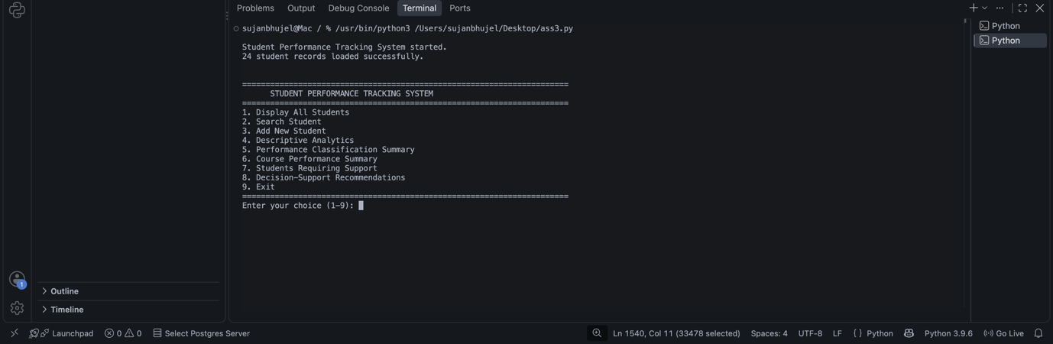
Figure 1: Main menu of the Student Performance Tracking System
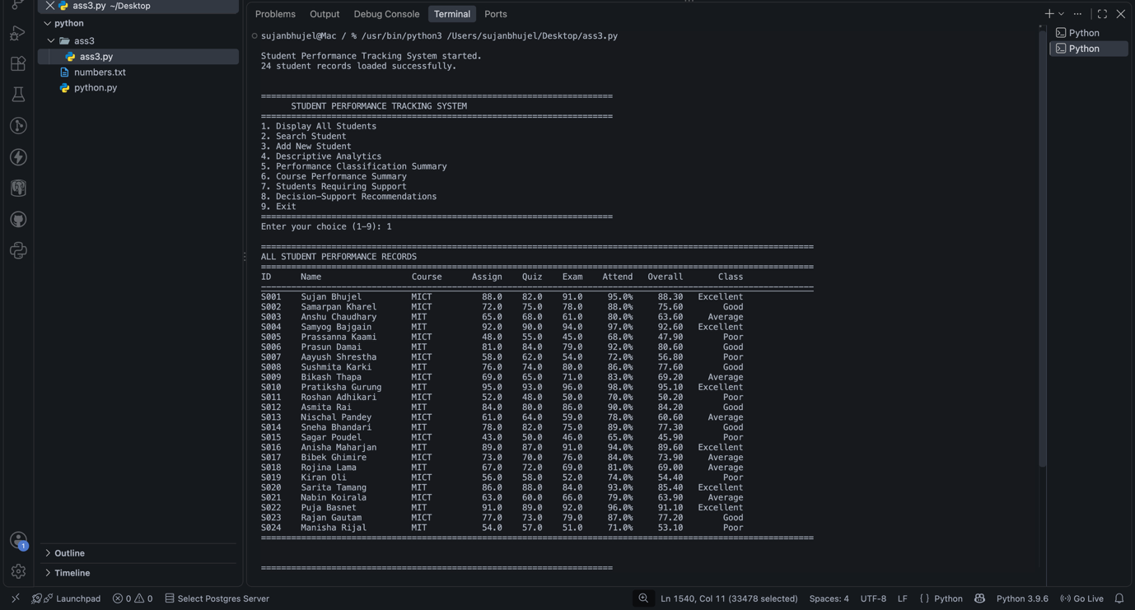
Figure 2. All student performance records
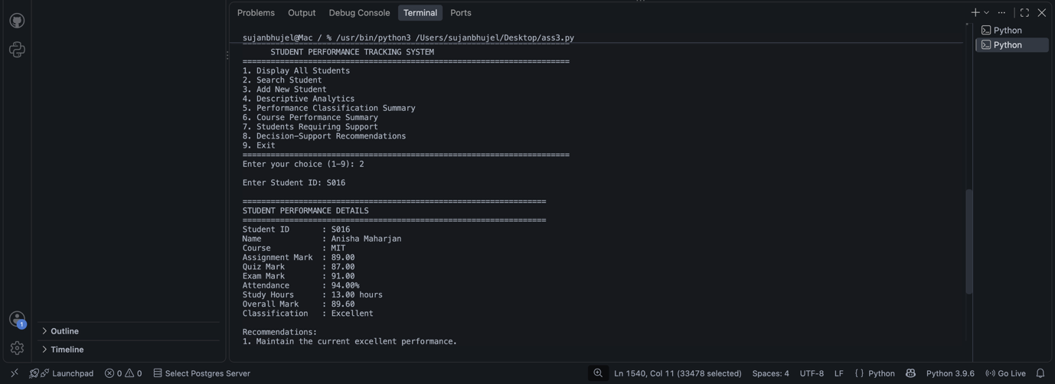
Figure 3. Search student performance detail
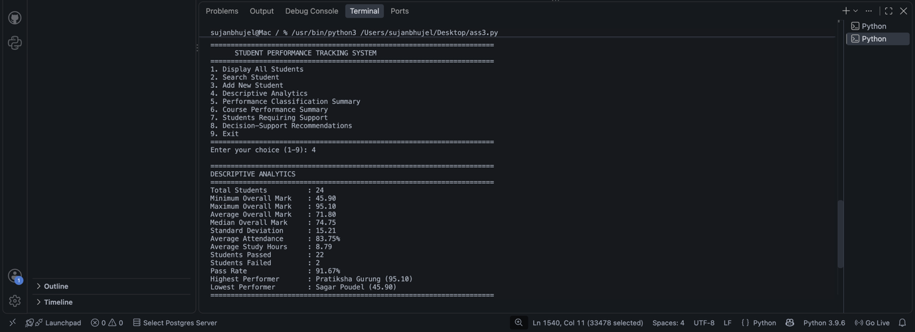
Figure 4. Descriptive analytics output
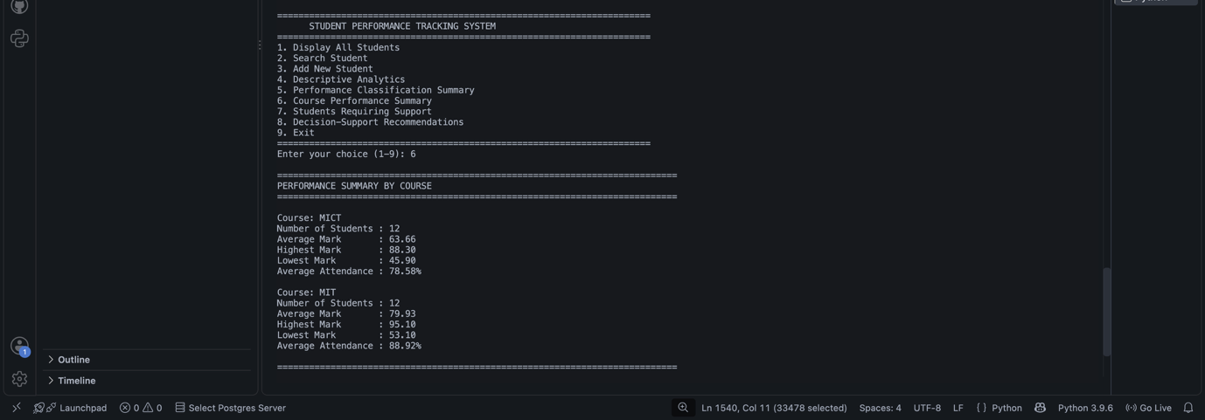Figure 5. Performance classification summary
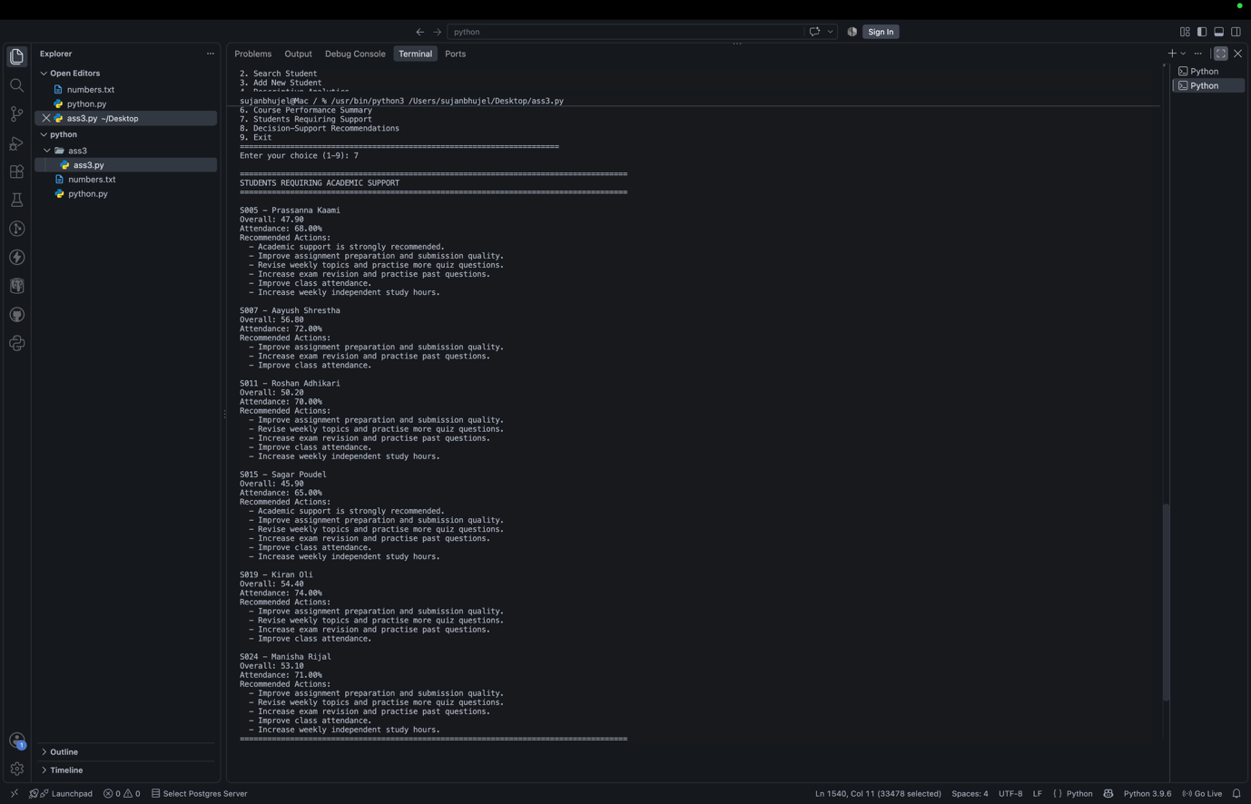
Figure 5. Students requiring academic support
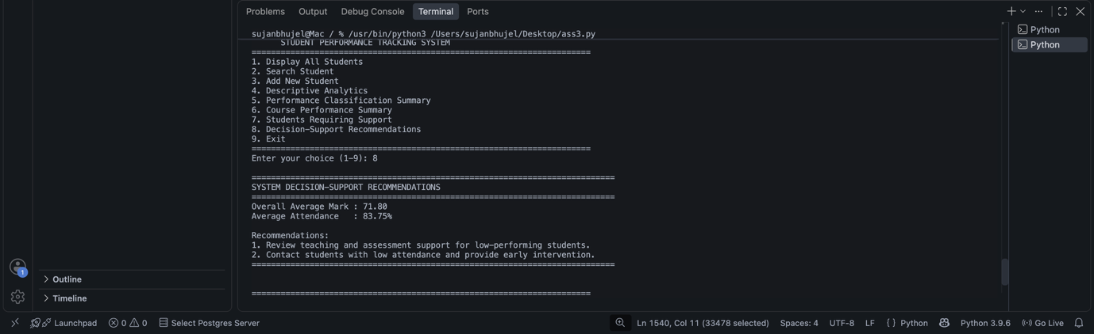
Figure 6. System decision-support recommendations
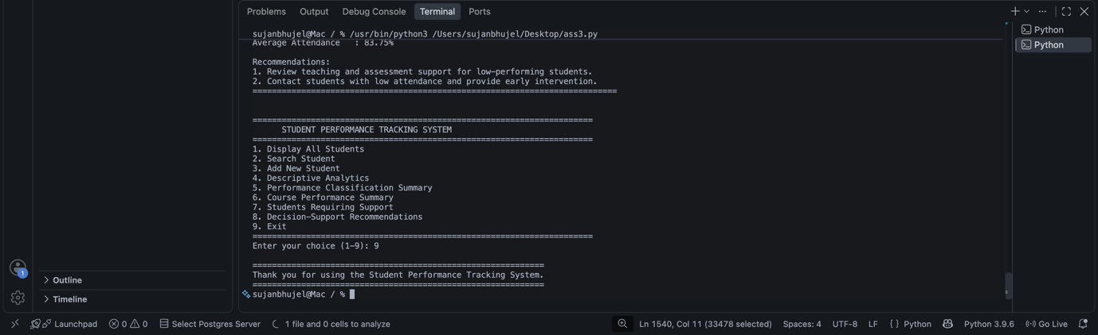
Figure 6. System Exit

5. Algorithms, Logic and Statistical Methods

5.1 Overall Mark Calculation
The overall mark is calculated as:
Overall = (Assignment × 0.30) + (Quiz × 0.20) + (Exam × 0.50)
For example, Sujan Bhujel has:
Assignment = 88
Quiz = 82
Exam = 91
Therefore:
Overall = (88 × 0.30) + (82 × 0.20) + (91 × 0.50)
Overall = 26.40 + 16.40 + 45.50
Overall = 88.30
This calculation is implemented directly within the Student class.

5.2 Descriptive Statistics
The system calculates several descriptive statistics.
Minimum
The minimum identifies the lowest overall mark.
Minimum overall mark = 45.90
Maximum
The maximum identifies the highest overall mark.
Maximum overall mark = 95.10
Mean
The mean represents average student performance:
\[ Mean = \frac{\sum x_i}{n} \]
For the current dataset:
Average overall mark ≈ 71.80
Median
The median represents the middle value after marks are arranged in order (Field, 2018).
Median overall mark = 74.75
Standard Deviation
Standard deviation measures how widely the marks vary around the mean (Field, 2018).
Standard deviation ≈ 15.21
A larger standard deviation indicates greater differences in student performance.
The application also gives details of the Average attendance, Average study hours, Pass Rate, Highest and Lowest performers. These measures are more than the requirement for minimum, maximum, average and at least two more meaningful statistics.

5.3 Classification Algorithm
Students are classified using the following rule-based thresholds:
Overall Mark | Classification
≥ 85 | Excellent
75–84.99 | Good
60–74.99 | Average
< 60 | Poor

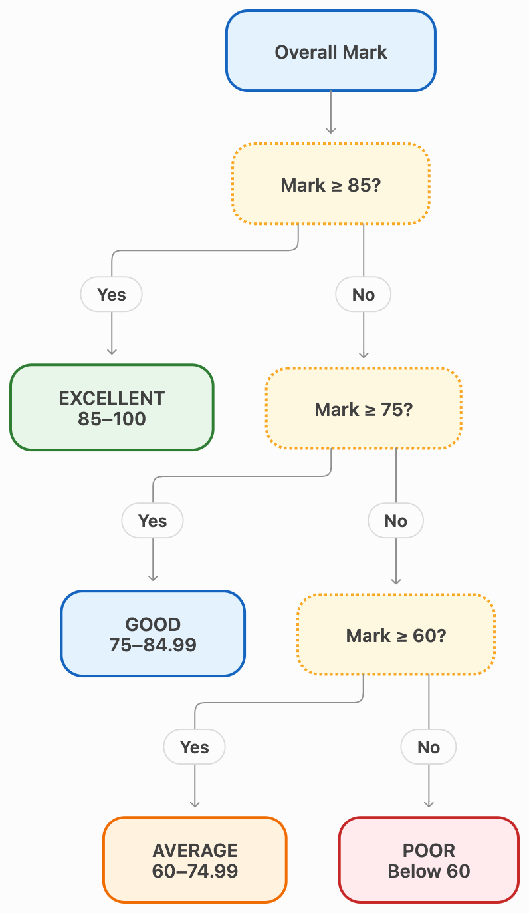
Figure: Performance Classification Algorithm
The application implements these thresholds through if, elif and else conditions.
These categories were chosen to enable meaningful grouping of performances, and to illustrate the process of data analytics to yield information for decision making.

5.4 At-Risk Algorithm
A student is identified as requiring academic support when at least one of the following conditions applies:
Overall mark < 60
OR
Attendance < 75%
OR
Examination mark < 50
This method takes into account other than the average grade. A pupil might attain an acceptable overall achievement but may have poor attendance which may be a risk to future academic success (Macfadyen and Dawson, 2010; Credé, Roch and Kieszczynka, 2010).

5.5 Recommendation Algorithm
Recommendations are generated using conditional rules.
Examples include:
Condition | Recommendation
Overall < 50 | Academic support strongly recommended
Assignment < 60 | Improve assignment preparation
Quiz < 60 | Revise weekly topics and practise quizzes
Exam < 60 | Increase examination revision
Attendance < 75% | Improve class attendance
Study hours < 5 | Increase independent study hours
Overall ≥ 85 and attendance ≥ 85% | Maintain excellent performance
The recommendation engine does not just categorize students, but rather it tells them what they can do to improve their ability. It gives a ‘handle' which is a function related to the detected performance problem (Arnold and Pistilli, 2012).

6. Analytics and Recommendations

6.1 Overall Dataset Analysis
Analysis of the 24 student records produced the following results:
Metric | Result
Total Students | 24
Minimum Overall Mark | 45.90
Maximum Overall Mark | 95.10
Average Overall Mark | 71.80
Median Overall Mark | 74.75
Standard Deviation | 15.21
Average Attendance | 83.75%
Average Study Hours | 8.79 hours
Students Passed | 22
Students Failed | 2
Pass Rate | 91.67%
The results suggest that the overall result achieved was a passing grade for the majority of students, with some variation in scores (as indicated by the standard deviation) between lower performing and higher performing students.

6.2 Performance Classification
The current dataset produces:
Classification | Students | Percentage
Excellent | 6 | 25%
Good | 6 | 25%
Average | 6 | 25%
Poor | 6 | 25%
Total | 24 | 100%
The evenly distributed sample data is useful for system testing because all four classification rules are exercised.

6.3 Highest and Lowest Performance
The highest-performing student in the sample dataset is Pratiksha Gurung, with an overall mark of 95.10.
The lowest-performing student is Sagar Poudel, with an overall mark of 45.90.
The application is able to automatically detect extremes in performance without having to make manual comparisons of records, as illustrated by these values.

6.4 Course Analysis
The system also groups students by course.
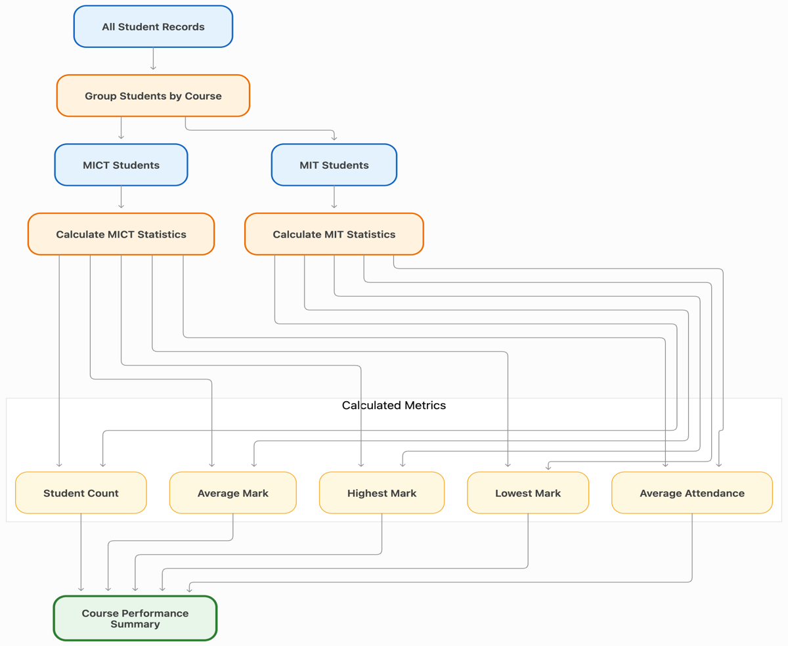
Figure: Course-Level Performance Analysis
Course | Students | Average Mark | Highest | Lowest | Average Attendance
MICT | 12 | 63.66 | 88.30 | 45.90 | 78.58%
MIT | 12 | 79.93 | 95.10 | 53.10 | 88.92%
The sample data set therefore illustrates the differences (or similarities) between categories as evidenced by grouped analysis.
The values shown should be taken with a grain of salt, however. These are the "made up" sample data set and not evidence for a better performing real course.

6.5 Students Requiring Academic Support
Applying the system's at-risk rules identifies six students:
Student | Overall Mark | Attendance
Prassanna Kaami | 47.90 | 68%
Aayush Shrestha | 56.80 | 72%
Roshan Adhikari | 50.20 | 70%
Sagar Poudel | 45.90 | 65%
Kiran Oli | 54.40 | 74%
Manisha Rijal | 53.10 | 71%
One or more of the defined risk conditions is met and these students are identified.
This feature is not intended to form a definitive opinion of a student's academic skills. Its purpose, rather, is to serve as an early-warning system to suggest that further review might be helpful (Arnold and Pistilli, 2012; Slade and Prinsloo, 2013).

6.6 Decision-Support Recommendations
The system based on the current data set can make individual and general recommendations. If students' results of assignments are weak, they can be encouraged to do better for the next time on how to prepare assignments.
Students that do not do well on quizzes can review and work on the assigned weekly questions. Students who have low marks in examinations may be given extra examination preparation support.
If attendance is low, it may result in an attendance improvement recommendation and if study hours are low, it may result in a recommendation to increase independent study.
This makes it valuable in practice as analytical results are not presented in the form of just numbers but as actions.

7. Evaluation and Design Justification

7.1 Effectiveness of Classification Rules
The advantage of the classification system is that it's very simple. The categories Excellent, Good, Average and Poor are easily understood by users, even if they are lacking in statistical expertise.
Additionally, each student can be assigned to only one category by using the thresholds.
The rules are however, solely based on pre-determined thresholds. Although a student's difference between 84.9 and 85 is very small, he/she is still classified as Good or Excellent, respectively.
Thus, the classifications are intended to be used as indicators of student capability to make decisions and not as measures of capability per se.

7.2 Effectiveness of Recommendations
The benefit of the recommendation engine is that they take various factors into account. For instance, if a student has a low examination performance, he/she is offered a different recommendation than a student with a low attendance.
This gives more useful information to students who are not performing as well, than to everybody else.
With another strength is that a number of recommendations can be produced for a single student.
If a student is having issues with examination marks, attendance and study hours, they can then get recommendations for all three.
Limitations include that recommendations are created based on rules, instead of specific information on the student's circumstances.

7.3 Design Justification
The choice of OOP was made as it is a natural fit with the student domain.
The Student class encapsulates individual student information and related behaviour, while StudentPerformanceSystem manages collection-level operations.
Also the use of separate methods for validation, analysis, classification and recommendations will minimize code duplication (Martin, 2008).
The statistics module was chosen to implement the mean, median and standard-deviation because they are common statistical operations, and the implementations in this module are readable and reliable (Python Software Foundation, no date e).

7.4 Strengths
The main strengths of the developed application include:
- structured OOP implementation;
- clear separation of responsibilities;
- multiple Python data structures;
- data validation;
- exception handling;
- duplicate ID detection;
- descriptive statistical analysis;
- individual classification;
- course-level summaries;
- at-risk detection;
- personalised recommendations;
- system-level decision support; and
- menu-driven interaction.
These are especially important to the High Distinction rubric which focuses on well-designed classes and functions, data validation and statistical analysis, good evaluation and a completed working professional application.

7.5 Ethical Considerations
Student academic information can be sensitive. A real implementation would therefore require appropriate privacy and security controls.
The access to students' records should be restricted to authorised people only. All information should be kept safe and any unnecessary personal information not collected (Slade and Prinsloo, 2013; Office of the Australian Information Commissioner, no date).
Another ethical question is on automated classification. The term "Poor" should not be used to label a student as a permanent term of the student's label. Illness, work, life circumstances, accessibility and other factors not included in the data set can impact on performance (Baker and Hawn, 2022).
The system should assist the reader in making their own decisions to make the reading process more efficient, but not eliminate academic judgement (Slade and Prinsloo, 2013).
The assessment should directly address ethical issues, as well as strengths, limitations and assessment of the classification and recommendation processes.

8. Limitations and Future Enhancements

8.1 Current Limitations
The current system has several limitations.
Sample dataset: This app for the moment shows its functionality by using a synthesized set of 24 records. Results are thus not an indicator of reality of the institutions, but of the program itself.
Hardcoded data: The sample records are included right in the source code. This works well for demonstration purposes, but is not as convenient for large data sets.
Fixed classification rules: Performance thresholds are set in advance and for the time being cannot be set by the user.
Console interface: The system uses text-based menus rather than a graphical interface.
No persistent database: Information will only be available during the run-time of the program, unless it is explicitly added to the code.
Limited contextual information: The recommendation engine does not take into account personal factors or past academic achievement.
No authentication: The current prototype does not implement user accounts or access permissions.

8.2 Future Enhancements
Future versions may have CSV import / export to allow for analysis of larger data sets without source code modifications.
To make the application more user-friendly, a graphical interface could be designed using Tkinter or a web-based application framework (Python Software Foundation, no date f).
Persistent data storage might be provided by a database, like SQLite (Python Software Foundation, no date d).
Other visual analytics might be bar charts, histograms and performance trend graphs.
Role based access can be used to differentiate between lecturers, administrators and students. Future versions may also consider taking account of the performance of students over several semesters instead of just a single set of marks.
More sophisticated analysis could be used in the future if there were enough historical data available that were valid for the purpose. But, a predictive system that includes students would need to be carefully validated, protected from privacy violation and must have human oversight (Slade and Prinsloo, 2013; Baker and Hawn, 2022).

9. Version Control and Collaboration
This project is designed to be a collaborative software-development effort. Collaboration is significant as that is one of the assessment learning outcomes; to share responsibilities and make accountable individual contributions.
Project's central version control platform can be GitHub (Chacon and Straub, 2014). All group members should take responsibility for specific components of the system and report, but still maintain a cohesive, integrated, tested application.
A suitable responsibility structure is:
Group Member | Main Responsibilities
Sujan Bhujel | System integration, Student class, final testing and report coordination
Samarpan Kharel | Data validation, exception handling and dataset testing
Anshu Chaudhary | Statistical analytics and course-level analysis
Samyog Bajgain | Classification, recommendation logic and testing
All group members should review the complete system rather than understanding only their own section because the assessment includes an individual viva.
The version-control process should include meaningful commit messages (Chacon and Straub, 2014) such as:
Created Student class
Added validation functions
Implemented descriptive analytics
Added performance classification
Implemented recommendation engine
Added sample student dataset
Fixed validation errors
Updated documentation
Final system testing
Important: Only claim GitHub commits, branches or individual contributions in the final submission if your group actually performed them. Add screenshots of your real repository and commit history here.
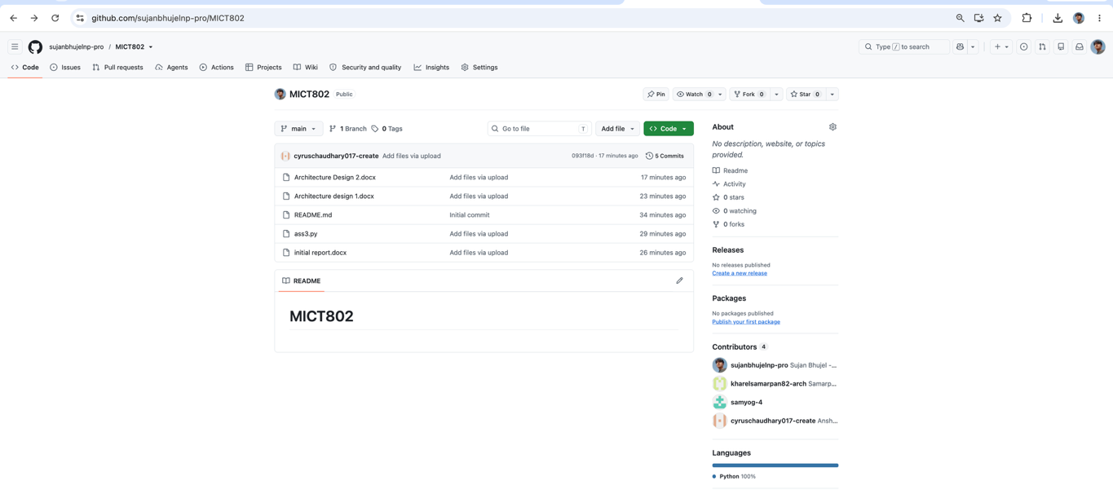
Figure 7. GitHub repository and project files
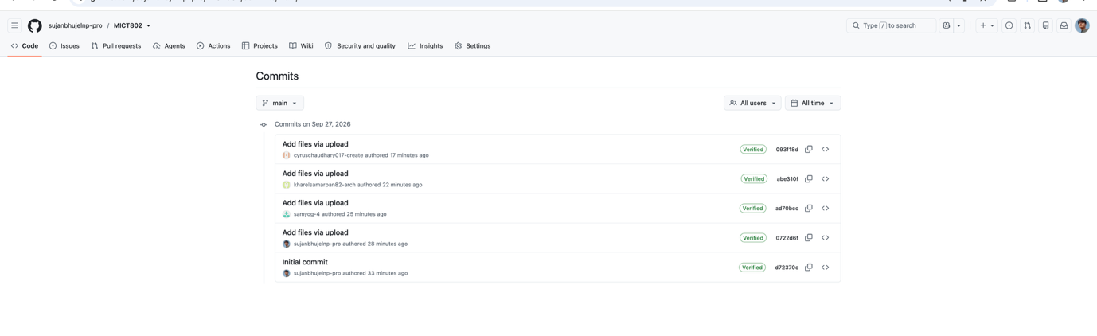
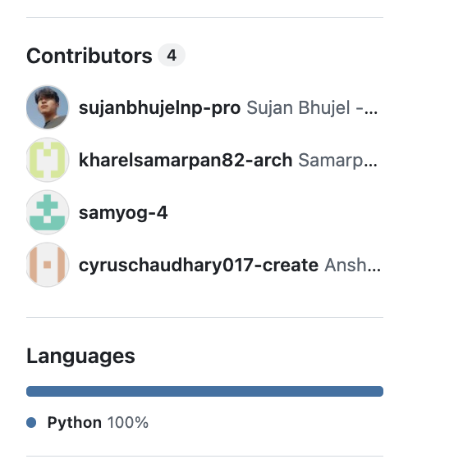
Figure 8. Group commit history
GITHUB LINK: https://github.com/sujanbhujelnp-pro/MICT802

Complete Student Performance System Program Flow

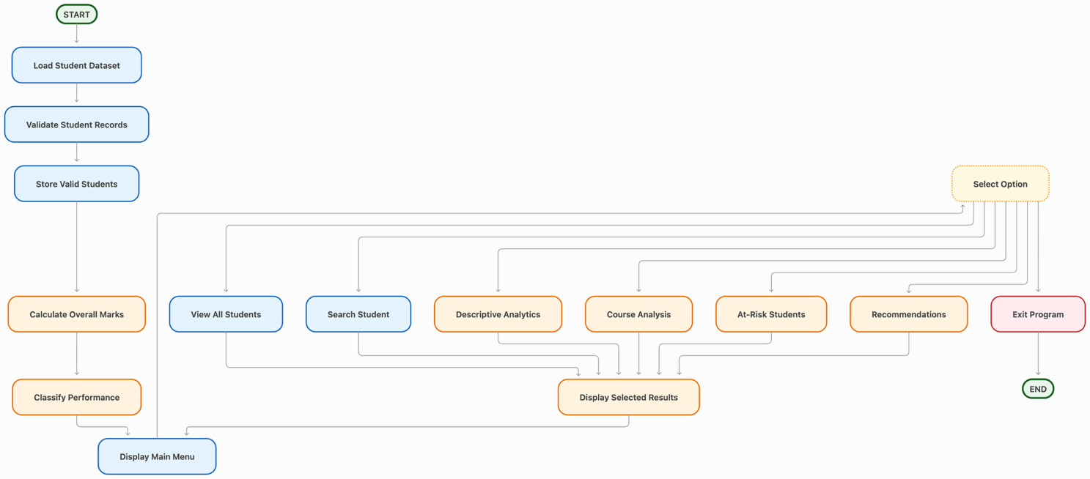
Figure: Complete Student Performance System Program Flow

10. Conclusion
The Student Performance Tracking and Decision Support System is a demonstration of the use of Python programming and description data analysis to solve an educational problem.
It is an application that deals with the student information, which includes academic results, attendance and study information. It checks data, generates weighted overall marks, does descriptive statistic analysis, classifies student performance and offers Rule-based recommendations.
The application also illustrates some key programming concepts in Python such as object-oriented programming, exception handling, conditional statements, loops, lists, dictionaries, tuples and sets.
The average mark for the 24-record sample data set is approximately 71.80, the median is 74.75 and the standard deviation is approximately 15.21. In addition, the application illustrates a grouped course analysis, and identifies students that meet certain academic-support criteria.
The key benefit of the system is that it converts the raw student data into analytical, structured data and recommendations to take action. The project also acknowledges that, while classifications based on rules have their limitations and can be used as a complement to academic judgment.
Overall, the project has shown that Python can be used in the field of data processing, descriptive statistics, classification, decision support in an educational context.

References
Arnold, K.E. and Pistilli, M.D. (2012) ‘Course Signals at Purdue: using learning analytics to increase student success’, in Proceedings of the 2nd International Conference on Learning Analytics and Knowledge. New York: Association for Computing Machinery, pp. 267–270. Available at: https://doi.org/10.1145/2330601.2330666.
Baker, R.S. and Hawn, A. (2022) ‘Algorithmic bias in education’, International Journal of Artificial Intelligence in Education, 32(4), pp. 1052–1092. Available at: https://doi.org/10.1007/s40593-021-00285-9.
Black, P. and Wiliam, D. (1998) ‘Assessment and classroom learning’, Assessment in Education: Principles, Policy & Practice, 5(1), pp. 7–74. Available at: https://doi.org/10.1080/0969595980050102.
Chacon, S. and Straub, B. (2014) Pro Git. 2nd edn. New York: Apress. Available at: https://git-scm.com/book/en/v2.
Credé, M., Roch, S.G. and Kieszczynka, U.M. (2010) ‘Class attendance in college: a meta-analytic review of the relationship of class attendance with grades and student characteristics’, Review of Educational Research, 80(2), pp. 272–295. Available at: https://doi.org/10.3102/0034654310362998.
Field, A. (2018) Discovering statistics using IBM SPSS Statistics. 5th edn. London: SAGE Publications.
Lutz, M. (2013) Learning Python. 5th edn. Sebastopol, CA: O’Reilly Media.
Macfadyen, L.P. and Dawson, S. (2010) ‘Mining LMS data to develop an “early warning system” for educators: a proof of concept’, Computers & Education, 54(2), pp. 588–599. Available at: https://doi.org/10.1016/j.compedu.2009.09.008.
Martin, R.C. (2008) Clean code: a handbook of agile software craftsmanship. Upper Saddle River, NJ: Prentice Hall.
Office of the Australian Information Commissioner (no date) Australian Privacy Principles. Available at: https://www.oaic.gov.au/privacy/australian-privacy-principles.
Python Software Foundation (no date a) Classes. Available at: https://docs.python.org/3/tutorial/classes.html.
Python Software Foundation (no date b) Data structures. Available at: https://docs.python.org/3/tutorial/datastructures.html.
Python Software Foundation (no date c) Errors and exceptions. Available at: https://docs.python.org/3/tutorial/errors.html.
Python Software Foundation (no date d) sqlite3 — DB-API 2.0 interface for SQLite databases. Available at: https://docs.python.org/3/library/sqlite3.html.
Python Software Foundation (no date e) statistics — Mathematical statistics functions. Available at: https://docs.python.org/3/library/statistics.html (Accessed: 27 September 2026).
Python Software Foundation (no date f) tkinter — Python interface to Tcl/Tk. Available at: https://docs.python.org/3/library/tkinter.html.
Romero, C. and Ventura, S. (2020) ‘Educational data mining and learning analytics: an updated survey’, WIREs Data Mining and Knowledge Discovery, 10(3), e1355. Available at: https://doi.org/10.1002/widm.1355.
Siemens, G. and Long, P. (2011) ‘Penetrating the fog: analytics in learning and education’, EDUCAUSE Review, 46(5), pp. 30–40.
Slade, S. and Prinsloo, P. (2013) ‘Learning analytics: ethical issues and dilemmas’, American Behavioral Scientist, 57(10), pp. 1510–1529. Available at: https://doi.org/10.1177/0002764213479366.
Wang, R.Y. and Strong, D.M. (1996) ‘Beyond accuracy: what data quality means to data consumers’, Journal of Management Information Systems, 12(4), pp. 5–33. Available at: https://doi.org/10.1080/07421222.1996.11518099.

