Project Title:

MEDIUM ENTERPRISE ACCOUNTING SYSTEM

Problem Statement: The enterprise needs to store its accounting information and day-to-day transactions in an accounting system. The Employees(identified by employee id) with first name, middle initial, last name, age, address, phone no as the attributes. Each transactional journal Voucher(identified by vno) with supporting document number, suppoting document description, tansaction date, transaction amount, debit account, credit account, authorised by, prepared by, narration as attributes. Each of the internal accounts in the system is (identified with account code) with attributes account name, accounts balance, account category id and account catgory name. The ledger is maintained by the system with all the external sundry/trade creditors/debtors (identified by their Trade Number) within the external relation. The attributes being the party name, account balance, account category id, account category type. A naive assumption is that two external accounts/parties can bear the same name.

The relations are:
1. employee(empid, fname, minit, lname, age, address(comp) = city & state, phno )
2. vouchers( vno, vdate, amount, supdoc_no, supdoc_desc, debit, credit, auth, prep, narration )
3. accounts( acc_code, acc_name, acc_bal, is_internal, acc_cat_id, acc_cat_name)

Identifying functional dependencies

Relation | Explanation
employee:  empid -> (all attributes)  phno -> (all attributes)  pincode -> city | #unique to every employee  #unique to every employee  #implicit
vouchers:  vno -> (all attributes) | #unique to every voucher
accounts:  acc_code -> (all atrributes)  acc_name -> (all attributes)  acc_cat_id -> acc_cat_name  acc_cat_name -> acc_cat_id | #serialised – unique  #unique to every account  #serialised – unique  #serialised - unique
external:  ext_code -> (All attributes)  acc_cat_id -> acc_cat_name  acc_cat_name -> acc_cat_id | #unique to every party  #serialised – unique  #serialised - unique

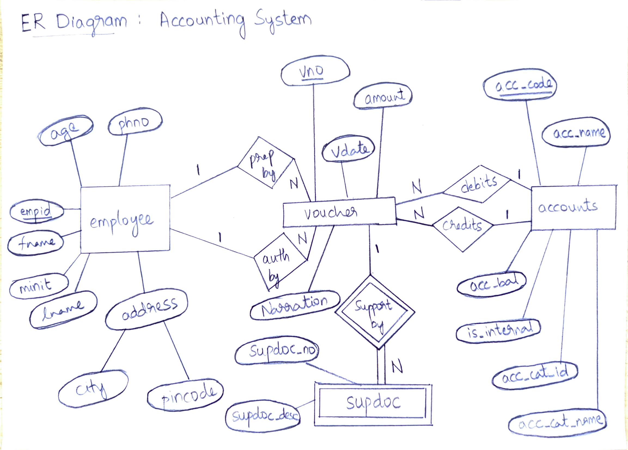

Identifying keys of the relations based on FDs

In employee relation, the super keys are:
1. empid : as each employee is provided with a unique employee ID. This allows us to determine each record as shown from functional dependencies.
2. phno : Each employee does have unique phone number, as no two employees can have the same phone number.
The Super Keys are itself the Candidate keys too.

In vouchers relation, the super key is:
1. vno : The voucher number is unique for every journal entry recorded in the system. No two records in the accounting system can have the same voucher number. Thus this is a Super Key, which is indeed the candidate key too.
Note: Given Supporting document number and supporting document desciption, it is possible to determine the voucher number if and only if they are not NULL but as the presence of supporting document is a not always guaranteed, this pair {supdoc_no, supdoc_desc} can not be presented as a Super Key.

In accounts relation, the super keys are:
1. acc_code : As specified in the problem, this relation not only consists of the accounts maintained by the firm but also the external Sundry/Trade Creditor/Debtor accounts. It is implicit that the trade number of any external party cannot be the same as of an internal account’s acc_code. Thus this becomes a super key and goes on to be the candidate key too.
2. acc_name : Every external account/party is identified by their Trade Name, all internal accounts are named naively. Thus, it is sure that there will be zero overlap between the two thus making the acc_name a super key.

Normalization
Before:

1. employee(empid, fname, minit, lname, age, address(comp) = pincode & city, phno)
2. vouchers(vno, vdate, amount, supdoc_no, supdoc_desc, debit, credit, auth, prep, narration)
3. accounts(acc_code, acc_name, acc_bal, acc_cat_id, acc_cat_name, bool is_internal)

After:

1. employee(empid, fname, minit, lname, age, phno, pincode)
2. address (pincode, city)
3. voucher(vno, vdate, amount, debit, credit, auth, prep, narration)
4. supdoc(vno, supdoc_no, supdoc_desc)
5. accounts(acc_code, acc_name, acc_bal, is_internal, acc_cat_id)
6. acc_type(acc_cat_id, acc_cat_name)

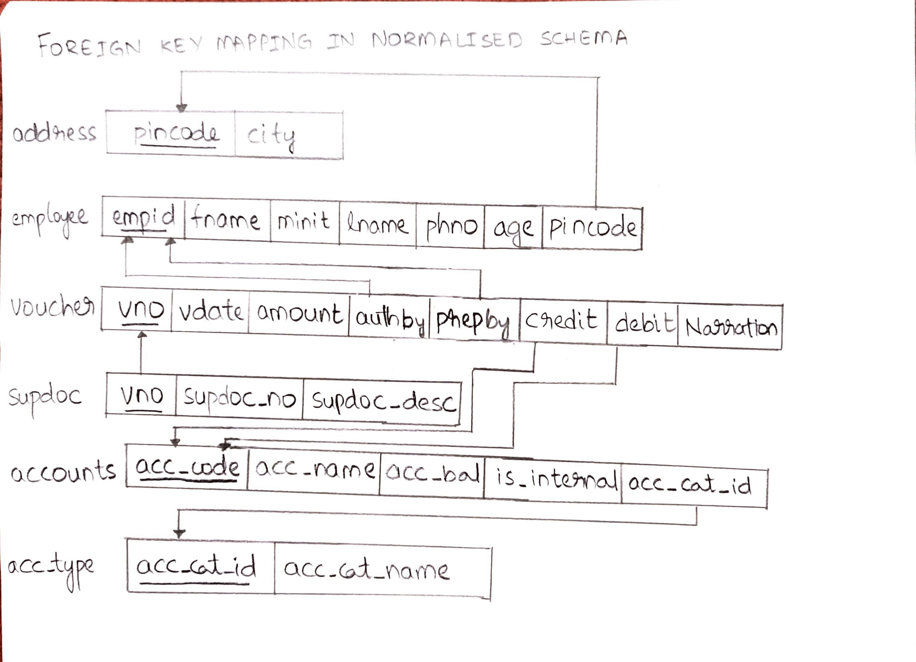

Functional dependencies after normalization:
1. employee:
empid -> (all attributes)
phno -> (all attributes)

2. address:
pincode -> city

3. voucher:
vno -> (all attributes)

4. supdoc:
vno -> (all attributes)
{supdoc_no,supdoc_desc} -> vno
Beacuse of the insert anomaly due to the non-determinism of the availabilty of the support documnets, the support documents are placed in a new relation so as to reduce the number of NULL values in the table. This is however a weak entity.

5. accounts:
acc_code -> (all attributes)
acc_name -> (all attributes)

6. acc_type:
acc_cat_id -> acc_cat_name
acc_cat_name -> acc_cat_id

As we can see, all the relations are in their BCNF forms.

Testing for lossless join property

The principles to govern the lossless decomposition/ lossless join are as follows:

1. Att(R1) ⋃ Att (R2) =Att(R) : Set of union of the all attributes in the sub relations = Set of attributes of the non-decomposed Relation.
2. Att(R1) ⋂ Att(R2) ≠ Φ : The set of intersection of all the attributes in all the sub relations is not empty.
3. Att(R1) ⋂ Att(R2) = CK(R1) or Att(R1) ⋂ Att(R2) = CK(R2) : Common attribute between two sub relations is a Super Key in atleast one of the sub relations.

Decompositions:

employee | employee  address
voucher | voucher  supdoc
accounts | accounts  acc_type

Decomposition 1:
Att(R) = {empid, fname, minit, lname, age, pincode, city, phno}
Att(R1) = {empid, fname, minit, lname, age, phno, pincode} Att(R2) = {pincode, city}
- UNION of Att(R1) and Att(R2) = Att(R)
- INTERSECTION of Att(R1) and Att(R2) = {pincode}
- {pincode} is the candidate key for R2

Decomposition 2:
Att(R) = {vno, vdate, amount, supdoc_no, supdoc_desc, debit, credit, auth, prep, narration}
Att(R1) = {vno, vdate, amount, debit, credit, auth, prep, narration}
Att(R2) = {vno, supdoc_no, supdoc_desc}
- UNION of Att(R1) and Att(R2) = Att(R)
- INTERSECTION of Att(R1) and Att(R2) = {vno}
- {vno} is the candidate key for R2

Decomposition 3:
Att(R) = {acc_code, acc_name, acc_bal, acc_cat_id, acc_cat_name, bool is_internal}
Att(R1) = {acc_code, acc_name, acc_bal, is_internal, acc_cat_id}
Att(R2) = {acc_cat_id, acc_cat_name}
- UNION of Att(R1) and Att(R2) = Att(R)
- INTERSECTION of Att(R1) and Att(R2) = {acc_cat_id}
- {acc_cat_id} is the candidate key for R2

Creating the tables including check constraints
Creating referencial Integrity constrints

For each relation, the constraints governing the fields of the relation are specified and the screenshots describing the relation are attached. The referencial integrity constraints have been specified within the table creation statements only. For each check constraint, a couple or two variations of inputs are shown as to validate the functioning of check constraint.

address:
- Pincode is a 6 digit number not starting with 0

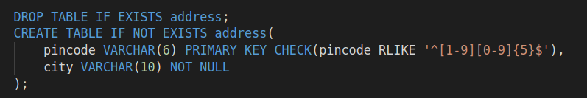
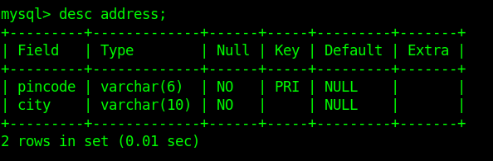
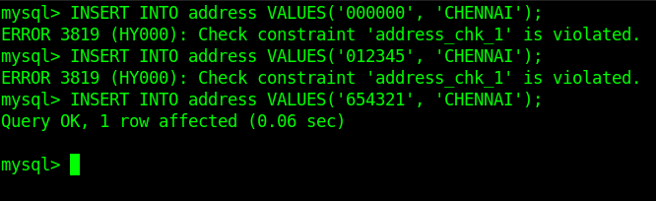

employee:
- Government imposes that each employee should not be aged less than 14 years. The retirement age is assumed at 60. So any person greater than 60 cannot be an employee.
- Phone number is a 10 digit number starting with 9,8,7,6

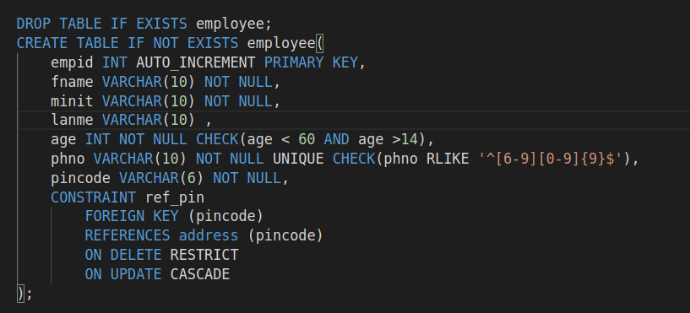

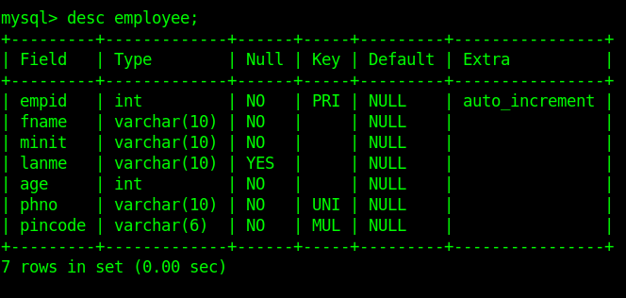
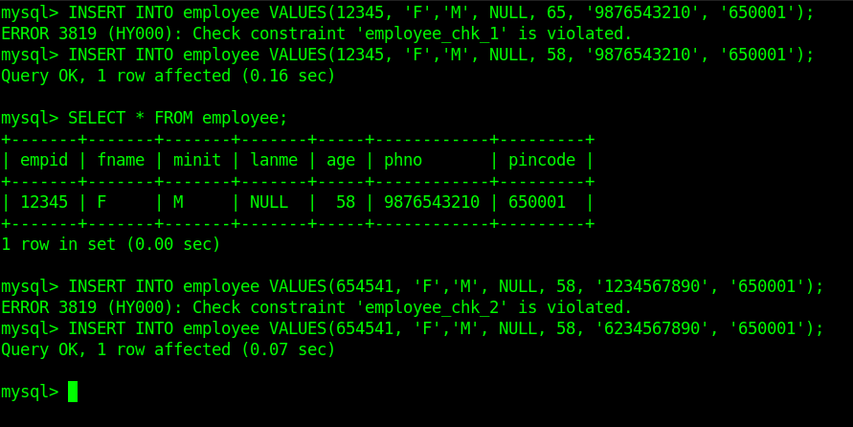
In the picture above from the first example(queries 1,2) , it is clear that 65 wasn’t accepted as it lies outside the range of age accepted. The same is the case with the lower bound.
From the second example (queries 3,4) , the phone number not starting with 6,7,8,9 are not accepted oweing to the second check constraint which is specified with the help of REGEXP.

supdoc:

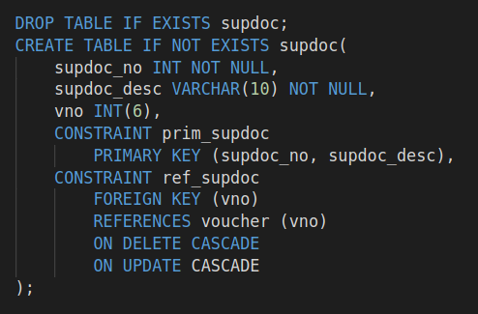

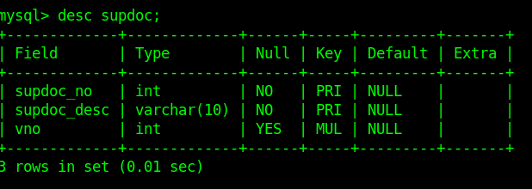

accounts:

- The account code is always a positive integer.

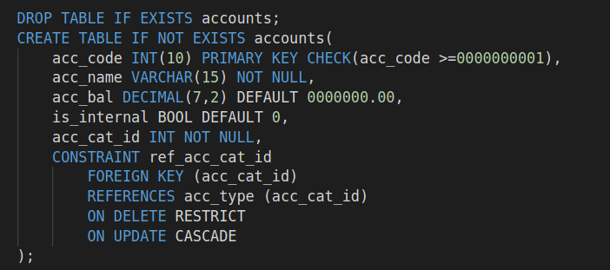
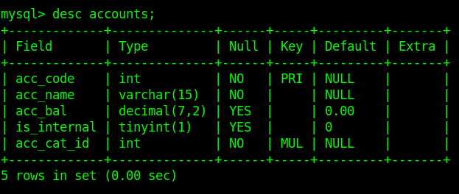
acc_type:

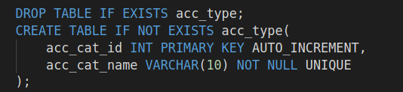
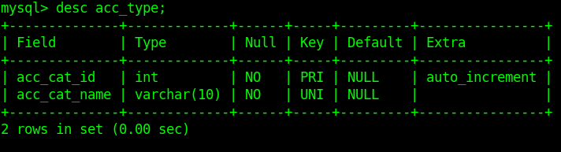
voucher:

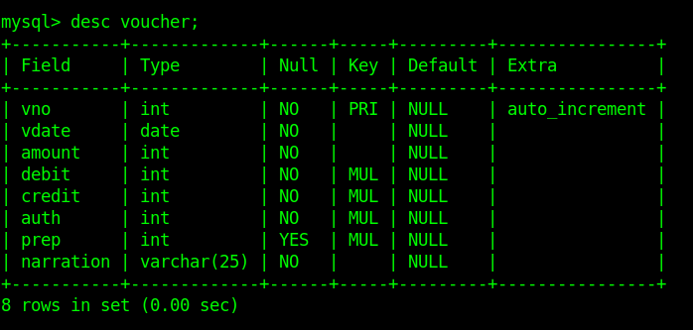

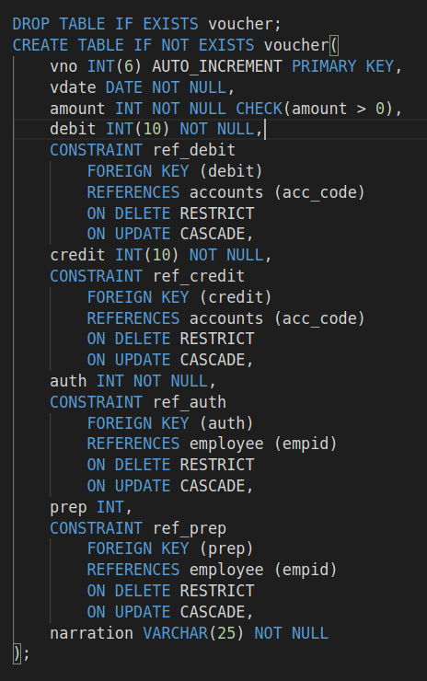

An Instance of the Mini World

An instance of the database is set up below by inserting sample values.

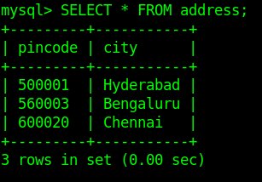

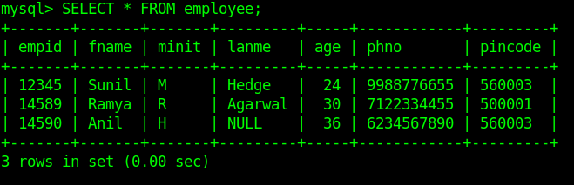

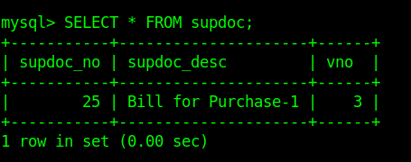

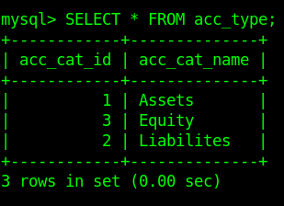

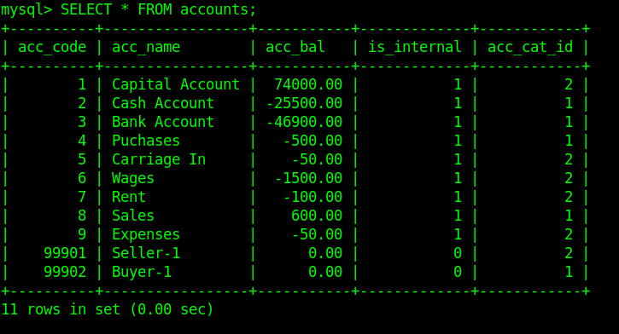
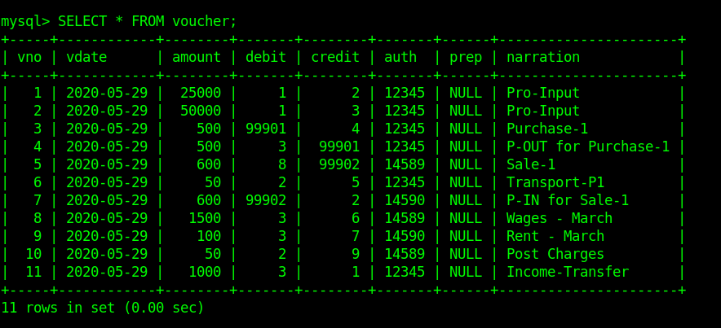

Creating a trigger
However to manage the account balances and to maintain consistency among various rules, a number of triggers have been created. As the listing is done, the purpose of the trigger is also given briefly.

1. settingdate:
As MySQL doesn’t allow deafult value to be fixed for the date type(Exception: Time Stamp can be defaulted), The following trigger ensures that if NULL is provided in place of vdate in the voucher table then, then it is replaced by the current date.

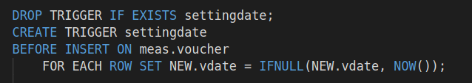
2. ins_deb_cred & up_deb_cred:
In accounting, if a voucher’s debit and credit accounts are same, that is an invalid voucher. These two triggers ensures that this functionality is implemented both on Insert and on update.

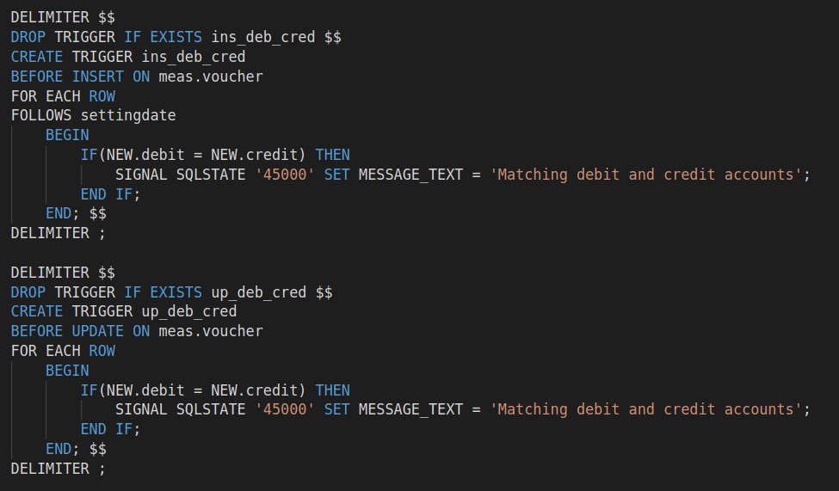

3. ins_cash_txns & up_cash_txns:
The governament of India enforces constraints on cash flow through the economy. It requires legal indentification when there are cash transactions more than Rs 50,000. This is the reason why banks ask for PAN card or other proof when ever there is a deposit of more than Rs 50,000. Thus whenever there is a transaction involving cash account of the firm with amount more than Rs. 50,000, then the system is designed to rollback the transaction and showing a custom message to the user. This functionality is enforced on both INSERT and UPDATE operations using the following triggers.

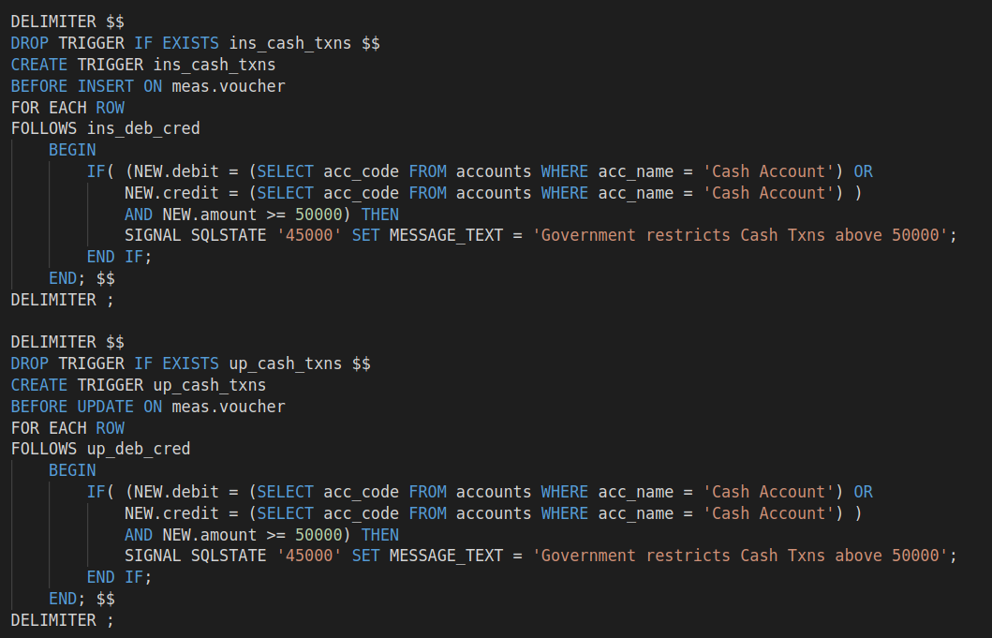

4. ins_vouch_txns & up_vouch_txns & del_vouch_txns:

Whenever, there is an entry in voucher table, the corresponding accounts should be debited and credited with the amount of the voucher. This functionality is ensured by these two triggers activated on all, INSERT, UPDATE and DELETE operations on the voucher table.

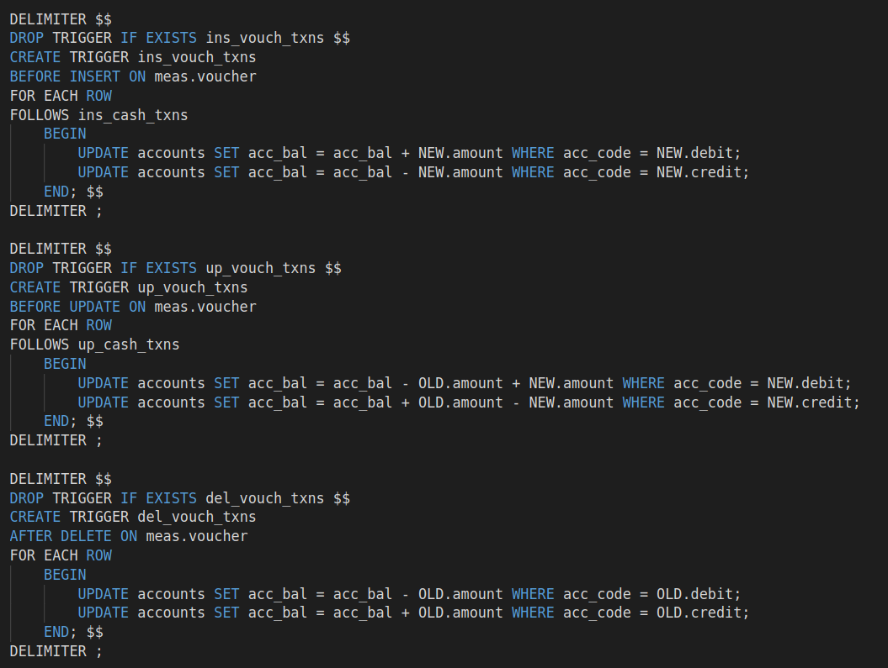
A total of 8 triggers are applied on different tables of the database which are activated on operations of INSERT, UPDATE and DELETE.

Writing complex SQL retrieval queries

1. Display all transactions involving a particular account. Ex: Cash Account

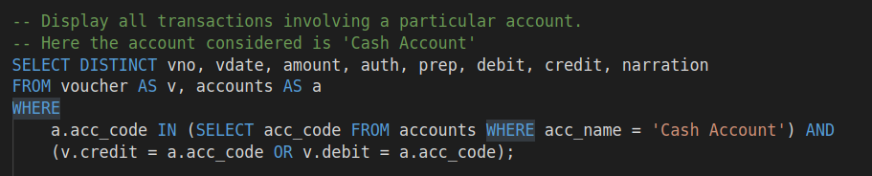
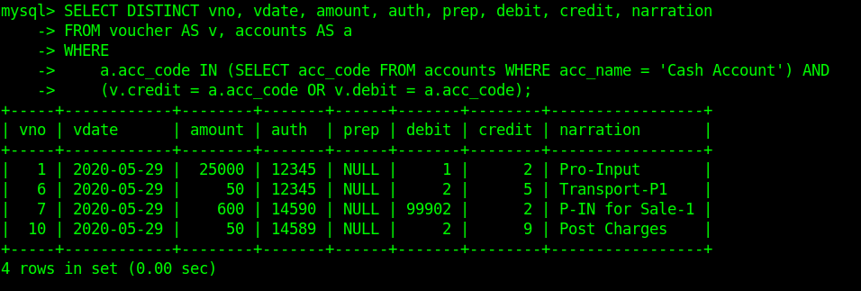
2. Display all transactions in which a particular employee is involved. Ex: Agarwal

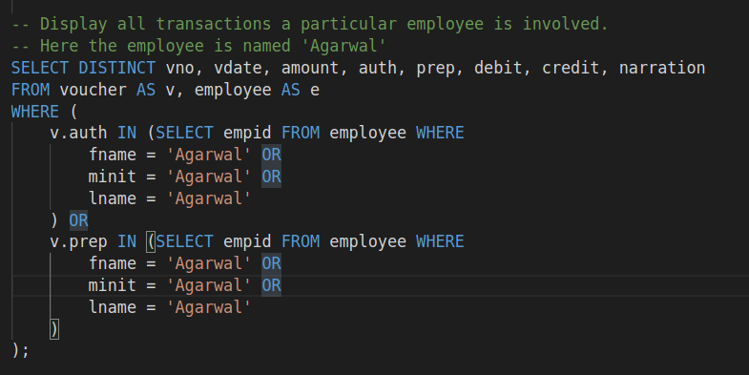
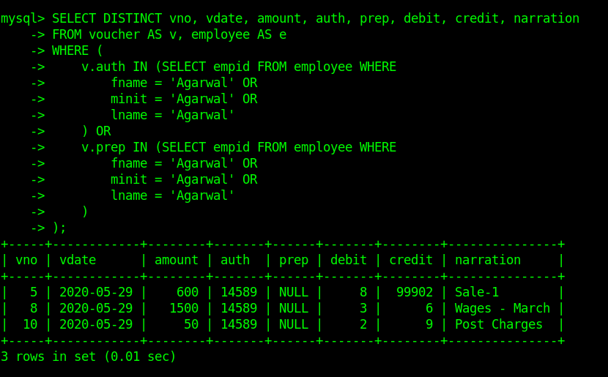
3. Produce the high-level Balance Sheet of the firm

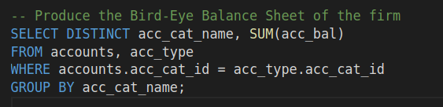
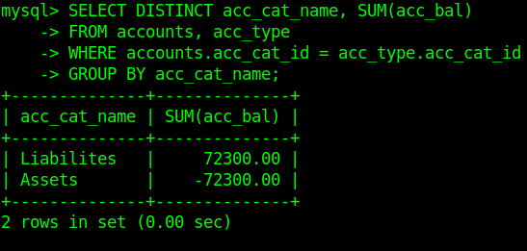
From basic equation of accounts: Assets = Liabilities + Equity

4. Display all external parties who have non-zero balance w.r.t to the firm

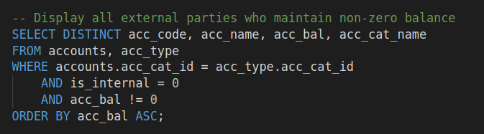
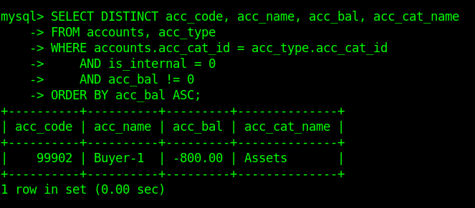
5. List all employee details who hail from Bengaluru using join.

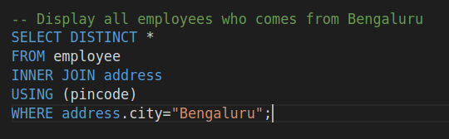

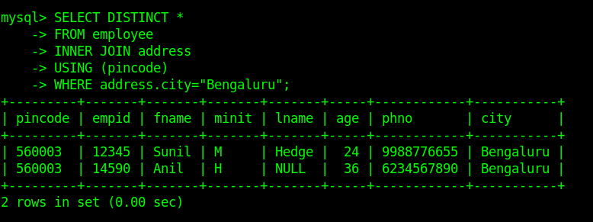
Conclusion:

Every accounting software now available in the market depends on DBMS. It’s a crucial part of these softwares which inarguably are much more complex than what is mimicked above.

