11/14/2022

|  |
| --- |
| Developed and Designed by | Trico |



|  |  |
| --- | --- |
| ROYAL | USER MANUAL |

***Site User login***

1. Enter user email and password and press ENTER or Click on login button

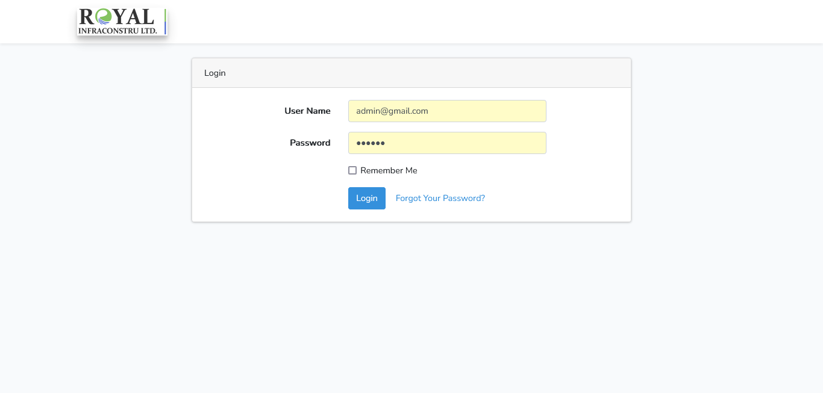

***User Module***

1. See user list

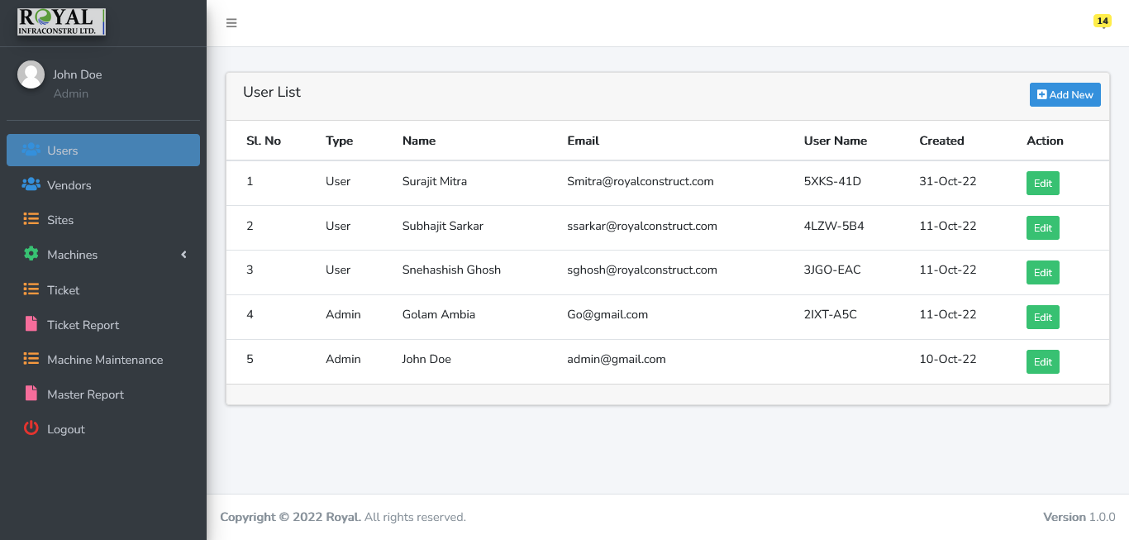

1. Add User (Click on Add New button) or Edit user (Click on Edit button)

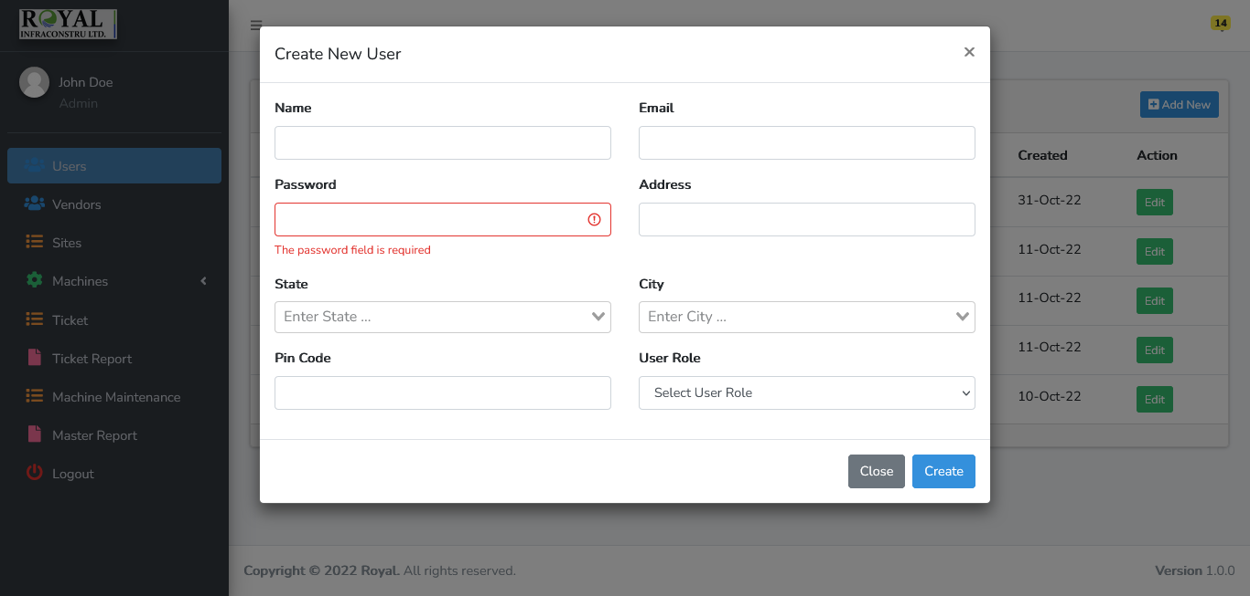

***Vendor Module***

1. See Machine vendor list and Add User (Click on Add New button) or Edit user (Click on Edit button)

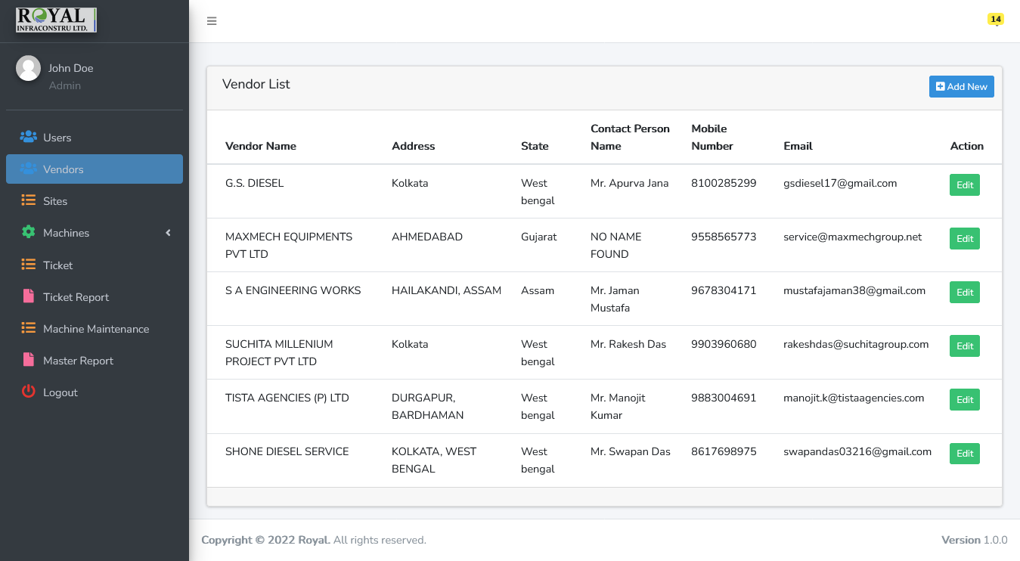 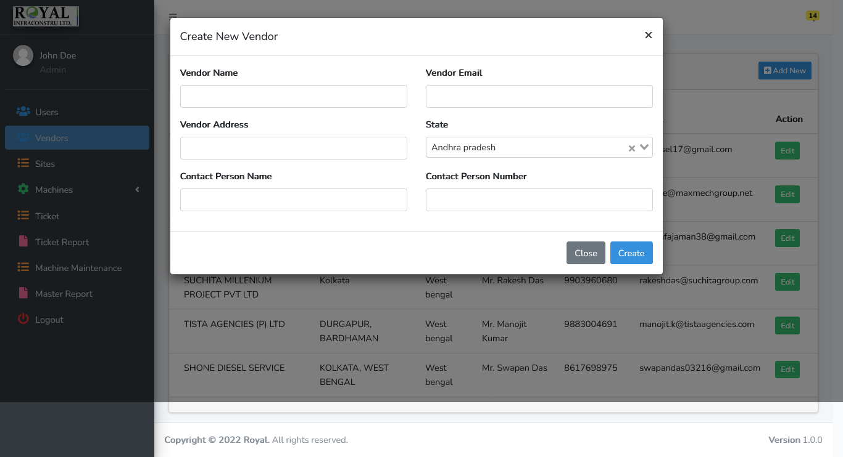

***Sites Module***

Add projects ongoing Sites details

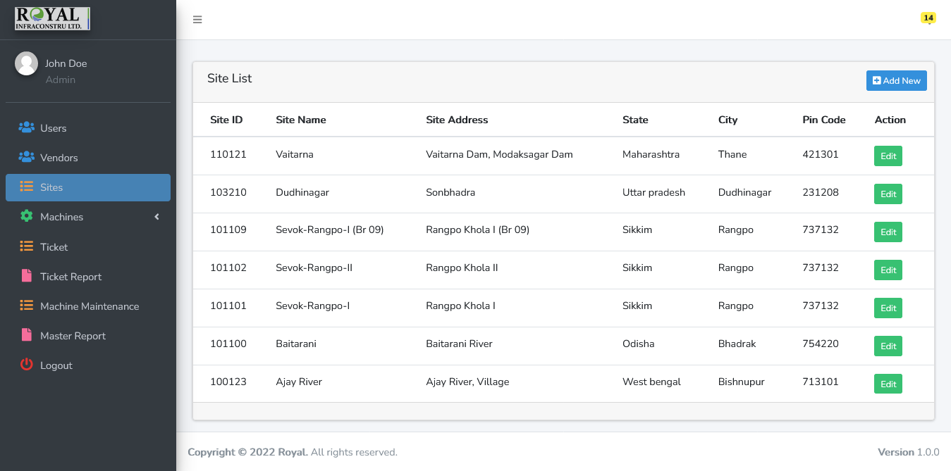

Add new sites or edit site and allocate user to the site



***Machine Category Module***

Add Machine Category

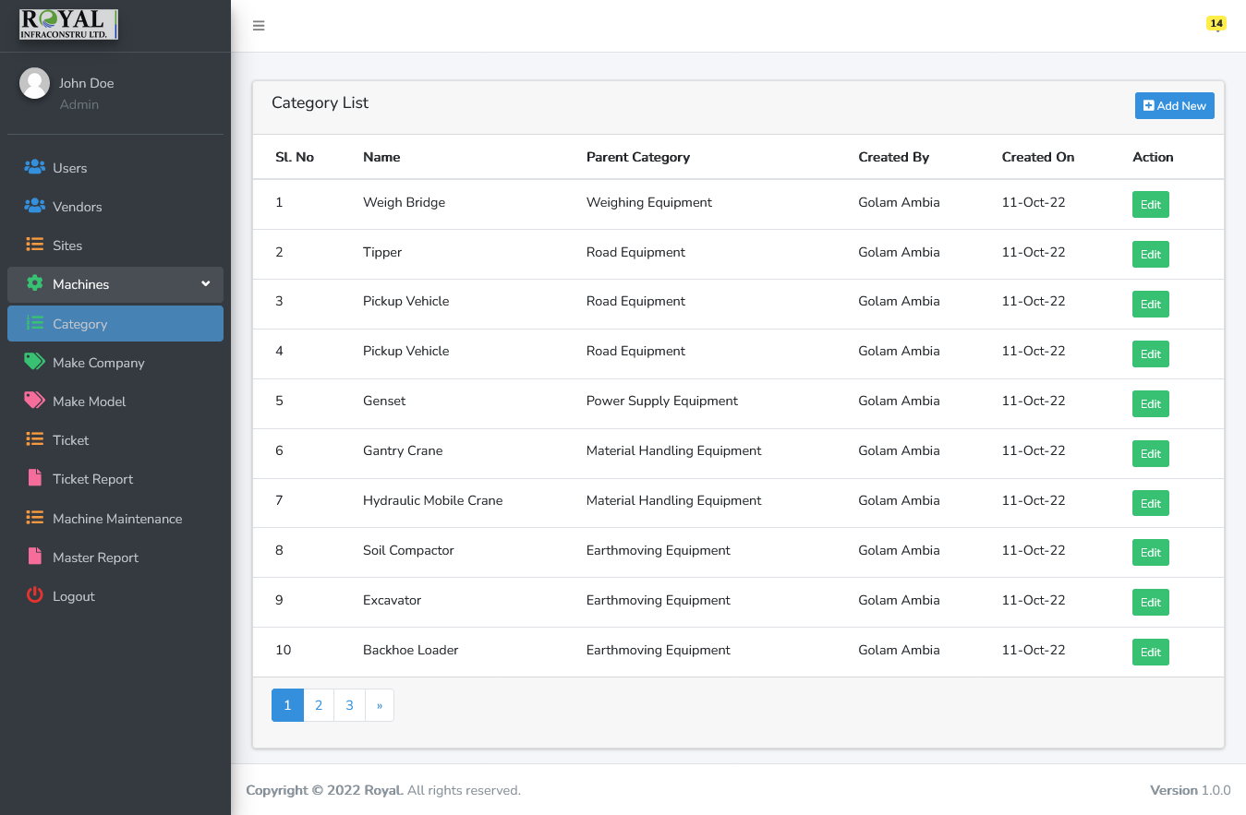

Create new Category or sub category (Leave blank Parent category field in you want make the category as parent)



***Machine Company Module***

List and Add Machine Make Company

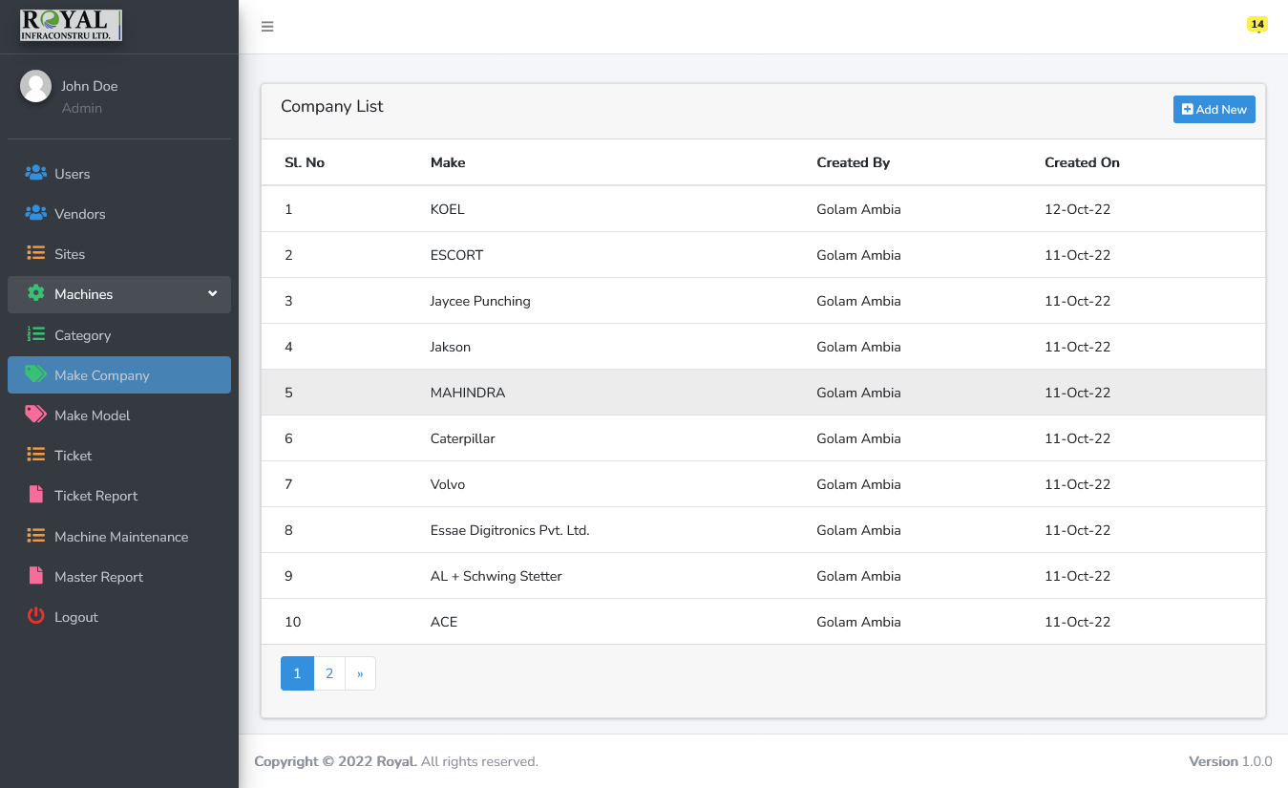 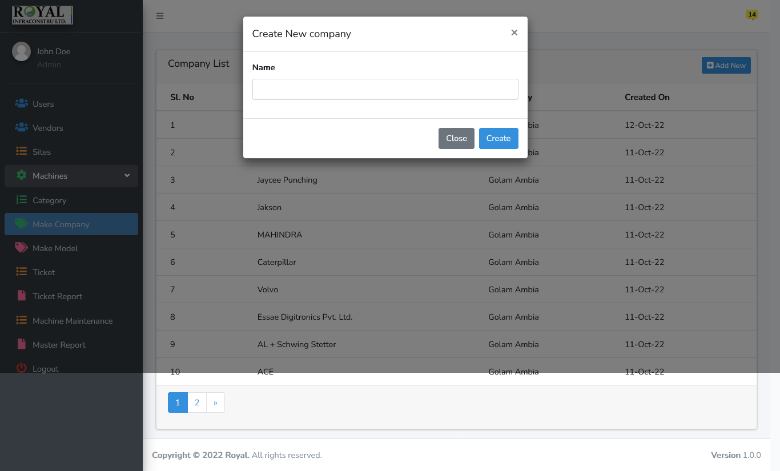

***Machine Company’s Model Module***

List and Add Machine Make Company’s Model

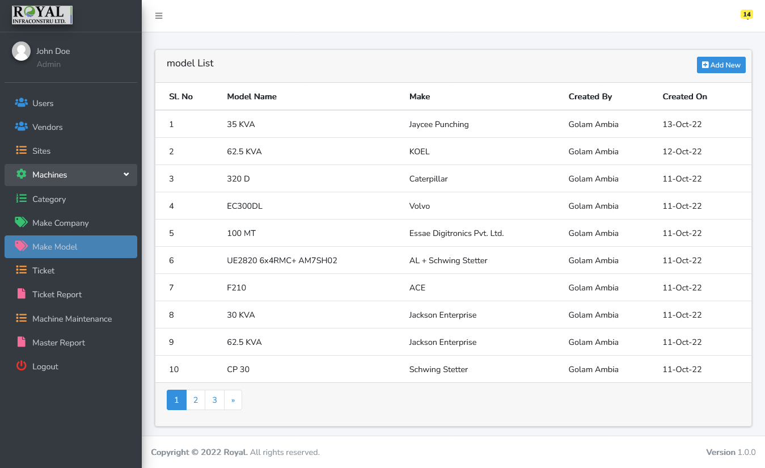

Create new model add model name and select make company from dropdown

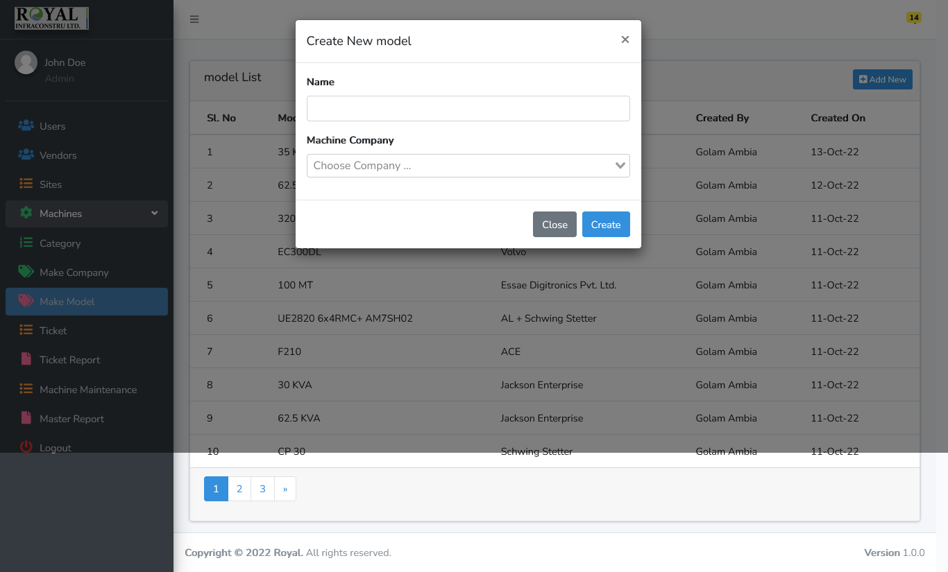

***Machine Module***

1. List of machines and filter and search.
2. Click on "PM Due Status" column graph to view more details and other graphs.
3. Click On “Add new” to create new machine and assign to the site.
4. Click on “Edit” button to edit the machine
5. Click on “CAM” button to add new cam .
6. Click on “CAM List” button to new vie the cam list details history..
7. Click on Far No column to view the machine’s maintanance

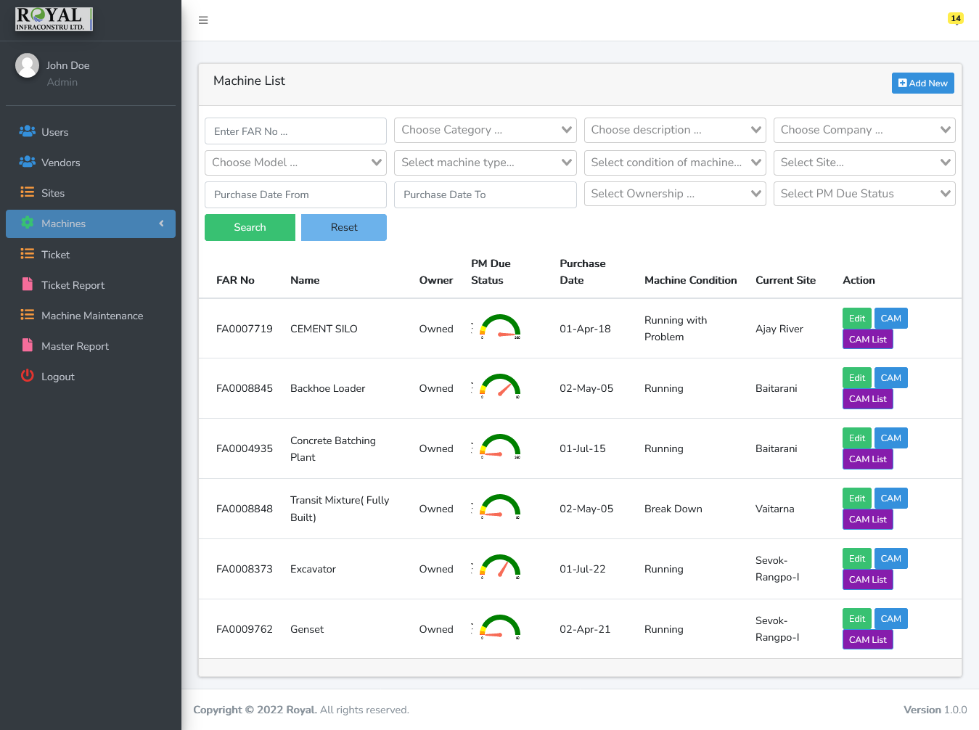

Add or edit the machine

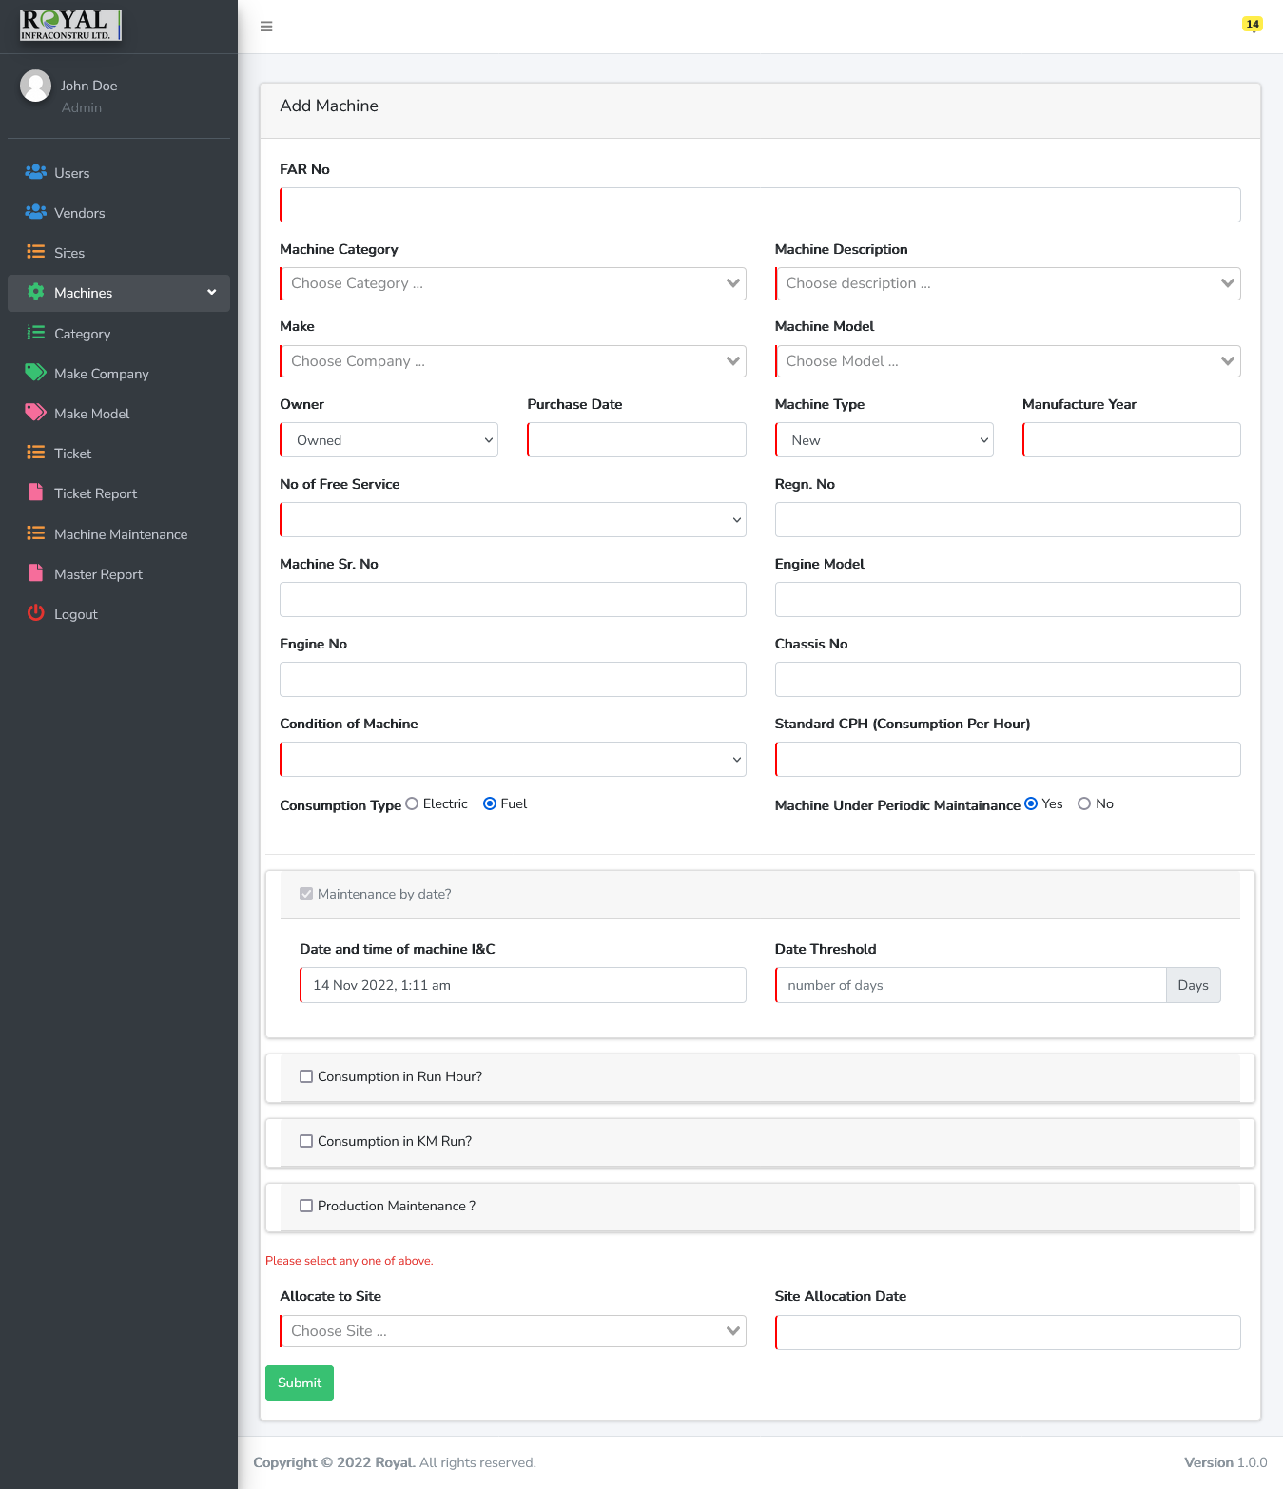

***Machine Maintenances Module***

1. List of machines and filter and search. And add the last maintenance data.

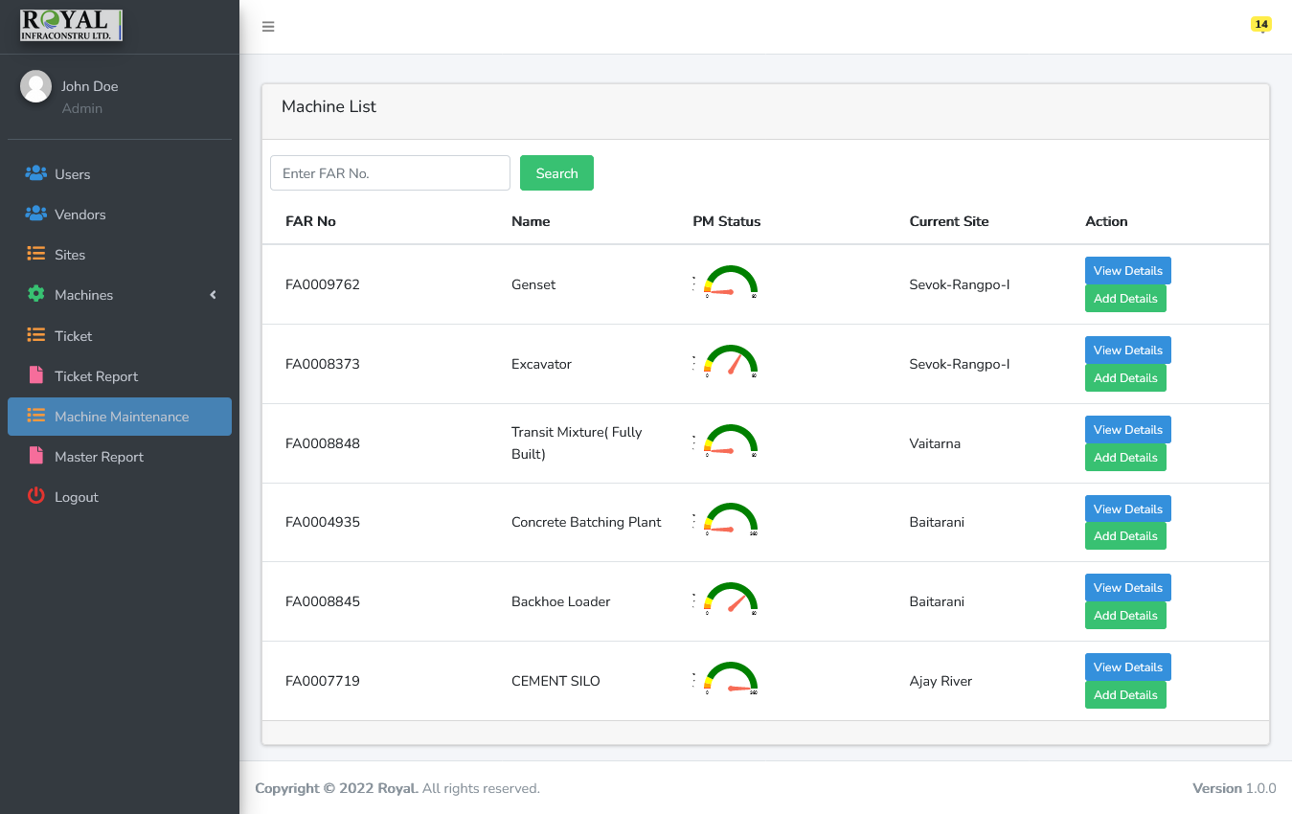 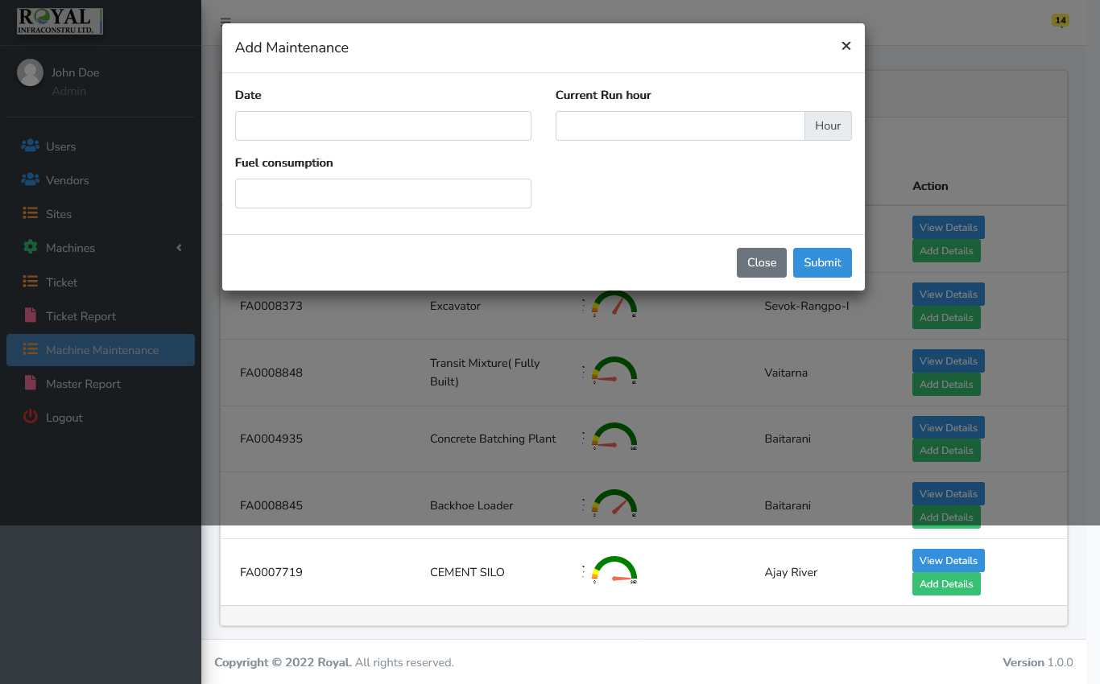

***Ticket Module***

1. List of all tickets and filter and search. And add the last maintenance data.
2. Click On View to see the submitted data as view mode.
3. Click on “Edit”, Admin can edit the ticket as per requirements.
4. Click on close to close the ticket with last maintenance data.

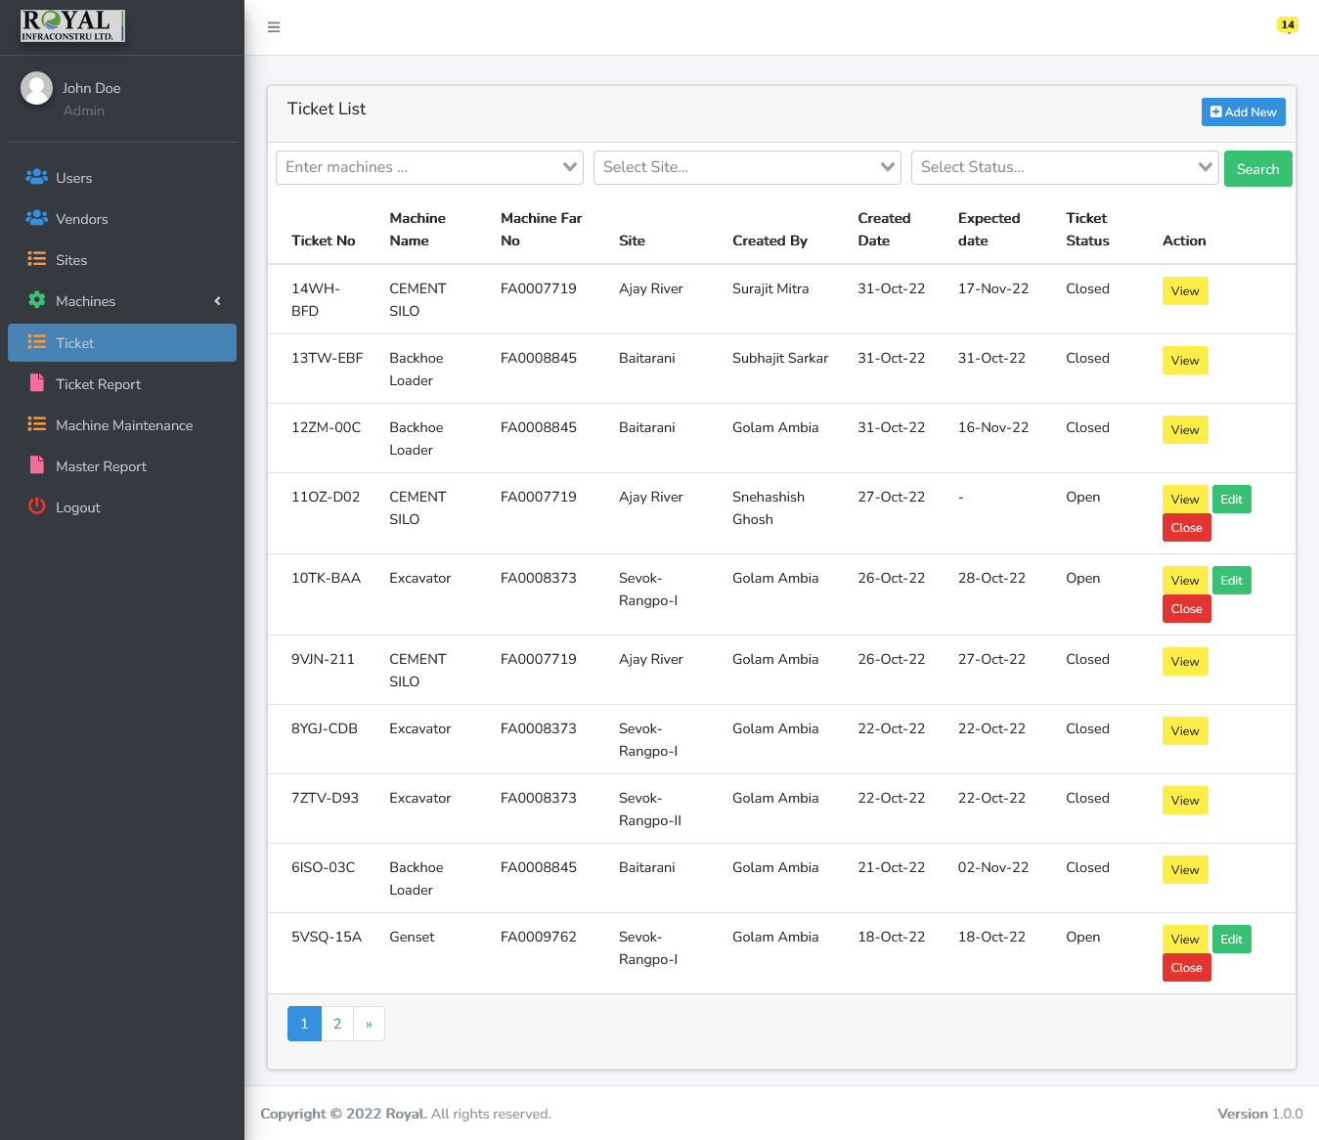

**View Mode**

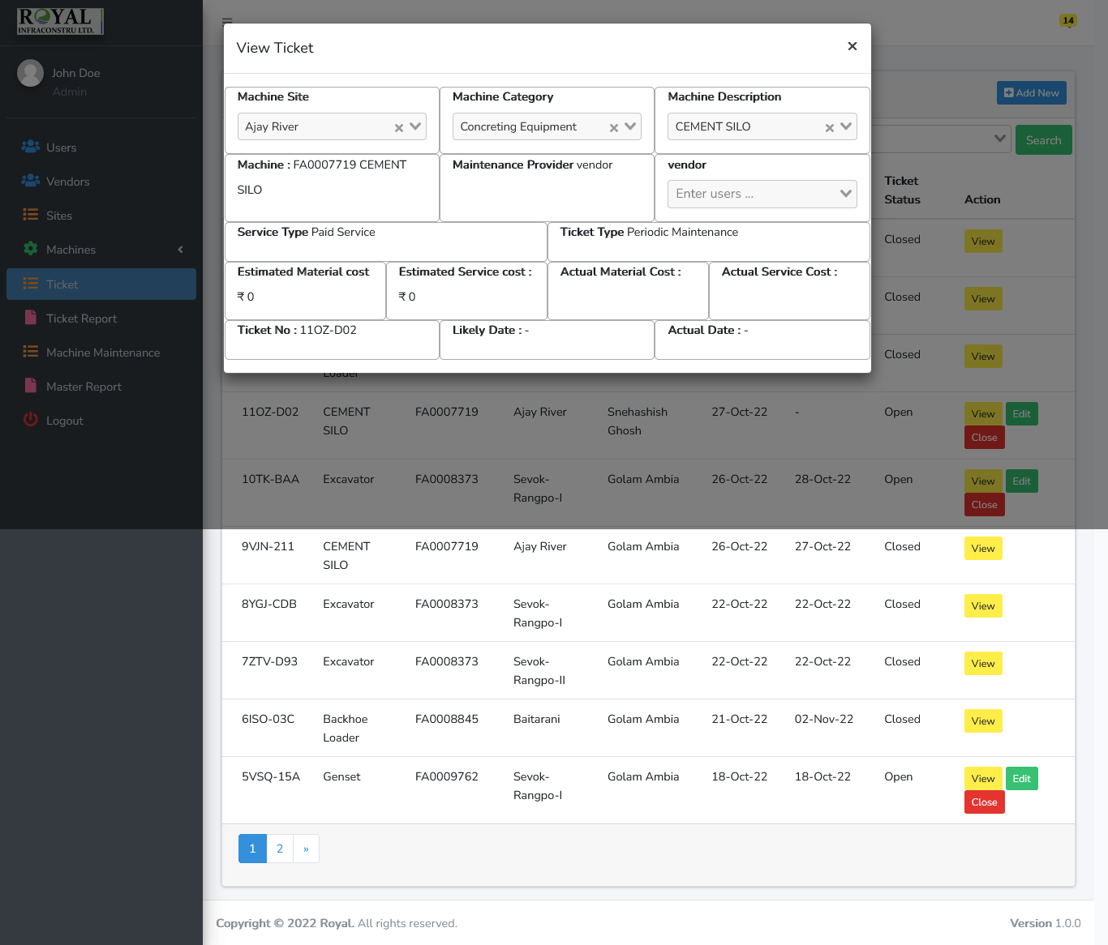

**Close the ticket**

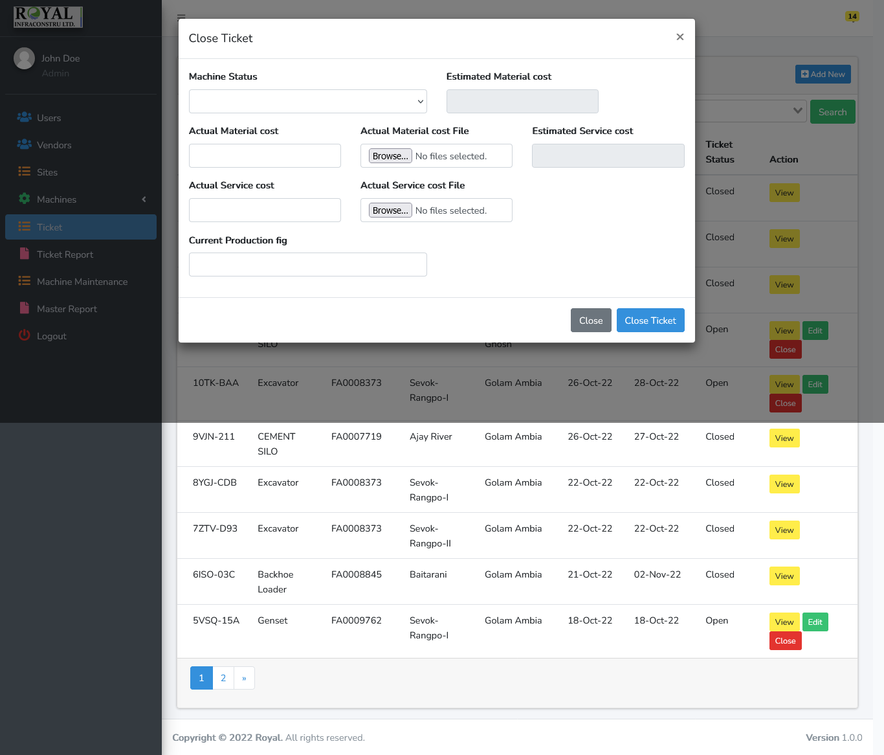

***Ticket Report Module***

1. List of all tickets and various filter and search.

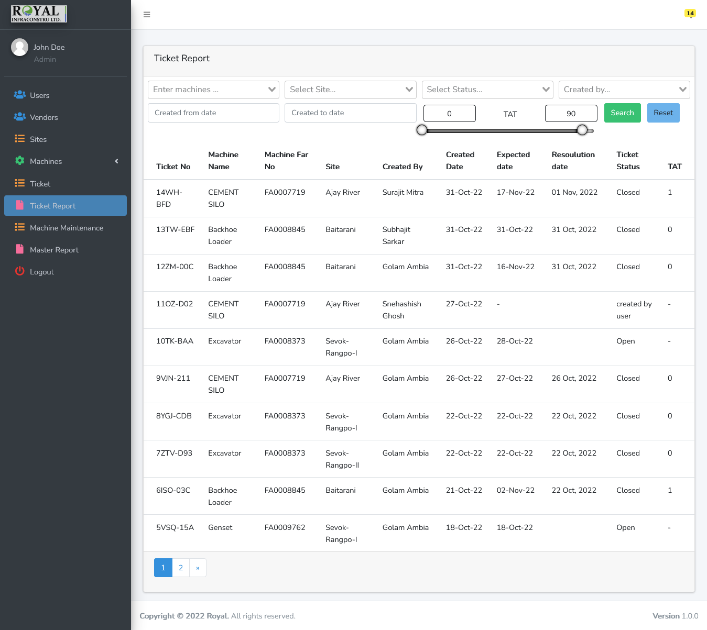

***Master Report Module***

1. List of all machine with sites and various filter and search and export to csv file.
2. Click “Export CSV” to export csv fie.

