**UNIVERSITY OF BARISAL**

**PROJECT REPORT**



**COURSE TITLE : Programming Fundamentals Lab-1**

**COURSE CODE : *CSE-1103***

**PROJECT NAME:A QUIZ­ GAME**

**SUBMITTED BY:**

**KHONDOKER RAZINUL KARIM**

**Exam Roll : CSE038**

**Class Roll :18CSE002**

**SUBMITTED TO:**

**Md. Mostafijur Rahman**

**Lecturer & Student Advisor Department of Computer Science & Engineering**

**DATE OF SUBMISSION 16/09/2018**

Page | 1

Date: 16/09/2018



I declare that this project report on “**A QUIZ­ GAME**” is submitted to , Md Mostafijur Rahman , Lecturer and Student Advisor in the department of Computer Science and Engineering at University of Barisal. . This documentation work has done under the guidance of **Md.** **Mostafijur Rahman .**

Page | 2

**Project : A QUIZ GAME**



**ABSTRACT**



The main objective of this project is to play a quiz game for recreation. There are many topics on which player can play a **“A QUIZ­ GAME” .**

This is a game on which a player can increase his/her general knowledge. This program also supports the player name as well as the player score in file.

Page | 3

**Contents**

ABSTRACT 2

INTRODUCTION 4

PROJECT SCHEDULING 5

PROBLEM STATEMENT 6

PROPOSTED SOLUTION 7

REQUIRMENTS 8

SOURCE CODE 9

PROJECT SCREENSHOT 11

PROJECT MANUAL 13

BENEFIT 14

SCOPE & FEASIBILITY 15

PURPOSE 16

BUSINESS VALUE 17

LIMITATIONS 18

RRQUIREMENTS 18

CONCLUSION 19

REFERENCES: 20

Page | 4

**INTRODUCTION**



This is a project of mapping, managing and showing the main food items and its specialty of any restaurant. It shows the newly added restaurant and famous restaurants. It is very easy for any user to locate the restaurant, find the new added restaurant, mapping the restaurant, knowing the specialty of the restaurant easily.

Page | 5

**PROJECT SCHEDULING**

|  |  |  |  |  |  |
| --- | --- | --- | --- | --- | --- |
| **Date** | |  |  | **Work** |  |
|  | |  |  |  |  |
| 31/05/2018 | |  |  | Project Proposal |  |
|  | |  |  |  |  |
| 15/06/2018 | |  |  | Searching and knowing for different topics |  |
|  | |  |  |  |  |
| 20/06/2017 | |  |  | Listing all the information |  |
|  | |  |  |  |  |
| 01/07/2017 | |  |  | Design the project for popularity |  |
|  |  |  |  |
|  | |  |  |  |
|  | |  |  |  |  |
| 15/07/2017 | |  |  | Write the the code of this project |  |
|  | |  |  | in C language. |  |
| 25/07/2017 | |  |  | Finally made the software and |  |
|  | |  |  | test it for several times |  |
|  | |  |  |  |  |
| 16/09/2018 | |  |  |  |  |
|  |  | Project Demonstration |  |
|  | |  |  |  |
|  | |  |  |  |  |
|  |
|  |
|  |

Page | 6

**PROBLEM STATEMENT**



All I need to do just draw a menu option for the user. In

the menu option there will be a option of adding new

restaurants by registration and removing any restaurants

with the help of file management. In the menu there will

be a list of restaurants and their famous food item or

price list. There will be also an option of finding the

easiest route from the user’s location. Finding the user’s

location is very hard for me. So the user need to enter his

location to know the current easiest route for the

restaurant.

Page | 7

**PROPOSTED SOLUTION**



At first I draw a menu option with printf function. Then I add file for input and output. I create a function for adding new restaurants, a function for showing all added restaurant and a function for deleting any restaurants from the list. I put if…else function for every menu option with character type data.

Page | 8

**REQUIRMENTS**



Codeblocks as IDE, Windows Operating System



Personal Computer, Ram 8 GB , AMD Readon 2gb Graphics.

Page | 9

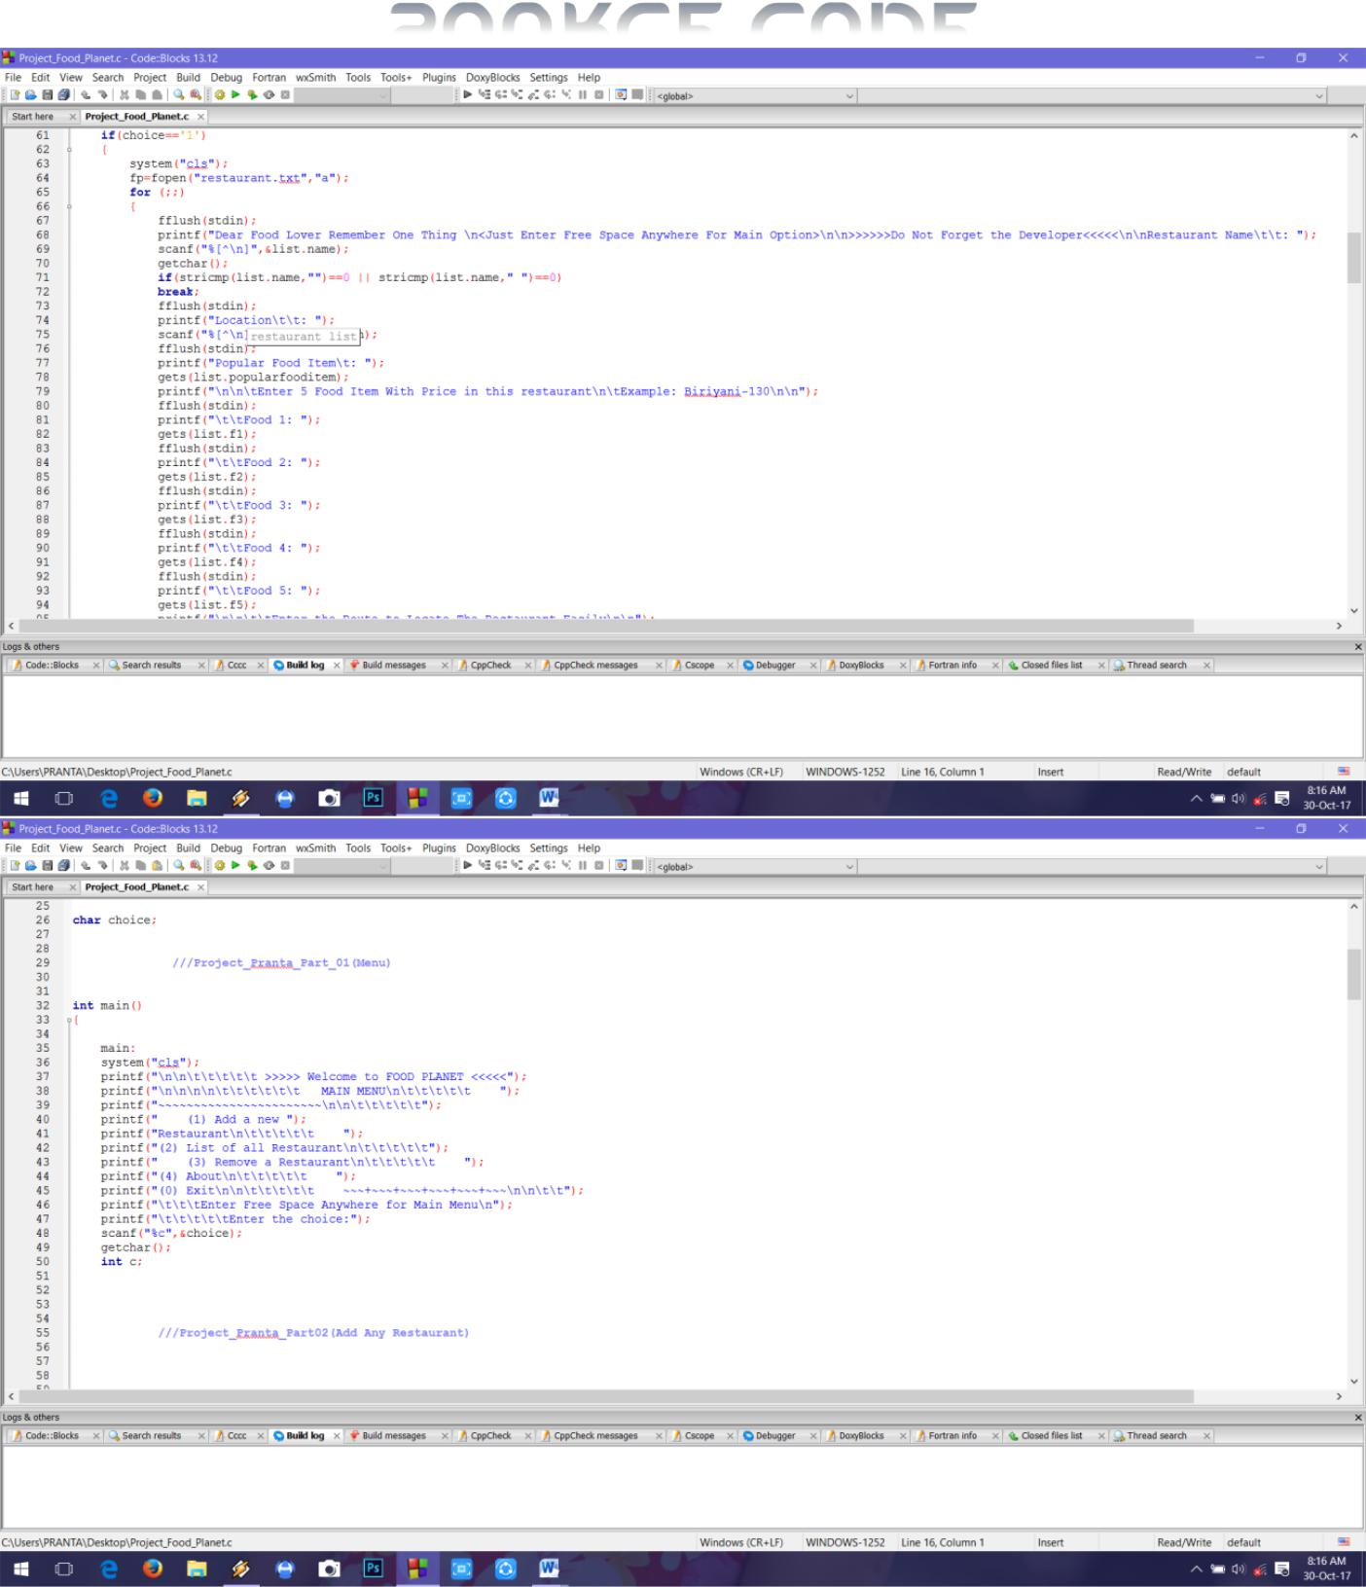**SOURCE CODE**

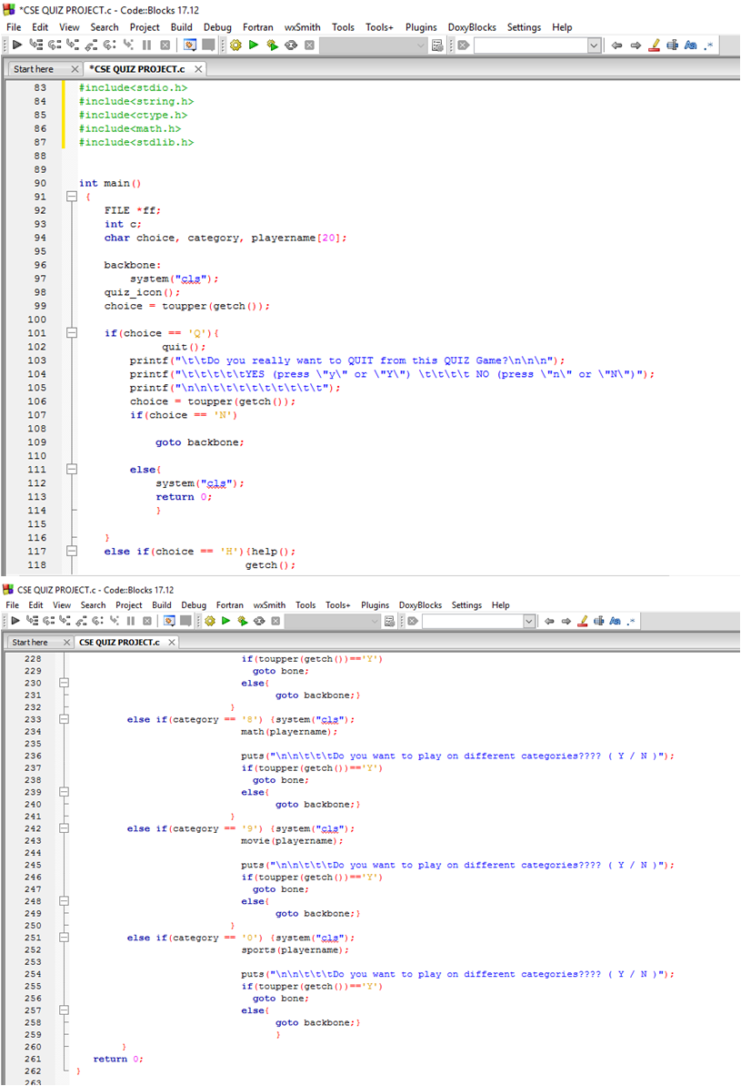

Page | 10

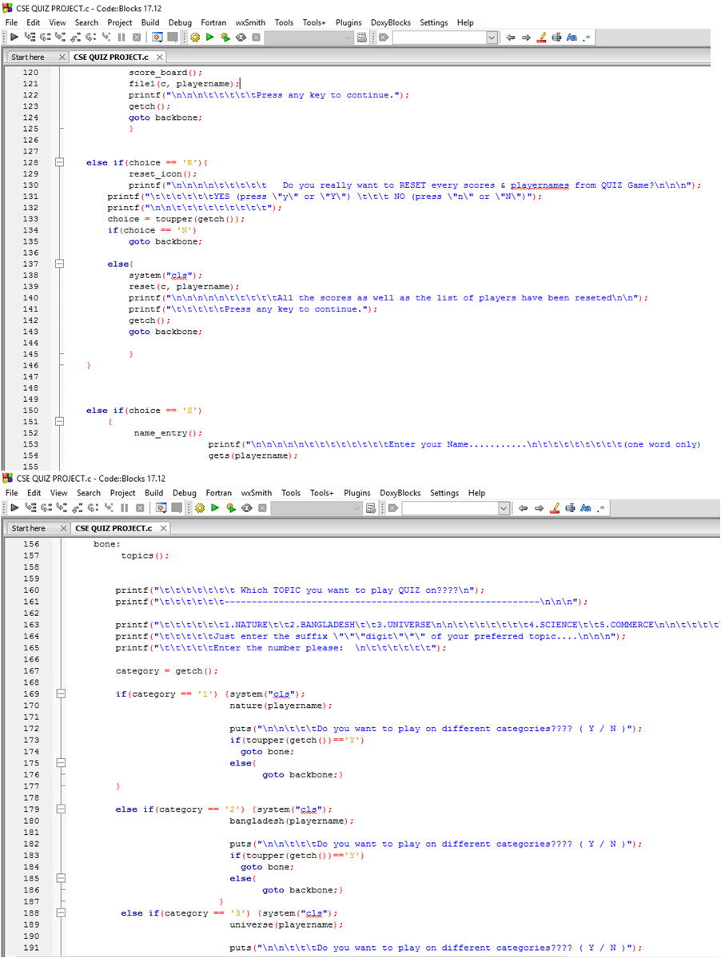

Page | 11

**PROJECT SCREENSHOT**



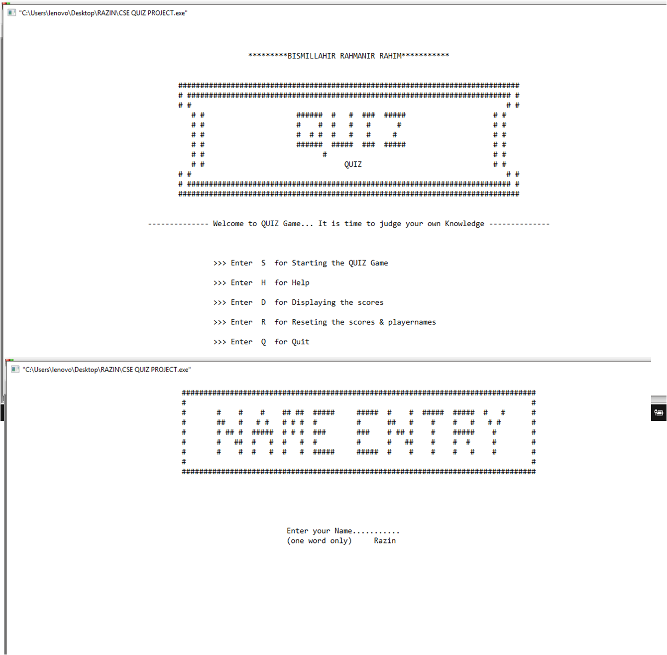

Page | 12

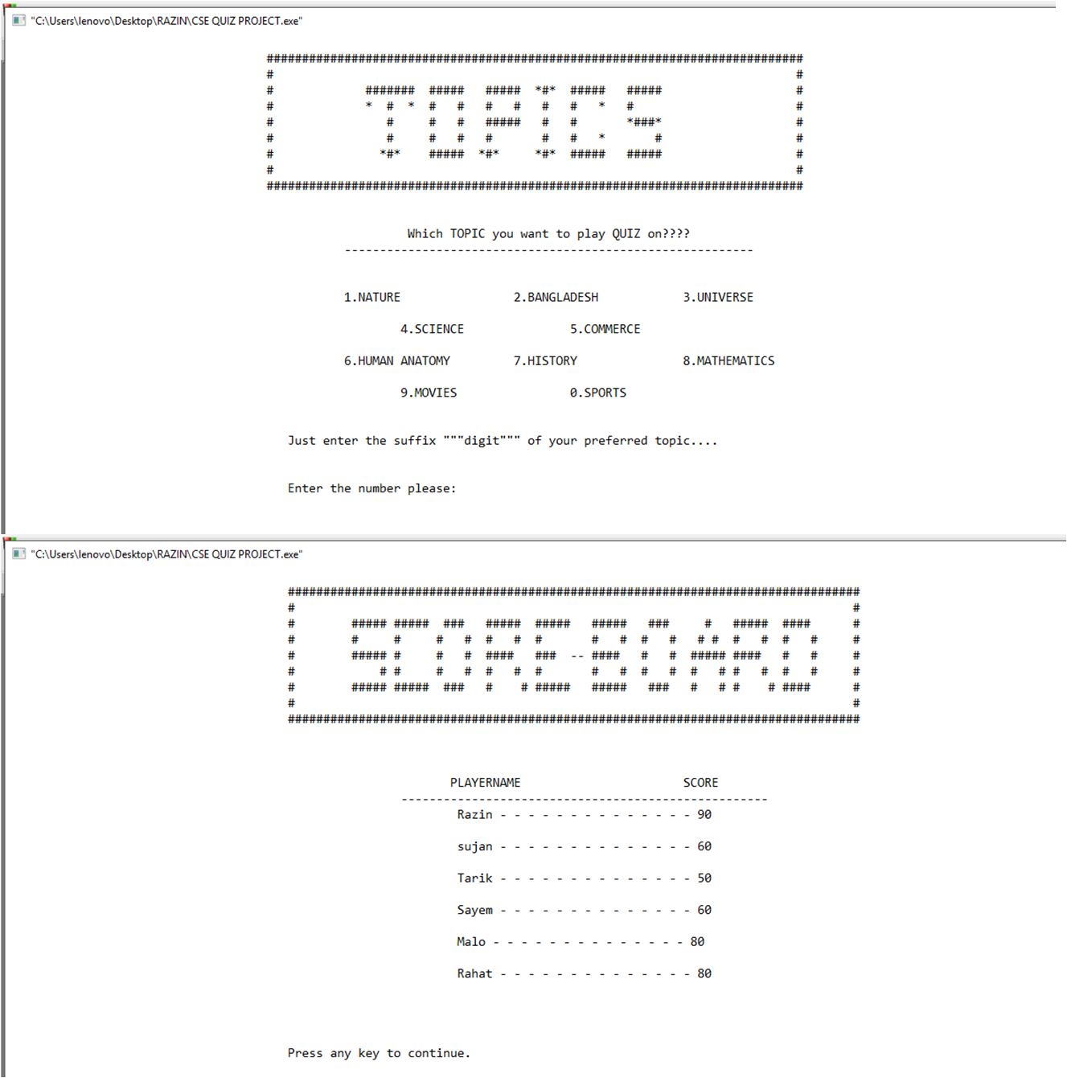

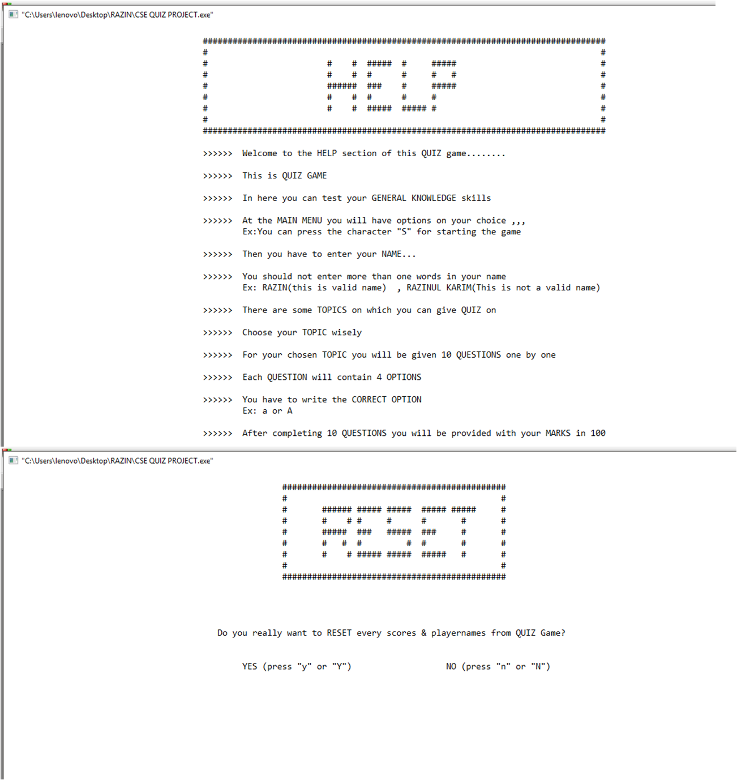

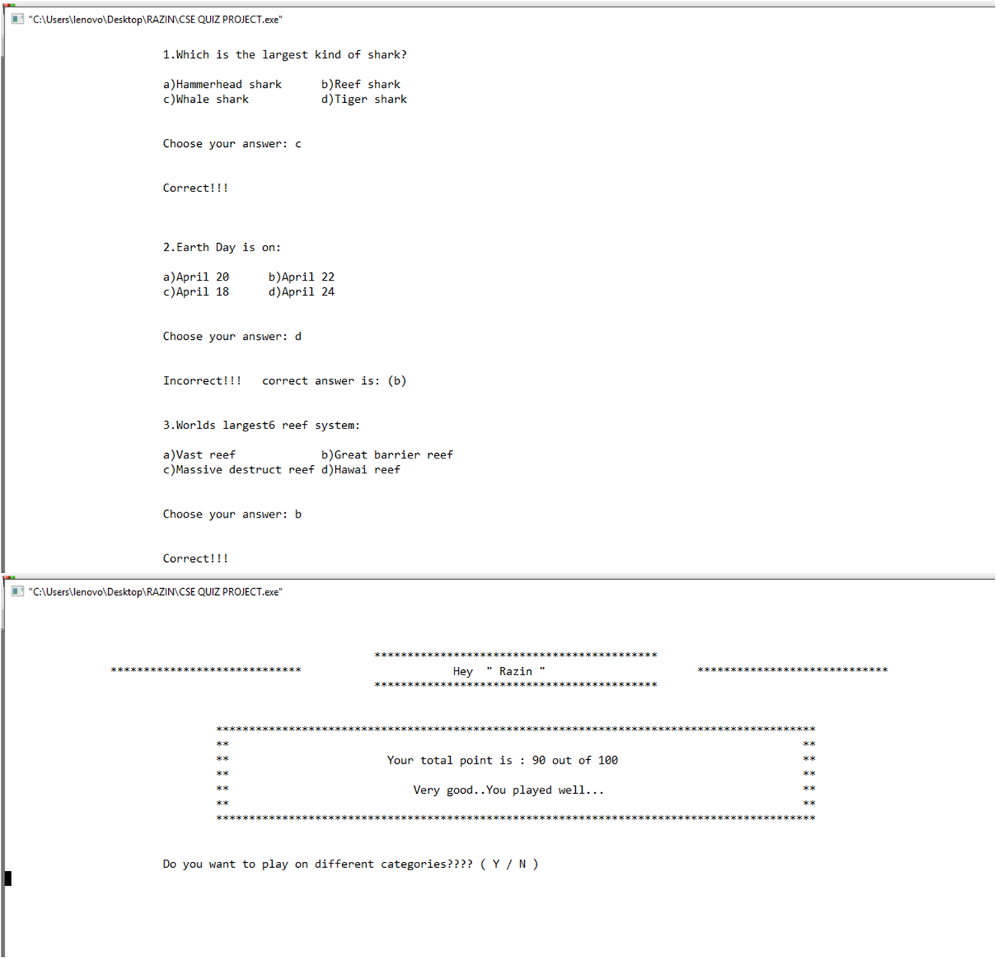

Page | 13

**PROJECT MANUAL**



* Open the application.
* For Adding new Restaurants Enter – 1

You Need To Enter Name,Location,Favourite food items, Other 5 food items and Route.

* Enter free space for going to main menu and 0 to exit
* From Main Menu – Enter 2 to view all restaurants details
* Enter 3 for deleting any restaurant.
* Enter 4 to View Developer and Project details
* And Finally 0 for Exit.

Page | 14

**BENEFIT**



The user will get the easiest route of the restaurant very easily.

They can know about the availability of food items, prices and specialty of the restaurant easily.

Page | 15

**SCOPE & FEASIBILITY**

There will be menu bar for selecting any options. A scope of adding new restaurant details and removing the restaurants. A map/route of every restaurant. Food menu and famous food items of every restaurant will be in the application.

A feasibility study is an evaluation of a proposal designed to determine

The difficulty in carrying out a designed task .Generally, a feasibility study precedes technical development and project implementation. In other words, a feasibility study is an evaluation or analysis of the potential impact of a proposed project.

I am confident on hard work. I have the ability to produce this type of project with a small help of our honorable teachers .

Page | 16

**PURPOSE**

Food Planet is a general purpose application that anyone can use it for searching any restaurants from new city, knowing the special food items of these with individual food menu and price.So It is very usefull for the food lovers. New restaurants authority can easily add their position in the list .Any restaurant authority can also remove their name from this.

Page | 17

**BUSINESS VALUE**

There are so many food lovers in our country.Some of these people do not know the speciality of any unknown retaurants .So they can take help easily from this app.They will find the easiest route of the specified restaurant.There are also so many people who does no known the food items and prices available in any restaurants. By using this app they can easily save money and time.

So the project is very useful and valuable to any user.

Page | 18

**LIMITATIONS**

* Useless for non-recreation lovers.
* It can not find the location of the user.

**RRQUIREMENTS**

* Ram – 512 mb
* Operating System : Windows – XP,7,8.1,10, Ubuntu,Linux.

**CONCLUSION**

The main objective of this project is for recreation as well as judging the players general knowledge skills. One can make recreation to himself/herself as well as to his/her friends or relatives.

The program of this project is written in C language using file, loop, 2d strings, various functions, library conditions etc.

Page | 19

**REFERENCES:**



* www.google.com
* www.en.wikipedia.org
* www.tutorialspoint.com

