Matplotlib
P01_Line_Plot.py
Code:
import matplotlib.pyplot as plt
import numpy as np

x = np.linspace(0, 5, 100)
y = x ** 2

plt.plot(x, y, color="blue", linewidth=2)
plt.title("y = x^2")
plt.xlabel("x")
plt.ylabel("y")
plt.grid(True)
plt.show()
Output:
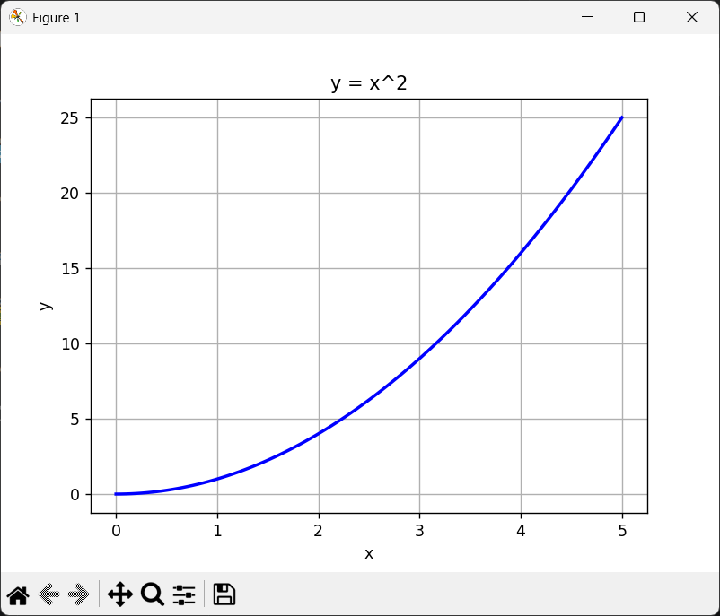

P02_Scatter_Plot.py
Code:
import matplotlib.pyplot as plt
import numpy as np

X1, Y1 = np.random.rand(30), np.random.rand(30)
X2, Y2 = np.random.rand(30), np.random.rand(30)

plt.scatter(X1, Y1, color="red", label="Set 1")
plt.scatter(X2, Y2, color="blue", label="Set 2")
plt.title("2 Random Scatter Plots")
plt.xlabel("X")
plt.ylabel("Y")
plt.legend()
plt.show()
Output:
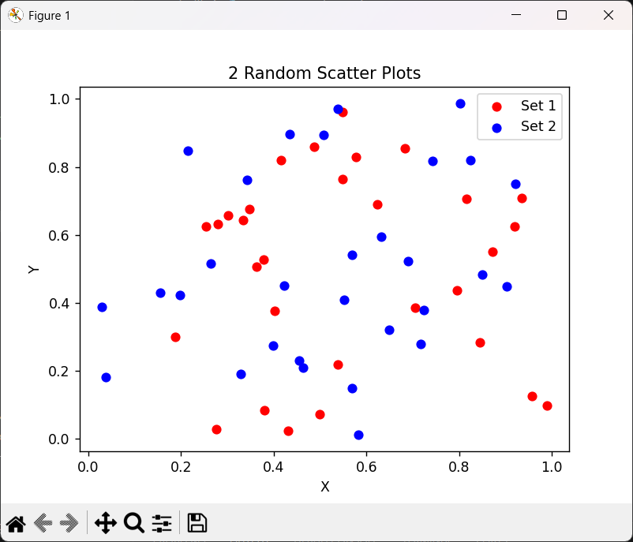

P03_Histogram.py
Code:
import matplotlib.pyplot as plt
import numpy as np

data = np.random.randn(500)
print(data)

plt.hist(data, bins=20, color="blue", edgecolor="white")
plt.title("Histogram (20 bins)")
plt.xlabel("Value")
plt.ylabel("Frequency")
plt.show()
Output:
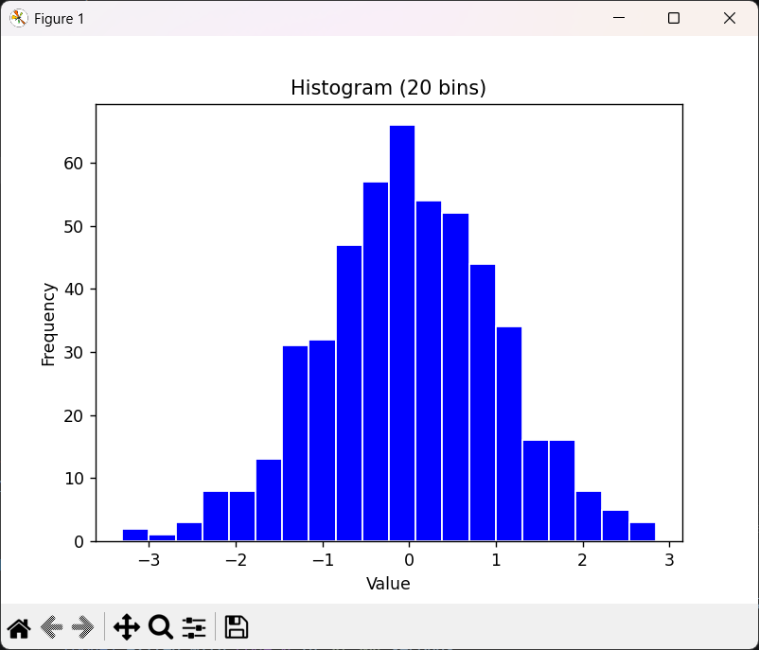

P04_Bar_Chart.py
Code:
import matplotlib.pyplot as plt

products = ["Laptop", "Phone", "Tablet", "Watch", "Headphones"]
sales = [120, 350, 95, 210, 180]

plt.bar(products, sales, color=["blue", "red", "green", "yellow", "purple"])
plt.title("Product Sales")
plt.xlabel("Product")
plt.ylabel("Units Sold")
plt.tight_layout()
plt.show()
Output:
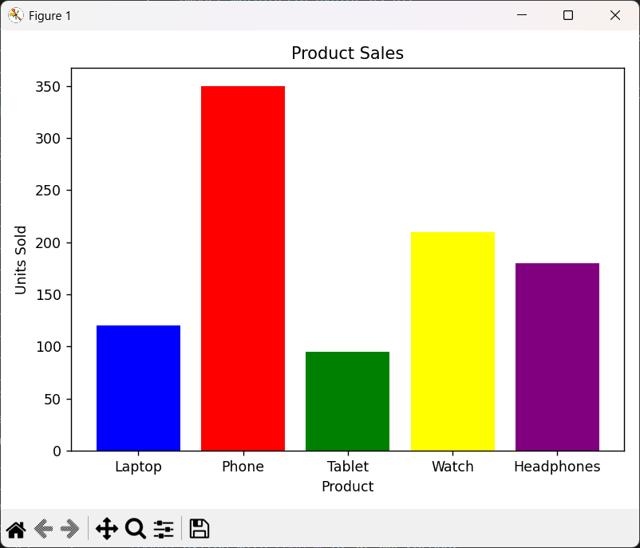

P05_Multiple_Subplots.py
Code:
import matplotlib.pyplot as plt
import numpy as np

x = np.linspace(0, 2*np.pi, 200)

fig, (ax1, ax2) = plt.subplots(1, 2)

ax1.plot(x, np.sin(x))
ax2.scatter(np.random.rand(50), np.random.rand(50))

plt.show()
Output:
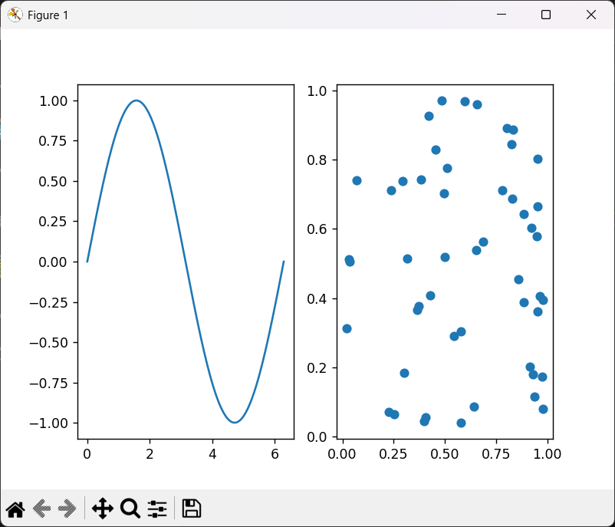

P06_Customize_Plot.py
Code:
import matplotlib.pyplot as plt
import numpy as np

x = np.array(["A", "B", "C", "D", "E"])
y = np.array([5, 7, 3, 8, 6])

plt.plot(x, y, color="blue", linewidth=2, label="cos(x)")
plt.title("Customized Plot", fontsize=14, fontweight="bold")
plt.xlabel("Name", fontsize=12)
plt.ylabel("Points", fontsize=12)
plt.legend(fontsize=11)
plt.grid(True)
plt.show()
Output:
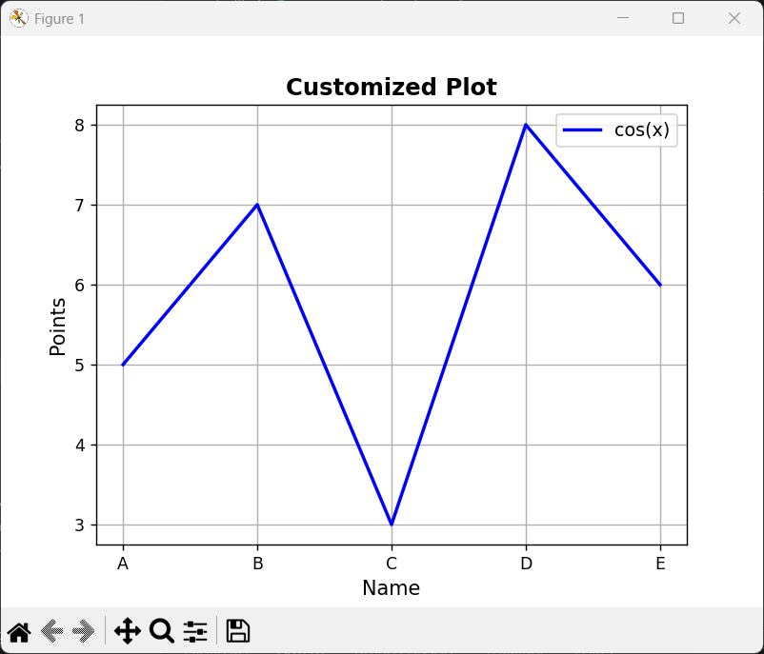

P07_Box_Plot.py
Code:
import matplotlib.pyplot as plt
import numpy as np

data = [np.random.normal(10, 1, 50),
np.random.normal(20, 1, 50),
np.random.normal(15, 1, 50),
np.random.normal(25, 1, 50)]

plt.boxplot(data)
plt.title("Distribution Box Plot")
plt.ylabel("Value")
plt.show()
Output:
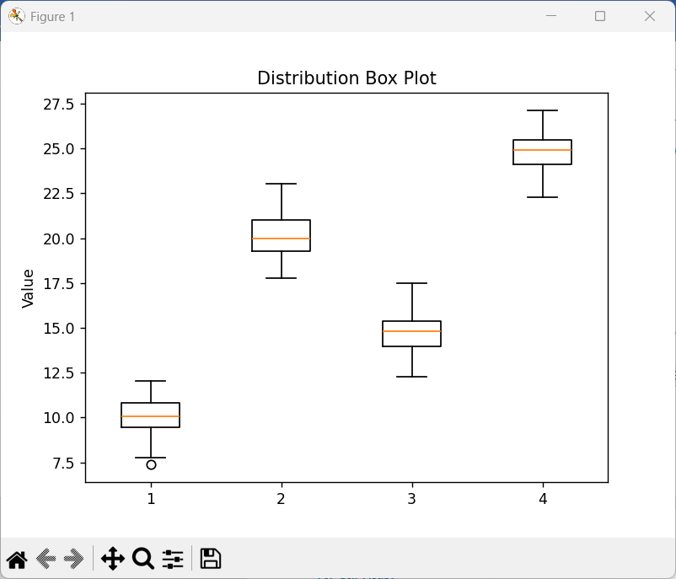

P08_Pie_Chart.py
Code:
import matplotlib.pyplot as plt

labels = ["Python", "Java", "JavaScript", "C++", "Others"]
sizes = [35, 25, 20, 12, 8]
colors = ["blue", "red", "yellow", "green", "purple"]
explode = (0.05, 0, 0, 0, 0)

plt.pie(sizes, labels=labels, colors=colors, explode=explode)
plt.title("Piechart of Programming Languages")
plt.show()
Output:
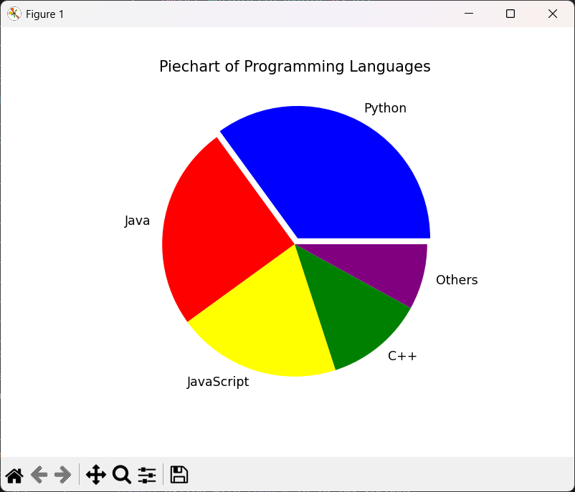

P09_3D_Surface.py
Code:
import matplotlib.pyplot as plt
import numpy as np

x = np.linspace(-3, 3, 60)
y = np.linspace(-3, 3, 60)
X, Y = np.meshgrid(x, y)
Z = np.sin(np.sqrt(X**2 + Y**2))

fig = plt.figure()
ax = fig.add_subplot(111, projection="3d")
ax.plot_surface(X, Y, Z, cmap="viridis", alpha=0.9)
ax.set_title("3D Surface of f(x, y) = sin(sqrt(x^2 + y^2))")
ax.set_xlabel("X")
ax.set_ylabel("Y")
ax.set_zlabel("Z")
plt.show()
Output:
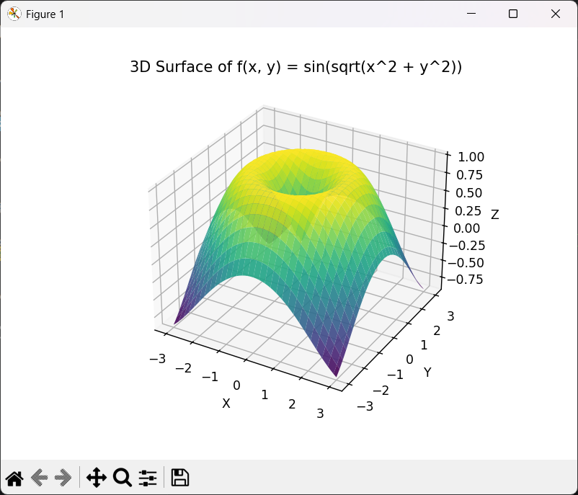
P10_Error_Bars.py
Code:
import matplotlib.pyplot as plt
import numpy as np

x = np.arange(1, 8)
means = [np.random.normal(i*2, 1, 20).mean() for i in x]
stds = [np.random.normal(i*2, 1, 20).std() for i in x]

plt.errorbar(x, means, yerr=stds, fmt="-o", color="blue",
ecolor="red", elinewidth=2, capsize=5, label="Mean ± Std")
plt.title("Line Plot with Error Bars")
plt.xlabel("Data Point")
plt.ylabel("Value")
plt.legend()
plt.show()
Output:
