Pandas
P101_Load_Data.py
Code:
import pandas as pd

test = pd.DataFrame({
"name": ["Alice", "Bob", "Charlie", "Diana", "Eve"],
"age": [25, 30, 22, 35, 28],
"column_name": [5, 15, 8, 20, 12],
"category": ["A", "B", "A", "C", "B"],
"date": ["2024-01-15", "2024-03-22", "2024-06-05", "2024-09-10", "2024-11-30"]
})
test.to_csv("data.csv", index=False)

df = pd.read_csv("data.csv")
print("DataFrame loaded from data.csv:")
print(df)
Output:
DataFrame loaded from data.csv:
name age column_name category date
0 Alice 25 5 A 2024-01-15
1 Bob 30 15 B 2024-03-22
2 Charlie 22 8 A 2024-06-05
3 Diana 35 20 C 2024-09-10
4 Eve 28 12 B 2024-11-30

P102_Display_Rows.py
Code:
import pandas as pd

df = pd.DataFrame({
"name": ["Alice", "Bob", "Charlie", "Diana", "Eve", "Frank", "Grace"],
"age": [25, 30, 22, 35, 28, 40, 19],
"column_name": [5, 15, 8, 20, 12, 7, 18],
"category": ["A", "B", "A", "C", "B", "C", "A"]
})

print("First 5 rows:")
print(df.head(5))
Output:
First 5 rows:
name age column_name category
0 Alice 25 5 A
1 Bob 30 15 B
2 Charlie 22 8 A
3 Diana 35 20 C
4 Eve 28 12 B

P103_No_Rows_Cols.py
Code:
import pandas as pd

df = pd.DataFrame({
"name": ["Alice", "Bob", "Charlie", "Diana", "Eve"],
"age": [25, 30, 22, 35, 28],
"score": [88, 75, 92, 60, 85],
"category": ["A", "B", "A", "C", "B"]
})

rows, cols = df.shape
print("Number of rows:", rows)
print("Number of columns:", cols)
Output:
Number of rows: 5
Number of columns: 4

P104_Filter_Data.py
Code:
import pandas as pd

df = pd.DataFrame({
"name": ["Alice", "Bob", "Charlie", "Diana", "Eve"],
"column_name": [5, 15, 8, 20, 12],
"category": ["A", "B", "A", "C", "B"]
})

df_filtered = df[df["column_name"] > 10]
print("Original DataFrame:\n", df)
print("\nFiltered (column_name > 10):\n", df_filtered)
Output:
Original DataFrame:
name column_name category
0 Alice 5 A
1 Bob 15 B
2 Charlie 8 A
3 Diana 20 C
4 Eve 12 B

Filtered (column_name > 10):
name column_name category
1 Bob 15 B
3 Diana 20 C
4 Eve 12 B

P105_Missing_Data.py
Code:
import pandas as pd
import numpy as np

df = pd.DataFrame({
"name": ["Alice", "Bob", None, "Diana", "Eve"],
"age": [25, np.nan, 22, 35, np.nan],
"score": [88, 75, np.nan, 60, 85]
})

print("Count:\n", df.isnull().sum())

df["age"] = df["age"].fillna(df["age"].mean())
df["score"] = df["score"].fillna(df["score"].mean())
df = df.dropna()
print("\nNew DataFrame:\n", df)
Output:
Count:
name 1
age 2
score 1
dtype: int64

New DataFrame:
name age score
0 Alice 25.000000 88.0
1 Bob 27.333333 75.0
3 Diana 35.000000 60.0
4 Eve 27.333333 85.0

P106_Group_Aggregate.py
Code:
import pandas as pd

df = pd.DataFrame({
"category": ["A", "B", "A", "C", "B", "C", "A"],
"value": [10, 20, 30, 40, 50, 60, 70]
})

gmean = df.groupby("category")["value"].mean()

print("DataFrame:\n", df)
print("\nMean values in each category:\n", gmean)
Output:
DataFrame:
category value
0 A 10
1 B 20
2 A 30
3 C 40
4 B 50
5 C 60
6 A 70

Mean values in each category:
category
A 36.666667
B 35.000000
C 50.000000
Name: value, dtype: float64

P107_Merge_DataFrames.py
Code:
import pandas as pd

df1 = pd.DataFrame({
"id": [1, 2, 3, 4],
"name": ["Alice", "Bob", "Charlie", "Diana"]
})

df2 = pd.DataFrame({
"id": [2, 3, 4, 5],
"score": [85, 90, 78, 92]
})

merged = pd.merge(df1, df2, on="id")
print("DF1:\n", df1)
print("\nDF2:\n", df2)
print("\nMerged DF:\n", merged)
Output:
DF1:
id name
0 1 Alice
1 2 Bob
2 3 Charlie
3 4 Diana

DF2:
id score
0 2 85
1 3 90
2 4 78
3 5 92

Merged DF:
id name score
0 2 Bob 85
1 3 Charlie 90
2 4 Diana 78

P108_Bar_Chart.py
Code:
import pandas as pd
import matplotlib.pyplot as plt

df = pd.DataFrame({
"category": ["A", "B", "A", "C", "B", "C", "A", "B"]
})

values = df["category"].value_counts()
values.plot(kind="bar", color=["red", "green", "blue"])

plt.title("Counts of Unique Values in 'category'")
plt.xlabel("Category")
plt.ylabel("Count")
plt.tight_layout()
plt.show()
Output:
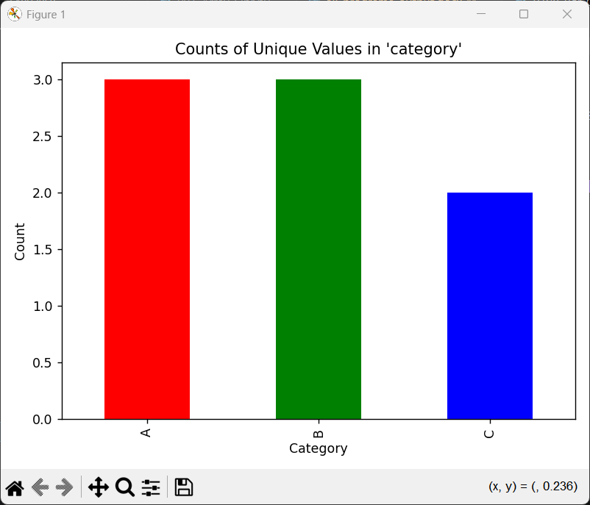

P109_Datetime_Ops.py
Code:
import pandas as pd

df = pd.DataFrame({
"event": ["A", "B", "C", "D"],
"date": ["2024-01-15", "2024-03-22", "2024-06-05", "2024-11-30"]
})

df["date_datetime"] = pd.to_datetime(df["date"],format="%Y-%m-%d")
df["month"] = df["date"].dt.month
print(df)
Output:
[stderr]
Traceback (most recent call last):
File "/mnt/documents/Essentials/SJU/SJU Programming/S5 - ML/Pandas/P109_Datetime_Ops.py", line 9, in <module>
df["month"] = df["date"].dt.month
File "/home/sujan/.local/lib/python3.10/site-packages/pandas/core/generic.py", line 6321, in __getattr__
return object.__getattribute__(self, name)
File "/home/sujan/.local/lib/python3.10/site-packages/pandas/core/accessor.py", line 224, in __get__
accessor_obj = self._accessor(obj)
File "/home/sujan/.local/lib/python3.10/site-packages/pandas/core/indexes/accessors.py", line 643, in __new__
raise AttributeError("Can only use .dt accessor with datetimelike values")
AttributeError: Can only use .dt accessor with datetimelike values. Did you mean: 'at'?

P110_Save_Data.py
Code:
import pandas as pd

df = pd.DataFrame({
"name": ["Alice", "Bob", "Charlie"],
"score": [88, 75, 92],
"category": ["A", "B", "A"]
})

df["grade"] = df["score"].apply(lambda x: "Pass" if x >= 80 else "Fail")

df.to_csv("output_data.csv", index=False)
print("\nOutput CSV:")
with open("output_data.csv", "r") as file:
print(file.read())
Output:

Output CSV:
name,score,category,grade
Alice,88,A,Pass
Bob,75,B,Fail
Charlie,92,A,Pass

P201_Load_Iris.py
Code:
import pandas as pd
from sklearn.datasets import load_iris

iris = load_iris(as_frame=True)
df = iris.frame
df["species"] = df["target"].map({0: "setosa", 1: "versicolor", 2: "virginica"})

print("\nFirst 5 rows:")
print(df.head())
Output:

First 5 rows:
sepal length (cm) sepal width (cm) ... target species
0 5.1 3.5 ... 0 setosa
1 4.9 3.0 ... 0 setosa
2 4.7 3.2 ... 0 setosa
3 4.6 3.1 ... 0 setosa
4 5.0 3.6 ... 0 setosa

[5 rows x 6 columns]

P202_Filter_Iris.py
Code:
import pandas as pd
from sklearn.datasets import load_iris

iris = load_iris(as_frame=True)
df = iris.frame
df["species"] = df["target"].map({0: "setosa", 1: "versicolor", 2: "virginica"})

df_filtered = df[(df["sepal length (cm)"] > 5) & (df["species"] == "setosa")]

print("Rows where sepal_length > 5 and species == setosa:")
print(df_filtered)
Output:
Rows where sepal_length > 5 and species == setosa:
sepal length (cm) sepal width (cm) ... target species
0 5.1 3.5 ... 0 setosa
5 5.4 3.9 ... 0 setosa
10 5.4 3.7 ... 0 setosa
14 5.8 4.0 ... 0 setosa
15 5.7 4.4 ... 0 setosa
16 5.4 3.9 ... 0 setosa
17 5.1 3.5 ... 0 setosa
18 5.7 3.8 ... 0 setosa
19 5.1 3.8 ... 0 setosa
20 5.4 3.4 ... 0 setosa
21 5.1 3.7 ... 0 setosa
23 5.1 3.3 ... 0 setosa
27 5.2 3.5 ... 0 setosa
28 5.2 3.4 ... 0 setosa
31 5.4 3.4 ... 0 setosa
32 5.2 4.1 ... 0 setosa
33 5.5 4.2 ... 0 setosa
36 5.5 3.5 ... 0 setosa
39 5.1 3.4 ... 0 setosa
44 5.1 3.8 ... 0 setosa
46 5.1 3.8 ... 0 setosa
48 5.3 3.7 ... 0 setosa

[22 rows x 6 columns]

P203_Handle_Missing.py
Code:
import pandas as pd
import numpy as np
from sklearn.datasets import load_iris

iris = load_iris(as_frame=True)
df = iris.frame

df.iloc[0, 0] = np.nan
df.iloc[5, 2] = np.nan

print("Missing values before:\n", df.isnull().sum())
df.fillna(df.mean(numeric_only=True), inplace=True)
print("\nMissing values after:\n", df.isnull().sum())
Output:
Missing values before:
sepal length (cm) 1
sepal width (cm) 0
petal length (cm) 1
petal width (cm) 0
target 0
dtype: int64

Missing values after:
sepal length (cm) 0
sepal width (cm) 0
petal length (cm) 0
petal width (cm) 0
target 0
dtype: int64

P204_Group_Stats.py
Code:
import pandas as pd
from sklearn.datasets import load_iris

iris = load_iris(as_frame=True)
df = iris.frame
df["species"] = df["target"].map({0: "setosa", 1: "versicolor", 2: "virginica"})

numeric_cols = ["sepal length (cm)", "sepal width (cm)", "petal length (cm)", "petal width (cm)"]
stats = df.groupby("species")[numeric_cols].agg(["mean", "median", "std"])

print(stats)
Output:
sepal length (cm) ... petal width (cm)
mean median std ... mean median std
species ...
setosa 5.006 5.0 0.352490 ... 0.246 0.2 0.105386
versicolor 5.936 5.9 0.516171 ... 1.326 1.3 0.197753
virginica 6.588 6.5 0.635880 ... 2.026 2.0 0.274650

[3 rows x 12 columns]

P205_Merge_Students.py
Code:
import pandas as pd

students = pd.DataFrame({
"student_id": [101, 102, 103, 104],
"name": ["Rahul", "Brian", "Yash", "Vigesh"]
})

courses = pd.DataFrame({
"student_id": [101, 102, 103, 105],
"course": ["Math", "Science", "English", "History"],
"grade": ["A", "B+", "A-", "B"]
})

merged = pd.merge(students, courses, on="student_id", how="inner")
print("Students:\n", students)
print("\nCourses:\n", courses)
print("\nMerged:\n", merged)
Output:
Students:
student_id name
0 101 Rahul
1 102 Brian
2 103 Yash
3 104 Vigesh

Courses:
student_id course grade
0 101 Math A
1 102 Science B+
2 103 English A-
3 105 History B

Merged:
student_id name course grade
0 101 Rahul Math A
1 102 Brian Science B+
2 103 Yash English A-

P206_Time_Series.py
Code:
import pandas as pd
import numpy as np
import matplotlib.pyplot as plt

dates = pd.date_range(start="2026-01-01", periods=30, freq="B")
prices = 100 + np.cumsum(np.random.randn(30))

df = pd.DataFrame({"date": dates, "price": prices})
df.set_index("date", inplace=True)

df["daily_return"] = df["price"].pct_change()
print(df.head(10))

fig, (price_plot, dr_plot) = plt.subplots(2, 1, figsize=(8, 5))
price_plot.plot(df["price"], label="Price")
price_plot.set_title("Stock Price")
dr_plot.bar(df.index, df["daily_return"], label="Daily Return", color="red")
dr_plot.set_title("Daily Returns")
plt.tight_layout()
plt.show()
Output:
price daily_return
date
2026-01-01 98.486668 NaN
2026-01-02 98.635305 0.001509
2026-01-05 97.039186 -0.016182
2026-01-06 98.621567 0.016307
2026-01-07 99.620498 0.010129
2026-01-08 99.326530 -0.002951
2026-01-09 100.939639 0.016240
2026-01-12 100.215729 -0.007172
2026-01-13 100.285994 0.000701
2026-01-14 100.769094 0.004817

P207_Pivot_Table.py
Code:
import pandas as pd

df = pd.DataFrame({
"month": ["Jan", "Jan", "Feb", "Feb", "Mar", "Mar"],
"category": ["Electronics", "Clothing", "Electronics", "Clothing", "Electronics", "Clothing"],
"sales": [5000, 2000, 4500, 2500, 6000, 3000]
})

pivot = pd.pivot_table(df, values="sales", index="category", columns="month", aggfunc="sum")

print("Pivot Table:")
print(pivot)
Output:
Pivot Table:
month Feb Jan Mar
category
Clothing 2500 2000 3000
Electronics 4500 5000 6000

P208_Visualizations.py
Code:
import pandas as pd
import matplotlib.pyplot as plt

df = pd.DataFrame({
"name": ["A","B","C",],
"age":[10,20,30],
"score":[100,50,300]
})

fig, [hist, scat, line] = plt.subplots(3,1, figsize=(10,10))

hist.bar(df["name"], df["age"], label="Histogram")
hist.set_title("Histogram")
scat.scatter(df["name"], df["score"], label="Scatter plot")
scat.set_title("Scatter plot")
line.plot(df["name"], df["age"], label="Line plot")
line.set_title("Line plot")
plt.tight_layout()
plt.show()
Output:
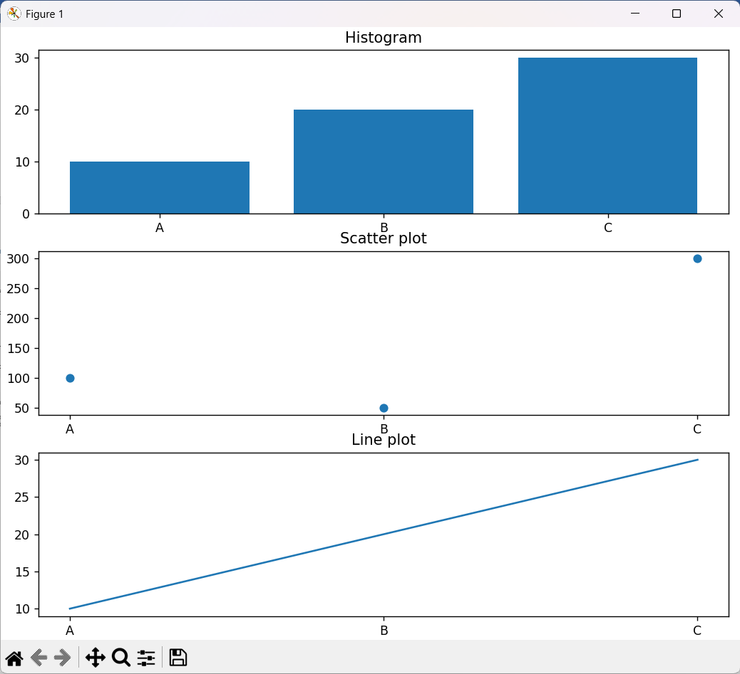
P209_Data_Transform.py
Code:
import pandas as pd
import numpy as np

df = pd.DataFrame({
"Var": ["A","B","C","D"],
"Val": [x**2 for x in range(1,5)]
})

df["ValSq"] = df["Val"].apply(np.sqrt)
print(df)
Output:
Var Val ValSq
0 A 1 1.0
1 B 4 2.0
2 C 9 3.0
3 D 16 4.0

P210_One_Hot_Encoding.py
Code:
import pandas as pd

df = pd.DataFrame({
"name": ["Rahul", "Sam", "Raj", "Tom"],
"department": ["HR", "IT", "HR", "Sales"]
})

print("Before Encoding:")
print(df)

df_encoded = pd.get_dummies(df, columns=["department"])

print("\nAfter Encoding:")
print(df_encoded)
Output:
Before Encoding:
name department
0 Rahul HR
1 Sam IT
2 Raj HR
3 Tom Sales

After Encoding:
name department_HR department_IT department_Sales
0 Rahul True False False
1 Sam False True False
2 Raj True False False
3 Tom False False True

