PROJECT DOCUMENTATION AND REPORT

Problem Statement:
To find probability of new sign ups converting into active users

Data Description
Information was collected from 385 FieldSense Customers against 16 variables for predicting the probability of them being an Active user.
Data source:
1. Super Admin Panel of FS
2. Customer Care lead sheet
3. SLAM
4. Web sources - Indiamart, LinkedIn, Company website, Zauba Corp

Objective
- Design most appropriate machine learning model to predict probability of new sign ups converting into active users
- Identify the co-relation between the “Active” and “In Active” users of FieldSense.

Chapter 2: Data Preparation

2.1 Data Description
“fieldsense.csv” is a raw file in csv format, and contains 385 observations with 16 variables as below.

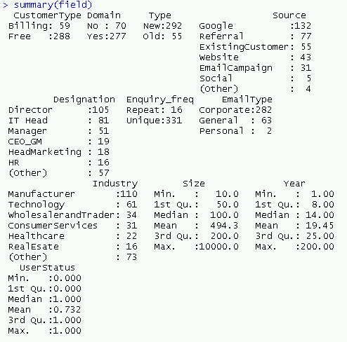
Figure: Summary of dataset

2.2 Predictor Variable

Domain
- Customer Type: Billing or Free
- Source: Referral, Website, Google, Existing Customer, Email Campaign, Existing Customer etc
- Designation of the person who put the enquiry
- Enquiry Frequency
- Email type: Corporate or General
- Industry of the organization
- Size of Company
- Year of Establishment

2.3 Outcome Variable: User Status
Proportion of the outcome variable in our dataset.
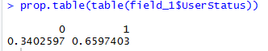

Active customers in our Dataset: 66%
Inactive customers in our Dataset: 34 %

Chapter 3: Plan of Action

3.1 Load data into R and install required packages
Load the dataset into R environment and importing required packages/ libraries which will include Caret, data table, grid Extra, corrplot, GGally, ggplot2, e1071, dplyr, e1071 etc.

3.2 Data Cleaning
Dataset was checked for discrepancies. Data cleaning was done to make it ready for analysis which involved treating
- Missing values - Missing values will be replaced with mean values for numerical variables and with mode values for categorical variables.
- Duplicate observations - Duplicate observations will be dropped if any.
- Outliers - Boxplot will be used to check outliers if any in the numerical variables.

3.3 Making data models and validating data models
The dataset was split to training set and test set in 75:25 proportions.

3.4 Pre modelling Bi-variate Analysis
To find the relationship between two categorical variables we use Chi-Square. This test is used to derive the statistical significance of relationship between the variables. Also, it tests whether the evidence in the sample is strong enough to generalize that the relationship for a larger population as well. It returns probability for the computed chi-square distribution with the degree of freedom.
1. Corelation between Customer Type and User Status
We have a chi-squared value of 13.002 and p value = 0.0003112. Since we get a p-Value less than the significance level of 0.05, we reject the null hypothesis and conclude that the two variables are in fact dependent
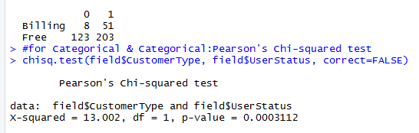

2. Corelation between Domain and User Status
We have a chi-squared value of 1.76 and p value = 0.18. Since we get a p-Value greater than the significance level of 0.05, we do not reject the null hypothesis and conclude that the two variables do not have high level of dependency.
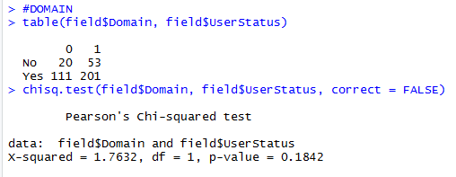

3. Corelation between Type and User Status
We have a chi-squared value of 1.2615 and p value = 0.26. Since we get a p-Value is greater than the significance level of 0.05, we do not reject the null hypothesis and conclude that the two variables do not have high level of dependency.
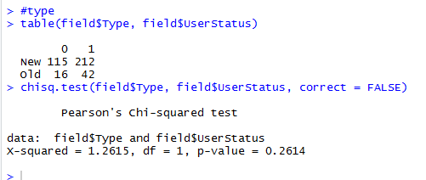

4. Corelation between Enquiry frequency and User Status
We have a chi-squared value of 3.5 and p value = 0.063. Since we get a p-Value less than the significance level of 0.05, we do not reject the null hypothesis and conclude that the two variables do not have high level of dependency.
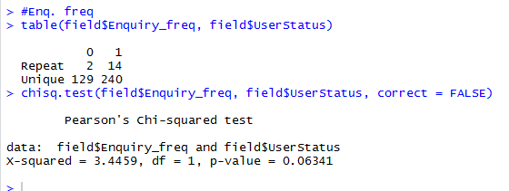

5. Box plot for Year of Establishment
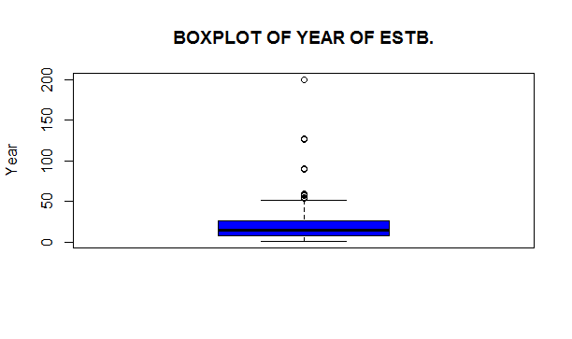
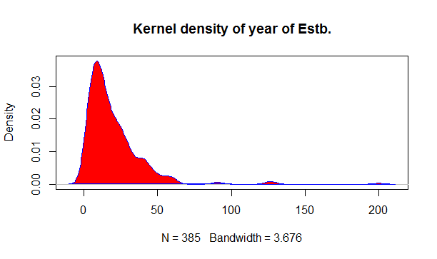
Box plot and density map shows there is a need to normalise data for the variable “Year of Establishment”, hence the data was normalized and added to the data list.

6. For Size
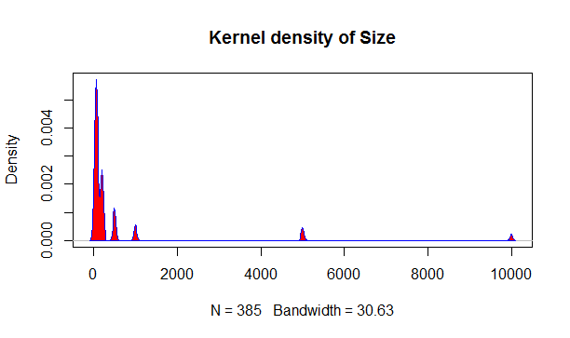
Density map shows there is a need to normalise data for the variable “Size”.
Hence normalization was done and the data was clustered and grouped as follows.
#For year
field$Year_1 <- as.numeric(field$Year >= 41 & field$Year <= 1000)
field$Year_2 <- as.numeric(field$Year >= 20 & field$Year <= 40)
field$Year_3 <- as.numeric(field$Year >= 10 & field$Year <= 19)
field$Year_4 <- as.numeric(field$Year >= 6 & field$Year <= 9)
field$Year_5 <- as.numeric(field$Year >= 1 & field$Year <= 5)
#For Size
field$Size[field$Size>=500 & field$Size<10000]=10000
field$Size[field$Size>=100 & field$Size<200]=200
field$Size[field$Size>=10 & field$Size<75]=75

Feature Extraction
From Chi-Square test we found the correlation of the available variables in our data set.
So only variable with good significance level were considered and the rest of the variables were dropped.
The data was featured down to 9 independent variables and one outcome variable.

Chapter 4: Model Building

4.1 Using Gradient Boosting (GBM) model:

Gradient boosting is a machine learning technique for regression and classification problems, which produces a prediction model in the form of an ensemble of weak prediction models, typically decision trees. It builds the model in a stage-wise fashion like other boosting methods do, and it generalizes them by allowing optimization of an arbitrary differentiable loss function.
4.2 Confusion Matrix – GBM model
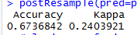
The classifier performed with an accuracy that is 24% (kappa of 67%) of 50%. is a statistic which measures inter-rater agreement for qualitative (categorical) items.
 | Y Actual |  |  | Model Accuracy
Y Pred. for n = 95 |  | Active | Inactive | 67%
Y Pred. for n = 95 | Active | TP=51 | FP= 12 | 67%
Y Pred. for n = 95 | Inactive | FN = 19 | TN = 13 | 67%

- The model made a total of 95 predictions.
- Out of those 95 cases, the classifier predicted "Active” 63 times, and "Inactive" 32 times.
- In actual, 70 customers in the sample are active, and 25 are Inactive.

- True positives (TP): These are cases in which we predicted active and they are active in the real dataset also.
- True negatives (TN): We predicted Inactive, and they are inactive in the real dataset.
- False positives (FP): We predicted Active, but they are actually inactive. (Also known as a "Type I error.")
- False negatives (FN): We predicted Inactive, but they are actually active. (Also known as a "Type II error.")

Test Data set 63 ACTIVE, 32 INACTIVE
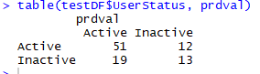
4.3: Area under the curve?
AUC is an abbreviation for area under the curve. It is used to determine which of the used models predicts the classes best. It is a measure of how well a parameter can distinguish between two diagnostic groups.

4.4 Findings

4.4.1 Relative influence weightage of the variable in the dataset according to the model.
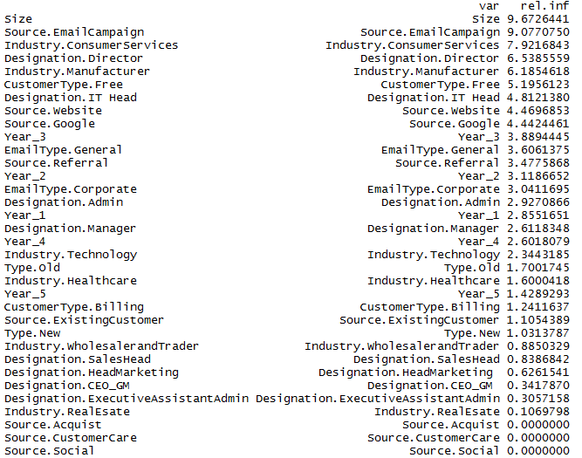
It was found by the model that the influence and weightage on being an active user was given to
  - Source: Email Campaign and Website.
  - Industry : Consumer Services and Manufacturer
  - Designation: Director and IT head.
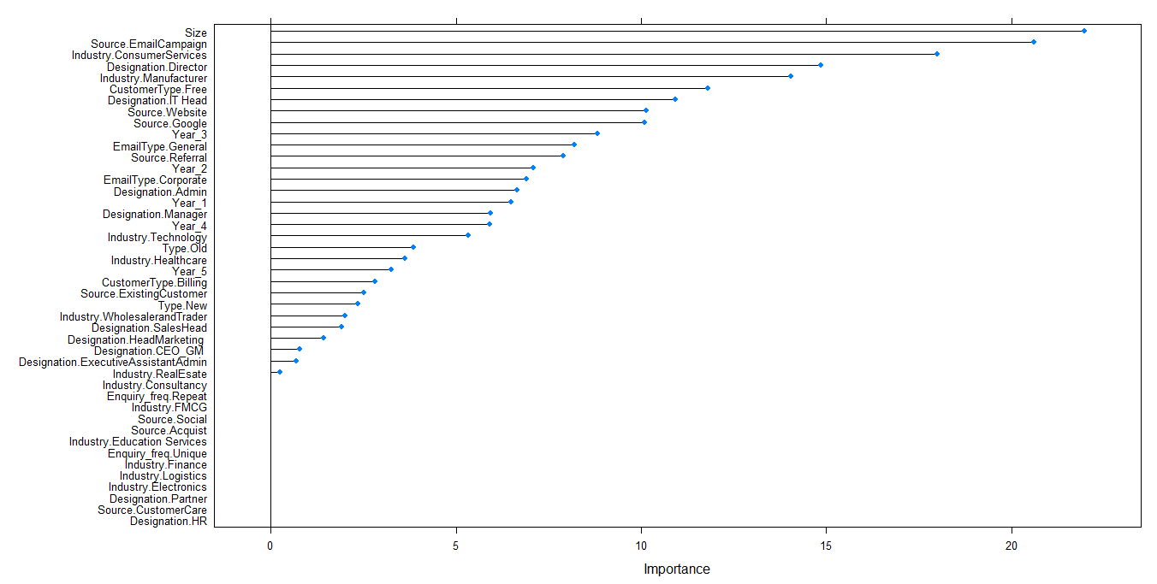
Figure: Relative importance of the variable

4.5 Output
For the test dataset of 95 variables, the model predicted the following probability of being an Active/Inactive user.
 | Active | Inactive
1 | 0.752247 | 0.247753 | 43 | 0.708048 | 0.291952 | 85 | 0.138555 | 0.861445
2 | 0.979714 | 0.020286 | 44 | 0.806249 | 0.193751 | 86 | 0.238613 | 0.761387
3 | 0.988811 | 0.011189 | 45 | 0.830659 | 0.169341 | 87 | 0.602136 | 0.397864
4 | 0.952138 | 0.047862 | 46 | 0.959668 | 0.040332 | 88 | 0.677235 | 0.322765
5 | 0.984559 | 0.015441 | 47 | 0.710525 | 0.289475 | 89 | 0.138555 | 0.861445
6 | 0.765347 | 0.234653 | 48 | 0.80558 | 0.19442 | 90 | 0.187494 | 0.812506
7 | 0.959417 | 0.040583 | 49 | 0.849317 | 0.150683 | 91 | 0.0375 | 0.9625
8 | 0.93258 | 0.06742 | 50 | 0.891045 | 0.108955 | 92 | 0.569017 | 0.430983
9 | 0.90696 | 0.09304 | 51 | 0.908817 | 0.091183 | 93 | 0.676077 | 0.323923
10 | 0.891655 | 0.108345 | 52 | 0.945933 | 0.054067 | 94 | 0.471931 | 0.528069
11 | 0.905768 | 0.094232 | 53 | 0.86447 | 0.13553 | 95 | 0.138555 | 0.861445
12 | 0.82071 | 0.17929 | 54 | 0.946849 | 0.053151
13 | 0.234327 | 0.765673 | 55 | 0.805294 | 0.194706
14 | 0.101612 | 0.898388 | 56 | 0.817739 | 0.182261
15 | 0.924625 | 0.075375 | 57 | 0.70317 | 0.29683
16 | 0.459468 | 0.540532 | 58 | 0.424506 | 0.575494
17 | 0.665551 | 0.334449 | 59 | 0.79287 | 0.20713
18 | 0.573169 | 0.426831 | 60 | 0.234401 | 0.765599
19 | 0.559283 | 0.440717 | 61 | 0.725586 | 0.274414
20 | 0.38752 | 0.61248 | 62 | 0.612364 | 0.387636
21 | 0.63509 | 0.36491 | 63 | 0.967954 | 0.032046
22 | 0.894505 | 0.105495 | 64 | 0.705751 | 0.294249
23 | 0.953969 | 0.046031 | 65 | 0.485516 | 0.514484
24 | 0.915802 | 0.084198 | 66 | 0.766994 | 0.233006
25 | 0.901691 | 0.098309 | 67 | 0.940789 | 0.059211
26 | 0.937763 | 0.062237 | 68 | 0.32468 | 0.67532
27 | 0.592674 | 0.407326 | 69 | 0.668454 | 0.331546
28 | 0.368523 | 0.631477 | 70 | 0.704256 | 0.295744
29 | 0.916205 | 0.083795 | 71 | 0.974557 | 0.025443
30 | 0.761388 | 0.238612 | 72 | 0.828043 | 0.171957
31 | 0.932024 | 0.067976 | 73 | 0.898819 | 0.101181
32 | 0.858141 | 0.141859 | 74 | 0.200542 | 0.799458
33 | 0.502174 | 0.497826 | 75 | 0.933001 | 0.066999
34 | 0.702735 | 0.297265 | 76 | 0.427913 | 0.572087
35 | 0.921848 | 0.078152 | 77 | 0.83784 | 0.16216
36 | 0.923209 | 0.076791 | 78 | 0.676077 | 0.323923
37 | 0.340382 | 0.659618 | 79 | 0.109613 | 0.890387
38 | 0.591555 | 0.408445 | 80 | 0.62752 | 0.37248
39 | 0.465582 | 0.534418 | 81 | 0.863802 | 0.136198
40 | 0.069521 | 0.930479 | 82 | 0.914425 | 0.085575
41 | 0.275897 | 0.724103 | 83 | 0.602136 | 0.397864
42 | 0.295758 | 0.704242 | 84 | 0.313471 | 0.686529

field<- read.csv("Fieldsense_2.csv")
View(field)

colnames(field)
dim(field)
str(field)
summary(field)

#Finding missing values
table(field$Designation)
str(field)

#Check NAs and less than 0 values
sapply(field, function(x) sum(is.na(x)))

#Univariate analysis

#Chi q. test
table(field$CustomerType, field$UserStatus)
chisq.test(field$CustomerType, field$UserStatus, correct=FALSE)
#We have a chi-squared value of 13.002 and p value = 0.0003112 Since we get a p-Value less than the significance level of 0.05, we reject the null hypothesis and conclude that the two variables

#DOMAIN
table(field$Domain, field$UserStatus)
chisq.test(field$Domain, field$UserStatus, correct = FALSE)

#type
table(field$Type, field$UserStatus)
chisq.test(field$Type, field$UserStatus, correct = FALSE)

#Enq. freq
table(field$Enquiry_freq, field$UserStatus)
chisq.test(field$Enquiry_freq, field$UserStatus, correct = FALSE)

#ANOVA
field$UserStatus <- as.factor(field$UserStatus)
aov1 = aov(field$Industry ~ field$UserStatus)
summary(aov1)

stat.desc(field$Size)

boxplot(field$Year,
main = toupper("Boxplot of Year of Estb."),
ylab = "Year",
col = "blue")

#Kernal desity plot
d <- density(field$Year)
plot(d, main = "Kernel density of year of Estb.")
polygon(d, col = "red", border = "blue")

#Kernal desity plot
d <- density(field$Size)
plot(d, main = "Kernel density of Size")
polygon(d, col = "red", border = "blue")

#for year
field$Year_1 <- as.numeric(field$Year >= 41 & field$Year <= 1000)
field$Year_2 <- as.numeric(field$Year >= 20 & field$Year <= 40)
field$Year_3 <- as.numeric(field$Year >= 10 & field$Year <= 19)
field$Year_4 <- as.numeric(field$Year >= 6 & field$Year <= 9)
field$Year_5 <- as.numeric(field$Year >= 1 & field$Year <= 5)

field$Year <- NULL

#for Size
field$Size[field$Size>=500 & field$Size<10000]=10000
field$Size[field$Size>=100 & field$Size<200]=200
field$Size[field$Size>=10 & field$Size<75]=75

#feature Extraction
field$Contacted <- NULL
field$Contact.Person <- NULL
field$Tel.No <- NULL
field$Email.ID <- NULL
field$Invoicee <- NULL
field$Domain <-NULL

View(field)

#field <- field[,c(11,1,2,3,5:11)] #Reorder variables to put target variable to the first place
#field$UserStatus.1 <- NULL

# dummy variables for factors/characters
field$CustomerType <- as.factor(field$CustomerType)
fielddummy <- dummyVars("~.",data=field, fullRank=F)
field_1 <- as.data.frame(predict(fielddummy,field))
print(names(field))

View(field_1)
str(field_1)
str(UserStatus)

#field_1$UserStatus.0 <- NULL
#field_1$UserStatus.1 <- NULL

#added usestatus column
field_1$UserStatus <- paste(field$UserStatus)

View(field_1)
str(field_1)

# Encoding the target feature as factor
field_1$UserStatus <- as.factor(field_1$UserStatus)

# what is the proportion of your outcome variable?
prop.table(table(field_1$UserStatus))

# save the outcome for the glmnet model
tempOutcome <- field_1$UserStatus

# generalize outcome and predictor variables
outcomeName <- 'UserStatus'
predictorsNames <- names(field_1)[names(field_1) != outcomeName]

# model it
#################################################
# get names of all caret supported models
names(getModelInfo())
field_1$UserStatus <- ifelse(field_1$UserStatus==1,'Active','Inactive')

# pick model gbm and find out what type of model it is
getModelInfo()$gbm$type

# split data into training and testing chunks
set.seed(1234)

splitIndex <- createDataPartition(field_1[,"UserStatus"], p = .75, list = FALSE, times = 1)
trainDF <- field_1[ splitIndex,]
testDF <- field_1[-splitIndex,]

View(testDF)
View(trainDF)
dim(trainDF)
dim(testDF)

splitIndex

# create caret trainControl object to control the number of cross-validations performed
objControl <- trainControl(method='cv', number=5, returnResamp='none',classProbs = TRUE)

# run model
objModel <- train(trainDF[,predictorsNames], as.factor(trainDF[,outcomeName]),
method='gbm',
trControl=objControl,
metric = "ROC",
preProc = c("center", "scale"))

# find out variable importance
summary(objModel)

# find out model details
objModel

# evalutate model
#################################################
# get predictions on your testing data

# class prediction
predictions <- predict(object=objModel, testDF[,predictorsNames], type='raw')
head(predictions)

library(klaR)
prdval <- predict(objModel, trainDF)
table(trainDF$UserStatus, prdval)
trainDF

# probabilities
predictions <- predict(object=objModel, testDF[,predictorsNames], type='prob')
View(predictions)

#PRINT roc
auc <- roc(ifelse(testDF[,outcomeName]=="Active",1,0), predictions[[2]])
print(auc$auc)

plot(varImp(objModel,scale=F))

#Exporting the Prob. on Test data set
write.csv(predictions, "Probabilty_test.csv")
write.csv(testDF, "Test_test.csv")

View(field)

library(ggplot2)
ggplot(field, aes(x=Size, y=Year)) + geom_point()

